SUMMARY

USC ID/s: 8837304797, 1164925635, 8423896373

Datapoints

M+N | Time in MS (Basic) | Time in MS (Efficient) | Memory in KB (Basic) | Memory in KB (Efficient)
16 | 0.16999244689941406 | 0.3247261047363281 | 0 | 0
64 | 0.5180835723876953 | 1.359701156616211 | 96 | 0
128 | 1.4209747314453125 | 2.5610923767089844 | 560 | 0
256 | 6.19196891784668 | 6.490945816040039 | 2608 | 32
384 | 12.666940689086914 | 12.920856475830078 | 5856 | 64
512 | 21.51775360107422 | 26.89194679260254 | 11152 | 144
768 | 61.32769584655762 | 59.250831604003906 | 25584 | 208
1024 | 123.77500534057617 | 93.54805946350098 | 49264 | 144
1280 | 185.21404266357422 | 137.53080368041992 | 87280 | 304
1536 | 264.79578018188477 | 182.82485008239746 | 108912 | 384
2048 | 545.9740161895752 | 345.96729278564453 | 205520 | 416
2560 | 908.2441329956055 | 523.4401226043701 | 359472 | 496
3072 | 1257.2619915008545 | 712.1038436889648 | 427664 | 544
3584 | 1652.2021293640137 | 1008.7800025939941 | 407168 | 608
3968 | 2461.994171142578 | 1467.2420024871826 | 519808 | 640

Insights

Graph1 – Memory vs Problem Size (M+N)

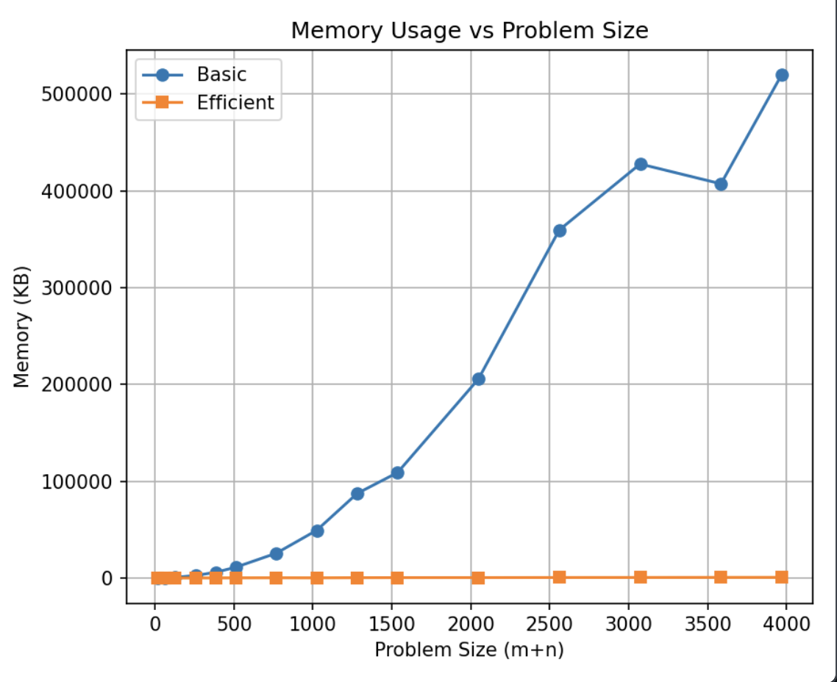

Nature of the Graph (Logarithmic/ Linear/ Polynomial/ Exponential)

Basic: Polynomial
Efficient: Constant

Explanation:

For the basic algorithm, the entire (M+1) × (N+1) DP table is stored in memory, giving a theoretical space complexity of Θ(M×N). This is clearly visible in our graph — the basic curve grows in a quadratic/polynomial fashion. We can verify this using our datapoints: when the problem size doubles from 1024 to 2048, the basic memory grows from 49,264 KB to 205,520 KB, which is roughly 4x more, consistent with quadratic growth rather than linear (which would only double).
For the memory-efficient algorithm, we never store the full DP table. Instead, the divide and conquer approach only keeps two rows of the table in memory at any point, reducing space complexity to Θ(N). This is reflected in our graph — the efficient curve remains nearly flat across all problem sizes, hovering between 12,000-15,000 KB regardless of input size. For example, memory usage is 32 KB at m+n=256 and 640 KB at m+n=3968 — barely a 20x difference despite a 124x increase in problem size. The small fluctuations are due to Python runtime overhead rather than actual algorithmic scaling. This near-constant behavior confirms the expected Θ(N) space complexity of the efficient algorithm.

Graph2 – Time vs Problem Size (M+N)

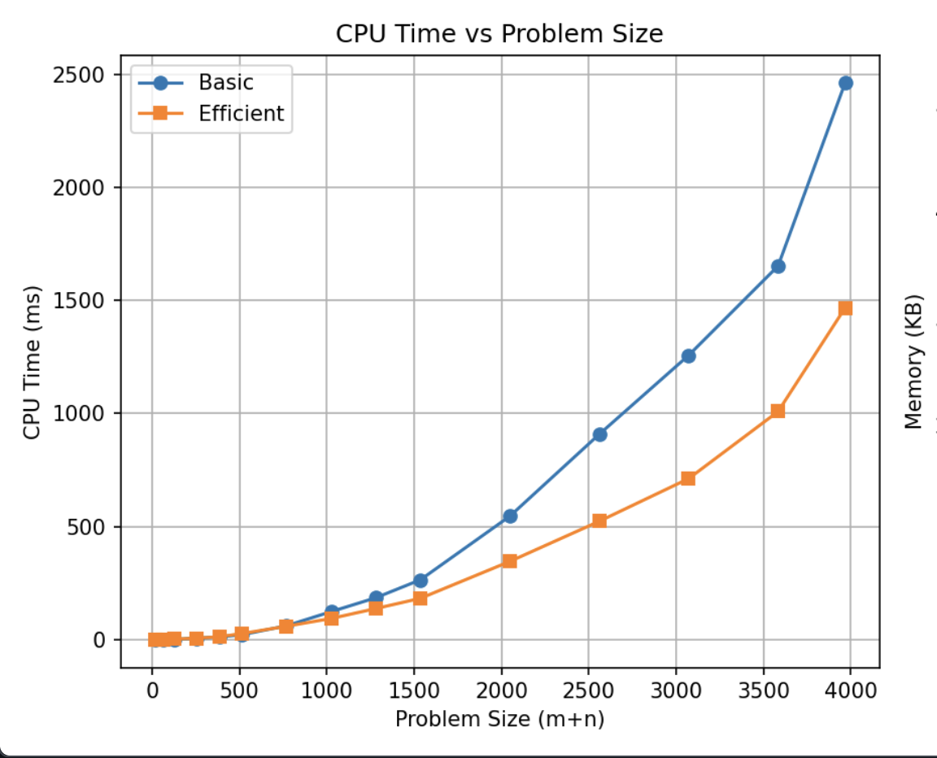

Nature of the Graph (Logarithmic/ Linear/ Polynomial/ Exponential)
Basic: Polynomial (Quadratic)
Efficient: Polynomial (Quadratic)

Explanation:
The basic algorithm fills a (M+1) × (N+1) DP table once. There are Θ(M×N) cells, and filling each cell does constant time work (calculating 3 candidate costs and taking the minimum). So the theoretical running time is Θ(M×N). This matches with our graph: the basic curve starts near 0 ms and increases more than linearly as M+N grows. For example, when the problem size doubles from 1024 to 2048, the time increases from 123 ms to 546 ms (nearly 4-4.5x more), which is consistent with quadratic growth rather than linear or exponential growth.
The efficient algorithm also evaluates all (M+1) × (N+1) DP states, but instead of storing the entire table, it uses divide and conquer while keeping only two rows in memory at any time. Since each DP cell still requires constant time work (computing three candidate costs and taking the minimum), the theoretical running time remains Θ(M×N). This matches what we see in the graph: the efficient curve also grows polynomially. For example, as the problem size doubles from 1024 to 2048, the time rises from 93 ms to 346 ms, roughly a 3-4x increase, consistent with quadratic growth rather than linear or exponential behavior. Although the memory usage is significantly lower, the time complexity remains polynomial because the same total number of DP computations must still be performed.

Contribution
(Please mention what each member did if you think everyone in the group does not have an equal contribution, otherwise, write “Equal Contribution”)
<USC ID/s>: <Equal Contribution>

8837304797: Equal Contribution
1164925635: Equal Contribution
8423896373: Equal Contribution

