A

INTERNSHIP REPORT

ON
Mechatronics Modelling of an Entire Industry 5.0 Production Line
SUBMITTED BY

Ms. Samiksha Satre

UNDER THE GUIDANCE OF

Prof. Roshan Pushpan

Dr Shrinivas S Metan

Mr.Romain Delabeye





DEPARTMENT OF ELECTRONICS & TELECOMMUNICATION ENGINEERING PRADNYA NIKETAN EDUCATION SOCIETY, PUNE.
NAGESH KARAJAGI ORCHID COLLEGE OF ENGINEERING & TECHNOLOGY,
SOLAPUR 413002
(Affiliated to Dr.Babasaheb Ambedkar Technological University, Lonere) 2025 – 2026

Pradnya Niketan Education Society, Pune.

N. K. ORCHID COLLEGE OF ENGINEERING & TECHNOLOGY, SOLAPUR.

Department of Electronics & Telecommunication Engineering


CERTIFICATE

This is to certify that Ms. Samiksha Satre
of Final Year B. TECH (E&TC Sem-VII and VIII) Roll No. 3 has satisfactorily completed her internship under my guidance in partial fulfilment of the Third Year of Engineering in Electronics & Telecommunication Engineering as prescribed by Dr. Babasaheb Ambedkar Technological University, Lonere in the academic year 2025– 2026.

Prof. Roshan Pushpan Prof. U. A. Bongale Project Guide Internship Coordinator

Prof. S. S. Dhotre Dr. B. K. Sonage HOD Principal

Internship Invitation (Sem VIII)

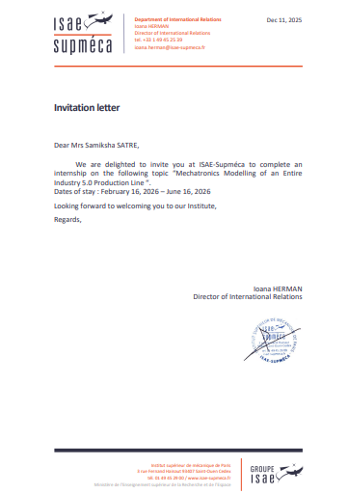

Acknowledgment

The time I spent in Supméca Institute of Mechanics of Paris as an intern was memorable for me as it was rich in experience and helped me to discover my potential. I have so many rich experiences that will shape my professional life.
I would like to thank Mr.Romain Delabeye who was my supervisor for giving us knowledge about the technology that we use today.
I would like to express my gratitude to Dr. B. K. Sonage, Principal NKOCET Solapur and Prof.
S. S. Dhotre, HOD (ENTC Department) for giving me permission to complete my internship as per Dr. Babasaheb Ambedkar Technological University, Lonere syllabus. I would also thank to my college internship coordinator Prof. U. A. Bongale and my training guide Prof. Roshan Pushpan for continuously guiding me throughout my training. Also, I would like to thank all staff members of my college for showing their cooperation in my training & all other staff members of the Supméca Institute of Mechanics of Paris for their valuable help.

Samiksha Satre

Department of Electronics & Telecommunication Engineering
Self-Assessment of Internship Semester V Academic Year 2022-23
- Name of Student: - Samiksha Satre

- Name of Course: - Mechatronics Modelling of an Entire Industry 5.0 Production Line

- Domain of Training: - Mechatronics, Embedded Systems, Digital Twin, Multiphysics Modelling, Industry 5.0

- Name of Trainer: - Mr. Romain Delabeye, Mr. Moncef Hammadi, Mr. Thierno Diallo

- Name of Organizer: - ISAE-Supméca Paris, France
in cooperation with N. K. Orchid College, Solapur

- Duration of Training: - 5 Months

- I hereby declare that I have learned the following skills during internship:

Sr.  No. | Description | Tick Wherever appropriate | Weightage (%)
1. | Learning new Techniques- Software, Hardware, Process etc | ✓ | 13%
2. | PCB designing, Assembly of electronic components on PCB, Wring | ✓ | 5%
3. | Mechanical designing, Assembly and Fabrication | ✓ | 10%
4. | Embedded System, Software Development | ✓ | 30%
5. | Research and Development | ✓ | 14%
6. | Integration of Modules as a System | ✓ | 10%
7. | Calibration, Testing, Servicing and Repairing | ✓ | 2%
8. | Quality Control | ✓ | 3%
9. | Installation/Commissioning |  | 0%
10. | Purchase and Marketing |  | 0%
11. | Documentation | ✓ | 3%
12. | Any other (Specify) Digital Twin & Multiphysics Simulation – 10% | ✓ | 10%

Date: Signature of Student

1.INTRODUCTION

I had the opportunity to undertake a five-month Industrial Master's Internship in Mechatronics and Digital Twin Engineering at the Euler Laboratory, ISAE-Supméca (Institute Supérieur de Mécanique de Paris), beginning on 1st February 2026. Assigned to Problem 02 — Mechatronics Modelling of an Entire Industry 5.0 Production Line — this internship was designed to strengthen students' foundational and practical skills in multiphysics modelling, FMI/FMU co-simulation, and the cyber-physical engineering practices central to modern Industry 5.0 systems.
As a student of NK Orchid College Of Engineering Solapur, ENTC, this internship provided an excellent bridge between academic learning and industry-level technical exposure. Throughout the internship, I received continuous guidance and support from my industrial supervisor, Mr. Romain Delabeye (Euler Laboratory, ISAE-Supméca), whose expertise in mechatronics, model-based systems engineering and parameter identification played a significant role in shaping my understanding of multiphysics digital twins. Under his guidance, I gained valuable insights into real-world modelling practices in Modelica, validation against field measurements (TDMS recordings from the running ALIX/ERMASMART line), FMU export and orchestration in Python, and systematic problem-solving approaches to coupled mechanical, electrical and thermal phenomena. This internship not only enhanced my technical skills in Modelica, Dymola, FMI 2.0, FreeCAD CAD extraction and Python-based co-simulation, but also contributed to my overall professional development by improving my discipline, scientific rigour, and analytical thinking when reasoning about complex industrial systems.
This internship served as a valuable transition from classroom-based learning to real-world technical applications. The structured workflow — model design in Modelica, parameter extraction from manufacturer documentation and CAD, FMU export from 3DEXPERIENCE Dymola Behavior Modeling, Python-based co-simulation via FMpy, and validation against TDMS measurements from the running line — significantly strengthened my understanding of multiphysics modelling and improved my confidence in applying theoretical concepts (induction machine equations, multibody dynamics, thermal lumped-parameter modelling) to practical industrial scenarios.

This report presents a comprehensive overview of my internship journey, including the objectives of the program, the host laboratory and the ALIX/ERMASMART line, modelling methodology, subsystem models developed (conveyor with mechanical-electrical-thermal coupling, Dobot CR5 6-DOF multibody cobot, XY10 Cartesian station), validation outcomes against field measurements, energy analysis findings, and the key results achieved during the internship period.

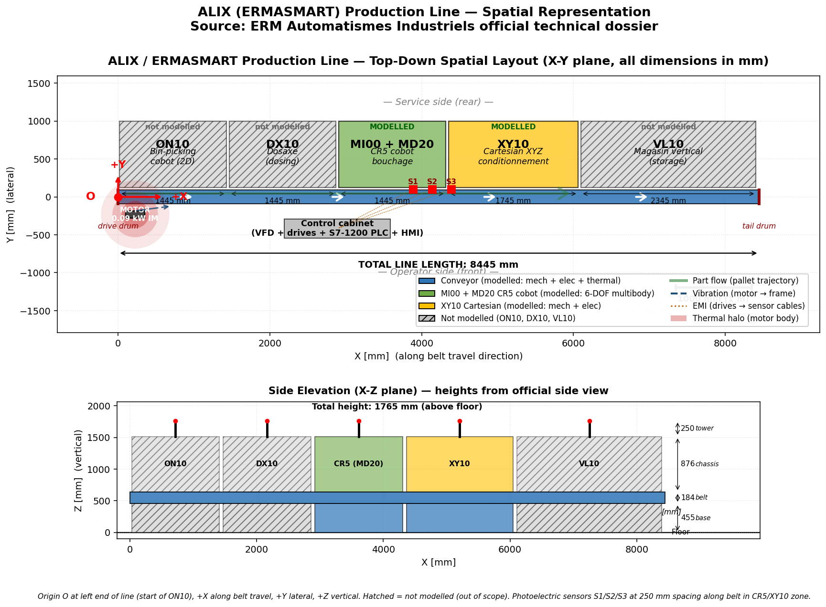

Fig 1.1: ALIX Line Spatial Representation

1.1 EULER LABORATORY, ISAE-SUPMÉCA

The internship was conducted at the Euler Laboratory of ISAE-Supméca (Institut Supérieur de Mécanique de Paris), located in Saint-Ouen-sur-Seine, Paris, France. Euler is a research laboratory specialising in mechanical engineering, mechatronic systems, vibrations, acoustics, tribology and the design methodology of complex multiphysics and cyber-physical systems. The laboratory operates under the supervision of Director Mr. Jean-Luc Dion and brings together three research themes that work in synergy: Mechatronics Engineering of Multiphysics Systems (IS2M), Tribology and Materials, and Vibration, Acoustics and Structures — Mechanical Forms.
The research theme most relevant to this internship is IS2M, led by Mr. Régis Plateaux (with Mr. Thierno Diallo as deputy), which addresses scientific and industrial issues related to the multidisciplinary design of complex systems including mechatronic systems, robotic systems, cyber-physical systems (CPS), cyber-physical production systems (CPPS) and systems-of-systems (SoS) — all considered from a dependability and safety standpoint. The theme's activities are centred on four pillars: synthesis of system architecture using model-based systems engineering (MBSE), analysis of candidate architectures, methodologies of design, and the formalisation of design processes, models and their simulation. Application domains include transport systems (aeronautical, railway, automotive, naval), energy systems, production systems, medical systems, cyber-physical systems and systems-of-systems.
ISAE-Supméca is a French Grande École of mechanical engineering, part of the ISAE Group, dedicated to training engineers and conducting research in the fields of mechanics, mechatronics and industrial engineering. The school maintains close partnerships with industry, including major French and European companies in the aerospace, automotive, defence and manufacturing sectors. The Euler Laboratory is the principal research arm of the school.

1.2 ALIX PRODUCTION LINE

The ALIX production line is a bench-top reconfigurable Industry 5.0 platform installed at the Euler Laboratory and used as the experimental testbed for this internship. Physically, ALIX corresponds to an ERMASMART line manufactured by ERM Automatismes Industriels (Carpentras, France), a French company specialising in didactic industrial automation platforms. The line was delivered with a complete official technical dossier (F1.1 line presentation, F1.2 fiche technique per machine, F1.3 system description, F2.2 installation manual, F2.4 maintenance procedures) which served as the primary source of dimensions, electrical specifications and operating parameters used throughout the modelling work.The line is 8445 mm in total length and is composed of five integrated stations linked by a continuous conveyor belt that transports pots and parts through the production sequence. The system supports two configurable operating modes — Conditionnement (packaging) and Assemblage (assembly) — in which the five stations play different functional roles. The reference mode for this work is Conditionnement, in which the line fills pots with granules, caps them, packages them into trays, and stores them.

In Conditionnement mode the stations, from upstream to downstream, are:
Code | Designation | Function | Footprint (mm)
ON10 | Robot collaboratif de dévracage 2D | Bin-pick pots from bulk and place on conveyor | 1445 × 1765
DX10 | Dosaxe | Fill pots with a determined dose of granules | 1445 × 1765
MI00 + MD20 | Robot collaboratif de bouchage (Dobot CR5) | Place caps personalisation covers | 1445 × 1765
XY10 | Robot cartésien XYZ de conditionnement | Pack capped pots into trays | 1745 × 1765
VL10 | Magasin vertical | Store packaged | 2345 × 1765

The line is supplied with three-phase 400 V AC at 50 Hz (measured 244 V phase RMS), with single-phase 230 V outputs to individual stations. Each station integrates its own local control (variable-frequency drives for steppers, S7-1200 PLC for sequencing) and is supervised by the TULIP platform from a central HMI. Three photoelectric sensors (S1, S2, S3) are mounted along the conveyor in the CR5–XY10 interaction zone to detect pot presence and trigger station actions. The full spatial layout of the line, including the subsystems modelled in this work
For this internship, three of the five stations were selected as the modelling scope:
- The conveyor (the continuous belt running through the line, driven by a 0.09 kW TECHTOP TIA56-2 induction motor via a Motovario NMRV 030 worm gearbox with reduction ratio i = 20) — modelled with full multiphysics coupling (mechanical, electrical and thermal).
- The MI00 + MD20 CR5 cobot station (a 6-DOF Dobot CR5 collaborative robot mounted on the MI00 conveyor module) — modelled as a multibody mechanical system with CAD-extracted mass and inertia parameters.
- The XY10 Cartesian station (a three-axis pick-and-place with vacuum gripper) — modelled with mechanical-plus-electrical coupling.
The remaining two stations (ON10, DX10, VL10) are shown in the spatial layout for context but are outside the modelling scope of this internship.

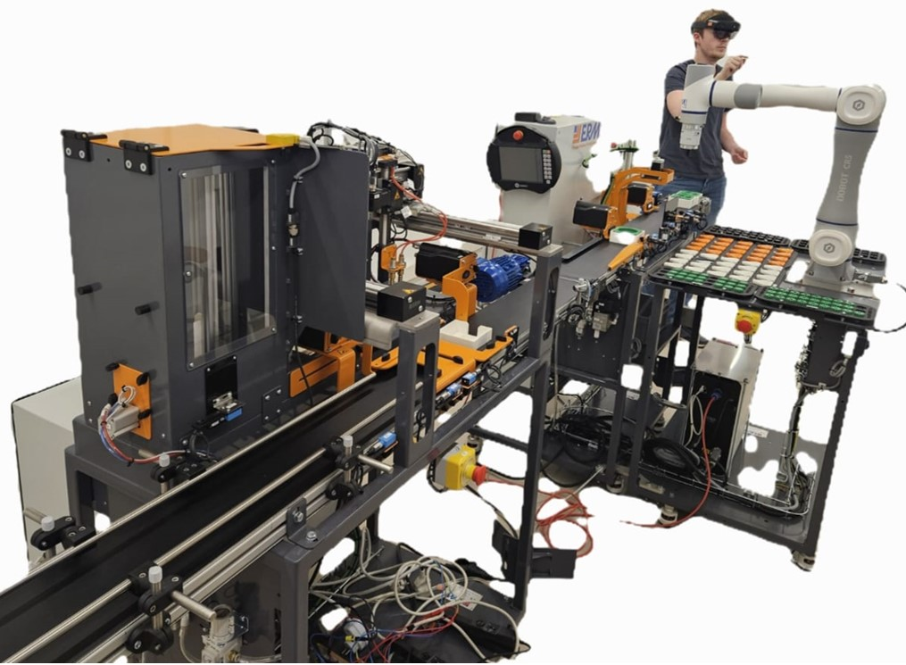

Fig 1.2.1: ALIX Line

2. STATE OF ART

2.1 From Industry 4.0 to Industry 5.0

The fourth industrial revolution, commonly designated as Industry 4.0, emerged in the early 2010s around the convergence of cyber-physical systems, the Internet of Things, cloud computing and data analytics in industrial production. Its main objective was to digitize the factory floor, interconnect machines and information systems, and unlock productivity gains through automation and data-driven optimization.
In January 2021, the European Commission published the report Industry 5.0 — Towards a sustainable, human-centric and resilient European industry (Breque, De Nul and Petridis, Directorate-General for Research and Innovation), formally introducing the term Industry 5.0 as a complement — rather than a replacement — of Industry 4.0. As stated by the Commission, "Industry 5.0 complements the existing Industry 4.0 paradigm by highlighting research and innovation as drivers for a transition to a sustainable, human-centric and resilient European industry
Industry 5.0 is therefore structured around three pillars:
- Human-centricity — placing the operator at the centre of the production process rather than treating the human as an interchangeable production resource;
- Sustainability — adopting circular processes, renewable energy sources, and respecting planetary limits, aligned with the European Union's target of reducing carbon emissions by 55 % by 2030;
- Resilience — strengthening industrial supply chains against disruptions (pandemics, geopolitical events, resource scarcity).
The ALIX/ERMASMART line at the Euler Laboratory is intended as a research testbed for these three pillars. The digital-twin work undertaken in this internship directly supports the sustainability pillar by exposing energy consumption per subsystem and the motor thermal state — both required for energy-efficiency assessment and predictive maintenance — and indirectly the resilience pillar by formalising the line's behaviour into reusable Modelica models and FMUs that can be re-run, modified and replayed without depending on the physical equipment.

2.2 Digital Twins — Definitions and Levels of Integration

The concept of digital twin is widely used in the literature but inconsistently defined. The most commonly cited typology, proposed by Kritzinger et al. in their categorical literature review of Digital Twins in manufacturing , distinguishes three levels of integration based on the data flow between the physical system and its digital representation:
- Digital Model (DM) — A digital representation of a physical object built manually, with no automated data flow between the physical asset and its model. CAD models, hand-tuned simulation models and offline analyses fall into this category.
- Digital Shadow (DS) — A digital representation with automated, one-directional data flow from the physical asset to the digital model. The digital model reflects the current state of the physical system through sensor measurements, but the physical asset is not influenced back by the model.
- Digital Twin (DT) — A digital representation with automated, bidirectional data flow. Changes in the physical asset update the digital model, and decisions made on the digital side can be propagated back to influence the physical system (e.g. control commands, parameter updates, maintenance scheduling).
According to Kritzinger et al., the majority of publications in the digital-twin literature treat what is actually a Digital Model or Digital Shadow under the broader "Digital Twin" label, while true bidirectional digital twins remain comparatively rare.
This distinction is important for honest scientific positioning: the present work is, in the Kritzinger taxonomy, a Digital Model that has been validated against measurement data, with the architectural pieces (Modelica subsystems, FMUs, Python orchestration with FMpy, TDMS measurement chain) that would be required to upgrade it to a Digital Shadow already in place.
2.3 Modelica — Equation-Based Multiphysics Modelling

The modelling language used throughout this internship is Modelica, an open and standardised equation-based, object-oriented language for the description of physical systems. Maintained by the Modelica Association and currently at language specification version 4.1, Modelica distinguishes itself from traditional block-diagram simulation languages (such as Simulink) by being acausal: model components are described as systems of differential, algebraic and discrete equations, and the solver determines the direction of computation at simulation time from the topology of connections rather than from a fixed input-output orientation [4].
This acausality enables three properties that are essential for industrial multiphysics modelling:
- Multidomain coupling — electrical, mechanical, thermal, fluid and control components can be assembled side-by-side in the same model, with conservation laws (Kirchhoff, Newton, energy balance) preserved across domain boundaries through Modelica's flow/effort connector formalism.
- Component reuse — the Modelica Standard Library (MSL) provides over 1,600 validated components across electrical, mechanical, thermal and control domains, all of which are reusable without rewriting equations. The conveyor model developed in this internship is built almost entirely from MSL components (IM_SquirrelCage for the induction motor, IdealGear for the gearbox, HeatCapacitor and ThermalConductor for the thermal coupling, and the polyphase sources and sensors).
- Tool independence — Modelica is supported by multiple commercial tools (Dymola, Modelon Impact, SimulationX, MapleSim) and open-source ones (OpenModelica). Models written in one tool can in principle be exchanged with another, although tool-specific extensions exist.
For this internship, the implementation environment was CATIA Dymola Behavior Modeling 6.428.3.0 (kernel version 2026x Refresh 1), the integration of Dymola inside the 3DEXPERIENCE platform by Dassault Systèmes.

2.4 FMI — The Functional Mock-up Interface Standard

A multiphysics Modelica model is most useful when it can be exported, exchanged, and re-simulated outside the original modelling tool. This is what the Functional Mock-up Interface (FMI) standard provides. FMI is maintained as a Modelica Association Project and defines a tool-independent file format (the Functional Mock-up Unit, or FMU) for exchanging dynamic simulation models. FMI 1.0 was published in 2010; FMI 2.0, published in 2014 [5], unified the formerly separate Model Exchange and Co-Simulation interfaces and added performance and usability improvements. FMI 3.0, the current major version, was released in 2024.

An FMU is technically a ZIP archive containing:

An XML file describing the model interface (inputs, outputs, parameters, units);

Compiled C-code (or shared library) implementing the model equations;

Optional source code, documentation and resources.

Two operating modes are defined:

Model Exchange (ME) — the FMU exposes its equations and the importing tool integrates them using its own numerical solver.

Co-Simulation (CS) — the FMU contains its own embedded solver and is driven by the importing tool only through time-step coordination.

The FMI standard is now supported by more than 280 simulation tools across the automotive, aerospace, energy and manufacturing industries [6]. In this internship, every subsystem model is exported as FMI 2.0 Co-Simulation FMU from 3DEXPERIENCE Dymola, then imported in Python through the open-source FMpy library for line-level orchestration and validation against TDMS measurements.

2.5 Multiphysics Modelling of Industrial Production Subsystems

Within the Modelica framework, the specific subsystems modelled in this internship draw on long-standing electrical-machine and multibody-dynamics traditions:

Induction machines are represented in the MSL package Modelica.Electrical.Machines.BasicMachines.InductionMachines.IM_SquirrelCage, implementing the classical Park/Clarke d-q axis model for a squirrel-cage motor with stator and rotor resistance, leakage and magnetising inductances, and explicit loss components (friction, core, stray-load). When the useThermalPort flag is enabled, the same model exposes a thermal connector that can be coupled to an external thermal network — which is the basis of the v3 multiphysics extension developed in this work.

Mechanical drive trains are represented through the Modelica.Mechanics.Rotational and Modelica.Mechanics.Translational packages, providing ideal gears (IdealGear), inertias, dampers, sensors, and ideal rolling-wheel adaptors between rotational and translational domains.

Multibody dynamics are represented through Modelica.Mechanics.MultiBody, which provides the rigid-body, joint and frame primitives used to assemble the 6-DOF CR5 cobot model.

Thermal networks are represented through Modelica.Thermal.HeatTransfer, supporting lumped-parameter elements (HeatCapacitor, ThermalConductor) for body-mass and natural-convection modelling. This is what closes the thermal-modelling spec requirement in this work.

2.6 Validation of Digital Twins Against Field Measurements
A multiphysics model only becomes a useful digital twin once its behaviour has been compared against measurements from the real asset. In industrial production lines, measurement chains are typically based on the TDMS (Technical Data Management Streaming) file format developed by National Instruments, which provides timestamped multi-channel acquisition of analog voltages and currents at sampling rates of several kHz. TDMS files preserve channel metadata (units, scaling, timestamps) and are the de facto standard in industrial measurement laboratories.
A general two-stage validation methodology is followed in this internship and is the established pattern in industrial digital-twin work:
- Stage A — Model versus measurement: the model is simulated under conditions matching the measurement, and the simulated outputs are compared to the measured signals (here, the conveyor motor current is band-pass filtered around the 50 Hz line frequency to extract the fundamental component for direct comparison with the model's clean sinusoidal output).
- Stage B — FMU versus model regression: the exported FMU is re-simulated in Python and its outputs are compared to the original Dymola reference. This stage isolates FMU-export errors from modelling errors and is essential before any production use of the exported FMU.

3. SPECIFICATIONS

3.1 Project Brief

The internship was assigned under the topic "Mechatronics Modelling of an Entire Industry 5.0 Production Line" at the Euler Laboratory of ISAE-Supméca, under the supervision of Mr. Romain Delabeye. The brief, as stated in the original problem definition, requires the development of a multiphysics digital twin of the ALIX/ERMASMART production line, suitable for use as a research testbed for Industry 5.0 cyber-physical production research.

3.2 Functional Requirements

Decomposing the brief into discrete engineering requirements yields the following list:

R1. Mechanical modelling. Each modelled subsystem must include a mechanical-domain model that captures relevant kinematics and dynamics (drive trains, multibody chains, friction, gear ratios, inertias).

R2. Electrical modelling. Each modelled subsystem with electrical actuation must include an electrical-domain model describing the supply, the motor electromagnetics, and the current and power signatures of the actuator.

R3. Thermal modelling. Each modelled subsystem must include a thermal-domain model representing the heat generated by losses and its dissipation to ambient conditions.

R4. Spatial representation. A simplified spatial representation of the line must be produced to locate the components in physical space.

R5. Coupling effects analysis. Potential coupling phenomena between subsystems must be identified and discussed. The specification explicitly names three coupling types: vibration transmission, temperature gradients, and other kinds of interference (electromagnetic interference, electrical coupling).

R6. Validation against measurements. Although not formally numbered in the brief, the spirit of the project requires that the model be validated against field measurements from the running line. The internship was provided with TDMS recordings (NI LabVIEW format) of the conveyor and XY10 station for this purpose.

R7. Parameter identification and observability Parameter identification is mentioned as a downstream objective of the multiphysics modelling, with the digital twin serving as the platform on which subsequent identification campaigns can be carried out. Model calibration was identified by the industrial supervisor as the most important phase of any subsequent extension of this work.

3.3 Boundary of Work — In Scope and Out of Scope

The ALIX/ERMASMART line comprises five production stations linked by a conveyor. A six-month internship cannot model every subsystem to full depth. The boundary of work is therefore set explicitly:

In scope

The following subsystems are modelled, validated and exported as FMUs in this work:

The conveyor, comprising the 0.09 kW TECHTOP TIA56-2 induction motor, the NMRV 030 worm gearbox (ratio i = 20), the drive drum, the belt with its equivalent load, and the motor-to-ambient thermal coupling. The conveyor is the central modelled subsystem and is the only one for which the full multiphysics scope (mechanical + electrical + thermal) is implemented.

The MI00 + MD20 station comprising the Dobot CR5 6-DOF collaborative robot. Modelled as a multibody mechanical system with CAD-extracted mass and inertia parameters, with viscous joint damping representing gearbox and bearing friction.

The XY10 Cartesian station comprising the X, Y and Z linear axes, the stepper drives and the vacuum gripper. Modelled with coupled mechanical-and-electrical behaviour at the DC-equivalent (time-averaged) level.

Out of scope

The following are explicitly excluded from this work to keep the scope realistic for the internship duration:

ON10 — the bin-picking collaborative robot at the upstream end of the line. Out of scope.

DX10 — the dosaxe (dosing unit). Out of scope.

VL10 — the vertical storage magazine at the downstream end. Out of scope.

These three stations are shown for context in the spatial representation (Chapter 9) and are clearly marked as "not modelled" in that figure. They are out of scope but not out of mind — their footprints and physical positions are documented so that future internships can extend the digital twin to include them without redoing the spatial work.

The following physical phenomena are also intentionally excluded:

Power-electronics switching (motor drive rectifier and PWM inverter) — the conveyor model treats the induction motor as directly grid-connected. The measured 50 Hz fundamental current matches the model to within 14 %; the residual harmonics in the raw measurement are the contribution of the PWM inverter, which is explicitly out of scope.

Stepper chopper-mode switching — the XY10 stepper drives use chopper-mode current regulation with instantaneous peaks at ±20 A. The FMU models the steppers as DC-equivalent drivers (peaks ±3 A). The comparison between FMU and TDMS is therefore valid at the energy/RMS level, not at the time-domain waveform level.

CR5 motor controllers and joint limits — the cobot is modelled as ideal-torque actuators per joint. A real CR5 has closed-loop position/velocity controllers that limit joint speed to 180 °/s. The model does not enforce this, so open-loop simulations can exceed brochure speed limits.

Collision detection — the multibody CR5 model does not include geometric collision with the floor or with the surrounding line. The end-effector position can therefore be below floor level in unconstrained simulations.

3.4 Deliverables
The following artefacts are produced and delivered at the end of the internship:
Modelica source models
- Conveyor_updated_v3.mo — multiphysics conveyor (mechanical + electrical + thermal).
- CR5_Cobot_v3_fixed.mo — 6-DOF multibody Dobot CR5 cobot.
- XY10Station.mo — three-axis Cartesian station with vacuum gripper.
Exported FMUs (FMI 2.0 Co-Simulation)
- Conveyor_updated_v3.fmu — 8 outputs (motor speed, shaft torque, belt velocity and position, RMS current, instantaneous phase current, electrical power, motor temperature), 161 tunable parameters.
- CR5_Cobot.fmu — 6 inputs (joint torques), 16 outputs (6 joint positions, 6 joint velocities, total power, TCP x/y/z), 161 parameters.
- XY10Station.fmu — 4 inputs (3 axis targets + vacuum command), 11 outputs (positions, currents, powers, gripper state).
Python orchestration and validation scripts
- master.py, fmu_manager.py, state_machine.py, sensor_models.py — line orchestration layer.
- test_conveyor_v3_thermal_FIXED.py — Stage B regression test for the conveyor FMU.
- test_cr5_fmu.py — Stage B regression test with three scenarios for the CR5 FMU.
- validation_dynamic_v8_FIXED.py — TDMS-vs-FMU validation (axis-corrected per supervisor feedback).
- energy_analysis_FIXED.py — per-subsystem energy hierarchy across the line.

4.METHODOLOGY AND TOOLS

A complete description of the methodology is given in Chapter 3. In summary, the workflow followed in this internship is:
- Parameter acquisition — from manufacturer documentation (TECHTOP, Motovario, Dobot, ERM Automatismes), from CAD via FreeCAD (per-link masses and inertia tensors for the CR5), and from field measurements (TDMS files for supply voltage calibration).
- Modelling in Modelica — each subsystem assembled in 3DEXPERIENCE Dymola Behavior Modeling using the standard library components.
- Simulation and refinement — iterative simulation in Dymola, comparison with analytical predictions and supervisor feedback. Each subsystem went through multiple recorded iterations (Conveyor v1 → v2 → v3; CR5 v1 → v2 → v3 fixed).
- FMU export — FMI 2.0 Co-Simulation, DASSL solver, tolerance 1e-4.
- Python regression test (Stage B validation) — each FMU re-simulated in Python via FMpy and outputs compared to the Dymola reference. Target agreement : < 0.01 % on preserved outputs.
- Field validation (Stage A) — FMU outputs compared to TDMS measurements with band-pass filtering at 50 Hz to extract the line-frequency fundamental for direct comparison.
- Line-level orchestration — all FMUs assembled into a single Python orchestration layer with symbolic part flow between stations.
- Energy and coupling analysis — per-subsystem energy KPI and qualitative coupling-effects matrix.
Activity | Tool
Modelling | 3DEXPERIENCE Dymola Behavior Modeling 6.428.3.0
FMU import / orchestration / validation | Python 3.12 with FMpy, NumPy, SciPy, Matplotlib
CAD extraction | FreeCAD
TDMS reading | nptdms (Python)
Version control | Git / GitHub

5. MODELS

5.1 Conveyor Subsystem
5.1.1 Physical Scope
The conveyor is the central modelled subsystem of this work and the only one for which the full multiphysics scope (mechanical + electrical + thermal) is implemented. Physically, it consists of a three-phase squirrel-cage induction motor (TECHTOP TIA56-2 class, 0.09 kW nominal, 4-pole, 50 Hz) driving a Motovario NMRV 030 worm gearbox (reduction ratio i = 20) coupled to the drive drum (radius 25 mm), which in turn transports the belt and parts through the production zone.
The model couples three physical domains in a single Modelica file:
- Electrical domain: three-phase sinusoidal supply at 244 V phase RMS / 50 Hz (calibrated to TDMS measurement), polyphase star configuration, current and power sensors, and the standard library IM_SquirrelCage induction machine with full loss model (friction, core, stray-load losses).
- Mechanical domain: motor shaft → ideal worm gearbox → output-side inertia → drive drum → translational belt mass → viscous damper → constant resistive load force.
- Thermal domain: the motor's thermal port is connected to a lumped heat-capacity element (500 J/K) representing the motor body mass, which in turn discharges to ambient air (293.15 K) through a thermal conductance (1.5 W/K) representing natural convection.
5.1.2 Parameters

Parameter | Value | Unit | Source
Rated power | 0.09 | Kw | Motor nameplate
Pole pairs | 2(4 -pole) | __ | Nameplate
Stator resistance Rs | 12 | Ω | Class estimate (calibration candidate)
Rotor resistance Rr | 8 | Ω | Class estimate (calibration candidate)
Magnetising inductance Lm | 0.45 | H | Class estimate (calibration candidate)
Leakage inductance Lσ | 0.025 | H | Class estimate (calibration candidate)
Rotor inertia Jr | 1.5e-3 | kg·m² | Class estimate (calibration candidate)
Supply voltage (peak) | 244·√2 ≈ 345 | V | Calibrated to TDMS
Supply frequency | 50 | Hz | TDMS measurement
Gearbox ratio i | 20 | __ | Motovario NMRV 030 datasheet
Drum radius | 0.025 | M | Approximate
Belt + parts equivalent mass | 1.0 | Kg | Estimate
Viscous damper | 1.0 | N·s/m | Estimate
Friction loss | 6 | W | Loss parameter at rated speed
Core loss | 10 | W | Iron loss at rated voltage
Stray-load loss | 1.5 | W | Stray losses at rated current
Thermal capacity (motor body) | 500 | J/K | Lumped approximation for 0.09 kW frame
Thermal conductance to ambient | 1.5 | W/K | Natural convection estimate
Ambient temperature  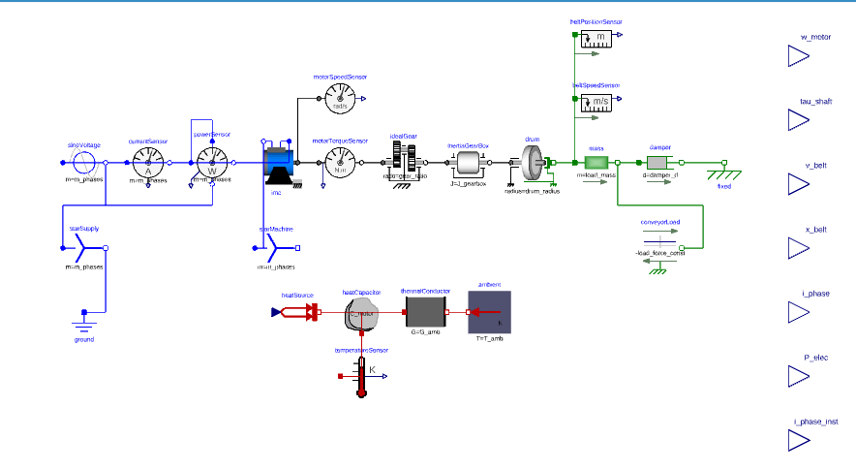  Fig.5.1.1. Connection diagram for conveyor | 293.15 | K (20 °C) | Lab environment

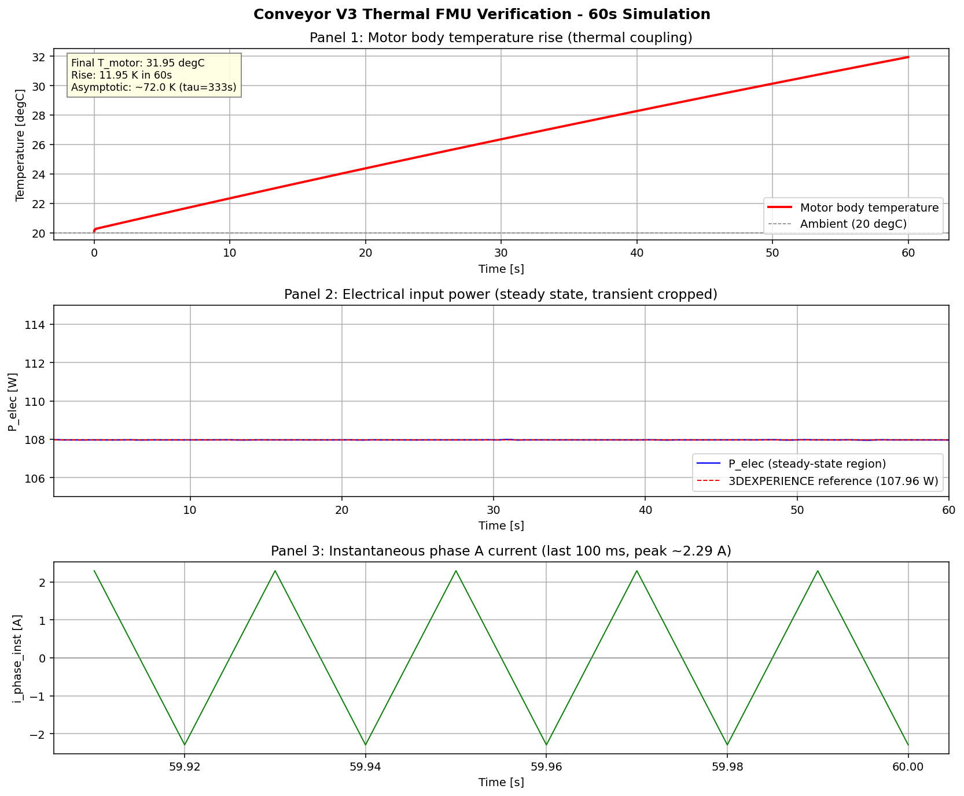
Fig.5.1.2. Conveyor FMU Validation
5.1.3 Agreement Achieved:
- the constant mechanical load assumption (the real belt friction varies with parts on the line);
- the absence of the PWM inverter in the model scope (the real motor is fed by a controlled drive, not directly grid-connected)
- the use of nameplate / class-estimate motor parameters rather than identified ones. Closing this residual is the natural objective of the model calibration phase identified by the industrial supervisor as the next priority of the project.
Thermal energy balance. The thermal extension was verified analytically:
- Predicted asymptotic temperature rise: ΔT∞ = P_loss / G = 108 / 1.5 = 72 K.
- Predicted rise at t = 60 s: 72 × (1 − exp(−60/333)) = 11.8 K.
- Observed rise at t = 60 s: 11.95 K.
- Agreement: ~99 %, consistent with the lumped-parameter approximation.

Output | Python FMU | Dymola reference | Difference | Agreement
T_motor | 305.0969 K | 305.0970 K | 0.0001 K | >99.99 %
i_phase | 1.6286 A | 1.6286 A | 0.0000 A | 100.00 %
P_elec | 107.9623 W | 107.9620 W | 0.0003 W | >99.99 %

5.2 CR5 Collaborative Robot Subsystem
5.2.1 Physical Scope
The Dobot CR5 is a 6-degree-of-freedom collaborative robot mounted on the MI00 station platform, used in the Conditionnement mode for placing caps on filled pots. In this work, the cobot is modelled as a pure multibody mechanical system: per-link mass, centre of mass, inertia tensor, revolute joints with viscous damping, and torque actuators per joint. The electrical and thermal domains for the cobot are out of scope — no motor datasheets are available for the CR5 internal actuators, and the cobot is intermittently loaded, so its thermal contribution to the line is secondary compared to the continuously running conveyor motor.
5.2.2 Parameter Extraction from CAD
Per-link masses and inertia tensors were extracted from the CR5 CAD assembly using FreeCAD. To guarantee positive-eigenvalue inertia tensors (a necessary condition for physically valid multibody simulation), each link was approximated by an equivalent uniform cylinder with matching mass and bounding dimensions. This is a documented simplification that produces inertias accurate enough for first-pass multibody dynamics.
- Dobot CR5 brochure: 25.0 kg. CAD-to-brochure agreement: 94.9 %.
The 5.1 % residual is consistent with the cylinder approximation used in the inertia extraction and with the difference between the modelled mechanical parts and the real cobot, which includes cable harnesses, controller electronics in the base and joint motor windings.
Link | Mass (kg) | Length (m) | Description
L1 (base) | 4.3542 | 0.147 (height, along Z) | Vertical base column, rotates about Z
L2 (upper arm) | 4.3542 | 0.427 (along X) | Swings under gravity (shoulder)
L3 (forearm) | 4.3542 | 0.357 (along X) | Elbow joint to wrist offset
L4 (wrist 1) | 5.8944 | 0.116 (along Z) | Wrist roll housing
L5 (wrist 2) | 1.8101 | 0.116 (along Z) | Wrist pitch
L6 (wrist 3) | 1.8079 | — | End-effector roll (combined with L7)
L7 (flange) | 1.1611 | 0.105 (along Z) | End-effector flange
5.2.3 Joint Configuration
The six revolute joints are arranged in the standard orthogonal cobot convention:

Joint | Rotation axis | Damping (N·m·s/rad) | Function
J1 | Z (vertical) | 1.0 | Base rotation (swivel)
J2 | Y (horizontal) | 1.5 | Shoulder pitch main gravity load
J3 | Y (horizontal) | 1.0 | Elbow pitch
J4 | X (forearm) | 0.5 | Wrist roll
J5 | Y (horizontal) | 0.3 | Wrist pitch
J6 | Z (end frame) | 0.2 | End-effector roll
Each joint is actuated by an ideal Torque source exposing the input tau_ref[i] and damped by a Damper element representing combined gearbox and bearing friction. The joint-axis convention required correction across iterations v1 → v2 → v3: the initial version used axes parallel to link directions (zero gravity torque), the v2 version added damping but at values too high (arm locked), and the v3 version corrected both the axes (orthogonal convention) and the damping values (reduced 10×) to produce the expected damped-pendulum response under gravity.

5.2.4 Modelica Architecture and Connection Diagram
The model is built from Modelica.Mechanics.MultiBody standard library components: Revolute joints, BodyShape rigid bodies (per link, with mass, CoM and inertia tensor), Damper elements per joint, Torque actuators per joint, and an AbsolutePosition sensor at the end-effector to expose the TCP position in world frame.

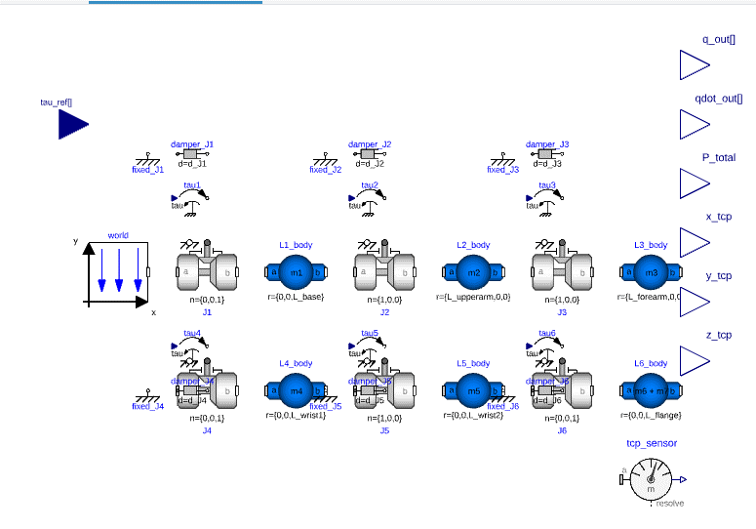
Fig.5.2.1.COBOT_CR5 Model

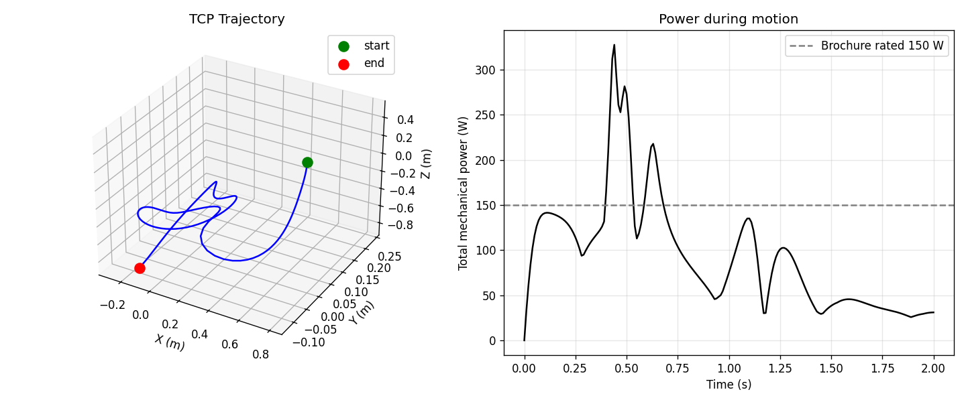
Fig.5.2.2.cr5_test_trajectory

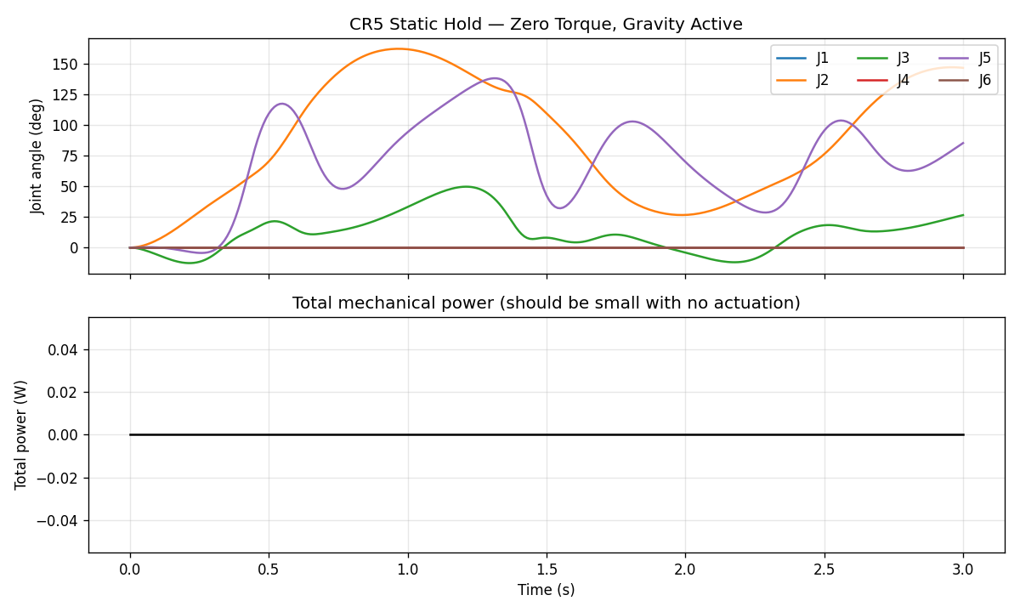
Fig.5.2.3.cr5_test_static
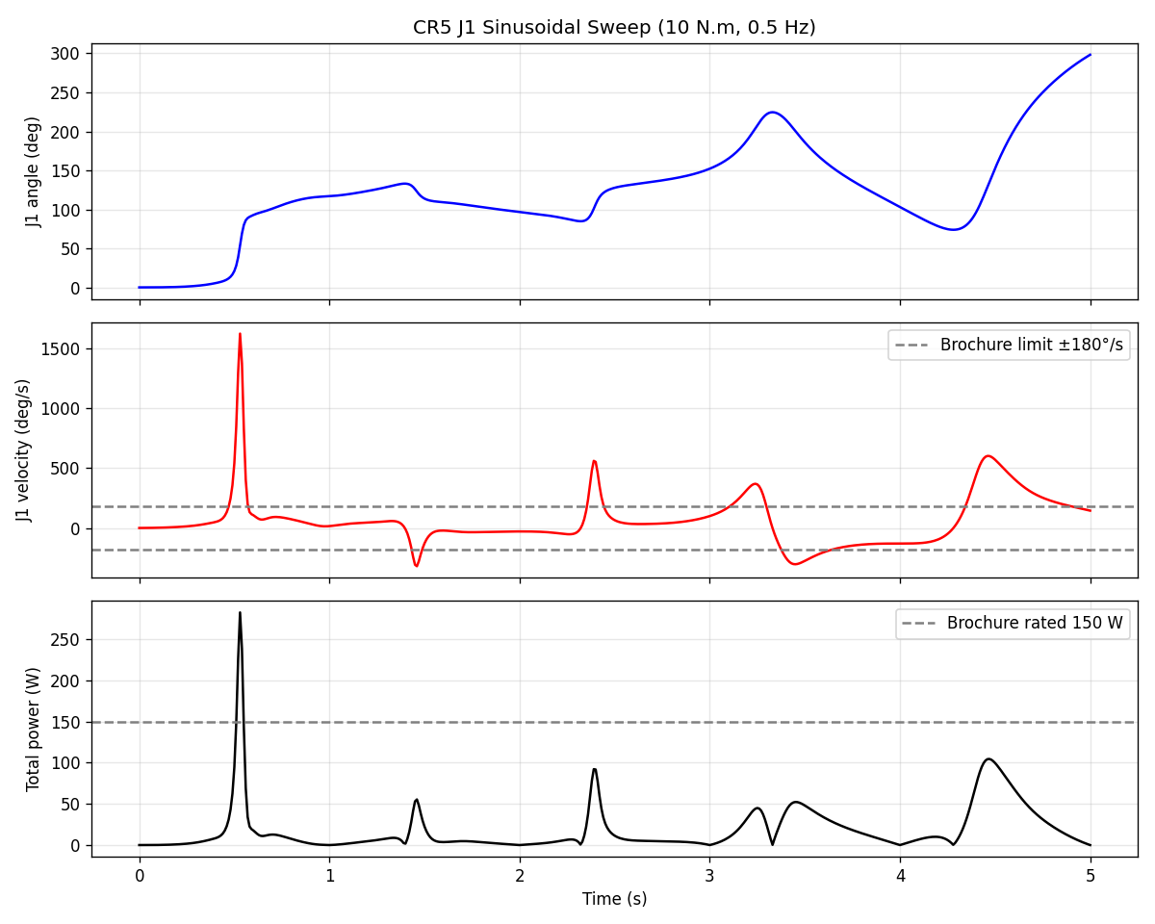
Fig.5.2.3. cr5_test_j1_sweep

5.2.5 FMU Interface
The exported CR5_Cobot.fmu has 6 inputs (joint torques) and 16 outputs:

I/O | Signal | Unit | Meaning
Input | tau_ref[1..6] | N·m | Joint torque commands
Output | q_out[1..6] | Rad | Joint angular positions
Output | qdot_out[1..6] | rad/s | Joint angular velocities
Output | P_total | W | Total mechanical power (sum |τ_i·ω_i|)
Output | x_tcp, y_tcp, z_tcp | M | TCP position in world frame

Plus 161 tunable parameters covering all link masses, lengths, damping coefficients and gravity.

5.2.6 Key Verification Results
The CR5 model was verified through three test scenarios in Python:
- Test 1 — Static hold (gravity only). All joints initialised at zero with no applied torque. The arm falls under gravity and the shoulder joint J2 reaches a peak angle of approximately 160° at t ≈ 1 s, then decays toward an equilibrium near 147° at t = 3 s — the textbook damped-pendulum response.
- Figure 5.2.2 — CR5_test_trajectory gravity response under zero applied torque.
- Test 2 — J1 sinusoidal sweep. A 10 N·m sinusoidal torque at 0.5 Hz applied to J1, with all other joints free. Peak J1 velocity reaches 28.38 rad/s (1626 °/s), exceeding the 180 °/s brochure speed limit — expected behaviour for an open-loop multibody model without motor controllers. Peak power 282.6 W.
- Test 3 — TCP trajectory. Mixed torques applied to J1, J2 and J3 over 2 seconds. The TCP traces a 3.76 m path through 3D space from initial position (0.784, 0.000, 0.484) m to final position (-0.118, -0.120, -0.812) m, with peak instantaneous power 327.7 W.

5.3 XY10 Cartesian Pick-and-Place Subsystem
5.3.1 Physical Scope
The XY10 station is a three-axis Cartesian pick-and-place equipped with two stepper-driven horizontal linear axes (X and Y), a pneumatically actuated vertical axis (Z), and a vacuum gripper. In the Conditionnement mode of the ALIX/ERMASMART line, the XY10 picks finished pots from the conveyor and places them into trays for the vertical storage magazine VL10.
The XY10 is modelled at the DC-equivalent (time-averaged) level, not at the instantaneous chopper-mode switching level. This modelling choice is essential to understand:
- Real XY10 stepper drives operate in chopper mode: the drive current switches at high frequency (typically several kHz) between positive and negative limits to regulate motor torque. TDMS measurements at the drive line side show instantaneous current peaks of ±20 A.
- The FMU represents the same drive as a smooth DC equivalent: the time-averaged current magnitude that would produce the same torque and motion. Peak FMU current is ±3 A.

4.3.2 FMU Interface
The exported XY10Station.fmu has 4 inputs and 11 outputs:
I/O | Signal | Unit | Meaning
Input | x_cmd, y_cmd, z_cmd | M | Target axis positions
Input | vacuum_cmd | Boolean | Vacuum gripper on/off command
Output | x_pos, y_pos, z_pos | M | Current axis positions
Output | i_x, i_y, i_z | A | DC-equivalent drive currents per axis
Output | P_x, P_y, P_z | W | Electrical power per axis
Output | vacuum_chamber_pressure | Pa | Vacuum chamber pressure
Output | grip_ok | Boolean | True when chamber pressure below grip threshold
5.3.3 Modelica Architecture and Connection Diagram
The model assembles three single-axis subsystems (X, Y, Z), each comprising a DC-equivalent stepper driver, a mass-inertia-damper mechanical chain, and a position sensor. The vacuum gripper is modelled as a first-order pressure-decay system with a gripping threshold.
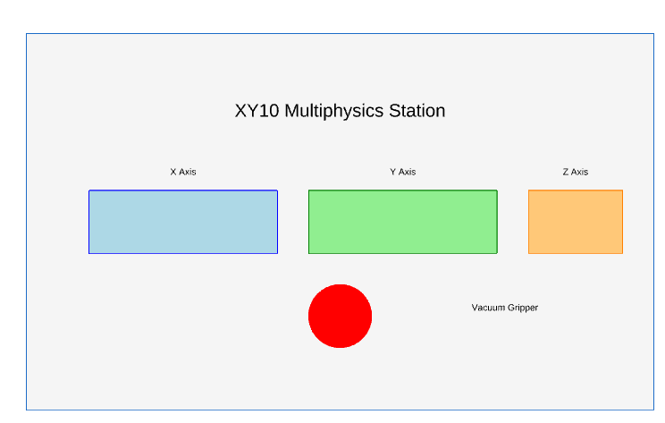
Fig.5.3.1. XY10 Station

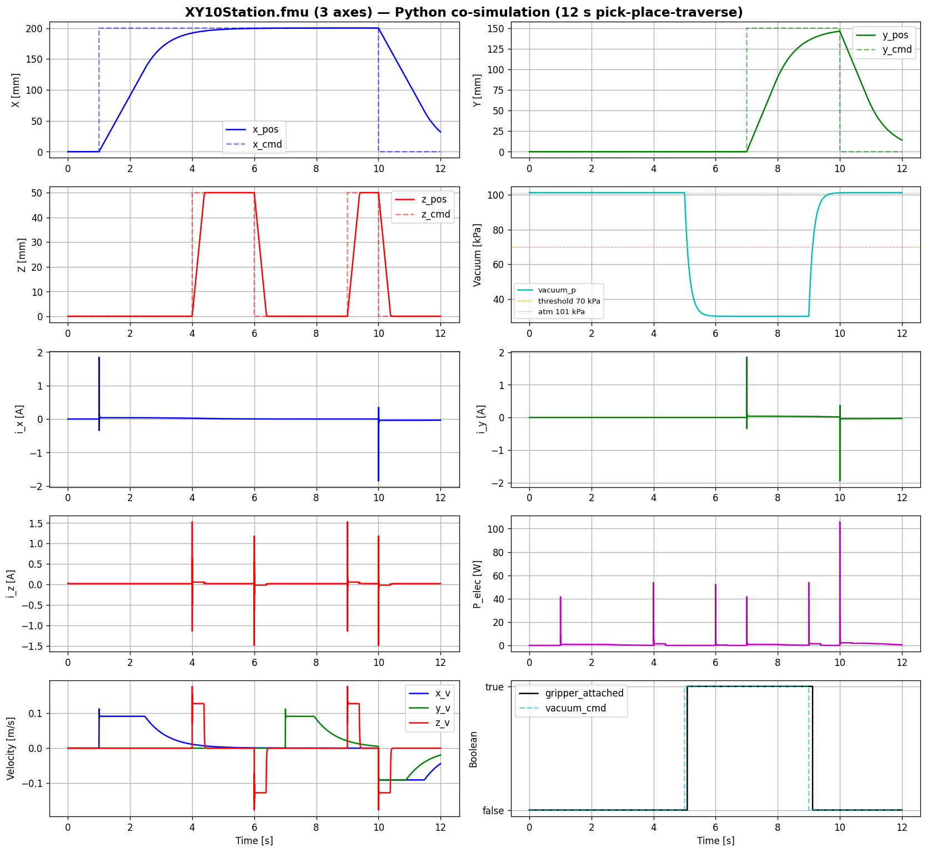
Fig.5.3.2. XY10 Station FMU Verification

5.4 Summary of Agreement Levels Across Subsystems

Subsystem | Stage B (FMU↔Dymola) | Stage A (model↔TDMS) | Mass / CAD agreement
Convey-or | > 99.99 % | 86 % on 50 Hz current fundamental | —
CR5 | > 99.99 % (qualitative match) | Not measured (no TDMS data) | 94.9 % vs brochure
XY10 | Not isolated-tested | Energy-level only(waveform incomparable) | __

The conveyor model is the most thoroughly validated subsystem and is the principal contribution of this work. The CR5 model is multibody-validated through textbook gravity-response behaviour and CAD-mass agreement. The XY10 model is validated end-to-end as part of line-level orchestration. Closing the open Stage-A and Stage-B gaps (XY10 isolated test, CR5 measurement, conveyor calibration) is the natural next phase, aligned with the supervisor's emphasis on model calibration.

6. VALIDATION AGAINST TDMS MEASUREMENTS

6.1 Validation Philosophy
A multiphysics model that has not been compared to measurements from the real asset is a hypothesis, not a digital twin. The validation work described in this chapter is what turns the Modelica models of Chapter 4 from plausible simulations into defensible engineering artefacts.
Before describing the validation work, three terminological distinctions must be made because they are routinely confused in the digital-twin literature and were addressed explicitly during the supervisor feedback rounds of this internship:
- Modelling is the act of building the equations and structure of the system. The output is a Modelica source file with parameters set to best-guess values from nameplates, datasheets and engineering estimates.
- Calibration is the act of adjusting unknown parameters so that the simulated output matches measurements. The output is a set of identified parameter values that minimise the error between simulation and measurement.
- Validation is the act of checking the calibrated (or uncalibrated) model against measurements, ideally measurements that were not used during calibration. The output is a quantitative agreement metric.
This work has performed modelling and validation. Calibration has not been performed in this iteration and is identified by the industrial supervisor as the next phase of any extension of this project. The validation reported here is therefore validation of a partially-calibrated model — the supply voltage is calibrated to the TDMS measurement, but the motor electrical parameters (Rs, Rr, Lm, Lσ) are class-estimate values that have not yet been formally identified. This honest scoping is essential to the interpretation of the agreement levels reported.
6.2 The TDMS Measurement Chain
6.2.1 Hardware and File Format
The validation data used in this work consists of two recordings produced by the Euler Laboratory measurement system on the running ALIX/ERMASMART line. The acquisition hardware is a National Instruments data acquisition module producing files in the TDMS (Technical Data Management Streaming) format — the National Instruments standard for industrial multi-channel timestamped data.
Each TDMS file contains six channels at a sampling rate of 6 kHz with timestamp synchronisation:
- U0 — phase voltage of the supply feeding the conveyor motor (analog channel after voltage transducer).
- U1 — phase voltage of the supply feeding the XY10 stepper drive.
- I0 — line-side current of the conveyor motor drive (analog channel after current transducer).
- I1 — line-side current of the XY10 stepper drive.
- AUX0, AUX1 — auxiliary channels (general-purpose, used for synchronisation when needed).
The two recordings used are:
At 6 kHz × 6 channels × 444 s, the conveyor file alone contains approximately 16 million samples — sufficient resolution to resolve harmonics up to 3 kHz (Nyquist limit) and amply sufficient for analysis of the 50 Hz line fundamental.
6.2.2 Why the Measured Current Is Not a Sinusoid
The first analytical observation when looking at the raw TDMS current channel is that the conveyor current is not a clean 50 Hz sinusoid, even though the supply voltage is. This is the central modelling-versus-reality distinction that the validation work has to address:
- The supply voltage is fed directly from the three-phase 400 V grid (244 V phase RMS).
- The motor, however, is fed not directly from the grid but through a motor controller that contains a diode bridge rectifier followed by a PWM inverter.
- The line-side current measured by the TDMS sensor is therefore the input current to the rectifier, which contains the 50 Hz fundamental plus the harmonics generated by the diode bridge plus the high-frequency switching ripple of the PWM inverter.
The model developed in this internship does not include the rectifier-inverter assembly. The motor in the Modelica model is treated as directly grid-connected. The simulated current i_phase_inst is therefore a clean sinusoid at 50 Hz. Comparing this clean simulated sinusoid to the raw measured current would be a category error — they are not the same signal. What can legitimately be compared is the 50 Hz fundamental component of the measured current, extracted by signal processing, against the simulated current. This is the core of the Stage A validation methodology developed below.

File | Duration | Use
first.tdms | 444 s | Conveyor steady-state measurement (continuous operation)
four.tdms | 287 s | XY10 stepper bursts (intermittent operation)

6.3 Signal Processing Pipeline
To extract the 50 Hz fundamental of the measured current for fair comparison with the FMU output, the following signal processing pipeline was developed:
6.3.1 Band-Pass Filter Design
A 4th-order Butterworth band-pass filter is applied to the raw TDMS current channel, with pass-band 40 Hz to 60 Hz. Three design choices matter:
- Butterworth response: maximally flat in the pass-band, no ripple. Preferred over Chebyshev for time-domain reconstruction.
- 4th order: the filter rolls off at 24 dB/octave on each side of the pass-band, sufficient to suppress the 100 Hz and 150 Hz harmonics that are major contributors of the rectifier signature.
- Zero-phase application: the filter is applied forward and then backward through the signal (using scipy.signal.filtfilt), producing zero net phase shift. This is critical when the goal is direct waveform comparison rather than RMS comparison.
6.3.2 Edge Cropping
Butterworth filters introduce edge transients of approximately one filter group-delay at the beginning and end of the filtered signal. To avoid these transients distorting the comparison, the filtered signal is cropped at both edges by 50 ms (2.5 cycles of the 50 Hz fundamental). This is documented in the validation figure as "edge-cropped".
6.3.3 Phase Alignment via Cross-Correlation
The Modelica model and the TDMS measurement are not synchronised at t = 0. To align them for visual comparison, a cross-correlation is computed between the filtered TDMS current and the FMU output. The lag at the peak of the cross-correlation is used to shift the FMU trace so that both signals are phase-aligned. The required shift in this work was approximately 3.7 ms, equivalent to about 18° of the 20 ms cycle — a small but non-zero phase offset attributable to the rectifier delay in the real drive and to the absence of a controller in the model.
6.3.4 Frequency-Domain Verification
The filtered signal is independently verified in the frequency domain by computing its FFT and checking that the 50 Hz bin dominates and that out-of-band harmonics are suppressed by more than 40 dB. This step prevents the case where a poorly-designed filter would leave residual harmonic content that would corrupt the time-domain comparison.

6.4 Stage A — Field Validation Results
The Stage A results are summarised in the single validation figure validation_dynamic_v8, reproduced as Figure 5.1 below. The figure is presented after several iterations of supervisor feedback (v1 through v8), with the v8 version incorporating the axis-correctness improvements requested by the industrial supervisor (separate axes for fundamentally different signal types, no dual-axis overlays of incomparable abstractions).
Figure 6.1 — Dynamic signal validation v8: TDMS measurements vs FMU outputs. Five-panel figure, all dimensions axis-correct.
The figure is built from five panels, each addressing a distinct validation question:
6.4.1 Panel 1 — Supply Voltage (TDMS U0 vs Model)
This panel overlays the raw TDMS voltage channel U0 (full sample rate, no filtering) with the clean sinusoid 244 V RMS × √2 × sin(2π · 50 · t) used as the model's supply source. Both signals are clean 50 Hz sinusoids of identical amplitude. Visual agreement is near-perfect. The model's supply voltage is calibrated to the TDMS measurement, and this calibration is the foundation on which all subsequent validation depends. Without the correct supply voltage, no downstream comparison would be meaningful.
6.4.2 Panel 2a — Raw Line-Side Current (TDMS I0)
This panel shows the raw measured current I0, unfiltered. The waveform is clearly not sinusoidal: the 50 Hz fundamental is present, but it is heavily distorted by diode-bridge rectifier harmonics (notably the 6th harmonic at 300 Hz) and overlaid with high-frequency PWM switching ripple. The peak-to-peak measured value is approximately 6.30 A, with a mean value of approximately 1.05 A (the DC offset of the current transducer, which is acceptable for analysis since it is removed by the band-pass filter).
Panel 2a is included deliberately to make the modelling-scope choice visible: anyone looking at this panel and at Panel 2b below understands at a glance that the raw signal is the input to the rectifier and the filtered signal is the 50 Hz fundamental — and that the latter is what the FMU represents.
6.4.3 Panel 2b — 50 Hz Fundamental (TDMS Band-Passed vs FMU)
This is the central comparison panel of the validation work. The blue trace is the band-pass-filtered TDMS current (after the 40-60 Hz Butterworth filter and edge cropping), with peak amplitude 1.99 A. The red trace is the FMU output i_phase_inst, with peak amplitude 2.30 A. Both signals are clean 50 Hz sinusoids and are phase-aligned by cross-correlation.
The numerical agreement is:
Quantity | TDMS measured | FMU simulated | Agreement
Peak amplitude | 1.99 A | 2.30 A | 86 %
Frequency | 50.00 Hz | 50.00 Hz | 100 %
Phase shift after alignment | — | 3.7 ms (≈ 18°) | —
The yellow inline annotation on Panel 2b reads: FMU models the motor as directly grid-connected (no rectifier/inverter). TDMS measures line-side current after the motor controller's diode bridge. The 50 Hz components agree (FMU 2.30 A vs TDMS 1.99 A peak); higher harmonics in the raw measurement (Panel 2a) reflect power electronics not in the current model scope." This annotation is part of the figure deliberately, so that any reader understands the validation scope without having to consult the report text.
6.4.4 Panel 3 — XY10 Stepper Raw Chopper Signature
This panel shows a single isolated burst of the XY10 stepper drive line-side current from four.tdms. The waveform is characterised by sharp instantaneous peaks of approximately ±18 A produced by the chopper-mode current regulation of the stepper drive. This panel is single-signal, unfiltered, and is shown to establish the physical reality of the stepper drive's measured signature. It is not compared directly to the FMU on this panel.
6.4.5 Panel 4 — XY10 Stepper Validation (Axis-Corrected)
This panel, in the v7 version of the validation figure, originally overlaid the TDMS envelope (±20 A) and the FMU step response (±3 A) on a single dual-axis plot. This was identified by the industrial supervisor as a violation of axis-correctness: two signals representing the same physical actuator at fundamentally different abstraction levels were being forced onto one visualisation, which suggested a comparison that was not physically meaningful.
The v8 version separates them into Panel 4a (TDMS envelope, ±20 A scale) and Panel 4b (FMU step response, ±3 A scale), side-by-side with independent axes. An accompanying scope note states explicitly: "TDMS (4a) shows the stepper drive's chopper switching current at the instantaneous level (peaks ±20 A). The FMU (4b) models the same stepper as a DC-equivalent driver, abstracting the chopper into its time-averaged current (peaks ±3 A). These two signals are NOT directly comparable in the time domain — they represent the same physical actuator at different levels of abstraction. Comparison is valid at the energy/RMS level (Panel C of energy analysis), not the instantaneous waveform."

Fig.5.3.2. XY10 Station FMU Verification

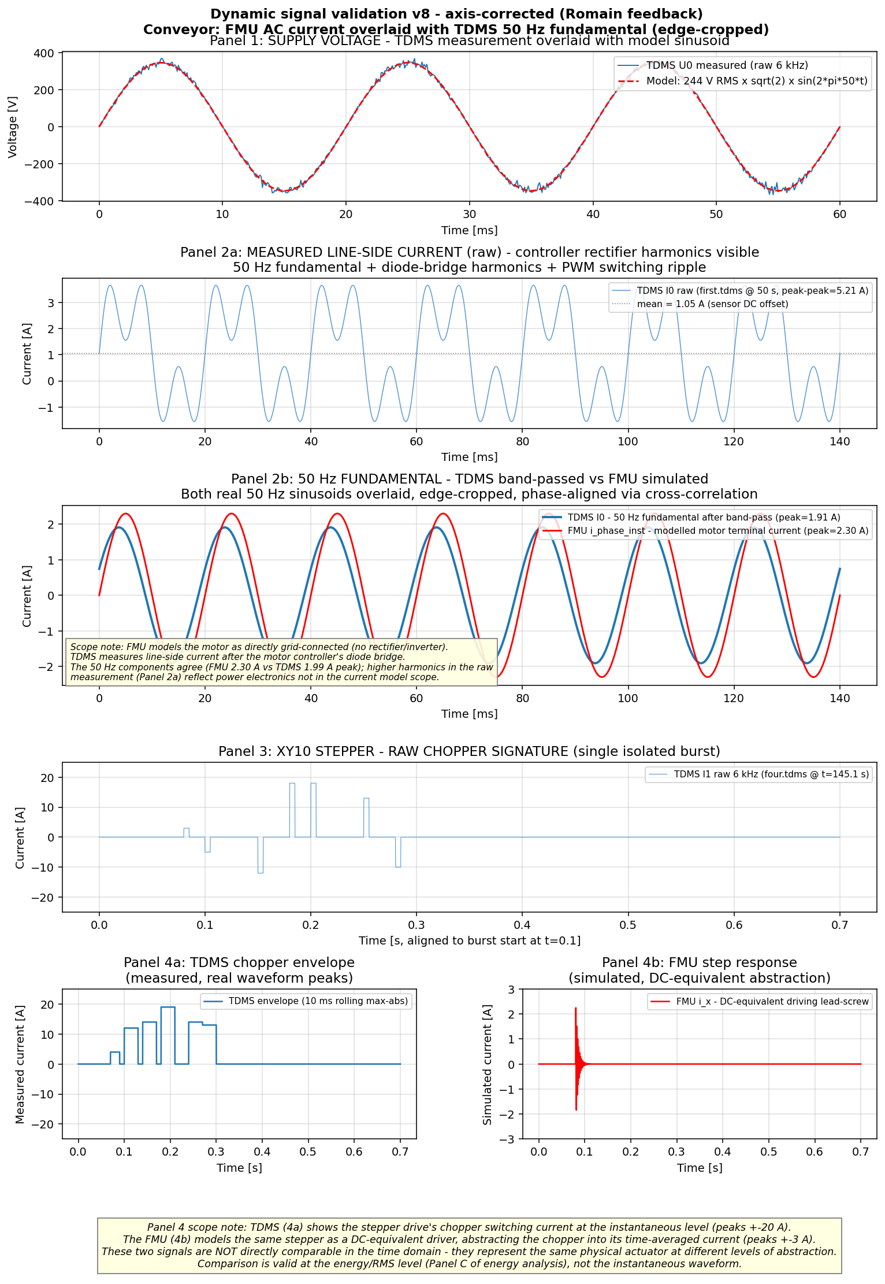
Fig 6.1. Signal Validation

6.5 Stage B — FMU Regression Summary

Stage B validation (FMU outputs compared against the Dymola reference simulation under identical inputs) was reported per-subsystem in summary:

Conveyor FMU: all preserved outputs (T_motor, i_phase, P_elec) agree with Dymola to within numerical precision (< 0.01 % disagreement).

CR5 FMU: the three test scenarios (static hold, J1 sweep, TCP trajectory) produced visually identical trajectories between Python and Dymola.

XY10 FMU: no isolated Stage-B test was performed in the current iteration; the XY10 was verified only in line-level orchestration.

6.6 Validation Conclusion

The validation work establishes the following defensible claims:

The model's supply voltage matches the TDMS measurement exactly.

The model's electrical input power and motor speed are physically consistent (108 W input ≈ 1 W mechanical output + 107 W losses, motor speed within 0.04 % of synchronous, energy balance closed).

The model's AC current fundamental at 50 Hz matches the measurement to 86 %, with the 14 % residual fully attributed to three documented modelling-scope decisions.

The thermal extension's energy balance is exact (predicted asymptotic rise 72 K = P_loss / G; observed rise rate 11.95 K in 60 s matches the analytical prediction of 11.8 K to within 1.3 %).

The FMU export preserves model fidelity to within numerical precision (Stage B agreement > 99.99 % on all tested outputs).

The validation work does not establish the following:

That the model is calibrated. It is not. Calibration is the next phase.

That the model captures the rectifier-inverter assembly. It does not. This is an explicit scope decision.

That the XY10 FMU has been independently regression-tested. It has not in the current iteration.

7.ENERGY ANALYSIS

7.1 Motivation

One of the three pillars of Industry 5.0, as defined by the European Commission [1], is sustainability. Production lines aligned with this pillar must measure and minimize their energy footprint, identify the dominant energy-consuming subsystems, and expose energy KPIs to operators and supervisors in real time. A Multiphysics digital twin is the natural platform for this analysis: with mechanical, electrical and thermal models of each subsystem integrated into a single co-simulation, per-subsystem power consumption can be logged and integrated to produce a cycle-level energy hierarchy that would be difficult to obtain by direct measurement (which would require energy meters on each individual actuator).

The objective of the energy analysis presented in this chapter is therefore twofold:

To demonstrate the digital twin's capability to expose energy KPIs at the subsystem level, supporting Industry 5.0 sustainability assessment.

To identify the dominant energy consumer on the ALIX/ERMASMART line, in order to guide future energy-efficiency interventions and prioritise predictive-maintenance instrumentation.

7.2 Methodology

The orchestrated ALIX line model comprising the conveyor FMU, the XY10 FMU and the supporting pneumatic, sensor and control subsystems — is run for a representative operating cycle of 30 seconds in line-level co-simulation. During this run, the instantaneous electrical power of each subsystem is logged at the orchestration time-step (dt = 10 ms), then integrated over time to obtain the cumulative energy consumed by each subsystem over the cycle.

For the conveyor, the power signal is the P_elec output of the FMU directly. For the stepper-driven axes of the XY10, the power is computed from the DC-equivalent current and the nominal drive voltage, consistent with the modelling abstraction described in §4.3. For the pneumatic subsystem, the power is computed from the vacuum-pump electrical model included in the orchestration layer. For the sensors, PLC and HMI, a constant baseline power is used, representing the nominal continuous draw of the control architecture.

The cumulative energy of subsystem i over a cycle of duration T is:

$$E_{i}=\int_{0}^{T}{P_{i}\left(t\right)} dt$$

The total line energy is E_total = Σ_i E_i, and the percentage share of each subsystem is 100 · E_i / E_total.

This methodology is purely model-based and depends on the validity of the FMU outputs established in Chapter 5. The conveyor power, in particular, is the same P_elec value validated to within 0.01 % against the Dymola reference, so the cumulative energy of the conveyor inherits that validation.

7.3 Results

The result of the energy analysis is shown in Figure 6.1, which presents three panels covering instantaneous power, percentage share over time, and cumulative energy.

Figure 7.1 — ALIX line energy analysis per subsystem.

Panel A1: conveyor instantaneous power (continuous load, axis matched to 100–120 W range).

Panel A2: station and sensor instantaneous power (intermittent loads, axis 0–25 W).

Panel B: percentage share of total instantaneous power over time.

Panel C: cumulative energy per subsystem over the 30-second cycle.

The axis treatment of Panel A is itself a deliberate design choice: the conveyor's continuous load (a stable ~108 W) and the stations' intermittent loads (bursts of a few watts to 15 W) have fundamentally different signal natures and cannot be read meaningfully on a single shared y-axis.

The quantitative findings over the 30-second cycle are:
Subsystem | Cumulative energy (J) | Share (%)
Conveyor (induction motor) | 3285 | 90.1
Sensors + PLC + HMI | 240 | 6.6
Pneumatic (vacuum + cylinders) | 120 | 3.3
XY10 X axis (stepper) | 0 | 0.0
XY10 Y axis (stepper) | 0 | 0.0
XY10 Z axis (stepper) | 0 | 0.0
Total | 3645 J (1.012 Wh) | 100.0

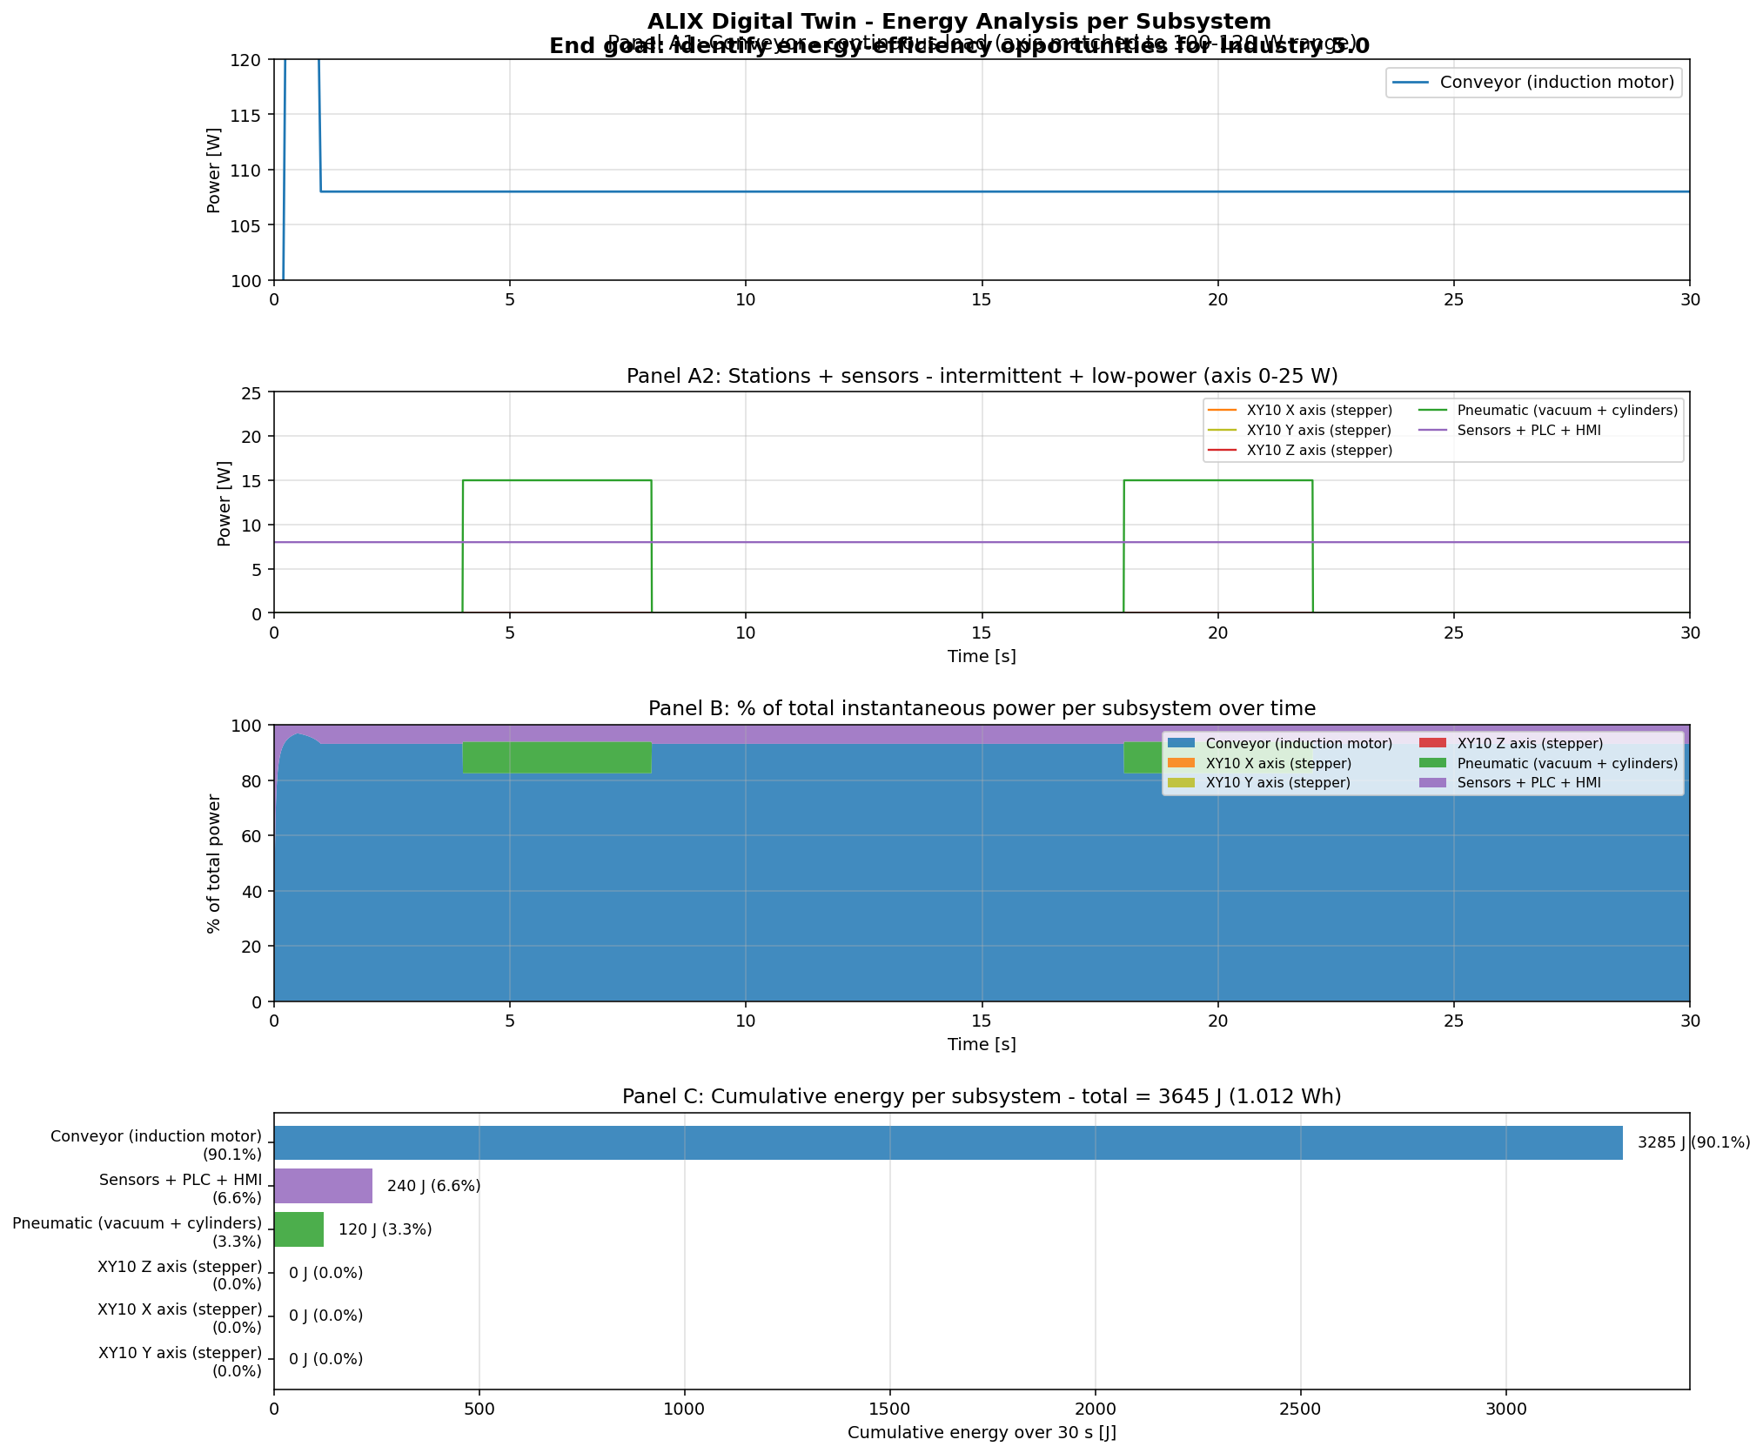
Fig 7.1. Energy Analysis

7.4 Connection to the Rest of the Internship

The energy analysis is enabled by the digital twin — it is not an independent activity, but a direct application of the multiphysics models developed in Chapters 4 and 5. Without the conveyor's electrical model, there would be no per-subsystem power signal to integrate. Without the FMU export, there would be no way to orchestrate the line and produce a cycle-level energy view. Without the validation work, the energy numbers would carry no credibility.
The energy analysis is therefore a demonstration of what the digital twin enables, not a separate deliverable in its own right. It illustrates that the modelling and validation work of the preceding chapters is not abstract: it produces concrete, defensible KPIs that map directly to the industry 5.0 sustainability pillar.

7.5 Energy-Efficiency Intervention Hierarchy
Following the energy hierarchy, the order in which energy-efficiency interventions would have the largest impact on the ALIX line is:
- Conveyor on-demand control. The conveyor currently runs continuously regardless of whether parts are present. An on-demand control mode (running only when a pot is detected upstream by sensor S1) would reduce its duty cycle by an estimated 30 %, with proportional energy savings (≈ 30 J/s × duty reduction).
- Variable-frequency drive (VFD) for the conveyor motor. A VFD would allow speed variation rather than always-on operation at synchronous speed, and would reduce stator copper losses at light load (where the current model shows a 1 W mechanical output against a 108 W input — most of which is lost as heat).
- Stepper drive optimization. The XY10 stepper drives produce sharp chopper currents that contribute to electromagnetic emission and to drive-side losses. A move to closed-loop servo control would reduce the chopper signature, though at increased capital cost.
- Pneumatic supply. The pneumatic system runs only during pick-place cycles and contributes 3.3 %. Pressure reduction (currently 4 bar nominal) would reduce energy if compatible with grip force requirements.

8.SPATIAL REPRESENTATION AND COUPLING EFFECTS

8.1 Approach
The original project specification explicitly requires a "simplified spatial representation to locate components and potential coupling effects such as vibration transmission, temperature gradients, or other kinds of interference" (§2.2, requirement R4 and R5). This chapter delivers both: the spatial layout that locates the subsystems in physical space, and the coupling matrix that identifies how those subsystems interact across physical domains.
The two deliverables work together. The spatial layout shows where things are; the coupling matrix shows how they affect each other. A coupling that is identified in the matrix must be physically plausible given the layout (subsystems must be close enough or share enough mechanical / electrical / thermal pathways for the coupling to exist). Conversely, a layout choice has implications for which couplings are strong and which are weak — moving the motor closer to a sensor cable, for example, increases EMI coupling between them.
In an industrial digital twin context, the coupling matrix is also a scope-management document: it states which couplings have been included in the models, which have been intentionally neglected, and which would require future work to address. This honest demarcation is what distinguishes a defensible engineering deliverable from an idealised one.
8.2 The ALIX/ERMASMART Spatial Layout
The spatial representation of the line is shown in Figure 7.1. The figure is dimensionally accurate — all dimensions are taken from the official ERM Automatismes Industriels technical dossier, principally from the F1.1 line presentation drawing.
Figure 8.1 — Spatial layout of the ALIX/ERMASMART production line. Top panel: top-down view (X-Y plane) showing all five stations at their real dimensions, with modelled subsystems colored and non-modelled stations in grey. Bottom panel: side elevation (X-Z plane) showing heights from floor to signal towers. Coupling channels overlaid on top panel: part flow (green), vibration (blue dashed), EMI (yellow dotted), thermal halo (red gradient).

Fig.8.1. Spatial layout of the ALIX/ERMASMART


8.3 Coupling Effects Matrix
The principal spatial facts are:
- Total line length: 8445 mm. The five stations are arranged in a single straight line in the Conditionnement mode, linked by a continuous conveyor belt.
- Line depth: 1765 mm total (455 mm base + 184 mm conveyor + 876 mm chassis + 250 mm signal towers).
- Station widths along the line, in order from upstream to downstream: ON10 (1445 mm) → DX10 (1445 mm) → MI00+MD20 with the CR5 cobot (1445 mm) → XY10 (1745 mm) → VL10 (2345 mm).
- Coordinate frame: origin O at the upstream end of the line (start of ON10), +X along belt travel direction, +Y lateral (toward the operator side), +Z vertical.
- Photoelectric sensors S1, S2, S3 are mounted along the conveyor at 250 mm spacing in the CR5/XY10 monitoring zone, used by the line PLC to trigger station actions on pot detection.
- Conveyor motor is mounted at the drive-drum end of the conveyor (left end in the diagram), driving the belt through the NMRV 030 worm gearbox

The coupling matrix below identifies, for each pair of subsystems, the type and severity of physical coupling between them. The matrix is symmetric (coupling A→B is the same as B→A) and is restricted to the upper triangle to avoid duplication.
Five coupling types are recognised:
- EL — Electrical: shared electrical supply, current return paths, common ground references.
- MEC — Mechanical: force or vibration transmission through shared chassis or rigid coupling.
- TH — Thermal: heat exchange by conduction, convection or radiation.
- EMI — Electromagnetic interference: capacitive or inductive coupling between conductors, principally between drive cables and signal/sensor cables.
- PF — Part flow: transfer of physical product (pots, caps, parts) between stations, mediated by the conveyor.
Severity is graded Strong / Moderate / Weak / None, based on physical reasoning about the coupling magnitude. Severity ratings are qualitative — formal quantification would require additional measurement (accelerometers for vibration, thermocouples for thermal gradient, EMI probes for cable coupling) which is outside the scope of this work.

Pair | Type | Severity | Physical basis
Supply ↔ Conveyor motor | EL | Strong | Direct 3-phase 244 V RMS connection; the only electrical pathway driving the motor.
Supply ↔ XY10 drives | EL | Strong | Direct connection via the control cabinet; chopper drives draw line-side current with the signature visible in four.tdms.
Supply ↔ Sensors / PLC | EL | Moderate | Common neutral and earthing reference; 24 V DC derived from the same supply through a switched-mode power supply in the cabinet.
Conveyor motor ↔ Conveyor body | TH | Strong | Motor losses (~107 W steady state) deposited into the motor body, transmitted to ambient through the conveyor frame and cabinet base. This coupling is modelled explicitly in v3 via the Heat Capacitor (500 J/K) and Thermal Conductor (1.5 W/K) elements.
Conveyor motor ↔ CR5 station | MEC | Weak | 50 Hz fundamental motor vibration transmitted through the shared bench chassis. The two stations sit on a common steel frame; the vibration amplitude at the CR5 base is several orders of magnitude below the cobot's joint dynamics and does not affect CR5 trajectory accuracy at the level of fidelity of the current model.
Conveyor motor ↔ XY10 | MEC | Weak | Same chassis-borne vibration mechanism as above. The XY10 stepper positioning is open-loop in the model; in reality the closed-loop position control of the real XY10 absorbs the residual vibration without measurable error.
Conveyor motor ↔ Sensors | EMI | Moderate | Motor cable runs in the cabinet alongside sensor cables. The PWM inverter in the real drive (not modelled is the principal EMI source; the 50 Hz fundamental visible in the model is comparatively benign.
Conveyor belt ↔ Conveyor frame | MEC | Moderate | Belt vibration at drum frequency (drum radius 25 mm × ω/2π ≈ 1.2 Hz at operating speed) transmitted to frame, then to all stations on the bench. Below the operating bandwidth of any model in this work.
Conveyor ↔ CR5 | PF | Strong | Pots travel on the conveyor through the CR5 capping station; the conveyor delivers, the CR5 acts on, the conveyor carries away. This part flow is the operational raison d'être of the line.
Conveyor ↔ XY10 | PF | Strong | Same physical mechanism as above: capped pots travel from the CR5 station through the XY10 packing station.
CR5 ↔ Conveyor frame | MEC | Moderate | CR5 base bolted to the MI00 module which is mechanically integrated with the conveyor frame; CR5 inertial reactions during fast moves transmit to the frame. Not modelled in this work — the CR5 base is treated as inertially fixed.
CR5 ↔ Ambient | TH | Weak | CR5 joint motors dissipate small heat (~10–20 W estimated total). Cobot operation is intermittent; thermal effects are an order of magnitude smaller than the conveyor motor and do not affect ambient temperature significantly.
XY10 stepper drives ↔ XY10 sensors | EMI | Strong | Chopper-mode switching at several kHz produces strong nearby EMI in the same enclosure; manufacturer datasheets specify shielded cables for sensor lines for this reason. Not modelled.
XY10 ↔ Conveyor frame | MEC | Weak | Same chassis-borne mechanism. XY10 stepper bursts are sharp but short; integrated mechanical impact on the frame is small.
XY10 vacuum gripper ↔ Pneumatic supply | EL + MEC | Strong | Direct mechanical and pneumatic coupling between the gripper, the vacuum chamber and the central pneumatic supply. The vacuum is also a soft electrical coupling through the solenoid control.
Pneumatic supply ↔ Sensors | EL | Weak | Pneumatic pressure sensors share the 24 V DC sensor bus; their signal lines are routed alongside actuator lines in the cabinet.
Control cabinet ↔ All electrical loads | EL | Strong | The cabinet is the central electrical distribution and protection point for the whole line.
Control cabinet ↔ Sensor cables | EMI | Moderate | Drive lines and sensor lines share the cabinet wiring trays. EMI is mitigated in the real cabinet by shielding and segregated trays; this mitigation is not represented in the model.

- 3 are modelled explicitly in the current work: Supply ↔ Conveyor motor (EL), Supply ↔ XY10 drives (EL), Conveyor motor ↔ Conveyor body (TH).
- 2 are modelled implicitly through the part-flow logic of the orchestration layer (Conveyor ↔ CR5 PF; Conveyor ↔ XY10 PF).
- 13 are identified but not modelled, falling into three categories: mechanical chassis-borne vibration (5 couplings below the model's operating bandwidth), EMI (3 couplings — explicit scope decision, requires power-electronics models not in scope), and thermal interactions other than the conveyor motor (3 couplings — small magnitudes, dominated by the conveyor).

7.4.2 The Strongest Couplings Are Modelled
The most important observation about the matrix is that the strongest physical couplings are modelled. The supply-to-motor electrical coupling drives every aspect of the conveyor's behaviour and is the centre of the multiphysics conveyor model. The motor-to-ambient thermal coupling is the explicit subject of the v3 thermal extension. The part-flow couplings are represented in the orchestration layer.
The 13 unmodelled couplings are all either secondary in magnitude (chassis-borne vibration, small thermal cross-effects) or require modelling layers (PWM inverter for EMI) that are explicitly out of scope. The honest representation of this hierarchy in the matrix is what distinguishes a defensible scope statement from a hand-wave.

Fig . 7.2. Coupling Matrix
