# CHANGES TO EXISTING SUPPLIER: GSAR EFORM STEPS

# Find the supplier account:

Go to: https://cummins-prods360int.mdm.informaticahosted.com/mdmapps/mdm/entity360view/

Click on GSAR Supplier

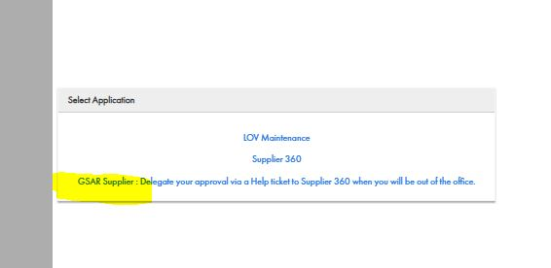

Click on Queries > Supplier_SimpleSearch

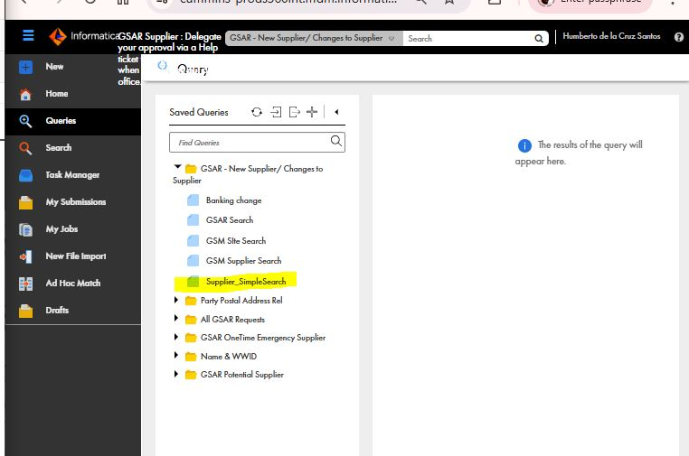

Enter the supplier number > Click on Run > Double Click on the supplier name

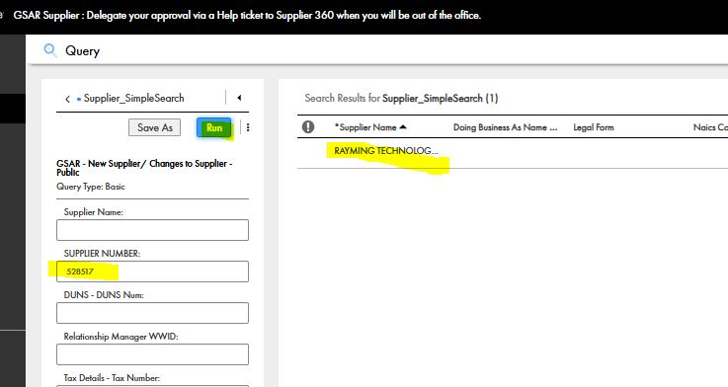

Click on the + under GSAR Request Details > Enter Title> Change Request type to Changes to Existing Supplier > Enter the OnBehalf OF

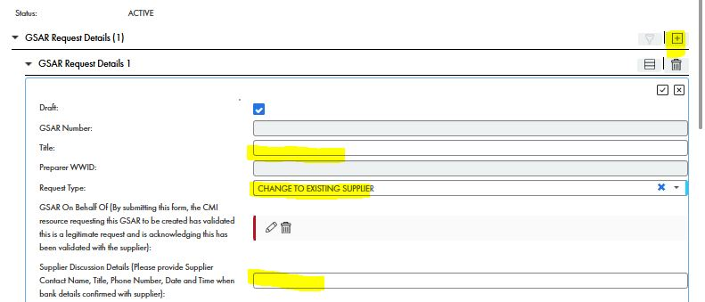

Scroll down and enter GSAR Operating Unit (where the supplier will be used) and the commodity or category

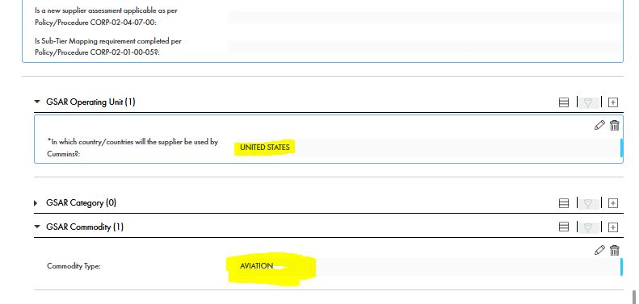

# Confirm Tax Confirmation:

Under Supplier Header Tax, confirm the tax information matches. If there is not tax info add it. If the tax information has changed, you may need to create a new supplier (if the supplier is not in the system already).

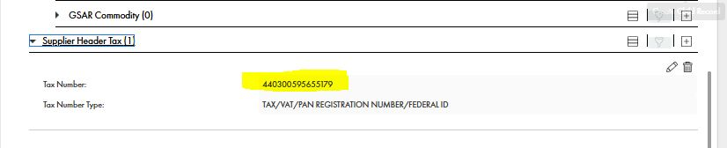

# Name Update:

Update the Supplier Name to match the tax documentation

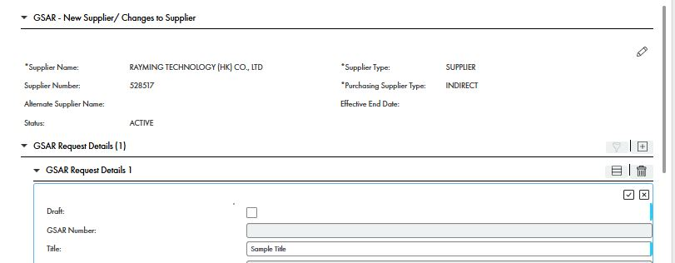

Answer question Is there a supplier name change?

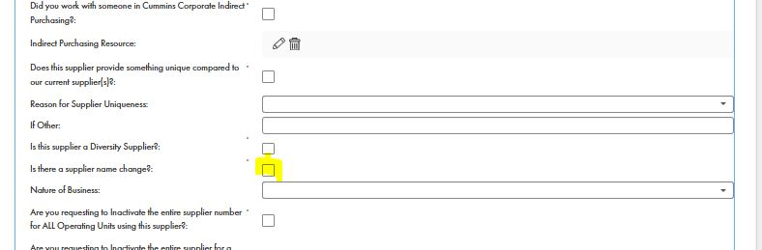

Under Supplier Header Attachments, attach the letterhead with the name and change relevant tax document.

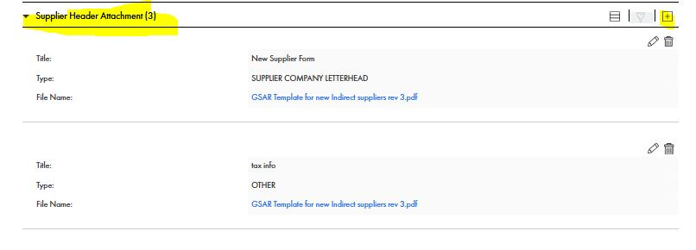

# Address Update:

Scroll to Supplier Header Address > find the address being updated > click on the pencil > update it > click on the checkmark to save

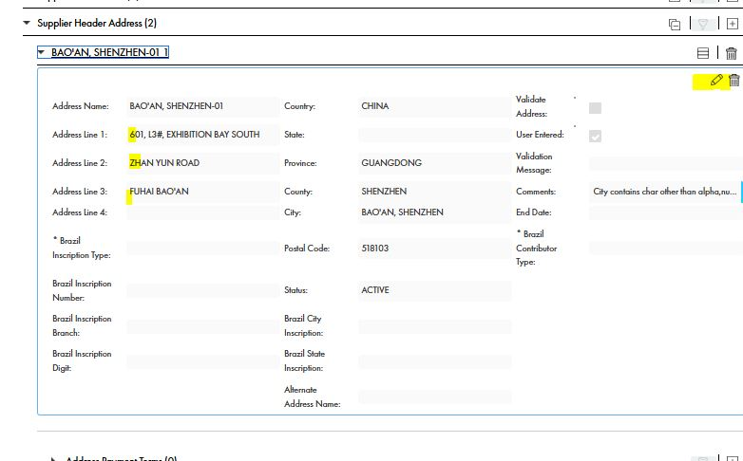

Under Supplier Header Attachments, attach the letterhead with the address change.



# Submit the GSAR eForm:

When you are ready to submit, remove the Draft checkmark, click Submit

