Sami Case

CSC-500 Principles of Programming

Module 6 Portfolio Milestone

**Source Code**

class ItemToPurchase:

def __init__(self, name = 'none', price = 0.00,quantity = 0, description=''):

self.name = name

self.price = price

self.quantity = quantity

self.description = description

def print_item_cost(self):

print('{:<20} {:.0f} @ ${:.2f} = ${:>6.2f}'.format(self.name,self.quantity,self.price, self.quantity*self.price))

class ShoppingCart:

def __init__(self,customer_name = 'none', current_date = 'January 1, 2020',cart_items=None):

if cart_items is None:

cart_items=[]

self.customer_name = customer_name

self.current_date = current_date

self.cart_items = cart_items

def add_item(self):

item_name = input('Enter item name: ')

item_description = input('Enter item description: ')

item_price = float(input('Enter the item\'s price: '))

item_quantity = int(input('Enter the item\'s quantity: '))

new_item = ItemToPurchase(item_name,item_price,item_quantity,item_description)

self.cart_items.append(new_item)

def remove_item(self):

item_name = input('Enter item name to remove: ')

found = False

for item in self.cart_items:

if item_name ==item.name:

self.cart_items.remove(item)

found = True

break

if not found:

print('Item not found in cart. Nothing removed.')

def modify_item(self):

#modifies an item's description?, price, and/or quanitity

item_name = input('Enter item name to modify: ')

found = False

for item in self.cart_items:

if item_name == item.name:

found = True

print('Modifying {}'.format(item_name))

new_description = input('Enter new description for {} (current: {}) or press Enter to Keep'.format(item.name,item.description))

new_price = input('Enter new price for {} (current: ${:.2f}) or press Enter to keep: '.format(item.name,item.price))

new_quantity = input('Enter new quantity for {} (current: {}) or press Enter to keep: '.format(item.name,item.quantity))

if new_description:

item.description = str(new_description)

if new_price:

item.price = float(new_price)

if new_quantity:

item.quantity = int(new_quantity)

break

if not found:

print('Item not found in cart. Nothing modified.')

def get_num_items_in_cart(self):

count = 0

for item in self.cart_items:

count += item.quantity

print('Number of items: {}'.format(count))

def get_cost_of_cart(self):

total_cost = 0

for item in self.cart_items:

total_cost += item.quantity * item.price

print('Total: ${:.2f}'.format(total_cost))

def print_total(self):

if not self.cart_items:

print('SHOPPING CART IS EMPTY')

else:

for item in self.cart_items:

item_cost = item.quantity * item.price

print('{} {} @ ${} = ${}'.format(item.name,item.quantity,item.price,item_cost))

def print_descriptions(self):

print('Item Descriptions')

for item in self.cart_items:

print('{}: {}'.format(item.name,item.description))

def print_menu(cart):

menu = (

'\nMENU\n'

'a - Add item to cart\n'

'r - Remove item from cart\n'

'c - Change item quantity\n'

'i - Output item descriptions\n'

'o - Output shopping cart\n'

'q - Quit\n'

)

command = ''

while command != 'q':

print(menu)

command = input('Choose an option: ').strip().lower()

if command == 'a':

cart.add_item()

elif command == 'r':

cart.remove_item()

elif command == 'c':

cart.modify_item()

elif command == 'i':

cart.print_descriptions()

elif command == 'o':

print('\n{}\'s Shopping Cart - {}'.format(cart.customer_name,cart.current_date))

cart.get_num_items_in_cart()

cart.print_total()

cart.get_cost_of_cart()

elif command == 'q':

print('Goodbye!')

else:

print('Invalid option. Please try again.')

def main():

customer_name = input('Enter customer\'s name: ')

current_date = input('Enter today\'s date: (e.g., January 1, 2024) ')

cart = ShoppingCart(customer_name,current_date)

print_menu(cart)

main()

**Image of Successful Execution**

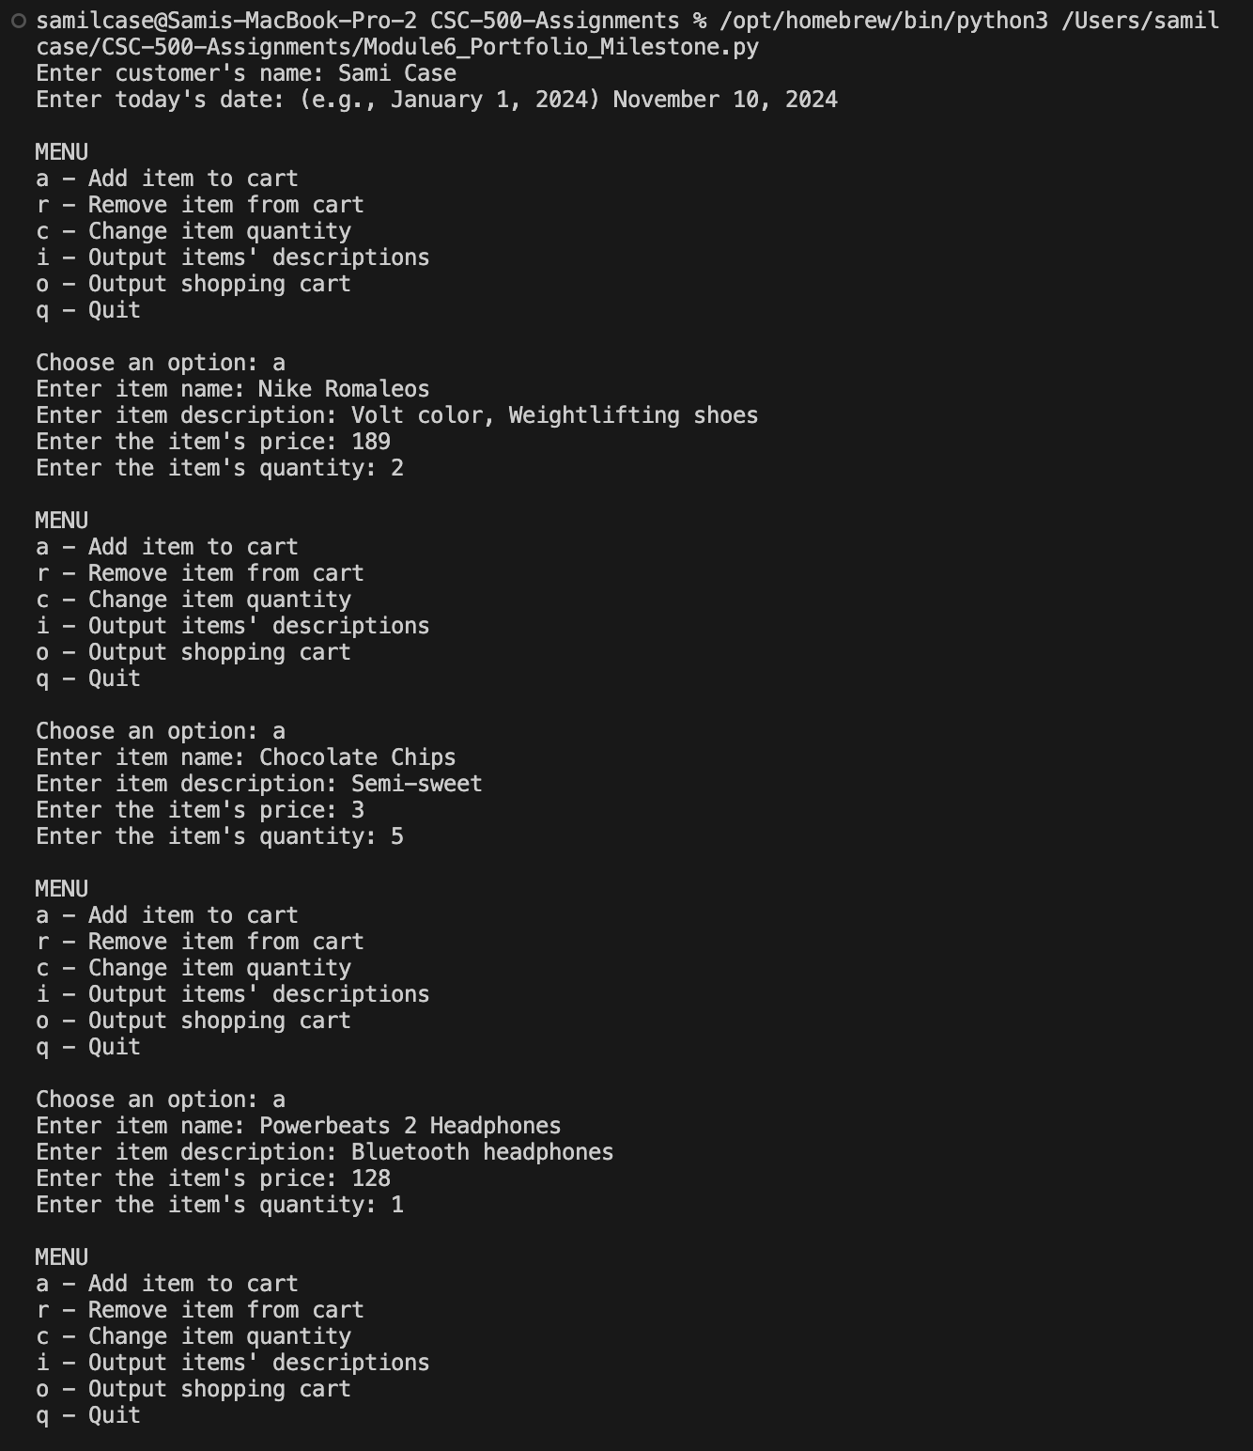

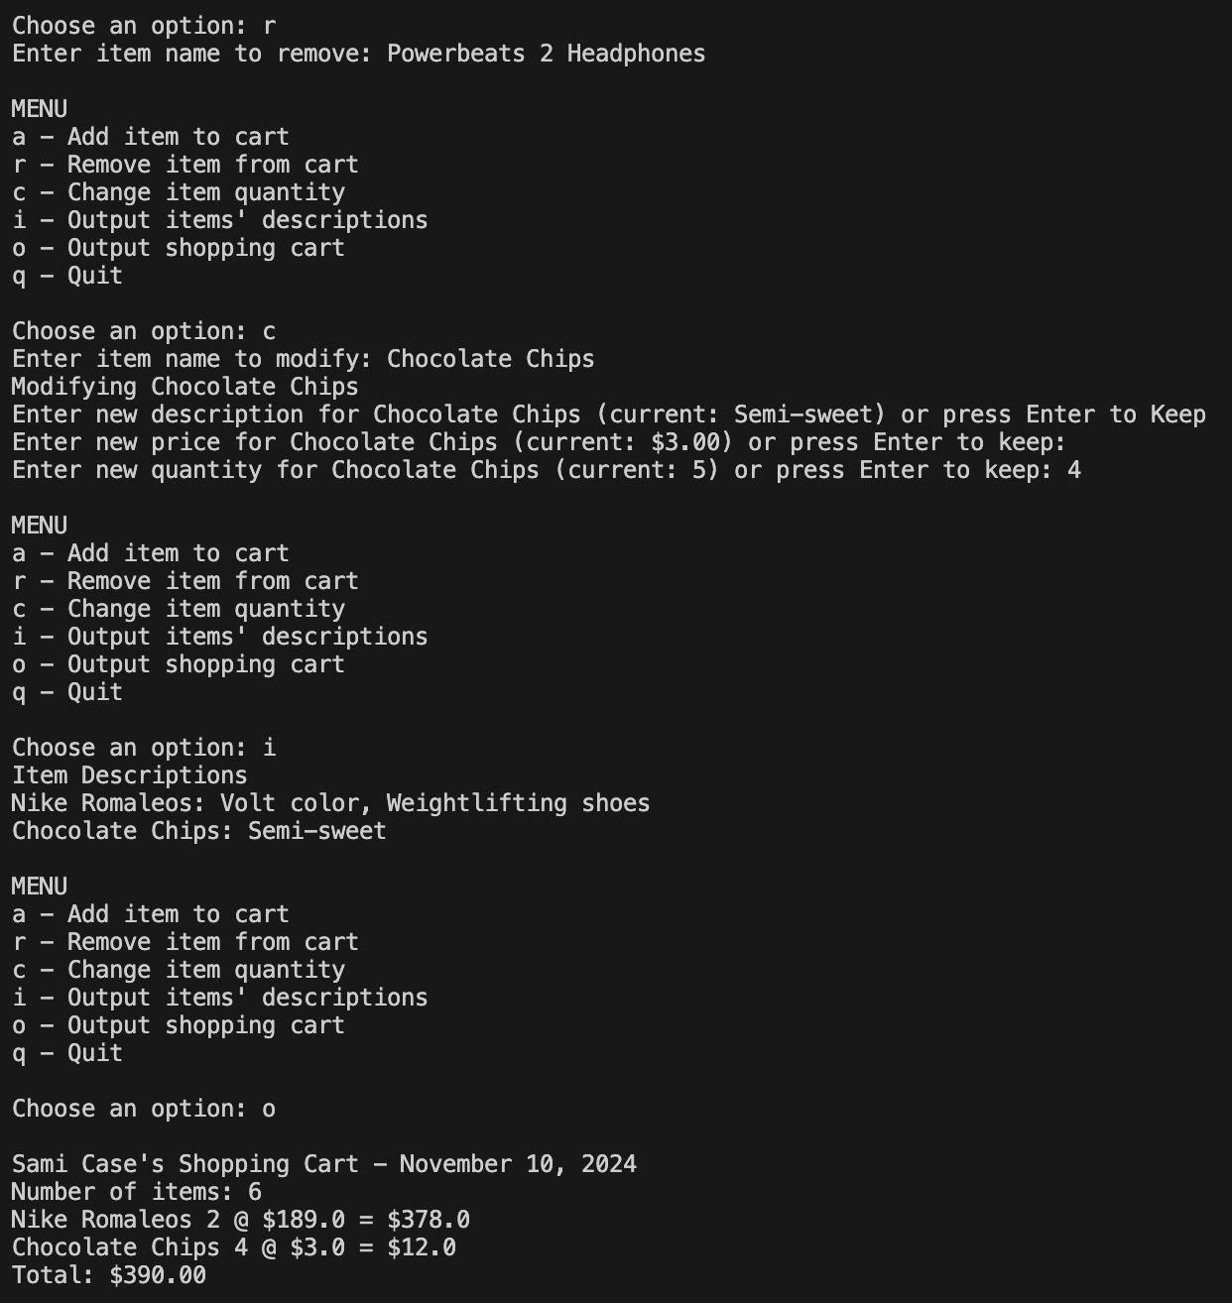

**GIT Repository**

<https://github.com/samilcase/CSC-500-Assignments>

