**MODULE 1**

* **In Installation guide check the command for setting up stabe repository. After setting the repository we will get an error while updating repository using: sudo apt-get update**

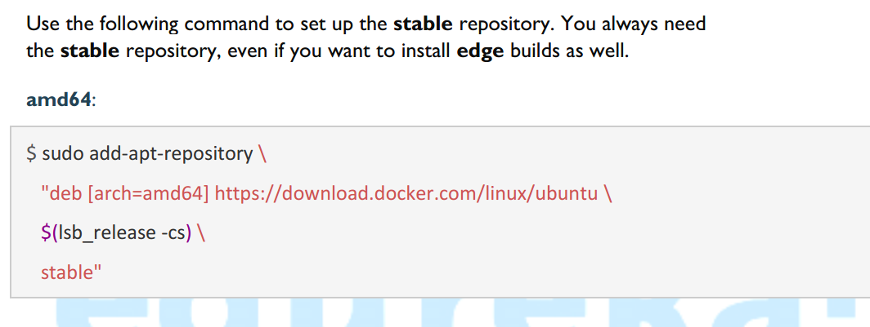

**After setting repository the error will come as shown:**

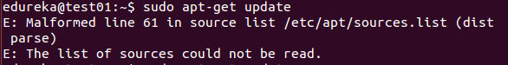

* **If the above problems are not checked then we will not be able to install docker –ce.**

**MODULE2**

**MODULE 3**

* **In Slide 16 : doubt on why the ports of wordpress _db are not inside “ ” while the ports of word-press are inside “”.**
* **The commands that are given in the assignment solution should be executed in the docker quickstart terminal or they should be executed in the VM after separetly installing docker ce and docker compose in the VM.**
* **Separate instructions if provided will be beneficial for the docker toolbox. Example do we need to install docker compose in the quickstart or it is already there.**