**A REPORT ON**

**AUTOMATED TOLL MANAGEMENT SYSTEM (ATMS) USING RFID**

**SUBMITTED IN PARTIAL FULFILLMENT OF THE REQUIREMENT FOR THE DEGREE IN INSTRUMENTATION ENGINEERING 2025**



**ELECTRONIC DESIGN PROJECT 2024**

(As per the B.Tech curriculum of Assam Science and Technology University)

***Submitted by:***

**DEBABRAT DEKA (210710015006)**

**SAMIM UDDIN AHMED (210710015014)**

**SIDDHANT PHUKAN (210710015015)**

**SNIGDHA DEKA (210710215016**)

**ANKUR PANGIRIA (220750015001)**

**DEPARTMENT OF INSTRUMENTATION ENGINEERING**

**JORHAT ENGINEERING COLLEGE**

**2024**

Abstract

ATMS is an Automated Toll Management System utilising Radio Frequency Identification(RFID) used for identifying the vehicles with it’s UID and managing the toll gates to operate without any manual force. This process reduces human intervention and improves operational efficiency. With the help of this project, we make identification of vehicles with the help of radio frequency. A vehicle will hold an RFID tag. This tag is nothing but unique identification number assigned. This could be assigned by RTO or traffic governing authority. In accordance with this number, we can acquire the information if one can access the toll against the payment made, through a database. Reader will be strategically placed at toll collection center. In case if one’s UID has not been registered by the traffic governing authority, access will be denied. As vehicles don’t have to stop in a queue, it assures time saving, fuel conservation and also contributing in saving of money. Automatic Toll Management systems have really helped a lot in reducing the heavy congestion caused in the metropolitan cities of today. It is one of the easiest methods used to organize the heavy flow of traffic.

Index

|  |  |  |  |
| --- | --- | --- | --- |
| ***Chapter no.*** | | ***Chapter*** | ***Page no.*** |
| **1** | | **Introduction** | **1** |
| **2** | | **Model design** | **3** |
| **3** | | **Circuit Diagram** | **9** |
| **4** | | **Schematic Diagram** | **10** |
| **5** | | **Block Diagram** | **11** |
| **6** | | **Working** | **12** |
| **7** | | **Coding** | **14** |
| **8** | | **Future Scope** | **17** |
| **9** | | **Conclusion** | **18** |
|  | **References**  **Miscellaneous** | | **19**  **20** |

CHAPTER-1: Introduction

In today's rapidly evolving world, efficient traffic management is paramount to ensuring seamless transportation networks. One critical aspect of this management is toll collection, where traditional manual methods often pose challenges such as traffic congestion and human error. To address these issues and streamline the toll collection process, the Automated Toll Management System emerges as a revolutionary solution.

This mini project presents a comprehensive implementation of an Automated Toll Management System utilizing RFID (Radio-Frequency Identification) technology, Arduino Uno microcontroller, OLED display, and servo mechanism. The system aims to expedite vehicle passage through toll gates while ensuring secure access control and accurate toll collection.

At its core, the system leverages RFID tags affixed to vehicles, which emit unique identification signals upon scanning. An RFID reader situated at the toll gate captures this information, initiating a verification process within the Arduino Uno microcontroller. The Arduino's database contains records of registered vehicles, enabling swift determination of access authorization.

Upon successful verification, the system grants access to registered vehicles by displaying "Access Granted" on the OLED display and automatically opening the toll gate for a specified duration using the servo mechanism. Conversely, unregistered vehicles are promptly denied access, with the display signalling "Access Denied" and the gate remaining closed.

This project amalgamates hardware components with intelligent software logic to create a robust and efficient toll management system. By minimizing human intervention and optimizing traffic flow, it promises to enhance transportation infrastructure's effectiveness and reliability.

Throughout this documentation, we delve into the system's architecture, hardware setup, software implementation, and operational workflow. Furthermore, we explore potential extensions, such as data logging and remote monitoring, to augment the system's capabilities and adaptability to diverse toll management scenarios.

The Benefits of this System are:

• Shorter queues at toll plazas by increasing toll booth service rates

• Faster and more efficient service

• The ability to make payments by keeping a balance on the card itself and

• The use of postpaid toll statements

• Other general advantages include minimization of fuel wastage and reduced emissions by reducing deceleration rate, waiting time of vehicles in queue, and acceleration.

For Toll Operators, the benefits include:

• Lowered toll collection costs

• Better audit control by centralized user account

• Expanded capacity without building more infrastructures.

Thus, the ATP system is useful for both the motorists and toll operators, this is the reason of extended use of ATP system throughout the world.

CHAPTER-2: Model Design

2.1 **COMPONENTS USED AND QUANTITY:**

* Arduino Uno
* MFRC522 RFID Module
* OLED Display
* SERVO MOTOR
* BREADBOARD

2.2 **DESCRIPTION OF COMPONENTS**

* **ARDIUNO UNO**

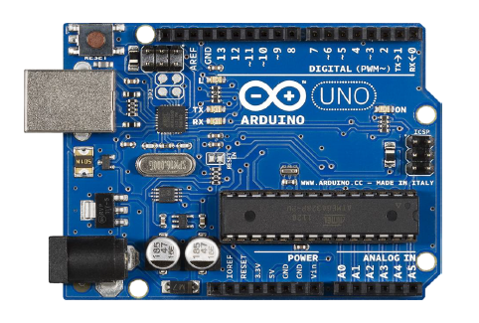

**Specifications:**

• Microcontroller ATmega328

• Operating Voltage 5V

• Input Voltage (recommended) 7-12V

• Digital I/O Pins 14 (of which 6 provide PWM output)

• Analog Input Pins 6 DC Current per I/O Pin 40 mA

• DC Current for 3.3V Pin 50 mA

• Flash Memory 32 KB of which 0.5 KB used by boot loader

• SRAM 2 KB

• EEPROM 1 KB

• Clock Speed 16 MHz

**The power pins are as follows:**

• VIN. The input voltage to the Arduino board when it's using an external power source (as opposed to 5 volts from the USB connection or other regulated power source). We can supply voltage through this pin, or, if supplying voltage via the power jack, access it through this pin.

• The regulated power supply used to power the microcontroller and other components on the board. This can come either from VIN via an on-board regulator, or be supplied by USB or another regulated 5V supply.

• A 3.3 volt supply generated by the on-board regulator. Maximum current draw is 50 mA. • GND. Ground pins.

**Input Output Pins:**

* Serial: 0 (RX) and 1 (TX). Used to receive (RX) and transmit (TX) TTL serial data. These pins are connected to the corresponding pins of the ATmega8U2 USB-to-TTL Serial chip.
* External Interrupts: 2 and 3. These pins can be configured to trigger an interrupt on a low value, a rising or falling edge, or a change in value. See the attachInterrupt() function for details.
* PWM: 3, 5, 6, 9, 10, and 11. Provide 8-bit PWM output with the analogWrite() function.
* SPI: 10 (SS), 11 (MOSI), 12 (MISO), 13 (SCK). These pins support SPI communication, which, although provided by the underlying hardware, is not currently included in the Arduino language.
* LED: 13. There is a built-in LED connected to digital pin 13. When the pin is HIGH value, the LED is on, when the pin is LOW, it's off.
* The Uno has 6 analog inputs, each of which provides 10 bits of resolution (i.e. 1024 different values). By default they measure from ground to 5 volts, though is it possible to change the upper end of their range using the AREF pin and the analogReference() function. Additionally, some pins have specialized functionality:
* I 2C: 4 (SDA) and 5 (SCL). Support I2C communication using the Wire library. There are a couple of other pins on the board:
* AREF. Reference voltage for the analog inputs. Used with analogReference().
* Reset. Bring this line LOW to reset the microcontroller.
* **MFRC522 RFID MODULE**

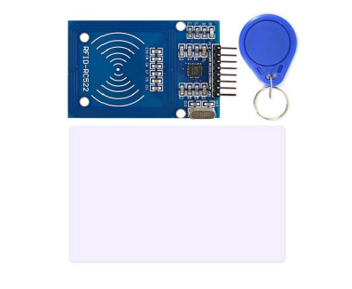

Mifare RC522 is the high integrated RFID card reader which works on non-contact 13.56 MHz communication, is designed by NXP as low power consumption, low cost and compact size read and write chip, is the best choice in the development of smart meters and portable hand-held devices. MF RC522 use the advanced modulation system, fully integrated at 13.56MHz with all kinds of positive non-contact communication protocols. Support 14443A compatible answer signal. DSP deal with ISO14443A frames and error correction. Furthermore, it also supports rapid CRYPTO1 encryption to validate Mifare series products. MFRC522 support Mifare series higher speed non-contact communication, duplex communication speed up to 424 kb/s. As a new family member in 13.56MHz RFID family, MF RC522 has many similarities to MF RC5200 and MF RC530, and also has more new features. This module can fit directly in hand held devices for mass production. Module use 3.3V power supply, and can communicate directly with any CPU board by connecting through SPI protocol, which ensure reliable work, good reading distance.

**Specifications**

* Voltage: DC 3.3V
* Operating Current :13-26mA
* Idle Current :10-13mA
* Sleep current: <80uA
* Peak current: <30mA
* Operating Frequency: 13.56MHz
* Supported card types: mifare1 S50, mifare1 S70, mifareUltraLight, mifare Pro, mifareDesfire
* Dimensions: 40mm × 60mm
* Module Interface SPI Data Transfer Rate: Max. 10Mbit/s
* Card reading distance ：0～30mm （Mifare1 card）

**RFID TECHNOLOGY**

The RFID reader is one kind of wireless module used for transferring the data to identify and track tags which are connected to objects. The RFID tag mainly includes the stored information. Some of the RFID tags are run by electromagnetic induction from magnetic fields formed nearby the reader. RFID reader comprises an RF module that works as a transmitter as well as a receiver of RF (radio frequency) signals. The TX of the RF module is inbuilt with an oscillator to make the carrier frequency. A modulator to intrude commands upon this carrier signal and an amplifier to raise the signal sample to wake the tag. The RX (receiver) of the RFID module contains a demodulator to remove the returned information and also grips an amplifier for supporting the signal of processing. A microprocessor is used for forming the control unit, which uses an operating system, a memory of the module filter and also stores the data.

* **OLED DISPLAY**

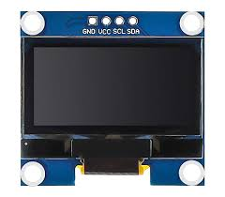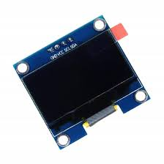

An OLED (Organic Light-Emitting Diode) display is a type of display technology that uses organic compounds to emit light when an electric current is applied. Unlike traditional LCD displays, OLED displays don't require a backlight, which allows them to be thinner, more flexible, and provide better image quality with higher contrast and deeper blacks.

OLED displays are commonly used in smartphones, TVs, computer monitors, and other electronic devices. They offer several advantages over other display technologies, including:

* Better Picture Quality: OLED displays offer higher contrast ratios, wider viewing angles, faster response times, and better color accuracy compared to traditional LCD displays.
* Thinner and Lighter: Since OLED displays don't require a backlight, they can be made thinner and lighter than LCD displays, making them ideal for portable devices like smartphones and tablets.
* Flexible and Curved Displays: OLED technology allows for the creation of flexible and curved displays, enabling innovative designs for products like curved smartphones and curved TVs.
* Energy Efficiency: OLED displays are more energy-efficient than traditional LCD displays because they only consume power for the pixels that are illuminated. In contrast, LCD displays require a constant backlight, regardless of the content being displayed.
* Faster Response Time: OLED displays have faster response times compared to LCD displays, which means they can display fast-moving content such as action scenes in movies and video games more smoothly, with less motion blur.
* Wide Color Gamut: OLED displays are capable of reproducing a wider range of colors compared to traditional LCD displays, resulting in more accurate and vibrant color representation.

Overall, OLED displays offer superior image quality, design flexibility, energy efficiency, and performance compared to traditional LCD displays, making them an increasingly popular choice for high-end electronic devices. Faster Response Time: OLED displays have faster response times compared to LCD displays, which means they can display fast-moving content such as action scenes in movies and video games more smoothly, with less motion blur.

* **BREADBOARD:**

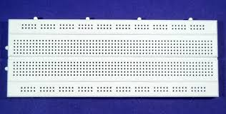

A breadboard is a fundamental tool used for prototyping electronic circuits. It allows you to create temporary circuits without the need for soldering. Here are some advantages of using a breadboard:

* No Soldering Required: Components can be easily connected and removed without soldering, making it ideal for testing and prototyping circuits.
* Reusable: Components can be used and reused multiple times without damaging them.
* Quick Prototyping: Circuits can be assembled quickly and easily, allowing for rapid prototyping and testing of electronic circuits.
* Easy Troubleshooting: If a circuit doesn't work as expected, it's easy to identify and fix the problem by inspecting the connections on the breadboard.
* No Special Tools Required: Unlike soldering, using a breadboard doesn't require any special tools or skills, making it accessible to beginners and experts alike.
* Versatility: Breadboards come in various sizes and configurations, allowing for the prototyping of a wide range of circuits, from simple to complex.
* Overall, breadboards are an essential tool for anyone working with electronics, whether you're a hobbyist, student, or professional engineer.

CHAPTER-3: Circuit Diagram

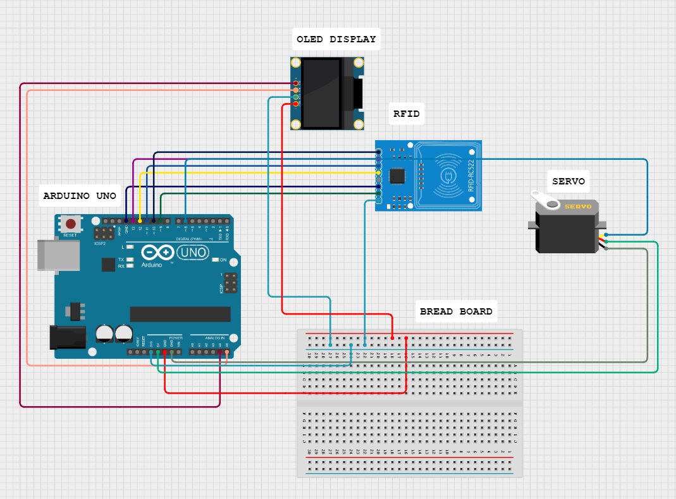

CHAPTER-4:Schematic Diagram

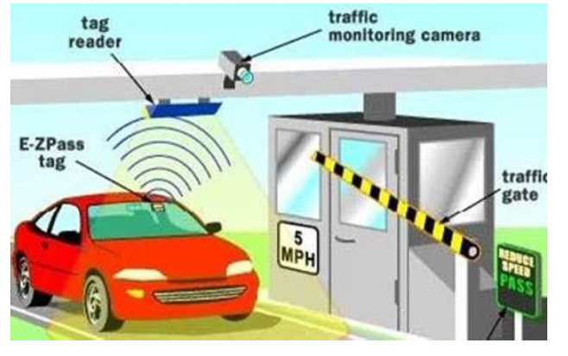

CHAPTER-5:Block Diagram

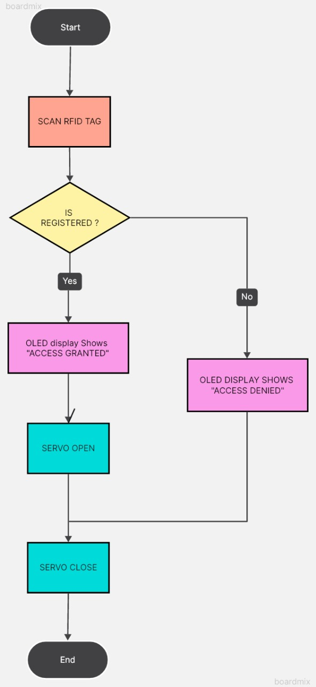

CHAPTER-6:Working

The automated toll management system we've developed is a integration of hardware components and software logic designed to streamline the process of vehicle access control at toll gates. At its core, the system relies on RFID (Radio-Frequency Identification) technology, which involves the use of RFID tags affixed to vehicles. These tags emit unique identification signals when prompted by an RFID reader situated at the toll gate.

When a vehicle approaches the toll gate, the RFID reader scans its RFID tag, capturing the vehicle's unique identification information. This data is then transmitted to the Arduino Uno microcontroller, which serves as the central processing unit of the system. Within the Arduino's memory, there exists a database containing records of registered vehicles, each associated with a unique RFID tag identifier.

Upon receiving the scanned RFID data, the Arduino Uno initiates a verification process. It compares the received RFID tag identifier against the entries in its database. If a match is found, indicating that the vehicle is registered, the system proceeds with granting access.

The access-granting process involves two primary actions:

**OLED Display Feedback**: The Arduino triggers the OLED display to showcase a message indicating "Access Granted". This visual feedback serves as immediate confirmation to the vehicle operator that they are authorized to proceed through the toll gate.

**Servo Mechanism Control:** Simultaneously, the Arduino sends signals to control a servo motor mechanism connected to the toll gate. The servo motor rotates to open the gate, allowing the authorized vehicle to pass through. The gate remains open for a predefined duration, typically around 2 seconds, before automatically closing.

In the event that the scanned RFID tag identifier does not match any entry in the Arduino's database, signifying that the vehicle is unregistered, the system proceeds with denying access.

The access-denial process involves similar actions:

**OLED Display Feedback:** The Arduino triggers the OLED display to showcase a message indicating "Access Denied". This visual feedback alerts the vehicle operator that they are not authorized to pass through the toll gate.

**Servo Mechanism Control:** Unlike in the access-granting scenario, the Arduino does not send signals to activate the servo motor. As a result, the toll gate remains closed, effectively blocking passage for the unauthorized vehicle.

CHAPTER-7:Coding

#include<SPI.h>

#include<MFRC522.h>

#include<Wire.h>

#include<Adafruit_GFX.h>

#include<Adafruit_SSD1306.h>

#include<Servo.h>// Include the Servo library

#defineRST_PIN9

#defineSS_PIN10

byte readCard[4];

String My_ID = "73DF61A";

String ID = "";

MFRC522 mfrc522(SS_PIN, RST_PIN);

Adafruit_SSD1306 display = Adafruit_SSD1306(128, 64, &Wire, -1);

Servo s1; // Create a servo object

voidsetup()

{

  Serial.begin(9600);

  SPI.begin();

  mfrc522.PCD_Init();

  display.begin(SSD1306_SWITCHCAPVCC, 0x3C);

  s1.attach(6); // Attach the servo to pin 6

  display.clearDisplay();

  display.setTextColor(WHITE);

  display.setCursor(0, 0);

  display.setTextSize(1);

  display.print("Scan Your Card...");

  display.display();

}

voidloop()

{

  while(getID())

  {

    display.clearDisplay();

    display.setCursor(0, 0);

    display.setTextSize(1);

   Serial.println("Your card ID");

   Serial.println(ID);

   Serial.println("----------------------");

    if(ID == My_ID)

    {

      Serial.println("ACCESS GRANTED!");

      display.print("ACCESS GRANTED!");

      openServo(); // Call the openServo function if access is granted

    }

    else

    {

     Serial.println("ACCESS dENIED!");

      display.print("ACCESS DENIED!");

      Serial.print(ID);

    }

    display.display();

    display.setCursor(0, 10);

    display.print(" ID : ");

    display.print(ID);

    display.display();

    delay(2000);

    display.clearDisplay();

    display.print(" Access Control ");

    display.setCursor(0, 10);

    display.print("Scan Your Card...");

    display.display();

    closeServo(); // Call the closeServo function after a delay

  }

}

booleangetID()

{

  if(!mfrc522.PICC_IsNewCardPresent())

  {

    returnfalse;

  }

  if(!mfrc522.PICC_ReadCardSerial())

  {

    returnfalse;

  }

  ID = "";

  for(uint8_ti = 0; i<4; i++)

  {

    //readCard[i] = mfrc522.uid.uidByte[i];

    ID.concat(String(mfrc522.uid.uidByte[i], HEX));

  }

  ID.toUpperCase();

  mfrc522.PICC_HaltA();

  returntrue;

}

voidopenServo()

{

  s1.write(90); // Set the servo to the open position (adjust the angle as needed)

  delay(2000);    // Delay to allow the servo to move

}

voidcloseServo()

{

  s1.write(0); // Set the servo to the closed position (adjust the angle as needed)

  delay(2000);   // Delay to allow the servo to move

}

CHAPTER-8:Future Scope

Despite the existing presence of automated toll management systems, there remains significant potential for future advancements and applications in this field. Building upon the foundation of established technologies, there is room for refinement and optimization to enhance system performance and user experience. One avenue for future exploration lies in the integration of artificial intelligence and machine learning algorithms to enable predictive analytics and real-time decision-making capabilities within the toll management system. Additionally, further research into the interoperability of existing toll systems and the development of standardized protocols could facilitate seamless integration across different toll networks, promoting interoperability and enhancing user convenience. Furthermore, there is scope for leveraging emerging technologies such as blockchain to enhance security and transparency in toll transactions, ensuring the integrity of toll collection processes. By embracing these future-oriented approaches and continuously refining existing technologies, the automated toll management systems of tomorrow can evolve into even more sophisticated and efficient solutions, driving the evolution of transportation infrastructure and urban mobility.

CHAPTER-9:Conclusion

The Automated Toll Management System, an intricate fusion of RFID technology, Arduino Uno ingenuity, OLED display clarity, and servo precision, epitomizes a modern marvel in transportation efficiency. With the finesse of a conductor, it orchestrates the ebb and flow of traffic, seamlessly verifying registered vehicles and gracefully granting access while tactfully denying entry to unregistered counterparts. Its OLED display serves as a beacon of guidance, illuminating pathways with "Access Granted" assurances or gently rebuffing with "Access Denied" declarations. our project on automated toll management system mirrors existing technologies in the field. While the concept of utilizing RFID, Arduino Uno, OLED displays, and servo mechanisms for toll management is not new, our implementation showcases a replication of these established technologies in a practical setting. By following existing methodologies and best practices, we've demonstrated the feasibility and effectiveness of automated toll systems in a controlled environment. While our contribution may not be groundbreaking in terms of technological innovation, it serves as a testament to the reliability and scalability of established toll management solutions. As we conclude this project, we acknowledge the importance of building upon existing technologies and refining processes to address contemporary transportation challenges effectively.

References:

[1] RFID based toll collection system 2011 IEEE third international Conference

[2] Active Wave Inc. http://www.activewaveinc.com

[3] Smart key Access Control System http://www.smartkey-rfid.com

[4] D. M. Grimes and T. O. Jones, ―Automotive radar: A brief review, Proc. IEEE, vol. 62, no. 6, pp. 804–822, Jun.1974.

[5] Klaus Finkenzeller, “*RFID Handbook: Radio-Frequency Identification Fundamentals and Applications”.* John Wiley & Sons, 2000.

[6] http://ieeexplore.ieee.org/document/8341461/

MISCILLEANOUS: Picture of the Project Model.

