User Manual

How can I register with this site?

OpenId Registration
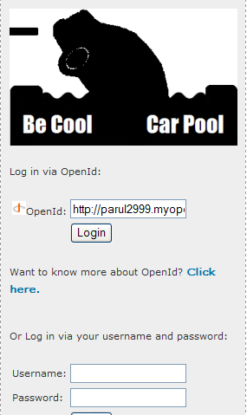
You may use an OpenId account to register with our site. To do this enter your OpenId account in the text box with the OpenId sign beside it (located in the left menu)

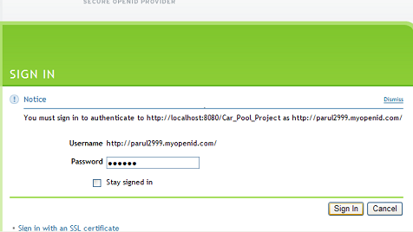
You will be taken to the appropriate OpenId provider's website where you can validate your account by entering your password.

Once you are signed in there you will be redirected to our website. If you have not previously registered with us you will be taken to the registration form where you can choose your username, enter an email address and other details required.
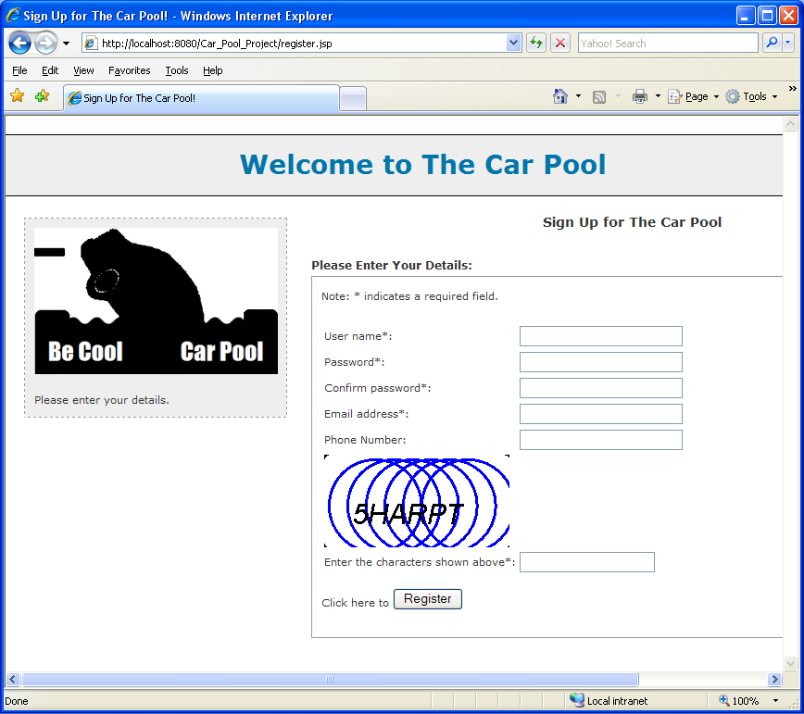

An email will be sent to you informing you of the success of your registration.

Username & Password
You can also register with our site using a username and password. Click on the --Register here-- link located in the left menu.
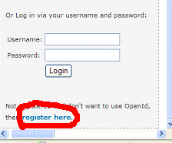

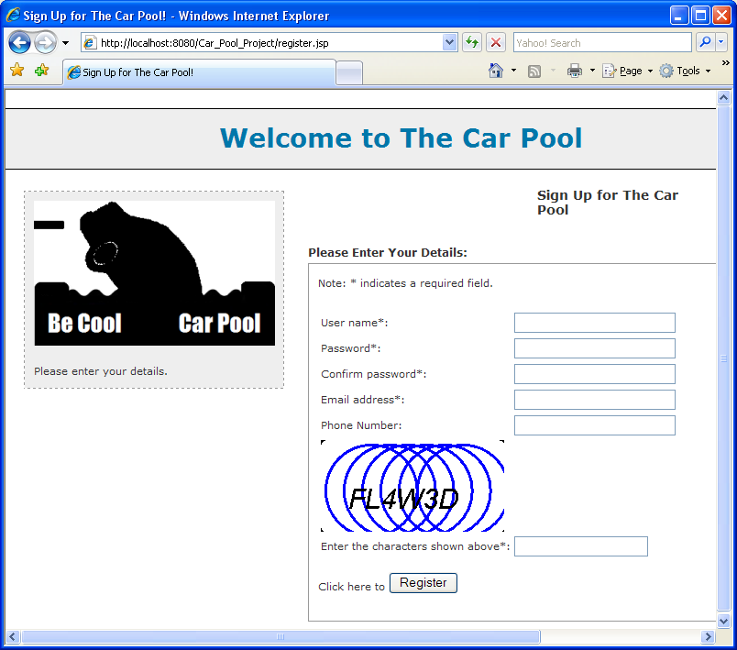
You will be taken to the Registration page where you can enter the relevant details and you are ready to go!

An email will be sent to you informing you of the success of your registration.

How can I change my email address, password, or other details?
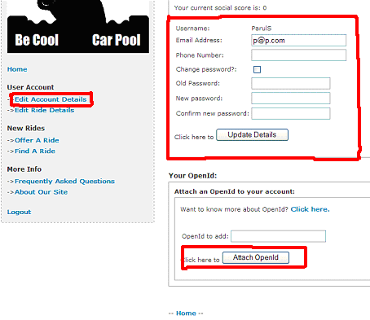
Once you are logged in click on the –Edit Account Details-- link in the menu on the left to be taken to your account page. Here you can change your account information such as email address or password by entering the relevant details and clicking --Update Details-- You can also choose to add an OpenId with your account if you do not have one (or add another if you already have one).

How can I offer a ride?
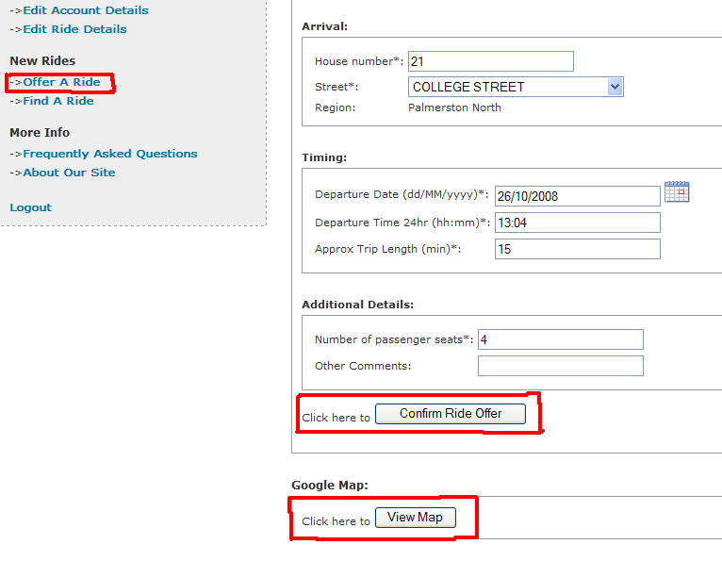
Once you are logged into the site you can click on the --Offer A Ride-- link on the menu in the left. You will be taken to the appropriate page where you can specify the departure and arrival addresses, the departure date, time and approximate time you think the trip will take, the number of seats you have available and anything else that needs to be mentioned. Clicking --View Map-- will open up a Google Map in a new window. This map will show you a route between the arrival and departure points. Clicking on --Confirm Ride Offer-- will add the ride to the system.

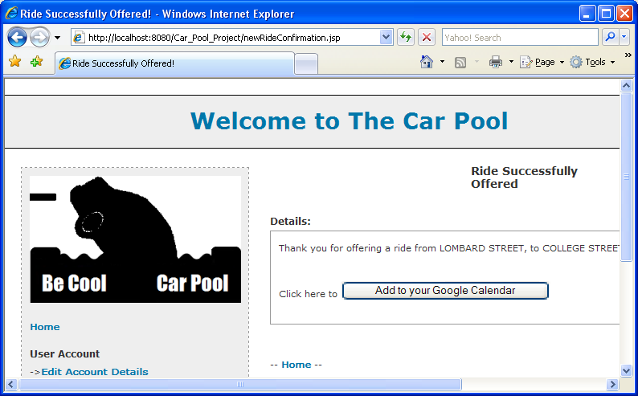
Once you have clicked --Confirm Ride Offer-- you will be taken to a page that gives you the option of adding the ride as an event in your Google Calendar. If you click on --Add to your Google Calendar-- a new window will open where you can log into your Gmail account and add the ride to your Google Calendar.

How can I find rides?
You can click on the --Search Rides-- link in the menu on the left. You will be directed to a page where you can choose --Show All Rides-- will show you all the current rides on offer. You can also search using criteria such as date, username and locations.

How do I register interest for a ride?
After you have searched for rides, click on the link that leads to more details of a ride that you are interested in.
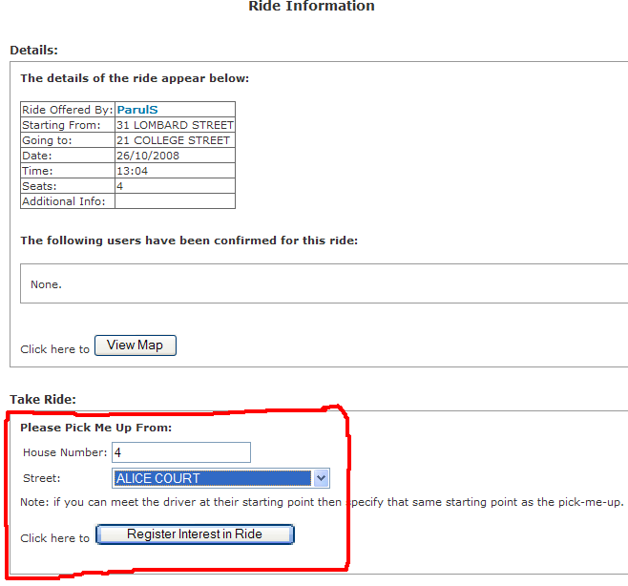
From the page you can request to be added to a ride by clicking on Register Interest for Ride after you have added details about where you would like to be picked up from. It is then up to the person who offered you the ride to decide if they can indeed pick you up from that location.

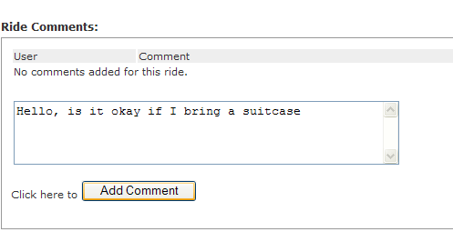
It is best to discuss details on the ride page through comments before taking a ride.

You will receive an email when you are accepted by the driver of the ride or rejected.

Some users have registered interest in my ride. What should I do?
When a member is interested in your ride they will mention the place they will like to be picked up from. You can see a list of the users interested in your ride through your --Edit Ride Details-- page by clicking on the --Manage Ride & Riders-- link for a particular ride.
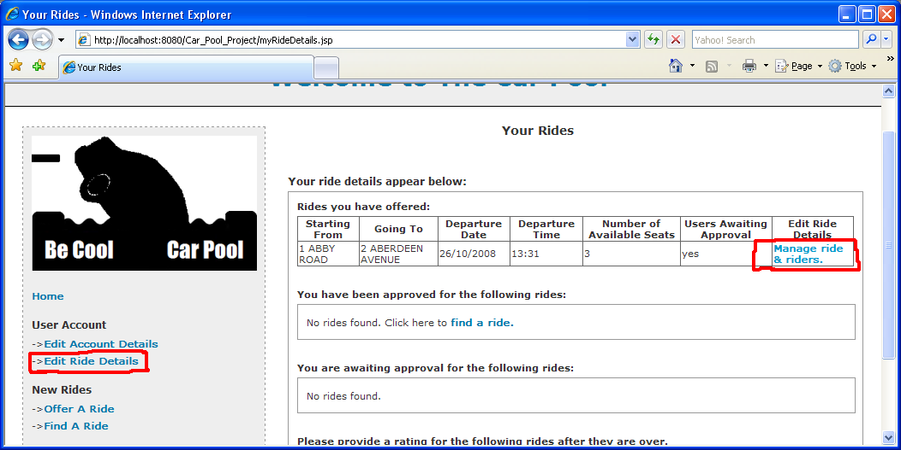
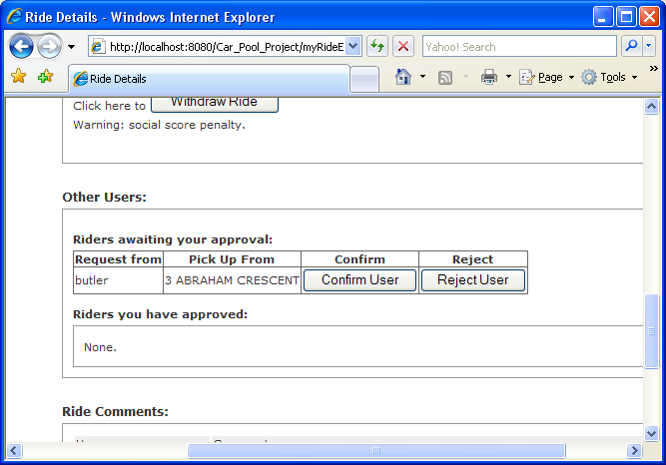
On the ride's page you will be able to see a table of the users who are awaiting your approval. Depending on if you can pick them up from the location they have mentioned and if you trust them you can confirm or reject a user. If you confirm a user then this user will move to the list of users approved for that ride. Either way the rider will be informed of your action via email.

How can I change the details of a ride or withdraw it?
You can see the details of your ride through your --Edit Ride Details-- page by clicking on the --Manage Ride & Riders-- link for a particular ride.

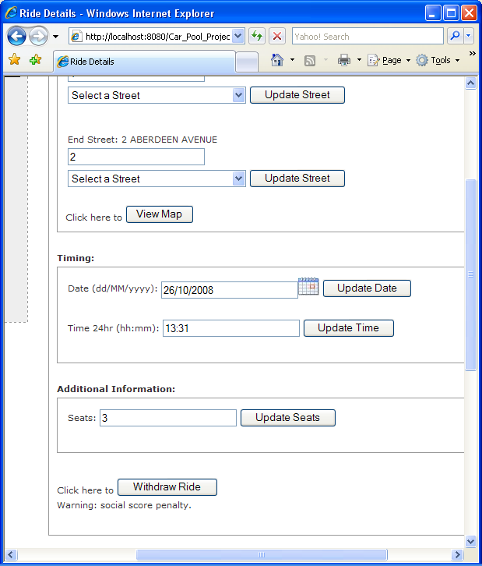
From there you can edit any of the details or withdraw the ride and when you do the other riders will be informed of this change.

How can I withdraw from a ride?
You can withdraw from a ride at any point – if you have been confirmed or not. This can be done by accessing the --Edit Ride Details-- page from the left menu and then clicking on Withdraw as indicated in the screenshot. The driver will be informed of this.
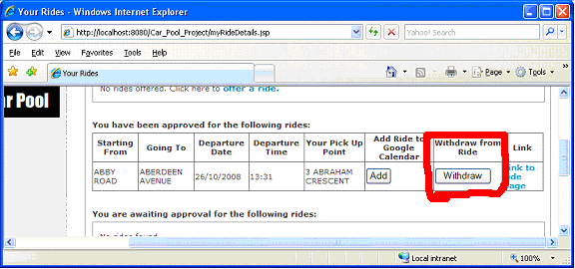

How does the Social Scoring system work?
Your social score enables other members in the community to find out how reliable you are. It depends on how many rides you have offered, how many people you have confirmed for your ride and the rating those riders give you.
How can I leave feedback for a ride?
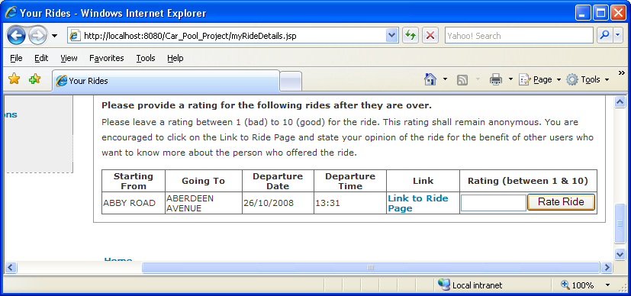
After a ride has finished you can leave a comment on the ride page of the ride stating your opinion of the ride and driver for the benefit of other users who might be browsing through the rides of the driver to know more about them. After that you can give the driver a rating between 1 to 10 where 1 is bad and 10 is good and this rating will then affect their social score.

Why is this site restricted to only Palmerston North streets?
Currently we have restricted the scope of this site to within Palmerston North only. If this site is successful in Palmerston North then we will consider expanding it first to all regions in Manawatu and then perhaps throughout New Zealand.

I can't find the street I want...
We aim to ensure that our information about the streets is up to date. However if you know a street exists that we do not have in our database please email us at carpoolproject@gmail.com and we will add it to the database as soon as we can.

When I search by streets other locations turn up as well.
Our site uses a cunning and intricately complicated ride path projection system to figure out the routes taken by drivers and to display the rides to you if they will pass by your origin and/or destination. This allows for a much more efficient car-to-passenger ratio, and if someone is passing by why not get them to pick you up? That’s what we are all about after all. The rides that show up can be seen from the figure below:
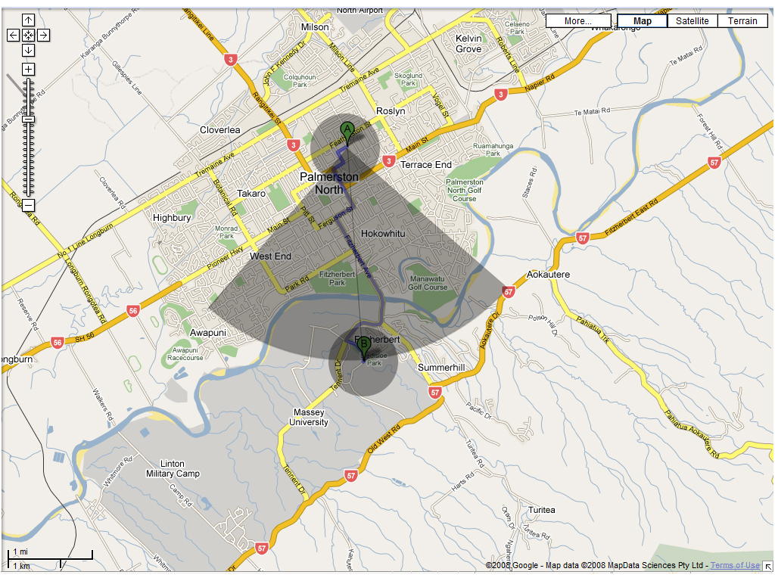
Beginning from the start location’s radius to the end location’s radius all rides in the shaded area are found.

Why won't the Google Map display correctly for me?
This could be because your browser does not support Google Maps. Currently Google Maps should display fine on Firefox 3.0.1, Opera 9.52 and Internet Explorer 8.

What browsers is this site compatible with?
This site should work well on Firefox 3.0.1, Opera 9.52 and Internet Explorer 8. This site is compatable with other browsers such as Internet Explorer 7 and older however Google Maps may not work well with them.

