**Amazon RDS Introduces Readable Standby Instances in Multi-AZ Deployments**

AWS has recently announced [readable standby instances in Amazon RDS](https://aws.amazon.com/blogs/database/readable-standby-instances-in-amazon-rds-multi-az-deployments-a-new-high-availability-option/) multi-AZ deployments. The new database cluster option provides high availability and durability for workloads requiring more read capacity and consistent transaction latency.

Introduced more than ten years after [multi-AZ deployments for RDS](https://aws.amazon.com/about-aws/whats-new/2010/05/18/announcing-multi-az-deployments-for-amazon-rds/), the new option in preview uses the database engine's native replication and relies on local NVMe SSD storage and R6gd/M6gd Graviton2 instances. The [standby instances](https://docs.aws.amazon.com/AmazonRDS/latest/UserGuide/multi-az-db-clusters-concepts.html) act as automatic failover targets and can serve read traffic to increase throughput, without adding read replica instances.

The new approach addresses one of the limitations of the traditional RDS multi-AZ deployment where the synchronously replicated standby instance cannot accept connections.

**A Multi-AZ DB cluster consists of one primary and two readable standby read replicas in three different Availability Zones. The primary (writer) DB instance serves read and write operations, and performs all the data modifications. The standby (reader) DB instance acts as a failover target for the primary and also serves read traffic. So, applications can offload read traffic from the primary DB instance to reader DB instances to increase application read throughput (...) Acknowledgement from at least one reader DB instance is required for a change to be committed and applied.**

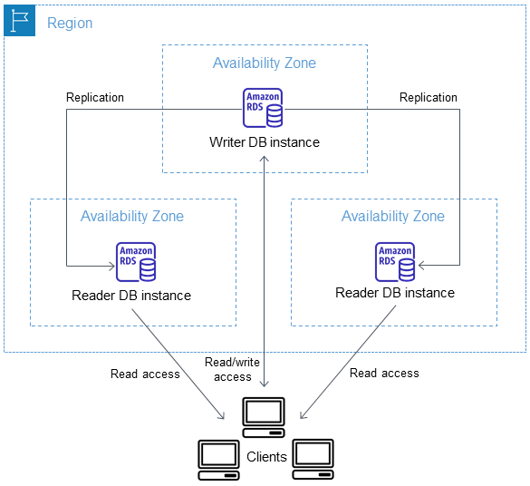

Source: <https://aws.amazon.com/blogs/database/readable-standby-instances-in-amazon-rds-multi-az-deployments-a-new-high-availability-option/>

Similarly to [Amazon Aurora](https://aws.amazon.com/rds/aurora/), applications do not need to handle host names, load-balancing or rerouting connections, with the multi-AZ database cluster relying on an endpoint mechanism to abstract the connections: each cluster has a cluster (read/write) endpoint, a reader endpoint, and instance endpoints associated with each DB instance in a cluster. As the cluster has a writer instance and two reader instances in different availability zones, the VPC must have at least one subnet in three different zones.

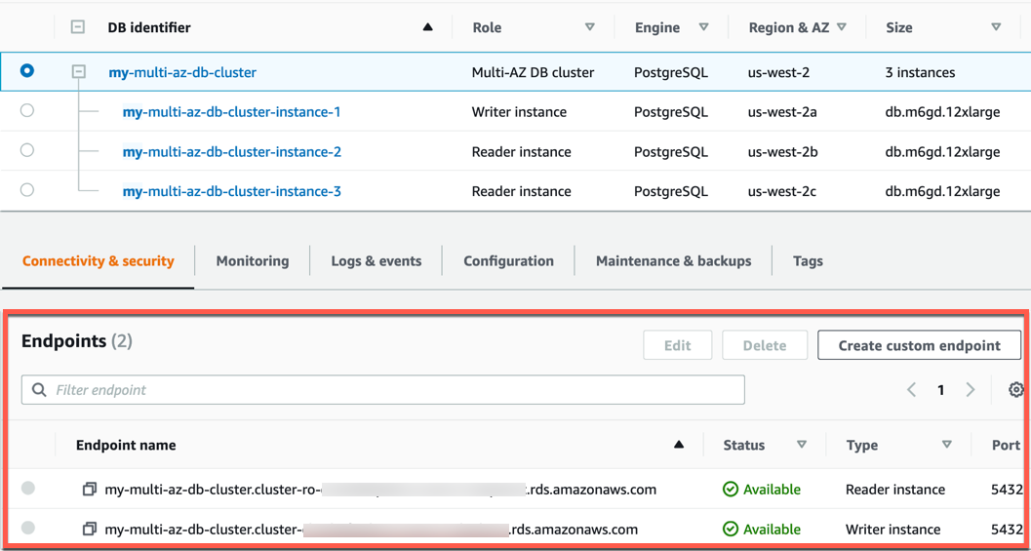

Source: <https://aws.amazon.com/blogs/database/readable-standby-instances-in-amazon-rds-multi-az-deployments-a-new-high-availability-option/>

The multi-AZ DB cluster deployment is currently supported on MySQL 8.0.26 and PostgreSQL 13.4.

Interesting if MariaDB is going to be supported.

Will existing clusters be able to convert across to this new architecture?

Multi-AZ deployments with readable standby instances are currently available in only three regions: North Virginia, Oregon and Ireland. The [cheapest option](https://aws.amazon.com/rds/mysql/pricing/) with two readable standby instances is the db.m6gd.large, at 0.522 USD per hour on demand, significantly more expensive than the traditional multi-AZ deployment where a comparable db.m6g.large costs 0.304 USD per hour and smaller and cheaper instances are available.