**Early Stopping in Practice: an example with Keras and TensorFlow 2.0**

A step to step tutorial to add and customize Early Stopping

**Introduction to Early Stopping**

In machine learning, early stopping is one of the most widely used [regularization techniques](https://towardsdatascience.com/machine-learning-model-regularization-in-practice-an-example-with-keras-and-tensorflow-2-0-52a96746123e) to combat the ***overfitting*** issue.

Early Stopping monitors the performance of the model for every epoch on a held-out validation set during the training, and terminate the training conditional on the validation performance.

From Hands-on ML [1]

Early Stopping is a very different way to regularize the machine learning model. The way it does is to stop training as soon as the validation error reaches a minimum. The figure below shows a model being trained.

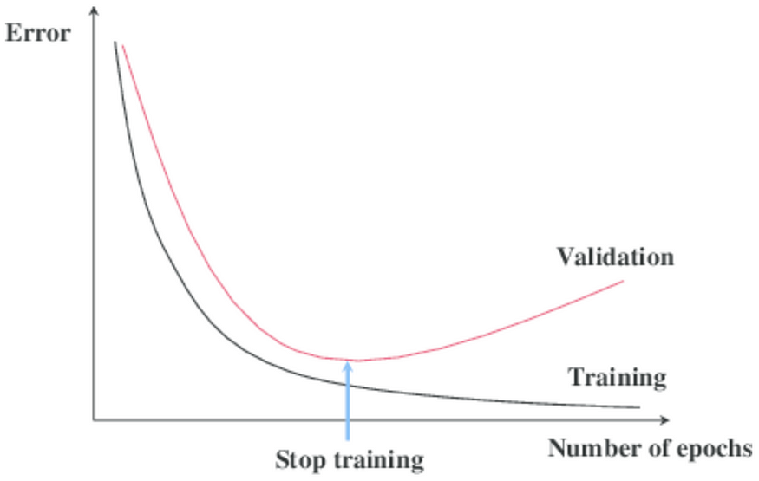

As the epochs go by, the algorithm leans and its error on the training set naturally goes down, and so does its error on the validation set. However, after a while, the validation error stops decreasing and actually starts to go back up. This indicates that the model has started to overfit the training data. With Early Stopping, you just stop training as soon as the validation error reaches the minimum.

It is such a simple and efficient regularization technique that Geoffrey Hinton called it a “beautiful free lunch.” [1].

**With Stochastic and Mini-batch Gradient Descent**

With Stochastic and Mini-batch Gradient Descent, the curves are not so smooth, and it may be hard to know whether you have reached the minimum or not. One solution is to stop only after the validation error has been above the minimum for some time (when you are confident that the model will not do any better), then roll back the model parameters to the point where the validation error was at a minimum.

In the following article, we are going to add and customize Early Stopping in our machine learning model.

**Environment setups and dataset preparation**

We will be using the same dataset as we did in the [model regularization](https://towardsdatascience.com/machine-learning-model-regularization-in-practice-an-example-with-keras-and-tensorflow-2-0-52a96746123e) and [batch normalization](https://towardsdatascience.com/batch-normalization-in-practice-an-example-with-keras-and-tensorflow-2-0-b1ec28bde96f). You can skip this chapter if you are already familiar with it.

In order to run this tutorial, you need to install

*TensorFlow 2, numpy, pandas, sklean, matplotlib*

They can all be installed directly vis PyPI and I strongly recommend to create a new Virtual Environment. For a tutorial on creating a Python virtual environment

* [Create Virtual Environment using “virtualenv” and add it to Jupyter Notebook](https://towardsdatascience.com/create-virtual-environment-using-virtualenv-and-add-it-to-jupyter-notebook-6e1bf4e03415)
* [Create Virtual Environment using “conda” and add it to Jupyter Notebook](https://medium.com/analytics-vidhya/create-virtual-environment-using-conda-and-add-it-to-jupyter-notebook-d319a81dfd1)

**Source code**

This is a step by step tutorial and all instructions are in this article. For source code, please check out my Github [machine learning repo](https://github.com/BindiChen/machine-learning/blob/master/tensorflow2/005-early-stopping/early-stopping.ipynb).

**Dataset preparation**

This tutorial uses the [Anderson Iris flower (iris)](https://en.wikipedia.org/wiki/Iris_flower_data_set) dataset for demonstration. The dataset contains a set of 150 records under five attributes: *sepal length*, *sepal width*, *petal length*, *petal width,* and *class* (known as *target* from sklearn datasets).

First, let’s import the libraries and obtain iris dataset from ***scikit-learn*** library. You can also download it from the [UCI Iris dataset](https://archive.ics.uci.edu/ml/datasets/iris).

import tensorflow as tf  
import pandas as pd  
import numpy as np  
import matplotlib.pyplot as plt  
from sklearn.datasets import load_iris  
from sklearn.model_selection import train_test_split**iris = load_iris()**

For the purpose of exploring data, let’s load data into a DataFrame

# Load data into a DataFrame  
**df = pd.DataFrame(iris.data, columns=iris.feature_names)**# Convert datatype to float  
**df = df.astype(float)**# append "target" and name it "label"  
**df['label'] = iris.target**# Use string label instead  
**df['label'] = df.label.replace(dict(enumerate(iris.target_names)))**

And the df should look like below:

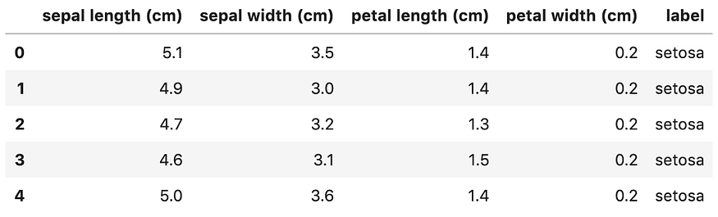

We notice the ***label*** column is a categorical feature and will need to convert it to [one-hot encoding](https://towardsdatascience.com/what-is-one-hot-encoding-and-how-to-use-pandas-get-dummies-function-922eb9bd4970). Otherwise, our machine learning algorithm won’t be able to directly take in that as input.

# label -> one-hot encoding  
**label = pd.get_dummies(df['label'], prefix='label')**  
**df = pd.concat([df, label], axis=1)**  
# drop old label  
df.drop(['label'], axis=1, inplace=True)

Now, the df should look like:

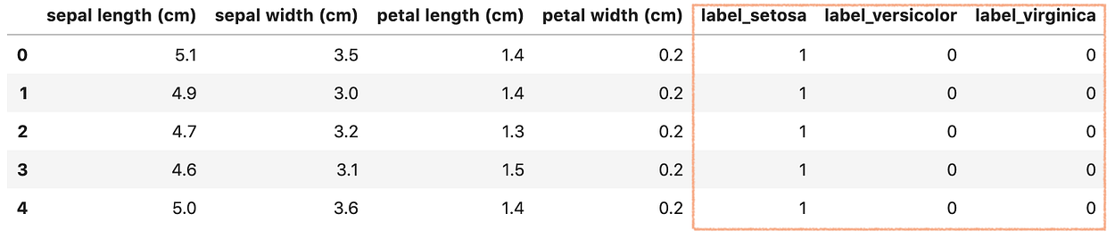

Next, let’s create X and y. Keras and TensorFlow 2.0 only take in Numpy array as inputs, so we will have to convert DataFrame back to Numpy array.

# Creating X and y**X = df[['sepal length (cm)', 'sepal width (cm)', 'petal length (cm)', 'petal width (cm)']]**  
# Convert DataFrame into np array  
**X = np.asarray(X)y = df[['label_setosa', 'label_versicolor', 'label_virginica']]**# Convert DataFrame into np array  
**y = np.asarray(y)**

Finally, let’s split the dataset into a training set (80%)and a test set (20%) using **train_test_split()**from **sklearn** library.

X_train, X_test, y_train, y_test = **train_test_split**(  
 **X,  
 y,  
 test_size=0.20**  
)

Great! our data is ready for building a Machine Learning model.

**Build a neural network**

There are [3 ways to create a machine learning model with Keras and TensorFlow 2.0](https://towardsdatascience.com/3-ways-to-create-a-machine-learning-model-with-keras-and-tensorflow-2-0-de09323af4d3). Since we are building a simple fully connected neural network and for simplicity, let’s use the easiest way: Sequential Model with Sequential().

Let’s go ahead and create a function called create_model() to return a Sequential model.

from tensorflow.keras.models import Sequential  
from tensorflow.keras.layers import Densedef **create_model()**:   
 model = Sequential([  
 Dense(64, activation='relu', **input_shape=(4,)**),  
 Dense(128, activation='relu'),  
 Dense(128, activation='relu'),  
 Dense(128, activation='relu'),  
 Dense(64, activation='relu'),  
 Dense(64, activation='relu'),  
 Dense(64, activation='relu'),  
 **Dense(3, activation='softmax')**  
 ])  
 return model

Our model has the following specifications:

* The first layer (also known as the input layer) has the input_shape to set the input size (4,)
* The input layer has 64 units, followed by 3 dense layers, each with 128 units. Then there are further 3 dense layers, each with 64 units. All these layers use the ReLU activation function.
* The output Dense layer has 3 units and the softmax activation function.

**Compile and train the model**

In order to train a model, we first have to configure our model using compile() and pass the following arguments:

* Use Adam (adam) optimization algorithm as the optimizer
* Use categorical cross-entropy loss function (categorical_crossentropy) for our ***multiple-class classification*** problem
* For simplicity, use accuracy as our evaluation metrics to evaluate the model during training and testing.

model.compile(  
 **optimizer='adam',   
 loss='categorical_crossentropy',   
 metrics=['accuracy']**  
)

After that, we can call model.fit() to fit our model to the training data.

history = model.fit(  
 X_train,   
 y_train,   
 **epochs=200,   
 validation_split=0.25,   
 batch_size=40,**   
 verbose=2  
)

If all runs smoothly, we should get an output like below

Train on 84 samples, validate on 28 samples  
Epoch 1/200  
84/84 - 1s - loss: 1.0901 - accuracy: 0.3214 - val_loss: 1.0210 - val_accuracy: 0.7143  
Epoch 2/200  
84/84 - 0s - loss: 1.0163 - accuracy: 0.6905 - val_loss: 0.9427 - val_accuracy: 0.7143  
......  
Epoch 200/200  
84/84 - 0s - loss: 0.5269 - accuracy: 0.8690 - val_loss: 0.4781 - val_accuracy: 0.8929

**Plot the learning curves**

Finally, let’s plot the loss vs. epochs graph on the training and validation sets.

It is preferable to create a small function for plotting metrics. Let’s go ahead and create a function plot_metric().

%matplotlib inline  
%config InlineBackend.figure_format = 'svg'def **plot_metric(history, metric)**:  
 train_metrics = history.history[metric]  
 val_metrics = history.history['val_'+metric]  
 epochs = range(1, len(train_metrics) + 1)  
 plt.plot(epochs, train_metrics)  
 plt.plot(epochs, val_metrics)  
 plt.title('Training and validation '+ metric)  
 plt.xlabel("Epochs")  
 plt.ylabel(metric)  
 plt.legend(["train_"+metric, 'val_'+metric])  
 plt.show()

By running plot_metric(history, 'loss') to get a picture of loss progress.

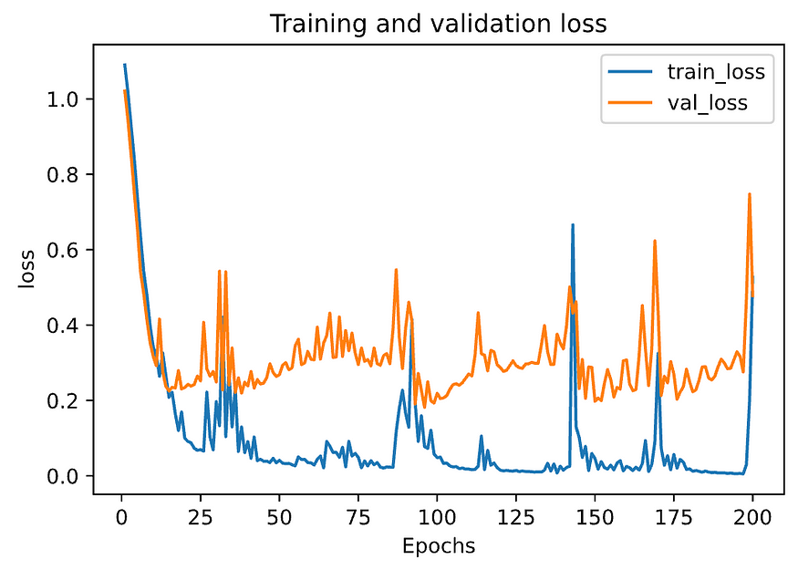

From the above graph, **we can see that the model has overfitted the training data, so it outperforms the validation set**.

**Adding Early Stopping**

The Keras module contains a built-in callback designed for Early Stopping [2].

First, let’s import EarlyStopping callback and create an early stopping object early_stopping .

from tensorflow.keras.callbacks import **EarlyStoppingearly_stopping = EarlyStopping()**

EarlyStopping() has a few options and by default:

* monitor='val_loss': to use validation loss as performance measure to terminate the training.
* patience=0: is the number of epochs with no improvement. The value 0 means the training is terminated as soon as the performance measure gets worse from one epoch to the next.

Next, we just need to pass the callback object to model.fit() method.

history = model.fit(  
 X_train,   
 y_train,   
 epochs=200,   
 validation_split=0.25,   
 batch_size=40,   
 verbose=2,  
 **callbacks=[early_stopping]**  
)

You can see that early_stopping get passed in a list to the callbacks argument. It is a list because in practice we might be passing a number of callbacks for performing different tasks, for example debugging and learning rate scheduler.

By executing the statement, you should get an output like below:

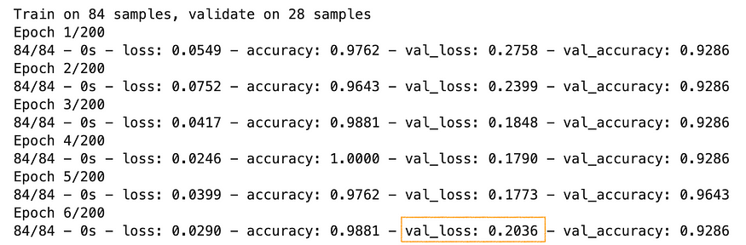

**Note:** your output can be different due to the different weight initialization.

The training gets terminated at Epoch 6 due to the increase of val_loss value and that is exactly the conditions monitor='val_loss' and patience=0.

It’s often more convenient to look at a plot, let’s run plot_metric(history, 'loss') to get a clear picture. In the below graph, validation loss is shown in orange and it’s clear that validation error increases at Epoch 6.

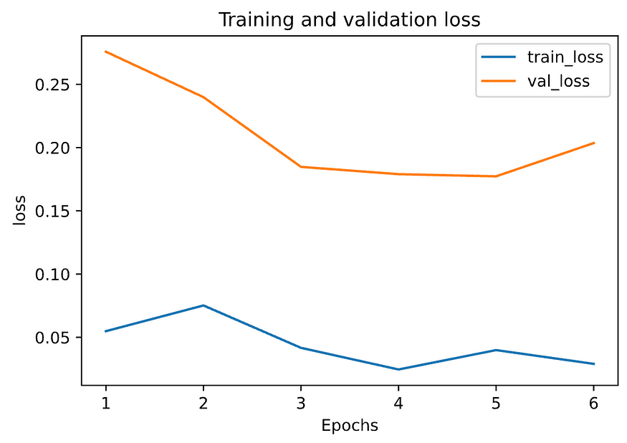

**Customizing Early Stopping**

Apart from the options monitor and patience we mentioned early, the other 2 options min_delta and mode are likely to be used quite often.

* monitor='val_loss': to use validation loss as performance measure to terminate the training.
* patience=0: is the number of epochs with no improvement. The value 0 means the training is terminated as soon as the performance measure gets worse from one epoch to the next.
* **min_delta**: Minimum change in the monitored quantity to qualify as an improvement, i.e. an absolute change of less than min_delta, will count as no improvement.
* **mode='auto'**: Should be one of auto, min or max. In 'min' mode, training will stop when the quantity monitored has stopped decreasing; in 'max' mode it will stop when the quantity monitored has stopped increasing; in 'auto' mode, the direction is automatically inferred from the name of the monitored quantity.

And here is an example of a customized early stopping:

custom_early_stopping = EarlyStopping(  
 **monitor='val_accuracy',**   
 **patience=8,**   
 **min_delta=0.001,**   
 **mode='max'**  
)

monitor='val_accuracy' to use **validation accuracy** as performance measure to terminate the training. patience=8 means the training is terminated as soon as 8 epochs with no improvement. min_delta=0.001 means the validation accuracy has to improve by at least 0.001 for it to count as an improvement. mode='max' means it will stop when the quantity monitored has stopped increasing.

Let’s go ahead and run it with the customized early stopping.

history = model.fit(  
 X_train,   
 y_train,   
 epochs=200,   
 validation_split=0.25,   
 batch_size=40,   
 verbose=2,  
 **callbacks=[custom_early_stopping]**  
)

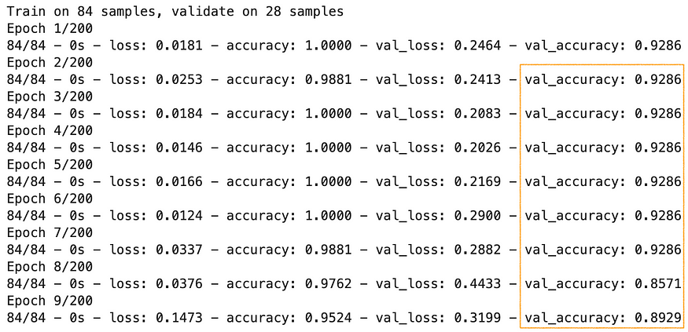

This time, the training gets terminated at Epoch 9 as there are 8 epochs with no improvement on validation accuracy (It has to be ≥ 0.001 to count as an improvement). For a clear picture, let’s look at a plot representation of accuracy by running plot_metric(history, 'accuracy'). In the below graph, validation accuracy is shown in orange and it’s clear that validation accuracy hasn’t got any improvement.

