**Department of Technical Education**

**Capstone project**

**Format- 2**

**Work Breakdown Structure**

Capstone project Name: Online MCQ Exam

Capstone project Members: Dharmraj Latte 339CS20008

Shahin Mirakhan 339CS20023

Vaishnavi Tharakar 339CS20034

Mohmmadhussain Shaikh 339CS21701

Capstone project Objective (s):

* + 1. Reduce the time of user.
    2. Reduce the manual work.
    3. Easy to use.
    4. Access from any location.
    5. Student can submit online test and get result easily.

Work Breakdown Structure

In this project there are two main modules: - Admin and User.

**Admin modules**

* Admin/Staff login: - In this using user name and password admin can login.
* Manage Test :- In this admin can manage the test (add or delete)
* Manage question and answer: - In this admin can add or delete question and answer.
* View result: - In this admin can view the result.

**User modules**

* User/Student registration: - In this user can register with his details.
* User login: - using username and password user can login.
* Submit test :- In this user can submit the test and get the result

**System Architecture**

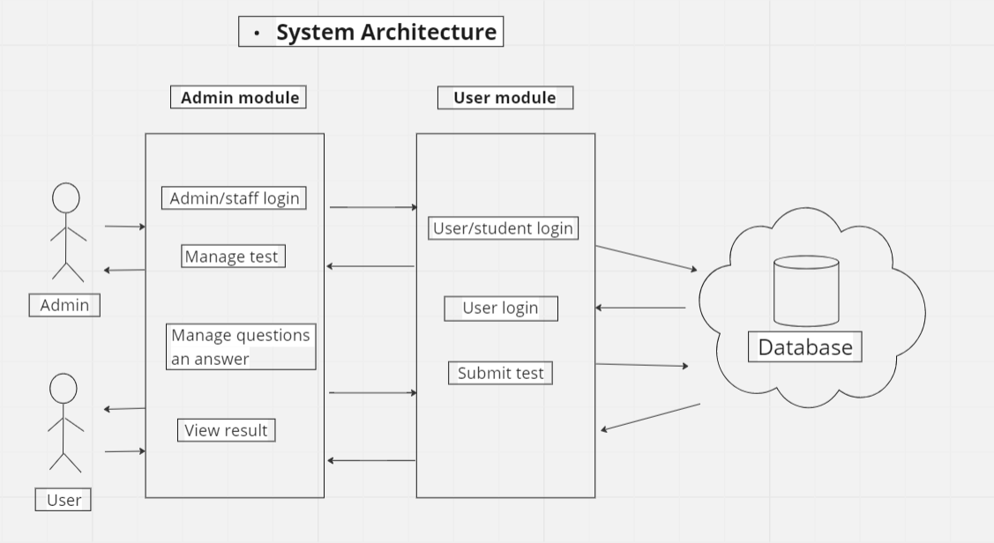

**Flow Chart**

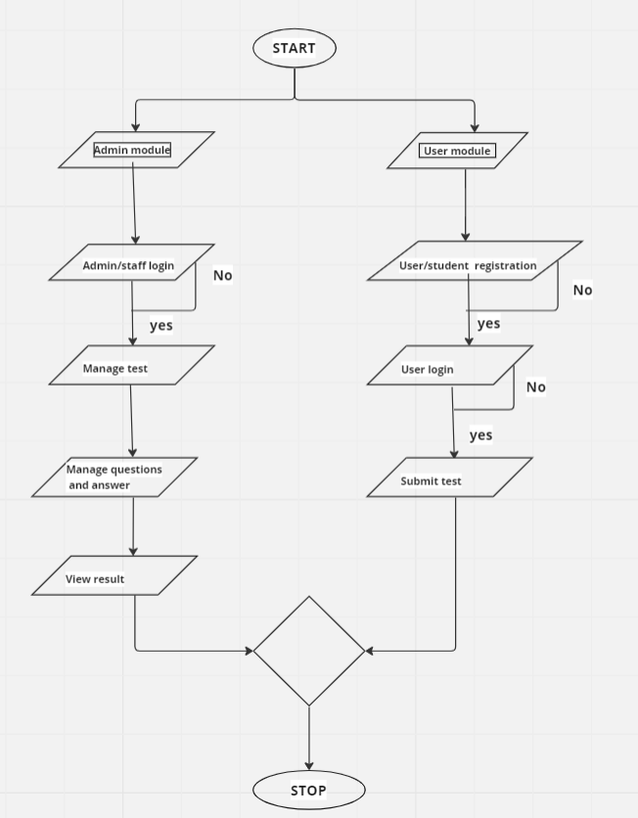

**Activities and tasks: -**

* Admin/Staff login

Task 1. Admin login must design properly.

Task 2. Entered details must validate properly.

Task 3. Entered detail must store in database.

* Manage test

Task 1. Admin must add or delete test to exam.

Task 2. Added tests must store properly.

* Manage question and answer

Task 1. Admin must able to add and delete question and answer.

Task 2. Added question and answers must store in database.

* View Result

Task 1. Admin must manage the result

Task 2. Result must calculate correctly.

* User Registration

Task 1. Student must register with correct details.

Task 2. Registered details must validate.

Task 3. Details must store to database without fail.

* User Login

Task 1. User must login with registered details.

Task 2. Entered details must validate.

Task 3. Login details must store to database.

* Submit test

Task 1. Submit button must work properly.

Task 2. After submitting result must show properly.

Date Signature of the student Signature of the cohort owner