Python vs JavaScript for Backend Development
Modern Report

Generated by Life OS — May 14, 2026

Introduction
Python and JavaScript are two popular programming languages used for backend development. Python is known for its simplicity, readability, and large community, while JavaScript is known for its versatility, flexibility, and widespread adoption.
Feature | Python | JavaScript
Syntax | Indentation-based | Bracket-based
Typing | Statically-typed | Dynamically-typed
Performance | Faster execution | Faster development
Libraries | NumPy, pandas | Express, React
Community | Large and established | Large and growing

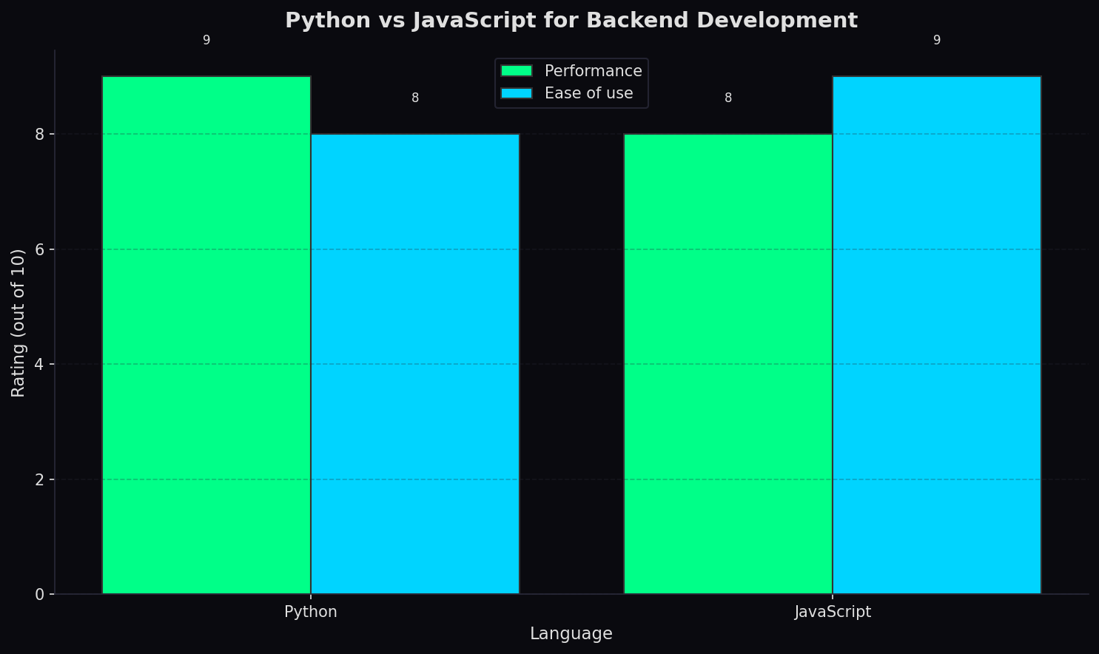

Conclusion
In conclusion, both Python and JavaScript are suitable for backend development, but the choice ultimately depends on the specific needs and goals of the project.

