SAMINA HAQ
ASSIGNMENT
COMPANY : MASTER CARD

Question # 01

Output

SOURCE CODE LOCATION :

Part # 01 (with Array)
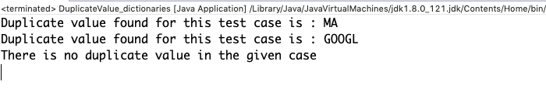
Part # 02 (with Dictionaries)
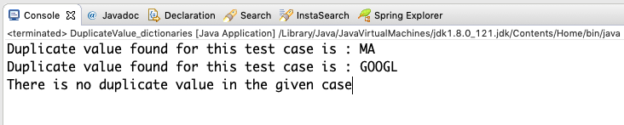

Question # 02

Output

SOURCE CODE LOCATION :

Question # 03

Output

SOURCE CODE LOCATION :

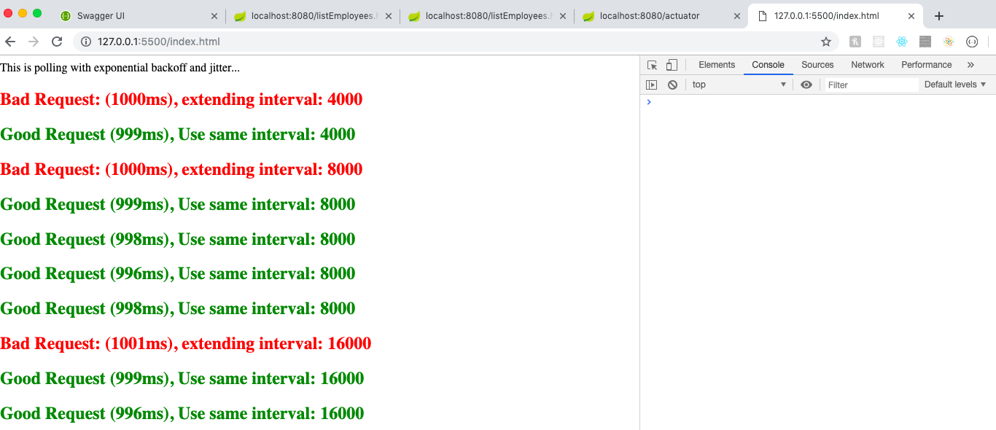

Question # 04

Output

SOURCE CODE LOCATION :

Question # 05

Output

SOURCE CODE LOCATION :

