Emissions and Land Use Analysis in different Countries

# Introduction

Climate change is a critical global issue that demands attention and understanding. In this project, I aim to analyze climate change data from the World Bank to gain insights into the United Arab Emirates (UAE). Specifically, I explore the emissions of greenhouse gases and examine the proportion of arable land over the years. By visualizing and examining these data points, we can better understand the environmental trends in the UAE and potentially identify areas for improvement or intervention.

# Data Analysis

## Emissions Analysis

To begin our analysis, I focused on the emissions of greenhouse gases in the UAE. I extracted data for four key greenhouse gases: nitrous oxide (N2O), methane, total greenhouse gasses, and carbon dioxide (CO2). I cleaned the data by removing any missing values and converted the emissions values to numeric format.

To gain further insights, I calculated the covariance and correlation matrices for the emissions data using statistical tools. The results suggest strong positive correlations among the emission variables, indicating that increases in one type of emission are likely to be associated with increases in the others. Additionally, there are negative but relatively weak correlations between emissions and arable land, implying that as emissions increase, there may be a slight decrease in the availability of arable land.

Then after that this information was plotted using line plot from matplotlib library. That plot can be seen below.

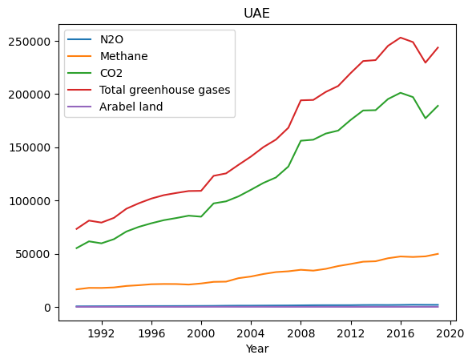

From the graph it can be seen that there is constant increase in CO2 emission and total greenhouse gasses. But there is a dip for year 2019 that could be because of lockdowns in COVID-19.

## Arable Land Analysis

Apart from emissions, I also explored the percentage of arable land in the UAE. I extracted data related to arable land and converted it to a numeric format.

The analysis focuses on three aspects: urban population, agricultural land, and arable land, for selected countries. For the United States (USA), the covariance and correlation matrices were calculated. The covariance values suggest that there is a positive covariance between urban population and agricultural land, indicating that as the urban population increases, agricultural land tends to decrease. Similarly, there is a positive covariance between agricultural land and arable land, suggesting a relationship where an increase in agricultural land corresponds to an increase in arable land. Then this info was also plotted for USA.

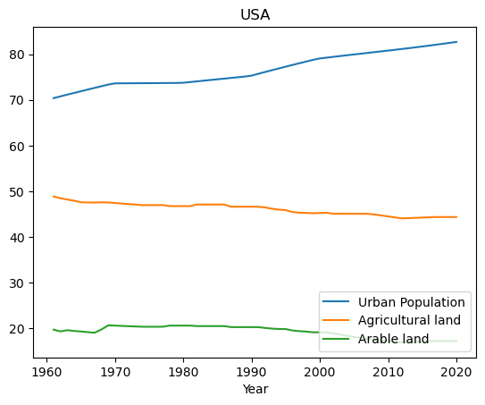

|  |  |
| --- | --- |
| Additionally, the analysis includes the CO2 emissions data for Australia, Bangladesh, Pakistan, and Canada. The average CO2 emissions were calculated for each country, revealing that Australia has the highest average CO2 emissions, followed by Canada, Pakistan, and Bangladesh. The standard deviation values demonstrate the variability in CO2 emissions across the years, with Canada exhibiting the highest deviation. A bar graph was generated to visualize the CO2 emissions for these countries between 2011 and 2019, illustrating the variations in emissions over time. | C:\Users\autom\AppData\Local\Microsoft\Windows\INetCache\Content.MSO\54F842E6.tmp |

Lastly, the analysis investigates the arable land percentages for the same four countries. The average arable land percentages were computed, indicating that Bangladesh has the highest average arable land, followed by Pakistan, Australia, and Canada. The standard deviation values highlight the degree of variation in arable land percentages over the years, with Bangladesh having the highest deviation. A bar graph was created to present the changes in arable land percentages from 2011 to 2020 for the selected countries.

Conclusion: Overall, the analysis provides insights into the relationships between urban population, agricultural land, and arable land in the United States, as well as the CO2 emissions and arable land percentages in Australia, Bangladesh, Pakistan, and Canada. The findings contribute to understanding the dynamics and trends in these key indicators across the selected countries.

GitHub repository:

<https://github.com/saminamushtaq/ADS1-Ref-def-rework-assignment-2-Statistics-and-Trends-30/tree/main>