

**SP Project - System Design**

Diploma in ICT

College of Technology - Ratnapura

Submitted by:

**M. Saminda Lakshan Perera | RP/22/ETB11/1/0004**

**Requirement for shoe manufacturing institute**

“Wing shoe” is a small-scale shoe manufacturing institute which is located in Rathnapura district. They sell ladies slippers as whole sale and also serve walk in customers. They have a shop in Millavitiya.

They accept special orders like wedding shoes. They have 3 types of sales normal, special and whole sale. They give a unique number to every order and the store the customer’s name, Type of order, Item name, unit price, quantity, total price and order date. They keep their customers information. They give a unique number to a customer and the stores their name, telephone number, Gender and customer’s address. Normally they deliver the special orders with a week. They have an inventory for shoes in their stores, they give an ID for each design, they identify shoes uniquely with design id and size. They have 3 to 10 sizes. And also, they store shoe quantity, unit price and manufactured date. They keep a different inventory for their materials. They for materials they give an ID to identify materials uniquely. And also, they store materials name, quantity which are in their stores, date of purchase, unit price, total price and supplier’s name. they keep their supplier’s information. They label their suppliers with supplier id to identify each supplier uniquely. And they keep supplier name, telephone number, address, total amount, paid amount and amount to be paid. Usually, they settle their suppliers bills within a month. When someone buy 12 or more than shoes, they identify it as whole sale and they give a 20% discount for whole sales. their issuing a bill for every order. In their bill they provide date of ordered, type of order, customer name, design name, design id, size, quantity, unit price, total price and type of payment. When someone order a special order, they add an advance payment to the bill.

They don’t have any IT related someone to handle the software so they need a user-friendly system that can easily complete their business activities. They need to start working on the shop system immediately with shoe inventory, customer inventory, order and the billing system.

**Requirements**

**Functional**

* System shall have a shoe Inventory and allows to display the inventory, add new shoe designs and quantity which are available in the stores.
* System shall have a Customer Contact list and allows to display, update and add new customer into it.
* System shall have a way to add new order, allow to update it and way to find it.
* When a whole sale order system shall automatically add 20% discount on to it.
* System shall generate an invoice for every order.

**Non-Functional**

* System must work smoothly without errors.
* Need a user-friendly interface.
* Users should be able to navigate its interface easily
* System needs to have accurate calculations.
* System must be work on windows operating system

**System Interfaces**

1. **Log in form**

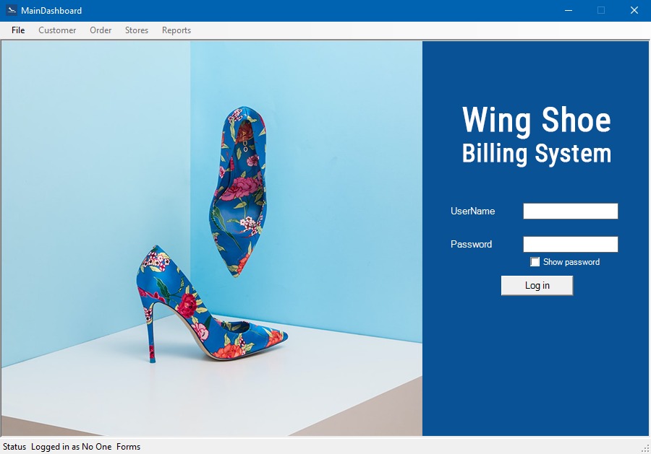

1. **MDI Home Form**

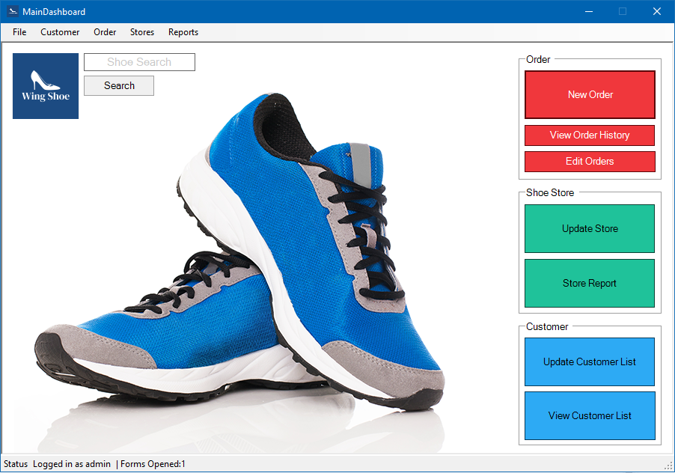

* 1. **Invoice form**

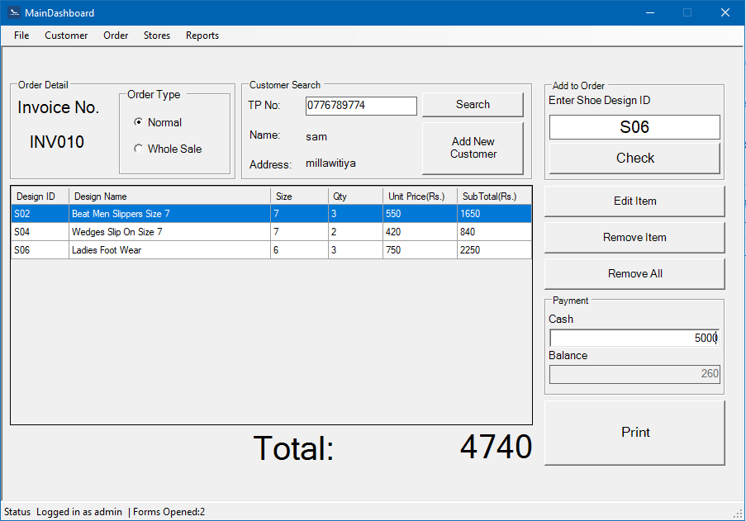

* 1. **Add New Customer Form**

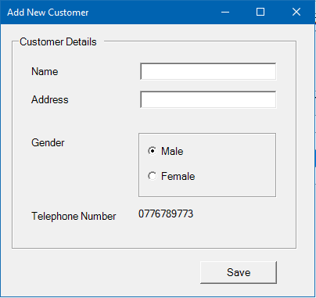

* 1. **Add items to order form**

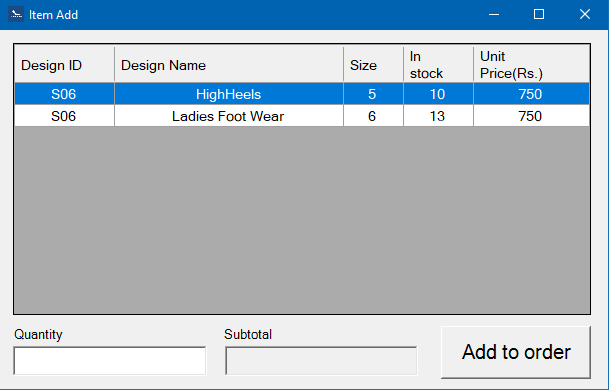

* + 1. **Add quantity form**

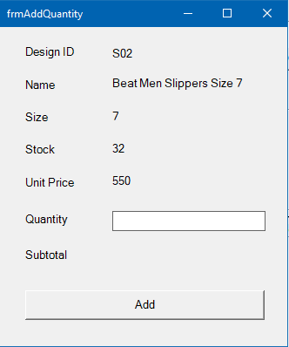

1. **Store Update Form**

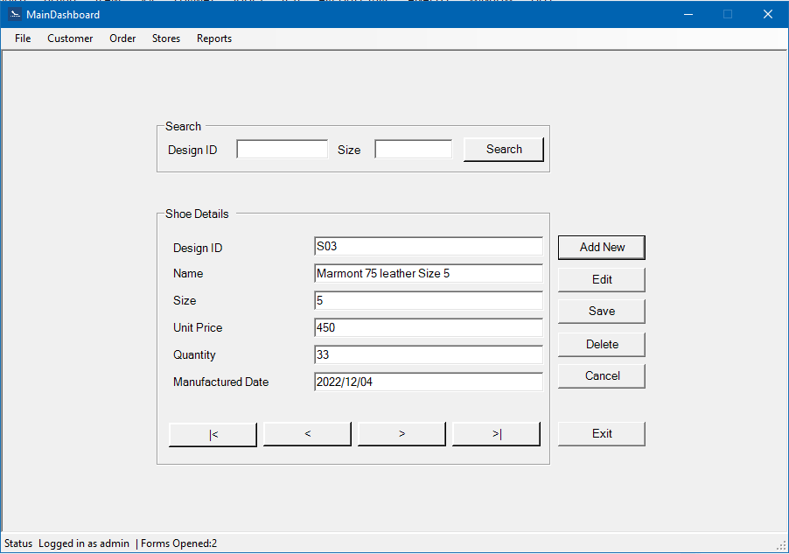

1. **Customer Update Form**

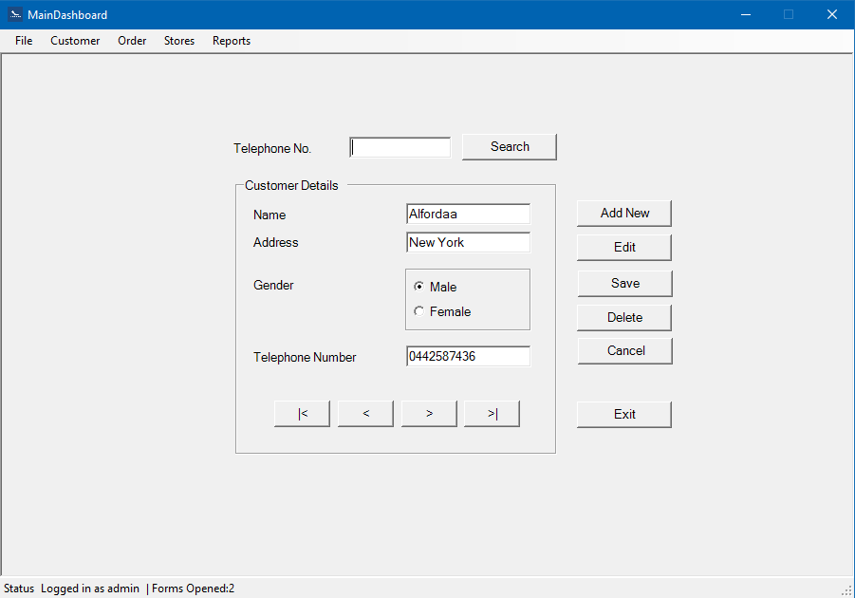

1. **Reports**
   1. **Invoice**

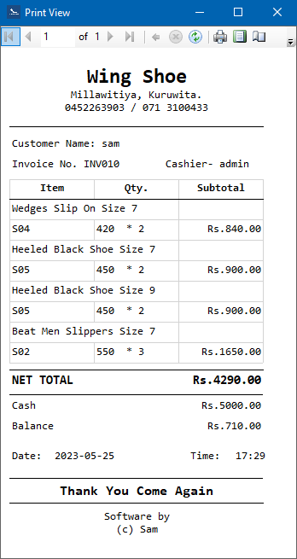

* 1. **Customer Report**

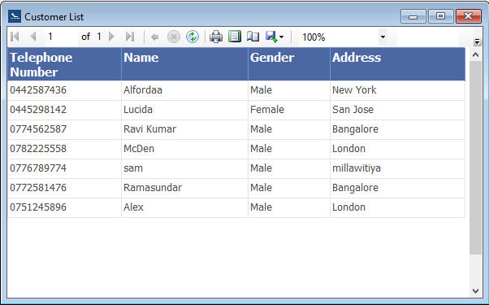

* 1. **Order History**

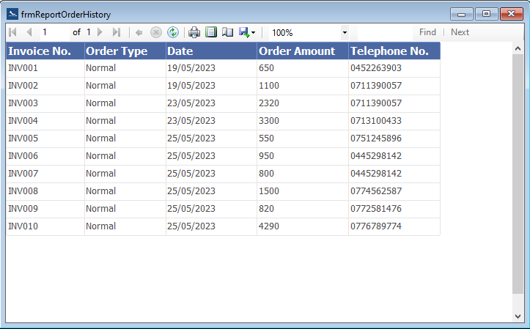

**Relationship Diagram**

