Part: 1

First I install the composer on my desktop using the .exe file then I make the path on my desktop environment variable. When the composer works well I create a directory and open it in my code editor then Using the terminal I run a command for installing laravel. It's done.

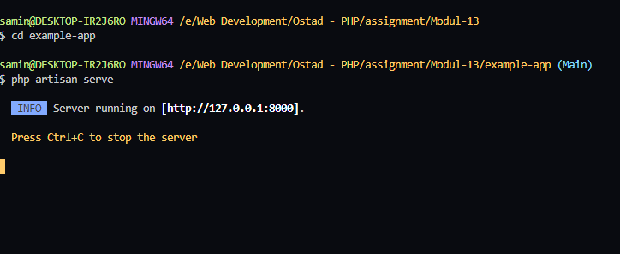

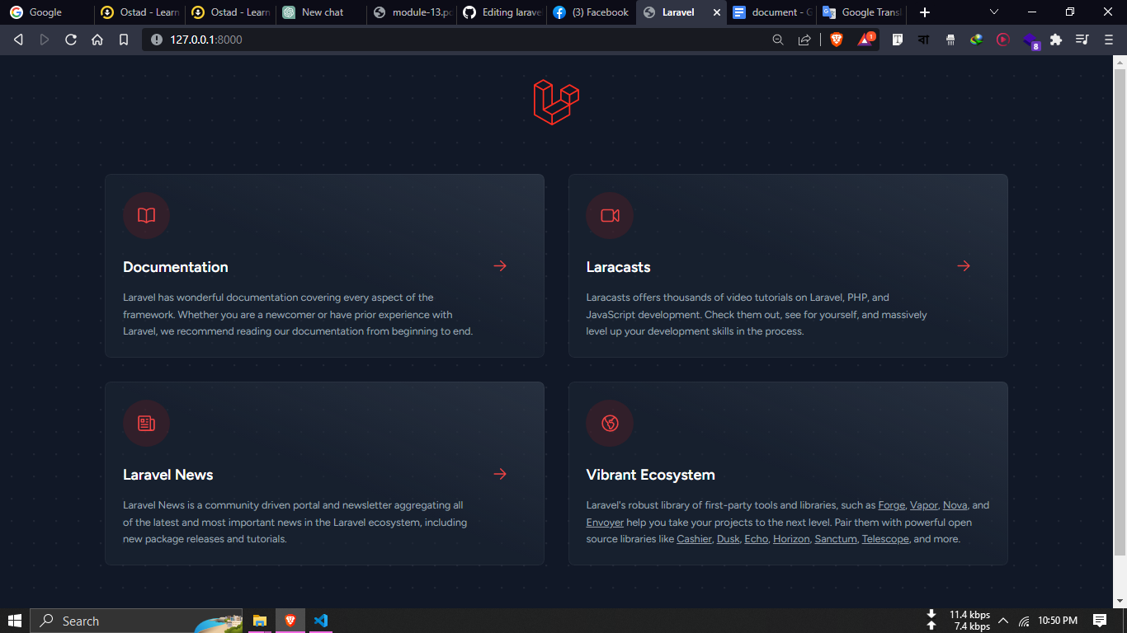

Part: 2

Purpose of each of the following folders in a Laravel project:

**app**: This directory contains the core Laravel application files, including the config, database, Http, and Providers subdirectories.

**bootstrap**: This directory contains the app.php file, which is the starting point for the Laravel application.

**config**: This directory contains the configuration files for the Laravel application, including app.php, database.php, and mail.php.

**database**: This directory contains the database migration files and seeders for the Laravel application.

**public**: This directory contains the publicly accessible files for the Laravel application, including the index.php file and any assets like images, stylesheets, or JavaScript files.

**resources**: This directory contains the views, language files, and assets that will be compiled and used by the Laravel application.

**routes**: This directory contains the route definitions for the Laravel application.

**storage**: This directory contains the application's logs, cached files, and any other files that should not be publicly accessible.

**tests**: This directory contains the test files for the Laravel application.

**vendor**: The "vendor" folder in Laravel stores all the third-party libraries and packages used in your project. It's created when you install these dependencies using Composer. This folder is important because it houses the code your application relies on but didn't write yourself.

I create a new route that shows a simple simple "Hello, World!" message

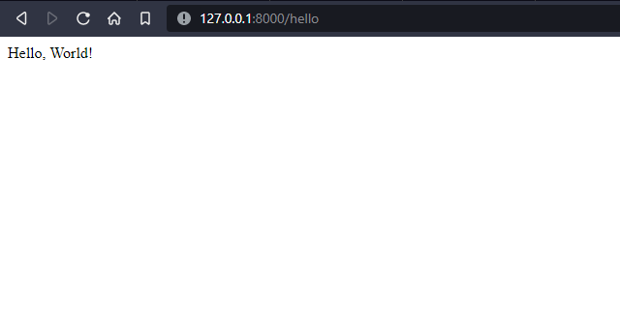

About completing the assignment

First, I install Laravel on my computer Then I push it on the github repository. After that, I create a route. Then Write the document and again push it my GitHub repository.