
AMERICAN INTERNATIONAL UNIVERSITY-BANGLADESH
Faculty of Science and Technology
Department of Computer Science
CSC 3215: Web Technologies

Semester: Summer 2025-26 | Group No: 03 |  | Section:AA

Group Members:
SL. | Student ID | Name | Role | Signature
1 | 23-51018-1 | SAMIN TASNIMA TISHA | Group Leader | TISHA
2 | 22-49245-3 | MOST.JENIFA AKTER | Member | JENIFA
3 | 22-49251-3 | FARIHA MEEM | Member | FARIHA
4 |  |  | Member
Project Title
Hospital Management System (HMS)

Prepared for CSC 3215: Web Technologies

Contents
- Project Title 1
- Short Description 1
- Introduction 1
- Background Study 2
- Users and Functional Requirements 2
- Non-Functional Requirements 4
- ER Diagram and Database Design 4
- Use Case Diagram 6
- UI (Figma/Sketch) 9
- System Architecture and Technology 13
- Data Validation and Security Plan 14
- Implementation and Validation Plan 15
- Expected Outcome 16
- Conclusion 16

1 Project Title
Hospital Management System (HMS)

2 Short Description
The Hospital Management System is a PHP/MySQL web application that coordinates hospital administration, clinical documentation, patient services, and front-desk operations. It provides four role-based workspaces: Admin, Doctor, Patient, and Receptionist. The project brings appointments, weekly doctor availability, patient queues, prescriptions, medical history, invoices, payments, doctor reviews, notices, queue alerts, and wheelchair-assistance requests into one application.
The supplied code is the implementation baseline for this proposal. It uses a front controller, procedural models and controllers, server-rendered views, custom CSS, and JavaScript/AJAX. The proposed work consolidates these modules into a demonstrable academic system and identifies validation and security improvements needed before any real deployment.

3 Introduction

3.1 Problem Statement
The project addresses a hospital workflow in which registration, appointment scheduling, clinical notes, billing, and service coordination are handled separately. Such a workflow makes it difficult to maintain a consistent patient record, communicate appointment status, track collections, and determine responsibility for changes. A shared system should connect these activities without giving every user unrestricted access.

3.2 Proposed Solution
HMS assigns operational responsibilities to four roles. Patients request appointments and inspect their own records. Doctors maintain schedules and document care. Receptionists coordinate patient registration, queues, invoices, collections, and assistance. Administrators maintain user accounts, notices, payment records, and revenue reports. Shared identifiers connect the records, while rolespecific navigation keeps each workspace focused.

3.3 Project Objectives
- Centralize user, appointment, clinical, billing, and assistance data in one database.
- Provide registration for permitted roles, authenticated access, and role-specific dashboards.
- Support doctor discovery, appointment requests, queue handling, and treatment records.
- Track invoice balances and recorded payments, with date-filtered revenue reporting.
- Include patient feedback, administrative notices, queue alerts, and wheelchair coordination.
- Validate workflows and strengthen authorization, integrity, and session handling.

3.4 Scope
The baseline is a single-hospital academic prototype. Payment entries, including those labelled online, are stored locally; there is no external payment-gateway integration. Pharmacy inventory, laboratorydevice integration, insurance claims, inpatient bed allocation, multi-branch synchronization, and SMS/email delivery are outside the initial scope. Medical-history categories such as lab describe records, not a complete laboratory-management module.

4 Background Study
This proposal uses a workflow comparison and a review of the supplied application, rather than claiming a survey or measured evaluation of external hospital products. The original proposal establishes the academic structure; the source code clarifies which features and data relationships are actually represented.
Area | Fragmented workflow scenario | HMS response
Appointments | Separate schedules with limited status visibility. | Doctor search, weekly availability, requests, and status tracking.
Clinical records | Notes are disconnected from patient identities. | Patient-linked prescriptions and medical-history records.
Patient flow | Queue position and assistance are handled informally. | Doctor/date queues, priority labels, alerts, and wheelchair requests.
Billing | Invoices and collections are tracked separately. | Linked invoice/payment records and remaining balances.
Administration | Account changes and announcements lack a central workspace. | User management, notices, activity logs, and reports.
Feedback | Comments are not associated with doctors. | Doctor reviews with a 1–5 rating and optional written feedback.
- Users and Functional Requirements
5.1 Types of Users
Role | Primary responsibility
Admin | Maintain users, notices, payments, logs, and revenue visibility.
Doctor | Maintain availability, review appointments/queues, and document care.
Patient | Request appointments and access personal records, bills, and reviews.
Receptionist | Handle registration, appointments, queues, billing, and assistance.

5.2 Common Access Features
- C1—Authentication: sign in with username or email and password; reject inactive accounts at login; log out of the session.
- C2—Registration: patients, doctors, and receptionists can self-register in the supplied code; public admin registration is not offered.
- C3—Dashboard and navigation: redirect signed-in users to their role dashboard and display role-specific menu items.
- C4—Interaction: provide form feedback, search/filter controls where implemented, CSRF tokens, and periodically refreshed dashboard statistics.
Self-service profile editing, password change/recovery, and account-deletion requests do not have dedicated routes. They are future enhancements, not common baseline features. Staff self-registration requires a proposed approval step before operational use.

5.3 Admin Features
A1 Add, view, search, edit, delete, and activate/deactivate doctors, patients, and receptionists. A2 Create, search, edit, and delete notices with audience, priority, expiry, and active status. A3 Add, search, view, edit, and delete payments. A4 View date-filtered revenue reports calculated from payments. A5 Search/filter activity logs and inspect dashboard summaries.

5.4 Doctor Features
- D1—Availability: add, edit, and delete weekly schedules with day, start/end time, maximum patients, and availability flag.
- D2—Appointments: search/view appointments and update status to confirmed, completed, cancelled, or no-show.
- D3—Queue and patients: inspect the doctor’s queue, update queue status, and search patients associated with appointments.
- D4—Prescriptions: add, view, search, edit, and delete records containing diagnosis, medicines, dosage instructions, and notes.
- D5—Medical history: add, view, search, edit, and delete dated records categorized as diagnosis, lab, surgery, allergy, vaccination, or other.

5.5 Patient Features
- P1—Doctor discovery: search active doctors by name or specialization and view availability and rating summaries.
- P2—Appointments: submit a date/time request, view appointment status, and cancel an own pending or confirmed appointment.
- P3—Clinical information: view personal medical history and view/search personal prescriptions.
- P4—Billing: view personal invoices, balances, and payment history; record a self-payment against an own invoice within the remaining balance. This is a demonstration, not gateway-verified payment.
- P5—Reviews: create, edit, delete, and search own doctor reviews; display 1–5 ratings and feedback. An appointment link is optional in the schema.

5.6 Receptionist Features
- R1—Patient records: register, view, search, edit, and delete patient accounts and additional profile data.
- R2—Appointments: create, search, update, and delete appointments, including confirmation and cancellation.
- R3—Queue: add/search/delete entries and update status; assign queue numbers by doctor and date and mark normal/urgent priority.
- R4—Billing: create, search, view, edit, and delete invoices; add, view, search, and delete payment collections.
- R5—Queue alerts: create, search, update, and delete call, reminder, delay, or custom alert records. A stored sent status does not establish external delivery.
- R6—Wheelchair assistance: create, search, update, and delete requests with location, date, assignment, and completion status.

5.7 Business Rules and Status Values
Record | Status values in the supplied schema
Appointment | pending, confirmed, completed, cancelled, no-show
Queue | waiting, called, in-progress, completed, skipped
Invoice / prescription | unpaid, partial, paid, cancelled / active, completed, cancelled
Alert / wheelchair | new, sent, dismissed / requested, assigned, completed, cancelled
These are allowed values, not a fully enforced transition sequence. Patient bookings begin as pending. Availability is displayed, but schedule/capacity checks and duplicate-slot prevention require implementation. Revenue is derived from payments, not issued invoices.

6 Non-Functional Requirements
The following are acceptance targets, not measured results or claims of production readiness.
Requirement | Target and verification approach
Security and privacy | Verify role and record ownership on protected reads/writes and AJAX responses. Reject forged actions; use synthetic patient data for testing.
Usability | Use consistent navigation, labelled inputs, readable status badges, and actionable validation messages; complete representative tasks with each role.
Performance | Target common list/dashboard responses within three seconds on the agreed local test machine and demonstration dataset; record measurements.
Reliability | Prevent duplicate bookings/queue numbers and preserve invoice-payment integrity through constraints and transactions.
Maintainability | Separate routing, controllers, models, views, assets, and configuration; document setup and reproducible tests.
Compatibility | Verify login, tables, forms, and navigation in desktop and mobile-width browser layouts.
Recovery | Export the database before demonstrations and prove a clean database can be restored from backup.

7 ER Diagram and Database Design

7.1 Schema Conventions
The supplied database.sql defines 14 tables. All roles are stored in users; only patients have a separate additional-profile table. There are no separate admin, doctor, receptionist, or diagnosis tables. Diagnosis appears in prescriptions and in categorized medical-history records.
Identifier rule: operational patient_id and doctor_id values refer logically to users.id, not patients.id. The latter is the extra-profile row’s primary key, linked through unique patients.user_id.
Table group | Tables and purpose
Identity and scheduling | users, patients, doctor_availability, appointments: accounts, patient details, weekly schedules, and visits.
Clinical and feedback | prescriptions, medical_history, doctor_reviews: treatment documentation and patient feedback.
Front-desk coordination | queue, queue_alerts, wheelchair_requests: patient flow, alert records, and assistance.
Finance | invoices, payments: charges, balances, collections, and revenue inputs.
Administration | notices, activity_logs: announcements and recorded actions.
The diagrams show logical relationships derived from application joins and identifier fields. The SQL declares primary keys, unique keys, and indexes, but no FOREIGN KEY constraints. Displayed references are therefore not database-enforced referential integrity. PK denotes a primary key, UQ a unique value, REF a logical reference, and ? a nullable reference. Arrows run from parent to dependent; other multiplicities are stated in the notes.

7.2 ER Diagram: Identity, Scheduling, and Clinical Records
users
PK id; UQ username, email
password, full_name, role, status
phone, address, gender,
date_of_birth
specialization, timestamps
patients
PK id; UQ REF user_id
blood_group, emergency_contact
allergies, created_at
doctor_availability
PK id; REF doctor_id
→
users
day_of_week, start_time, end_time
max_patients, is_available
appointments
PK id; REF patient_id, doctor_id
REF? created_by
→
users
appointment_date, appoint-
ment_time
reason, status, notes
prescriptions
PK id; REF patient_id, doctor_id
REF? appointment_id
diagnosis, medicines,
dosage_instructions
prescribed_date, status, notes
doctor_reviews
PK id; REF doctor_id, patient_id
REF? appointment_id
rating, review, status, created_at
medical_history
PK id; REF patient_id
REF? doctor_id
→
users
record_type, title, description
record_date, attachment
patient profile
1 : 0..1
1 : 0
..N
patient/doctor/creator
..N
1 : 0
1: 0
..N
Relationship interpretation
- A patient user may have one additional patients row. A doctor user can have many weekly availability rows; patient and doctor users can participate in many appointments.
- Prescriptions, reviews, and history also reference patient/doctor users. These user links are recorded inside the boxes to keep the diagram readable.
- A prescription or review may optionally reference one appointment; an appointment can be referenced by many such rows. Medical history has no appointment_id field.
- Availability is not directly linked from appointments. Proposed booking validation must match the requested date/time to the doctor’s weekly schedule.

7.3 ER Diagram: Finance, Queues, and Administration
appointments (reference)
PK id
Patient and doctor users identify the
visit.
users (reference)
PK id
Patients, doctors, creators, collectors,
assignees, and logged actors.
queue
PK id; REF? appointment_id
REF patient_id, doctor_id
→
users
queue_number, queue_date, priority
status, called_at, completed_at
invoices
PK id; UQ invoice_number
REF patient_id; REF? created_by
REF? appointment_id
amount, tax, discount, total_amount
status, due_date, description
queue_alerts
PK id; REF queue_id
REF patient_id, doctor_id
REF? created_by
→
users
message, alert_type, status
payments
PK id; REF invoice_id, patient_id
REF? received_by
→
users
amount, payment_method
transaction_ref, payment_date, notes
wheelchair_requests
PK id; REF patient_id
REF? appointment_id
REF? assigned_to, created_by
request_date, location, notes, status
notices
PK id; REF created_by
→
users
title, content, target_role, priority
is_active, expires_at, created_at
activity_logs
PK id; REF? user_id
→
users
action, details, ip_address
user_agent, created_at
1 : 0
..N
..N
1: 0
..N
1 : 0
..N
1 : 0
Additional relationships: patient/doctor, creator, collector, and assignee references point to users.id; one user may be referenced by many records. Each alert belongs logically to one queue entry and each payment to one invoice. Optional appointment links allow a queue entry, invoice, or wheelchair request to exist without an appointment. They do not impose a one-record-perappointment restriction.

8 Use Case Diagram
Related use cases are grouped for readability. Actors share sign-in, sign-out, and role-dashboard access. Each association denotes participation, not permission to access another user’s records.
Hospital Management System
Admin
Doctor
Patient
Receptionist
Manage users and notices
Manage payments; view
revenue and activity logs
Manage availability, ap-
pointments, and queue
Review patients; manage
prescriptions and history
Browse doctors; re-
quest/cancel appoint-
ments; review doctors
View own clinical/billing
records; record demo payment
Manage patients, appoint-
ments, queues, and alerts
Manage invoices, collections,
and wheelchair requests
Common to all four actors:
Sign in / Sign out /
View role dashboard
Registration exception: patient, doctor, and receptionist registration is public in the baseline. Admin registration is not. A staff-approval workflow is a planned restriction.

8.1 Key Use Case Descriptions
Use case /  actor | Precondition and main flow | Result / exception
UC1: Sign in /  All | Submit username/email and password; validate credentials and active status. | Session identifies the user and role; invalid credentials/inactive accounts are rejected.
UC2: Request appointment / Patient | Sign in, find a doctor, inspect schedule, enter date/time and reason, and submit. | Record a pending appointment. Reject past dates; conflict/capacity validation is planned.
UC3: Document care / Doctor | Open relevant patient information; create a prescription or dated history record. | Store treatment information; strengthen server-side record-ownership checks.
UC4: Manage queue /  Receptionist,  Doctor | Receptionist adds a patient to a doctor/date queue; staff or doctor updates status. | Record queue number/state; atomic number allocation is a planned safeguard.
UC5: Issue invoice / Receptionist | Select patient, optionally link appointment, enter amount, tax, discount, and due date. | Store total and status; payment records are linked separately.
UC6: Record payment / Staff,  Admin, Patient | Select invoice and enter amount/method; check own invoice balance for patient payment. | Store payment and recalculate invoice status; no gateway verification occurs.
UC7: Review doctor / Patient | Select doctor, provide 1–5 rating and optional review/appointment link. | Store feedback and show rating summaries patient updates/deletes require review ownership.
UC8: Coordinate assistance / Receptionist | Register wheelchair request with patient, date, location, and optional assignment. | Track requested, assigned, completed, or cancelled state.
;

8.2 Illustrative End-to-End Scenario
- A patient registers and signs in. A doctor maintains a weekly availability schedule.
- The patient submits an appointment request. The doctor or receptionist confirms it.
- On arrival, the receptionist adds a queue entry and records any required alert or wheelchair assistance.
- The doctor updates the queue, documents history, and issues a prescription. The appointment is marked completed when appropriate.
- The receptionist creates an invoice and records a collection. The patient views bills and clinical records; the admin reviews payment-derived revenue.
These are coordinated user actions across modules, not an assertion that every step automatically creates or updates the next record.

9 UI (Figma/Sketch)
The following screens are exported Figma designs for the login, registration, and role-based dashboard views, shown alongside low-fidelity sketches for the remaining flows. Values shown are illustrative, not real patient data.
9.1 Public Login and Registration

Sign In – Desktop
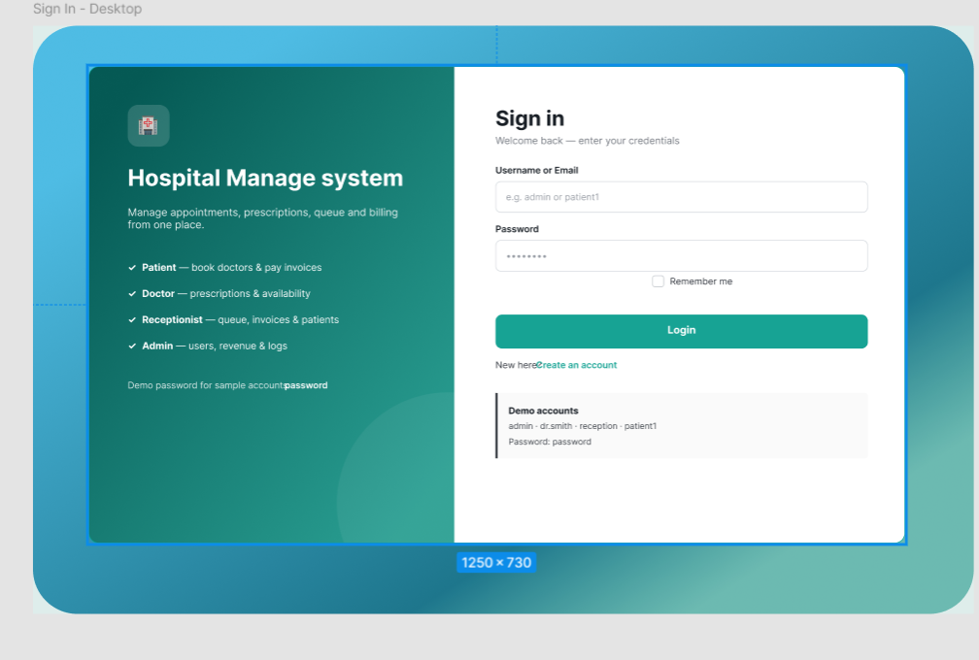

Sign Up – Desktop
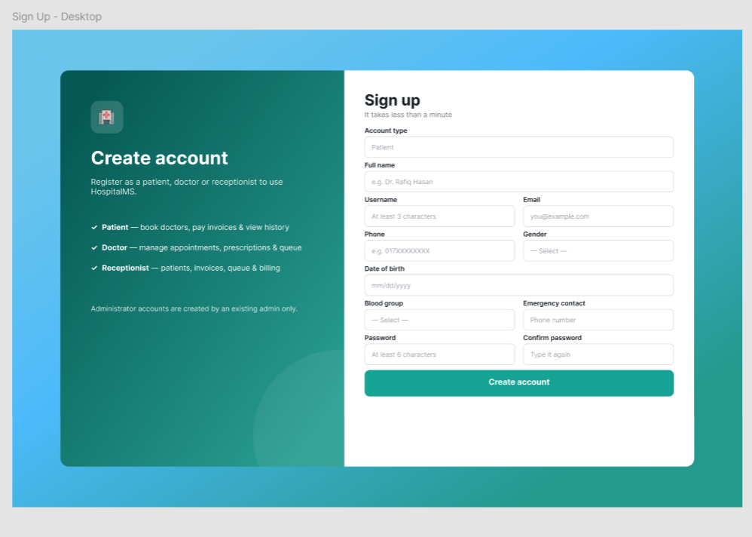

Username/email availability checks use AJAX. The login template includes remember-me, but the source does not implement a complete persistent-login token validation flow. Password recovery and self-service profile pages are not baseline features.

9.2 Role-Based Dashboard Pattern
Admin Dashboard – Desktop
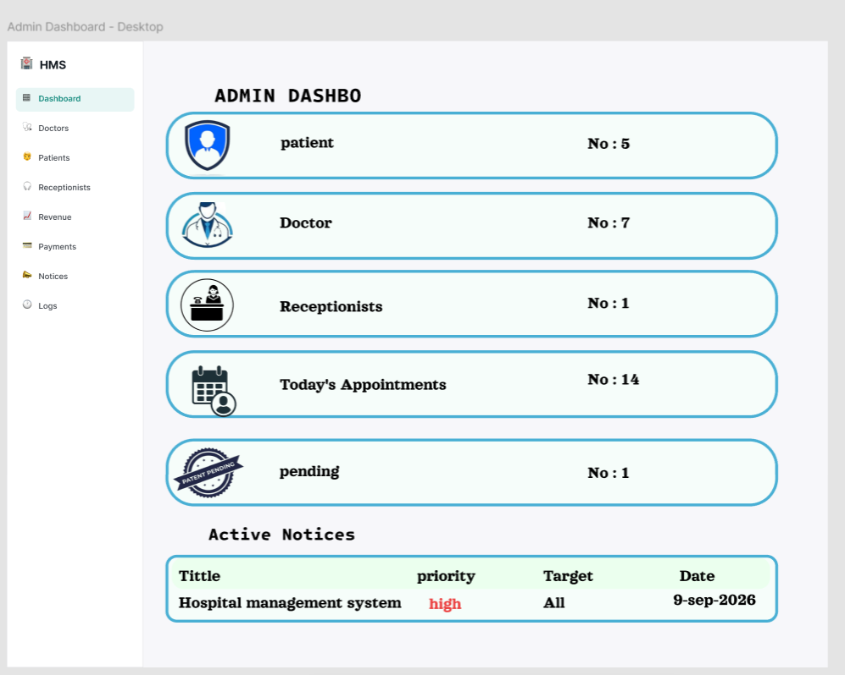

Dashboard Concept – Dark Surgical
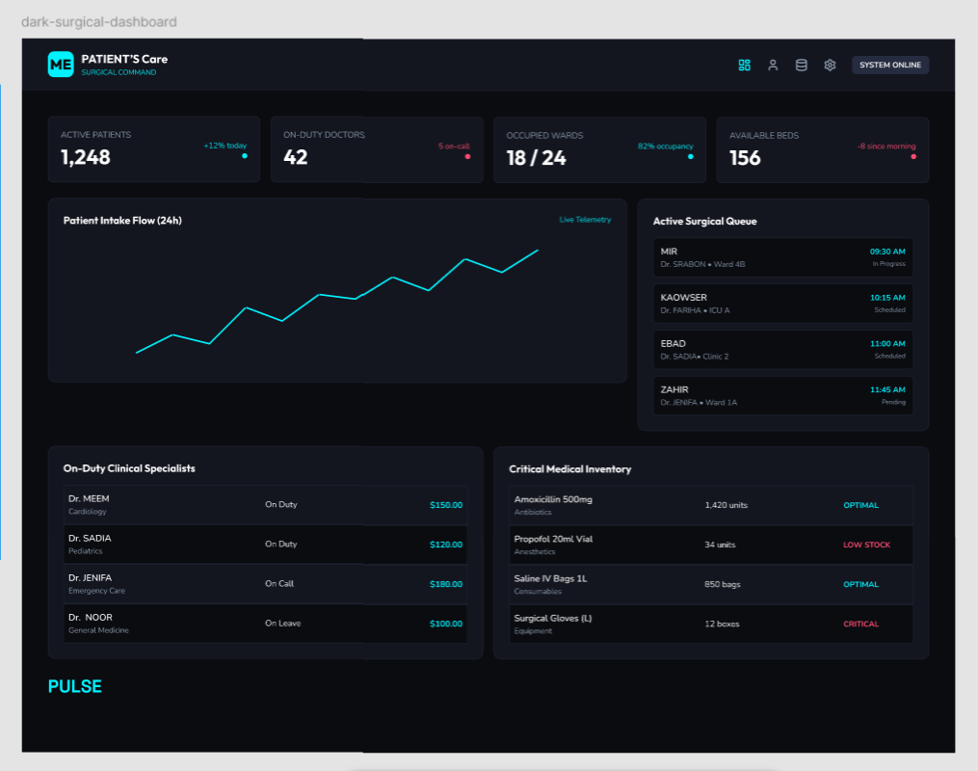

Dashboard Concept – Neo-Brutalist
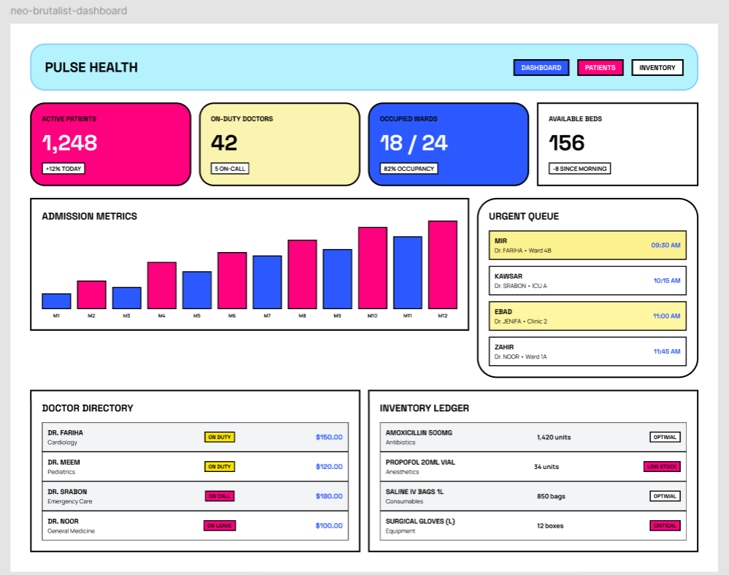

JavaScript requests refreshed statistics every 30 seconds where dashboard elements carry the data-stat attribute. Role-specific navigation determines which modules are visible.

9.3 Appointment Request Screen
PATIENT | Find & Book Doctors
Search by name or specialization
SEARCH
Doctor name
Specialization
Contact information
Average rating / review count
Availability: Monday 09:00–13:00
Book Appointment
Date: [date input]
Time: [time input]
Reason: [free-text field]
SUBMIT REQUEST
The actual view accepts a date and time, not a generated list of guaranteed free slots. Schedule-aware slot selection is a proposed enhancement.

9.4 Front-Desk Queue and Assistance Pattern
RECEPTIONIST | Queue / Alerts / Wheelchair
Date [filter]
Doctor [filter]
Search [text]
ADD
No.
Patient
Doctor
Priority
Status
Actions
001
Example
Doctor A
Normal
Waiting
Update
Related screens maintain alert messages and assistance assignments.

9.5 Module Navigation by Role
Role | Main navigation destinations
Admin | Dashboard, users, revenue, payments, notices, activity logs.
Doctor | Dashboard, appointments, queue, patients, prescriptions, history, availability.
Patient | Dashboard, doctors/availability, reviews, appointments, prescriptions, history, payments.
Receptionist | Dashboard, patients, appointments, queue, queue alerts, wheelchair, invoices, payments.

10 System Architecture and Technology
10.1 Application Architecture
Web browser
HTML forms, custom CSS, JavaScript, Fetch/AJAX
Front controller: index.php?page=...
Route lookup, session checks, and controller dispatch
Role controllers and shared helpers
Validation, role checks, CSRF checks, flash messages, activity logging
Models and views
Procedural database functions; server-rendered pages / JSON responses
MySQL / MariaDB via MySQLi
Fourteen InnoDB tables in the hospital_management database
Requests move down the layers; HTML or JSON returns to the browser. This is an MVC-style procedural application, not a framework-based REST service.

10.2 Technology Stack
Component | Responsibility in the supplied project
HTML and custom  CSS | Forms, navigation, cards, tables, badges, and responsive presentation.
JavaScript / Fetch | Client-side validation, registration availability checks, AJAX helpers, and dashboard polling.
PHP | Sessions, routing, controllers, validation, models, templates, and JSON output.
MySQLi +  MySQL/MariaDB | Procedural queries and persistent relational records using utf8mb4.
XAMPP / Apache | Intended local demonstration environment described by the README.
Font Awesome | Icon stylesheet referenced from a CDN by the shared header; offline demonstrations need a local copy or may omit icons.

10.3 Project Organization
index.php is the entry point; config/database.php supplies connection and query helpers. controllers/ contains authentication, role, and AJAX handlers. models/ contains domain data functions; views/ contains role folders and shared partials. assets/css/style.css and assets/js/app.js provide presentation and interaction. Schema and sample data are in database.sql.

11 Data Validation and Security Plan

11.1 Controls Present in the Code Baseline
The source contains PHP password hashing/verification, session-based login, role-check helpers, CSRF token generation/validation, HTML escaping helpers, field validation, and activity-log writes for selected actions. Patient-facing clinical and billing lists are filtered by the logged-in patient. These mechanisms provide a starting point, not complete authorization coverage or a production security guarantee.

11.2 Required Hardening Before Deployment
- Database access: replace escaped/interpolated SQL with prepared statements. The current helper uses mysqli_query; parameterized queries are not already implemented.
- Record-level authorization: verify ownership and care relationships on reads, edits, deletes, and status changes, including direct IDs and AJAX endpoints. A role check alone is insufficient.
- Session controls: regenerate the session ID after login, enforce inactivity timeout, use secure cookie settings under HTTPS, and implement or remove incomplete remember-me functionality. Configuration constants alone do not prove enforcement.
- Account provisioning: approve doctor/receptionist registrations, re-check account status on protected requests, and replace shared sample credentials. Add rate limiting and a tested password-recovery workflow if recovery is included later.
- Scheduling and integrity: validate doctor identity, availability, date/time, patient limits, and conflicts server-side. Add reference constraints, safe deletion policies, and transaction-protected queue-number allocation.
- Billing: enforce positive amounts, allowed methods, invoice ownership, consistent invoice/patient links, cancellation rules, and overpayment checks across every role. Perform payment/status updates transactionally.
- Privacy and accountability: restrict AJAX response data, protect logs, and record important changes consistently. An attachment column is not a secure upload feature; any future upload flow requires a separate design.

11.3 Financial Rules
The invoice model treats tax and discount as entered amounts, not percentages:
Invoice total = Amount + Tax − Discount.
Remaining balance = Invoice total −^{X}Recorded payments.
Payment create/update/delete operations call invoice-status recalculation. Test partial, full, cancelled, and invalid-payment cases. Admin revenue reports aggregate payments.amount with date filtering; they do not establish gateway-settled funds.

11.4 Limits of the Baseline
No security audit, workload benchmark, or live hospital trial is claimed. Availability enforcement, staff approval, password recovery, external payments, externally delivered notifications, and comprehensive audit coverage remain planned improvements.

12 Implementation and Validation Plan

12.1 Proposed Completion Sequence
The schedule is relative to project approval, not a claim of completed development dates.
Period | Work package | Deliverable
Week 1 | Import database; verify routes, sample data, and role workflows. | Reproducible local setup and issue register.
Week 2 | Strengthen authorization, sessions, staff approval, and queries. | Hardened authentication and data-access paths.
Week 3 | Validate scheduling, queue concurrency, payments, and integrity. | Correct rules and regression checks.
Week 4 | Run acceptance tests, responsive checks, and backup restoration. | Demonstration, evidence, and documentation.

12.2 Acceptance Test Matrix
All cases below are planned tests; no execution result is asserted in this proposal.
ID | Scenario | Expected acceptance result
T01 | Login and inactive account | Correct dashboard on valid login; reject invalid/inactive access; verify session rotation after hardening.
T02 | Registration and approval | Reject duplicates/invalid fields; block unapproved staff after implementing approval.
T03 | Cross-role/record requests | Deny unauthorized URLs, object IDs, updates, and AJAX access for every role.
T04 | CSRF and output handling | Reject absent/invalid tokens on state changes; render injected markup as inert text.
T05 | Appointment scheduling | Accept eligible requests; reject past/out-of-schedule, full, and conflicting bookings after validation is added.
T06 | Clinical-record ownership | Allow authorized actions; patients see only own data; deny foreign-record modification.
T07 | Queue and concurrency | Update allowed states; create unique doctor/date queue numbers under concurrent requests.
T08 | Invoice/payment lifecycle | Verify total, partial/full payment, deletion recalculation, cancellation, and overpayment rejection.
T09 | Reviews | Enforce rating 1–5 and review ownership; verify search and rating summaries.
T10 | Notices, alerts, wheelchair | Verify filters, audience/expiry handling where displayed, alert states, and assistance assignment/completion.
T11 | Reports and polling | Reconcile revenue with payment rows; verify periodic statistics refresh.
T12 | Layout and recovery | Check narrow/wide layouts, measure response times, and successfully restore a database export.

12.3 Demonstration Setup
Place the application under the local web server’s document directory, start Apache and
MySQL/MariaDB, import database.sql, configure config/database.php, and open the application’s index.php. Use a disposable database and synthetic users. Confirm sample credentials against seed data rather than conflicting seed comments, then replace them. This proposal is based on static inspection; the PHP/MySQL application was not executed during document preparation.

13 Expected Outcome
The project should deliver a coherent academic demonstration of four users collaborating through a shared hospital-management application. The expected operational result is a traceable sequence from registration and appointment request to queue handling, clinical documentation, billing, and recorded collection, with administrative oversight and supporting service requests.
The final project deliverables are:
- a PHP/MySQL application with role-specific modules and reproducible database setup;
- an accurate data model covering all fourteen tables and logical relationships;
- tested appointment, clinical, queue, invoice, payment, review, and assistance workflows;
- documented validation/security improvements and acceptance-test evidence;
- a project proposal, editable source, and role-based demonstration guide.
Success will be assessed against the acceptance matrix rather than assumed reductions in waiting time or error rates. Operational benefits are intended outcomes; controlled evaluation would be needed to quantify them.

14 Conclusion
The Hospital Management System connects patient services, clinical work, front-desk operations, and administration in a focused Web Technologies project. Its supplied implementation represents appointments, weekly availability, prescriptions, history, invoices, payments, reviews, queues, alerts,
wheelchair requests, notices, and logs.
This revised proposal aligns functional requirements, ER diagrams, use cases, interface sketches, and architecture with the source code. It distinguishes present modules from proposed hardening and future features. The result supports academic implementation and demonstration while recognizing the additional work required for reliable real-world use.

End of Project Proposal

