How to run the program?

First of all, we need to install OpenCV for segmentation

Panda for reading the CSV files for preparing the Dataset of EMNSIT, TensorFlow and keras for building the CNN Model, SciPy for Calculating the center of Mass of a given image, NumPy for Complex Algebra and arrays calculations and Tkinter for GUI.

The dataset used is the EMNIST.

In the CMD we have to type the Python App.py in order to open the GUI and draw a text in order to filter the letters from it and gives the output only the digits, or we can upload an image from a folder and detect it.

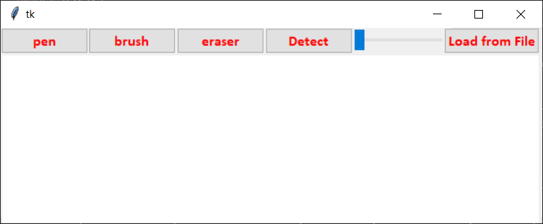

Pen or brush is to draw, eraser to delete what have been drawn, Detect is to recognize the text, in other words: segment into lines and chars then insert each one into the CNN, if its label 10 (anything that is not a digit) then filter it, if it’s a digit then put it as output. The algorithm also can calculate if there is a distance space between digits, the slider is the font size, and load from file is to recognize from a file and not by drawing.

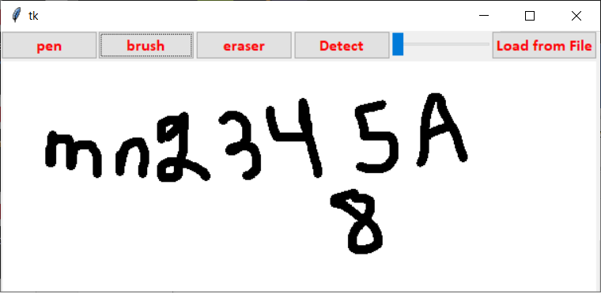

Output:

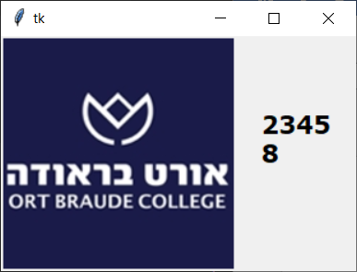

Test the app.py with the image seg.png

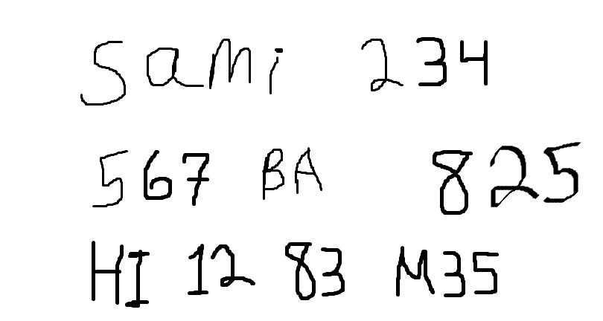

And the results will be:

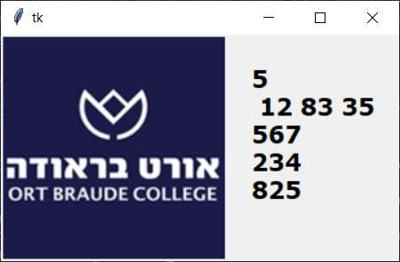

Since the Dataset is not included, we have to rename the files of the dataset of EMNIST to these names and save them in a new Folder Manage_Data/English related to the project folder:

