# List of Figures

Figure 1 10

Figure 2 11

Figure 3 11

Figure 4 12

Figure 5 12

Figure 6 12

Figure 7 13

Figure 8 13

Figure 9 14

Figure 10 14

Figure 11 15

Figure 12 16

Figure 13 16

Figure 14 16

Figure 15 16

Figure 16 16

# List of Tables

Table 1: Database 9

# Index

1. List of Figures 1

2. List of Tables 2

3. Index 3

4. Introduction 4

4.1 Overview of Project 4

4.2 Scope of Project 4

4.3 Purpose of Project 4

5. Hardware and Software Requirement 5

6. Main Modules of Project 6

6.1 User Management 6

6.2 Home Page (Navigation) 6

6.3 Submit Idea 6

6.4 Get List of Registered Users & Join WhatsApp Group of E-Cell UVPCE 6

6.5 Contact E-Cell UVPCE 6

7. System Flow Chart of Implementation 7

8. Data Dictionary 9

9. Implementation Details with snap shot 10

10. Further Enhancement 17

# Introduction

## **4.1 Overview of Project**

The Business Incubator helps young entrepreneurs to connect with other entrepreneurs of U. V. Patel College of Engineering. The Business Incubator application can help students to directly connect to E-Cell UVPCE. It can also be helpful to connect with other registered users as well.

## **4.2 Scope of Project**

Using this application students can directly connect with E-Cell UVPCE. It can also be helpful to connect with other student entrepreneurs and ask for help whenever required. The E-Cell can keep a track of students registered in their application how they are working among each other

## **4.3 Purpose of Project**

Many a times, students with innovative idea don’t find a platform or proper contact to whom he can explain it and implement it. Not all the students have all skills required to implement their idea. On submitting their idea through this application, student can get possible help from E-Cell.

Registered users can contact each other and ask for help if they need. For example, sometimes it happens that a person with coding skills need to work on project, but he/she might not be having any idea on what to work. And on other hand who has an idea of great application, but not comfortable with coding. So that type of students can find each other on this application and work together.

Even the E-Cell can keep the track of ideas they received and interested students. Students can join WhatsApp group of E-cell UVPCE through this application. E-Cell can contact all registered users via that group. Students can go to Facebook page and get all the updates of E-Cell UVPCE through this application.

# 5. Hardware and Software Requirement

* An android smart phone with android version minimum 7.0 i.e. the Nougat version.
* Maximum android versions 8.0 i.e. Oreo
* A Firebase Account
* Android Studio
* A working desktop/laptop with minimum 8 GB ram

# 6. Main Modules of Project

## **6.1 User Management**

A login/register page is basically first module of every project. It authenticates the user and allows him/her to proceed to next screen only if correct credentials are entered. On first time registering to this application, it will ask for your full name, active email ID, password which you want to set, your mobile number on which you want people to contact you (Preferred WhatsApp number), and most importantly what is your speciality i.e. on what, which field you can/want to work.

## **6.2 Home Page (Navigation)**

So this will be the first page user will see after successfully registering or logging in into the application. It provides the basic information that what business incubator is and how can it be helpful to you people. This is the only page from where user can logout from the application. On exiting from any other page, will not log out user and on next time reopening the app, this will be the page from where it will start. This page is main entry point of other activities user can perform.

## **6.3 Submit Idea**

On selecting ‘idea’, from navigation page, user will be directed to different activity, where he/she can read what it is to start a startup and how it be successful. There is button at last from where the user can submit his/her idea to E-Cell UVPCE. If it is logical and practically possible, E-Cell UVPCE will revert back to them with possible help they can provide to user.

## **6.4 Get List of Registered Users & Join WhatsApp Group of E-Cell UVPCE**

On selecting ‘users’, user can get list of other registered users along with their personal details like name, email ID, contact number and most importantly specialty of that person. User can also join WhatsApp group of E-Cell UVPCE from here and get updates provided by team E-Cell UVPCE.

## **6.5 Contact E-Cell UVPCE**

Lastly, User can directly contact team E-Cell UVPCE, via SMS or Gmail. Personal details of every team member is displayed there. Link to get updates from Facebook page is also available. And detailed location of E-Cell UVPCE i.e. New Building, UVPCE, Ganpat University is also available on single click along with direction from user’s current location.

# 7. System Flow Chart of Implementation

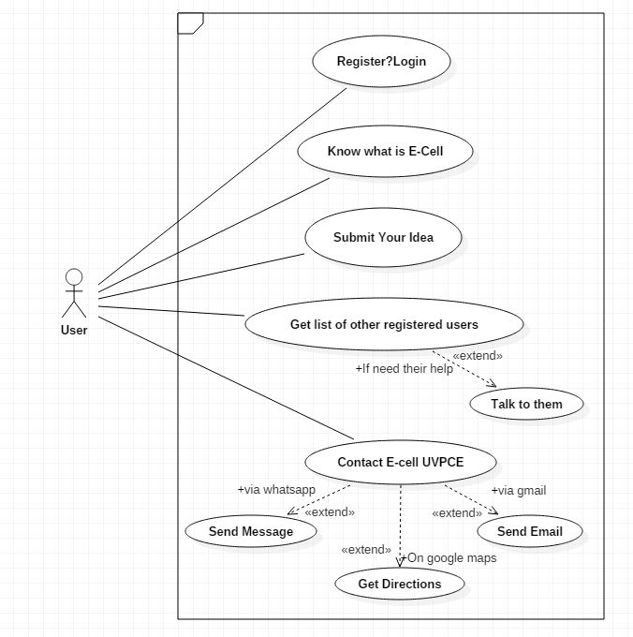

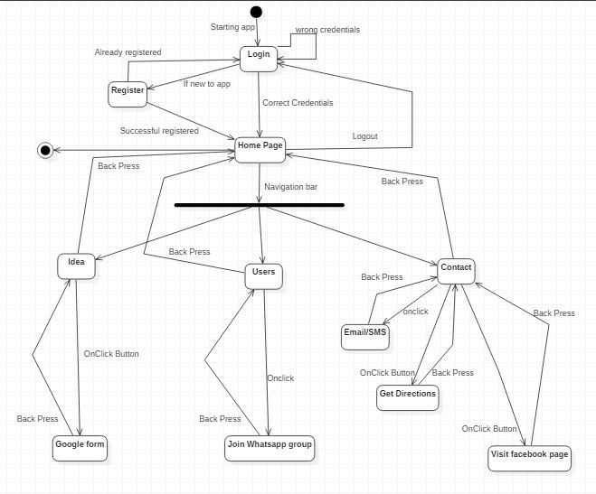

# 8. Data Dictionary

|  |  |  |
| --- | --- | --- |
| **Column Name** | **Data type** | **Description** |
| Email | String | To verify while logging in and for other users to contact. |
| Name | String | Simply for identity |
| Password | String | To maintain the security of their account. |
| Phone | String | So that other user can contact them personally if required. |
| Speciality | String | So that other users can know at what you are good. |

Table : Database

# 9. Implementation Details with snap shot

**Splash Page**

This is the first launching activity which will be displayed every time the application will be started.



Figure

**Login Page**

After splash activity, login page will be shown. It will be shown only if application is started for first time. It will be also displayed when user will logout from the application. If the user is registered and will enter correct credentials, it will proceed to home page. If user has not registered, he/she can get registered by clicking “not a member yet? Click here”. After that user will be directed to register page. On clicking “Already a member? Login here” user will be taken back to login page. Credential verification is also done using firebase authentication.

API: compile 'com.google.firebase:firebase-auth:15.0.0'

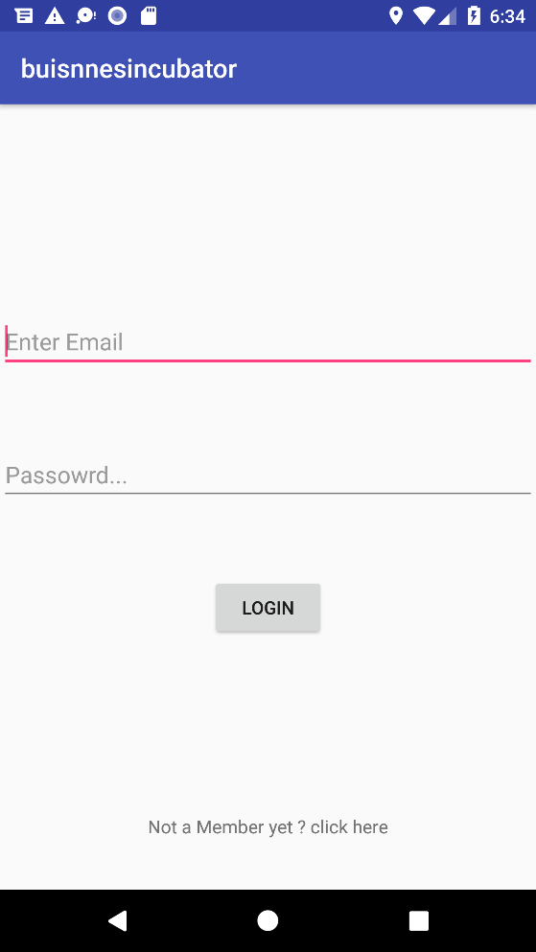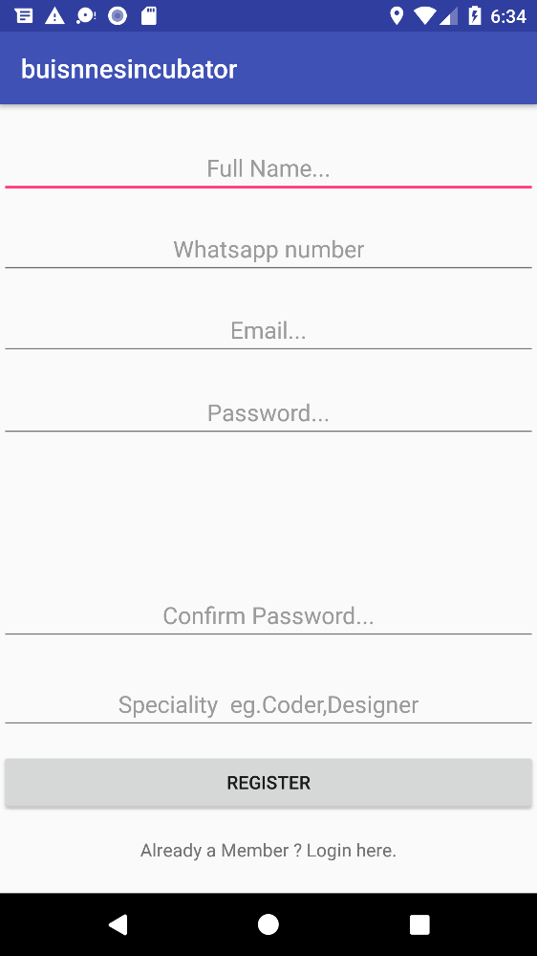

Figure

Figure

**Home Page**

This is page where user will be coming after successfully registering or entering correct credentials on login page. This page shows what business incubator is and how it can be helpful to users.

The navigation activity on left side can take users to different page while there is option menu on top right corner which has logout option. In clicking there user can successfully go to login page.

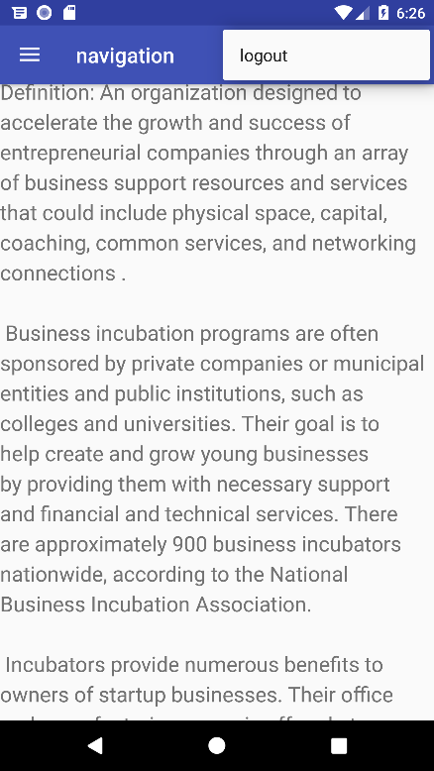

Figure

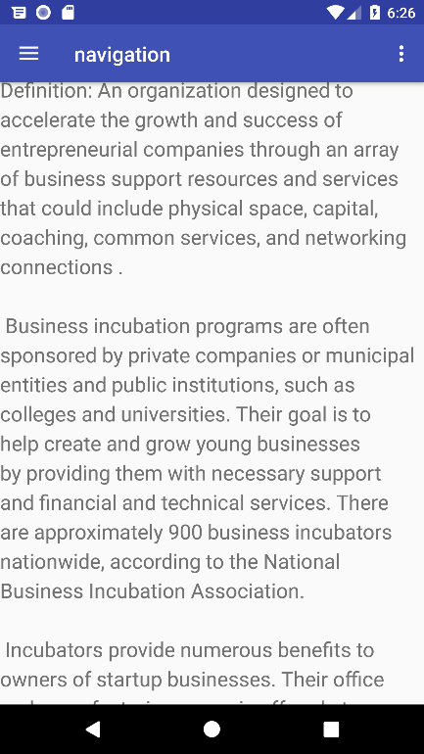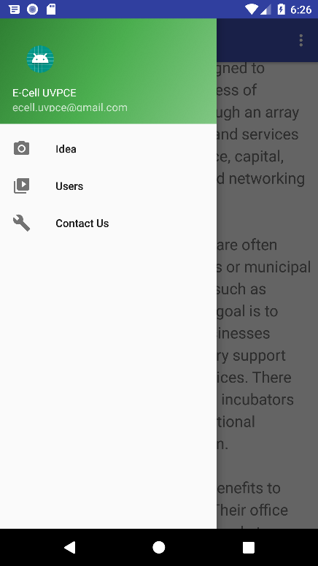

Figure

Figure

**Idea**

Here user can read simple rules of what it takes to make a successful startup. On clicking a button below the rules, user will be redirected to a google form where he/she can submit idea to team E-Cell UVPCE. Once the idea is submitted, the team will look at it and revert back accordingly with whatever help they can provide.

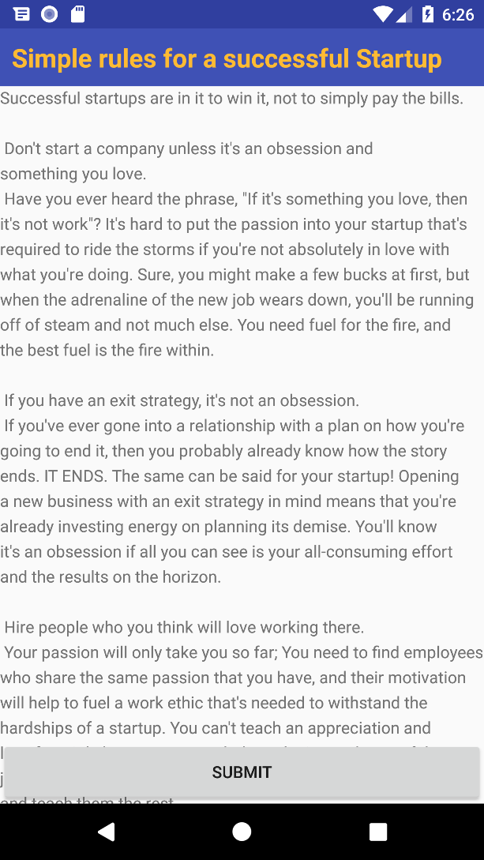 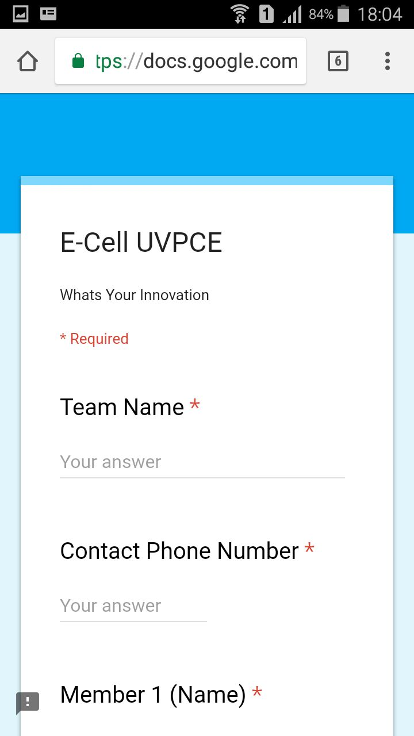

Figure

Figure

**Users**

On this page, there is list of registered users along with their contact details. User can contact them anytime and ask for help. This page is using recycler view and firebase recycler adapter method. It will be automatically updated on registering new user. There is also a text at bottom saying “ Join WhatsApp group”, on clicking that, user will be redirected to WhatsApp and they will be asked, whether they want to join E-Cell UVPCE group or not.

API: compile 'com.android.support:recyclerview-v7:27.1.1'

compile 'com.firebaseui:firebase-ui-database:3.3.0'

compile 'com.android.support:cardview-v7:27.1.1'

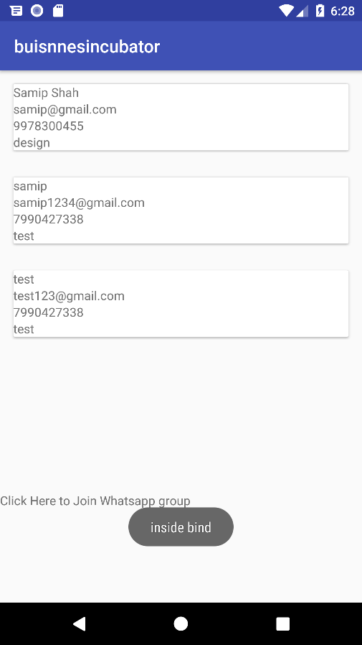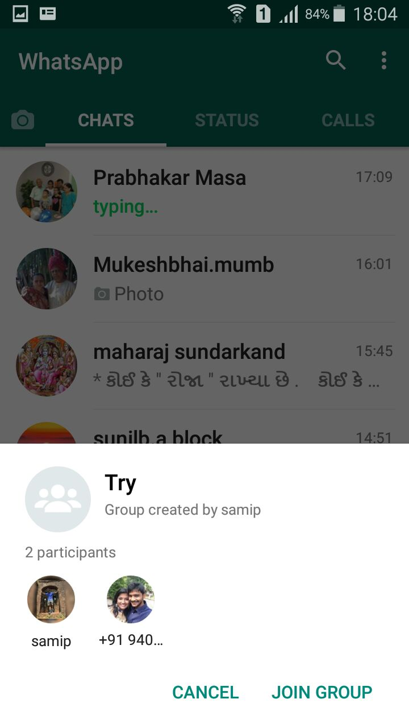

Figure

Figure

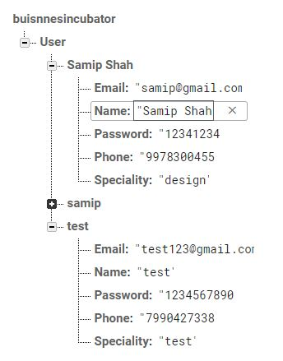

Figure

**Contact Us**

This page, helps user to directly contact the team E-Cell UVPCE. It has expandable list view, which will help user to get contact details of every member on clicking their name. On clicking on email ID, user will be redirected to its mail composer (user will be asked to select). On clicking user will be redirected to standard SMS application where user can send it directly to Team member. There are two buttons below that. First one is Directions, on clicking that, user will be redirected to google maps and it will be showing location of E-Cell uvpce and user can simply get directions from his current location. Next one is Facebook, where user will be taken to E-Cell UVPCE Facebook page.

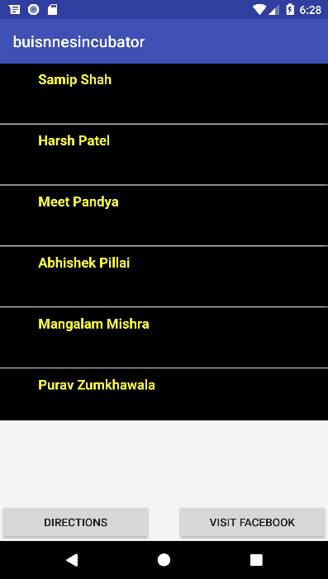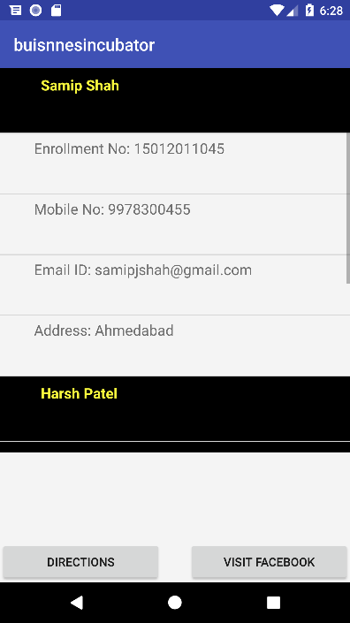

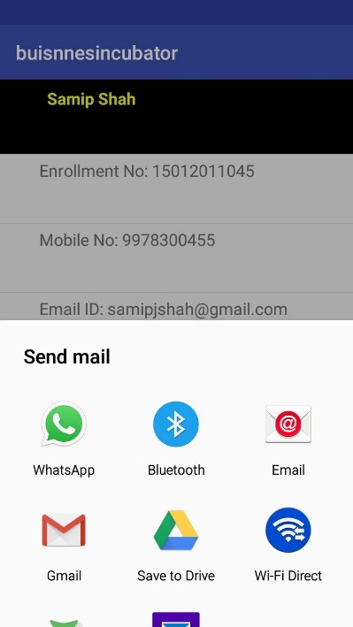

Figure

Figure

Figure

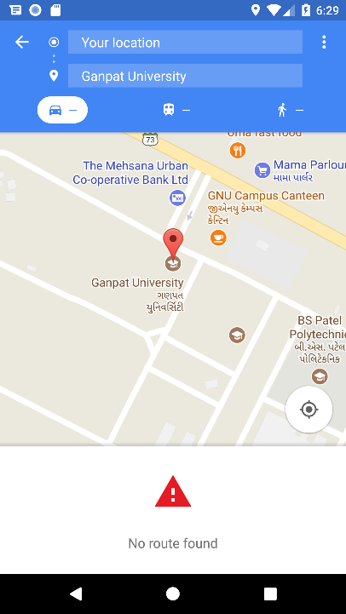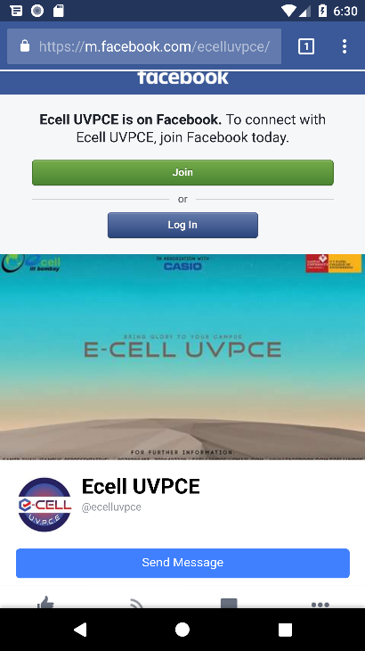

Figure

Figure

# 10. Further Enhancement

* An activity, where users will get updates about previous and future events by E-Cell UVPCE.
* Personal chat feature where users can talk to each other in application only.
* Direct calling from application to team members and other users.
* An activity, where users can read success stories of few entrepreneurs and watch videos.