

**Green University of Bangladesh**

**Department of Computer Science and Engineering (CSE)**

**Faculty of Sciences and Engineering Semester: (Spring, Year: 2022), B.Sc. in CSE (Day)**

**Course Title: Object Oriented Programming Lab Course Code: CSE 202 Section: 213D3**

**Lab Project Name:** Pharmacy Inventory Management System.

**Student Details**

|  |  |  |
| --- | --- | --- |
|  | **Name** | **ID** |
| **1.** | Alamin -Shahidullah (samir) | 213002019 |

|  |  |
| --- | --- |
| **Submission Date** | **: 10-1-23** |
| **Course Teacher’s Name** | **:** Ayesha Khatun |

**[For Teachers use only: Don’t Write Anything inside this box]**

**Lab Project Status**

**Marks: ………………………………… Signature: .....................**

**Comments: .............................................. Date: ..............................**

Table of Contents

**Chapter 1 Introduction ........................................................................................... 3**

1.1 Introduction ......................................................................................................... 3

1.2 Design Goals/Objective ....................................................................................... 3

**Chapter 2 Design/Development/Implementation of the Project ......................... 4-6**

2.1 Design .................................................................................................................. 4

2.1.1 Database Design................................................................................................ 5-6

2.1.2 Library............................................................................................................... 6

2.1.3 Simulator .......................................................................................................... 6

**Chapter 3 Performance Evaluation ....................................................................... 6-9**

3.1 Results and Discussions ....................................................................................... 6

3.1.1 Sample inputs and outputs .................................................................................6-8

3.2 Discussions …………...........................................................................................8-9

**Chapter 4 Conclusion .............................................................................................. 9-10**

4.1 Introduction …….................................................................................................. 9

4.2 Scope of Future Work ..........................................................................................9

4.3 Limitation ............................................................................................................. 10

**References................................................................................................................. 10**

# Chapter 1 Introduction

# 1.1 Introduction

The Pharmacy Inventory Management System is a project developed to automate medical stores’ activities and improve their productivity. This helps pharmacies organize, manage, and secure drug information efficiently. Its’ features aids in the resolution of challenges with manual pharmacy management.

Pharmacy Inventory management system is a management system that is designed to improve accuracy and to enhance safety and efficiency in the pharmaceutical store. This program can be used in any pharmaceutical shops having a database to maintain. It is a computer based system which helps the Pharmacist to improve inventory management, cost, medical safety etc. The software used can generate reports, as per the user’s requirements. Using this pharmacy inventory management system user is also able to generate report within a specified period of time. The software can print invoices, bills, receipts etc. The system services and goals are established by consultation with system user. It also involves manual entry upon arrival of new batches of drugs and upon drug movement out of the pharmacy for a certain period. Pharmacy inventory management system is being build. Pharmacy inventory management system is robust, integrated technology. Every month, the pharmacist may want to generate report for the movement of drugs in and out of the pharmacy, getting information about the drugs number of drug type left, and location of a drug in the pharmacy. Pharmacy inventory management system deals with the maintenance of drugs and consumables in the pharmacy unit. This pharmacy inventory management system is user friendly.

# 1.2 Design Goals/Objective

The main objective of the study is to develop a drug inventory system for pharmacy.

* The main aim of the project is the management of the database of the pharmaceutical shop.
* To improve the efficiency of the system by ensuring effective monitoring of services and activities.
* Making the pharmacy organizations computerized by creating network through minimizing and decreasing malfunctioned works on the medical usage by giving correct information on each medicine.
* Minimize time and resource by which, searching the medicine data you can get the data in quickest time.

**Chapter 2**

**Design/** **Development /Implementation of the Project**

# 2.1 Design

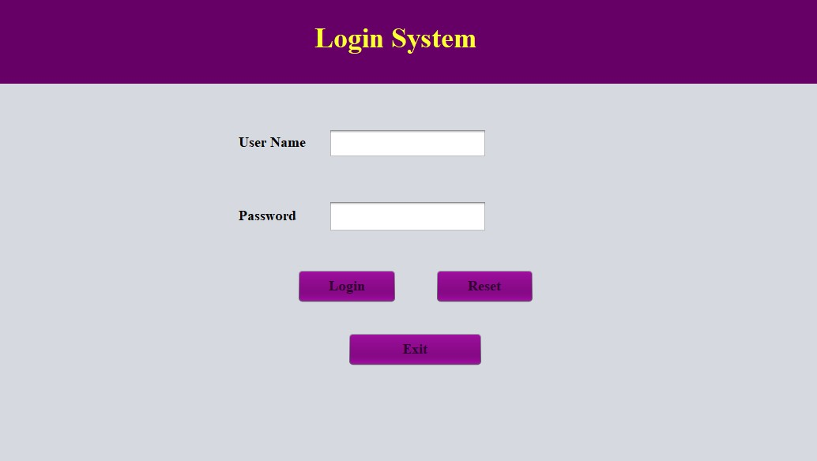

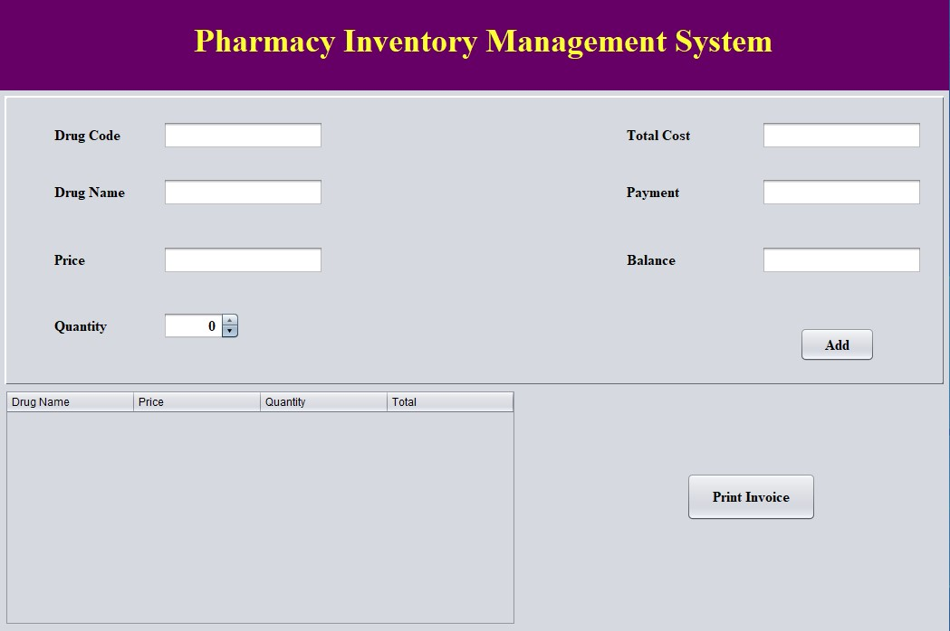

## 2.1.1 Database design:

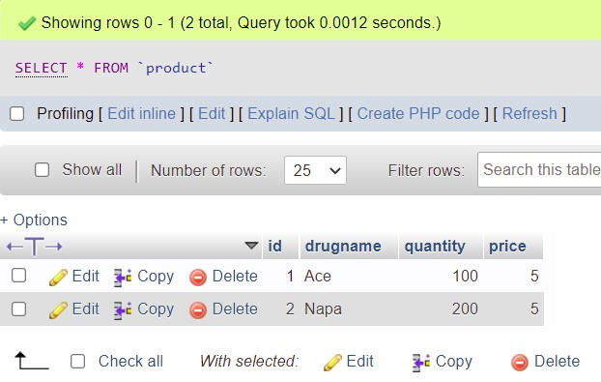

### Fig: Product Table

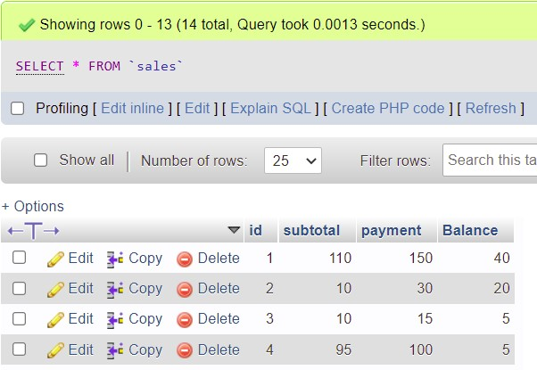

### Fig: Sales Table

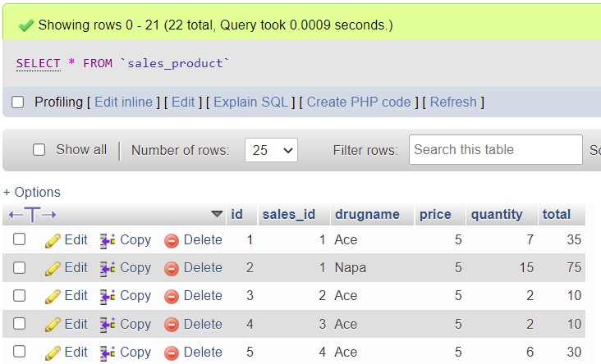

### Fig: Sales_Product Table

## 2.1.2 Library:

Mysql-connector-java-8.0.28, ireport, jarfile.

## 2.1.3 Simulator:

• NetBeans IDE 8.2

**Chapter 3**

**Performance Evaluation**

# 3.1 Results and Discussions

**3.1.1 Sample inputs and outputs**

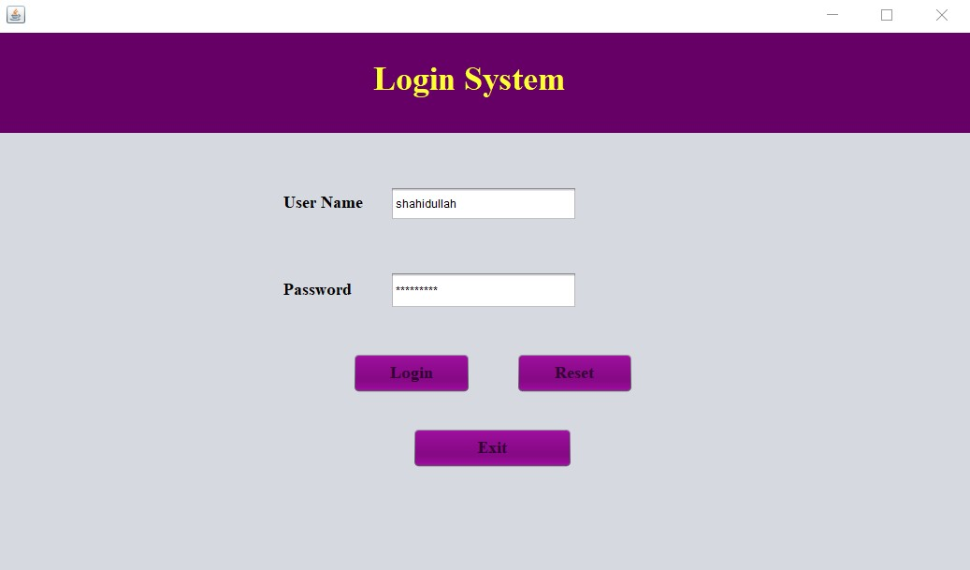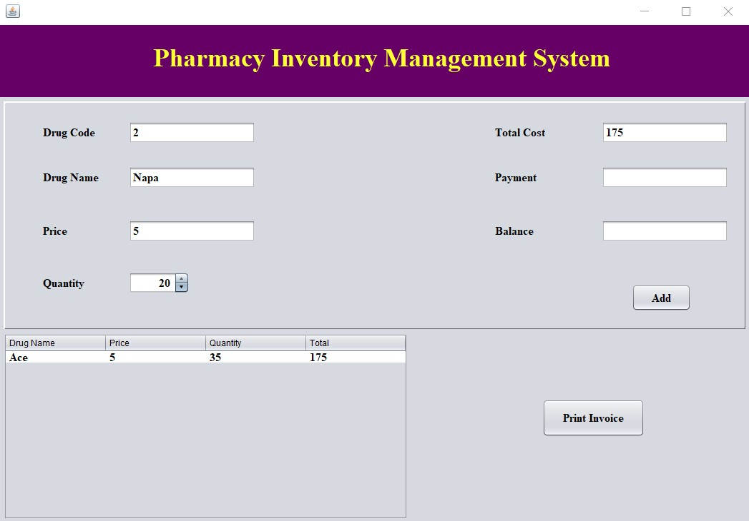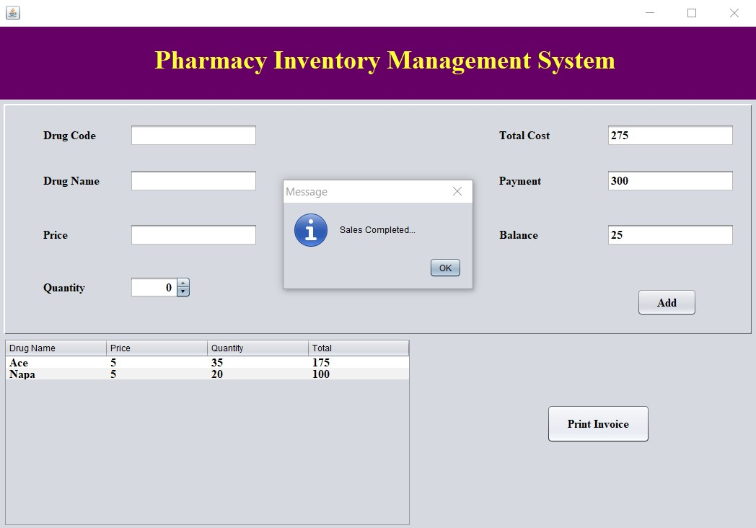

**Outputs:**

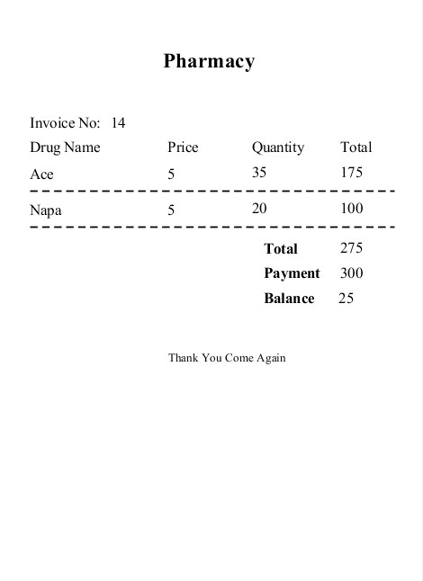

# 3.2 Discussions

The Pharmacy Inventory Management System is developed using Java and mysql servers. The project is built to manage pharmacy items and transactions. To make a new transaction, fields such as: drag name, qty and payment needs to be selected. If you like to learn point of sales systems step by step, this is the right place to learn from the beginning. In this tutorial, we will learn crystal reports step by step and design and print receipts for the payments.

The system shall be able to search the drag name, and price by the relevant “Drug Code”. Paste this Code inside the keypress Event of the textbox. we created the textbox name txtdcode of this project. After receiving the drag name and price where the user has the option to add the qty by clicking the add button to see all Products details which will be shown in the below table.if you want remove items from the datagridview. select the row of table which item wants to. then click delete button in the datagridview. After that create the method Salessave().we have to create two different tables to store data into the database. I also have to create the following tables from database. sales tables consist of following columns – id, subtotal, pay, balance. sales_products tables consist of following columns –id, sales_id, drugname, price, qty, total Call the Salessave() method inside the Print Invoice button. after calculating the total Print receipt will be released. This print receipt is design by Jsper Reporting.

# Chapter 4 Conclusion

**4.1 Introduction**

The Pharmacy Inventory Management System is a project developed to automate medical stores’ activities and improve their productivity. This helps pharmacies organize, manage, and secure drug information efficiently. Its’ features aids in the resolution of challenges with manual pharmacy management.

**4.2 Scope of Future Work**

Detailed information gathering has to be done. Without that the purpose for using the software won’t be satisfied properly.

1. However it can give good profits in the long run.
2. Implementing the software requires change in the business practices.
3. Efficient organization of all knowledge is the analysis company and easy analysis access and retrieval of information is possible.
4. In this project we can also include BAR CODE facility using the bar code reader, which will detect the expiry date and the other information about the related medicines.
5. Company using this software will always be able to plan in future and always be aware of their financial position in the market.
6. It leads to streaming of business processes.
7. The implementation and maintence costs run very high (about 2 to 3 % of the company’s revenue.)

**4.3 Limitation**

* In this project I tried to give an overall idea of the pharmacy inventory management system.
* The library I am using in this project is just designed, some libraries like this work automatically.
* If you want all the functionality to work automatically, then in the future you have to automate programming-related work.
* Future I will add a payment method option etc.

**References**

1. [https://itsourcecode.com/fyp/pharmacy-management-system-project-abstract-pdfdocumentation/](https://itsourcecode.com/fyp/pharmacy-management-system-project-abstract-pdf-documentation/)
2. <https://www.academia.edu/11672313/Pharmacy_Management_System_Complete_Report>
3. [https://sites.google.com/site/ignoubcafinalyearprojects/project-report/pharmecymanagement-system-project-report](https://sites.google.com/site/ignoubcafinalyearprojects/project-report/pharmecy-management-system-project-report)
4. <https://www.slideshare.net/sudiahmad1/pharmacy-management-system-112602894>
5. [https://pdfcoffee.com/pharmacy-management-system-project-documentation-ofpharmacy-management-system-a-desktop-application-pdf-free.html](https://pdfcoffee.com/pharmacy-management-system-project-documentation-of-pharmacy-management-system-a-desktop-application-pdf-free.html)
6. <http://ignousupport.blogspot.com/p/pharmacy-management-system-project.html>
7. [https://www.tutussfunny.com/pharmacy-inventory-management-system-point-of-salessystem/](https://www.tutussfunny.com/pharmacy-inventory-management-system-point-of-sales-system/)

**|** P a g e