

SEM-Team 3

HIH-CU
Software Design Specification (SDS)
Version: <1.0>
SEM-Team 3

Revision History

Sl. No. | Prepared/  Modified by | E-mail | Version | Date | Descriptions/  Remarks
1. | Ahmed Mohamed Soliman | ahmadalkady1997@yahoo.com | <1.0> | <15/03/2018> | <The action performed on the document. Include a link to the modified part>
2. | Ehab Rabie Amin | ehabraelsherif@gamil.com | <1.0> | </03/2018>
3. | Samir Hosny Mohamed | samir7osny@yahoo.com | <1.0> | </03/2018>
4. | Omar Samir Touny | omartouny2@gmail.com | <1.0> | <15/03/2018>

Distribution list
Name | E-mail | Notes
Eng. Dina Elreedy | dinaelreedy@gmail.com | Feedback Needed
HIH’s HR head | handinhandhr@gmail.com | For Approval

Table of Contents

1. Introduction 5
1.1 Purpose of this Document 5
1.2 Scope 5
1.3 Table of Acronyms and Definitions 5
1.3.1 Definition 5
1.4 References 6
1.5 Overview of Document 6
2. System Architecture 6
2.1 Design Patterns Description 6
2.1.1 Design Pattern I 7
2.1.2 Design Pattern II 7
2.1.3 Design Pattern III 7
3. Design Models 7
3.1 Class Diagrams 7
3.2 Interaction Diagrams 7
3.3 State Chart Diagrams (if needed) 7
3.4 Activity Diagrams (if needed) 7
3.5 Component Diagrams (if needed) 7
4. Data Models 7
5. System Deployment 7
6. Traceability to Requirements 8

List of Tables

List of Figures

Introduction
This document is to describe the software design specifications of the first iteration of the project (HIH-CU). Section one starts with the purpose of the document and then the scope of the project. After that we will list the definitions and abbreviations and finally the references.
In the second section we will talk about the system architecture. The third section contains the design models and the forth one contains the data models. System deployment will be discussed in section five. And finally chapters six will discuss the traceability to requirements

Purpose of this Document

The purpose of this document is to define what is being delivered to the customer in iteration 1.

To provide an overview of the design of the purpose solution to the topics and problems covered in the software requirement specifications (SRS).

Scope

At this iteration, HIH-CU website will offer all the functions for members mentioned in their stories in the SRS, such as: accept/deny the received tasks and sending/ receiving messages between members.
In addition to that, all the functions for visitors will be offered too, such as: Signing up, enrolling in events & workshops and viewing HIH info.

Table of Acronyms and Definitions
HIH | Hand In Hand
HR | Human Resource
PR | Public Relations
FR | Fund Raising
UC | User Case
US | User Story
HB | High board

References

- “Software Engineering”, 10th Edition, Ian Sommerville, 2016
- Software Engineering Course Lecture Notes, Dr. Ahmed Hamdy.
- The Software Requirements Specifications document (SRS).

Overview of Document

The rest of the document shows the system architecture and the design models describing each subsystem class diagrams and sequence diagrams, showing also the data models (Entity Relationship diagram) is included showing the database design ER and each entity fields. The last two things are the system deployment diagram which shows how the system will be deployed and the Traceability matrix which maps requirements to design elements.

System Architecture
The system of this project is following the MVC Model and is going to be decomposed into three subsystems, or layers;
▪ The User Application Layer.
▪ The Web Service Layer.
▪ The Database Layer.

Each layer has its own classes and methods of interacting with other layers, so the structural model we are going to use here is the layered model; the following figure shows the system architecture and its layers

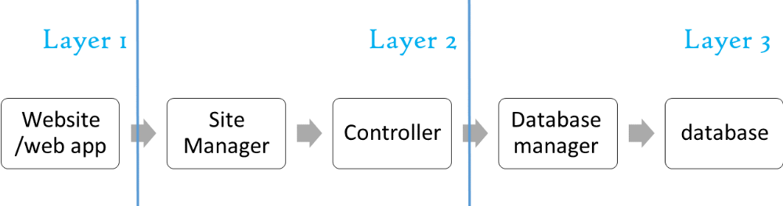
Figure 1 – System Architecture

Design Models

Design Patterns Description

MVC Design Pattern: The whole business logic of this project is based on the idea of Model-View-Controller. This pattern is used for the sake of decoupling the business logic from the user interface for the sake of re-usability.

Class Diagrams
<You should use one or more class diagram to model the relationships between the classes of the system. Each class diagram may contain classes from different layers.>

Interaction Diagrams
<For each service provided by the system, you should use sequence diagrams to model the interaction between objects to realize this service. Each sequence diagram may contain classes from different layers.>

State Chart Diagrams (if needed)
<You may use state chart diagrams to model how individual objects change their state in response to events or to model how the subsystem changes its sates.>

Activity Diagrams (if needed)
<You may use activity diagrams to model the work flow inside the subsystem or to model a specific operation/algorithm.>

Component Diagrams (if needed)
<You should use component diagrams to model the organization and dependencies among the source files of this system>

Data Models

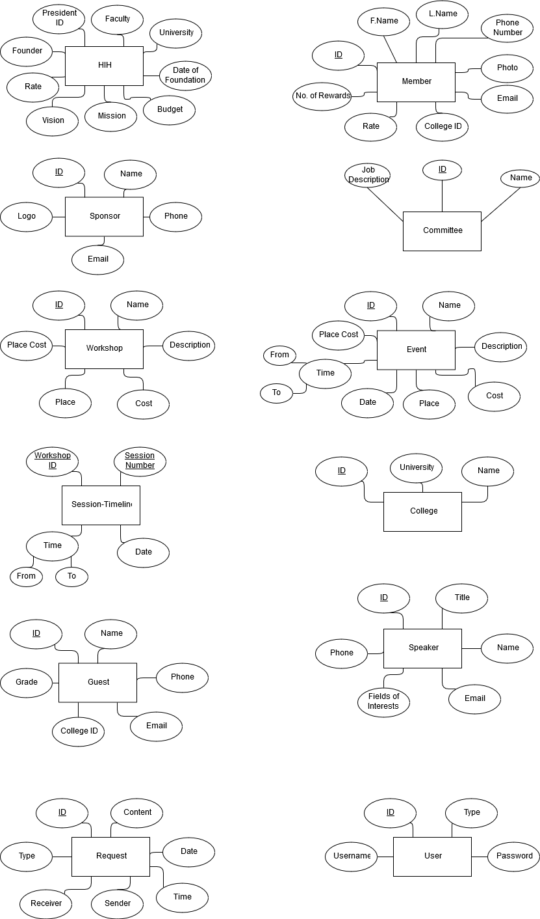

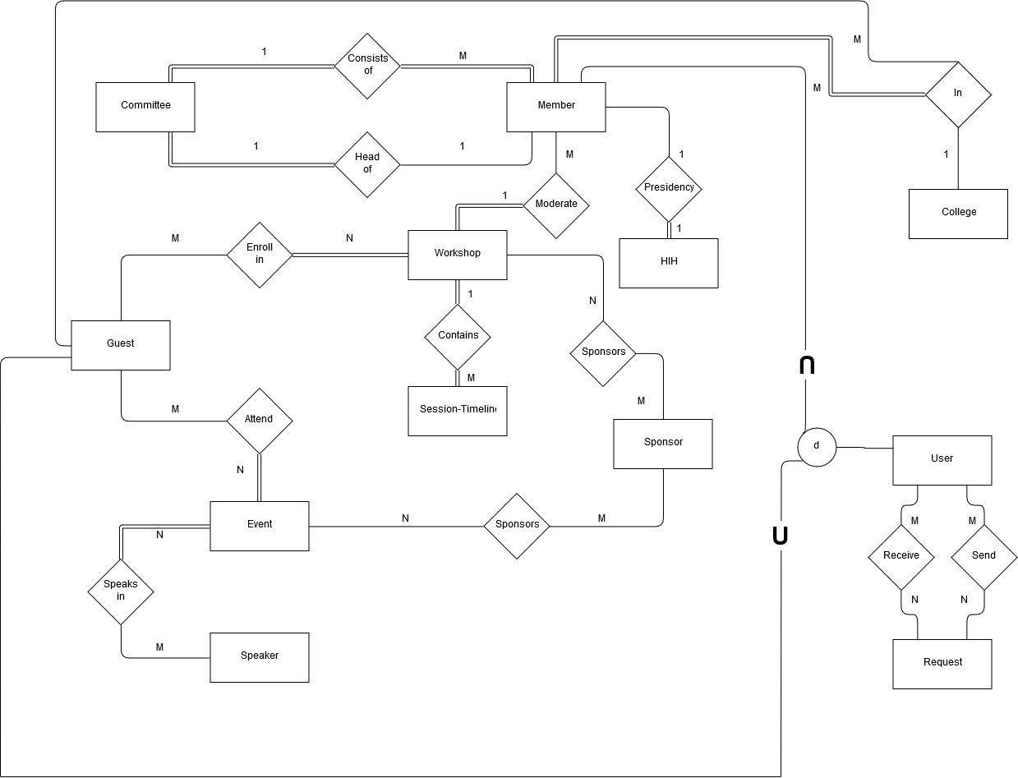

System Deployment
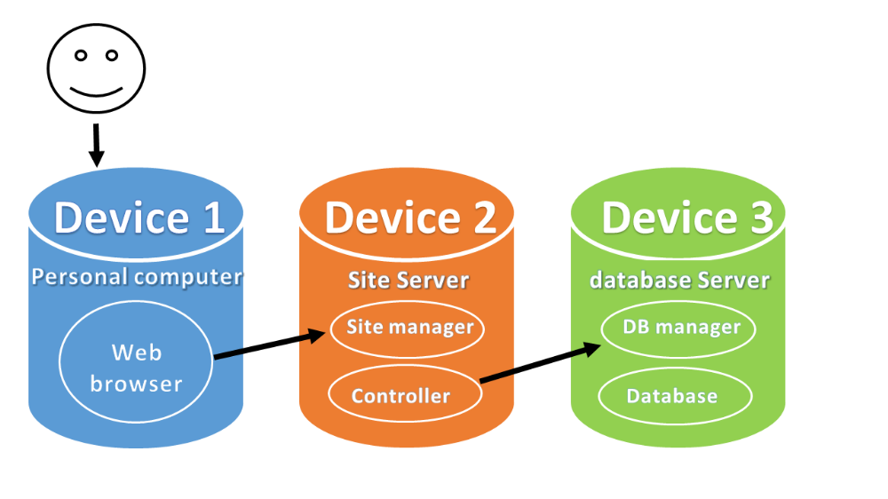

Traceability to Requirements
<This should maintain a matrix similar to the Traceability Matrix in the Software Requirements Specification document. The purpose of this matrix is to map requirements to design elements. This will immediately point out requirements that have not been considered. It will also allow you to trace into the design elements that require to be changed if requirements change. Use requirement IDs as row headers and design element IDs as column headers>

