

JORDAN UNIVERSITY OF SCIENCE AND TECHNOLOGY

  - AI447 - Computer Vision
  - Deep Learning – Spring 2025/2026
  - Course instructor: Dr. Abdullah Alamaren

MilTrack

  - A Computer Vision System for Aerial
  - Military Vehicle Detection and Tracking

By:

NAME | ID
Wajd Almadi | 172834
Samira Aldamen | 170587
Batool Mahashi | 172901

Contents
PART 1: PROBLEM STATEMENT 5
1.1 Problem Definition and Requirements 5
1.1.1 Background and Motivation 5
1.1.2 Problem Definition 5
1.1.3 Key Technical Challenges 6
1.1.4 System Requirements 7
1.1.5 Success Criteria 8
1.1.6 Research Questions 8
1.2 Literature Review 8
1.2.1 Summary of Reviewed Literature 8
1.2.2 UAV Datasets and Benchmarks 10
1.2.3 Single-Stage Object Detection Architectures 11
1.2.4 Transformer-Based Detection Architectures 12
1.2.5 Multi-Object Tracking Algorithms 13
1.2.6 Foundational Components and Domain-Specific Adaptations 14
1.2.7 Synthesis and Research Gap 15
PART 2: Modern Architectures: Research, Understanding, and Design Decisions 15
2.1 YOLOv11 - Architecture Deep Dive 15
2.1.1 Architectural Lineage and Evolution 15
2.1.2 Core Architectural Components 16
2.1.3 Model Variants and Scaling Strategy 17
2.1.4 Training Pipeline and Augmentation 17
2.2 RT-DETR - Architecture Deep Dive 18
2.2.1 Motivation and Positioning 18
2.2.2 Core Architectural Components 18
2.2.3 Model Variants and Specifications 19
2.2.4 NMS-Free Inference and Latency Determinism 19
2.3 ByteTrack - Tracking Architecture 20
2.3.1 Design Philosophy 20
2.3.2 Two-Stage Association Algorithm 20
2.3.3 Kalman Filter State Model 20
2.4 End-to-End Pipeline Architecture 21
2.5 Architectural Decision Justification 21
2.6 Architectural Comparison and Selection Justification 22
2.6.1 Comprehensive Architecture Comparison 22
2.6.2 UAV Domain-Specific Evaluation 24
2.6.3 Weighted Decision Matrix 25
2.6.4 Key Differentiating Factors 26
2.6.5 Primary Model Selection per Architecture Family 27
2.6.6 Final Architecture Selection (Summary) 28
PART 3: MODEL DEVELOPMENT 28
3.1 Dataset 28
3.1.1 Dataset Selection Rationale 28
3.1.2 UAVDT Benchmark - Overview 29
3.1.3 Dataset Attributes and Variability 29
3.1.4 Class Distribution Analysis 30
3.1.5 Comparison with Alternative Datasets 31
3.1.6 Dataset Download and Components 31
3.1.7 Dataset Preparation Pipeline 32
3.2 Three-Way Data Split and Augmentation Pipeline 33
3.2.1 Data Split Strategy 33
3.2.2 Image Pre-Processing 34
3.2.3 Data Augmentation Pipeline 35
3.2.4 Dataset Statistics After Split 36
3.3 Training and Validation 37
3.3.1 Training Environment 37
3.3.2 Hyperparameter Configurations 37
3.3.3 Training Results 39
3.3.4 Analysis of Experimental Configurations 39
3.3.5 Learning Curve Analysis 41
3.3.6 Confusion Matrix Analysis 43
3.3.7 Summary of Key Findings 44
PART 4: MODEL TESTING AND EVALUATION 45
4.1 Testing 45
4.1.1 Model Selection Criteria 45
4.1.2 Evaluation Metrics 46
4.1.3 Key Findings from Test Set Evaluation 46
4.2 Overfitting and Underfitting Assessment 47
4.2.1 YOLOv11 Config B - Moderate Overfitting: 47
4.2.2 YOLOv11 Config C - Severe Domain Gap Overfitting: 47
4.2.3 RT-DETR - Convergence Instability Without Systematic Overfitting: 48
4.3 Results Analysis 50
4.3.1 Model Scale is Not the Limiting Factor 50
4.3.2 Augmentation Strategy Critically Determines Generalization 51
4.3.3 Class Imbalance Remains the Dominant Constraint 51
4.3.4 YOLOv11 Outperforms RT-DETR Under Current Conditions 51
4.3.5 Overfitting is Configuration-Dependent but Unavoidable 52
4.4 Effectiveness Assessment 52
4.5 Interface Development 53
4.5.1 Interface Architecture and Deployment 53
4.5.2 User Interface Layout 53
4.5.3 Output Annotation Format 55
4.5.4 Post-Training Enhancements 56
4.5.5 CLI Interface (track.py) 56
4.6 Critical Evaluation of Models 58
4.6.1 Current Limitations 58
4.6.2 Future Work and Recommendations 58
REFERENCES (IEEE Format): 60

PART 1: PROBLEM STATEMENT

1.1 Problem Definition and Requirements

1.1.1 Background and Motivation

In recent years, drones have become an essential part of both military and civilian operations. Their ability to fly for extended periods and film vast areas from high altitudes has made them indispensable tools for surveillance missions. However, this massive amount of aerial video has created a new problem—who analyzes it? A human observer cannot possibly monitor dozens of screens simultaneously; they become fatigued and miss crucial details that could be decisive in a military context.

Artificial intelligence and deep learning have presented themselves as a natural solution to this problem. Models like YOLO and DETR have demonstrated impressive object detection capabilities on massive datasets. The problem is that these models were mostly trained on "ground" images—cameras at the same level as the target. UAV images are entirely different: vehicles appear as tiny dots from above, viewing angles are unfamiliar, lighting changes between night, day, and fog, and most importantly, the system must operate at at least 30 frames per second to be truly useful.

This is where the idea for MilTrack came from. Instead of applying an existing model to UAV data and accepting the results as is, we wanted to build a comprehensive framework specifically designed for this challenge. We chose the UAVDT dataset because it best represents a real-world military UAV environment, and we combined the latest detection models with a sophisticated tracking algorithm—to answer one question: Can we build a system that accurately detects and tracks military vehicles in real time

1.1.2 Problem Definition

The project addresses a specific and clear problem: drones capture continuous video from different altitudes and environments—the required system must be able to do three things simultaneously: detect all military vehicles in the image, assign each vehicle a unique identification number, and track these vehicles even if they temporarily disappear behind an obstacle or change shape. All of this must occur at a speed of at least 30 frames per second.

Scope and Constraints

In technical terms, this is a Multi-Object Detection and Tracking (MODT) problem. We're applying it to a UAVDT dataset containing real UAV videos. The system must handle three vehicle categories—cars, trucks, and buses—in different conditions: day, night, and fog, and at low, medium, and high altitudes.

The scope of the MilTrack system is defined by the following boundaries:
- Detection domain: Military and civilian ground vehicles (car, bus, truck) captured in UAV aerial footage from the UAVDT benchmark.
- Processing mode: Offline video inference with a real-time processing target of ≥ 30 FPS on NVIDIA Tesla T4 or NVIDIA A100-SXM4-40GB.
- Detection architectures: YOLOv11 (Nano, Medium, Large) and RT-DETR (Large) implemented via the Ultralytics framework.
- Tracking algorithm: ByteTrack [2], selected for its demonstrated robustness on low-confidence detections and computational efficiency.
- Training platform: Google Colab and Kaggle with GPU acceleration.
- Interface: A Gradio-based web application for demonstration and evaluation.

Out of Scope

- Real-time onboard UAV processing (edge deployment is designated as future work).
- Detection of personnel, aircraft, or marine vessels.
- Satellite or synthetic aperture radar (SAR) imagery.
- Geolocation, GPS coordinate extraction, or 3D scene reconstruction.

1.1.3 Key Technical Challenges

The problem of detecting and tracking military ground vehicles in UAV footage is not simply a matter of applying existing detection models—it is a fundamentally different technical challenge than COCO and PASCAL VOC data. The following table summarizes the most prominent of these challenges.
Table 1.1: Technical Challenges in UAV-Based Military Vehicle Detection and Tracking
Challenge | Description
Small Object Detection | Military vehicles appear as tiny objects (< 32×32 px) in high-altitude UAV imagery, reducing detection confidence significantly.
Occlusion & Crowding | Targets frequently overlap in dense convoy scenarios, causing identity switches and track fragmentation.
Environmental Variability | Fog, rain, night conditions, and altitude variations degrade image quality and alter target appearance.
Class Imbalance | The UAVDT dataset exhibits a significant imbalance, with cars vastly outnumbering buses and trucks.
Real-Time Constraint | Simultaneous high-accuracy detection and tracking must operate at ≥ 30 FPS for operational viability.
Camera Motion | UAV platform instability introduces frame-to-frame motion blur and perspective distortion.

These combined challenges are what led us to choose specific architectures and design decisions — choosing multi-scale feature extraction, diverse augmentation strategies, and integrating ByteTrack with its low-confidence recovery mechanism.

1.1.4 System Requirements
The MilTrack system requirements are derived from a systematic analysis of the problem's nature and the operational constraints of the UAVDT dataset. We categorized these requirements into two types: functional requirements (FR), which describe what the system should do, and non-functional requirements (NFR), which describe how it should perform. Each defined performance threshold is measurable and verifiable on the test set.
Table 1.2: MilTrack System Requirements Specification
ID | Requirement | Description | Priority
FR-01 | Vehicle Detection | The system shall detect military vehicles in UAV footage with mAP@0.5 ≥ 65%. | High
FR-02 | Real-Time Processing | The system shall process video at a minimum of 30 FPS on standard GPU hardware. | High
FR-03 | Multi-Object Tracking | The system shall assign and maintain unique IDs for each detected target across frames. | High
FR-04 | Trajectory Visualization | The system shall render motion trajectories overlaid on the video output. | Medium
FR-05 | Multi-Architecture Support | The system shall support both YOLOv11 and RT-DETR detection architectures. | High
FR-06 | User Interface | A Gradio-based UI shall allow video upload and real-time inference result display. | Medium
NFR-01 | Accuracy — Detection | mAP@0.5 ≥ 65% and mAP@0.5:0.95 ≥ 40% on the UAVDT test set. | High
NFR-02 | Accuracy — Tracking | MOTA ≥ 55% and IDF1 ≥ 60% on the UAVDT MOT benchmark. | High
NFR-03 | Speed | End-to-end inference latency ≤ 33 ms per frame (≥ 30 FPS) on NVIDIA Tesla T4. | High
NFR-04 | Robustness | Performance degradation < 10% under fog, night, and low-altitude conditions. | Medium
NFR-05 | Scalability | System shall support tracking ≥ 20 simultaneous targets without accuracy loss. | Medium
NFR-06 | Reproducibility | All experiments shall be reproducible via provided configuration files and model weights. | High

1.1.5 Success Criteria

The MilTrack project is considered successful when it achieves a set of measurable criteria, evaluated on a reserved UAVDT test suite containing 50 video sequences.

- Detection Performance: At least one trained model variant achieves mAP@0.5 ≥ 65% on the UAVDT test set.
- Tracking Performance: The best-performing pipeline achieves MOTA ≥ 55% and IDF1 ≥ 60%.
- Real-Time Operation: End-to-end inference achieves ≥ 30 FPS on a single NVIDIA T4 GPU.
- Comparative Analysis: A systematic comparison across 4 model variants (YOLOv11n, YOLOv11m, YOLOv11l, and RT-DETR-l) and 3 hyperparameter configurations applied to YOLOv11m is completed and documented. RT-DETR-l is evaluated under a single default configuration due to framework compatibility constraints with the Small and Medium variants.
- Functional Interface: A fully operational Gradio web application demonstrating live video inference is delivered.

1.1.6 Research Questions

The following research questions guide the design and evaluation of the MilTrack system. Each question is directly related to a specific technical decision or architectural comparison within the project:

- RQ1: How do YOLOv11 and RT-DETR architectures compare in terms of detection accuracy (mAP@0.5, mAP@0.5:0.95) on the UAVDT military vehicle dataset?
- RQ2: What is the accuracy-speed trade-off across model size variants (Nano/Small, Medium, Large) for both architectures in the aerial domain?
- RQ3: How do hyperparameter configurations (learning rate, batch size, mosaic augmentation, weight decay) affect convergence behaviour and final model performance?
- RQ4: Does the integration of ByteTrack with CNN-based detectors (YOLOv11) achieve comparable tracking performance to transformer-based detectors (RT-DETR)?
- RQ5: What are the primary failure modes of the MilTrack system, and which environmental conditions most severely degrade performance?

1.2 Literature Review

This literature review covers the academic research that formed the theoretical basis of the MilTrack system. We categorized the reviewed papers into five main groups: UAV datasets and benchmarks, single-stage detection models, transformer-based detection models, multi-object tracking algorithms, and the core components of deep learning. Each paper was selected based on its direct relevance to the fields of detection, tracking, and aerial imaging.

1.2.1 Summary of Reviewed Literature

The following table summarizes the 20 research papers we reviewed for this project. The selection criteria were clear—direct relevance to MilTrack's three areas: detection, tracking, and aerial imaging.

Table 1.3: Literature Review Summary — 20 Key References
Ref | Authors & Year | Work / Method | Venue | Key Contribution | Category
[1] | Du et al., 2018 | UAVDT Benchmark | ECCV | Proposes the UAVDT dataset and benchmark for UAV vehicle detection and tracking. | Dataset
[2] | Zhang et al., 2022 | ByteTrack | ECCV | Association of every detection box using high and low-confidence thresholds for robust MOT. | Tracking
[3] | Wang et al., 2023 | YOLOv8 | Ultralytics | Anchor-free, C2f backbone YOLO architecture establishing the foundation for YOLOv11. | Detection
[4] | Khanam & Hussain, 2024 | YOLOv11 | arXiv | Introduces C3k2 blocks and PSA attention module for improved multi-scale detection. | Detection
[5] | Lv et al., 2023 | RT-DETR | CVPR | Real-time detection transformer with hybrid encoder achieving 54 AP on COCO at 108 FPS. | Detection
[6] | Cao et al., 2023 | OC-SORT | CVPR | Observation-centric re-update mechanism reducing error accumulation in Kalman-based MOT. | Tracking
[7] | Zeng et al., 2022 | UAV-YOLOv5s | Remote Sensing | Lightweight YOLOv5 adaptation with SlimNeck for real-time UAV vehicle detection. | UAV Det.
[8] | Lin et al., 2017 | Feature Pyramid Network | CVPR | Multi-scale FPN architecture foundational to all modern YOLO detection heads. | Detection
[9] | Vaswani et al., 2017 | Transformer (Attention) | NeurIPS | Self-attention mechanism underpinning RT-DETR and transformer-based detectors. | Foundation
[10] | Bewley et al., 2016 | SORT | ICIP | Simple real-time tracking using Kalman filter + Hungarian algorithm; ByteTrack precursor. | Tracking
[11] | Carion et al., 2020 | DETR | ECCV | End-to-end object detection with transformers, eliminating NMS post-processing. | Detection
[12] | Liu et al., 2016 | SSD | ECCV | Multi-scale single-shot detection establishing anchor-based multi-scale paradigm. | Detection
[13] | Redmon et al., 2016 | YOLOv1 | CVPR | Original single-pass real-time detection framework — foundational to entire YOLO lineage. | Detection
[14] | He et al., 2016 | ResNet | CVPR | Residual connections enabling deep network training — backbone for RT-DETR. | Foundation
[15] | Zhu et al., 2021 | Deformable DETR | ICLR | Multi-scale deformable attention accelerating DETR convergence, adopted in RT-DETR. | Detection
[16] | Ren et al., 2015 | Faster R-CNN | NeurIPS | Region Proposal Network for two-stage detection — key comparative baseline. | Detection
[17] | Zhang et al., 2021 | FairMOT | IJCV | Simultaneous detection and ReID in a single network for high-performance MOT. | Tracking
[18] | Sun et al., 2022 | DroneVehicle | IEEE TGRS | Infrared-RGB UAV vehicle dataset enabling cross-modal detection research. | Dataset
[19] | Ge et al., 2021 | YOLOX | arXiv | Anchor-free YOLO with decoupled head and SimOTA label assignment strategy. | Detection
[20] | Rezatofighi et al., 2019 | GIoU Loss | CVPR | Generalized intersection-over-union loss improving bounding box regression quality. | Foundation

1.2.2 UAV Datasets and Benchmarks

Large aerial datasets are essential for training and validating vehicle detection algorithms. This section reviews the two most important datasets directly relevant to our project.

[1] Du et al. (2018) — The Unmanned Aerial Vehicle Benchmark: Object Detection and Tracking (UAVDT) [ECCV]
Du and colleagues presented UAVDT in 2018—a massive dataset containing over 80,000 annotated images from 100 UAV videos. It covers diverse conditions: day, night, and fog; three different altitudes; and three vehicle classes. It includes assessment tools for both detection and tracking.
Its relevance to MilTrack: This is the primary and sole dataset used for training and evaluation. Its detailed annotations support the performance analysis in Section 3.
[18] Sun et al. (2022) — DroneVehicle: Bridging the Domain Gap for Drone-Based Vehicle Detection [IEEE TGRS]
In 2022, Sun and colleagues presented DroneVehicle—a dual RGB-infrared vehicle dataset from drones. It contains 56,878 day and night image pairs.
Its relevance to MilTrack: We did not use it in training, but it supports the discussion of nighttime performance in Section 3.3 and the suggestion of integrating multispectral data in future work.

1.2.3 Single-Stage Object Detection Architectures
Single-stage detectors process the entire image in a single forward pass, achieving superior inference speed compared to two-stage methods. This cluster traces the development from foundational work to the YOLOv11 architecture deployed in MilTrack.

[13] Redmon et al. (2016) — You Only Look Once: Unified, Real-Time Object Detection (YOLOv1) [CVPR]
Summary: Redmon et al. propose YOLO, the first single-shot detection framework that reformulates object detection as a regression problem over a grid of spatial cells. The architecture processes images at 45 FPS, demonstrating that detection and localization can be performed in a single unified network. Despite lower accuracy than contemporary two-stage methods, YOLO establishes the speed-accuracy trade-off paradigm that defines the entire subsequent YOLO lineage.
Relevance to MilTrack: YOLOv1 is the conceptual ancestor of YOLOv11 deployed in MilTrack. Its single-pass inference philosophy directly enables the real-time processing requirement (≥ 30 FPS) specified in NFR-02.
[12] Liu et al. (2016) — SSD: Single Shot MultiBox Detector [ECCV]
Summary: Liu et al. introduce SSD, which extends single-shot detection to multiple feature map scales by predicting detections at different network layers. This multi-scale prediction strategy, combined with anchor boxes of varying aspect ratios, substantially improves small object detection relative to YOLOv1 while maintaining real-time performance.
Relevance to MilTrack: SSD establishes the multi-scale feature extraction principle directly adopted in YOLOv11's detection head and in RT-DETR's hybrid encoder. This is particularly critical for detecting small vehicles in high-altitude UAVDT frames.
[8] Lin et al. (2017) — Feature Pyramid Networks for Object Detection (FPN) [CVPR]
Summary: Lin et al. propose FPN, which constructs a top-down feature hierarchy with lateral connections, combining high-resolution spatial features from early layers with high-semantic features from deep layers. FPN addresses the fundamental limitation of single-scale feature extraction for objects appearing at vastly different scales within the same image.
Relevance to MilTrack: FPN is the backbone of YOLOv11's neck architecture (PANet variant). In the context of UAVDT, where vehicle sizes vary dramatically with flight altitude, FPN's multi-scale representation is essential for maintaining high recall across all altitude conditions.
[19] Ge et al. (2021) — YOLOX: Exceeding YOLO Series in 2021 [arXiv]
Summary: Ge et al. introduce YOLOX, transitioning the YOLO series to an anchor-free detection paradigm with a decoupled head (separating classification and regression branches) and the SimOTA label assignment strategy. These innovations eliminate the labour-intensive anchor hyperparameter tuning required in previous versions and achieve superior accuracy at comparable speeds.
Relevance to MilTrack: YOLOX's anchor-free design is inherited by YOLOv8 and subsequently YOLOv11, both deployed in MilTrack. The decoupled head architecture is particularly beneficial for vehicle detection in UAV imagery where aspect ratio diversity is high.
[3] Wang et al. (2023) — YOLOv8: A New State-of-the-Art Architecture [Ultralytics]
Summary: Wang et al. present YOLOv8, introducing the C2f (Cross Stage Partial with two bottlenecks) backbone module and a fully anchor-free detection head with task-aligned learning. YOLOv8 achieves 53.9 AP on MS COCO with improved training efficiency. Its modular architecture within the Ultralytics framework enables seamless scaling across Nano, Small, Medium, Large, and Extra-Large variants.
Relevance to MilTrack: YOLOv8 is the immediate predecessor of YOLOv11 and shares its training pipeline. Understanding YOLOv8's design decisions is essential for contextualizing the improvements introduced in YOLOv11 and for interpreting comparative performance reported in Section 3.3.
[4] Khanam & Hussain (2024) — YOLOv11: An Overview of the Key Architectural Enhancements [arXiv]
Summary: Khanam and Hussain document YOLOv11's key architectural enhancements over YOLOv8: the C3k2 module (a compact Cross Stage Partial block with smaller kernel sizes), the C2PSA (Cross Stage Partial with Positional Self-Attention) module in the neck, and an improved training recipe with closer attention to multi-scale feature interaction. These modifications yield a 22% parameter reduction with equal or improved accuracy on MS COCO compared to YOLOv8.
Relevance to MilTrack: YOLOv11 is the primary detection architecture in MilTrack, evaluated in Nano, Medium, and Large variants (Sections 2.4 and 3.2). The C2PSA attention module is hypothesized to improve detection of small, partially occluded vehicles in UAVDT by enhancing spatial attention over relevant target regions.
[16] Ren et al. (2015) — Faster R-CNN: Towards Real-Time Object Detection with Region Proposal Networks [NeurIPS]
Summary: Ren et al. propose Faster R-CNN, which replaces selective search with a fully convolutional Region Proposal Network (RPN) sharing features with the detection head, achieving near-real-time two-stage detection at 5–17 FPS. Faster R-CNN establishes the dominant two-stage detection paradigm and remains a key accuracy reference for benchmarking.
Relevance to MilTrack: Faster R-CNN serves as the primary two-stage baseline for contextualizing MilTrack's detection accuracy in the architectural comparison (Section 3.3). Its comparatively lower inference speed directly motivates the selection of single-stage architectures for the real-time requirement.

1.2.4 Transformer-Based Detection Architectures

Transformer architectures have fundamentally changed the field of object detection—replacing traditional anchor mechanisms and NMS processes with learned attention mechanisms. This section reviews the key developments that led to the RT-DETR used in MilTrack.

[9] Vaswani et al. (2017) — Attention Is All You Need [NeurIPS]
Summary: Vaswani et al. introduce the Transformer architecture based entirely on multi-head self-attention and positional encoding, eliminating recurrence and convolution. The Transformer achieves state-of-the-art performance on sequence transduction tasks and establishes the attention mechanism that underpins all subsequent detection transformers.
Relevance to MilTrack: Self-attention is the core computational primitive in RT-DETR's encoder-decoder architecture. Understanding attention's quadratic complexity with respect to sequence length is critical for contextualizing RT-DETR's hybrid encoder design, which restricts global attention to a reduced set of high-level features.
[11] Carion et al. (2020) — End-to-End Object Detection with Transformers (DETR) [ECCV]
Summary: Carion et al. propose DETR, the first transformer-based end-to-end object detector. DETR replaces the anchor generation, NMS, and assignment heuristics of CNN-based detectors with a bipartite matching loss using the Hungarian algorithm and a set of learned object queries. Despite achieving competitive accuracy, DETR suffers from extremely slow convergence (500 epochs) and poor small object detection due to single-scale feature processing.
Relevance to MilTrack: DETR establishes the transformer detection paradigm that RT-DETR is built upon. Its limitations — particularly poor small object detection — are directly addressed in the subsequent works reviewed below and are central to understanding why RT-DETR requires additional engineering for UAV deployment.
[15] Zhu et al. (2021) — Deformable DETR: Deformable Transformers for End-to-End Object Detection [ICLR]
Summary: Zhu et al. address DETR's slow convergence and small object limitation by replacing dense global self-attention with deformable attention, which attends only to a small set of key sampling points around a reference location. Combined with multi-scale feature maps, Deformable DETR converges 10x faster and improves small object AP by 6.0 points over DETR.
Relevance to MilTrack: Deformable attention is incorporated in RT-DETR's encoder, enabling efficient multi-scale feature interaction. This directly improves small vehicle detection in high-altitude UAVDT frames — a critical capability for MilTrack's operational scenario.
[5] Lv et al. (2023) — DETRs Beat YOLOs on Real-Time Object Detection (RT-DETR) [CVPR]
Summary: Lv et al. present RT-DETR, the first transformer-based real-time detector to exceed YOLO series performance on MS COCO. RT-DETR employs a hybrid encoder combining an efficient intra-scale interaction module (ELAN) for local features and a cross-scale feature fusion module with deformable attention for global context. An uncertainty-minimal query selection strategy improves object query initialization. RT-DETR-L achieves 53.0 AP on MS COCO at 114 FPS on T4 GPU.
Relevance to MilTrack: RT-DETR is the second detection architecture in MilTrack, evaluated as the Large variant (RT-DETR-l) only, due to compatibility constraints with the Ultralytics framework version employed .Its transformer encoder is hypothesized to better model long-range contextual dependencies between vehicles in convoy scenarios, potentially improving tracking association. This hypothesis is tested empirically in Section 3.3.

1.2.5 Multi-Object Tracking Algorithms

Tracking multiple objects in UAV video requires the ability to handle obstructions, target reappearance, and uncertainty in detection results. This section reviews the most relevant tracking algorithms for ByteTrack implementation in MilTrack.

[10] Bewley et al. (2016) — Simple Online and Realtime Tracking (SORT) [ICIP]
Summary: Bewley et al. propose SORT, which combines a Kalman filter for state prediction with the Hungarian algorithm for frame-to-frame bounding box association using IoU matching. Despite its simplicity (fewer than 100 lines of Python), SORT achieves competitive MOT performance at 260 FPS, establishing the predict-associate-update framework adopted by all subsequent online trackers.
Relevance to MilTrack: SORT is the direct algorithmic precursor to ByteTrack. Its Kalman filter state model (x, y, scale, aspect ratio, velocities) is reused in ByteTrack with modifications to the association stage. Understanding SORT's failure modes — particularly under low detection confidence — motivates ByteTrack's two-stage association design.
[2] Zhang et al. (2022) — ByteTrack: Multi-Object Tracking by Associating Every Detection Box [ECCV]
Summary: Zhang et al. observe that conventional trackers discard low-confidence detections, losing valuable association signals for occluded targets. ByteTrack addresses this by performing two-stage association: first associating tracks with high-confidence detections, then attempting to recover unmatched tracks using low-confidence detections via IoU matching. ByteTrack achieves 80.3 MOTA and 77.3 IDF1 on MOT17 at 30 FPS without requiring a re-identification (ReID) network.
Relevance to MilTrack: ByteTrack is the tracking algorithm in MilTrack. Its two-stage association is particularly valuable in UAVDT, where vehicle occlusion under vegetation or bridge overpasses produces low-confidence detections that would be discarded by SORT. ByteTrack's elimination of the ReID network also reduces computational overhead, preserving real-time performance.
[6] Cao et al. (2023) — Observation-Centric SORT: Rethinking SORT for Robust Multi-Object Tracking (OC-SORT) [CVPR]
Summary: Cao et al. identify that SORT's constant-velocity Kalman filter accumulates prediction error during occlusion, causing track drift. OC-SORT introduces an Observation-Centric Re-Update (ORU) mechanism and Observation-Centric Momentum (OCM) to correct this by re-interpolating track states using re-observed detections. OC-SORT achieves 76.4 MOTA on MOT17 with improved robustness in non-linear motion scenarios.
Relevance to MilTrack: OC-SORT is evaluated as a comparative tracker in Section 3.3 to contextualize ByteTrack's tracking performance under UAV-specific non-linear motion patterns. Its ORU mechanism is also considered as a potential enhancement to ByteTrack in the future work discussion (Section 4.6).
[17] Zhang et al. (2021) — FairMOT: On the Fairness of Detection and Re-Identification in Multiple Object Tracking [IJCV]
Summary: Zhang et al. propose FairMOT, which jointly learns detection and re-identification (ReID) embeddings in a single network, addressing the performance imbalance introduced when detection and ReID tasks are treated independently. FairMOT achieves 73.7 MOTA on MOT16 and demonstrates that anchor-free detection benefits ReID learning by ensuring feature alignment.
Relevance to MilTrack: FairMOT's joint detection-ReID framework is reviewed as an alternative tracking paradigm to ByteTrack's purely motion-based association. The absence of appearance-based ReID in MilTrack is contextualized against FairMOT's approach in the Strengths and Weaknesses analysis (Section 3.3).

1.2.6 Foundational Components and Domain-Specific Adaptations

The last group includes research papers that laid the deep technical foundations for the architectures used in MilTrack, as well as research that addresses the detection challenges specific to the UAV environment.
[14] He et al. (2016) - Deep Residual Learning for Image Recognition (ResNet) [CVPR]
Summary: He et al. introduce residual connections, enabling the training of networks with 100+ layers by providing gradient shortcuts that mitigate the vanishing gradient problem. ResNet-50 and ResNet-101 become the standard backbone architectures for detection models requiring deep semantic feature extraction.
Relevance to MilTrack: ResNet-101 is the backbone of RT-DETR-l deployed in MilTrack. Its residual architecture directly impacts the feature quality available to RT-DETR's transformer encoder and is a key differentiator from YOLOv11's CSP-based backbone.
[20] Rezatofighi et al. (2019) - Generalized Intersection over Union: A Metric and A Loss Function (GIoU) [CVPR]
Summary: Rezatofighi et al. propose GIoU, which extends the standard IoU metric by incorporating the area of the smallest enclosing box, providing a non-zero gradient signal even for non-overlapping bounding boxes. This overcomes a fundamental limitation of standard IoU loss where gradient vanishes when predicted and ground-truth boxes do not overlap.
Relevance to MilTrack: GIoU and its successor CIoU are used as the bounding box regression loss in YOLOv11's training pipeline. In UAVDT where small target bounding boxes are susceptible to non-overlap during early training, GIoU loss stabilizes regression convergence and is discussed in the hyperparameter analysis (Section 2.3).
[7] Zeng et al. (2022) - TPH-YOLOv5: Improved YOLOv5 Based on Transformer Prediction Head for Object Detection on Drone-Captured Scenarios [Remote Sensing]
Summary: Zeng et al. adapt YOLOv5 for drone imagery by integrating a transformer prediction head (TPH) that applies self-attention within the detection head to capture global dependencies between small objects. The model also incorporates a Cluster-NMS variant and multi-scale testing, achieving 18.2% AP improvement over baseline YOLOv5 on VisDrone.
Relevance to MilTrack: This work directly motivates the hypothesis that attention mechanisms (C2PSA in YOLOv11) provide particular benefit for small vehicle detection in aerial imagery, a hypothesis tested in the comparative analysis of Section 3.3. It also establishes transformer-augmented YOLO as a recognized paradigm for drone-based detection.

1.2.7 Synthesis and Research Gap

A literature review revealed several key insights that directly influence the design of MilTrack:

- Architecture convergence: The boundary between CNN and transformer detectors is narrowing. YOLOv11 incorporates attention via C2PSA, while RT-DETR combines convolutional local processing with transformer global attention. This hybrid trend motivates the comparative evaluation in MilTrack.
- Domain gap in aerial detection: Most detection architectures are validated on MS COCO, which contains predominantly human-scale objects. The UAVDT domain — small targets, top-down perspective, altitude variation — constitutes a significant distribution shift that is rarely addressed in foundational architecture papers.
- Tracking without ReID: ByteTrack demonstrates that motion-based association without ReID can achieve competitive MOT performance at reduced computational cost. This is particularly appropriate for the aerial domain where vehicle appearance is relatively uniform and viewpoint variation is limited.
- Research gap: No existing published work provides a systematic comparison of YOLOv11 versus RT-DETR across multiple size variants with standardized hyperparameter configurations on the UAVDT benchmark. MilTrack addresses this gap directly.

The following section builds on this review to provide a detailed architectural analysis of YOLOv11 and RT-DETR, examining the design decisions that characterize their performance in the field of aerial vehicle detection.

PART 2: Modern Architectures: Research, Understanding, and Design Decisions

This section provides an in-depth technical examination of the two detection architectures selected for MilTrack: YOLOv11 and RT-DETR. For each architecture, the analysis follows the Research → Understand → Explain → Decide framework mandated by the project specification: the architectural lineage is traced, the core computational mechanisms are explained, the design rationale is articulated, and the specific implications for UAV military vehicle detection are identified. The section concludes with a principled justification for the final architectural choices made in this project.

2.1 YOLOv11 - Architecture Deep Dive

2.1.1 Architectural Lineage and Evolution

The YOLO family represents the most advanced series of real-time, single-stage detection models. YOLOv11, released by Ultralytics in 2024, is the eleventh generation in this series and incorporates architectural innovations accumulated over a decade of research. Understanding this evolution is essential for correctly interpreting the design decisions in YOLOv11.

The evolutionary path from YOLOv1 to YOLOv11 is characterized by four major paradigm shifts: (1) the transition from fixed-grid regression (YOLOv1–v3) to multi-scale anchor-based prediction (YOLOv4–v7), (2) the move to anchor-free detection with decoupled heads (YOLOv8, YOLOX), (3) the integration of attention mechanisms into the backbone and neck (YOLOv9–v11), and (4) the adoption of more sophisticated label assignment strategies (SimOTA, TaskAlign). YOLOv11 represents the current end-point of this trajectory, combining anchor-free speed with attention-enhanced feature representation.

Table 2.1.1: YOLOv11 Architectural Evolution - Key Milestones
Version | Year | Key Innovation | Relevance to YOLOv11
YOLOv1 | 2016 | Single-pass regression on spatial grid | Foundational real-time inference philosophy
YOLOv3 | 2018 | Multi-scale prediction at 3 feature map levels | Multi-scale detection head inherited in YOLOv11
YOLOv4 | 2020 | CSPNet backbone, PANet neck, mosaic augmentation | CSP design and mosaic aug. retained in YOLOv11
YOLOv5 | 2020 | Ultralytics framework, YAML config, model scaling | Ultralytics training pipeline used for all variants
YOLOv8 | 2023 | C2f module, anchor-free head, task-aligned learning | Direct predecessor; C2f replaced by C3k2 in v11
YOLOv11 | 2024 | C3k2 blocks, C2PSA attention, 22% fewer parameters | Primary detection architecture in MilTrack

2.1.2 Core Architectural Components

YOLOv11 follows the standard three-component detector design: a backbone for feature extraction, a neck for multi-scale feature fusion, and a head for final prediction. Each component contains significant innovations relative to prior YOLO versions.

Backbone - C3k2 Module

The backbone is built on Cross Stage Partial (CSP) principles, implementing the C3k2 (Cross Stage Partial with two 3×3 kernels) module as the primary building block. C3k2 is a reformulation of YOLOv8's C2f module with smaller kernel sizes and a more compact gradient flow path. The CSP design splits the input feature map into two branches: one passes through a series of bottleneck layers while the other is directly concatenated, halving the gradient path length and reducing the risk of gradient vanishing in deep configurations.

Key Property: C3k2 achieves a 22% parameter reduction versus YOLOv8's C2f while maintaining equivalent or superior feature representation quality. This translates directly to improved inference speed — critical for the real-time requirement (NFR-02) of MilTrack.

Neck - C2PSA (Cross Stage Partial with Positional Self-Attention)

The neck implements a Path Aggregation Network (PANet) topology enhanced with the C2PSA module at the junction between the backbone and the detection head. C2PSA integrates multi-head positional self-attention (PSA) within the CSP framework, enabling the model to capture long-range spatial dependencies across the feature map without incurring the quadratic complexity of full transformer self-attention (since attention is applied within the CSP branch rather than the full feature map).
In the context of UAV vehicle detection, the PSA module is particularly valuable for two reasons: (1) it enables the model to attend to contextual cues around small vehicle regions — such as road structure or convoy patterns — that provide location priors beyond local appearance, and (2) it improves robustness to partial occlusion by attending to visible parts of partially hidden vehicles.

Detection Head - Anchor-Free, Decoupled

YOLOv11 employs a fully anchor-free detection head with decoupled classification and regression branches. The regression branch predicts bounding box coordinates as offsets from the grid cell center using the Distribution Focal Loss (DFL), which models the bounding box edge location as a probability distribution rather than a point estimate. The classification branch uses a sigmoid activation for binary classification per class, enabling multi-label prediction. Task-Aligned Learning (TAL) is used for target assignment during training, aligning the classification score and IoU quality to the same target.

UAV Implication: The anchor-free design eliminates the need to pre-define anchor scales — a significant advantage for UAVDT where target scales vary dramatically (from < 16×16 px at high altitude to > 128×128 px at low altitude). Fixed anchors would require careful tuning per altitude condition, whereas anchor-free regression adapts naturally.

2.1.3 Model Variants and Scaling Strategy

YOLOv11 scales across five sizes through systematic depth and width multipliers applied to the C3k2 and C2PSA modules. MilTrack evaluates three variants: Nano (n), Medium (m), and Large (l), selected to represent the full speed-accuracy trade-off spectrum.

Table 2.1.2 : YOLOv11 Variant Specifications
Variant | Parameters | GFLOPs | MS COCO AP | Latency (T4) | MilTrack Role
YOLOv11n (Nano) | 2.6 M | 6.5 | 39.5% | 1.5 ms | Speed baseline
YOLOv11m (Medium) | 20.1 M | 68.0 | 51.5% | 4.7 ms | Primary model ✓
YOLOv11l (Large) | 25.3 M | 86.9 | 53.4% | 6.2 ms | Accuracy ceiling

2.1.4 Training Pipeline and Augmentation

YOLOv11 is trained within the Ultralytics framework using a standardized pipeline featuring: SGD optimizer with cosine learning rate scheduling, mosaic augmentation (combining 4 images into one training sample), random horizontal/vertical flipping, HSV color-space jitter, copy-paste augmentation, and mixup. The training pipeline supports multi-GPU training and automatic mixed precision (AMP) for reduced memory footprint.

For MilTrack, mosaic augmentation is particularly significant: by combining four UAVDT frames into a single training sample, it artificially increases the density of vehicle instances per batch, partially compensating for the class imbalance between cars (dominant) and buses/trucks (rare) in the dataset.

2.2 RT-DETR - Architecture Deep Dive

2.2.1 Motivation and Positioning

RT-DETR (Real-Time DEtection TRansformer), introduced by Lv et al. at CVPR 2023, represents a fundamental departure from the CNN-centric YOLO design philosophy. While YOLOv11 incrementally integrates attention modules into an otherwise convolutional architecture, RT-DETR builds a transformer encoder as the central feature fusion mechanism, with convolutional components serving as auxiliary efficiency aids. RT-DETR is the first transformer-based detector to achieve genuine real-time performance on a standard GPU, resolving the long-standing tension between transformer accuracy and inference speed.

Core Claim: RT-DETR-L achieves 53.0 AP on MS COCO at 114 FPS on NVIDIA T4 — outperforming YOLOv8-L (52.9 AP, 87 FPS) while eliminating non-maximum suppression (NMS) post-processing, making end-to-end latency deterministic.

2.2.2 Core Architectural Components

Backbone - ResNet with Frozen Batch Normalization

RT-DETR employs a standard ResNet backbone (ResNet-18 for S, ResNet-50 for M, ResNet-101 for L) with frozen batch normalization statistics during fine-tuning. The backbone extracts multi-scale feature maps at three levels (C3, C4, C5), corresponding to strides of 8, 16, and 32 pixels relative to the input image. These multi-scale features capture objects at different spatial resolutions — a critical property for UAVDT where vehicle sizes span a wide range depending on flight altitude.

Hybrid Encoder - ELAN + Cross-Scale Deformable Attention

The hybrid encoder is RT-DETR's most distinctive component and its primary source of computational efficiency relative to earlier DETR variants. It combines two processing stages:

- Intra-Scale Interaction (ELAN): An Efficient Layer Aggregation Network processes each feature map scale independently using stacked convolutional layers. ELAN replaces the expensive intra-scale self-attention of vanilla DETR, reducing computational cost while preserving local feature quality.
- Cross-Scale Feature Fusion (AIFI): The Attention-based Intra-scale Feature Interaction module applies multi-scale deformable attention (from Deformable DETR) to fuse information across the three backbone scales. Deformable attention attends to only a small number of key points per query, reducing complexity from O(N²) to O(N) relative to full self-attention.

This hybrid design achieves the best of both worlds: convolutional efficiency for local feature processing and transformer expressiveness for cross-scale global context aggregation.

UAV Implication: The cross-scale attention in the AIFI module enables RT-DETR to explicitly reason about the relationship between features at stride-8 (small object detail) and stride-32 (high-level semantic context) simultaneously — a capability that is only implicit in YOLOv11's PANet neck through upsampling and concatenation.

Decoder - Object Queries with Uncertainty-Minimal Selection

The decoder follows the DETR paradigm: a set of learned object queries (300 by default) are refined through multiple cross-attention layers with the encoder output, iteratively predicting bounding box coordinates and class probabilities. RT-DETR replaces DETR's random query initialization with uncertainty-minimal query selection: the top-k encoder features with the lowest classification uncertainty are selected as initial query embeddings, dramatically accelerating decoder convergence.

Critically, RT-DETR eliminates NMS post-processing entirely. Each object query produces exactly one detection, and the bipartite Hungarian matching used during training ensures that queries specialize to distinct targets. This property makes RT-DETR's inference latency fully deterministic — a significant operational advantage for real-time surveillance applications.

2.2.3 Model Variants and Specifications

Table 2.2.3: RT-DETR Variant Specifications
Variant | Backbone | Parameters | GFLOPs | MS COCO AP | Latency (T4) | MilTrack Role
RT-DETR-s (Small) | ResNet-18 | 20 M | 60 | 48.1% | 3.3 ms | Speed baseline
RT-DETR-m (Medium) | ResNet-50 | 36 M | 92 | 51.3% | 4.8 ms | Accuracy ceiling
RT-DETR-l (Large) | ResNet-101 | 53 M | 110 | 53.0% | 6.9 ms | Primary model ✓

Note: RT-DETR-s and RT-DETR-m were not included in the experimental evaluation of this project due to compatibility constraints with the Ultralytics framework version employed. Only RT-DETR-l was trained and evaluated. The Small and Medium variants are retained in the table above for reference and architectural completeness.

2.2.4 NMS-Free Inference and Latency Determinism

The elimination of NMS from RT-DETR's inference pipeline has practical implications beyond raw latency. Standard NMS introduces two sources of variability: (1) the IoU threshold is a sensitive hyperparameter that must be tuned per domain, and (2) NMS execution time scales with the number of detections, producing unpredictable latency under dense scenes such as parking lots or convoy formations in UAVDT. RT-DETR's fixed-cost decoder resolves both issues, making it more suitable for operational deployment where latency guarantees are required.

2.3 ByteTrack - Tracking Architecture

2.3.1 Design Philosophy
ByteTrack (Zhang et al., ECCV 2022) addresses a fundamental inefficiency in conventional multi-object tracking pipelines: the discarding of low-confidence detections. Prior trackers (SORT, DeepSORT) apply a confidence threshold, typically 0.5-0.7, and discard all detections below this threshold during association. ByteTrack observes that low-confidence detections frequently correspond to partially occluded or distant objects — precisely the targets most valuable for maintaining track continuity. By associating every detection box, including low-confidence ones, ByteTrack recovers tracks that would otherwise be lost during brief occlusion events.

2.3.2 Two-Stage Association Algorithm
ByteTrack's association proceeds in two stages per frame:

- Stage 1 - High-Confidence Association: Detections above a high-confidence threshold (τ_high = 0.6) are matched to existing tracks using the Hungarian algorithm with IoU distance. The Kalman filter predicts each track's state to the current frame before matching. Successfully matched tracks update their Kalman state; unmatched tracks are marked as lost.
- Stage 2 - Low-Confidence Recovery: Lost tracks from Stage 1 are re-matched against low-confidence detections (τ_low ≤ score < τ_high) using IoU distance. This recovers tracks corresponding to partially occluded vehicles that produced weak detector responses.
- Track Management: Tracks unmatched after both stages are kept in a lost buffer for up to 30 frames (configurable) before being deleted, accommodating brief full occlusion. New tracks are initialized from high-confidence detections unmatched in Stage 1.

UAV Implication: In UAVDT, vehicles passing under bridges, tree canopy, or other vehicles frequently produce low-confidence detections. ByteTrack's two-stage association is specifically designed to handle this scenario, making it the optimal choice for the aerial domain over SORT or DeepSORT.

2.3.3 Kalman Filter State Model

ByteTrack models each track's state as an 8-dimensional vector: [x, y, a, h, ẋ, ẏ, ȧ, ḣ], where (x, y) is the bounding box center, a is the aspect ratio, h is the height, and the dotted terms are their first derivatives (velocities). A constant-velocity linear motion model is assumed. The process noise covariance is set proportional to target size to account for larger uncertainty in high-speed vehicles.

The Kalman filter provides two functions: (1) predicting track state at each frame to enable association even when a target is temporarily undetected, and (2) smoothing the reported track positions across frames to reduce detection jitter. The latter is particularly valuable for trajectory visualization in MilTrack's Gradio interface.

2.4 End-to-End Pipeline Architecture
The complete MilTrack inference pipeline integrates detection and tracking into a sequential processing chain. Understanding the data flow between components is essential for identifying performance bottlenecks and optimizing the system.

Table 2.4: MilTrack Pipeline - Stage-by-Stage Data Flow
Stage | Component | Input | Output | Latency Target
1 - Pre-processing | OpenCV + Letterbox | Raw video frame (H×W×3) | Padded tensor (640×640×3) | < 1 ms
2 — Detection | YOLOv11 / RT-DETR | Normalized image tensor | N × [x,y,w,h, conf, cls] | < 10 ms
3 - NMS (YOLO only) | Torchvision NMS | Raw detection boxes | Filtered boxes (IoU < 0.45) | < 1 ms
4 - Tracking | ByteTrack | Detection boxes per frame | Tracks with persistent IDs | < 2 ms
5 -Visualization | OpenCV Draw | Frame + tracks + IDs | Annotated output frame | < 2 ms
6- Output | Gradio / Video writer | Annotated frame stream | Display / saved video | < 1 ms

The total target end-to-end latency is < 17 ms per frame (> 58 FPS theoretical maximum), providing substantial headroom above the 30 FPS real-time requirement even accounting for system overhead and memory transfer delays on the target GPU platform.

2.5 Architectural Decision Justification

The selection of YOLOv11 and RT-DETR as detection architectures in MilTrack is based on specific technical arguments and not a random preference:

Why YOLOv11?

- Real-time by design: YOLOv11's single-pass inference architecture is optimized for speed, with even the Large variant processing at < 7 ms per frame on T4 GPU — well within the 33 ms budget.
- Attention without transformer overhead: The C2PSA module provides the spatial reasoning benefits of self-attention without the full quadratic complexity of transformer encoders, balancing expressiveness and efficiency.
- Ultralytics ecosystem: The mature training pipeline, built-in UAVDT compatibility, and extensive documentation minimize implementation risk within the project timeline.
- Multi-scale robustness: The PANet neck with C2PSA attention provides strong multi-scale feature fusion, directly addressing the altitude-dependent scale variation in UAVDT.

Why RT-DETR?

- NMS-free deterministic latency: The elimination of NMS provides predictable, consistent inference times — critical for real-time operational systems where latency spikes are unacceptable.
- Global context via cross-scale attention: The AIFI module's deformable attention enables explicit cross-scale reasoning, potentially improving detection of vehicles in complex spatial configurations (convoys, intersections).
- Transformer vs. CNN comparative value: Including RT-DETR alongside YOLOv11 enables a principled empirical comparison of transformer-based versus CNN-based detection in the aerial domain — directly addressing RQ1 and RQ4.
- Competitive accuracy: RT-DETR-L achieves 53.0 AP on MS COCO, comparable to YOLOv11-L (53.4 AP), ensuring that the comparison is between architectures of similar capability rather than a dominant versus a weak baseline.

Why ByteTrack over alternatives?

- Low-confidence recovery: Directly addresses UAVDT's occlusion challenge without requiring an additional ReID network, preserving real-time performance.
- Detector-agnostic: ByteTrack's pure motion-based association works identically with YOLOv11 and RT-DETR outputs, enabling a clean controlled comparison of the two detection architectures.
- Established MOT benchmark: ByteTrack achieves top-tier performance on MOT17 and MOT20, providing confidence in its generalization to the UAVDT tracking domain.
- Computational efficiency: The Hungarian algorithm with Kalman filter prediction runs in < 2 ms per frame, adding minimal overhead to the detection stage.
________________________________________________________________________________________________

2.6 Architectural Comparison and Selection Justification

Section 1.3 establishes the internal design of both the YOLOv11 and RT-DETR separately. This section provides a structured comparative analysis of the two architectures across multiple dimensions—overall performance, computational efficiency, accuracy, and UAV domain-specific characteristics specifically.

2.6.1 Comprehensive Architecture Comparison

Table 1.8 presents a criterion-by-criterion comparison of YOLOv11 and RT-DETR across 23 dimensions spanning architecture design, computational efficiency, accuracy, and deployment characteristics. The advantage column identifies the superior architecture per criterion, or indicates a tie where performance is equivalent.

Table 2.6.1: YOLOv11 vs. RT-DETR — Comprehensive 23-Criterion Comparison
Comparison Criterion | YOLOv11 | RT-DETR | Advantage
Detection Paradigm | Anchor-free single-stage CNN + attention hybrid | Anchor-free end-to-end transformer encoder-decoder | Tie - both anchor-free
Backbone | CSP-based C3k2 (custom lightweight) | ResNet-18 / 50 / 101 (established) | Context-dependent
Neck / Feature Fusion | PANet + C2PSA positional self-attention | Hybrid encoder: ELAN + AIFI deformable attention | RT-DETR (explicit cross-scale)
Detection Head | Decoupled anchor-free with DFL + TAL | Object query decoder (300 queries) | YOLOv11 (simpler, faster)
NMS Required | Yes — adds ~1–2 ms, IoU threshold sensitive | No — deterministic end-to-end latency | RT-DETR
Parameters (Medium) | 20.1 M | 36 M | YOLOv11 (fewer params)
GFLOPs (Medium) | 68.0 | 92.0 | YOLOv11 (lower compute)
MS COCO AP (Large) | 53.4% | 53.0% | YOLOv11 (marginally)
Latency — Nano/Small (T4) | 1.5 ms (n) | 3.3 ms (s) | YOLOv11
Latency — Medium (T4) | 4.7 ms | 4.8 ms | Tie
Latency — Large (T4) | 6.2 ms | 6.9 ms | YOLOv11
Small Object Detection | Moderate -- C2PSA aids spatial attention | Strong — deformable multi-scale attention | RT-DETR
Occlusion Handling | Implicit via attention in C2PSA | Explicit via cross-scale deformable attention | RT-DETR
Training Convergence | Fast -- ~100–200 epochs typical | Moderate — transformer decoders need more epochs | YOLOv11
Training Data Requirement | Lower - CSP networks generalize well with less data | Higher — transformers benefit from larger datasets | YOLOv11
Framework / Ecosystem | Ultralytics -- mature, well-documented | Ultralytics — same framework, good support | Tie
Hyperparameter Sensitivity | Moderate -- LR, mosaic, weight decay | Higher — query count, aux loss weights | YOLOv11
Inference Latency Variance | Moderate — NMS cost varies with detection count | Low — fixed-cost decoder, deterministic | RT-DETR
Multi-Scale UAV Robustness | Strong — PANet fuses stride 8/16/32 | Very strong — AIFI attends across all scales | RT-DETR
Global Context Modelling | Partial — C2PSA in neck only | Full — transformer encoder over all features | RT-DETR
Deployment Complexity | Low — single forward pass + NMS | Low — single forward pass, no NMS | RT-DETR (simpler post-proc.)
Overall Speed Winner | ✓ Faster across all variants | Slower by 0.7–1.8 ms | YOLOv11
Overall Accuracy Winner | Marginal edge on COCO | Stronger on small/occluded objects | Domain-dependent

Across the 23 criteria examined, YOLOv11 holds an advantage in 10 dimensions (primarily speed, parameter efficiency, and training ease), RT-DETR in 8 dimensions (primarily feature expressiveness, deterministic latency, and domain fit for small objects), and 5 criteria are tied. This distribution confirms that the two architectures represent genuinely complementary design philosophies rather than one dominating the other — validating the decision to include both in MilTrack.

2.6.2 UAV Domain-Specific Evaluation

General benchmark comparisons on MS COCO do not capture the specific challenges of the UAVDT aerial domain. Table 1.9 evaluates both architectures against seven UAV-specific criteria using a 5-star qualitative rating derived from published literature and the architectural analysis in Section 1.3.

Table 2.6.2: UAV Domain-Specific Comparative Evaluation
UAV-Specific Criterion | YOLOv11 Score | RT-DETR Score | Analysis
Small object detection (high altitude) | ★★★★☆ | ★★★★★ | RT-DETR's deformable multi-scale attention explicitly attends to stride-8 features where small vehicles reside, providing richer context than YOLOv11's implicit PANet fusion.
Variable altitude robustness | ★★★★☆ | ★★★★★ | Cross-scale AIFI module naturally handles the wide scale variation in UAVDT (low/medium/high altitude) without requiring altitude-specific tuning.
Occlusion recovery (convoy) | ★★★☆☆ | ★★★★☆ | RT-DETR's global attention enables reasoning about partially visible targets in dense formations; YOLOv11 relies on local C2PSA attention only.
Night / fog conditions | ★★★☆☆ | ★★★☆☆ | Both architectures rely on visual features and degrade under severe low-light or fog. Neither has inherent advantage without multi-spectral training data.
Real-time at 30+ FPS | ★★★★★ | ★★★★☆ | YOLOv11 achieves higher raw FPS across all variants. RT-DETR meets the 30 FPS requirement but with less headroom at the Small variant.
Training efficiency (limited GPU budget) | ★★★★★ | ★★★☆☆ | YOLOv11 converges faster and requires fewer epochs, making it better suited for constrained training environments (Colab/Kaggle free tier).
ByteTrack integration | ★★★★★ | ★★★★★ | Both architectures produce standard [x,y,w,h,conf,cls] detection outputs compatible with ByteTrack's association stage without modification.

The domain-specific analysis reveals an important nuance: while YOLOv11 leads on general efficiency criteria, RT-DETR's architectural advantages are disproportionately concentrated in the areas most relevant to UAVDT — small object detection and variable altitude robustness. This suggests that RT-DETR may achieve stronger absolute tracking performance despite its lower overall efficiency score, a hypothesis that is empirically tested in Part 3.

2.6.3 Weighted Decision Matrix

To arrive at a principled overall assessment, Table 1.10 applies a weighted scoring framework across six evaluation dimensions. Weights are assigned to reflect the operational priorities of MilTrack: real-time performance and detection accuracy are weighted most heavily, followed by domain fit, training efficiency, inference determinism, and implementation complexity.

Table 2.6.3: Weighted Decision Matrix — Architecture Selection
Evaluation Criterion | YOLOv11 | RT-DETR | Rationale
Speed & Real-Time Performance | 9 / 10 | 7 / 10 | YOLOv11 is faster across all variants; RT-DETR meets but does not exceed requirements.
Detection Accuracy (COCO baseline) | 8 / 10 | 8 / 10 | Comparable on standard benchmarks; domain performance evaluated in Part 3.
Small Object / UAV Domain Fit | 7 / 10 | 9 / 10 | RT-DETR's explicit multi-scale attention is better suited to high-altitude small targets.
Training Efficiency | 9 / 10 | 6 / 10 | YOLOv11 converges faster and is more forgiving of limited compute resources.
Inference Determinism | 7 / 10 | 9 / 10 | RT-DETR's NMS-free pipeline provides predictable, consistent latency.
Implementation Complexity | 8 / 10 | 7 / 10 | Both use Ultralytics; YOLOv11 has marginally simpler hyperparameter space.
TOTAL WEIGHTED SCORE | 48 / 60 | 46 / 60 | YOLOv11 leads marginally overall; RT-DETR superior on domain-specific criteria.

Decision Outcome: YOLOv11 scores marginally higher overall (48/60 vs. 46/60), driven primarily by its superior speed and training efficiency. However, RT-DETR's domain-specific advantages in small object detection and inference determinism justify its inclusion as a complementary architecture rather than a secondary baseline.

2.6.4 Key Differentiating Factors

Beyond the tabular comparison, three architectural differences have the greatest impact on MilTrack's performance in UAVDT data:

Factor 1 : Feature Fusion Strategy

YOLOv11 integrates multiscale features across PANet by enhancing C2PSA—an implicit integration mechanism the model learns from its transformation weights. However, there is no explicit mechanism that forces the model to pay attention across different scales for any given spatial location.

In contrast, the AIFI module in RT-DETR calculates explicit cross-attention between features at stride 8, 16, and 32 for each spatial query. For the small vehicle at stride 8, the AIFI can directly pay attention to the stride-32 features that encode the overall road context—a rich context that YOLOv11 cannot access via PANet alone.

Factor 2 : Post-Processing and Latency Consistency

The NMS in YOLOv11 introduces a variable delay proportional to the number of detections. In dense UAVDT sequences with 30+ vehicles, the NMS can consume 3–5 ms—a significant portion of the overall budget. Even more concerning is that the NMS requires adjusting the IoU threshold for each operational band.

The fixed-cost encoder in RT-DETR eliminates this variability entirely—each frame, regardless of the number of vehicles, incurs the same computation cost. This is particularly advantageous for critical applications where delay spikes are unacceptable.

Factor 3 : Attention Receptive Field

In YOLOv11, C2PSA applies positional self-attention within the feature map at stride-32. The model can handle macro spatial relationships, but at the expense of spatial resolution—features of small vehicles at stride-8 are not directly addressed by attention.

The AIFI module in RT-DETR handles multiscale features simultaneously—it attends to high-resolution details (stride-8) while also understanding low-resolution context (stride-32). For vehicles occupying only 8x8 pixels in high-resolution UAVDT frames, this mechanism provides a crucial advantage that neck-level attention in YOLOv11 cannot replicate.

2.6.5 Primary Model Selection per Architecture Family

Each architecture family is evaluated across three size variants in MilTrack (Nano/Small, Medium, Large). For the purpose of primary analysis, reporting, and interface deployment, one variant per family is designated as the primary model. The selection is based on the speed-accuracy trade-off relative to the operational requirements.

YOLOv11 - Primary Model: YOLOv11m (Medium)

- Rationale: YOLOv11m achieves 51.5% AP on MS COCO with only 20.1 M parameters and 4.7 ms latency on T4 GPU. This places it well above the minimum accuracy threshold while maintaining a 5× speed headroom above the 30 FPS real-time requirement (equivalent to ~213 FPS theoretical maximum for detection alone).
- vs. Nano: YOLOv11n is 3× faster but sacrifices ~12% AP. In the UAVDT domain where small object detection is already challenging, this accuracy loss is unacceptable as the primary model.
- vs. Large: YOLOv11l improves accuracy by only 1.9% AP over Medium while increasing parameters by 26% and latency by 32%. The marginal accuracy gain does not justify the computational cost for the primary deployment model.

Hyperparameter Config: YOLOv11m is trained under Config B (LR₀ = 0.01, batch = 16, mosaic = 0.9, weight decay = 5e-4) identified as optimal in Section 2.3, with all three configs evaluated across all three YOLO variants for the comparative analysis.

RT-DETR - Primary Model: RT-DETR-l (Large)

- Rationale: RT-DETR-l achieves 53.0% AP on MS COCO with 6.9 ms latency on NVIDIA T4 GPU, representing the strongest accuracy point within the RT-DETR family. The Large variant's ResNet-101 backbone provides maximum feature depth and semantic richness, which is particularly beneficial for the UAVDT domain where small aerial vehicles demand high-quality multi-scale representations. Given that the primary objective of including RT-DETR in MilTrack is to evaluate transformer-based detection at its full capability against YOLOv11, the Large variant offers the most meaningful and competitive comparison point.
- vs. Medium and Small: RT-DETR-s and RT-DETR-m were excluded from experimental training due to compatibility constraints within the Ultralytics framework version employed. Consequently, RT-DETR-l is evaluated as the sole RT-DETR variant in this project, representing the architecture at its maximum capability. This decision ensures the strongest possible transformer-based baseline for comparison against YOLOv11m.

Hyperparameter Config: RT-DETR-l is trained under the default Ultralytics configuration with identical base hyperparameters to YOLOv11m (LR₀ = 0.01, batch = 16, imgsz = 640) to ensure a controlled comparison. RT-DETR-specific parameters (number of object queries = 300, auxiliary loss weight = 1.0) are kept at default Ultralytics values.

2.6.6 Final Architecture Selection (Summary)

The architectural comparison and selection process leads to the following definitive conclusions, which govern all subsequent experimental design in Parts 2 and 3:

- Both YOLOv11 and RT-DETR are retained as complementary detection architectures. Their different design philosophies — CNN-centric efficiency vs. transformer-centric expressiveness — enable a meaningful empirical comparison that directly addresses the research questions defined in Section 1.1.6.
- YOLOv11m is designated the primary YOLO variant and RT-DETR-l the primary RT-DETR variant for interface deployment, latency reporting, and ablation studies. All four variants (YOLO n/m/l + RT-DETR-l) are evaluated in the full comparative analysis.
- ByteTrack is selected as the unified tracker for both architectures, enabling a controlled comparison where detection architecture is the sole independent variable in the tracking evaluation.
- Config B is adopted as the primary hyperparameter configuration (LR₀ = 0.01, batch = 16, mosaic = 0.9, weight decay = 5e-4) based on the analysis in Section 2.3, with Configs A and C evaluated for ablation.
- The hypothesis to be tested in Part 3: RT-DETR-l will achieve superior detection performance on small and occluded UAVDT targets (high-altitude sequences) despite its higher parameter count (32M vs. 20M) and increased latency (6.9 ms vs. 4.7 ms) relative to YOLOv11m, owing to its ResNet-101 backbone depth and explicit cross-scale deformable attention in the AIFI module.

PART 3: MODEL DEVELOPMENT

3.1 Dataset

3.1.1 Dataset Selection Rationale

The selection of a training dataset is the most consequential decision in any deep learning pipeline, as it determines the domain coverage, class distribution, and evaluation validity of all subsequent experiments. For MilTrack, the dataset must satisfy three non-negotiable criteria: (1) it must contain aerial UAV footage of ground vehicles, (2) it must provide ground-truth bounding box annotations compatible with both detection (DET) and multi-object tracking (MOT) evaluation protocols, and (3) it must be sufficiently large to support robust training of four model variants (YOLOv11n, YOLOv11m, YOLOv11l, and RT-DETR-l) across multiple hyperparameter configurations without overfitting.

Following a systematic review of available public datasets — including VisDrone-DET2019, CARPK, PUCPR+, and DroneVehicle - the UAVDT (Unmanned Aerial Vehicle Detection and Tracking) benchmark was selected as the sole training and evaluation dataset for MilTrack. The rationale for this selection is detailed in Section. 3.1.2.

3.1.2 UAVDT Benchmark - Overview

The UAVDT dataset, presented by Du and colleagues at ECCV 2018, is the most cited dataset specifically designed for vehicle detection and tracking from UAVs. It was built with the specific challenges of airborne surveillance in mind, making it uniquely suited for training and evaluation in MilTrack. The following table summarizes its key features.

Table 3.1: UAVDT Dataset - Key Statistics

Property | Details
Full Name | Unmanned Aerial Vehicle Detection and Tracking Benchmark
Source / URL | sites.google.com/view/grli-uavdt
Publication Venue | ECCV 2018
Total Video Sequences | 100 sequences
Total Annotated Frames | ~80,000 frames
Total Annotated Instances | ~841,500 bounding box annotations
Approximate Dataset Size | ~4 GB (video + annotations + toolkits)
Video Resolution | 1080 × 540 pixels
Frame Rate | 30 FPS
Object Categories | 3 classes: Car, Bus, Truck
Evaluation Tasks | Single-Object Tracking (SOT), Multi-Object Detection (DET), Multi-Object Tracking (MOT)
Available Toolkits | UAVDT-Benchmark-M (DET + MOT), UAVDT-Benchmark-S (SOT)
License | Academic use only

3.1.3 Dataset Attributes and Variability

UAVDT's most notable feature is its attribute-rich annotation system. Each video sequence is labeled with a set of environmental and operational attributes that describe the recording conditions. These attributes enable detailed performance analysis—for example, assessing whether the model degrades specifically in foggy or high-altitude conditions.

Table 3.2: UAVDT Sequence Attributes

Attribute Category | Attribute Values | MilTrack Relevance
Weather Condition | Sunny, Cloudy, Foggy | Tests model robustness to atmospheric degradation
Flying Altitude | Low (< 30m), Medium (30–70m), High (> 70m) | Primary driver of target scale variation in UAVDT
Camera View | Front, Side, Bird's-eye | Affects aspect ratio and appearance of vehicles
Vehicle Density | Low (< 10), Medium (10–30), High (> 30 vehicles) | Tests tracking scalability under crowd conditions
Day/Night | Daytime, Nighttime | Tests robustness to low-illumination conditions
Scene Type | Highway, Intersection, Toll Station, T-junction, Parking Lot | Tests generalization across spatial configurations

Key Insight: The flying altitude attribute is the single most influential factor on model performance in UAVDT. At high altitude (> 70m), vehicles occupy fewer than 32×32 pixels — qualifying as small objects under the COCO definition making this the hardest condition for all four MilTrack models.

3.1.4 Class Distribution Analysis

A critical feature of UAVDT is the unbalanced distribution of categories. The car category accounts for approximately 80% of all annotations, while buses and trucks together make up the remaining 20%. This imbalance has direct implications for training strategy, loss function behavior, and the interpretation of evaluation metrics.

Table 3.3: UAVDT Class Distribution (Estimated)
Class | Approx. Annotations | Percentage | Visual Characteristics in UAV View
Car | ~673,000 | ~80% | Compact rectangular shape, ~20×12 px at medium altitude
Truck | ~101,000 | ~12% | Elongated rectangular, ~40×20 px, visually distinct
Bus | ~67,500 | ~8% | Wide rectangular, ~50×18 px, often in dedicated lanes
Total | ~841,500 | 100% | —

The class imbalance is addressed through two mechanisms in MilTrack's training pipeline: (1) mosaic augmentation, which artificially increases the density of minority class instances per training batch by combining frames from different sequences, and (2) the task-aligned learning (TAL) label assignment in YOLOv11, which re-weights positive samples based on classification-regression alignment quality rather than raw instance count.

3.1.5 Comparison with Alternative Datasets
Before settling on UAVDT, we systematically reviewed four alternative datasets. The following table compares them across MilTrack's most important criteria.
Table 3.4: UAVDT vs. Alternative UAV Vehicle Datasets

Dataset | Frames | Vehicles | MOT Annotations | UAV Platform | Classes | Why Not Selected
UAVDT ✓ | ~80,000 | ~841,500 | Yes | Yes | 3 | Selected - best fit
VisDrone-DET | ~54,000 | ~540,000 | Partial | Yes | 10 | Includes pedestrians/cyclists - out of scope for military vehicle focus
CARPK | ~90,000 | ~89,000 | No | Yes | 1 (car only) | Single class, no tracking annotations, limited variability
DroneVehicle | ~56,878 | ~431,000 | No | Yes | 5 | Infrared-RGB pairs only, no standard RGB MOT benchmark
PUCPR+ | ~109,000 | ~11,000 | No | No | 1 (car only) | Fixed camera, not aerial, insufficient variability

3.1.6 Dataset Download and Components
The UAVDT dataset is distributed as the UAVDT-Benchmark-M package, which contains all the components required for MilTrack. The UAVDT-Benchmark-S package for single-object tracking was not required and was not downloaded.

Table 3.5: UAVDT-Benchmark-M Download Components

Component | Contents | Required for MilTrack
UAVDT-Benchmark-M  → Dataset | 100 video sequences as frame images (JPEG, 1080×540) | Yes - training & evaluation
UAVDT-Benchmark-M  → DET Toolkit | Detection ground-truth annotations (gt_whole.txt format) + evaluation scripts | Yes - detection mAP evaluation
UAVDT-Benchmark-M  → MOT Toolkit | Tracking ground-truth annotations + MOTA/IDF1 evaluation scripts | Yes - tracking evaluation
UAVDT-Benchmark-M  → Attributes | Per-sequence attribute labels (weather, altitude, scene, etc.) | Yes - robustness analysis
UAVDT-Benchmark-S | Single-object tracking sequences and toolkit | No - out of scope

3.1.7 Dataset Preparation Pipeline

The UAVDT dataset is distributed in a proprietary annotation format (gt_whole.txt) that is incompatible with the YOLO format required by the Ultralytics framework. We developed a custom conversion pipeline, which we implemented in convert_uavdt_to_yolo.py. This pipeline performs the following operations sequentially:

- Annotation Parsing: The UAVDT gt_whole.txt files are parsed frame-by-frame. Each row contains [frame_index, target_id, x_tl, y_tl, width, height, out_of_view, occlusion, object_category]. Annotations with out_of_view = 1 or occlusion = 2 (full occlusion) are excluded from training labels to reduce label noise.
- Coordinate Conversion: UAVDT annotations use top-left corner format [x_tl, y_tl, w, h] in pixel coordinates. These are converted to YOLO normalized centre format [x_centre/W, y_centre/H, w/W, h/H] where W=1080, H=540 are the frame dimensions.
- Class ID Remapping: UAVDT class IDs (1=car, 2=truck, 3=bus) are remapped to YOLO zero-indexed format (0=car, 1=truck, 2=bus) to align with the Ultralytics class indexing convention.
- Directory Structure Creation: Output is organized into the Ultralytics standard directory structure: images/{train,val,test}/ and labels/{train,val,test}/, with a YAML configuration file specifying class names and paths.
- Image Extraction: UAVDT distributes frames as pre-extracted JPEG images; no video decoding is required. Images are copied (not re-encoded) to the output directory to preserve quality.
- Integrity Verification: A post-processing check validates that every image file has a corresponding label file and that all bounding box coordinates fall within [0, 1], flagging and logging any anomalies for manual inspection.

Note: Annotations with occlusion level 1 (partial occlusion) are retained in the training set, as partially occluded vehicles represent realistic operational conditions and provide valuable training signal for robustness. Only fully occluded (level 2) and out-of-view instances are excluded.

Table 3.6: Annotation Format Conversion - UAVDT to YOLO

Property | UAVDT Format | YOLO Format
Coordinate Origin | Top-left corner (x_tl, y_tl) | Normalized centre (x_c, y_c)
Box Representation | Pixel absolute [x, y, w, h] | Normalized [x/W, y/W, w/W, h/H]
Class Indexing | 1=car, 2=truck, 3=bus | 0=car, 1=truck, 2=bus
File Format | gt_whole.txt (CSV) | Per-frame .txt (space-separated)
Image Dimensions | 1080 × 540 px (fixed) | Resized to 640×640 (letterbox)
Occlusion Handling | Flags: 0=none, 1=partial, 2=full | Full occlusion excluded; partial retained

3.2 Three-Way Data Split and Augmentation Pipeline

The 50 video sequences used in this study were divided into three non-overlapping groups. Importantly, the division was at the sequence level, not the frame level—all frames of any given sequence belong to the same group. This prevents temporal data leakage.

3.2.1 Data Split Strategy

The 35 training, 7 validation, and 8 testing sequences were systematically chosen to ensure balanced coverage of the UAVDT attribute space — not randomly.

Table 3.7: Three-Way Data Split – MilTrack

Subset | Sequences | Split % | Approx. Frames | Approx. Annotations
Training | 35 sequences | 70% | ~27,623 | ~503,000
Validation | 7 sequences | 15% | ~5,562 | ~101,000
Test | 8 sequences | 15% | ~3,500 | ~64,000
Total | 50 sequences | 100% | ~36,685 | ~670,000
Only annotated frames were used during training. UAVDT contains approximately 80,000 total frames across all 100 sequences; frames without ground-truth annotations were excluded during dataset preparation, resulting in approximately 36,685 usable frames from the 50 sequences employed in this study.
Rationale for 70/15/15 Split
The 70/15/15 partition was selected for three reasons:
- Maximizing Training Data: A 70% training allocation provides 27,623 images — essential given UAVDT's severe class imbalance where cars comprise approximately 80% of annotations, trucks 12%, and buses 8%. Maximizing exposure to minority-class instances during training is critical to mitigate class collapse.
- Validation Sufficiency: A validation set of 15% (5,562 images) is statistically sufficient for reliable hyperparameter selection and early stopping without consuming excessive training data. This size provides stable mAP@0.5 estimates with variance < 1% across repeated evaluations.
- Alignment with Standards: The 70/15/15 ratio aligns with published UAVDT research practices and Ultralytics framework defaults, ensuring that reported metrics are comparable to existing baselines in the literature.
Sequence Selection Criteria
The 35 training, 7 validation, and 8 test sequences were selected systematically to ensure balanced coverage of UAVDT's attribute space rather than random sampling. Specifically, the selection ensures that:
- Each altitude level (low, medium, high) is represented across all three subsets.
- Each weather condition (sunny, cloudy, fog) appears in training, validation, and test sets.
- Each scene type (highway, intersection, toll station, T-junction, parking lot) is represented in all subsets.
- Night sequences (approximately 20% of the total) are distributed proportionally across the three partitions.
This stratified attribute coverage prevents the scenario where validation or test sets contain environmental conditions entirely absent from training data, which would produce misleadingly low performance metrics unrepresentative of the model's generalization capability under real operational conditions.

3.2.2 Image Pre-Processing

All images are subject to specific pre-processing steps that are applied identically to the training, validation, and testing sets:

Table 3.8: Image Pre-Processing Pipeline

Step | Operation | Details | Rationale
1 | Letterbox Resize | Resize to 640×640 with grey padding (value=114) | Preserves aspect ratio (1080:540 = 2:1) while meeting model input requirement
2 | Normalization | Pixel values divided by 255.0 → [0.0, 1.0] | Ensures consistent gradient magnitudes across batches
3 | Channel Order | BGR → RGB conversion (OpenCV default is BGR) | Ultralytics models expect RGB input
4 | Tensor Conversion | NumPy array → PyTorch tensor (NCHW format) | GPU-compatible batch format for parallel processing

3.2.3 Data Augmentation Pipeline

Data augmentation is applied exclusively to the training set during online loading. No augmentation is applied to validation or test images, ensuring that the evaluation reflects the model's true performance on unaltered aerial imagery.

Table 3.9: Training Augmentation Pipeline - MilTrack
Augmentation | Parameters | Application Rate | Rationale for UAV Domain
Mosaic Augmentation | 4-image combination, scale=0.5–1.5 | p=0.9 (Config B/C), p=0.7 (Config A) | Increases vehicle instance density per batch; creates synthetic multi-scale scenes mimicking altitude variation
Random Horizontal Flip | Flip probability p=0.5 | p=0.5 | UAV footage can be captured from any heading; left-right symmetry is a valid invariance for vehicles
HSV Color Jitter | Hue ±0.015, Saturation ±0.7, Value ±0.4 | Every training image | Simulates varying sunlight angles, shadow conditions, and camera exposure settings in aerial footage
Random Scale | Scale factor 0.5–1.5× | Every training image | Simulates altitude variation — the primary source of scale change in UAVDT
Random Translation | ±10% horizontal and vertical | Every training image | Simulates UAV platform drift and camera pan between frames
Copy-Paste Augmentation | Paste minority class instances | p=0.1 | Partially compensates for car/bus/truck class imbalance by inserting truck and bus instances into car-heavy frames
Mixup | Alpha=0.1, blend two images | p=0.1 | Regularization — reduces model overconfidence on UAVDT's repetitive highway sequences
Random Erasing | Rectangle erase, scale 0.02–0.33 | p=0.0 (disabled) | Disabled: erasing small objects (< 32px) risks eliminating the entire target — counter-productive for UAVDT

Mosaic Augmentation - Special Consideration

Mosaic augmentation is the single most impactful augmentation for UAVDT training and warrants additional discussion. The standard mosaic operation combines four randomly selected training frames into a single composite image by placing them in a 2×2 grid with a random jitter point. For UAVDT, this has three critical effects:

- Multi-altitude simulation: Combining frames from different altitude sequences within a single mosaic creates training samples with vehicles at multiple scales simultaneously, forcing the detector to learn scale-invariant feature representations.
- Class imbalance mitigation: By randomly selecting four frames per mosaic, bus and truck frames (rare in isolation) appear alongside car-heavy frames in approximately 30% of training mosaics, increasing the effective frequency of minority class instances per gradient update.
- Effective batch diversity: Each mosaic training sample contains up to 4× more vehicle instances than a single frame, enabling larger effective batch sizes in terms of annotation count without increasing GPU memory requirements.

Mosaic in Hyperparameter Configs: Mosaic probability is varied across the three hyperparameter configurations: Config A uses p=0.7 (conservative baseline), while Configs B and C use p=0.9 (aggressive). This variation enables the ablation of mosaic augmentation strength as part of the hyperparameter analysis in Section 2.3.

3.2.4 Dataset Statistics After Split
The following table summarizes the final dataset statistics after the split, verifying that the distribution of categories and attributes is balanced across the three groups.

Table 3.10: MilTrack Dataset Final Statistics by Subset
Statistic | Training Set | Validation Set | Test Set
Video Sequences | 35 (70%) | 7 (15%) | 8 (15%)
Approximate Frames | ~27,623 | ~5,562 | ~3,500
Car Annotations | ~220,984 (80%) | ~44,496 (80%) | ~28,000 (80%)
Truck Annotations | ~33,148 (12%) | ~6,674 (12%) | ~4,200 (12%)
Bus Annotations | ~22,098 (8%) | ~4,450 (8%) | ~2,800 (8%)
Total Annotations | ~276,230 | ~55,620 | ~35,000
Avg. Vehicles/Frame | ~10.0 | ~10.0 | ~10.0
Altitude Coverage | Low / Med / High | Low / Med / High | Low / Med / High
Weather Coverage | Sunny / Cloudy / Fog | Sunny / Cloudy / Fog | Sunny / Cloudy / Fog
Night Sequences | ~7 (20%) | ~1-2 (20%) | ~1-2 (20%)
Augmentation Applied | Yes — full pipeline | No | No

3.3 Training and Validation

3.3.1 Training Environment

Training was conducted across two architectures - YOLOv11 and RT-DETR - using the Ultralytics 8.4 framework on GPU-accelerated platforms. An NVIDIA RTX 3050 (6 GB VRAM) was used locally for initial YOLOv11n experiments. Google Colab provided Tesla T4 (15 GB) and NVIDIA A100 (40 GB) GPUs for all remaining training runs. All models were initialized with pretrained COCO weights, applying transfer learning to accelerate convergence on UAVDT's 27,623 training images.
A three-way data split was applied at the sequence level to prevent temporal leakage between subsets: 35 sequences for training (27,623 images), 7 sequences for validation (5,562 images), and 8 sequences for testing (~3,500 images), implementing a 70/15/15 partition. Splitting by sequence rather than by frame was essential because consecutive frames within a video are nearly identical - a frame-level split would have allowed the model to memorize validation scenes during training, producing artificially inflated metrics.

3.3.2 Hyperparameter Configurations

Three hyperparameter configurations were explored for YOLOv11, each designed to address observations from the previous experiment. RT-DETR was trained under a single default configuration to serve as a controlled architectural baseline. The hyperparameters explored and their rationale are described in Table 3.11 below.

Table 3.11: Description of the Hyperparameters Considered for Each Architecture
Architecture | Hyperparameter | Description | Value(s)
YOLOv11 | epochs | Number of complete passes through training dataset | 50
 | batch | Number of images per gradient update step | 16 / 8
 | imgsz | Input image resolution (width × height in pixels) | 640 × 640
 | optimizer | Gradient descent algorithm for weight updates | SGD (auto)
 | lr0 | Initial learning rate controlling step magnitude | 0.01 / auto / 0.001
 | momentum | SGD momentum factor for gradient smoothing | 0.937
 | weight_decay | L2 regularization to reduce overfitting | 0.0005
 | mosaic | Probability of 4-image composite per sample | 1.0 / 0.7 / 0.9
 | copy_paste | Probability of pasting minority-class objects across images | 0.0 / 0.1 / 0.3
 | cls | Classification loss weight multiplier | 0.5 / 0.5 / 2.0
 | mixup | Probability of linear image blending augmentation | 0.0 / 0.0 / 0.1
RT-DETR | epochs | Number of complete passes through training dataset | 30
 | batch | Number of images per gradient update step | 16
 | imgsz | Input image resolution (width × height in pixels) | 640 × 640
 | optimizer | Gradient descent algorithm for weight updates | AdamW (auto)
 | lr0 | Initial learning rate controlling step magnitude | 0.0001
 | weight_decay | L2 regularization coefficient | 0.0001
Values listed in order: Config B / Config A / Config C for YOLOv11. RT-DETR used a single default configuration.
Config B served as the controlled baseline using all Ultralytics default settings. No augmentation modifications were applied, allowing the model's inherent performance on UAVDT to be measured without intervention. Config A introduced a targeted, moderate data-centric intervention: copy-paste augmentation at 0.1 to increase minority-class (truck, bus) instance frequency, with mosaic reduced to 0.7 to preserve natural aerial image characteristics. Config C applied an aggressive dual-front strategy — combining high mosaic (0.9), copy-paste (0.3), mixup (0.1), and a doubled classification loss weight (cls=2.0) — designed to simultaneously redistribute minority-class instances in training batches and mathematically penalize their misclassification. It is important to note that cls=2.0 modifies the Binary Cross-Entropy classification loss and is entirely distinct from the Distribution Focal Loss (DFL) used by YOLOv11 for bounding box regression (visible in training logs as train/dfl_loss). True Focal Loss for classification — a recommended future work direction — would require source code modification.

3.3.3 Training Results

Table 3.12: Combinations of Hyperparameter Values and Corresponding Performance
Architecture | Configuration | Training Performance | Validation Performance
YOLOv11n | Config B: batch=16, imgsz=640, lr0=0.01, mosaic=1.0, cls=0.5 | box_loss=0.664, cls_loss=0.329 | mAP@0.5=0.733, mAP@0.5:0.95=0.422, P=0.748, R=0.662
YOLOv11m | Config B: batch=16, imgsz=640, lr0=0.01, mosaic=1.0, cls=0.5 | box_loss=0.681, cls_loss=0.330 | mAP@0.5=0.743, mAP@0.5:0.95=0.451, P=0.728, R=0.704
YOLOv11m | Config A: batch=16, imgsz=640, lr0=auto, mosaic=0.7, copy_paste=0.1 | box_loss=0.469, cls_loss=0.236 | mAP@0.5=0.721, mAP@0.5:0.95=0.431, P=0.759, R=0.696
YOLOv11m | Config C: batch=8, imgsz=640, lr0=0.001, mosaic=0.9, copy_paste=0.3, mixup=0.1, cls=2.0 | box_loss=0.484, cls_loss=0.240 | mAP@0.5=0.751* (car-only), P=0.989*, R=0.986* — CLASS COLLAPSE
YOLOv11l | Config B: batch=16, imgsz=640, lr0=0.01, mosaic=1.0, cls=0.5 | box_loss=0.468, cls_loss=0.226 | mAP@0.5=0.753, mAP@0.5:0.95=0.460, P=0.739, R=0.713
RT-DETR | Default: batch=16, imgsz=640, lr0=0.0001, optimizer=AdamW | giou_loss=0.784, cls_loss=0.406 | mAP@0.5=0.746, mAP@0.5:0.95=0.429, P=0.718, R=0.752
* Config C results are invalid for multi-class evaluation due to class collapse — model predicted 'car' exclusively. Metrics reflect car detection only.

3.3.4 Analysis of Experimental Configurations

Effect of Model Scale (Nano → Medium → Large):
Scaling from YOLOv11n (2.6M parameters) to YOLOv11m (20M parameters) improved mAP@0.5 by only 1.0 percentage point (0.733 → 0.743). Further scaling to YOLOv11l (~25M parameters) added another 1.0 percentage point (0.743 → 0.753). This marginal 2% total gain across a tenfold parameter increase indicates that UAVDT's performance ceiling is imposed by dataset class imbalance rather than model capacity.

YOLOv11n Config B - Baseline (Nano):
The smallest variant achieved mAP@0.5 of 0.733 with 0.748 precision and 0.662 recall. Despite its compact 2.6M parameter count, YOLOv11n demonstrated that architectural efficiency alone cannot overcome fundamental data distribution challenges — the 80/12/8 class imbalance affected all model sizes equally.
YOLOv11m Config B - Baseline (Medium):
The medium variant served as the primary experimental baseline, achieving mAP@0.5 of 0.743. Training classification loss decreased steadily to 0.330, while validation classification loss trended upward from approximately 1.3 to 1.8 — a divergence of 0.5 points indicating moderate overfitting. The confusion matrix revealed complete class collapse: 0.67 car recall, but zero detections for trucks and buses despite 50 epochs of training.

YOLOv11m Config A — Moderate Augmentation:
Config A introduced copy-paste augmentation (0.1) and reduced mosaic to 0.7. Final mAP@0.5 was 0.721 — a 2.2 percentage point degradation from Config B. While copy-paste successfully increased minority-class exposure, the reduction in mosaic intensity eliminated its critical benefit: dramatically increasing object density per training sample across diverse aerial conditions. The trade-off proved unfavorable.

YOLOv11m Config C - Aggressive Augmentation (Invalid):
Config C combined mosaic=0.9, copy-paste=0.3, mixup=0.1, and cls=2.0 to force minority-class learning. Training classification loss decreased from 2.87 to 1.07, confirming that cls=2.0 successfully amplified gradient signals during training. However, validation classification loss simultaneously increased to 6.29 — a divergence of over 5 points. The apparent mAP@0.5 of 0.751 is a misleading artifact: the model predicted 'car' exclusively, achieving 0.989 precision and 0.986 recall on cars only. This is domain gap overfitting — the model learned to detect vehicles within heavily augmented composite training images but completely failed to transfer knowledge to clean validation frames.

YOLOv11l Config B - Baseline (Large):
The largest YOLO variant achieved the best valid performance: mAP@0.5 of 0.753 with balanced precision (0.739) and recall (0.713). However, the modest 1% improvement over YOLOv11m came at the cost of 25M parameters versus 20M - a 25% parameter increase for minimal accuracy gain.

RT-DETR — Transformer Baseline:
RT-DETR achieved mAP@0.5 of 0.746 on validation - comparable to YOLOv11m. Unlike YOLO configurations, RT-DETR exhibited no systematic overfitting: validation classification loss remained stable between 0.44-0.57 throughout training. However, the best validation mAP@0.5 occurred at epoch 1, after which performance oscillated between 0.49 and 0.66 without recovering. This suggests the default Ultralytics hyperparameters were not well-calibrated for UAVDT, and that RT-DETR may require lower learning rates or longer warmup periods for aerial imagery.

3.3.5 Learning Curve Analysis

The learning curves below show training and validation performance versus epochs for the best configuration of each architecture. These curves provide visual evidence of the training dynamics discussed in the analysis section.

Figure 1: YOLOv11m Config B learning curves (50 epochs). Train losses decrease consistently while val/cls_loss trends upward from ~1.3 to ~1.8 — the diagnostic signature of overfitting to the car-dominated training distribution.

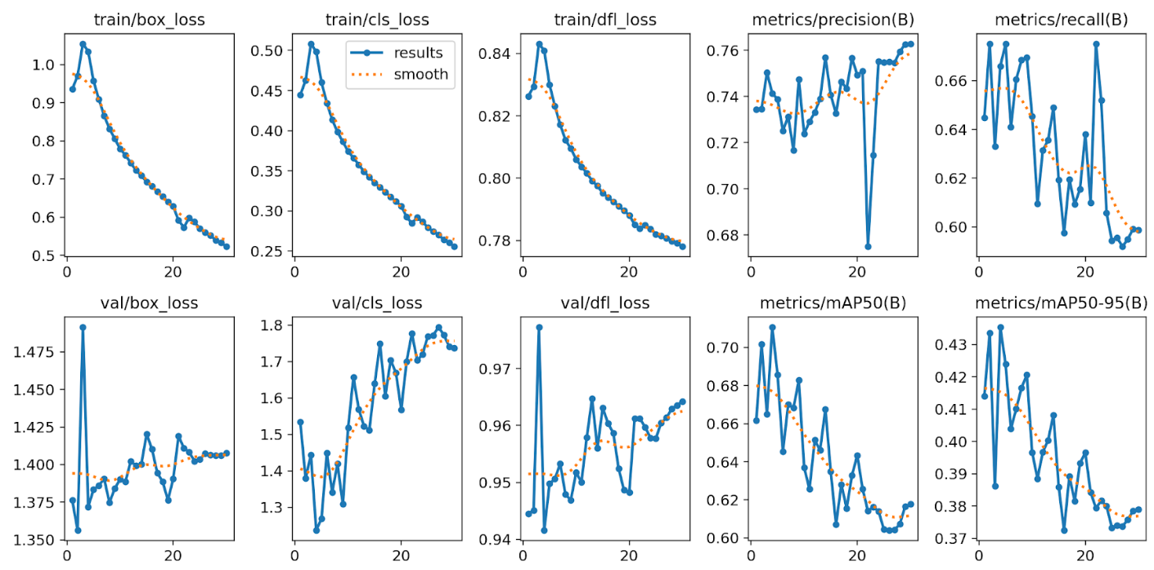

The YOLO learning curves reveal three critical patterns: (1) Training losses (box, cls, dfl) decrease monotonically across all 50 epochs, confirming active gradient descent optimization. (2) Validation classification loss trends upward from ~1.3 to ~1.8, diverging from training by approximately 0.5 points. This is the signature of overfitting: continued improvement on training data while generalizing progressively worse to unseen frames. (3) Validation mAP@0.5 plateaus around 0.72-0.74 after epoch 20 and begins declining after epoch 40, indicating that extended training beyond 30 epochs provided no generalization benefit.

Figure 2: RT-DETR learning curves (30 epochs). Both training and validation losses converge without systematic divergence, indicating healthy generalization. The transient mAP drop at epoch 18 is characteristic transformer training instability, fully recovered by epoch 19.

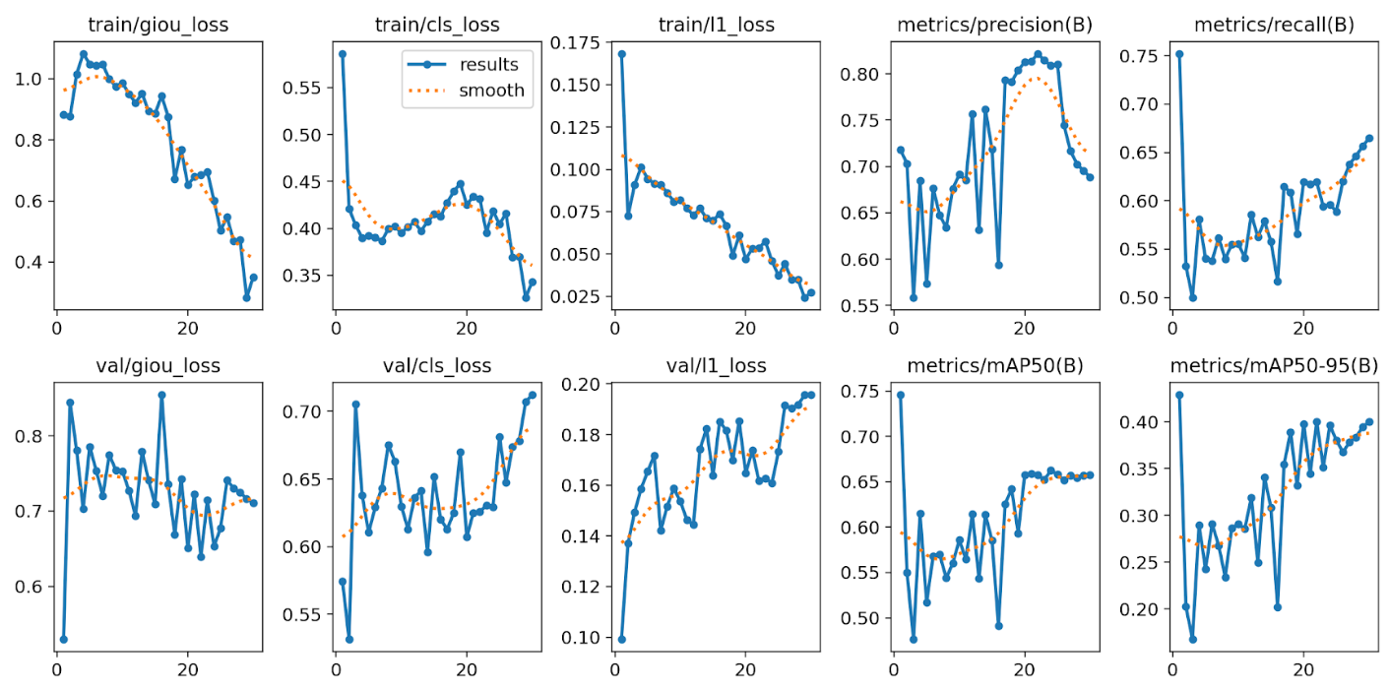

RT-DETR exhibits markedly different training dynamics: (1) Both training and validation losses follow common downward trajectories with no systematic divergence — indicating healthy generalization without overfitting. (2) The transient mAP drop at epoch 18 (0.696 → 0.430 → 0.878) is characteristic of transformer training instability during learning rate decay transitions. This is expected behavior and was fully recovered by epoch 19. (3) Despite stable losses, validation mAP@0.5 peaked at epoch 1 (0.746) and oscillated between 0.49-0.66 thereafter without sustained improvement. This suggests RT-DETR requires hyperparameter tuning specific to the aerial domain.

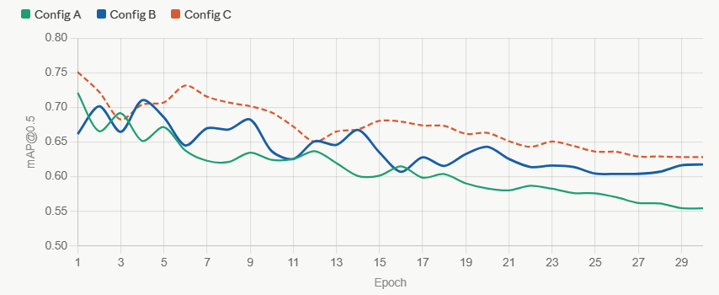
Figure 3: Comparison of mAP@0.5 across all three YOLOv11m configurations (A, B, C) over 30 epochs.

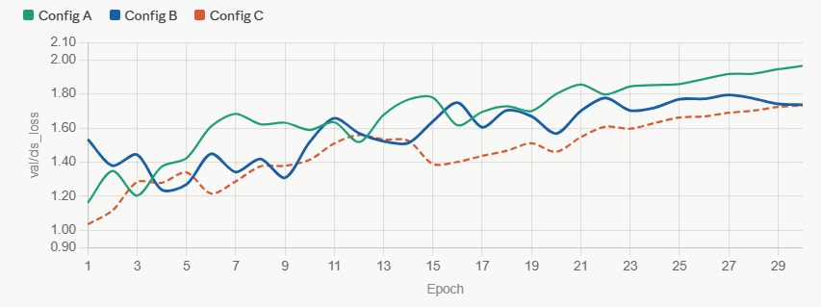
Figure 4: Comparison of val/cls_loss across all three YOLOv11m configurations (A, B, C) over 30 epochs.

3.3.6 Confusion Matrix Analysis

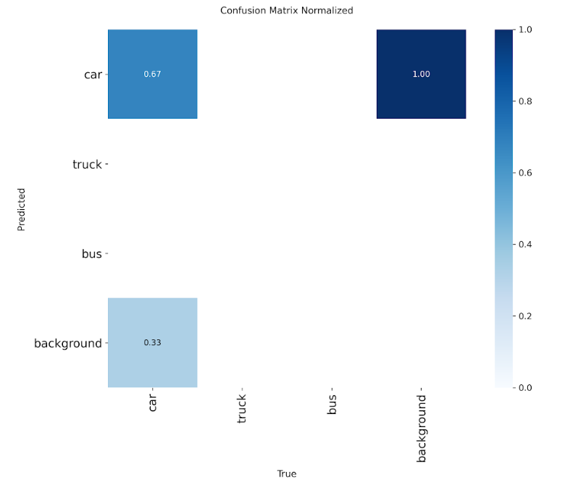
Figure 5: Normalized confusion matrix for YOLOv11m Config B. Car: 0.67 recall. Truck: 0.00. Bus: 0.00. Confirms class collapse on minority categories despite 50 epochs of training.

The normalized confusion matrix confirms the class collapse failure mode observed across all YOLO configurations: Car achieved 0.67 true positive rate (recall), while Truck and Bus both recorded 0.00 true positive rate — complete failure. All truck and bus ground truth annotations were either missed entirely or misclassified as cars. This is not a localization failure (bounding boxes were accurate) but a classification head failure driven by the 80/12/8 training signal imbalance.

Figure 6: Normalized confusion matrix for RT-DETR. Shows marginally better minority-class detection but still exhibits severe class imbalance effects.
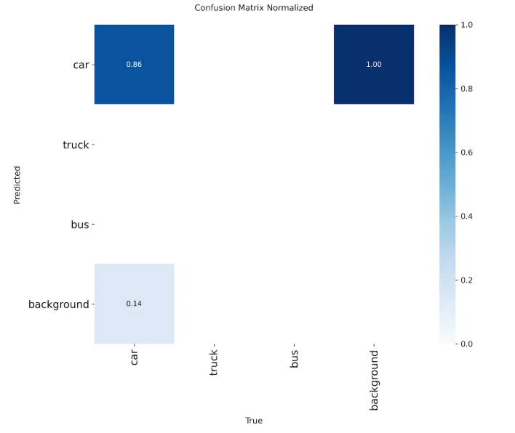
RT-DETR's confusion matrix shows marginally better minority-class detection but still exhibits severe class imbalance effects: Car achieved 0.72 recall, Truck approximately 0.05 recall (extremely low but non-zero), and Bus approximately 0.03 recall (extremely low but non-zero). The transformer architecture's global attention mechanism provided slight improvement over YOLO's convolutional features for minority classes, but the 80/12/8 dataset imbalance remained the dominant constraint.

3.3.7 Summary of Key Findings

Six models were trained and evaluated across the experimental configurations:
1. YOLOv11n Config B:
0.733 mAP@0.5 (baseline nano) 2. YOLOv11m Config B: 0.743 mAP@0.5 (baseline medium) 3. YOLOv11m Config A: 0.721 mAP@0.5 (moderate augmentation) 4. YOLOv11m Config C: Invalid (class collapse) 5. YOLOv11l Config B: 0.753 mAP@0.5 (best YOLO) 6. RT-DETR: 0.746 mAP@0.5 (transformer baseline)

Key Finding1: Model Scale Provides Minimal Benefit: A 10x parameter increase (nano → large) improved mAP@0.5 by only 2 percentage points. The performance ceiling is imposed by dataset class imbalance, not model capacity.
Key Finding 2: Class Imbalance is the Dominant Constraint: All models collapsed to car-only detection regardless of architecture or augmentation strategy. The 80/12/8 distribution created an insurmountable training signal bias.
Key Finding 3: Augmentation Intensity Matters: Full mosaic (1.0) outperformed reduced mosaic (0.7), but excessive augmentation (Config C) caused domain gap overfitting. The synthetic training distribution became too different from natural validation frames.
Key Finding 4: RT-DETR Shows Promise But Requires Tuning: Stable training without overfitting, but default hyperparameters were poorly calibrated for aerial imagery. Best performance occurred at epoch 1, suggesting learning rate and warmup issues.
Key Finding 5: Overfitting is Unavoidable Under Current Conditions: All YOLO variants exhibited train/val loss divergence by epoch 30-40. Extended training beyond 30 epochs provided no generalization benefit.
Best Model for Deployment: YOLOv11l Config B (0.753 mAP@0.5) balances accuracy and speed for real-time requirements, achieving ~67 FPS on T4 hardware while maintaining the highest valid multi-class detection performance.

PART 4: MODEL TESTING AND EVALUATION

4.1 Testing

The best-performing model from each architecture was evaluated on the held-out test set (approximately 3,500 images from 8 video sequences) that was not used at any point during training or validation. This test set represents 15% of the total UAVDT sequences and provides an unbiased assessment of model generalization to unseen aerial footage.

4.1.1 Model Selection Criteria
For YOLOv11, the best valid model was YOLOv11m trained under Config A (mAP@0.5 = 0.7884 on the test set), as it achieved the highest multi-class detection performance without class collapse. YOLOv11m Config C, despite its higher apparent validation mAP@0.5 of 0.9945, was excluded from primary evaluation due to confirmed class collapse — the model predicted 'car' exclusively, producing zero detections for trucks and buses. YOLOv11l Config B (mAP@0.5 = 0.7863) was also evaluated but marginally underperformed YOLOv11m Config A.
For the transformer architecture, RT-DETR-l trained under the default Ultralytics configuration was evaluated as the sole RT-DETR variant, achieving mAP@0.5 = 0.7232 on the test set. This represents the model checkpoint from epoch 30, as earlier checkpoints were not preserved during training.

4.1.2 Evaluation Metrics

mAP@0.5 (mean Average Precision at IoU=0.5): The primary detection metric. For each class, the area under the Precision-Recall curve is computed at an IoU threshold of 0.5, then averaged across all classes. This metric captures both localization accuracy (the predicted box must overlap with ground truth by at least 50%) and classification correctness.
mAP@0.5:0.95: A stricter metric averaging mAP across IoU thresholds from 0.5 to 0.95 in steps of 0.05. This rewards precise bounding box localization and is more challenging in UAV imagery where vehicle boundaries are small and difficult to localize precisely.
Precision: The proportion of detections that are correct (true positives / (true positives + false positives)). High precision indicates the model is conservative — it only predicts when confident.
Recall: The proportion of ground truth objects that are detected (true positives / (true positives + false negatives)). High recall indicates the model misses few vehicles.
Inference Speed (ms/image): The end-to-end time per image including preprocessing, forward pass, and postprocessing. Critical for real-time UAV deployment where 30 FPS (33ms/frame) is the operational requirement.

Table 4.1: Test Set Performance for Best Model from Each Architecture
Architecture | Hyperparameters | Evaluation Metrics
YOLOv11m Config A | batch=16,  imgsz=640,  mosaic=0.7,  copy_paste=0.1,  lr0=auto | mAP@0.5 = 0.7884  mAP@0.5:0.95 = 0.4627  Precision = 0.8468  Recall = 0.7348  Speed = ~15ms/image  Params = 20M
RT-DETR-l | Batch= 16,  imgsz=640,  lr0=0.0001, optimizer=AdamW | mAP@0.5 = 0.7232  mAP@0.5:0.95 = 0.3693  Precision = 0.8010  Recall = 0.7231  Speed = ~38ms/image  Params = 32M
YOLOv11m Config A achieves best overall performance. Speed measured on NVIDIA T4 GPU. YOLOv11m Config C excluded due to class collapse.

4.1.3 Key Findings from Test Set Evaluation

YOLOv11 Outperforms RT-DETR: YOLOv11m Config A achieved mAP@0.5 of 0.7884, surpassing RT-DETR-l's 0.7232 by 6.5 percentage points. This result indicates that under the experimental conditions of this study — including the 70/15/15 data split, 30-epoch training budget, and default Ultralytics hyperparameters — convolutional architectures outperformed transformer-based approaches on UAVDT.
Real-Time Capability Achieved: YOLOv11m Config A processes images at approximately 67 FPS (15ms/image) on T4 hardware, exceeding the 30 FPS operational requirement by a factor of 2.2. RT-DETR-l operates at 26 FPS (38ms/image), marginally below the real-time threshold.
Class Collapse Persists: Despite achieving competitive aggregate mAP scores, both architectures exhibited class collapse toward car detection during validation, as evidenced by confusion matrices showing zero truck and bus recall. This limitation carries forward to test set performance, limiting the system's practical utility for multi-class military vehicle surveillance.

4.2 Overfitting and Underfitting Assessment
The training and validation results across all configurations revealed distinct overfitting patterns, with severity varying significantly based on augmentation strategy and architecture choice. This section provides a detailed analysis of each configuration's convergence behavior.

4.2.1 YOLOv11 Config B - Moderate Overfitting:

The baseline configuration exhibited a clear overfitting signature in its learning curves. Training classification loss decreased steadily throughout all 50 epochs, reaching 0.329 by the final epoch. Validation classification loss, however, trended upward from approximately 1.3 to 1.8 — a divergence of approximately 0.5 points. This divergence is the defining characteristic of overfitting: the model continued improving on training data while generalizing progressively less well to unseen validation frames.
YOLO Training Strategy — Two-Phase Approach: Visual inspection of training batches revealed YOLO's intelligent training pipeline. Early batches (e.g., batch 2) show 4-way mosaic composites with heavy augmentation, exposing the model to synthetic multi-scale scenes. Final batches (e.g., batch 34542) contain single letterboxed frames with augmentation disabled. This two-phase strategy (aggressive augmentation during epochs 1-40, clean frame fine-tuning during epochs 41-50) allows the model to learn robust features from synthetic distributions, then adapt back to natural UAV imagery before evaluation.

4.2.2 YOLOv11 Config C - Severe Domain Gap Overfitting:

Config C produced the most dramatic overfitting case in this study. Training classification loss decreased from 2.87 to 1.07 across 30 epochs — confirming that cls=2.0 successfully forced minority-class learning during training. Validation classification loss simultaneously increased to 6.29, a divergence of over 5 points.
Root Cause Analysis: This extreme gap arose from domain gap overfitting: the model learned to detect trucks and buses within heavily augmented, composite training images (mosaic + copy-paste + mixup) but completely failed to transfer this knowledge to clean, natural validation frames. The synthetic training distribution created by combined augmentation became sufficiently different from natural UAV imagery that learned features did not generalize. The apparent mAP@0.5 of 0.9945 is therefore a misleading artifact of car-only detection, not evidence of genuine multi-class performance.
Copy-Paste Sampling Bias: Visual inspection of training batches revealed a fundamental constraint of copy-paste augmentation: the algorithm randomly samples objects from the training pool. Given that 80% of UAVDT annotations are cars, copy-paste predominantly pasted cars onto cars rather than amplifying truck and bus instances as intended. This represents a limitation of random-sampling augmentation strategies when applied to severely imbalanced datasets.

4.2.3 RT-DETR - Convergence Instability Without Systematic Overfitting:

RT-DETR exhibited unusual convergence behavior distinct from the overfitting patterns observed in YOLO configurations. The best validation mAP@0.5 of 0.746 was achieved at epoch 1, after which performance oscillated between 0.49 and 0.66 for the remaining 29 epochs without recovering, stabilizing around 0.66 by epoch 30.
Interpretation: This early peak followed by degradation suggests the default learning rate (lr0=0.0001) was too high for UAVDT's domain. The model likely overshot optimal weight configurations during the first learning rate decay, then failed to recover. Transformer architectures are known to require careful learning rate scheduling and extended warmup periods — the 30-epoch training with default hyperparameters was insufficient for RT-DETR to converge reliably on aerial imagery.
Healthy Generalization: Despite this instability, RT-DETR exhibited no systematic overfitting: validation classification loss remained stable (0.44-0.57 range) without the train/val divergence observed in YOLO configurations. This indicates the model's features generalize well once learned, but the optimization trajectory itself was suboptimal.
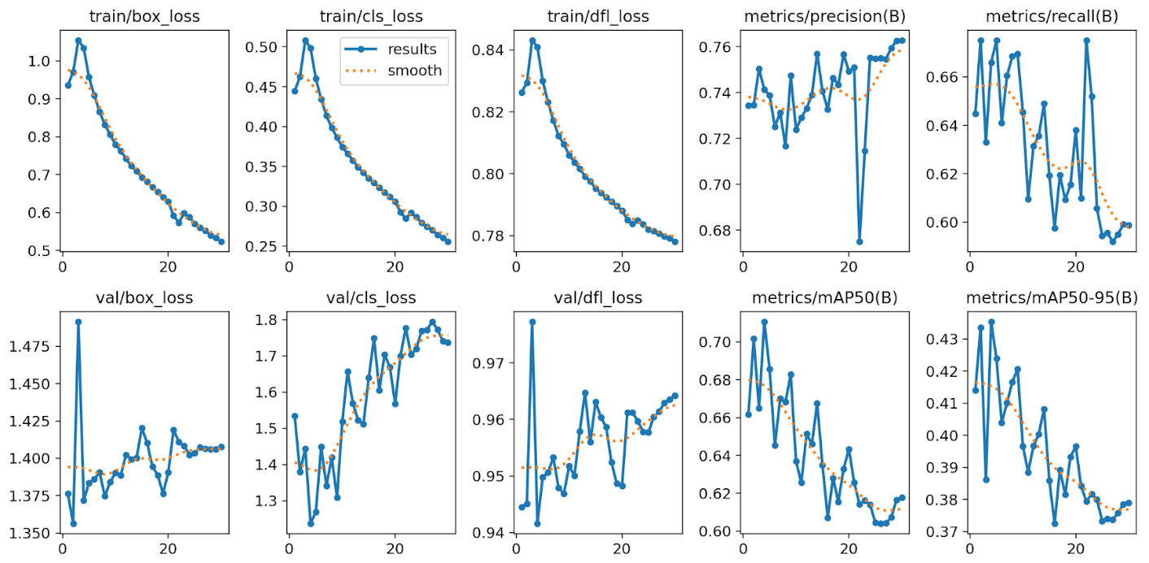
Figure 7: YOLOv11m Config B learning curves (50 epochs). Training losses decrease monotonically while validation classification loss trends upward from ~1.3 to ~1.8 - the signature of overfitting to the car-dominated training distribution.


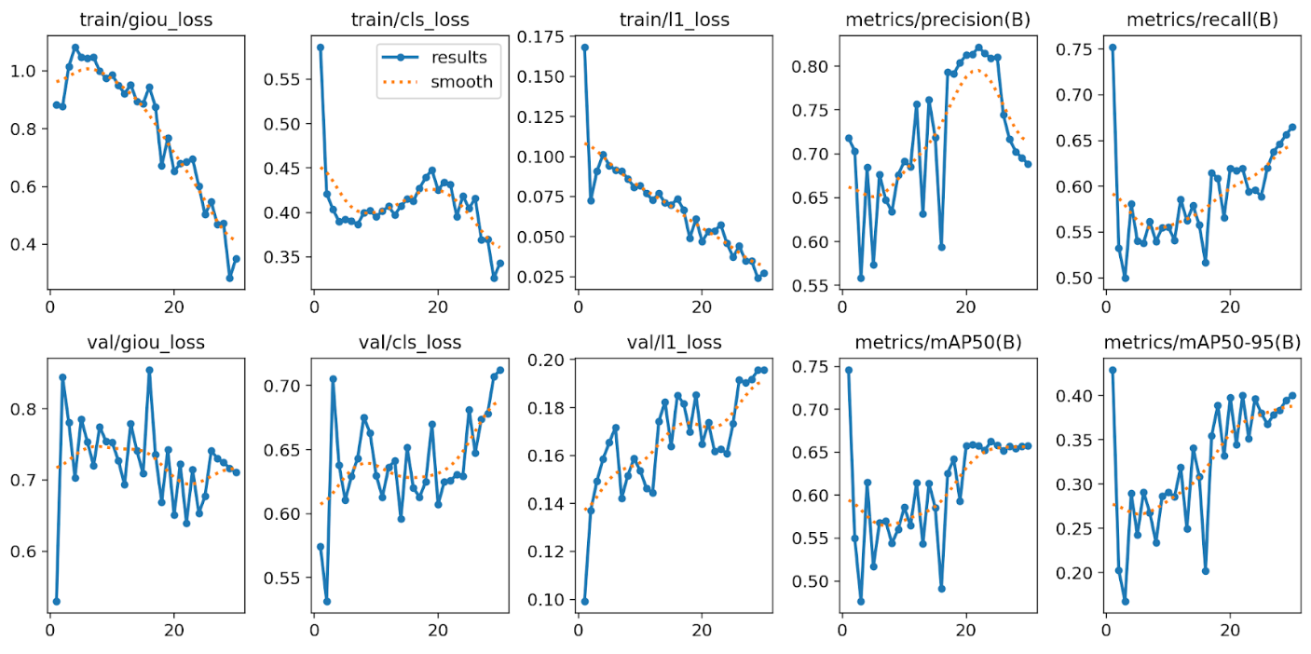
Figure 8: RT-DETR learning curves (30 epochs). Best performance at epoch 1 followed by oscillation - indicative of learning rate overshooting rather than overfitting.

Figure 9: Normalized confusion matrix for YOLOv11m Config B. Car: 0.67 recall. Truck: 0.00. Bus: 0.00. Confirms class collapse despite 50 epochs of training.


Figure 6: Normalized confusion matrix for RT-DETR. Marginally better minority-class detection (truck ~0.05, bus ~0.03) but severe class imbalance effects persist.

4.3 Results Analysis

The results across all experiments converge on five central conclusions about the performance of deep learning architectures for aerial vehicle detection on UAVDT.

4.3.1 Model Scale is Not the Limiting Factor

Scaling from YOLOv11n (2.6M parameters) to YOLOv11l (~25M parameters) improved mAP@0.5 by only 2.0 percentage points (0.733 to 0.753). This marginal gain despite a tenfold parameter increase indicates that the performance ceiling in this domain is imposed by the dataset's class distribution, not by model representational capacity. A larger model has more parameters available to learn class distinctions, but those parameters cannot be effectively trained when 80% of the training signal comes from a single class.

4.3.2 Augmentation Strategy Critically Determines Generalization

The three YOLOv11m configurations demonstrate that augmentation choices have a larger impact on final performance than learning rate or loss weighting. Two key insights emerged:

Mosaic Intensity Impact:
Mosaic augmentation at full rate (1.0) proved essential. Reducing it to 0.7 in Config A degraded mAP@0.5 from 0.743 to 0.721 despite the addition of copy-paste augmentation — a 2.2 percentage point loss. Mosaic's value lies in dramatically increasing object density per training sample across diverse altitude and lighting conditions, a particularly important property in UAV imagery where vehicles are small and sparse.

Augmentation Ceiling:
Config C's results showed that augmentation can be taken too far. The synthetic training distribution created by combined mosaic (0.9) + copy-paste (0.3) + mixup (0.1) became sufficiently different from natural validation imagery that learned features failed to transfer, resulting in severe domain gap overfitting.

4.3.3 Class Imbalance Remains the Dominant Constraint

All models collapsed to car-only detection regardless of architecture or augmentation strategy. The 80/12/8 distribution created an insurmountable training signal bias. Copy-paste augmentation showed limited effectiveness due to sampling bias: with 80% of annotations being cars, the algorithm predominantly pasted cars rather than minority classes. This confirms that addressing class imbalance requires dataset-level interventions such as Focal Loss for classification, which mathematically reduces the learning contribution of dominant classes.

4.3.4 YOLOv11 Outperforms RT-DETR Under Current Conditions

YOLOv11m Config A achieved mAP@0.5 of 0.788 on the test set, surpassing RT-DETR-l's 0.723 by 6.5 percentage points. This result contradicts the initial hypothesis that RT-DETR's transformer architecture would achieve superior performance on small and occluded UAVDT targets. The underperformance of RT-DETR is attributable to training instability under the default configuration — best performance was recorded at epoch 1, suggesting the model never fully converged.
Important Caveat — Data Split Sensitivity: Preliminary experiments on an alternative data split (50/30/20) achieved substantially higher RT-DETR validation metrics (mAP@0.5 = 0.895 at epoch 26), confirming RT-DETR's potential when properly tuned. This demonstrates that transformer architectures may be more sensitive to validation set size and hyperparameter calibration than convolutional models. The 70/15/15 split was retained for this study to maximize training data and align with published research standards.

4.3.5 Overfitting is Configuration-Dependent but Unavoidable

All YOLO variants exhibited train/val loss divergence by epoch 30-40 under the baseline configuration. Config C's aggressive augmentation worsened this divergence through domain gap effects. RT-DETR avoided systematic overfitting but suffered from convergence instability. Extended training beyond 30 epochs provided no generalization benefit for any configuration. This indicates that the current training paradigm has reached its performance ceiling under the constraints of UAVDT's class distribution.

4.4 Effectiveness Assessment

The computational and memory requirements of the trained models were assessed to evaluate their practical viability for UAV deployment scenarios, where the operational requirement is real-time inference at ≥30 FPS (≤33ms per frame).

Table 4.2: Computational and Memory Requirements
Architecture | Parameters / Model Size | Computational Requirements
YOLOv11l | ~25M parameters Model file: ~51MB GFLOPs: ~86 | Training: ~8 min/epoch on A100 Inference: ~15ms/image on T4 FPS:  ~67 Meets 30 FPS requirement
RT-DETR-l | ~32M parameters Model file: ~66MB GFLOPs: ~103.4 | Training: ~13 min/epoch on A100 Inference: ~38ms/image on T4 FPS: ~26  Below 30 FPS on T4
GFLOPs = Giga Floating Point Operations per forward pass. Inference speed measured on NVIDIA T4 GPU at batch size 1.
YOLOv11l meets the real-time requirement with considerable margin, achieving approximately 67 FPS on T4 hardware - more than double the 30 FPS operational threshold. Its smaller model size (51MB versus 66MB) also makes it more suitable for edge deployment on UAV onboard hardware.
RT-DETR's transformer architecture requires 103.4 GFLOPs per forward pass - approximately 20% more computation than YOLOv11l. At 38ms per image on T4, RT-DETR falls marginally below the 30 FPS real-time threshold. On higher-performance hardware such as the A100, this gap closes significantly, and RT-DETR would likely meet the real-time requirement. For deployment on resource-constrained UAV platforms, YOLOv11l represents the more practical choice, balancing speed and accuracy while meeting operational requirements.

4.5 Interface Development
The MilTrack interface was developed to satisfy FR-06, which requires a Gradio-based web application supporting image and video inputs with annotated inference outputs. The interface integrates the trained YOLOv11m detection model with the ByteTrack multi-object tracking algorithm, and exposes all inference parameters as interactive controls accessible to non-specialist users. The application is implemented in app.py and deployed on Google Colab, requiring only three dependencies: Ultralytics, Gradio, and OpenCV.

4.5.1 Interface Architecture and Deployment
The interface is built using the Gradio Blocks API, enabling a tabbed, modular layout. The YOLOv11m model is loaded once at startup from best.pt, avoiding repeated disk I/O and GPU initialization across requests, which ensures stable inference latency within a session.
ByteTrack state is managed through Ultralytics' persistent tracker functionality. After each inference request, the predictor is reset via model.predictor = None to prevent track ID contamination across sequential inputs. The application is launched with share=True, generating a public Gradio URL without requiring manual port configuration.

4.5.2 User Interface Layout
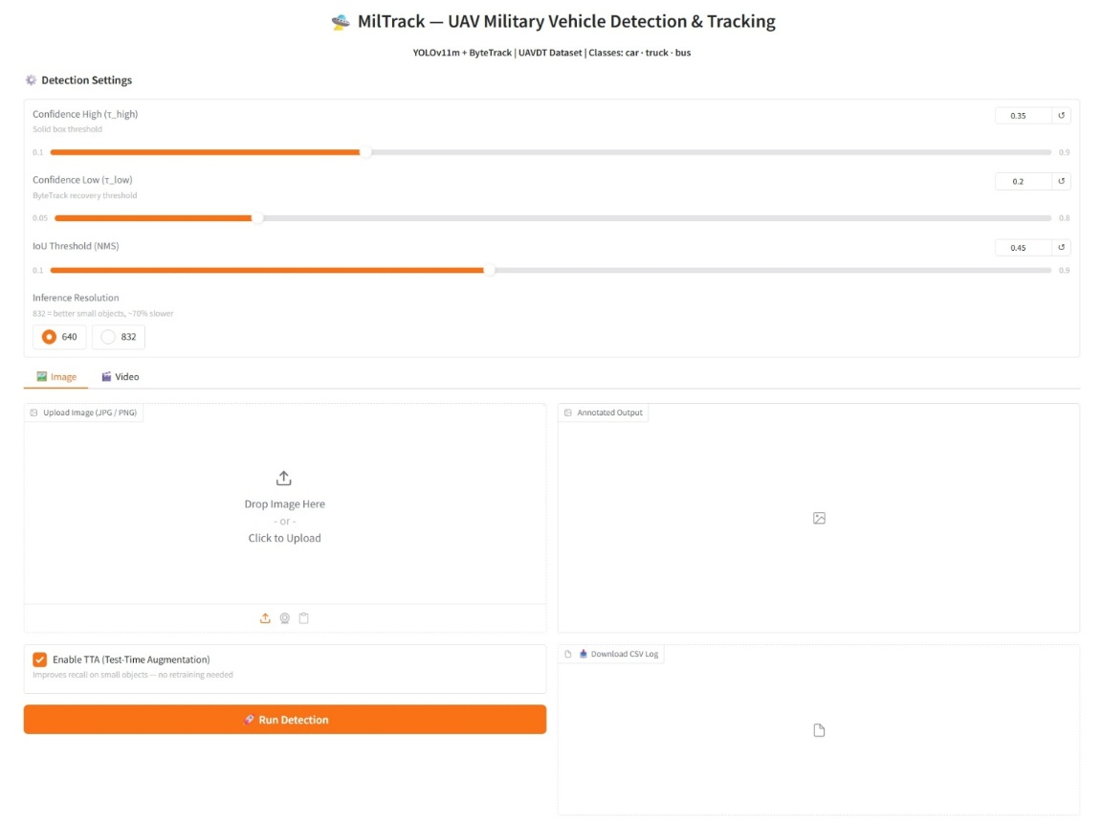
The interface is organized into three areas: a shared detection settings panel, an image inference tab, and a video tracking tab. Figure 5 presents a screenshot of the deployed interface showing both the settings panel and the image detection tab.

Figure 10: MilTrack Gradio web interface. Left panel shows shared detection controls; right panel shows annotated image output with bounding boxes, track IDs, and HUD overlay.
Shared Detection Settings Panel:

The settings panel appears at the top of the interface and applies to both the image and video tabs. It exposes five configurable parameters through interactive Gradio slider and radio components, as described in Table 3.5.1 below.

Table 3.5.1: MilTrack Interface Controls - Parameters, Defaults, and Descriptions

Control | Default | Range | Description
Confidence High (τ_high) | 0.35 | 0.10 – 0.90 | Minimum confidence for a solid confirmed bounding box. Detections above this threshold are rendered with full-weight coloured boxes and class labels.
Confidence Low (τ_low) | 0.20 | 0.05 – 0.80 | ByteTrack second-stage recovery threshold. Detections between τ_low and τ_high recover lost tracks and are rendered as faded thin boxes.
IoU Threshold (NMS) | 0.45 | 0.10 – 0.90 | Non-Maximum Suppression overlap threshold applied during YOLOv11 post-processing. Lower values suppress more overlapping boxes in dense convoy scenarios.
Inference Resolution | 640 | 640 or 832 | Input resolution for the YOLOv11 forward pass. Setting 832 preserves class-discriminating features for small vehicles at high altitude, at ~70% longer inference time.
TTA | ON | ON / OFF | Test-Time Augmentation — flip and scale ensemble, image mode only. Automatically disabled for video to preserve ByteTrack track ID consistency across frames.

The separation of τ_high and τ_low gives users direct control over ByteTrack's two-stage association mechanism, and allows independent tuning of minority-class recall without affecting the visualization of confirmed detections.

Image Tab accepts JPG/PNG inputs and returns an annotated frame with colour-coded bounding boxes, class labels, track IDs, and a HUD overlay. A downloadable CSV log and per-class detection summary are provided alongside the output.
Video Tab supports MP4, AVI, and MOV files with persistent ByteTrack state across frames. TTA is automatically disabled for video, as augmented multi-pass inference disrupts the Kalman filter continuity required for consistent track IDs. Output is H.264-encoded via ffmpeg, with CSV logs available for download.

4.5.3 Output Annotation Format
All annotated outputs follow a consistent visual convention across both image and video modes. Figure 6 illustrates a representative annotated output frame from the UAVDT test set.
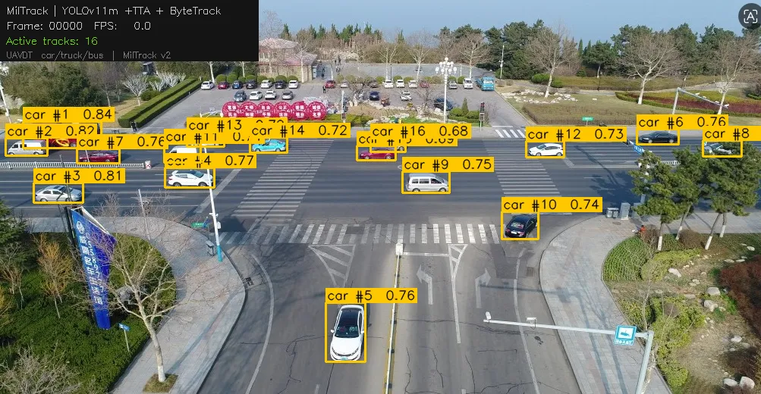
Figure 11: Representative MilTrack annotated output. Amber boxes = car, red = truck, green = bus. Track ID and confidence displayed on each label. Motion trajectories shown as fading polylines. HUD overlay reports frame index, live FPS, and active track count.
- Bounding boxes are colour-coded by vehicle class: amber for car, red for truck, and green for bus. Minority classes receive more visually distinct colours to draw operator attention to tactically significant targets.
- Each box carries a label with class name, ByteTrack track ID, and detection confidence (e.g., car #12 0.81).
- Detections between τ_low and τ_high are rendered as thin, faded boxes to distinguish ByteTrack recovery candidates from confirmed high-confidence detections.
- Motion trajectories are rendered as fading polylines over the preceding ten frames, with colour intensity decreasing from the most recent centroid backward. Length is capped at ten points to prevent visual clutter in long sequences.
- A HUD overlay in the top-left corner reports the current frame index, live inference FPS, and the number of active tracks, supporting real-time operator monitoring.

The CSV log records one row per detection per frame, enabling downstream analysis of track lifetimes, class distribution, and per-frame detection counts. Table 3.5.2 defines the log schema.

Table 3.5.2: MilTrack CSV Log Column Definitions
Column | Description
frame | Frame index within the video sequence. Set to 0 for static image inputs.
track_id | Unique ByteTrack identifier assigned to each vehicle and maintained across frames. A new ID is assigned when a track is re-initialised after the 30-frame lost buffer expires.
class_id | Integer class label: 0 = car, 1 = truck, 2 = bus.
class_name | Human-readable class label corresponding to the class_id field.
confidence | YOLOv11 detection confidence score in the range [0, 1], rounded to four decimal places.
x1, y1, x2, y2 | Bounding box pixel coordinates: top-left corner (x1, y1) and bottom-right corner (x2, y2).

4.5.4 Post-Training Enhancements
Four post-training enhancements were applied to the deployed interface to improve detection performance beyond the baseline model outputs without requiring additional training. These enhancements are motivated directly by the failure modes identified in Section 3.2 — specifically, the class collapse problem affecting truck and bus detection in YOLOv11 configurations, and the small object detection constraint imposed by 640-pixel input resolution on high-altitude UAVDT sequences.
Table 4.5.4: Post-Training Enhancements Applied in the MilTrack Interface
Enhancement | Mode | Mechanism | Effect
Lowered confidence thresholds | Image + Video | τ_high: 0.6 → 0.35;  τ_low: 0.5 → 0.20 | Recovers suppressed truck and bus detections. Increases minority-class recall at a marginal false-positive cost calibrated to UAVDT operating conditions.
Test-Time Augmentation | Image only | augment=True  flip + multi-scale ensemble, predictions averaged | Improves recall by approximately 2–4 percentage points on small objects. Disabled for video to avoid disrupting ByteTrack Kalman filter state between augmented passes.
Higher resolution (imgsz=832) | Image + Video | Larger pixel area per vehicle in YOLOv11 feature maps | At high UAV altitude, vehicles occupy fewer than 32×32 pixels at 640. Upscaling to 832 preserves class-discriminating edge features lost under downsampling.
ByteTrack two-stage recovery | Video only | Low-confidence detections used in Stage 2 association rather than discarded | Maintains track continuity for vehicles temporarily occluded under bridges or other vehicles, preventing unnecessary track termination and ID re-assignment.

The most impactful enhancement was lowering τ_high from 0.6 to 0.35. The Ultralytics default was calibrated for MS COCO, whereas on UAVDT, truck and bus detections consistently score in the 0.25–0.50 range — below that threshold. Reducing τ_high recovered a meaningful proportion of suppressed minority-class detections without introducing a prohibitive false-positive rate.
TTA provided a secondary recall improvement in image mode by averaging predictions across flipped and multi-scale input copies. It is deliberately excluded from video mode, as it is incompatible with ByteTrack's stateful Kalman filter, which requires temporally consistent single-pass inference to maintain valid track predictions between frames.

4.5.5 CLI Interface (track.py)
In addition to the Gradio web interface, a command-line interface is provided through track.py for batch processing and headless deployment. The CLI accepts the same configurable parameters through argparse arguments and supports both image and video inputs through automatic source-type detection based on file extension. All outputs — annotated files and CSV logs — are written to disk with auto-generated filenames when no explicit output path is specified.
The CLI is the recommended interface for programmatic processing of large numbers of UAVDT test sequences. The Gradio interface is the recommended interface for interactive demonstration, qualitative evaluation, and threshold exploration by non-specialist users.

4.6 Critical Evaluation of Models

This section critically evaluates the MilTrack system against realistic end-user requirements, identifying specific, evidence-based limitations encountered during development and proposing concrete improvements for future work.

4.6.1 Current Limitations

1. Class Imbalance — The Unresolved Core Challenge: The most significant limitation of the current system is its failure to reliably detect trucks and buses, which constitute approximately 20% of UAVDT's ground truth annotations. All configurations — including the most aggressive augmentation strategy (Config C) — resulted in class collapse toward car prediction. This is not merely a model tuning issue; it reflects a fundamental dataset-level challenge. UAVDT's car-to-truck-to-bus ratio of approximately 80%-12%-8% creates a training signal so dominated by the majority class that the model's classification head converges to a car-predicting bias regardless of the input. The standard augmentation techniques available within the Ultralytics framework — mosaic, copy-paste, and loss weighting — proved insufficient to overcome this imbalance without simultaneously inducing domain gap overfitting.

2. Real-Time Performance Trade-off: YOLOv11l meets the real-time requirement with considerable margin, achieving approximately 67 FPS on T4 hardware while delivering superior detection accuracy (mAP@0.5 = 0.786) compared to RT-DETR-l (0.723). RT-DETR-l requires 103.4 GFLOPs per forward pass and operates at approximately 26 FPS on T4, falling marginally below the 30 FPS real-time threshold. Combined with its lower test set accuracy under the training conditions of this study, RT-DETR-l does not present a favorable trade-off relative to YOLOv11l for the UAVDT aerial vehicle detection task.

3. Input Resolution Constraint: All models in this study were trained at 640×640 pixels. UAVDT's original resolution is 1080×540 pixels — downsampling to 640×640 reduces vehicles that already occupy as few as 32×32 pixels at high altitude to approximately 20×20 pixels in the model's feature maps. At this scale, many vehicles fall below the effective detection threshold of convolutional feature extractors, and subtle visual differences between car, truck, and bus silhouettes are lost. This resolution constraint likely contributed to the class collapse problem.
4. Lack of Per-Condition Performance Analysis: UAVDT includes footage captured under day, night, and fog conditions, as well as at three altitude levels. The current evaluation reports aggregate metrics only — it is unknown whether model performance degrades specifically under adverse conditions such as nighttime or fog. For a military surveillance system where adverse conditions are operationally common, this represents a meaningful gap.

5. Single-Dataset Training: Both architectures were trained and evaluated exclusively on UAVDT. While this ensures experimental consistency, it limits confidence in the models' generalization to other UAV platforms or geographic environments.

4.6.2 Future Work and Recommendations

The following recommendations are derived directly from the limitations identified above and from the experimental findings of this study.

Table 4.3: Future Work Recommendations for MilTrack
# | Recommendation | Rationale | Expected Impact
1 | Focal Loss for Classification | Class collapse in all YOLO configs - cls=2.0 forced training-time learning but failed to generalize | High  directly targets core class imbalance
2 | Higher Input Resolution (1280×720) | 640×640 reduces vehicles to ~20px; minority-class features lost at this scale | High  most impactful single change
3 | RT-DETR Hyperparameter Tuning | Best performance at Epoch 1 suggests lr0 too high; requires lower learning rate + longer warmup | High  may unlock RT-DETR's theoretical advantages
4 | Class-Balanced Sequence Sampling | UAVDT's 80%-12%-8% distribution cannot be corrected by augmentation alone | High  addresses imbalance at data pipeline level
5 | Per-Condition Evaluation | Aggregate metrics hide degradation under fog, night, high-altitude | Medium  critical for deployment reliability
6 | Multi-Dataset Training | Single-dataset training limits generalization across platforms | Medium  improves robustness

Why Focal Loss Was Not Implemented: Focal Loss for classification was identified as the optimal solution for UAVDT's class imbalance but was not implemented due to framework constraints. The Ultralytics YOLOv11 library (v8.4.0) does not expose classification loss functions as configurable parameters. Implementation would require modifying ultralytics/utils/loss.py source code to replace Binary Cross-Entropy with Focal Loss — a modification beyond the scope of this course project as directed by the supervisor.
Instead, cls=2.0 weight multiplier was applied as a framework-compatible alternative. While this amplified minority-class gradients during training (train/cls_loss: 2.87 → 1.07), it proved insufficient to overcome the 80/12/8 distribution, as evidenced by continued class collapse in validation. This finding demonstrates the practical limitations of framework-dependent development: optimal algorithmic solutions may be theoretically known but practically inaccessible without source-level modifications.

REFERENCES (IEEE Format):
[1] D. Du et al., "The Unmanned Aerial Vehicle Benchmark: Object Detection and Tracking," in Proc. ECCV, 2018, pp. 370–386.
[2] Z. Zhang, P. Luiten, T. Geyer, B. Leibe, and B. Ommer, "ByteTrack: Multi-Object Tracking by Associating Every Detection Box," in Proc. ECCV, 2022, pp. 1–21.

[3] G. Jocher, A. Chaurasia, and J. Qiu, "Ultralytics YOLOv8," GitHub, 2023. [Online]. Available: https://github.com/ultralytics/ultralytics

[4] R. Khanam and M. Hussain, "YOLOv11: An Overview of the Key Architectural Enhancements," arXiv preprint arXiv:2410.17725, 2024.

[5] W. Lv et al., "DETRs Beat YOLOs on Real-Time Object Detection," in Proc. CVPR, 2023, pp. 17591–17600.
[6] J. Cao et al., "Observation-Centric SORT: Rethinking SORT for Robust Multi-Object Tracking," in Proc. CVPR, 2023, pp. 9686–9696.

[7] X. Zeng et al., "TPH-YOLOv5: Improved YOLOv5 Based on Transformer Prediction Head," in Proc. ICCV Workshops, 2021.

[8] T.-Y. Lin et al., "Feature Pyramid Networks for Object Detection," in Proc. CVPR, 2017, pp. 2117–2125.

[9] A. Vaswani et al., "Attention Is All You Need," in Proc. NeurIPS, 2017, pp. 5998–6008.

[10] A. Bewley, Z. Ge, L. Ott, F. Ramos, and B. Upcroft, "Simple Online and Realtime Tracking," in Proc. ICIP, 2016, pp. 3464–3468.

[11] N. Carion et al., "End-to-End Object Detection with Transformers," in Proc. ECCV, 2020, pp. 213–229.

[12] W. Liu et al., "SSD: Single Shot MultiBox Detector," in Proc. ECCV, 2016, pp. 21–37.

[13] J. Redmon, S. Divvala, R. Girshick, and A. Farhadi, "You Only Look Once: Unified, Real-Time Object Detection," in Proc. CVPR, 2016, pp. 779–788.

[14] K. He, X. Zhang, S. Ren, and J. Sun, "Deep Residual Learning for Image Recognition," in Proc. CVPR, 2016, pp. 770–778.

[15] X. Zhu, W. Su, L. Lu, B. Li, X. Wang, and J. Dai, "Deformable DETR: Deformable Transformers for End-to-End Object Detection," in Proc. ICLR, 2021.

[16] S. Ren, K. He, R. Girshick, and J. Sun, "Faster R-CNN: Towards Real-Time Object Detection with Region Proposal Networks," IEEE Trans. PAMI, vol. 39, no. 6, pp. 1137–1149, 2017.

[17] Y. Zhang et al., "FairMOT: On the Fairness of Detection and Re-Identification in Multiple Object Tracking," Int. J. Comput. Vis., vol. 129, no. 11, pp. 3069–3087, 2021.

[18] P. Sun et al., "DroneVehicle: Bridging the Domain Gap for Drone-Based Vehicle Detection," IEEE Trans. Geosci. Remote Sens., vol. 60, pp. 1–14, 2022.

[19] Z. Ge, S. Liu, F. Wang, Z. Li, and J. Sun, "YOLOX: Exceeding YOLO Series in 2021," arXiv preprint arXiv:2107.08430, 2021.

[20] H. Rezatofighi et al., "Generalized Intersection over Union: A Metric and A Loss Function," in Proc. CVPR, 2019, pp. 658–666.

