American Community Survey - 2010 – 2014
Albert Alva | Rob Rivens | Samira Zarandioon

Abstract:
The goal of this study is to futher the understanding of the income disparty between men and women. It will investgate how geographaphy and education attainment effects the difference in the income of men and women.
Data from the National Center for Education Statistics was used in the exploration. Analysis confirmed men have higher income. This difference is influenced by
,
1. Introduction
Women are paid at a lower rate than men. This has been consistent over time despite awareness and regulation designed to prevent it. In fact, in 2011, the Economic Policy Institute reported the trend in inequality is increasing [1].

Income disparity in the United States is a well-researched subject. Donna Bobbitt-Zeher illustrated the disparity in terms of total dollars [2].

2. Methods
2.1 Data / Technology
Dataset of annual incomes estimates for men and wemen over 25 years of age by geographic location, and education attained was obtained from the National Center for Educational Statititics.
The data was imported into a Mysql database and normalized using MySQL Workbench 6.3. Appendix A contains the EER diagram. Python 2.7.13 |Anaconda 4.0.0 (64-bit)| (default, May 11 2017, 13:17:26) [MSC v.1500 64 bit (AMD64)] was used to process the data. Microsoft Excel 360 proplus and Tableau 9.3.

3. Results
3.1 National Income
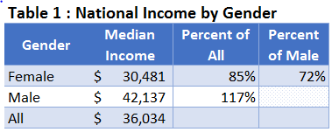
Initial analysis showed national median salaries estimated at $36,034 and ranged from $18,262 in Utah and $55,100 in Washington D.C. The disparity in income is apparent at the national level. Table 1 shows while females only earned 85% of the median, men earned 117% of the median national income. Furthermore, females earned only 72% of that of their male counterparts. Washington D.C. leads salary at all degree levels, and, as expected, males in Washington D.C. also lead income (Figure 1)
Pueto Rico was on the other end of the range at only $18,262.
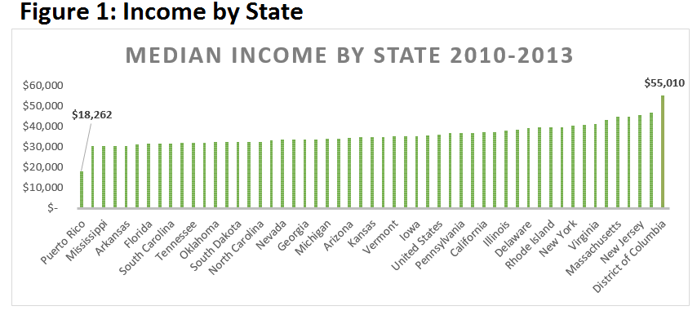  The States that showed the least disparity and even a reverse of the trend are lead by Pueto Rico where women earned 103% of mens income. The next closest States were Washington D.C. Nevada at 90% and 81% respectively figure(2). | 0.808500987
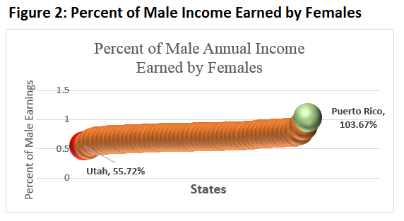 | 0.896728278
Utah and Wyoming had the highest difference in earnings at 56% followed by and women from Louisiana earning 61% of men’s earnings. | 1.036741748

3.2 Income and Education
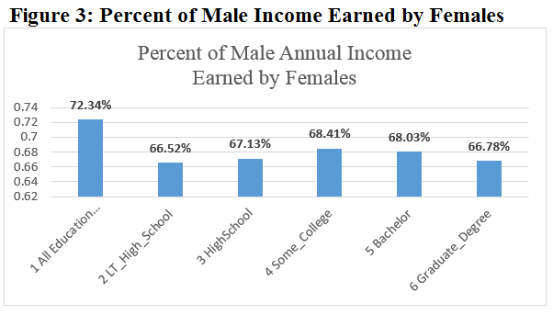
When income is stratified by education level, the disparity is even greater, the closest income was for women with some college, 68.41%. Even more discurageing was the result that women with less then a highschool education and women that have graduate degrees both only make 65% of the income men earn (Figure 3).

Street address-level data was added and analyzed in Tableau, the illustration shows how median salaries are impacted by values above and below the median salaries across the state. The darker shaded areas are the highest annual income areas (Figure 4). Florida’s median income is aprox. $31K with a range between $18,318 and $59,068.

Figure 4: Income disparity by county in Florida.

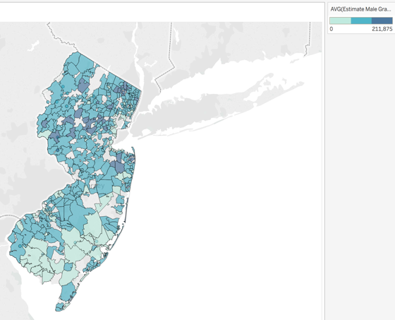

The disparity of male vs female median annual salaries is most obvious in the northeastern region of the United States.

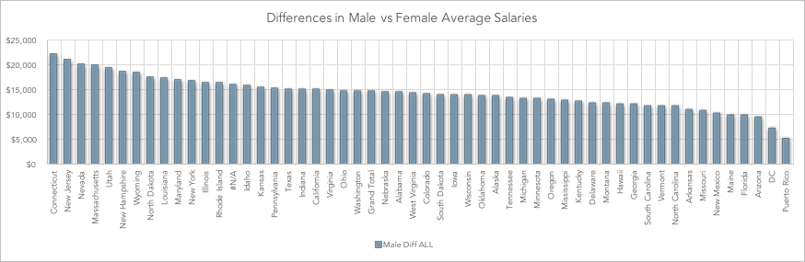

Figure 5: Differences Male and Female Income
Connecticut has the largest variance, with males earning almost $25K more than females with similar backgrounds (figure 5).
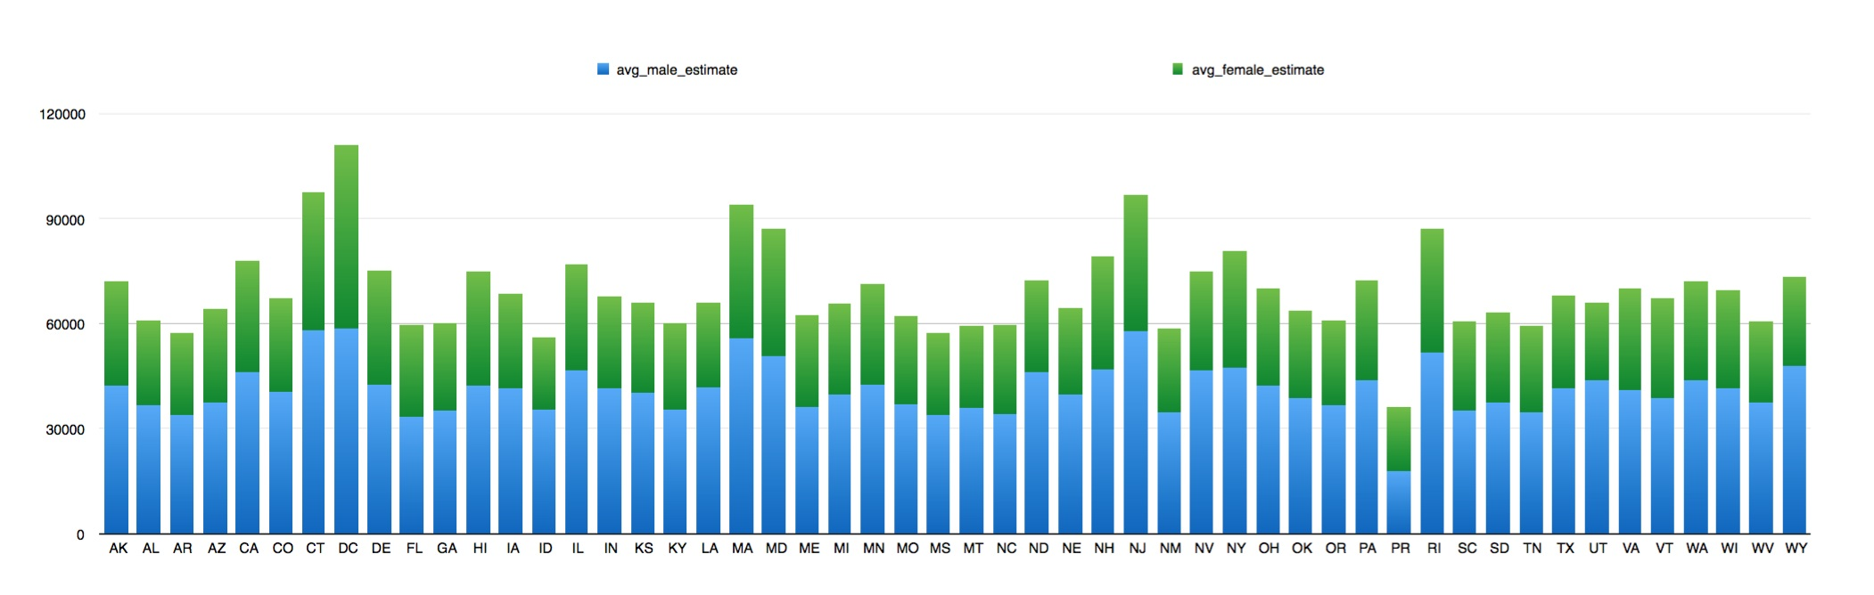
The lowest variances are seen in Puerto Rico, however, this is due to the lower overall median annual salaries across education groups.
The disparities are evident on figure 6. It shows both male and female incomes. It shows Washington DC incomes almost even and Utah with females earning just over half what men earn.

4. Conclusion
The results of this study shows that there is still a disparitiy in the income between men and women in America. The gap is a consistant 65%. This study was able to show that income increases with education attained for both men and women. This is consistant across the Uniited States. What also consitant, with only Puerto Rico reversing the trend, was that females still earn less then men. This is consistant across all education levels as well.
More investigation needs to be conducted to better understand why these trends are so enduring.
References:
1 Economic Policy Institute. 2011. “Upper Tail” inequality growing steadily: Men's wage inequality, 1973-2009. Washington, D.C.: Economic Policy Institute. May 11, 2011

2 Donna Bobbitt-Zeher, The Gender Income Gap and the Role of Education, Sociology of Education, vol. 80, 1: pp. 1-22., First Published Jan 1, 2007.

Appendix A: Study Database EER Diagram

