case_study_2

Ghizlane Zerouali and Samira Zarandioon

April 21, 2017

# Question 1

## SAS code:

proc iml;  
reset print;  
A={4 5 1 2, 1 0 3 5, 2 1 8 2};  
quit;

Output:

A 3 rows 4 cols (numeric)

4 5 1 2 1 0 3 5 2 1 8 2

## R code:

mymat = matrix(c(4,5,1,2,1,0,3,5,2,1,8,2), ncol = 4, byrow = TRUE)  
mymat

## [,1] [,2] [,3] [,4]  
## [1,] 4 5 1 2  
## [2,] 1 0 3 5  
## [3,] 2 1 8 2

## Python Code:

import numpy as np  
a = np.matrix('4 5 1 2; 1 0 3 5; 2 1 8 2')  
print(a)

## [[4 5 1 2]  
## [1 0 3 5]  
## [2 1 8 2]]

# Question 2

#install.packages("tseries")  
library(tseries)  
XOMData <- get.hist.quote("xom", quote = "Close")

## time series ends 2017-04-21

XOMret <- log(lag(XOMData)) - log(XOMData)  
  
XOMVol <- sd(XOMret) * sqrt(250)* 100  
  
## volatility get  
getVol <- function(d, logrets) {  
 var = 0  
 lam = 0  
 varlist <- c()  
 for (r in logrets) {  
 if (! is.na(r)) {  
 lam = lam*(1-1/d)+1  
 var=(1-1/lam)*var+(1/lam)*r^2  
 varlist <- c(varlist, var)  
 }  
 }  
 sqrt(varlist)  
}  
  
volest <- getVol(10,XOMret)  
volest2 <- getVol(30,XOMret)  
volest3 <- getVol(100,XOMret)  
  
plot(volest, type="l")  
lines(volest2, type="l", col="yellow")  
lines(volest3, type="l", col="Red")

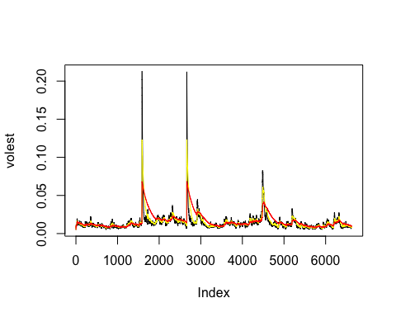

# Question 3

## a

#install.packages("dplyr")  
library(dplyr)

##   
## Attaching package: 'dplyr'

## The following objects are masked from 'package:stats':  
##   
## filter, lag

## The following objects are masked from 'package:base':  
##   
## intersect, setdiff, setequal, union

orange_grouped <- group_by(Orange, Tree)  
summarise(orange_grouped, mean=mean(circumference), median=median(circumference))

## # A tibble: 5 × 3  
## Tree mean median  
## <ord> <dbl> <dbl>  
## 1 3 94.00000 108  
## 2 1 99.57143 115  
## 3 5 111.14286 125  
## 4 2 135.28571 156  
## 5 4 139.28571 167

## b

plot(Orange$age, Orange$circumference, xlab="age", ylab = "circumfence")

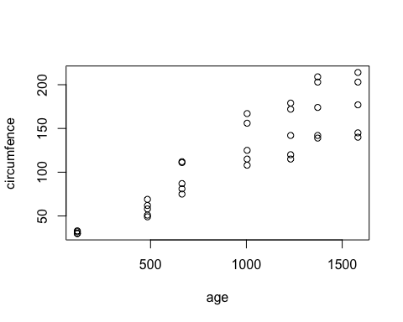 ## c

boxplot(Orange$circumference ~ Orange$Tree)

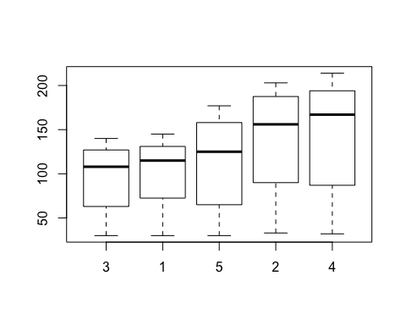

# Question 05

t<-seq(0,10,length=1000)  
x<-sqrt(t)*cos(2*pi*t)  
y<-sqrt(t)*sin(2*pi*t)  
plot(x,y,axes=F,type="l",lwd=3,xlab="x(t)",ylab="y(t)",col="red")  
axis(1,at=seq(-3,3,by=0.5),labels=seq(-3,3,by=0.5))  
axis(2)  
box()  
title(main=expression(  
paste("(x(t),y(t)) with polar coordinates", (list(sqrt(t),2*pi*t))  
)))

