**WAP in Javascript to check whether the person is eligible to vote or not using logical operator. A person is eligible to vote if person’s  age is greater than 18 and is the citizen of country.**

<!DOCTYPE html>

<html lang="en">

<head>

<meta charset="UTF-8">

<meta name="viewport" content="width=device-width, initial-scale=1.0">

<title>Voting Eligibility Checker</title>

<script>

function checkEligibility() {

// Get age and citizenship status from user input

var age = parseInt(document.getElementById("ageInput").value, 10);

var isCitizen = document.getElementById("citizenCheckbox").checked;

// Check eligibility using logical operator (AND)

var isEligible = age > 18 && isCitizen;

// Display the result

var resultMessage = isEligible ? "You are eligible to vote!" : "You are not eligible to vote.";

document.getElementById("result").innerHTML = resultMessage;

}

</script>

</head>

<body>

<h1>Voting Eligibility Checker</h1>

<label for="ageInput">Enter your age:</label>

<input type="number" id="ageInput" min="0" required>

<br>

<label for="citizenCheckbox">Are you a citizen of the country?</label>

<input type="checkbox" id="citizenCheckbox">

<br>

<button onclick="checkEligibility()">Check Eligibility</button>

<br>

<p id="result"></p>

</body>

</html>

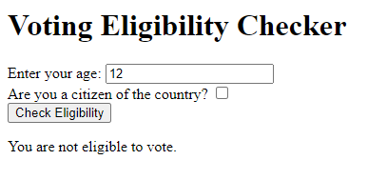

**WAP in Javascript to compare three numbers using conditional operator.**

<!DOCTYPE html>

<html lang="en">

<head>

<meta charset="UTF-8">

<meta name="viewport" content="width=device-width, initial-scale=1.0">

<title>Number Comparison</title>

</head>

<body>

<script>

// Get three numbers from the user (you can also hardcode them)

var num1 = parseFloat(prompt("Enter the first number:"));

var num2 = parseFloat(prompt("Enter the second number:"));

var num3 = parseFloat(prompt("Enter the third number:"));

// Compare the numbers using conditional operators

var result = (num1 > num2) ? ((num1 > num3) ? "Number 1 is the greatest." : "Number 3 is the greatest.")

: ((num2 > num3) ? "Number 2 is the greatest." : "Number 3 is the greatest.");

// Display the result

alert(result);

</script>

</body>

</html>

**WAP in Javascript to check whether the number is prime or not using break statement. Also do the same program using function as well.**

<!DOCTYPE html>

<html lang="en">

<head>

<meta charset="UTF-8">

<meta name="viewport" content="width=device-width, initial-scale=1.0">

<title>Prime Number Checker</title>

</head>

<body>

<script>

// Using break statement

function checkPrimeWithBreak() {

let number = prompt("Enter a number to check if it's prime:");

if (number <= 1) {

alert("Please enter a number greater than 1.");

return;

}

for (let i = 2; i < number; i++) {

if (number % i === 0) {

alert(number + " is not a prime number.");

break;

}

}

if (i === number) {

alert(number + " is a prime number.");

}

}

// Using function

function isPrime(number) {

if (number <= 1) {

return false;

}

for (let i = 2; i < number; i++) {

if (number % i === 0) {

return false;

}

}

return true;

}

function checkPrimeWithFunction() {

let number = prompt("Enter a number to check if it's prime:");

if (isPrime(number)) {

alert(number + " is a prime number.");

} else {

alert(number + " is not a prime number.");

}

}

</script>

<h2>Prime Number Checker</h2>

<button onclick="checkPrimeWithBreak()">Check Prime (Using break)</button>

<button onclick="checkPrimeWithFunction()">Check Prime (Using function)</button>

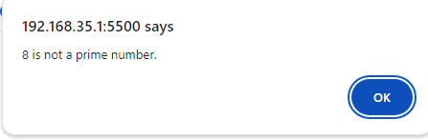</body>

</html>

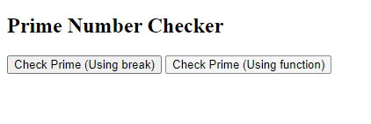

**Create a text field for the phone number. Write a regular expression to check if it is a phone number. And if it’s a phone number then pop up an alert(“It's a phone number”) else pop up an alert(“Enter phone number correctly”).**

<!DOCTYPE html>

<html lang="en">

<head>

<meta charset="UTF-8">

<meta name="viewport" content="width=device-width, initial-scale=1.0">

<title>Phone Number Validation</title>

<script>

function validatePhoneNumber() {

// Get the phone number input value

var phoneNumber = document.getElementById("phoneNumber").value;

// Regular expression for a simple 10-digit US phone number

var phoneRegex = /^\d{10}$/;

// Check if the entered value matches the regular expression

if (phoneRegex.test(phoneNumber)) {

alert("It's a phone number");

} else {

alert("Enter phone number correctly");

}

}

</script>

</head>

<body>

<label for="phoneNumber">Phone Number:</label>

<input type="text" id="phoneNumber" placeholder="Enter your phone number">

<button onclick="validatePhoneNumber()">Check</button>

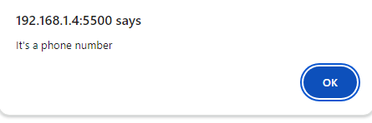</body>

</html>

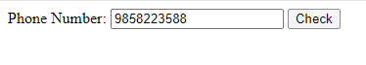

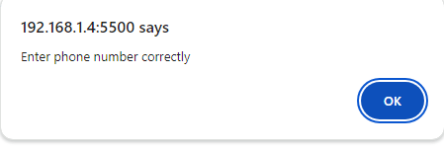



**Create a text field for the email address. Write a regular expression to check if pattern of email address is correct or not. And if pattern of email address get matched  then pop up an alert(“Pattern matched”) else pop up an alert(“Enter correct email address”).**

<!DOCTYPE html>

<html lang="en">

<head>

<meta charset="UTF-8">

<meta name="viewport" content="width=device-width, initial-scale=1.0">

<title>Email Address Validation</title>

<script>

function validateEmailAddress() {

// Get the email address input value

var emailAddress = document.getElementById("emailAddress").value;

// Regular expression for a simple email address pattern

var emailRegex = /^[a-zA-Z0-9._-]+@[a-zA-Z0-9.-]+\.[a-zA-Z]{2,4}$/;

// Check if the entered value matches the regular expression

if (emailRegex.test(emailAddress)) {

alert("Pattern matched");

} else {

alert("Enter correct email address");

}

}

</script>

</head>

<body>

<label for="emailAddress">Email Address:</label>

<input type="text" id="emailAddress" placeholder="Enter your email address">

<button onclick="validateEmailAddress()">Check</button>

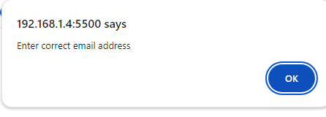

</body>

</html>

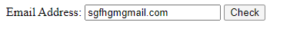

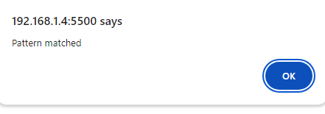

**In lab 1 you have created a form where you have different widgets like radio button, drop down. Add validation in all those widgets where necessary.**

<!DOCTYPE html>

<html lang="en">

<head>

<meta charset="UTF-8">

<meta http-equiv="X-UA-Compatible" content="IE=edge">

<meta name="viewport" content="width=device-width, initial-scale=1.0">

<title>Form</title>

<script>

function validateForm() {

// Validation for Name

var name = document.getElementById("name").value;

if (name.trim() === "") {

alert("Please enter your name");

return false;

}

// Validation for Email

var email = document.getElementById("email").value;

var emailRegex = /^[^\s@]+@[^\s@]+\.[^\s@]+$/;

if (!emailRegex.test(email)) {

alert("Please enter a valid email address");

return false;

}

// Validation for Password

var password = document.getElementById("password").value;

if (password.length < 6) {

alert("Password must be at least 6 characters long");

return false;

}

// Validation for Birth Date

var dob = document.getElementById("dob").value;

if (dob.trim() === "") {

alert("Please enter your birth date");

return false;

}

// Validation for Age

var age = document.getElementById("age").value;

if (isNaN(age) || age <= 0) {

alert("Please enter a valid age");

return false;

}

// Validation for Gender

var gender = document.querySelector('input[name="gender"]:checked');

if (!gender) {

alert("Please select your gender");

return false;

}

// Validation for Courses

var courses = document.querySelectorAll('input[name^="course"]:checked');

if (courses.length === 0) {

alert("Please select at least one course");

return false;

}

// Validation for Payment

var payment = document.getElementById("payment").value;

if (payment === "") {

alert("Please select a payment method");

return false;

}

// Validation for Feedback

var feedback = document.getElementById("feedback").value;

if (feedback.trim() === "") {

alert("Please provide your feedback");

return false;

}

// If all validations pass, submit the form

alert("Form submitted successfully!");

return true;

}

</script>

</head>

<body>

<br><br>

<form style="border: 2px solid black; width:fit-content; padding:20px;" onsubmit="return validateForm()">

<label for="name">Name</label>

<input placeholder="Enter your name" type="text" id="name" name="name"><br><br>

<label for="email">Email</label>

<input placeholder="Enter your email" type="email" id="email" name="email"><br><br>

<label for="password">Password</label>

<input placeholder="Enter your password" type="password" id="password" name="password"><br><br>

<label for="dob">Birth Date</label>

<input type="date" id="dob" name="dob"><br><br>

<label for="age">Age</label>

<input placeholder="Enter your age" type="number" id="age" name="age"><br><br>

<label>Gender:</label>

<input type="radio" id="male" name="gender">

<label for="male">male</label>

<input type="radio" id="female" name="gender">

<label for="female">female</label>

<input type="radio" id="other" name="gender">

<label for="other">other</label><br><br>

<label>Courses that I want to join for:</label>

<input type="checkbox" id="c" name="course_c">

<label for="c">C</label>

<input type="checkbox" id="c++" name="course_c++">

<label for="c++">C++</label>

<input type="checkbox" id="java" name="course_java">

<label for="java">Java</label>

<input type="checkbox" id="javascript" name="course_javascript">

<label for="javascript">JavaScript</label><br><br>

<label for="payment">Payment</label>

<select name="payment" id="payment">

<option value="">Select payment method</option>

<option value="visa">Visa</option>

<option value="credit card">Credit Card</option>

<option value="atm">ATM</option>

</select><br><br>

<label for="feedback">Your feedback</label><br><br>

<textarea name="feedback" id="feedback"></textarea><br>

<input type="submit" name="submit" value="Submit">

</form>

</body>

</html>