**Create two divs and put the background image on both divs. The background-attachment of the upper div should be fixed while the background-attachment of the lower div should be scrolled.**

<!DOCTYPE html>

<html lang="en">

<head>

    <meta charset="UTF-8">

    <meta http-equiv="X-UA-Compatible" content="IE=edge">

    <meta name="viewport" content="width=device-width, initial-scale=1.0">

    <style>

        .div1 {

            background-image: url("1.jpg");

            height: 1000px;

            background-attachment: fixed;

            border: 2px solid black;

            color: #fbfe7c;

        }

        .div2 {

            background-image: url("2jpg");

            height: 1000px;

            background-attachment: scroll;

        }

    </style>

    <title>lab</title>

</head>

<body>

    <div class="div1"></div>

    <div class="div2"></div>

</body>

</html>

**Add the CSS on the form that we have created in the lab 1.**

<!DOCTYPE html>

<html lang="en">

<head>

    <meta charset="UTF-8">

    <meta http-equiv="X-UA-Compatible" content="IE=edge">

    <meta name="viewport" content="width=device-width, initial-scale=1.0">

    <link rel="stylesheet" href="lab.css">

    <title>lab</title>

</head>

<body>

    <div class="div1">

        <form>

            <label for="name">Name:</label>

            <input  placeholder="Enter name" type="text" id="name" name="name"><br><br>

            <label for="email">Email:</label>

            <input  placeholder="Enter email" type="email" id="email" name="email"><br><br>

            <label for="password">Password:</label>

            <input placeholder="Enter password" type="password" id="password" name="password"><br><br>

            <label for="dob">Birth Date:</label>

            <input type="date" id="dob" name="dob"><br><br>

            <label for="age">Age:</label>

            <input placeholder="Enter age" type="number" id="age" name="age"><br><br>

            <label>Gender:</label>

            <input type="radio" id="male" name="gender">

            <label for="male">male</label>

            <input type="radio" id="female" name="gender">

            <label for="female">female</label>

            <input type="radio" id="other" name="gender">

            <label for="other">other</label><br><br>

            <label>Courses that i want to join for: </label>

            <input type="checkbox" id="c" name="c">

            <label for="c">C</label>

            <input type="checkbox" id="c++" name="c++">

            <label for="c++">C++</label>

            <input type="checkbox" id="java" name="java">

            <label for="java">java</label>

            <input type="checkbox" id="javascript" name="javascript">

            <label for="javascript">javascript</label><br><br>

            <label for="payment">Payment</label>

            <select name="payment" id="payment">

                <option value="visa">visa</option>

                <option value="credit card">credit card</option>

                <option value="atm">atm</option>

            </select><br><br>

            <label for="feedback">Your feedback</label><br><br>

            <textarea placeholder="Give your feedback here" class="feedback1" name="feedback" id="feedback"></textarea><br>

            <input class="submit" type="submit" name="submit" value="submit">

        </form>

    </div>

</body>

</html>

CSS:

form{

     width:fit-content;

     padding:20px 10px 10px 20px;

     height: 500px;

     background-color: rgb(246 247 248);

     border-radius: 10px;

}

input{

    border-radius: 5px;

}

#payment{

    border-radius: 5px;

    border: 2px solid black;

}

.feedback1{

    border-radius: 5px;

    border: 2px solid black;

    width: 250px;

    height: 75px;

}

.submit{

    background-color: rgb(221 255 255);

    padding: 10px;

    margin-top: 10px;

}

.div1{

    margin: 10px 0px 0px 300px;

    padding: 100px 100px 15px 150px;

    height: 600px;

    width: 500px;

    border: 30px solid #5250c9;

    background-color: rgb(150, 252, 158);

}

Output:

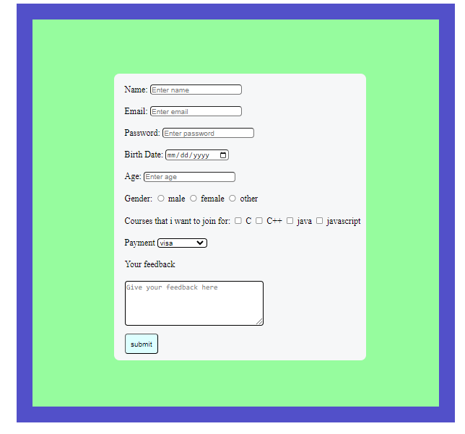

**Create the following design as shown in the figure. The header and footer should be fixed while in the case of the main content, they should have the features of scrolling the content.**

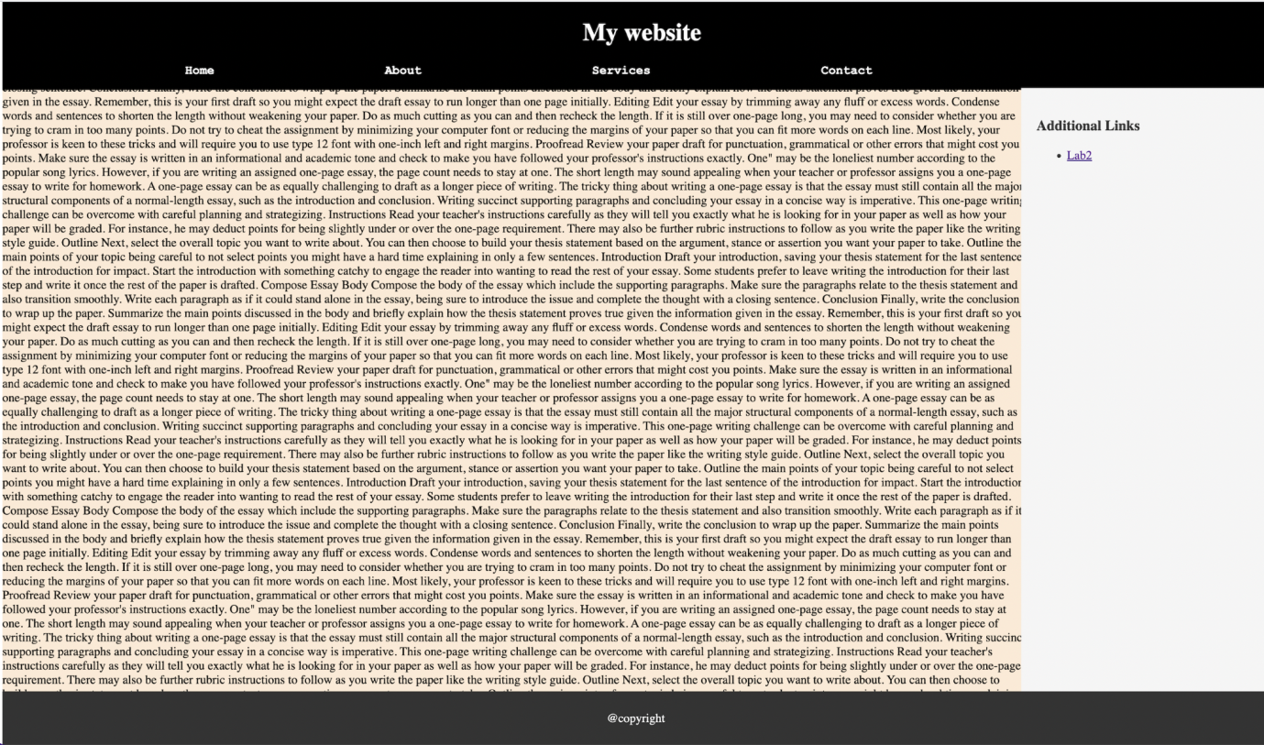

<!DOCTYPE html>

<html lang="en">

<head>

    <meta charset="UTF-8">

    <meta http-equiv="X-UA-Compatible" content="IE=edge">

    <meta name="viewport" content="width=device-width, initial-scale=1.0">

    <title>Lab</title>

    <style>

        body {

            margin: 0px;

            padding: 0px;

        }

        .header {

            background-color: black;

            color: white;

            padding: 0px 60px 0px 50px;

            position: fixed;

            width: 100%;

            top: 0px;

            display: flex;

            flex-direction: column;

            justify-content: center;

        }

        .content {

            background-color: antiquewhite;

            width: 1100px;

            left: 0px;

            position: static;

            margin: 50px 0px;

        }

        .footer {

            background-color: black;

            color: white;

            padding: 15px;

            position: fixed;

            bottom: 0px;

            text-align: center;

            width: 100%;

        }

        .nav {

            margin: 0px 50px 0px 50px;

        }

        .title {

            text-align: center;

            font-size: 1.3rem;

        }

        .menu {

            display: flex;

            justify-content: center;

            font-size: 18px;

        }

        .flex{

            display: flex;

            flex-direction: row;

        }

        .div2{

            position:fixed;

            right: 30px;

            top: 50px;

        }

    </style>

</head>

<body>

    <div class="header">

        <div class="title">My Website</div><br>

        <div class="menu">

            <div class="nav">Home</div>

            <div class="nav">About</div>

            <div class="nav">Services</div>

            <div class="nav">Contact</div>

        </div>

    </div>

    <div class="flex">

        <div class="content">

            <pre>

                ipsum dolor sit amet consectetur, adipisicing elit. Placeat eaque commodi voluptatibus

                vitae mollitia enim minus modi eveniet suscipit, in nam dignissimos ratione rerum distinctio impedit magnam

                natus, et fugiat.Lorem ipsum dolor sit amet consectetur, adipisicing elit. Placeat eaque commodi voluptatibus

                vitae mollitia enim minus modi eveniet suscipit, in nam dignissimos ratione rerum distinctio impedit magnam

                natus, et fugiat.Lorem ipsum dolor sit amet consectetur, adipisicing elit. Placeat eaque commodi voluptatibus

                vitae mollitia enim minus modi eveniet suscipit, in nam dignissimos ratione rerum distinctio impedit magnam

                natus, et fugiat.Lorem ipsum dolor sit amet consectetur, adipisicing elit. Placeat eaque commodi voluptatibus

                vitae mollitia enim minus modi eveniet suscipit, in nam dignissimos ratione rerum distinctio impedit magnam

                natus, et fugiat.Lorem ipsum dolor sit amet consectetur, adipisicing elit. Placeat eaque commodi voluptatibus

                vitae mollitia enim minus modi eveniet suscipit, in nam dignissimos ratione rerum distinctio impedit magnam

                natus, et fugiat.Lorem ipsum

            </pre>

        </div>

        <div class="div2">

            <h2>Additional links</h2>

            <a href="#">Click here</a>

        </div>

    </div>

    <div class="footer">@Copyright</div>

</body>

</html>

**Write an appropriate media query that displays the following with the screen size mentioned in the table below:**

| Things to display | Min Width | Max Width |
| --- | --- | --- |
| I am mobile |  | 575px |
| I am tab | 576px | 767px |
| I am small laptop | 768px | 991px |
| I am laptop/desktop | 992px | 1999px |

<!DOCTYPE html>

<html lang="en">

<head>

    <meta charset="UTF-8">

    <meta http-equiv="X-UA-Compatible" content="IE=edge">

    <meta name="viewport" content="width=device-width, initial-scale=1.0">

    <title>lab</title>

</head>

<style>

    .box {

        display: none;

    }

    @media (max-width:575px){

        #box1{

            display: block;

        }

    }

    @media (min-width:576px) and (max-width:767px){

        #box2{

            display: block;

        }

    }

    @media (min-width:768px) and (max-width:991px){

        #box3{

            display: block;

        }

    }

        @media (min-width:992px) and (max-width:1999px){

        #box4{

            display: block;

        }

    }

</style>

<body>

    <div class="box" id="box1">Mobile</div>

    <div class="box" id="box2">Tablet</div>

    <div class="box" id="box3">Small Laptop</div>

    <div class="box" id="box4">Laptop/Desktop</div>

</body>

</html>

**Create four divs consisting of paragraphs inside the row class provided by bootstrap. Write an appropriate media query for the grid classes xs, sm, md and lg to display all the four divs in one row in the case of lg and md, while 2 divs in one row in the case of sm and only one div in one row in the case of xs.**

<!DOCTYPE html>

<html lang="en">

<head>

    <meta charset="UTF-8">

    <meta http-equiv="X-UA-Compatible" content="IE=edge">

    <meta name="viewport" content="width=device-width, initial-scale=1.0">

    <title>lab</title>

    <link rel="stylesheet" href="https://maxcdn.bootstrapcdn.com/bootstrap/3.4.1/css/bootstrap.min.css">

</head>

<body>

    <div class="container">

        <div class="row">

            <div class="col-lg-3 col-md-3 col-sm-6 col-xs-12">1

                Lorem ipsum dolor sit amet consectetur adipisicing elit. Excepturi numquam ratione

                fuga neque suscipit. Suscipit enim fugiat reiciendis perferendis ducimus exercitationem, labore tenetur

                corrupti laborum sed quam, sint architecto numquam.

                Lorem ipsum dolor sit amet consectetur adipisicing elit. Excepturi numquam ratione

                fuga neque suscipit. Suscipit enim fugiat reiciendis perferendis ducimus exercitationem, labore tenetur

                corrupti laborum sed quam, sint architecto numquam.

                Lorem ipsum dolor sit amet consectetur adipisicing elit. Excepturi numquam ratione

                fuga neque suscipit. Suscipit enim fugiat reiciendis perferendis ducimus exercitationem, labore tenetur

                corrupti laborum sed quam, sint architecto numquam.

                Lorem ipsum dolor sit amet consectetur adipisicing elit. Excepturi numquam ratione

                fuga neque suscipit. Suscipit enim fugiat reiciendis perferendis ducimus exercitationem, labore tenetur

                corrupti laborum sed quam, sint architecto numquam.

            </div>

            <div class="col-lg-3 col-md-3 col-sm-6 col-xs-12">2

                Lorem ipsum dolor sit amet consectetur adipisicing elit. Excepturi numquam ratione

                fuga neque suscipit. Suscipit enim fugiat reiciendis perferendis ducimus exercitationem, labore tenetur

                corrupti laborum sed quam, sint architecto numquam.

                Lorem ipsum dolor sit amet consectetur adipisicing elit. Excepturi numquam ratione

                fuga neque suscipit. Suscipit enim fugiat reiciendis perferendis ducimus exercitationem, labore tenetur

                corrupti laborum sed quam, sint architecto numquam.

                Lorem ipsum dolor sit amet consectetur adipisicing elit. Excepturi numquam ratione

                fuga neque suscipit. Suscipit enim fugiat reiciendis perferendis ducimus exercitationem, labore tenetur

                corrupti laborum sed quam, sint architecto numquam.

                Lorem ipsum dolor sit amet consectetur adipisicing elit. Excepturi numquam ratione

                fuga neque suscipit. Suscipit enim fugiat reiciendis perferendis ducimus exercitationem, labore tenetur

                corrupti laborum sed quam, sint architecto numquam.

            </div>

            <div class="col-lg-3 col-md-3 col-sm-6 col-xs-12">3

                Lorem ipsum dolor sit amet consectetur adipisicing elit. Excepturi numquam ratione

                fuga neque suscipit. Suscipit enim fugiat reiciendis perferendis ducimus exercitationem, labore tenetur

                corrupti laborum sed quam, sint architecto numquam.

                Lorem ipsum dolor sit amet consectetur adipisicing elit. Excepturi numquam ratione

                fuga neque suscipit. Suscipit enim fugiat reiciendis perferendis ducimus exercitationem, labore tenetur

                corrupti laborum sed quam, sint architecto numquam.

                Lorem ipsum dolor sit amet consectetur adipisicing elit. Excepturi numquam ratione

                fuga neque suscipit. Suscipit enim fugiat reiciendis perferendis ducimus exercitationem, labore tenetur

                corrupti laborum sed quam, sint architecto numquam.

                Lorem ipsum dolor sit amet consectetur adipisicing elit. Excepturi numquam ratione

                fuga neque suscipit. Suscipit enim fugiat reiciendis perferendis ducimus exercitationem, labore tenetur

                corrupti laborum sed quam, sint architecto numquam.

            </div>

            <div class="col-lg-3 col-md-3 col-sm-6 col-xs-12">4

                Lorem ipsum dolor sit amet consectetur adipisicing elit. Excepturi numquam ratione

                fuga neque suscipit. Suscipit enim fugiat reiciendis perferendis ducimus exercitationem, labore tenetur

                corrupti laborum sed quam, sint architecto numquam.

                Lorem ipsum dolor sit amet consectetur adipisicing elit. Excepturi numquam ratione

                fuga neque suscipit. Suscipit enim fugiat reiciendis perferendis ducimus exercitationem, labore tenetur

                corrupti laborum sed quam, sint architecto numquam.

                Lorem ipsum dolor sit amet consectetur adipisicing elit. Excepturi numquam ratione

                fuga neque suscipit. Suscipit enim fugiat reiciendis perferendis ducimus exercitationem, labore tenetur

                corrupti laborum sed quam, sint architecto numquam.

                Lorem ipsum dolor sit amet consectetur adipisicing elit. Excepturi numquam ratione

                fuga neque suscipit. Suscipit enim fugiat reiciendis perferendis ducimus exercitationem, labore tenetur

                corrupti laborum sed quam, sint architecto numquam.

            </div>

        </div>

    </div>

    <script src="https://maxcdn.bootstrapcdn.com/bootstrap/3.4.1/js/bootstrap.min.js"></script>

</body>

</html>

**Create the following responsive design with the bootstrap.**

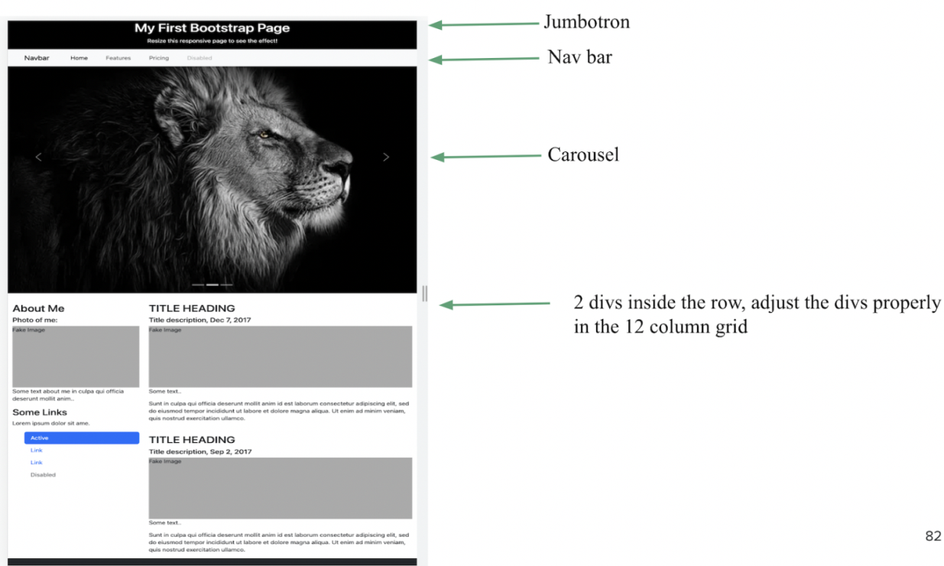

<!DOCTYPE html>

<html lang="en">

<head>

  <meta charset="UTF-8">

  <meta http-equiv="X-UA-Compatible" content="IE=edge">

  <meta name="viewport" content="width=device-width, initial-scale=1.0">

  <title>Lab</title>

  <link rel="stylesheet" href="https://maxcdn.bootstrapcdn.com/bootstrap/3.4.1/css/bootstrap.min.css">

  <link href="https://cdn.jsdelivr.net/npm/bootstrap@5.0.2/dist/css/bootstrap.min.css" rel="stylesheet"

    integrity="sha384-EVSTQN3/azprG1Anm3QDgpJLIm9Nao0Yz1ztcQTwFspd3yD65VohhpuuCOmLASjC" crossorigin="anonymous">

  <style>

    .marginbt {

      margin-top: 0px;

      margin-bottom: 0px;

    }

    .marginlr {

      margin-left: 10px;

      margin-bottom: 10px;

    }

    .navfont {

      font-size: 3rem;

    }

    .jumbotron {

      background-color: #181515;

      color: white;

      text-align: center;

      padding: 10px;

    }

    .height {

      height: 15rem;

      background-color: #c1c1c1;

    }

    .textDecor {

      text-decoration: none;

    }

    .disabledlink {

      padding-left: 20px;

    }

    .links {

      padding-left: 20px;

    }

    .links:hover {

      background-color: #0d6efd;

      color: white;

      border-radius: 4px;

      width: 100%;

      padding-left: 20px;

    }

    .marginl20 {

      margin-left: 25px;

    }

    .footer {

      background-color: #181515;

      height: 30px;

    }

    .nav-link:hover{

      background-color: #c1c1c1;

      text-decoration: none;

    }

  </style>

</head>

<body>

  <div class="jumbotron marginbt">

    <h1>My first bootstrap Page</h1>

    <p>Bootstrap is the most popular HTML, CSS...</p>

  </div>

  <nav class="navbar navbar-expand-lg navbar-light bg-light  marginbt navfont">

    <div class="container-fluid">

      <a class="navbar-brand" href="#">

        <h1 class="navfont">Navbar</h1>

      </a>

      <button class="navbar-toggler" type="button" data-bs-toggle="collapse" data-bs-target="#navbarNavAltMarkup"

        aria-controls="navbarNavAltMarkup" aria-expanded="false" aria-label="Toggle navigation">

        <span class="navbar-toggler-icon"></span>

      </button>

      <div class="collapse navbar-collapse" id="navbarNavAltMarkup">

        <div class="navbar-nav navbar">

          <a class="nav-link active" aria-current="page" href="#">Home</a>

          <a class="nav-link" href="#">Features</a>

          <a class="nav-link" href="#">Pricing</a>

          <a class="nav-link disabled" href="#" tabindex="-1" aria-disabled="true">Disabled</a>

        </div>

      </div>

    </div>

  </nav>

  <div id="carouselExampleControls" class="carousel slide" data-bs-ride="carousel">

    <div class="carousel-inner">

      <div class="carousel-item active">

        <img src="1.jpg" class="d-block w-100" alt="...">

      </div>

      <div class="carousel-item">

        <img src="2.jpg" class="d-block w-100" alt="...">

      </div>

      <div class="carousel-item">

        <img src="3.jpg" class="d-block w-100" alt="...">

      </div>

    </div>

    <button class="carousel-control-prev" type="button" data-bs-target="#carouselExampleControls" data-bs-slide="prev">

      <span class="carousel-control-prev-icon" aria-hidden="true"></span>

      <span class="visually-hidden">Previous</span>

    </button>

    <button class="carousel-control-next" type="button" data-bs-target="#carouselExampleControls" data-bs-slide="next">

      <span class="carousel-control-next-icon" aria-hidden="true"></span>

      <span class="visually-hidden">Next</span>

    </button>

  </div>

  <br><br>

  <div class="row marginlr">

    <div class="col-4">

      <div>

        <h1>About me</h1>

        <h3>Photo of me:</h3>

        <div class="height">

          image

        </div>

        <h4>Lorem ipsum dolor, sit amet consectetur adipisicing elit. </h4>

      </div>

      <br>

      <div>

        <h1>Some links</h1>

        <h5>Lorem ipsum, dolor sit amet.</h5>

        <div class="marginl20">

          <a class="textDecor" href="#">

            <h3 class="links">Active</h3>

          </a>

          <a class="textDecor" href="#">

            <h3 class="links">Link</h3>

          </a>

          <a class="textDecor" href="#">

            <h3 class="links">Link</h3>

          </a>

          <a class="nav-link disabled h3 disabledlink" href="#">Disabled</a>

        </div>

      </div>

    </div>

    <div class="col-8">

      <div>

        <h1>Title heading1</h1>

        <h3>Title description</h3>

        <div class="height">

          image

        </div>

        <h4>Lorem ipsum... </h4><br>

        <h4>Sit amet consectetur adipisicing elit. Minus odit quibusdam, enim, dolores alias nemo

          illo a delectus saepe aliquid cum aperiam iste praesentium nulla porro Dolorem voluptates laboriosam nam.

        </h4>

        <br><br>

      </div>

      <div>

        <h1>Title heading2</h1>

        <h3>Title description</h3>

        <div class="height">

          image

        </div>

        <h4>Lorem ipsum... </h4><br>

        <h4>Sit amet consectetur adipisicing elit. Minus odit quibusdam, enim, dolores alias nemo

          illo a delectus saepe aliquid cum aperiam iste praesentium nulla porro Dolorem voluptates laboriosam nam.

        </h4>

        <br><br>

      </div>

    </div>

  </div>

  </div>

<div class="footer">

</div>

  <script src="https://cdn.jsdelivr.net/npm/bootstrap@5.0.2/dist/js/bootstrap.bundle.min.js"

    integrity="sha384-MrcW6ZMFYlzcLA8Nl+NtUVF0sA7MsXsP1UyJoMp4YLEuNSfAP+JcXn/tWtIaxVXM"

    crossorigin="anonymous"></script>

  <script src="https://cdn.jsdelivr.net/npm/@popperjs/core@2.9.2/dist/umd/popper.min.js"

    integrity="sha384-IQsoLXl5PILFhosVNubq5LC7Qb9DXgDA9i+tQ8Zj3iwWAwPtgFTxbJ8NT4GN1R8p"

    crossorigin="anonymous"></script>

  <script src="https://cdn.jsdelivr.net/npm/bootstrap@5.0.2/dist/js/bootstrap.min.js"

    integrity="sha384-cVKIPhGWiC2Al4u+LWgxfKTRIcfu0JTxR+EQDz/bgldoEyl4H0zUF0QKbrJ0EcQF"

    crossorigin="anonymous"></script>

</body>

</html>