SCAN: https://www.scanhealthplan.com/lut/doctor?state=CA

Steps:
name + zip code->search->view all filters-> search radius + plans accepted

2 plans shown in our PCP search portal:
1. Venture: if user select Venture, select the following plans in carrier website

2. Classic: if user select Classic, select the following plans in carrier website
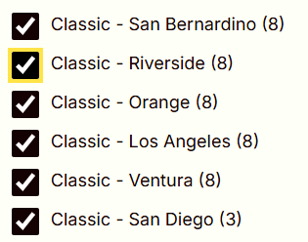

Also HMO for allied and Essential Savings.

PCP information needed: Name, address, Doctor ID, IPA name(i.e. Optum Care Network Pasadena), IPA# (i.e.0674), accepting patients
