**SOME BASIC CONCEPTS OF CHEMISTRY**

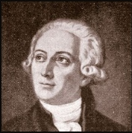

“Nothing is born, nothing dies.”

― **Antoine Lavoisier**

**DEVELOPMENT OF CHEMISTRY**

The development of chemistry is a long and fascinating journey, evolving from ancient practical crafts to a sophisticated scientific discipline.

## Early Period (Ancient Chemistry / Alchemy)

* **Alchemy (300 BC – 1600 AD):**
  + Practiced in Egypt, China, India, and later in Europe.
  + Main goals:
    - Convert base metals into gold: *Philosopher’s stone (Paras)*.
    - Discover the *elixir of life* (immortality potion).
    - Prepare medicines.
  + Though mystical, alchemy developed many experimental techniques (distillation, sublimation, crystallization).
* **Iatrochemistry**: Iatrochemistry (also called Medical Chemistry) was an early branch of chemistry that developed during the 16th and 17th centuries. It represents a transitional stage between alchemy and modern chemistry. The word comes from Greek: *"iatros"* = physician, and *"chemistry"*.

**The Transition Period (16th – 17th Century)**

* **Paracelsus (1493–1541):** Introduced the use of minerals and chemicals in medicine (medical chemistry).
* **Robert Boyle (1627–1691):**
  + Known as the Father of Modern Chemistry.
  + Defined elements as substances that cannot be broken into simpler substances.
  + His book The Sceptical Chymist (1661) separated chemistry from alchemy.

**Birth of Modern Chemistry (18th Century)**

* **Phlogiston Theory (Stahl):** Early attempt to explain combustion (later disproved).
* **Antoine Lavoisier (1743–1794):**
  + Disproved Phlogiston theory.
  + Demonstrated that combustion and respiration are due to oxygen.
  + Established Law of Conservation of Mass.
  + Wrote Traité Élémentaire de Chimie (1789), the first modern textbook of chemistry.

**19th Century Advances**

* **Dalton’s Atomic Theory (1803):** Matter is made of small indivisible atoms.
* **Gay-Lussac’s Law (1808):** Volumes of gases react in simple ratios.
* **Avogadro’s Hypothesis (1811)**: Equal volumes of gases under same conditions contain equal number of molecules.
* **Dmitri Mendeleev (1869):** Gave the Periodic Table of Elements, predicting new elements.
* **Kekulé & Couper:** Developed structural theory of organic chemistry.

**20th Century Chemistry**

* **Physical Chemistry**: Quantum theory (Planck, Bohr, Schrödinger, Heisenberg) explained atomic and molecular structure.
* **Nuclear Chemistry**: Discovery of radioactivity (Becquerel, Curie). Development of nuclear energy and isotopes.
* **Organic Chemistry**: Synthesis of dyes, plastics, drugs, and polymers.
* **Analytical Chemistry**: Development of spectroscopy, chromatography, and instrumental analysis.
* **Biochemistry**: Discovery of DNA structure (Watson & Crick, 1953), enzymes, hormones.

**Modern (21st Century) Chemistry**

* **Green Chemistry**: Focus on eco-friendly and sustainable chemical processes.
* **Nanotechnology**: Use of materials at molecular and atomic levels.
* **Medicinal Chemistry**: Development of new drugs and vaccines.
* **Computational Chemistry & AI**: Simulations, molecular design, and drug discovery.
* **Material Science**: Superconductors, nanomaterials, smart materials.

**Summary**:  
Chemistry evolved from alchemy and practical crafts to experimental science with laws and theories to modern chemistry, which integrates physics, biology, and technology to solve real-world problems.

**IMPORTANCE OF CHEMISTRY**

**Chemistry is the science of molecules and their transformations that deals with the study of matter, its composition, the changes that matter undergoes and the relation between changes in com-position and energy.**

**Chemistry plays a vital and centralized role in Science. It has a vital role in fulfiling human needs for food, health care products, life saving drugs, etc. For example, cis-platin and tatol are being used for cancer therapy and AZT (Aziodothymidine) is being used for AIDS victims. Similarly, chemistry has provided us antiseptics (eg.. dettol), disinfectants (eg, phenol), insecticides (eg, DDT and gammexane), anal-gesics (like Paracetamol), antibiotics, tranquilizers , antipyretics etc.**

**States of Matter:** Matter is anything that has **mass** and occupies **space**. Depending on the arrangement of particles and the forces between them, matter exists in different **states (phases).**

## Classical States of Matter

### (a) Solid

* **Shape & Volume:** Fixed
* **Particle arrangement:** Closely packed, strong intermolecular forces.
* **Movement:** Particles vibrate about fixed positions, no free movement.
* **Compressibility:** Almost incompressible.
* **Examples:** Ice, metals, wood, salt.

### (b) Liquid

* **Shape:** No fixed shape, takes the shape of container.
* **Volume:** Fixed.
* **Particle arrangement:** Close but not as tightly packed as solids.
* **Movement:** Particles slide over one another (fluidity).
* **Compressibility:** Very small (almost incompressible).
* **Examples:** Water, oil, alcohol.

### (c) Gas

* **Shape & Volume:** Neither fixed; occupies entire container.
* **Particle arrangement:** Far apart, very weak intermolecular forces.
* **Movement:** Random and very fast (high kinetic energy).
* **Compressibility:** Highly compressible.
* **Examples:** Oxygen, carbon dioxide, nitrogen.

## Modern / Special States of Matter

### (d) Plasma

* **What:** Superheated gas of ions and electrons.
* **Properties:**
  + Conducts electricity.
  + Affected by magnetic & electric fields.
* **Examples:** Sun, stars, lightning, neon signs.

### (e) Bose–Einstein Condensate (BEC)

* **Discovered by:** Satyendra Nath Bose & Albert Einstein (1924–25).
* **What:** State of matter at **extremely low temperature (near absolute zero, –273 °C)**.
* **Properties:**
  + Atoms lose individual identity and behave like one “super atom.”
  + Shows superfluidity (flows without resistance).

## Classification of Matter by Composition

This classification divides matter into pure substances and mixtures.

### Pure Substances

Pure substances have a fixed chemical composition and characteristic properties. They cannot be separated into simpler components by physical means.

* **Elements**: These are the simplest pure substances. They are made up of only one type of atom and cannot be broken down into simpler substances by chemical means. Examples include oxygen (O), iron (Fe), and gold (Au). Elements are listed on the periodic table.
* **Compounds**: These are pure substances formed when two or more elements combine chemically in a fixed ratio. Compounds have properties that are different from those of their constituent elements. They can be broken down into their elements by chemical reactions. Examples include water (H2​O), carbon dioxide (CO2​), and table salt (NaCl).

### Mixtures

Mixtures are formed when two or more pure substances are physically combined but not chemically bonded. The components of a mixture retain their individual identities and can often be separated by physical means (e.g., filtration, evaporation, distillation).

* **Homogeneous Mixtures (Solutions)**: These mixtures have a uniform composition throughout. The components are evenly distributed and cannot be visually distinguished. Examples include saltwater, air, and sugar dissolved in water. Alloys (mixtures of metals) are also homogeneous mixtures.
* **Heterogeneous Mixtures**: These mixtures have a non-uniform composition. The different components can be visually distinguished, and they are not evenly distributed. Examples include sand and water, a salad, trail mix, and oil and vinegar. Suspensions and colloids are also types of heterogeneous mixtures.

**Physical and chemical properties**

Matter is described and identified by its properties, which can be broadly categorized into two types: physical properties and chemical properties.

**Physical Properties**

Physical properties are characteristics of a substance that can be observed or measured without changing the substance's chemical identity. In essence, you can measure them without altering what the substance fundamentally is.

* **Intensive Physical Properties: These properties do not depend on the amount of matter present**.
  + Color: The hue of a substance (e.g., the red of a stop sign, the green of grass).
  + Odor: The smell of a substance (e.g., the scent of a rose, the odor of ammonia).
  + Density: The mass per unit volume of a substance (e.g., gold is denser than aluminum). It's often expressed as ρ=Vm​.
  + Hardness: A substance's resistance to scratching or abrasion (e.g., diamond is harder than graphite).
  + Melting Point: The temperature at which a solid turns into a liquid (e.g., ice melts at 0°C).
  + Boiling Point: The temperature at which a liquid turns into a gas (e.g., water boils at 100°C at standard atmospheric pressure).
  + Solubility: The ability of a substance to dissolve in another substance (e.g., sugar is soluble in water).
  + Electrical Conductivity: The ability to conduct electric current (e.g., copper is a good conductor).
  + Malleability: The ability of a substance to be hammered or rolled into thin sheets (e.g., gold is highly malleable).
  + Ductility: The ability of a substance to be drawn into wires (e.g., copper is ductile).
  + Luster: The way light reflects off a substance (e.g., a shiny metallic luster).
  + State of Matter: Whether it's a solid, liquid, or gas at a given temperature and pressure.
* **Extensive Physical Properties:** These properties depend on the amount of matter present.
  + Mass: The amount of matter in a substance.
  + Volume: The amount of space a substance occupies.
  + Length: The linear dimension of a substance.

**Chemical Properties**

Chemical properties describe a substance's ability to undergo a specific chemical change or reaction that results in the formation of a new substance with different properties. To observe a chemical property, a chemical reaction must occur, altering the substance's chemical identity.

* Flammability: The ability of a substance to burn or ignite in the presence of oxygen (e.g., wood is flammable).
* Reactivity: The tendency of a substance to undergo a chemical reaction with other substances (e.g., iron reacts with oxygen to form rust).
* Oxidation State: The tendency of an element to achieve a particular oxidation state in compounds.
* Acidity/Basicity: A substance's tendency to donate or accept protons, often measured by pH.
* Toxicity: The degree to which a substance can damage an organism.
* Heat of Combustion: The amount of energy released when a substance burns.
* Chemical Stability: Whether a substance will react with air, water, or other common substances under normal conditions.

**Measurement of physical properties :** Quantitative measurement of properties is reaquired for scientific investigation. Many properties of matter, such as length, area,volume, etc., are quantitative in nature. Any quantitative observation or measurement is represented by a number followed by units in which it is measured.

**The International System of Units (SI)**: The SI system (Système International d’Unités) is the modern form of the metric system.It is the globally accepted standard for measurement in science, industry, and daily life.Established in 1960 by the General Conference on Weights and Measures (CGPM), it ensures uniformity and precision in measurements worldwide.

## SI Base Quantities and Units

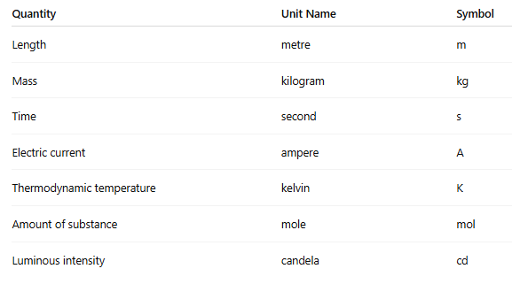There are 7 fundamental quantities with their base units:

**Definitions of SI Base Units**:

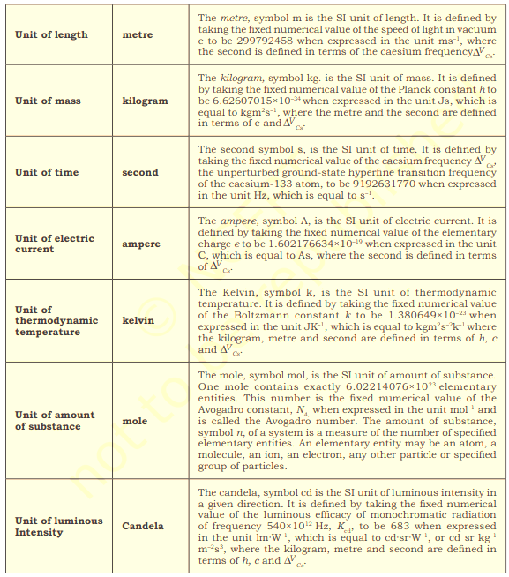

**SI Prefixes**

**Prefixes help express very large or very small quantities.**

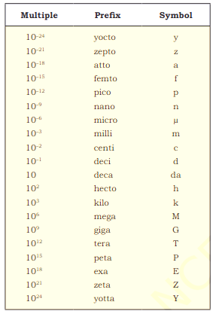

**Precision and accuracy of measurement**

**Accuracy**: It is the agreement of a particular value to the true value.

Aim of any measurement is to get the actual value called true value or accepted value of a quantity. Nearness of the measured value to the true value is called the accuracy of measurement. Larger the accuracy smaller the error. Accuracy depends upon the sensitivity or least count (the smallest quantity that can be measured) of the measuring equipment.

**Precision** in measurement refers to the **consistency** and **reproducibility** of a set of measurements. It indicates how close multiple measurements of the same quantity are to each other, regardless of whether they are close to the true or accepted value.

Precision is primarily concerned with random errors, which cause variations in measurements. A precise measurement system minimizes these variations.

**Errors:** It may be expressed as absolute or relative error.

**Absolute error** = Observed value - True value

Relative error is the ratio of an absolute error to the true value. It is expressed as a percentage.

**Relative error** = (Absolute error/ True value) x 100%.

There can be error in a measurement due to a number of reasons including inefficiency of the person doing the measurement.

**Example:** Let the true weight of a substance be 3.00g. The measurements reported by three students A,B,C are as follows:

|  |  |  |  |
| --- | --- | --- | --- |
| **Student** | **Measurements** | | **Average** |
|  | **1** | **2** |  |
| **A** | **2.95** | **2.93** | **2.94** |
| **B** | **3.01** | **2.99** | **3** |
| **C** | **2.94** | **3.05** | **2.99** |

**Case of student A** : It is precise but not accurate since measurements one close but not accurate. **Case of student B** : Measurements are close (precise) and accurate.

**Case of student C**: Measurement are not close (not precise) and not accurate.

**Uncertainty in Measurement**:

In any measurement, the result is never perfectly exact. **Uncertainty** quantifies the doubt associated with a measurement result, representing the range within which the true value of the quantity being measured (the measurand) is expected to lie. It's not the same as error, which is the difference between the measured value and the true value; uncertainty expresses the *dispersion* of possible values.

There are meaningful ways to handle the numbers conveniently and present the data realistically with certainty to the extent possible.

**Scientific notation** is a standardized way of writing numbers that are either very large or very small, making them easier to read, compare, and use in calculations. It expresses a number as a product of two parts: a **coefficient** and a **power of 10**.

A number in scientific notation is written in the form: **a × 10n**

Where: **a** is the **coefficient** (or significand/mantissa). It must be a number greater than or equal to 1 and less than 10 (i.e., 1≤ ∣a∣ <10 ).

* **10** is the **base**.
* **n** is the **exponent** (or power), which is an integer (a whole number, positive, negative, or zero). It indicates how many places the decimal point has been moved.

Thus, we can write 232.508 as 2.32508 ×102 in scientific notation.

Similarly, 0.00016 can be written as 1.6 × 10–4 in scientific notation.

**Multiplication and Division**: These two operations follow the same rules which are there for exponential numbers, i.e.

(5.6 × 10 5) × (6.9 × 108)

= (5.6 × 6.9) × 10 (5 + 8)

= (5.6 × 6.9) ×1013

= 38.64 × 1013

= 3.864 × 1014

**Addition and Subtraction**: For these two operations, first the numbers are written in such a way that they have the same exponent. After that, the coefficients (digit terms) are added or subtracted as the case may be. For example,

6.65×10 4 + 8.95×10 3

= (6.65×104) + (0.895×10 4)

= (6.65 + 0.895) ×10 4

= 7.545×104

**Significant Figures:**

Uncertainty in measured value leads to uncertainty in calculated result. Uncertainty in a value is indicated by mentioning the number of significant figures in that value. **Significant figures** are meaningful digits which are known with certainty plus one (last digit) which is estimated or uncertain.

Consider, the column reading 10.2 ± 0.1 mL recorded on a burette having the least count of 0.1 mL. Here it is said that the last digit '2' in the reading is uncertain, its uncertainty is ±0.1 mL. On the other hand, the figure '10' is certain.

The significant figures in a measurement or result are the number of digits known with certainty plus one uncertain digit, i.e. 3 in this case.

**Rules for deciding significant figures:**

1. All non-zero digits are significant; e. g. 127.34 g contains five significant figures which are 1, 2, 7, 3 and 4.

2. All zeros between two non-zero digits are significant e. g. 120.007 m contains six significant figures.

3. Zeroes on the left of the first non-zero digit are not significant. Such a zero indicates the position of the decimal point. For example, 0.025 has two significant figures.

4. Zeroes at the end of a number are significant if they are on the right side of the decimal point. Terminal zeros are not significant if there is no decimal point. (This is beacause the least count of an instrument contains decimal point) For example 0.400 g has three singnificant figures. The measurements here indicate that it is made on a weighing machine having least count of 0.001 g.

Significant figures are also indicated in scientific notation by means of decimal point. For example, the measurment 400 g has one significant figure. The measurement 4.0×102 g has two significant figures, wheras the measurment 4.00 ×102 g has three significant figures. The zeros after the decimal points in these cases indicate that the least counts of the weighing machines are 1 g, 0.1 g and 0.01 g, respectively.

5. Counting the numbers of object, for example, 2 balls or 20 eggs, have infinite significant figures as these are exact numbers and can be represented by writing infinite number of zeros after placing a decimal i.e., 2 = 2.000000 or 20 = 20.000000.

**Rounding off:** The following rules are observed.

(a) If the digit after the last digit to be retained is less than 5, the last digit is retained as such. e.g. 1.752 = 1.75 (2 is less than 5).

(b) If the digit after the last digit to be retained is more than 5, the digit to be retained is increased by 1 e.g. 1.756 1.76 (6 is more than 5).

(c) If the digit after the last digit to be retained is equal to 5, the last digit is retained as such if it is even and increased by 1 if odd.

e.g. 1.755 =1.76 and 1.765= 1.76

**Calculations involving addition and substraction**:

(1) In case of **addition and substraction** the final result should be reported to the same number of decimal places as the number with the minimum number of decimal places e.g.

34.72 (with two decimal places)

+ 8.1 (with one decimal place)

-------------------------------------------

= 42.82

But it should have only one decimal place. So answer is 42.8.

**Calculations involving multiplication and division**: In this case the final result should be reported having same number of significant digits as that of the number having least significant digits. Example:

(i) 9.24 × 3.6 = 33.264, Rounded off to 33.

(ii) In case of division: = 0.3996, rounded off to 0.400.

**Dimensional analysis:** It is a powerful problem-solving technique used in science and mathematics to analyze relationships between different physical quantities. In Chemistry it is used for unit conversions and stoichiometry calculations. Unit conversion is done by **factor label method** **or unit factor method** or **dimensional analysis**.

**Example-1** : A piece of metal is 3 inch (represented by in) long. What is its length in cm?

**Solution**: We know that

1in = 2.54cm

From this equivalence, we can write Thus,

= 1 =

Thus, equals 1 and also equals 1. Both of these are called **unit factors**. If some number is multiplied by these unit factors (i.e., 1), it will not be affected otherwise.

So, 3in = 3in × = 3 × 2.54cm = 7.62cm

**Example-2** : Distance between two places is 5 miles. Calculate the distance in centimeter.

**Solution**:

**1.** Given distance: 5 miles

**2**. Relevant conversion factors:

1 mile = 5280 foot

1 foot = 12 inch

1 inch = 2.54 cm

**3**. Setting up the calculation using conversion factors as fractions:

5 miles x X X

**4.** Cancelling out units and multiplying the remaining numbers we get:

5 x 5280 x 12 x 2.54cm = 804, 672cm

So, **5 miles is equal to 804,672 centimeters**.

**Laws of Chemical Combination**: The elements combine with each other and form

compounds. This process is governed by five basic laws discovered before the knowledge of molecular formulae.

**1. Law of conservation of mass**: This law was put forth by **Antoine Lavoisier** in 1789

**Law**: ***Mass can neither be created nor destroyed, although it may be rearranged in space, or the entities associated with it may be changed in form.***

During any chemical reaction and low-energy [thermodynamic processes](https://en.wikipedia.org/wiki/Thermodynamic_process) in an isolated system

Total mass of reactants = Total mass of products.

For example, in the following reaction

CH4 + 2O2 → CO2 + 2H2O

**mCH4  + mO2  = mCO2 + mH2O**

Chemical equations are balanced based on the Law of conservation of mass**.**

**Problem**. 10 grams of calcium carbonate (CaCO3) produces 3.8 grams of carbon dioxide (CO2) and 6.2 grams of calcium oxide (CaO). Represent this reaction in terms of law of conservation of mass.

Ans: According to law of conservation of mass:

Mass of reactants = Mass of products.

10 gram of CaCO3 = 3.8 grams of CO2 + 6.2 grams of CaO

10 grams of reactant = 10 grams of products

Hence, it is proved that the law of conservation of mass is followed by the above reaction.

**Limitations of Law of conservation of mass:** In general, mass is not conserved. The conservation of mass is a law that holds only in the classical limit. For example, the overlap of the electron and positron wave functions, where the interacting particles are nearly at rest, will proceed to annihilate via electromagnetic interaction. This process creates two photons and is the mechanism for PET scans.

Mass is also not generally conserved in open systems. Such is the case when any energy or matter is allowed into, or out of, the system. However, unless radioactivity or nuclear reactions are involved, the amount of energy entering or escaping such systems (as heat, mechanical work, or electromagnetic radiation) is usually too small to be measured as a change in the mass of the system.

**Formulation**: The law of conservation of mass can only be formulated in classical mechanics, in which the energy scales associated with an isolated system are much smaller than mc², where m is the mass of a typical object in the system, measured in the frame of reference where the object is at rest, and c is the speed of light in a vacuum.

The law can be formulated mathematically in the fields of fluid mechanics and continuum mechanics, where the conservation of mass is usually expressed using the continuity equation, given in differential form as:

+ Δ.(

Where p is the density (mass per unit volume), t is the time, Δ. is the divergence, and v is the flow velocity field.

The interpretation of the continuity equation for mass is the following: For a given closed surface in the system, the change, over any time interval, of the mass enclosed by the surface is equal to the mass that traverses the surface during that time interval: positive if the matter goes in and negative if the matter goes out. For the whole isolated system, this condition implies that the total mass M, the sum of the masses of all components in the system, does not change over time, i.e.

*= = 0*

where dV is the differential that defines the integral over the whole volume of the system.

**2. Law of Definite Proportions**: This law was given by a French chemist, **Joseph Proust** in 1794.

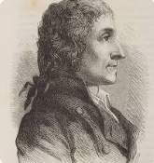***Law: A given chemical compound contains its constituent***

***elements in a fixed ratio (by mass) and does not depend***

***on its source or method of preparation. For example,***

***oxygen makes up about 8/9 of the mass of any sample***

***of pure water, while hydrogen makes up the remaining***

***1/9 of the mass.***

The Law of Constant Proportions is important because it allows us to predict the composition of compounds. If we know the ratio of the masses of the elements in a compound, we can calculate the mass of each element in any amount of the compound.

The Law of Constant Proportions was first proposed by Joseph Proust in 1799. Proust’s law was based on his experiments with copper and oxygen. He found that when copper is heated in air, it reacts with oxygen to form a compound called copper oxide. The ratio of the mass of copper to the mass of oxygen in copper oxide is always the same, regardless of the amount of copper oxide that is formed.

**Exceptions to the Law of Constant Proportions**:

1. Non-stoichiometric compounds (Berthollides’ compounds): Some compounds do not have a fixed composition and can vary in their elemental ratios. These compounds are called non-stoichiometric compounds or Berthollides’ compounds. An example of a non-stoichiometric compound is wustite, which is an iron oxide with the formula FeO. The composition of wustite can vary from Fe0.95O to Fe0.98O.Another example is copper(I) oxide, which can have a composition ranging from Cu2O to CuO.

2. Isotopic composition:Elements can have isotopes, which are atoms of the same element with different atomic masses. If a compound contains different isotopes of an element, the mass proportion of elements in the compound will vary.

3.Natural polymers:

Large, complex molecules like proteins and DNA can also have varying compositions from one sample to another, leading to different mass proportions.

4. Solid solutions: Solid solutions are mixtures of two or more substances that form a single phase. The composition of a solid solution can vary continuously over a range of compositions. An example of a solid solution is the alloy brass, which is a mixture of copper and zinc. The composition of brass can vary from 30% to 45% zinc.

5. Clathrates: Clathrates are compounds that contain molecules or atoms trapped within a crystal lattice. The composition of a clathrate can vary depending on the size and shape of the guest molecules. An example of a clathrate is the gas hydrate methane clathrate, which contains methane molecules trapped within a water lattice. The composition of methane clathrate can vary from 5.75% to 13.5% methane.

**Problem:** When 1.375 g of cupric oxide is reduced on heating in a current of hydrogen, the weight of copper remaining 1.098 g. In another experiment, 1.179 g of copper is dissolved in nitric acid and resulting copper nitrate converted into cupric oxide by ignition. The weight of cupric oxide formed is 1.476 g. Show that these results illustrate the law of constant proportion.

**Solution:**

**First experiment**

Copper oxide = 1.375 g

Copper left = 1.098 g

Oxygen present = 1.375 - 1.098 = 0.277g

Percentage of oxygen in CuO = 20.15%

**Second Experiment**

Copper taken = 1.179 g

Copper oxide formed = 1.476 g

Oxygen present = 1.476 - 1.179 = 0.297g

Percentage of oxygen in CuO == 20.11%

Percentage of oxygen is approximately (within significant figures) the same in both the above cases. So the law of constant composition is illustrated.

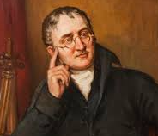**Law of multiple proportions**: This law was proposed by Dalton in 1803.

***Law: when two***[***elements***](https://www.britannica.com/science/chemical-element)[***combine***](https://www.britannica.com/dictionary/combine)***with each other to form more than one***[***compound***](https://www.britannica.com/science/chemical-compound)***, the weights of one element that combine with a fixed weight of the other are in a ratio of small whole numbers***.

**For example**, hydrogen combines with oxygen to form two compounds, namely, water and hydrogen peroxide.

Hydrogen + Oxygen → Water (H2O)

2g 16g 18g

Hydrogen + Oxygen → Hydrogen Peroxide (H2O2)

2g 32g 34g

Here, the masses of oxygen (i.e., 16 g and 32 g), which combine with a fixed mass of hydrogen (2g) bear a simple ratio, i.e., 16:32 or 1: 2.

**Limitations of the Law of Multiple Proportions**

1. Complexity of Compounds: The law is not easily applicable to complex compounds like polymers or large organic molecules, which have very high molecular weights and complicated structures. For example, a slight variation in the number of repeating units in a polymer can lead to a mass ratio that is not a simple whole number.
2. Isotopes: The law assumes that all atoms of a given element have the same mass. However, an element can exist in different isotopic forms (atoms of the same element with different numbers of neutrons), which have different masses. If a compound is formed with a different ratio of isotopes, the mass ratio of the elements may not be a simple whole number. For instance, the mass of hydrogen and deuterium (an isotope of hydrogen) are different, so compounds formed with them may not adhere to the law.
3. Non-Stoichiometric Compounds: The law does not apply to non-stoichiometric compounds, which are solid chemical compounds that have an elemental composition that cannot be represented by a ratio of small whole numbers. Their composition can vary slightly due to crystal defects. A classic example is wüstite (iron oxide), which can have a composition ranging from Fe0.83​O to Fe0.95​O.

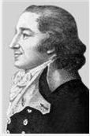**Law of Reciprocal proportions**: The law of reciprocal proportions

was proposed by **Jeremias Ritcher** in 1792.

Law: If two different elements combine separately

with a fixed mass of a third element, the ratio of

the masses in which they do so are either the same

as or a simple multiple of the ratio of the masses

in which they combine with each other.

**Example:**

Oxygen and sulfur react with copper to give copper oxide and copper sulfide, respectively. Sulfur and oxygen also react with each other to form SO2. Therefore,

in CuS: Cu : S = 63.5 : 32

in CuO: Cu : 0 = 63.5 : 16

Therefore, the ratio of S and O that combines with fixed mass (63.5 g) is 32 : 16, i.e. 2 : 1

Now in SO2: S : 0 = 32 : 32 = 1 : 1

Thus the ratio between the two ratios is the following:

:

=1 : 1

**This is a simple multiple ratio.**

**Problem: Carbon dioxide (CO2​) contains 27.27% carbon. Carbon disulfide (CS2​) contains 15.79% carbon. Sulfur dioxide (SO2​) contains 50% sulfur. Show that these data illustrate the Law of Reciprocal Proportions**.

**Solution:**

In CO2 :

%C = 27.27, %0 = 72.73

Ratio C : 0 = 27.27:72.73 = 3:8

So, 3 g C combines with 8 g O

In CS₂

%C = 15.79, %S = 84.21

Ratio C : S = 15.79 : 84.21 = 3 : 16

So, 3 g C combines with 16 g S.

Comparing O and S (through C)

For the same mass of C (3 g):

O = 8 g

S = 16 g

So, O : S = 8 : 16 = 1 : 2

Direct combination of O and S in SO₂

%S = 50, %O = 50

Ratio S : O = 32 : 32 = 1 : 1

Hence O : S = 1 : 1

Verification

From C-compounds → O : S = 1 : 2

From SO₂ → O : S = 1 : 1

Since 1 : 2 and 1 : 1 are simple multiples, the Law of Reciprocal Proportions is verified.

**Limitations of the Law of Reciprocal Proportions:**

1. Fails for non-stoichiometric compounds: Compounds like FeO, CuO, or TiO (which do not have exact whole-number atomic ratios) cannot be explained.
2. Not valid for isotopic mixtures: If an element has isotopes (like Cl, with Cl-35 and Cl-37), the law does not account for variations in composition due to isotopes.

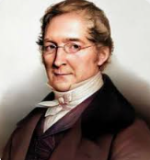**Gay Lussac Law of Gaseous Volume**:

This law was given by Gay Lussac in 1808.

***Law: When gases combine or are produced in a chemical***

***reaction they do so in a simple ratio by volume, provided***

***all gases are at same temperature and pressure.***

Thus, 100 mL of hydrogen combine with 50 mL of oxygen to give 100 mL of water vapour.

Hydrogen + Oxygen → Water

100 mL 50 mL 100 mL

Thus, the volumes of hydrogen and oxygen which combine (i.e., 100 mL and 50 mL) bear a simple ratio of 2:1.

Gay Lussac’s discovery of integer ratio in volume relationship is actually the law of definite proportions by volume. The law of definite proportions, stated earlier, was with respect to mass. The Gay Lussac’s law was explained properly by the work of Avogadro in 1811.

**Limitations of Gay Lussac’s Law of Gaseous Volumes:**

1. Applies only to gases: The law is valid only when the reacting substances and products are in the gaseous state. It cannot be applied to solids or liquids.
2. Measured under identical conditions: The law holds true only if the volumes of gases are measured at the same temperature and pressure.
3. Deviation for real gases: It strictly applies to ideal gases. Real gases show deviations from ideal behavior, especially at high pressure and low temperature.
4. Does not give information about masses: The law deals with combining volumes of gases, not with the actual masses of reactants and products.
5. Does not explain atomicity: The law cannot predict the molecular formula or atomicity of elements (e.g., why oxygen is O₂, not O or O₃). Dalton’s atomic theory and Avogadro’s hypothesis were later needed for this.

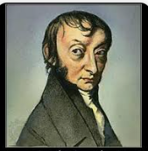

**Avogadro Law**: Avogadro proposed the law in 1811.

***Law:Equal volumes of all gases at the same temperature***

***and pressure contain equal number of molecules***.

**Mathematical Expression**:

The relationship can be expressed mathematically as:

V∝n

Or, as a proportionality:

= k

where:

V is the volume of the gas.

n is the number of moles of the gas.

k is a constant.

**Limitations of Avogadro's Law**:

**1. Ideal vs. Real Gases: Avogadro’s** Law is based on the assumptions of the ideal gas model. Real gases, however, deviate from ideal behavior, especially at high pressures and low temperatures.

These deviations mean that for real gases, the volume may not be perfectly proportional to the number of molecules under extreme conditions.

**2. Extreme Conditions: The** law holds best under conditions of moderate temperature and pressure. When gases are subjected to very high pressures or very low temperatures, they can condense into liquids or solidify. In these states, the concept of a gas occupying a volume and behaving according to Avogadro's Law no longer applies.

**3. Intermolecular Forces :**Avogadro's Law assumes that gas molecules are in constant, random motion and do not interact with each other significantly. While this is a good approximation for many gases under normal conditions, strong intermolecular forces can influence the gas's behavior, leading to deviations from the ideal law.

In summary, Avogadro's Law is a fundamental principle for understanding the behavior of gases, but its accuracy is limited to ideal gas conditions and deviations occur with real gases under extreme temperatures and pressures.

**Dalton's Atomic Theory**:

Dalton's Atomic Theory, proposed by English chemist John Dalton in the early 19th century, was a groundbreaking attempt to explain the nature of matter based on the concept of atoms. It laid the foundation for modern atomic theory and chemistry.

**Key Postulates of Dalton's Atomic Theory**

1. All matter is composed of extremely small particles called atoms. This fundamental idea proposed that atoms are the indivisible building blocks of all substances.
2. Atoms of a given element are identical in size, mass, and other properties. Dalton believed that all atoms of the same element were exactly the same.
3. Atoms of different elements differ in size, mass, and other properties. Conversely, he asserted that atoms of different elements possessed distinct characteristics.
4. Atoms cannot be subdivided, created, or destroyed. This postulate reflects the law of conservation of mass, suggesting that atoms are immutable.
5. Atoms of different elements can combine in simple whole-number ratios to form chemical compounds. This explained the law of definite proportions and the law of multiple proportions, illustrating how elements form compounds in fixed ratios.
6. In chemical reactions, atoms are combined, separated, or rearranged. This postulate described chemical changes as the rearrangement of existing atoms, not their creation or destruction.

**Evidence Supporting Dalton's Atomic Theory**

Dalton's theory was supported by several key observations and laws:

1. Law of Conservation of Mass: This law states that matter cannot be created or destroyed in a chemical reaction. Dalton's postulate that atoms are indivisible and indestructible aligns perfectly with this principle, as chemical reactions merely rearrange atoms without changing their fundamental nature.
2. Law of Constant Composition (or Definite Proportions): This law states that a given chemical compound always contains its component elements in fixed ratios (by mass). Dalton's idea that atoms of different elements combine in fixed, whole-number ratios explained why compounds exhibit this consistent composition. For example, water (H2​O) always has a fixed ratio of hydrogen to oxygen atoms.
3. Law of Multiple Proportions: When two elements form more than one compound, the masses of one element that combine with a fixed mass of the other are in ratios of small whole numbers. Dalton's theory provided a compelling explanation for this by suggesting that different compounds could be formed by combining different numbers of atoms of each element (e.g., one atom of A with one atom of B, or one atom of A with two atoms of B).

**Limitations and Modern Adaptations**

While revolutionary, Dalton's Atomic Theory has been refined and expanded upon with subsequent discoveries:

1. **Indivisibility of Atoms**: The discovery of subatomic particles like electrons, protons, and neutrons proved that atoms are not indivisible.
2. **Identical Atoms of an Element**: The existence of isotopes, atoms of the same element with different masses, contradicted the idea that all atoms of an element are identical.
3. **Atoms Cannot Be Created or Destroyed**: Nuclear reactions, such as fission and fusion, demonstrate that atoms can be created or destroyed, or transmuted into other elements.

Despite these modifications, Dalton's core concepts—that matter is composed of atoms, and that these atoms combine and rearrange in chemical reactions—remain fundamental to our understanding of chemistry.

**Atomic Mass**: Atomic mass is the mass of an atom. It is actually very very small and not easy to measure. In the present system, mass of an atom is determined relative to the mass of a carbon - 12 atom as the standard. The atomic masses are expressed in amu. One amu is defined as a mass exactly equal to one twelfth of the mass of one carbon-12 atom.

1 amu = × mass of one C-12

= × 1.992648 × 10 -23 g

= 1.66056 × 10-24 g

Recently, amu has been replaced by unified mass unit called Dalton (symbol 'u' or 'Da'), 'u' means unified mass.

**Measurement of Atomic Mass:**

The most common and precise method for measuring atomic masses is through mass spectrometry. This technique separates ions based on their mass-to-charge ratio, allowing for highly accurate determination of isotopic masses.

**Average Atomic Mass**: Many naturally occuring elements exist as mixture of more than one

isotope. Isotopes have different atomic masses. The atomic mass of such an element is the weighted average of atomic masses of its isotopes (taking into account the atomic masses of isotopes and their relative abundance i.e. percent occurrance. This is called average atomic mass of an element.

For example the average atomic mass of carbon

= (12u) × + (13.00335u) × + (14.00317) ×

=12.011 u

**Molecular Mass**: Molecular mass of a substance is the sum of average atomic masses of all the atoms of elements which constitute the molecule. Molecular mass of a substance is the mass of one molecule of that substance relative to the mass of one carbon-12 atom.

For example, molecular mass of methane, which contains one carbon atom and four hydrogen atoms, can be obtained as follows:

Molecular mass of methane (CH4) = (12.011 u) + 4 (1.008 u) = 16.043 u

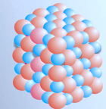**Formula Mass**: Some substances such as sodium chloride

do not contain discrete molecules as the constituent units.

In such compounds, cationic (sodium) and anionic (chloride)

entities are arranged in a three dimensional structure, NaCl

is the formula used to represent sodium chloride, though it is

not a molecule. The formula mass of a substance is the sum

of atomic masses of the atoms present in the formula.

**Mole:** Atoms and molecules are extremely small in size and their numbers in even a small amount of any substance is really very large. To handle such large numbers, a unit of convenient magnitude is required.

In SI system, mole (symbol, mol) was introduced as seventh base quantity for the amount of a substance

One mole is the amount of a substance that contains as many entities or particles as there are atoms in exactly 12 g (or 0.012 kg) of the carbon -12 isotope.

The mole, symbol mol, is the SI unit of amount of substance. One mole contains exactly

6.02214076 ×1023 elementary entities.

This number is the fixed numerical value of the **Avogadro constant, NA**, when expressed in the unit mol–1 and is called the **Avogadro number**.

Having defined the mole, it is easier to know the mass of one mole of a substance or the constituent entities. The mass of one mole of a substance in grams is called its molar mass.

**Relation between moles, mass, and number of particles**:

Moles (n) =

Number of particles (N) = n x NA

**Moles and gases:** "One mole of any gas occupies a volume of 22.4 dm3 at standard temperature (00 C) and pressure (1 atm) (STP). The volume of 22.4 dm3 at STP is known as molar volume of a gas.

Molar Mass: The mass of one mole of a substance (element/compound) in grams is called its molar mass.

**Problem -1**: How many molecules are present in 9 g of water?

**Solution**:

Molar mass of H2O = 18g / mol

Moles of H2O = 9/18 = 0.5mol

Number of molecules = 0.5× 6.022 × 1023

= 3.011×1023 molecules

**Problem- 2**: Find the mass of 1 mole of CO2.

**Solution**:

Atomic mass: C = 12, O = 16

M (CO2) = 12+2×16 = 44g/mol

So, 1 mole CO2 = 44 g.

**Percentage Composition:** The **percentage composition** of a compound is the percentage by mass of each element present in that compound.

**Formula**

**% of an element = × 100**

Example: Percentage composition of Water (H2O):

Molar mass = 2 ×1 + 16 = 18 g/mol

Mass of Hydrogen = 2 g

Mass of Oxygen = 16 g

% H = × 100 = 11.11%

% O = × 100 = 88.89%

**Applications of Percentage Composition:**

1. **Chemical Formula Determination**: It helps in determining the empirical formula (the simplest whole-number ratio of atoms in a compound) and sometimes the molecular formula of a substance.
2. **Purity Analysis**: It's used to assess the purity of chemical samples.
3. **Stoichiometry**: It's crucial for calculations involving chemical reactions, helping to determine the amount of reactants or products.
4. **Qualitative Analysis**: It can aid in identifying unknown substances.

**Concentration of solution**: The concerntration of a solution or the amount of substance present in given volume of a solution can be expressed in any of the following ways:

1. Mass percent or weight percent (w/w%)

2. Mole fraction

3. Molarity (M)

4. Molality (m)

**Mass percent**: It is obtained by using following relation:

Mass percent = × 100%

**Mole fraction**: It is the ratio of number of moles of a particular component of a solution to the total number of moles of the solution.

For a mixture with components A,B,C

χA​=

where

χA = mole fraction of component A

NA = number of moles of A

ntotal = nA+ nB + nC +...

Note:

1. Mole fraction is a ratio, so it has no unit.
2. Sum of all mole fractions in a mixture is always equal to 1.

**Problem**: Find the mole fraction of NaCl in a solution containing **5.85 g NaCl** dissolved in **180 g H₂O**.

**Solution**:

Moles of NaCl = = 0.1 mol

Moles of H₂O= = 10 mol

Total number of moles= 0.1+10=10.10.1 + 10 = 10.10.1+10=10.1

χNaCl = = 0.0099

χH2O = = 0.990

**Molarity:**It is the most wideley used unit and is denoted by M. It is defined as the number of moles of the solute present in 1 litre of the solution. Thus,

Molarity (M) =

**Problem**: Find the molarity of a solution prepared by dissolving **40 g of NaOH** in **500 mL of solution**.

**Solution**:

Molar mass of NaOH = 40 g/mol

Moles of NaOH = 40/40 = 1 mol

Volume = 500 mL=0.5 L

Molarity (M) =

= 1/0.5

=2

So, solution is **2 M NaOH**.

**The molarity equation for the dilution of a solution**:

M1​V1​=M2​V2​

Where:

M1​ is the initial molarity (concentration) of the stock solution.

V1​ is the initial volume of the stock solution.

M2​ is the final molarity (concentration) of the diluted solution.

V2​ is the final volume of the diluted solution.

**Understanding the Equation:**

Dilution is the process of decreasing the concentration of a solute in a solution by adding more solvent. When you dilute a solution, you are not adding more solute, only more solvent. Therefore, the total amount of solute (in moles) in the solution before dilution is the same as the total amount of solute in the solution after dilution.

The number of moles of a solute can be calculated by multiplying its molarity (moles/liter) by its volume (liters).

Moles of solute before dilution = M1​V1​

Moles of solute after dilution = M2​V2​​

Since the moles of solute are conserved:

M1​V1​=M2​V2​

**Problem**: You have a stock solution of 12 M hydrochloric acid (HCl). How many milliliters of this stock solution do you need to prepare 2 liters (2000 mL) of a 1 M HCl solution?

**Solution:**

We will use the dilution equation: M1​V1​=M2​V2

M1​ (initial molarity) = 12 M

V1​ (initial volume) = ? (This is what we need to find)

M2​ (final molarity) = 1 M

V2​ (final volume) = 2L = 2000 mL

Rearrange the equation to solve for V₁:

V1 =

Now, plug in the values:

V1 =

V1 =

V1​=166.67 mL

Answer: You need to take 166.67 mL of the 12 M HCI stock solution and dilute it with enough water to a final volume of 2000 mL (2 L) to obtain a 1 M HCI solution.

**Molality**: It is defined as the number of moles of solute present in 1 kg of solvent. It is denoted by m. Note that molality of a solution does not change with temperature since mass remains unaffected with temperature.

Molality (m) =

**Problem**: Calculate molality of a solution containing **40 g NaOH** in **250 g of water**.

**Solution**:

Molar mass of NaOH = 40 g/mol

Moles of NaOH = 40/40 = 1mol

Mass of solvent = 250g = 0.250kg

Molality (m) =

=1/0.250

= 4

So, solution is **4 m NaOH**.

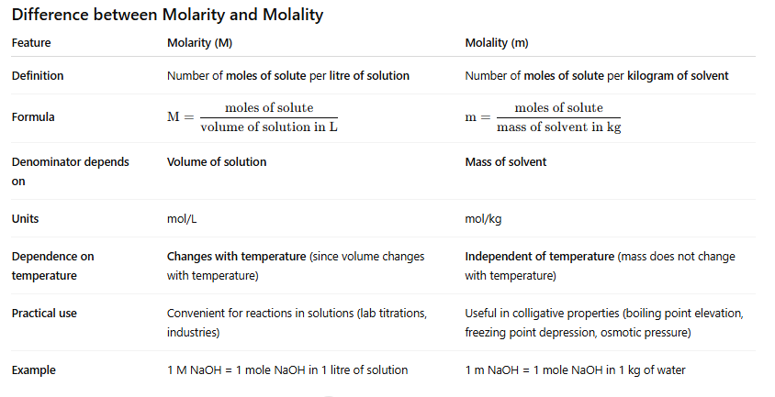

**NORMALITY**: It is the number of gram equivalents of a solute present in one litre of solution,

Normality =

**Number of gram equivalents:**

**Number of gram equivalents =**

**Equivalent Weight =**

What is the n-factor?

The n-factor (or valency factor) is a crucial part of the calculation. It represents the number of reactive units per molecule. Its value changes based on the type of reaction:

For Acids: The number of replaceable H+ ions.

Example: For sulfuric acid (H₂SO₄), the n-factor is 2.

For Bases: The number of replaceable OH ions.

Example: For calcium hydroxide Ca(OH)2), the n-factor is 2.

For Salts: The total positive or negative charge of the ions.

Example: For aluminum chloride (AlCl3), the n-factor is 3.

For Redox Agents: The number of electrons gained or lost per molecule.

Example: For potassium permanganate (KMnO4) in an acidic medium, the manganese changes its oxidation state from +7 to +2, gaining 5 electrons. Thus, the n-factor is 5.

The relation between normality (N) and molarity (M):

The simple and direct relationship is:

**N=M×n-factor**

**Normality Equation for Neutralization**:

**Na × Va = Nb × Vb**

Where:

Na​ = Normality of the acid

Va​ = Volume of the acid

Nb​ = Normality of the base

Vb​ = Volume of the base

**Example** :

Suppose you have 25 mL of an unknown acid and you want to find its normality. You titrate it with a 0.1 N solution of sodium hydroxide (NaOH) and find that it takes 20 mL of the NaOH solution to reach the equivalence point.

Using the equation:

Nacid​Vacid​=Nbase​Vbase​

Nacid​×25 mL=0.1 N×20 mL

Nacid​=25 mL0.1 N×20 mL​

Nacid​=0.08 N

The normality of the unknown acid is 0.08 N.

**The normality equation for dilution**: It is same as the one used for molarity or other concentration units:

**N1​V1​=N2​V2**​

This equation is derived from the principle of **conservation of mass** during dilution. When you dilute a solution by adding more solvent, the total amount of solute doesn't change. In the context of normality, the total number of **gram equivalents** of the solute remains constant before and after dilution.

What the Variables Mean

**N1​**: The initial normality of the concentrated solution.

**V1​**: The initial volume of the concentrated solution.

**N2​**: The final normality of the diluted solution.

**V2​**: The final volume of the diluted solution.

**EQUIVALENT MASS**: Equivalent mass (or equivalent weight) is a concept in chemistry that refers to the mass of a substance that will react with or displace a fixed amount of another substance. It's an older concept, but still useful in some contexts, particularly for describing the reactive capacity of a substance in a specific reaction.

Unlike molar mass, which is a fixed property of a compound, **equivalent mass depends on the reaction** in which the substance is participating. A substance can have different equivalent masses in different reactions.

**Definition: *It is the number of parts by weight of the substance that combines or displaces, directly or indirectly, 1.008 parts by mass of hydrogen or 8 parts by mass of oxygen or 35.5 parts by mass of chlorine or equivalent mass of any other element.***

**Relation between atomic weight, equivalent weight and valency**

**Equivalent weight =**

**Derivation**:

Let's say:

Atomic weight of an element = A

Valency of the element =V

Equivalent weight of the element = E

By definition, the equivalent weight is the amount of the element that would combine with 1 gram of hydrogen.

Since one atom of hydrogen has 1 valence electron and atomic weight 1, then:

1 equivalent of an element ≡ Amount that supplies or combines with 1 mol of H atoms (1g)

If an element has valency n, One atom of it will combine with or displace n hydrogen atoms.

Therefore, 1 mole of the element (which weighs A grams) can supply or combine with n equivalents of hydrogen (which weighs n grams).

Therefore, A/ n grams can supply or combine with 1 equivalent of hydrogen.

So:

**Equivalent weight(E) =**

* The relation shows that **equivalent weight is inversely proportional to valency**.
* Some elements have multiple valencies (e.g., Fe²⁺ and Fe³⁺).Therefore, the equivalent weight of such elements is not fixed — it depends on the oxidation state in a given compound or reaction.

**Problem:**

The atomic weight of iron (Fe) is 56 g/mol. In one of its ionic forms, iron has a valency of 3.  
Calculate the equivalent weight of iron in this oxidation state.

**Solution:**

We use the formula:

Equivalent weight(E) =

=

=18.67 g/equiv

**The general formula to calculate equivalent mass is**:

**Equivalent mass =**

(i) Equivalent mass for elements =

(ii) Equivalent mass for Radicals =

(iii) Equivalent mass for acids =

Example: H₂SO₄ (Sulfuric acid)

Molar mass = 98 g/mol

Basicity = 2

Equivalent mass==49 g/equiv

(iv) Equivalent mass for bases =

(v) Equivalent mass for salts =

**Problem:**  
Find the equivalent weight of **Na₂CO₃ (Sodium carbonate)**.

**Solution**:

Step 1: Molar Mass of

Na2CO3=2×23+12+3×16=46+12+48=106 g/mol

Step 2: Find n (Total Positive or Negative Charge)

In aqueous solution: Na2CO3→2Na+ + CO32-

The anion has a **2-** charge → means it can accept **2 H⁺ ions** in neutralization.

So, **n = 2**

Step 3: Use Formula

Equivalent weight= = 53 g/equiv ​

### (vi) For Redox Reactions:

Equivalent Mass =

Example: KMnO₄ in acidic medium

Molar mass = 158 g/mol

Mn changes from +7 to +2 ⇒ gains 5 electrons

Equivalent mass = = 31.6 g/equiv

**METHODS OF DETERMINING EQUIVALENT MASSES:**

(1) **Hydrogen displacement method:** It is used for metals which can displace H2 from acids. When a metal reacts with an acid, it displaces hydrogen gas. The amount of hydrogen displaced can be measured, and from this, the **equivalent weight** of the metal can be calculated using:

Equivalent mass of metal =×1.008

= x 11.2

**Problem:**

A student reacted 1.95 g of a metal (M) with excess dilute hydrochloric acid, and collected 448 mL of hydrogen gas at STP.Calculate the equivalent weight of the metal.

**Solution**:

Equivalent mass of metal = x 11.2

= x 11.2 = 48.75

(ii) **Metal displacement method**: In this method, a **more reactive metal** (say, Metal A) displaces a **less reactive metal** (say, Metal B) from its salt solution. The equivalent weight of the more reactive metal is calculated based on the mass of metal deposited (Metal B) and the amount of metal A used.



**Problem:**

**A strip of magnesium weighing 0.60 g is dipped into a solution of copper sulfate. After some time, 1.27 g of copper is deposited. If the equivalent weight of copper is 63.5, calculate the equivalent weight of magnesium.**

**Solution:**

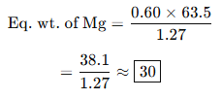

(iii) **Oxide formation method**: This method is based on measuring the mass of a metal before and after it has been oxidized (typically by heating in air) to form a metal oxide.You can then determine how much oxygen has combined with the metal and use this to calculate the equivalent weight of the metal.

Eq. wt. of metal =

**Problem**:

When a sample of magnesium is heated in air, it reacts with oxygen and forms **2.40 g of magnesium oxide**. The mass of magnesium used was **1.44 g**.

Calculate the **equivalent weight of magnesium** using the **oxide formation method**.

**Solution:**

Mass of oxygen=Mass of MgO−Mass of Mg

=2.40 g−1.44 g=0.96 g

Eq. wt. of metal =

=

=12 g/equiv

(iv**) Chloride formation method**: To determine the equivalent weight of a metal (especially a reactive metal like magnesium, zinc, or aluminum), one common method is the chloride formation method, which involves reacting the metal with hydrochloric acid (HCl) to form a metal chloride, then isolating and weighing the chloride compound.

Eqv. mass of metal = ×35.5

**Numerical Problem**:

A 1.00 g sample of a metal M is reacted completely with excess hydrochloric acid. After the reaction, the solution is evaporated to dryness, and 4.10 g of the metal chloride (MClₓ) is obtained.

Determine the equivalent weight of the metal.

**Solution**:

Mass of metal (M) = 1.00 g

Mass of metal chloride (MClₓ) = 4.10 g

Therefore, Mass of chlorine (Cl) in the compound = 4.10 − 1.00 = 3.10 g

Eqv. mass of metal = ×35.5

= × 35.5

=11.45

(v) **Neutralisation method for acids and bases**: The neutralization method is used to determine the equivalent weight of an acid or a base based on the acid-base reaction:

Acid + Base → Salt + Water

During neutralization, one equivalent of acid reacts with one equivalent of base. By using a standard solution of known normality, we can calculate the equivalent weight of the unknown acid or base.

For example,

Equivalent mass of acid =

**Problem:**  
0.49 g of an unknown acid requires 100 mL **0.1 N NaOH solution for complete neutralization.  
Find the equivalent weight of the acid.**

**Solution:**

Equivalent mass of acid =

=

=49

(vi) **Conversion method**: When one compound of a metal is converted to another compound of similar metal then

=

where E is the eqv. mass of the metal.

**Problem**: 10 g of a metal carbonate gives 4.6 g of metal oxide on strong heating . Calculate the equivalent weight of the metal.

**Solution**: Let equivalent weight of the metal be E. Using the formula

=

We can write,

=

؞ =

؞ E=20

**(vii)** The **electrolysis method:** The **electrolysis method** for determining the **equivalent weight** of a substance is based on **Faraday’s laws of electrolysis**.

Using Faraday’s Laws of electrolysis, Equivalent weight of an element can be calculated by using the following formula:

**E = , where,**

m = mass of the substance deposited or liberated

I = Current(amp)

T = time(sec)

E = equivalent weight

F = Faraday's constant (≈ 96500 C/mol)

**Numerical Problem**

During the electrolysis of a metal salt solution, a **current of 2.5 A** was passed through the electrolyte for **40 minutes**. As a result, **1.48 grams** of the metal were deposited on the cathode.Calculate the **equivalent weight** of the metal.  
(Use Faraday's constant F=96500 C/mol)

**Solution**:

**E =**

**=**

**= 23.8 g/equiv**

**DETERMINATION OF ATOMIC MASS**:

(1) **Dulong and petit's rule**: It is based on experimental facts. "At ordinary temperature,product of atomic mass and specific heat for solid elements is approximately 6.4 and this product is known as atomic heat of the element".

Atomic mass x specific heat = 6.4

؞ **Atomic mass =**

**Limitations**:

* The rule works well mainly for solid metals at room temperature.
* It fails for:
  + Non-metals (like carbon, sulfur)
  + Elements with low atomic mass (like beryllium, boron)
  + Low temperatures, where quantum effects are significant (explained by Einstein and Debye models later)

**Problem:**

The specific heat of a metal is 0. 11 and its equivalent weight is 18. 61 Calculate its exact atomic weight .

**Solution:**

At. wt. x Sp. heat = 6.4 (approx)

Approx atomic wt. = = 58.1

Valency =

=

Exact atomic weight = 3 × 18. 61 = 55.83

(ii) **Volatile chloride vapour density method :** This method can be used for those elements whose chlorides are volatile so that their vapour densities can be determined

Then

Mol. wt. of the chloride = 2×V.D

If V is the valency of the element (M), then the formula of its chloride will be MCIV, Hence,

Mol. wt. of the chloride, MClV

= At. wt. of M + V × 35 * 5

= Eq. wt. of M × Valency of M + 35.5 x V

= E xV + 35.5 x V

=(E+35.5) x V

؞(E+35.5) x V = 2×V.D

؞V =

Knowing the eq. wt. E of the element, the valency V can be calculated.

Then Atomic weight = Eq. wt. x Valency.

**Problem**:

Vapour density of a metal chloride is 66. Its oxide contains 53% metal. Calculate the atomic weight of the metal.

**Solution**:

Eq. wt. of metal == 9.02

Valency of the metal

V =

=

Atomic wt. 9.02 × 3 = 27.06

(iii) **Isomorphism method**: Compounds having similar molecular formulae and identical crystal structure are called isomorphous. The method is based upon the fact that elements in isomorphous compounds have same valencies, e.g,

(a) K2SO4, K2CrO4 and K2SeO4 are isomor-phous. Hence, valency of S, Cr and Sc = 6

(b) ZnSO4.7H2O, FeSO4.7H2O, MgSO4.7H2O are isomorphous. Hence, valency of Zn, Fe and Mg = 2

(c) Alums, M₂SO₄.M2 (SO4)3.24H2O in which M is monovalent and M' is trivalent are isomorphous.

Knowing the valency,

Atomic wt. = Eq. wt. x Valency

**Problem**:

The sulphate of metal contains 20.9% of the metal and is isomorphous with ZnSO4.7H2O. What is the probable atomic mass of the metal?

**Solution**:

The sulphate is isomorphous with ZnSO4.7H2O.

Hence by the law of isomorphism, its chemical formula should be MSO4.7H2O.

Let atomic mass of metal M be 'x'

The molecular mass of metal sulphate = (x + 32 + 64) + 7 x 18 = x + 222

Percentage of metal in sulphate = x 100 =20.9

؞ x=58.65

Thus the probable atomic mass of the metal is 58.65

**EMPIRICAL FORMULA:** An empirical formula represents the simplest whole-number ratio of atoms of each element present in a compound. It tells you the relative number of atoms, not the actual number of atoms in a molecule.

**Steps to determine Empirical Formula**:

1. Find the percent composition of each element in the compound. This is usually given or can be calculated from the molecular formula.
2. Convert the percentages to grams by assuming a 100 gram sample. So, 30% carbon becomes 30 grams of carbon.
3. Convert grams to moles for each element using their respective atomic masses from the periodic table.
4. Divide each mole value by the smallest mole value obtained in the previous step. This gives you a ratio.
5. If the ratios are not whole numbers, multiply all ratios by the smallest integer that will convert them into whole numbers.

**Problem:**

Find out the empirical formula for a compound that is 40.0% carbon, 6.7% hydrogen, and 53.3% oxygen by mass.

**Solution:**

Assuming 100g sample: 40.0g C, 6.7g H, 53.3g O.

Converting to moles:

C: 40.0 g/12.01 g/mol≈3.33 mol

H: 6.7 g/1.01 g/mol≈6.63 mol

O: 53.3 g/16.00 g/mol≈3.33 mol

Divide by the smallest mole value (3.33 mol):

C: 3.33/3.33=1

H: 6.63/3.33≈2

O: 3.33/3.33=1

The simplest whole-number ratio is 1:2:1.

Therefore, the empirical formula for this compound is **CH2​O**.

**MOLECULAR FORMULA**: A molecular formula is a chemical formula that indicates the actual number of atoms of each element present in a single molecule of a compound. It shows the precise composition of a molecule.

**Key Differences from Empirical Formula**:

While an empirical formula shows the simplest whole-number ratio of atoms, the molecular formula shows the exact number of atoms. This means that a molecular formula is always a whole-number multiple (say n) of its empirical formula.

**Steps to Calculate Molecular Formula**:

1. Find the empirical formula of the compound.
2. Calculate the mass of the empirical formula (sum of atomic masses).
3. Divide molar mass by empirical formula mass to get n.
4. Multiply subscripts in empirical formula by n to get molecular formula.

**Problem**:

The empirical formula of a compound is **CH₂O**. Its molar mass is **180 g/mol**. Find its molecular formula.

**Solution**:

Empirical formula = CH₂O

Empirical formula mass = (12 + 2×1 + 16) = **30 g/mol**

n== 6

Molecular formula = (CH2O)×6 = C6​H12​O6​

Molecular Formula = **Glucose (C₆H₁₂O₆)**

**Stoichiometry : The Chemistry of Proportions**

Stoichiometry is a fundamental concept in chemistry that deals with the quantitative relationships between reactants and products in a chemical reaction. It's essentially the "recipe" for chemical reactions, allowing us to predict how much of a substance is needed or will be produced.

The word "***stoichiometry***" comes from the Greek words "***stoicheion***" (meaning element) and "***metron***" (meaning measure).

**Key Steps in Stoichiometric Calculations**

* Write a balanced chemical equation.
* Convert given quantity (mass, volume, particles) into moles.

Moles= = =

* Use mole ratio from the balanced equation to relate reactant ↔ product.
* Convert moles back into required unit (grams, liters, molecules).

**Important Concepts**

* Mole: 1 mol = 6.022×1023 particles
* Molar volume (at STP): 1 mol gas=22.4 L
* Law of conservation of mass: Total mass of reactants = Total mass of products

**Generally problems based on stoichiometry are of the following types**:

a. Problems based on mass-mass relationship;

b. Problems based on mass-volume relationship and

c. Problems based on volume-volume relationship.

d***. Eudiometry or "gas analysis"*** involves a calculation based on gaseous reactions in which at least two components are gases & their amount is given in terms of volumes measured at same pressure & Temperature.

**Limiting reagent**: The reactant which gets consumed, limits the amount of product formed and is therefore, called the limiting reagent.

*********************************************************************************

**Numerical problems**:

## 1) Simple mass → mass

**Problem:** How many grams of CO₂ are produced when **10.0 g** of propane (C₃H₈) burns completely?  
Reaction: C3H8 + 5 O2 → 3 CO2 + 4 H2O

**Solution:**

1. Molar mass C₃H₈ = 3×12.01 + 8×1.008 = 36.03 + 8.064 = **44.094 g/mol**.
2. Moles C₃H₈ = 10.0 ÷ 44.094 = **0.2268 mol** (carry extra digits).
3. From equation: 1 mol C₃H₈ → 3 mol CO₂. So moles of CO₂ = 0.2268 × 3 = **0.6804 mol**.
4. Molar mass CO₂ = 12.01 + 2×16.00 = **44.01 g/mol**.
5. Mass CO₂ = 0.6804 × 44.01 = **29.94 g**.

**Answer:** **29.94 g CO₂** (≈ 29.9 g)

## 2) Limiting reagent

**Problem:** 5.00 g of iron reacts with 7.00 g of oxygen to form Fe₂O₃. What is the limiting reagent and how many grams of Fe₂O₃ form?  
Reaction: 4 Fe + 3O2 → 2Fe2O3

**Solution:**

1. Molar mass Fe = 55.85 g/mol → moles Fe = 5.00 ÷ 55.85 = **0.08952 mol**.
2. Molar mass O₂ = 32.00 g/mol → moles O₂ = 7.00 ÷ 32.00 = **0.21875 mol**.
3. Stoichiometry: 4 mol Fe react with 3 mol O₂ → mole ratio Fe:O₂ required = 4:3 = 1.333...:1  
   For available moles, required O₂ for given Fe = 0.08952 × (3/4) = 0.08952 × 0.75 = **0.06714 mol O₂**.We have 0.21875 mol O₂ which is more than required → **Fe is limiting**.
4. Moles Fe₂O₃ produced: from eqn 4 Fe → 2 Fe₂O₃, so 4 mol Fe produce 2 mol Fe₂O₃ → factor = 2/4 = 0.5.  
   Moles Fe₂O₃ = 0.08952 × 0.5 = **0.04476 mol**.
5. Molar mass Fe₂O₃ = 2×55.85 + 3×16.00 = 111.70 + 48.00 = **159.70 g/mol**.
6. Mass Fe₂O₃ = 0.04476 × 159.70 = **7.144 g**.

**Answer:** Limiting reagent: **Fe**. Mass Fe₂O₃ = **7.14 g**

## 3) Percent yield

**Problem:** Theoretical yield of product = 12.0 g. If actual yield obtained is 9.60 g, what is the percent yield?

**Solution:**  
Percent yield = (actual ÷ theoretical) × 100% = (9.60 ÷ 12.0) × 100% = 0.8 × 100% = **80.0%**.

**Answer:** **80.0%**

## 4) Gas stoichiometry at STP

**Problem:** If 2.50 L of N₂ (g) react with excess H₂ at STP to produce ammonia, what volume of NH₃ (g) is produced at STP?  
Reaction: N2 + 3H2 → 2NH3  
(At STP use 1 mol gas = 22.4 L)

**Solution:**

1. Moles N₂ = 2.50 ÷ 22.4 = **0.11161 mol**.
2. Ratio: 1 mol N₂ → 2 mol NH₃, so moles NH₃ = 0.11161 × 2 = **0.22322 mol**.
3. Volume NH₃ = 0.22322 × 22.4 = **5.00 L** (neat result).

**Answer:** **5.00 L NH₃** at STP

## 5) Empirical → molecular (with given molar mass)

**Problem:** A compound has empirical formula CH₂ and molar mass 56.0 g/mol. Find the molecular formula.

**Solution:**

1. Empirical mass CH₂ = 12.01 + 2×1.008 = 14.026 g/mol.
2. n = molar mass ÷ empirical mass = 56.0 ÷ 14.026 = **3.993 ≈ 4.00** → n = 4.
3. Molecular formula = (CH₂)₄ = **C₄H₈**.

**Answer:** **C₄H₈**

## 6) Solution concentration → stoichiometry (titration)

**Problem:** 25.00 mL of HCl is titrated with 0.1000 M NaOH and requires 30.00 mL of NaOH to reach endpoint. Find molarity of HCl.

**Solution:**

1. Reaction: HCl + NaOH → NaCl + H2O (1:1).
2. Moles NaOH used = 0.1000 M × 0.03000 L = **0.003000 mol**.
3. Therefore moles HCl = 0.003000 mol. Volume HCl = 0.02500 L → Molarity HCl = 0.003000 ÷ 0.02500 = **0.1200 M**.

**Answer:** **0.1200 M HCl**

## 7) Multi-step stoichiometry + limiting reagent + percent yield

**Problem:** 10.0 g of Al react with excess Fe₂O₃ in a thermite reaction: 2 Al + Fe2O3 → Al2O3 + 2 Fe. If the reaction actually produces 7.00 g of Fe, what is the percent yield? (Molar masses: Al = 26.98, Fe = 55.85)

**Solution:**

1. Moles Al available = 10.0 ÷ 26.98 = **0.3706 mol**.
2. Stoichiometry: 2 mol Al → 2 mol Fe (1:1 in Al:Fe via equation factoring). More carefully: 2 Al + Fe₂O₃ → Al₂O₃ + 2 Fe → so 2 mol Al produce 2 mol Fe → 1 mol Al produces 1 mol Fe. So moles Fe theoretical = moles Al = **0.3706 mol**.
3. Theoretical mass Fe = 0.3706 × 55.85 = **20.69 g**.
4. Actual Fe = 7.00 g → percent yield = (7.00 ÷ 20.69) × 100% = 0.3382 × 100% = **33.82%** → **33.8%** .

**Answer:** **33.8% yield**

\*\*\*\*\*\*\*\*\*\*\*\*\*\*\*\*\*\*\*\*\*\*\*\*\*\*\*\*\*\*\*\*\*\*\*\*\*\*\*\*\*\*\*\*\*\*\*\*\*\*\*\*\*\*\*\*\*\*\*\*\*\*\*\*\*\*\*\*\*\*\*\*\*\*\*\*\*\*\*\*\*\***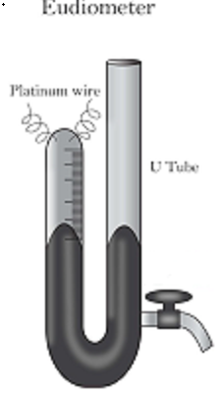Eudiometry** is the study of gaseous reactions, focusing on the quantitative relationship between the volumes of gaseous reactants and products. It's a type of stoichiometry that applies specifically to gases. The core principle of eudiometry is Gay-Lussac's Law of Combining Volumes, which states that when gases react, they do so in volumes that bear a simple whole-number ratio to one another, as long as the volumes are measured at the same temperature and pressure.

Eudiometry calculations are often performed using a device called a **eudiometer** . This is a graduated glass tube used to measure changes in gas volume in a reaction.

### Key Principles and Assumptions in Eudiometry

* **Gay-Lussac's Law:** The coefficients in a balanced chemical equation for a gas-phase reaction directly represent the ratios of the volumes of the gases involved. For example, in the reaction 2H2​(g)+O2​(g)→2H2​O(g), the volume ratio is 2:1:2. This allows you to perform calculations directly with volumes instead of converting to moles.
* **Constant Temperature and Pressure:** All gas volumes must be measured under the same conditions of temperature and pressure to ensure the validity of Gay-Lussac's Law.
* **Negligible Volume of Solids and Liquids:** The volume of any solid or liquid reactants or products is considered insignificant compared to the volume of gases. For instance, in the formation of liquid water from hydrogen and oxygen gas, the volume of the liquid water is treated as zero.
* **Non-Reacting Gases:** Eudiometry problems often include gases that do not react under the given conditions, such as nitrogen from the air. These gases are considered non-reactive and their volume contributes to the total volume but doesn't change during the reaction.
* **Absorption of Gases:** Specific chemical reagents are used to absorb certain gases, allowing for the determination of the volume of each component in a gaseous mixture. For example, a solution of potassium hydroxide (KOH) is used to absorb carbon dioxide (CO2​), and alkaline pyrogallol absorbs oxygen (O2​).

## Determining Hydrocarbon Formula via Eudiometry

1. **Combustion Reaction:** A known volume of the gaseous hydrocarbon (Cx​Hy​) is mixed with an excess of oxygen (O2​) in a eudiometer tube. The mixture is ignited, usually by an electric spark. The hydrocarbon burns completely to form carbon dioxide (CO2​) and water vapor (H2​O).The general balanced equation is:

Cx​Hy​(g) + (x+y/4​)O2​(g)→xCO2​(g) + y/2​H2​O(g)

1. **Volume Measurement After Combustion and Cooling:** After ignition, the eudiometer is cooled. The water vapor condenses into liquid water, which has a negligible volume. The remaining gases are typically CO2​ and any excess O2​. The volume of this gaseous mixture is measured. Due to negligible volume of liquid water, volume of product is found to be less than that of reactants. The contraction in volume is called **First volume contraction**.

For the combustion of V volume of hydrocarbon,

**First volume contraction = V(1 + x + –x) =V(1+) ………………………(I)**

1. **Absorption of Carbon Dioxide:** A substance that absorbs CO2​, such as potassium hydroxide (KOH) solution or sodium hydroxide (NaOH) solution, is introduced into the eudiometer. The decrease in volume after absorption indicates the volume of CO2​ produced. This decrease in volume is called Second volume contraction.

For the combustion of V volume of hydrocarbon,

**Second volume contraction =Vx …………………………………………..(II)**

1. **Determination of Unreacted Oxygen (Optional but common):** If the initial volume of O2​ was known, the volume of O2​ that reacted can be calculated by subtracting the volume of unreacted O2​ (found after CO2​ absorption) from the initial volume of O2​. Sometimes, a substance like alkaline pyrogallol is used to absorb the remaining O2​, and the volume decrease is measured.

From equations (I) and (II) we can calculate the values of x and y and hence the formula of the hydrocarbon.

**Problem**:

Suppose 10 mL of a gaseous hydrocarbon is exploded with 80 mL of O2​. After cooling, the residual gas volume is 70 mL. This volume reduces to 50 mL upon treatment with KOH solution.Find out the formula of the Hydrocarbon.

**Solution**:

Suppose, the formula of the hydrocarbon is CxHy . The equation for combustion is:

**Cx​Hy​(g) + (x+y/4​)O2​(g)→xCO2​(g) + y/2​H2​O(g)**

First volume contraction = 10(1+) = (10+80-70) ………………………(I)

Second volume contraction =10x = (70-50) …………………………………………..(II)

From (I) and (II), x=2, y=4

؞The formula of the Hydrocarbon is **C2H4**.

**The Principle of Atom Conservation (POAC)**:

In any chemical reaction, the **total number of each type of atom remains conserved**. This principle is used to directly relate the quantities of reactants and products without balancing the full reaction in detail.

**Number of atoms of each element before reaction = Number of atoms after reaction**

**Why it works?**

* A chemical reaction is just a rearrangement of atoms.
* Atoms are neither created nor destroyed (Law of Conservation of Mass).
* Instead of balancing full equations, we can use **POAC relations** for quick numerical problem-solving in stoichiometry.

**General Relation**

If element **E** is common to two reacting substances, then:

**Moles of substance A × atoms of E in A = Moles of substance B × atoms of E in B**

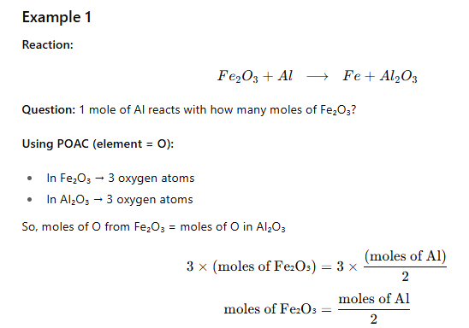

For **1 mole Al → 0.5 mole Fe₂O₃**

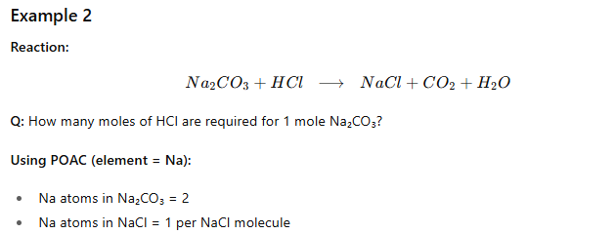

So, 1 mole Na₂CO₃ gives 2 moles NaCl → needs **2 moles HCl**

# ****Volumetric Analysis****

Volumetric analysis is a **quantitative analytical technique** where the volume of a standard solution of known concentration is used to determine the concentration of an unknown solution.

It is based on **titration** — the process of adding one solution from a burette to another solution until the reaction between them is complete.

## ****Key Terms****

1. **Titration** → The process of gradually adding one solution (titrant) to another (analyte) until the reaction is just complete.
2. **Titrant** → Solution of **known concentration** (placed in burette).
3. **Analyte** → Solution of **unknown concentration** (taken in flask).
4. **Indicator** → Substance that shows the **end point** (completion of reaction) by a visible change (usually color).
5. **End Point** → The stage where titration is complete (observed by color change).
6. **Equivalence Point** → The exact point where chemically equivalent amounts of reactants have reacted (theoretical).

End point ≈ Equivalence point (small difference due to indicator).

## ****Types of Volumetric Analysis****

1. **Acid–Base Titrations**
   * Based on neutralization reactions.
   * Example: HCl vs NaOH using phenolphthalein or methyl orange.
   * Equation:

HCl+NaOH  →  NaCl+H2O

1. **Redox Titrations**
   * Based on oxidation–reduction reactions.
   * Example: KMnO₄ vs FeSO₄.
   * Indicators are often **self-indicators** (like KMnO₄, purple → colorless).
2. **Complexometric Titrations**
   * Based on formation of stable complexes.
   * Example: EDTA vs Ca²⁺/Mg²⁺ ions in water hardness determination.
3. **Precipitation Titrations**
   * Based on formation of precipitate.
   * Example: AgNO₃ vs NaCl (Mohr’s method, Volhard’s method).

## ****General Formula for Calculations****

N1V1=N2V2

Where:

* N1​ = Normality of solution 1
* V1 = Volume of solution 1 (in mL)
* N2​ = Normality of solution 2
* V2 = Volume of solution 2

If normality is not given, use **Molarity**:

=

(where n1,n2 ​ = stoichiometric coefficients in balanced equation)

## Problem

**Q:** 25.0 mL of NaOH solution requires 20.0 mL of 0.1 N HCl for neutralization. Find the normality of NaOH.

**Solution:**

N1V1=N2V2

​ NNaOH × 25.0=0.1 × 20.

NNaOH = = 0.08

Normality of NaOH = **0.08 N**

**Exercise (NCERT)**

1.1 Calculate the molar mass of the following:

(i) H2O

(ii) CO2

(iii) CH4

**Solution:**

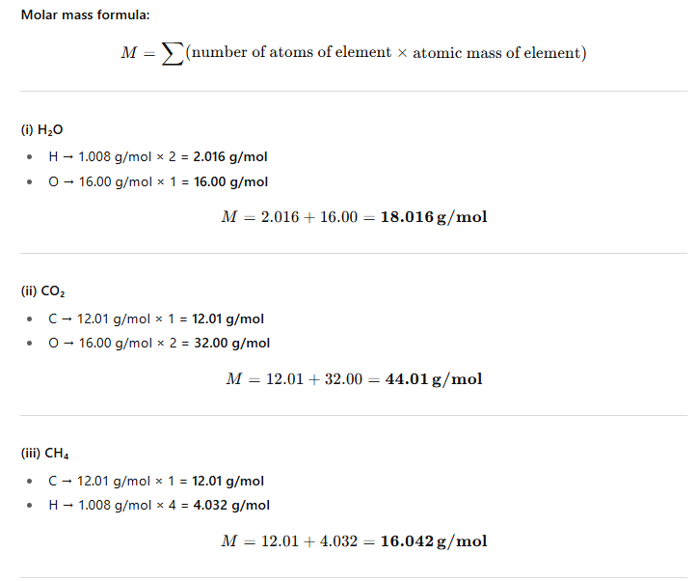

1.2 Calculate the mass per cent of different elements present in sodium sulphate (Na2SO4).

**Solution:**

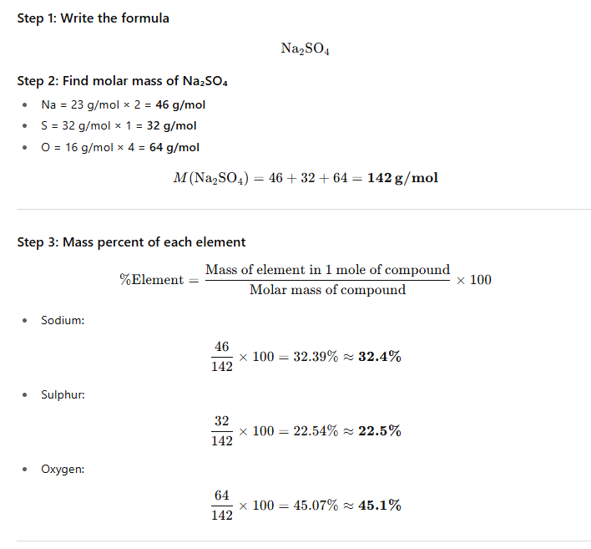

1.3 Determine the empirical formula of an oxide of iron, which has 69.9% iron and 30.1% dioxygen by mass.

**Solution:**

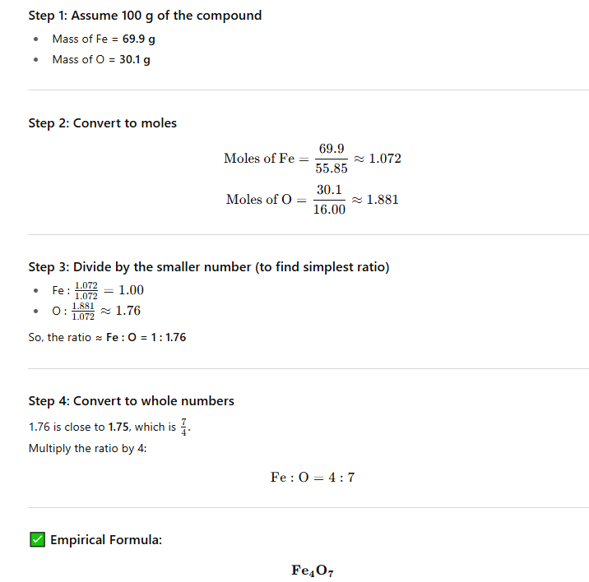

1.4 Calculate the amount of carbon dioxide that could be produced when

(i) 1 mole of carbon is burnt in air.

(ii) 1 mole of carbon is burnt in 16 g of dioxygen.

(iii) 2 moles of carbon are burnt in 16 g of dioxygen.

**Solution:**

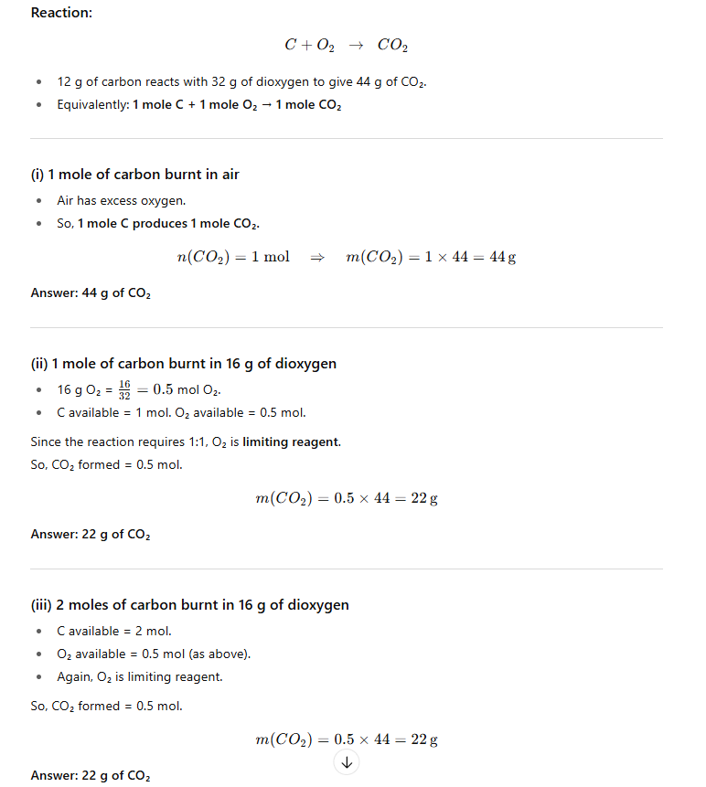

1.5 Calculate the mass of sodium acetate (CH3COONa) required to make 500 mL of 0.375 molar aqueous solution. Molar mass of sodium acetate is 82.0245 g mol–1.

**Solution:**

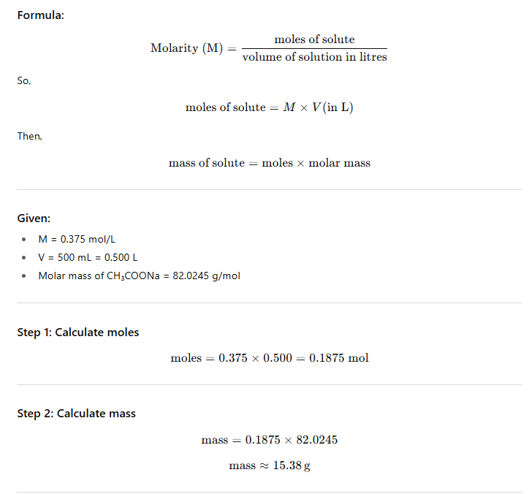

1.6 Calculate the concentration of nitric acid in moles per litre in a sample which has a density, 1.41 g mL–1 and the mass per cent of nitric acid in it being 69%.

**Solution:**

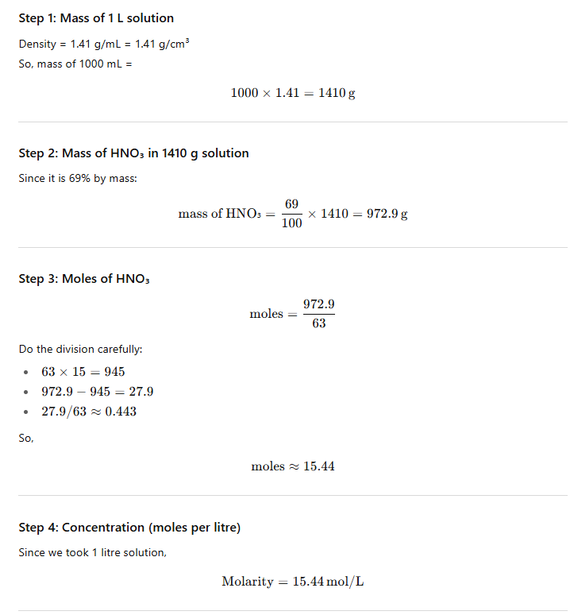

1.7 How much copper can be obtained from 100 g of copper sulphate (CuSO4)?

**Solution:**

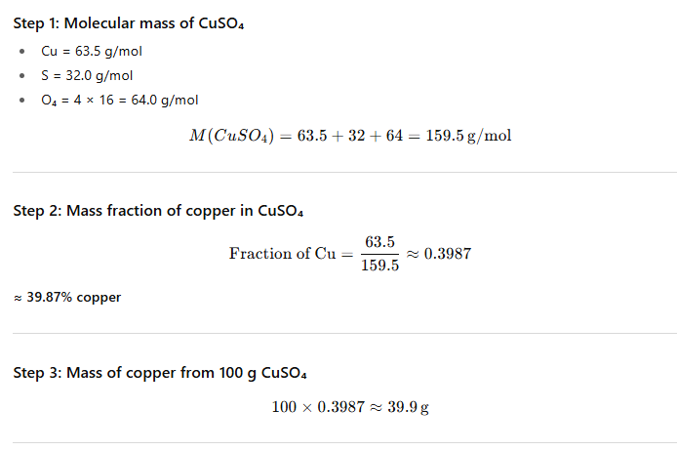

1.8 Determine the molecular formula of an oxide of iron, in which the mass per cent of iron and oxygen are 69.9 and 30.1, respectively.

**Solution:**

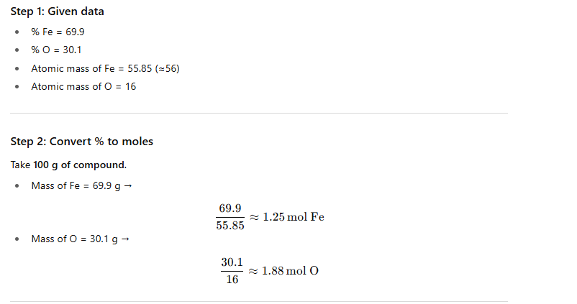

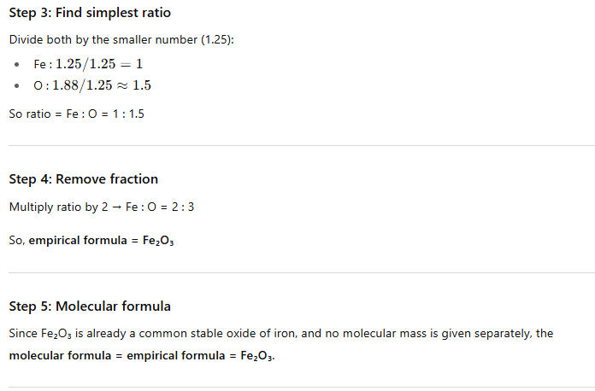

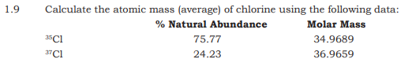

**Solution:**

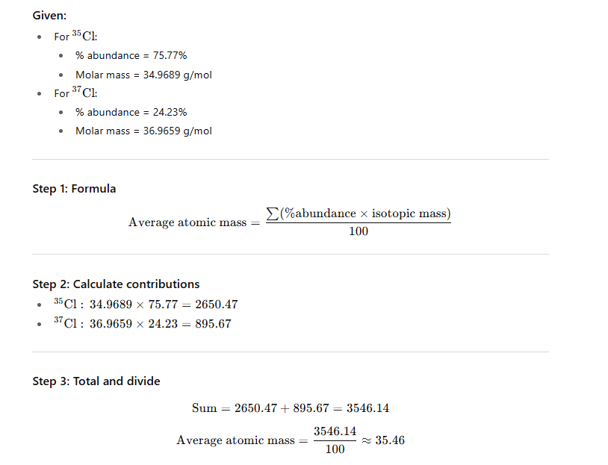

1.10 In three moles of ethane (C2H6), calculate the following:

(i) Number of moles of carbon atoms.

(ii) Number of moles of hydrogen atoms.

(iii) Number of molecules of ethane.

**Solution:**

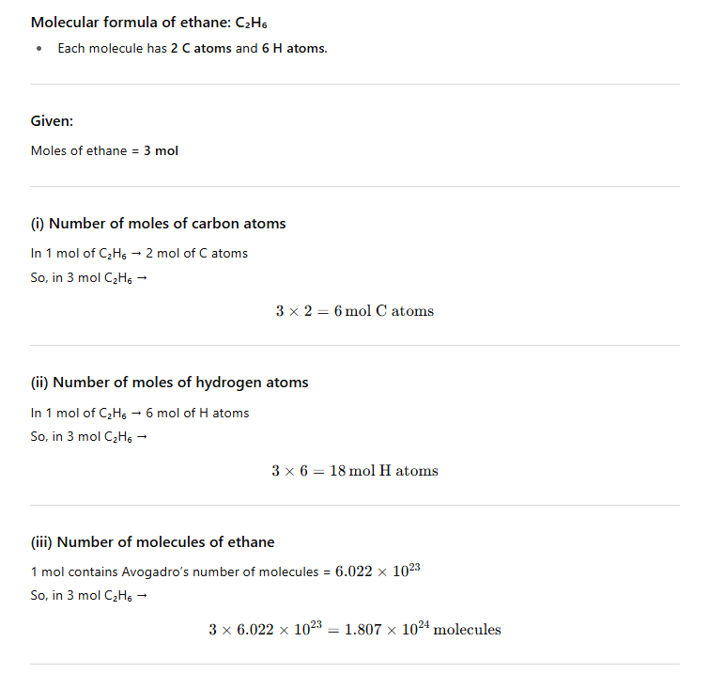

1.11 What is the concentration of sugar (C12H22O11) in mol L–1 if its 20 g are dissolved in enough water to make a final volume up to 2L?

**Solution:**

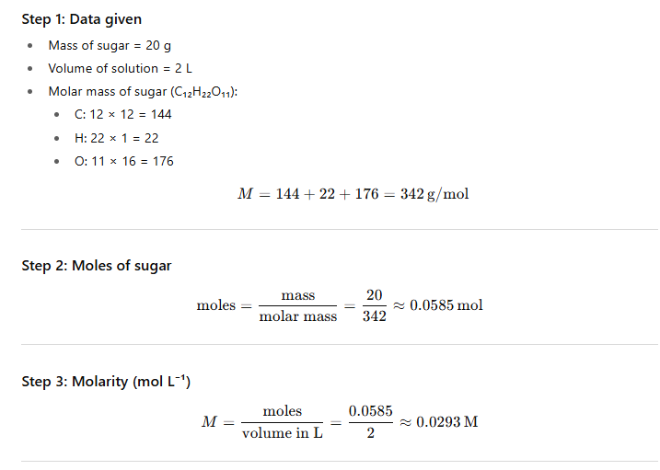

1.12 If the density of methanol is 0.793 kg L–1, what is its volume needed for making 2.5 L of its

0.25 M solution?

**Solution:**

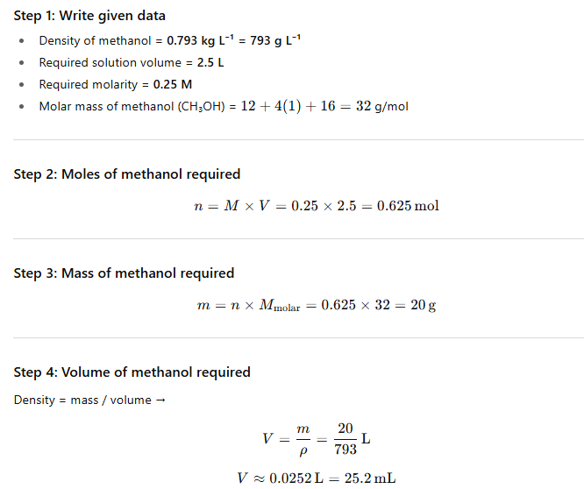

1.13 Pressure is determined as force per unit area of the surface. The SI unit of pressure, pascal is as shown below: 1Pa = 1N m–2 If mass of air at sea level is 1034 g cm–2, calculate the pressure in pascal.

**Solution:**

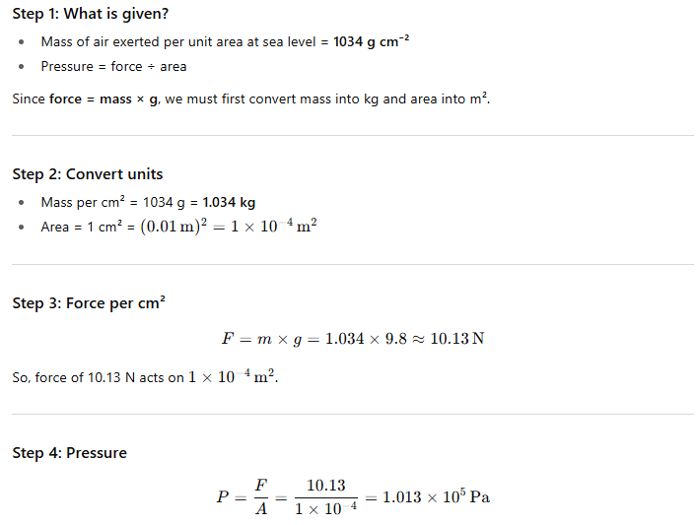

1.14 What is the SI unit of mass? How is it defined?

**Solution:**

The kilogram is defined based on the **Planck constant**, denoted by h. Its value is fixed at exactly 6.62607015×10−34 joule-seconds (J·s).

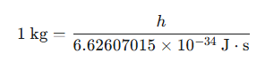

This redefinition, which occurred in 2019, replaced the previous definition that was based on a physical artifact: the International Prototype of the Kilogram (IPK). The IPK was a platinum-iridium cylinder kept in a vault near Paris. The shift to a definition based on a fundamental physical constant ensures greater stability and universality.

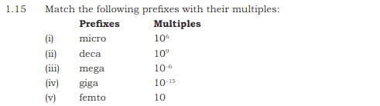

**Solution:**

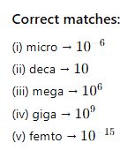

1.16 What do you mean by significant figures?

**Solution:**

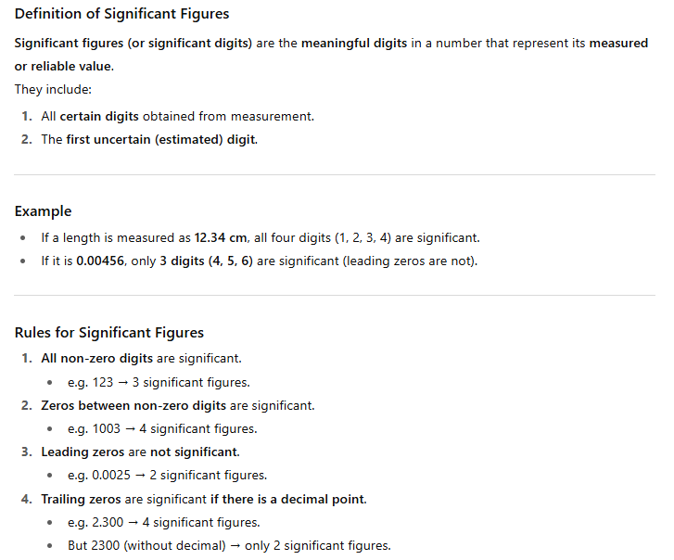

1.17 A sample of drinking water was found to be severely contaminated with chloroform, CHCl3, supposed to be carcinogenic in nature. The level of contamination was 15 ppm (by mass).

(i) Express this in per cent by mass.

(ii) Determine the molality of chloroform in the water sample.

**Solution:**

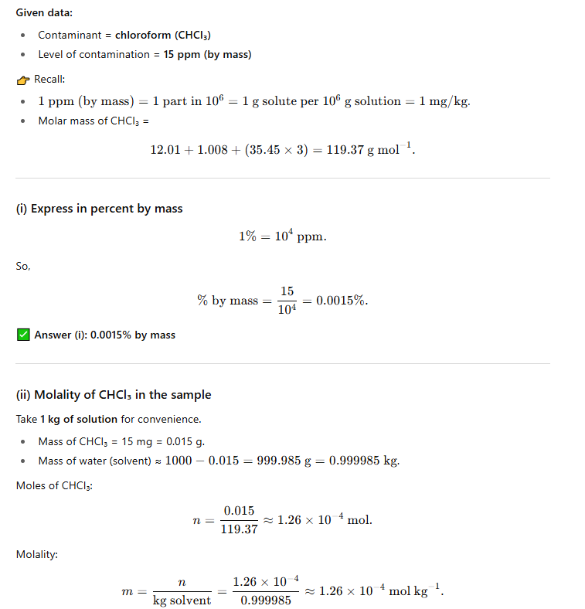

1.18 Express the following in the scientific notation:

(i) 0.0048

(ii) 234,000

(iii) 8008

(iv) 500.0

(v) 6.0012

**Solution:**

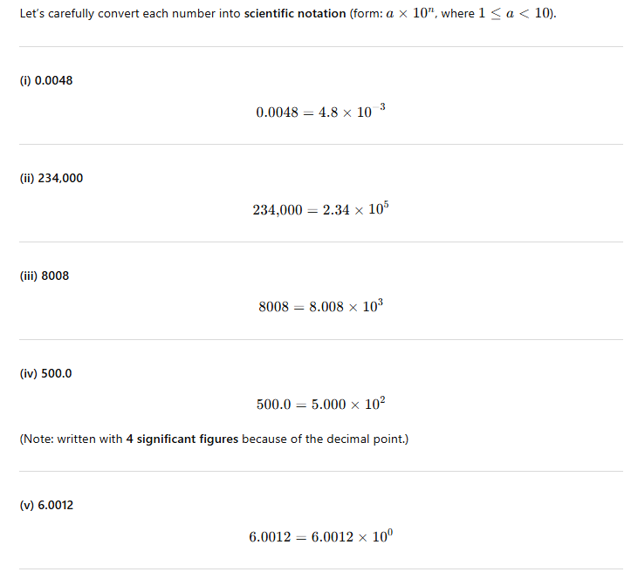

1.19 How many significant figures are present in the following?

(i) 0.0025

(ii) 208

(iii) 5005

(iv) 126,000

(v) 500.0

(vi) 2.0034

**Solution:**

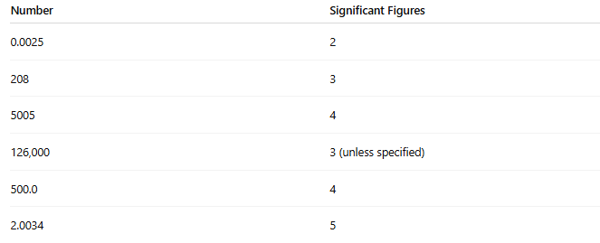

1.20 Round up the following upto three significant figures:

(i) 34.216

(ii) 10.4107

(iii) 0.04597

(iv) 2808

**Solution:**

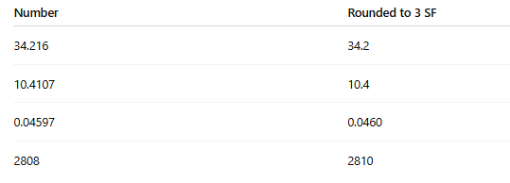

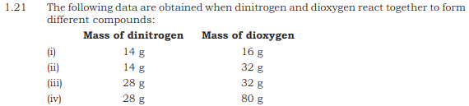

Which law of chemical combination is obeyed by the above experimental data?

**Solution:**

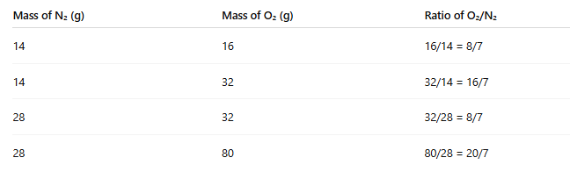

The masses of dioxygen that combine with a fixed mass (14 g) of dinitrogen are 16 g, 32 g, 16 g, and 40 g.

Let's simplify these masses to find the ratio:

16:32:16:40

By dividing each number by the greatest common divisor (in this case, 8), we get:

2:4:2:5

Since the ratio of the masses of dioxygen is a simple whole number ratio (2:4:2:5), the data follows the ***Law of Multiple Proportions***.

1.22 If the speed of light is 3.0 × 108 ms–1, calculate the distance covered by light in 2.00 ns.

**Solution:**

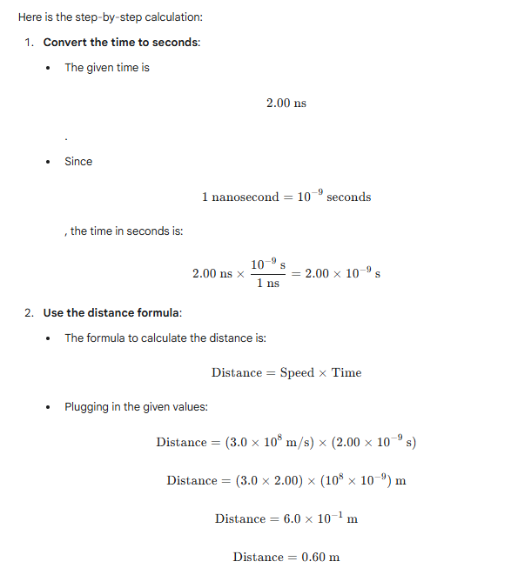

1.23 In a reaction

A + B2 AB2 Identify the limiting reagent, if any, in the following reaction mixtures.

(i) 300 atoms of A + 200 molecules of B

(ii) 2 mol A + 3 mol B

(iii) 100 atoms of A + 100 molecules of B

(iv) 5 mol A + 2.5 mol B

(v) 2.5 mol A + 5 mol B

**Solution:**

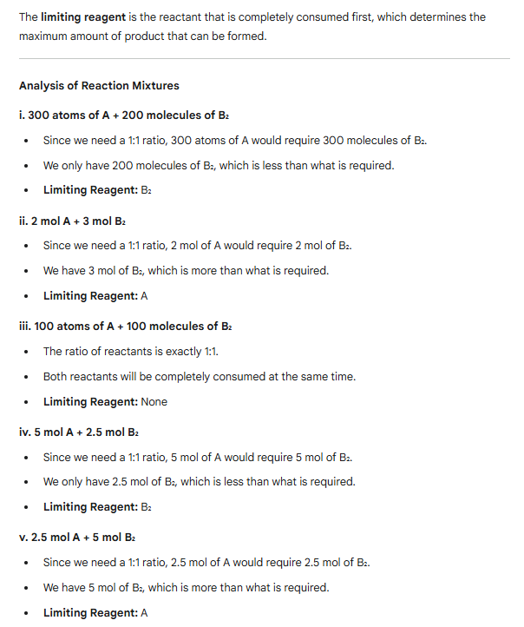

1.24 N2 and O2 react with each other to produce ammonia according to the following chemical equation: N2 (g) + H2 (g) 2NH3 (g)

(i) Calculate the mass of ammonia produced if 2.00 × 103 g N2 reacts with 1.00 × 103 g of dihydrogen.

(ii) Will any of the two reactants remain unreacted?

(iii) If yes, which one and what would be its mass?

**Solution**:

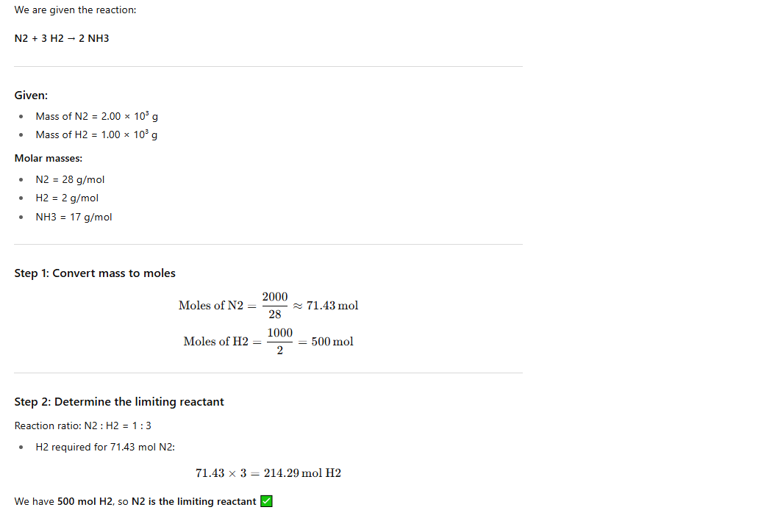

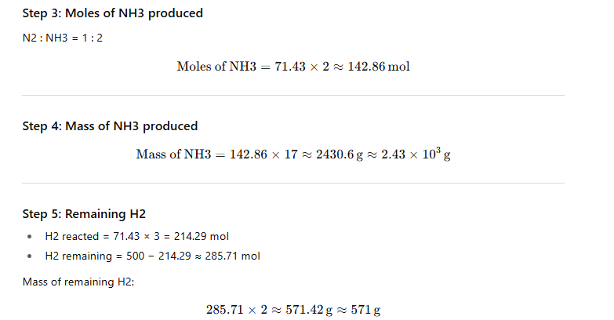

1.25 How are 0.50 mol Na2CO3 and 0.50 M Na2CO3 different?

**Solution**:

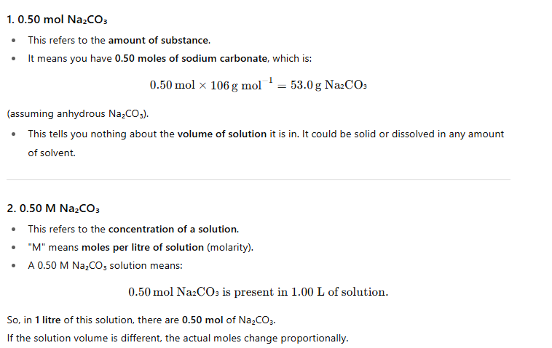

1.26 If 10 volumes of H2 gas reacts with five volumes of O2 gas, how many volumes of water vapour would be produced?

**Solution**:

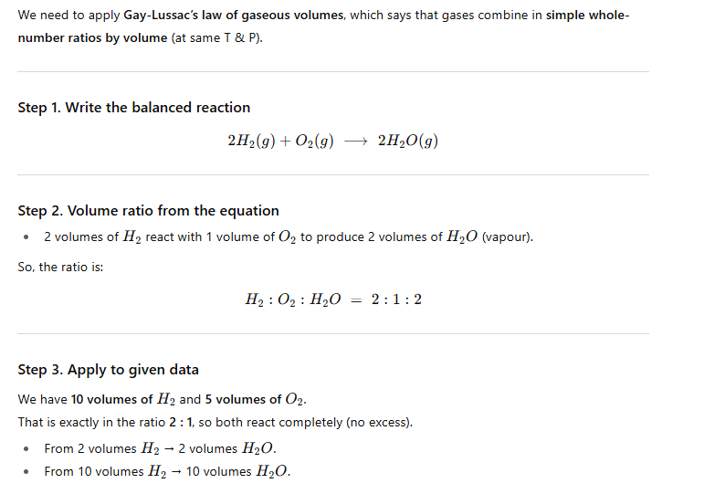

1.27 Convert the following into basic units:

(i) 28.7 pm

(ii) 15.15 pm

(iii) 25365 mg

**Solution:**

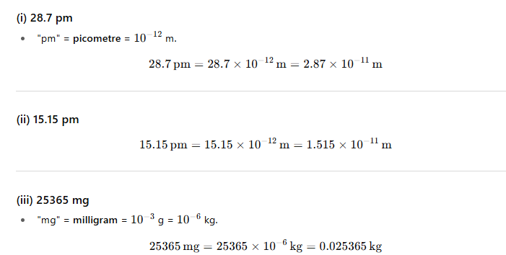

1.28 Which one of the following will have the largest number of atoms?

(i) 1 g Au (s)

(ii) 1 g Na (s)

(iii) 1 g Li (s)

(iv) 1 g of Cl2 (g)

**Solution:**

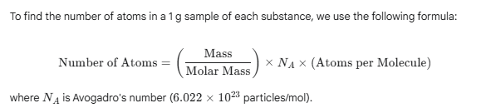

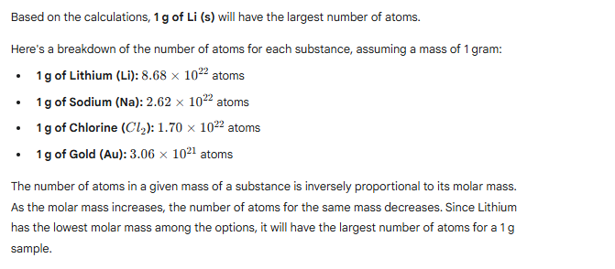

1.29 Calculate the molarity of a solution of ethanol in water, in which the mole fraction of ethanol is 0.040 (assume the density of water to be one).

**Solution:**

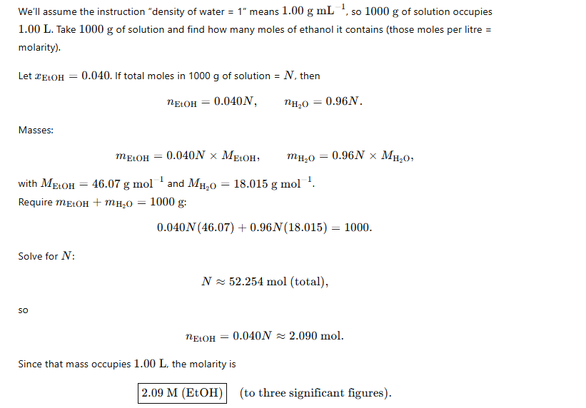

1.30. What will be the mass of one 12C atom in g?

**Solution:**

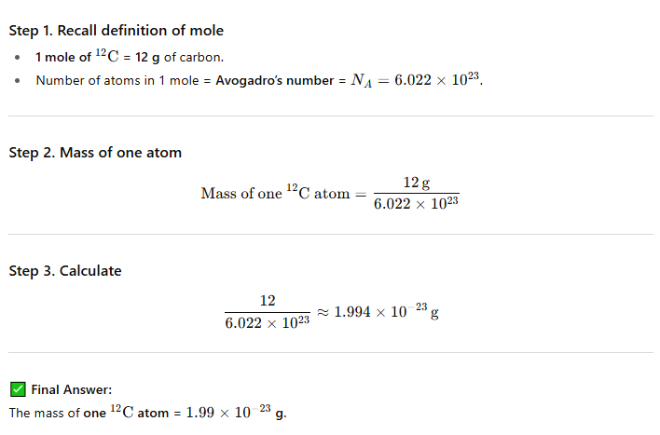

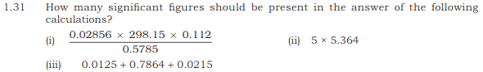

**Solution:**

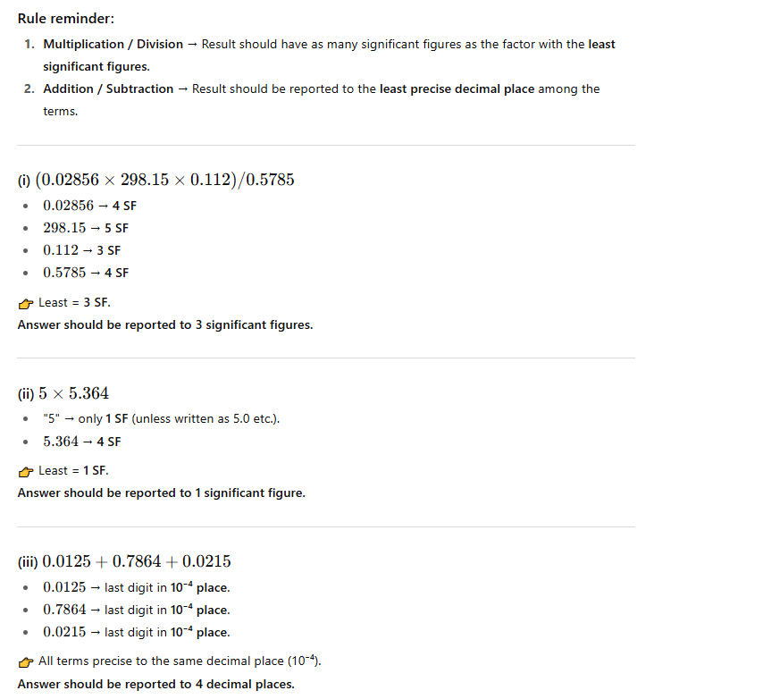

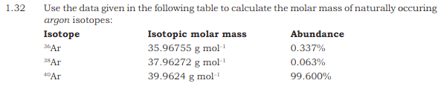

**Solution:**

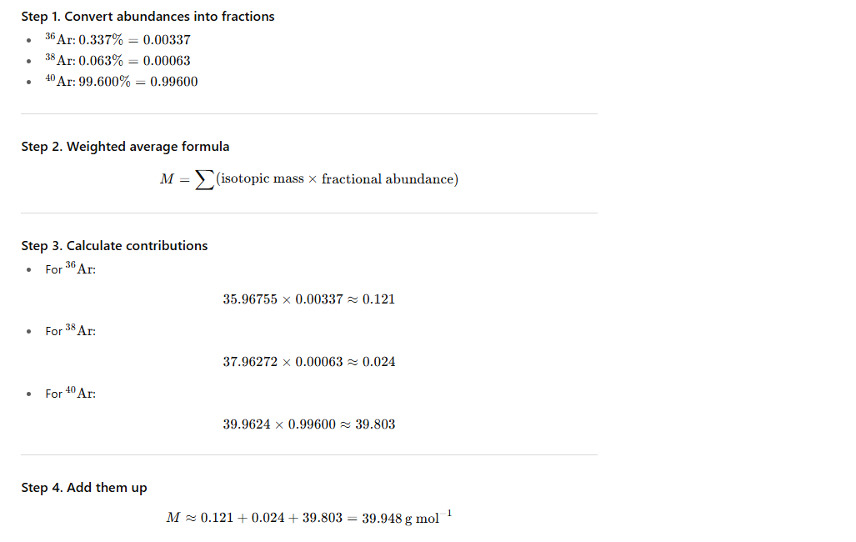

1.33 Calculate the number of atoms in each of the following

(i) 52 moles of Ar

(ii) 52 u of He

(iii) 52 g of He.

**Solution:**

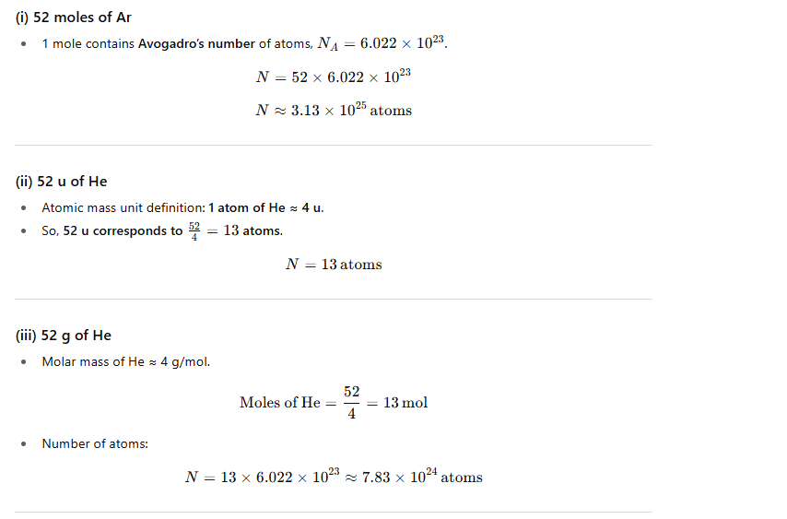

1.34 A welding fuel gas contains carbon and hydrogen only. Burning a small sample of it in oxygen gives 3.38 g carbon dioxide, 0.690 g of water and no other products. A volume of 10.0 L (measured at STP) of this welding gas is found to weigh 11.6 g. Calculate

(i) Empirical formula,

(ii) Molar mass of the gas, and

(iii) Molecular formula.

**Solution:**

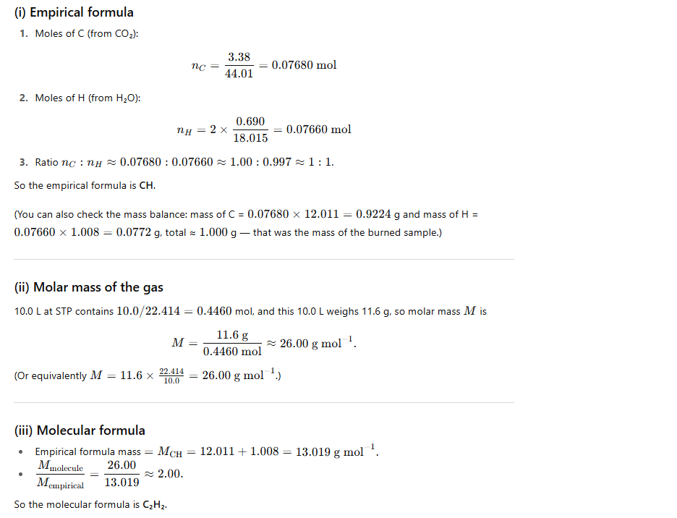

1.35 Calcium carbonate reacts with aqueous HCl to give CaCl2 and CO2 according to the reaction, CaCO3 (s) + 2 HCl (aq) → CaCl2 (aq) + CO2 (g) + H2O (l) what mass of CaCO3 is required to react completely with 25 mL of 0.75 M HCl?

**Solution:**

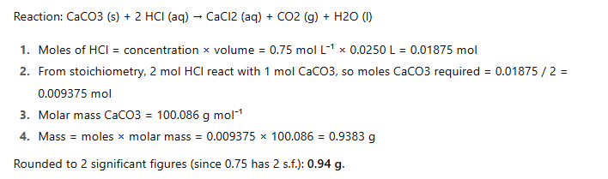

1.36 Chlorine is prepared in the laboratory by treating manganese dioxide (MnO2) with aqueous hydrochloric acid according to the reaction :4HCl (aq) + MnO2(s) → 2H2O (l) + MnCl2 (aq) + Cl2 (g)

How many grams of HCl react with 5.0 g of manganese dioxide?

**Solution:**

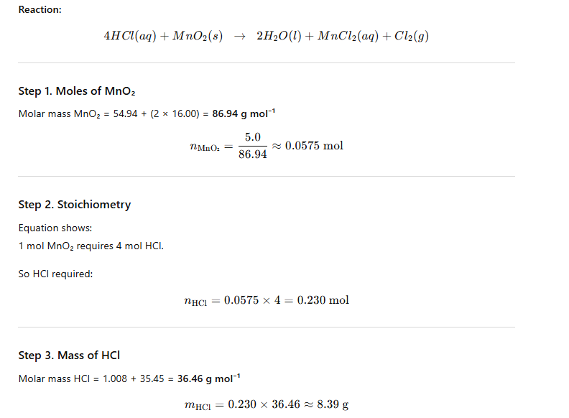

**Multiple Choice Questions:**

1. 25.4 g of I2 and 14.2 g of Cl2 are made to react completely to yield a mixture of ICI and ICl3. Calculate moles of ICl and ICl3 formed

(a) 0.1, 0.1 (b) 0.2, 0.2 (c) 0.1, 0.2 (d) 0.2, 0.1

2. In the final answer of the expression

(29.2 - 20.2)(1.79×10 5) / 1.37 the number of significant figures is

(a) 1 (b) 3 (c) 2 (d) 4

3. The vapour density of a gas is 11.2. The volume occupied by 11.2 g of the gas at NTP will be

(a) 22.4 L (b) 11.2 L (c) 1 L (d) 44.8 L

4. The percentage of Se in peroxidase anhydrous enzyme is 0.5% by weight (atomic weight 78.4). Then minimum molecular weight of peroxidase anhydrous enzyme is

(a) 1.568×103 (b) 1.568 ×104 (c) 15.68 (d) 3.136 ×104

5. Equivalent weight of crystalline oxalic acid is

(a) 90 (b) 53 (c) 63 (d) 45

6. 3 g of an oxide of a metal is converted to chloride completely and it yielded 5 g of chloride. The equivalent weight of the metal is

(a) 3.325 (b) 33.25 (c) 12 (d) 20

7. Number of moles of KMnO4 required to oxidize one mole of Fe(C2O4) in acidic medium is

(a) 0.167 (b) 0.6 (c) 0.2 (d) 0.4

8. 100 cm³ of 0.1 N HCl is mixed with 100 cm³ of 0.2 N NaOH solution. The resulting solution is

(a) 0.1 N and the solution is basic (b) 0.1 N and the solution is acidic

(c) 0.05 N and the solution is basic (d) 0.05 N and the solution is acidic

9. In order to prepare one litre normal solution of KMnO4, how many grams of KMnO4 are required if the solution is to be used in acid medium for oxidation?

(a) 158 g (b) 62.0 g (c) 31.6 g (d) 790 g

10. An aqueous solution of 6.3 g of oxalic acid dihydrate is made up to 250 ml. The volume of 0.1 N NaOH required to completely neutralise 10 ml of this solution is

(a) 20 ml (b) 40 ml (c) 10 ml (d) 4 ml

11. If potassium chlorate is 80% pure, then 48 gm of oxygen would be produced from

(atomic mass of K = 39 )

(a) 153.12gm of KClO3 (b) 122.5 gm of KClO3

(c) 245 gm of KClO3 (d) 98 gm of KCIO3

12. If 0.5 mol of BaCl2 is mixed with 0.2 mol of Na3PO4 then maximum number of moles of Ba3(PO4)2 that can be formed is

(a) 0.7 (b) 0.5 (c) 0.3 (d) 0.1

13. If 3.01×1020 molecules are removed from 98 mg of H2SO4, then the number of moles of H2SO4 left are

(a) 0.1 ×10- 3 (b) 0.5 ×10 – 3 (c) 1.66 ×10 – 3 (d) 9.95 ×10 - 2

14. Gastric juice contains 3.0 g of HCl per litre. If a person produces 2.5 litre of gastric juice per day. How many antacid tablets each containing 400 mg of Al(OH)3 are needed to neutralize all the HCl produced in one day?

(a) 18 (b) 14 (c) 20 (d) 17

15. A 100 ml solution of 0.1 N HCl was titrated with 0.2 N NaOH solution. The titration was discontinued after adding 30 ml of NaOH solution. The remaining titration was completed by adding 0.25 N KOH solution. The volume of KOH required for completing the titration is

(a) 16 ml (b) 32 ml (c) 35 ml (d) 70 ml

16. 6.02 ×1020 molecules of urea are present in 100 mL of its solution. The concentration of solution is:

(a) 0.01 M (b) 0.001 M (c) 0.1 M (d) 0.02 M

17. A gaseous hydrocarbon gives upon combustion 0.72 g of water and 3.08 g. of CO2.

The empirical formula of the hydrocarbon is:

(a) C2H4 (b) C3H4 (c) C6H5 (d) C7H8

18. Two oxides of a metal contain 50% and 40% metal (M) respectively. If the formula of first oxide is MO2 the formula of second oxide will be

(a) MO2 (b) MO3 (c) M₂O (d) M2O5

19. In which of the following number all zeros are significant?

(a) 0.0005 (b) 0.0500 (c) 50.000 (d) 0.0050

20. The number of moles of KMnO4 reduced by one mole of KI in alkaline medium is:

(a) One (b) two (c) five (d) one fifth

**Answer for MCQ**

|  |  |  |  |  |  |  |  |  |  |  |
| --- | --- | --- | --- | --- | --- | --- | --- | --- | --- | --- |
| **Question** | **Answer** |  | **Question** | **Answer** |  | **Question** | **Answer** |  | **Question** | **Answer** |
| **1** | **a** |  | **6** | **b** |  | **11** | **a** |  | **16** | **a** |
| **2** | **b** |  | **7** | **b** |  | **12** | **d** |  | **17** | **d** |
| **3** | **b** |  | **8** | **c** |  | **13** | **b** |  | **18** | **b** |
| **4** | **b** |  | **9** | **c** |  | **14** | **b** |  | **19** | **c** |
| **5** | **c** |  | **10** | **b** |  | **15** | **a** |  | **20** | **a** |

Samir Dutta