Title: Analysis of Australian Business Condition and Sentiments post Covid-19

Table of Contents

Index of Figures 3

Abstract 4

Introduction 5

Data Collection and Preparation 5

Result 6

Discussion and Future Works 13

References 14

Appendix 16

# Index of Figures

Figure 1: Ability to Recover Lost Hours 7

Figure 2: Insufficiency of staff by Types of Organization 8

Figure 3: Change in Revenue by the size of the organization 9

Figure 4:Monthly Revenue and the Expectation 10

Figure 5: Top Reason for Not taking funds 11

Figure 6: Business entities that sought Extra Funds 12

# Abstract

**Background:** Numerous business sectors are negatively affected due to the Covid-19 pandemic. There was a large gap in employee availability, a large drop in revenue, as well supply chain disruptions were being identified as a great challenge. However, a significant change in business condition is identified after the Covid-19 pandemic eradication. The sentiments of the individuals (consumers) are also changed towards business entities. In this report, a visual study of the Australian business condition and sentiments are analyzed and reported.

**Data Collection and Methods:** For analysis work, the dataset is collected from the Australian Social Survey site. The originally collected dataset was in CSV format and was not appropriate for analysis in R Studio. The dataset comprises the information related to business entities as well as individuals' sentiments for the financial months January, and February 2022. The original dataset is transformed and numerous sheets are derived for proper analysis. The visual analytics is used for the analysis of the transformed data using the essential R packages "ggplot2", "LatticeExtra", and "Geom-Bar". The business entities in the dataset are divided into three groups as small, medium, and large businesses.

**Result:** The interpretation of the visual results derived using the different R packages is accomplished and the findings depict that there is still a significant disruption in the supply chain is recorded for the various business entities post Covid-19. However, as compared to the Jan-2022 supply chain disruption, a 10% decrease is recorded for the disruption in the supply chain for Feb-2022. A great increase in staff presence is also recorded for Feb-2022 as compared to Jan-2022. Also, various business entities can gain higher revenue in the last month. Overall, the business entities are now operating well post Covid-19 pandemic.

**Conclusion:** The release of covid-19 restriction has significantly helped the business entities to sustain and make higher revenues. It is found that most organizations are making massive improvements in most in numerous aspects of the business industry. The disruption in the supply chain is also significantly reduced over the past three months.

# Introduction

In the wake of Covid-19 in 2019, almost all business entities had faced a lot of financial losses as well as economic instability. One of the most affected business sectors was the education, and transportation sector. Many great challenges were posed to the global supply chain network due to Covid-19. Regular lockdowns posed restrictions on transportation temporarily seized the flow of materials and hence the global supply chain was largely impacted. There was a sudden downfall in generating revenues is identified for almost all business industries due to regular continuous lockdowns and disruptions in the supply chain. The global economy is adversely impacted due to the Covid-19 pandemic. The economic sustainability of energy sector organizations was also adversely impacted. According to (Fu, & Shen, 2020) negative impact of Covid-19 was recognized on the corporate functioning of the energy sector companies. The energy sector companies were badly impacted that they were not able to cover fixed costs. Chetty, et al 2020, have proposed a study for examining the short term and long term impact of Covi-19 impact of pharmaceutical companies. The demand for pharmaceutical products was suddenly increased with a positive trend of the covid-19 cases. An abrupt increase in pharmaceutical products results in changing the production regulations, change in R & D and telemedicine. The overall growth of the industry become slowed as delays in approvals from the government. Also, a significant change in the consumption of medicinal products was recorded during the Covid-19 rise time. The positive trend of the Covid-19 cases pushes the decision-makers towards more strategic and analytical planning to sustain and fulfills the sudden rise in demand for medicinal products (Ranasinghe, et al 2020).

# Data Collection and Preparation

The dataset collected, provides insights into the sentiments and the condition of the Australian business entities. The survey site comprises the monthly record of the Australian business data and a timely survey is conducted to collect the insights for researchers, business entities, and governments. The data was collected by using the telephonic based business survey between 17 - 24 February 2022. The survey comprises the information of business status and the sentiments are collected by following the Standard Industrial Classification for Australia as well as New Zealand. Manufacturing industries, miming, education, construction, retail trade, transportation and Health care are some of the major business sectors which are included in this survey data collection (Lau, 2020). The survey does not include the insights of the different departments, authorities, and organizations regulated by the local and state government.

A randomly selected individual's response of 2000 business entities are included in the survey and stratified by employment size and type of industry. The overall response percentage of the survey was sixty per cent (60%). To provide the population estimates and exclude the non-responses the survey sample is re-weighted. There is a high likelihood of systematic biasing of the dataset which is also a major drawback of the collected data. For analysis work, the dataset is collected from the Australian Social Survey site. The originally collected dataset was in CSV format and was not appropriate for analysis in R Studio. The dataset comprises the information related to business entities as well as individuals' sentiments for the financial years 2021, and 2022 (Telukdarie, Munsamy, & Mohlala, 2020). The original dataset is transformed and numerous sheets are derived for proper analysis.

# Result

The visual analytic approach is implemented in this storytelling report to analyze the Australian Social Survey Dataset. The R-Studio has used an analytical tool for capturing the different visual graphs. Numerous R packages are implemented for capturing the graphs. However, the common and frequently used R packages such as "GGplot2" (Maag, 2018), "LatticeExtra", and "Geom-bar" is used in this analysis (Ahlmann-Eltze, & Patil, 2021). The transformed dataset is in excel format which is imported to the R environment using the "readxl" R-package (Wickham, et al 2019).

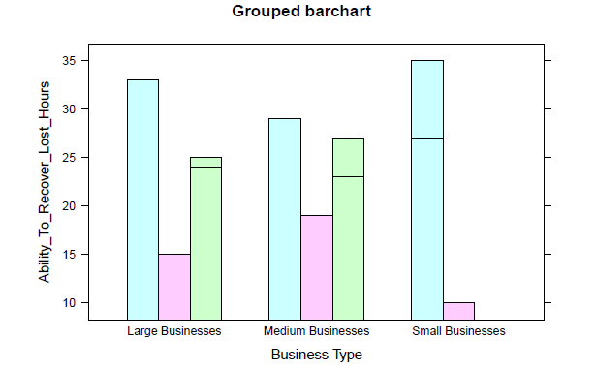

Figure 1: Ability to Recover Lost Hours

The stacked bar chart shown above depicts the capability of different types of businesses to recover the lost hours. From the above plot, it is clear that the small business entities have a higher capability of recovering the lost hours. The bar in light blue colour represents the data collected for the month February-2022, and the bar in light green colour represents the data collected for the month January-2022. The ability of each business type is increasing with the increase in time after the Covid-19 pandemic. The above plot is captured in R-Studio using the "latticeExtra" r package (Sarkar, & Sarkar, 2019).

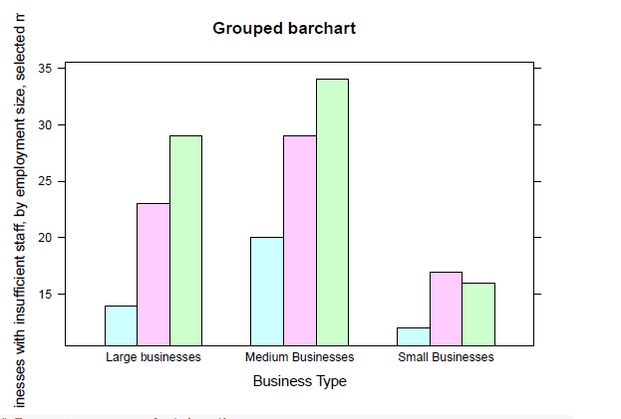

Figure 2: Insufficiency of staff by Types of Organization

Small business entities can fulfil staff shortages as shown in the above-grouped chart. The medium-sized business entities are still facing staff shortage challenges as shown in the above chart. The three coloured bars represent the data of Feb-2022, Jan-2022, and Jan-2021. The staff insufficiency was highest in Jan-2021 which is significantly reduced in Jan-2022. Also, fast recovery in staff insufficiency is recorded for Feb-2022. Small business entities are performing well in managing employee insufficiency. However, medium-sized business entities are still facing issues in managing staff availability.

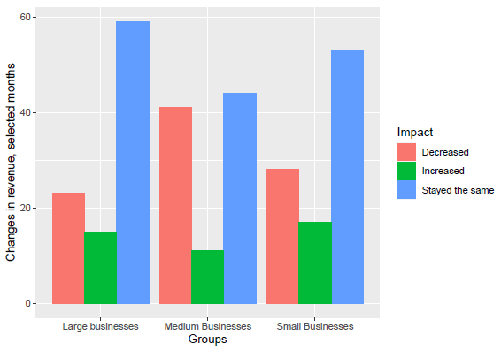

Figure 3: Change in Revenue by the size of the organization

The above chart depicts the change recorded in revenue for different types of business entities over the last month and the expected change for the upcoming months. For Feb-2022, a decrease in revenue (23%) is recorded as compared to Jan-2022 (41%). However, the proportion of reporting an increase in revenue has increased from 11% to 15%. The graph shown below depicts the expected revenue for the upcoming months. Expected revenues percentage is shown as some business has mentioned due to lower restrictions, they will be able to generate higher revenue.

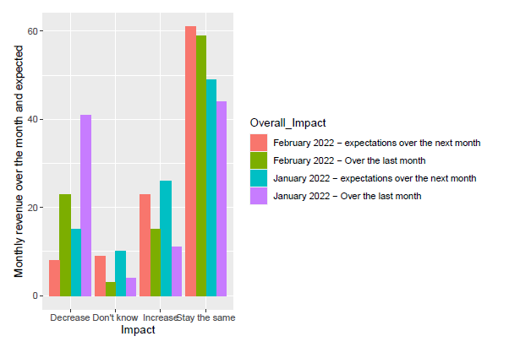

Figure 4:Monthly Revenue and the Expectation

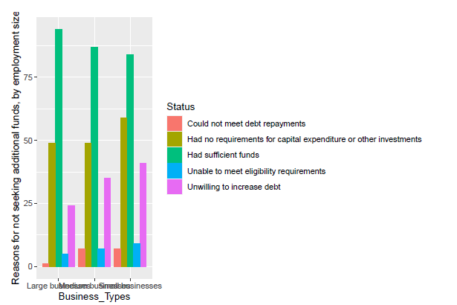

Figure 5: Top Reason for Not taking funds

The above bar chart depicts the top reason why business entities do not want to seek additional funds. Most of the businesses (Small, Medium, and Large) depicts they have sufficient funds to run the business operation. Some of them reported that there is no requirement for capital expenditure or any other type of investment (Aburumman, 2020). Also, a significant proportion of responses is reported as the business will not be able to make a debt repayment.

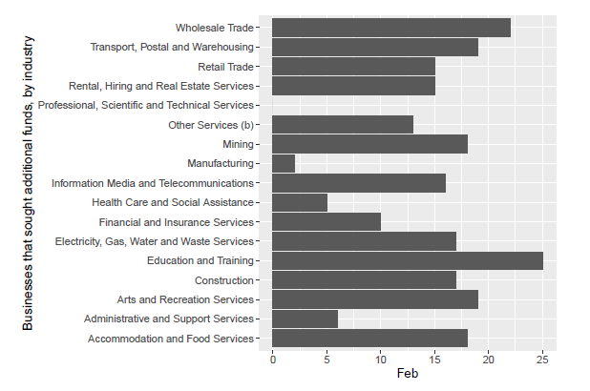

Figure 6: Business entities that sought Extra Funds

The business sectors that sought extra funds for running the business in the last three months is shown above. The business organization in the field of education and training has sought for seeking huge additional funds. In small business entities, a total of 12% of organizations have sought extra financial funds (Chowdhury, et al 2020).

# Discussion and Future Works

After the interpretation of the result from the visual graphs, it is found that most organizations are making massive improvements in most in numerous aspects of the business industry. The disruption in the supply chain is also significantly reduced over the past three months. The release of covid-19 restriction has significantly helped the business entities to sustain and make higher revenues. The growth percentage of organizations are continuously increasing. Also, the expected revenue graph (Figure 4) depicts more revenue that can be generated by the organization in the upcoming months.

# References

Aburumman, A. A. (2020). COVID-19 impact and survival strategy in business tourism market: the example of the UAE MICE industry. Humanities and social sciences communications, 7(1), 1-11.

Ahlmann-Eltze, C., & Patil, I. (2021). ggsignif: R Package for Displaying Significance Brackets for'ggplot2'.

Chetty, R., Friedman, J. N., Hendren, N., & Stepner, M. (2020). The economic impacts of COVID-19: Evidence from a new public database built using private sector data (No. w27431). national Bureau of economic research.

Chowdhury, M., Sarkar, A., Paul, S. K., & Moktadir, M. (2020). A case study on strategies to deal with the impacts of COVID-19 pandemic in the food and beverage industry. Operations Management Research, 1-13.

Della Vedova, C. (2019). Initiation au Logiciel de statistiques R: réalisez vos premières visualisations avec le package ggplot2. Bulletin de la Dialyse à Domicile, 2(4), 229-238.

Elavarasan, R. M., Shafiullah, G. M., Raju, K., Mudgal, V., Arif, M. T., Jamal, T., ... & Subramaniam, U. (2020). COVID-19: Impact analysis and recommendations for power sector operation. Applied energy, 279, 115739.

Fu, M., & Shen, H. (2020). COVID-19 and corporate performance in the energy industry. Energy Research Letters, 1(1), 12967.

Hao, F., Xiao, Q., & Chon, K. (2020). COVID-19 and China’s hotel industry: Impacts, a disaster management framework, and post-pandemic agenda. International journal of hospitality management, 90, 102636.

Jiang, Y., & Wen, J. (2020). Effects of COVID-19 on hotel marketing and management: a perspective article. International Journal of Contemporary Hospitality Management.

Lau, A. (2020). New technologies used in COVID-19 for business survival: Insights from the Hotel Sector in China. Information Technology & Tourism, 22(4), 497-504.

Maag, J. L. (2018). gganatogram: An R package for modular visualisation of anatograms and tissues based on ggplot2. F1000Research, 7.

Ranasinghe, R., Damunupola, A., Wijesundara, S., Karunarathna, C., Nawarathna, D., Gamage, S., ... & Idroos, A. A. (2020). Tourism after corona: Impacts of COVID 19 pandemic and way forward for tourism, hotel and mice industry in Sri Lanka. Hotel and Mice Industry in Sri Lanka (April 22, 2020).

Sarkar, D., & Sarkar, M. D. (2019). Package ‘latticeExtra’.

Telukdarie, A., Munsamy, M., & Mohlala, P. (2020). Analysis of the Impact of COVID-19 on the Food and Beverages Manufacturing Sector. Sustainability, 12(22), 9331.

Wickham, H., Bryan, J., Kalicinski, M., Valery, K., Leitienne, C., Colbert, B., ... & Bryan, M. J. (2019). Package ‘readxl’.

# Appendix

**Link To Dataset**

https://www.abs.gov.au/statistics/economy/business-indicators/business-conditions-and-sentiments/latest-release#methodology

**List of Questionnaires**

