FOODEE

A Skill Oriented Course Web Application report

Submitted in the partial fulfillment of the requirements for

the award of the degree of

Bachelor of Technology

in

Computer Science and Engineering

by

KUNDETI VAMSI 20761A0597.

Under the guidance of

Dr. K Devi Priya
Associate Professor, Dept. of CSE


Department of Computer Science and Engineering
Lakireddy Bali Reddy College of Engineering (Autonomous)
Accredited by NAAC & NBA (Under Tier - I)
Affiliated to JNTUK, Kakinada; ISO 9001:2015 Certified
2021-22

Certificate

This is to certify that the Skill Oriented Course Web Application / Project entitled
“FOODEE” is being submitted by Kundeti vamsi in partial fulfillment for the award of B. Techin Computer Science & Engineering to the Jawaharlal Nehru Technological University Kakinada is a record of bonafide work carried out by him/her under our guidance.

The results embodied in this Skill Oriented Course Web Application / Project report have not been submitted to any other University or Institute for the award of any degree or diploma.

Projectguide Head of the department
Dr. K Devi Priya Dr.D.Veeraiah
Associate Professor Professor

External Examiner
ACKNOWLEDGEMENT

I would like to thank Dr. K Devi Priya, Associate Professor, CSE department for the encouraging and support in carrying out this Skill Oriented Course Web Application.

I also take the privilege to record my thanks to Dr. D. Veeraiah, Professor,Head of the Department of CSE whose encouragement, cooperation and valuable support crown my success.

I express my thanks to the support given by management in completing my Web Application / Project. I also express my sincere gratitude & deep sense of respect to the Principal, Dr.K. Appa Rao for making us available all the required assistance and his support and inspiration to carry out this Skill Oriented Course Web Application / Project in the Institute.

I am thankful to the teaching and non-teaching staff of CSE department for their direct as well as indirect help in my Skill Oriented Course Web Application / Project.

I am elated to avail my selves to this opportunity to express my deep sense of gratitude to my parents.

FOODEE

Abstract

FOODEE website is a best food website where we can find wide
varieties of food items from different places. we assure the quality of food.
Thre are many braches all over India.we can delivery your orders
to any any corner of India within specified time.Launched in 2022, Our technology platform connects customers, restaurant partners and delivery partners, serving their multiple needs. Customers use our platform to search and discover food items, read and write customer generated reviews and view and upload photos, order food delivery, book a table and make payments while dining-out at restaurants. On the other hand, we provide restaurant partners with industry-specific marketing tools which enable them to engage and acquire customers to grow their business while also providing a reliable and efficient last mile delivery service. We also operate a one-stop procurement solution, Hyperpure, which supplies high quality ingredients and kitchen products to restaurant partners. We also provide our delivery partners with transparent and flexible earning opportunities. From our blog

CONTENTS
CONCEPTS Page No
1. Introduction 1
2. Modules/Technogies Used
2.1 HTML 6
2.2 CSS 9
2.3 Javascript 12
3. Coding 15
5.Results/Screens 24
6. Conclusion 27
7. References 27

INTRODUCTION:
Developing an Online Food Ordering system to promote a greater count of food lovers to splurge into the field of Restaurant was the objective of this study. Нis particular system provide the benefit of the easy ordering process online from anywhere along with ample choices for the customers in less time and less expenditures. Нis latest will definitely usher an edge in the existing manual platform used so far for such an important aspect along with greater flexibility and sophistication in the use of the technology. Нe system also aided E-ordering option for the customers with multiple other benefits [1-5]. Нe user should register in the system to avail the utility. Users will be able to select their preferable food items from the existing E-menu card and order their requirement online.
User will receive an onscreen presence of the selected items immediately aіer item selection. Application of this system will reduce the additional service associated manpower used in the hospitality industry, thus may provide financial benefits to the owners of such industry. Moreover, this system will be useful during the rush hours in the food courts when waiters or other service providers remain busy and unavailable to all the customers at a time. Нe user will have a username and a password for their regular use and personalised account maintenance.
Food Ordering System So far, the traditional service system in the restaurant industry follows huge paper work and human labour which may not be suٹcient with the ever-growing demand in quick service in the industry. On the other hand, manual maintenance of the crucial information in papers are tedious and risky certain times. Нis system is developed as a complete framework which demonstrates stage by stage information from procuring materials to preparing an online environment [6]. Due to enormous busy schedule and concentration on professional and personal work, the present generation is not willing to waste time in a queue of a restaurant, be it for occupying a place or receiving the ordered menu. Working and student community gathers in restaurants during their break time which is limited, therefore, they do not prefer to wait in a queue for any reason. Нis tool will help such kind of customer to save their valuable time by ordering their food without any manual interference and delay. Нe following objectives were considered while designing the project: • Ordering food within limited span of time without any interference. • Providing more convenience and choices to the customers. • Automated order and billing system. Review of Food Ordering Systems Нe following sections review the current food ordering systems available in the market. Manual
food ordering system Manual Food Ordering System uses waiter to take order from customers. During peak hour, customers may be too many to be served by waiters. Нe quality of the service may drop thus causing dissatisfactory of customers. However, if there are too many waiters are hired, it may be a waste of resources during non-peak hour.

2.MODULES/TECHNOLOGIES USED:
2.1 HTML
2.2 CSS
2.3 JAVASCRIPT

HTML
HTML stands for Hyper Text Markup Language.
HTML is the standard markup language for creating Web pages.
HTML describes the structure of a Web page.
HTML consists of a series of elements.
HTML elements tell the browser how to display the content.

HTML Headings:

HTML headings are defined with the <h1> to <h6> tags.
<h1> defines the most important heading.
<h6> defines the least important heading.
EXAMPLE:
<h1>heading</h1>

HTML Paragraphs:

HTML paragraphs are defined with the <p> tag.
EXAMPLE:
<p>paragraph</p>

HTML Links:

HTML links are defined with the <a> tag:
EXAMPLE:
<a href="https://www.w3schools.com">This is a link</a>

HTML Images:

HTML images are defined with the <img> tag.
The source file (src), alternative text (alt), width, and height are provided as attributes:
EXAMPLE:
<img src="w3schools.jpg" alt="W3Schools.com" width="104" height="142">

HTML Styles:

The HTML style attribute is used to add styles to an element, such as color, font, size, and more.
Setting the style of an HTML element, can be done with the style attribute.
<tagname style="property:value;">
Background Color:The CSS background-color property defines the background color for an HTML element.
EXAMPLE:
<h1 style="background-color:powderblue;">This is a heading</h1>
<p style="background-color:tomato;">This is a paragraph.</p>

HTML Formatting Elements:
Formatting elements were designed to display special types of text:

<b> - Bold text
<strong> - Important text
<i> - Italic text
<em> - Emphasized text
<mark> - Marked text
<small> - Smaller text
<del> - Deleted text
<ins> - Inserted text
<sub> - Subscript text
<sup> - Superscript text

HTML Forms:

An HTML form is used to collect user input. The user input is most often sent to a server for processing.
The <form> element is a container for different types of input elements, such as: text fields, checkboxes, radio buttons, submit buttons, etc.
An <input> element can be displayed in many ways, depending on the type attribute.

Here are some examples:

Type | Description
<input type="text"> | Displays a single-line text input field
<input type="radio"> | Displays a radio button (for selecting one of many choices)
<input type="checkbox"> | Displays a checkbox (for selecting zero or more of many choices)
<input type="submit"> | Displays a submit button (for submitting the form)
<input type="button"> | Displays a clickable button

EXAMPLE:
<form>
<label for="fname">First name:</label><br>
<input type="text" id="fname" name="fname"><br>
<input type="radio" id="html" name="fav_language" value="HTML">
<label for="html">HTML</label><br> <input type="checkbox" id="vehicle1" name="vehicle1" value="Bike">
<label for="vehicle1"> I have a bike</label><br>
<input type="submit" value="Submit">
</form>

HTML TABLES:

HTML tables allow web developers to arrange data into rows and columns.
Each table cell is defined by a <td> and a </td> tag.
Each table row starts with a <tr> and end with a </tr> tag.
Sometimes you want your cells to be headers, in those cases use the <th> tag instead of the <td> tag:

EXAMPLE:

<table>
<tr>
<th>Person 1</th>
<th>Person 2</th>
<th>Person 3</th>
</tr>
<tr>
<td>Emil</td>
<td>Tobias</td>
<td>Linus</td>
</tr>
<tr>
<td>16</td>
<td>14</td>
<td>10</td>
</tr>
</table>

HTML Lists:

HTML lists allow web developers to group a set of related items in lists.

Unordered HTML List:
An unordered list starts with the <ul> tag. Each list item starts with the <li> tag.
The list items will be marked with bullets (small black circles) by default:

Example:
<ul>
<li>Coffee</li>
<li>Tea</li>
<li>Milk</li>
</ul>

Ordered HTML List:
An ordered list starts with the <ol> tag. Each list item starts with the <li> tag.
The list items will be marked with numbers by default:

EXAMPLE:
<ol>
<li>Coffee</li>
<li>Tea</li>
<li>Milk</li>
</ol>

CSS

CSS stands for Cascading Style Sheets.
CSS describes how HTML elements are to be displayed on screen, paper, or in other media.
CSS saves a lot of work. It can control the layout of multiple web pages all at once.
External stylesheets are stored in CSS files.

Three Ways to Insert CSS:

1.External CSS
2.Internal CSS
3.Inline CSS

EXTERNAL CSS:
Each HTML page must include a reference to the external style sheet file inside the <link> element, inside the head section.

EXAMPLE:
<head>
<link rel="stylesheet" href="mystyle.css">
</head>
INTERNAL CSS:
An internal style sheet may be used if one single HTML page has a unique style.
The internal style is defined inside the <style> element, inside the head section.

EXAMPLE:
<style>
body {
background-color: linen;
}
h1 {
color: maroon;
margin-left: 40px;
}
</style>

Inline CSS:
An inline style may be used to apply a unique style for a single element.
To use inline styles, add the style attribute to the relevant element. The style attribute can contain any CSS property.

EXAMPLE:
<h1 style="color:blue;text-align:center;">This is a heading</h1>
<p style="color:red;">This is a paragraph.</p>

CSS BACKGROUNDS:

The CSS background properties are used to add background effects for elements.
In these chapters, you will learn about the following CSS background properties:
1.background-color
2.background-image
3.background-repeat
4.background-attachment
5.background-position

EXAMPLE:

div {
background-color: green;
opacity: 0.3;
}

body {
background-image: url("paper.gif");
background-repeat: no-repeat;
background-position: right top;
background-attachment: scroll;
}

The background-attachment property specifies whether the background image should scroll or be fixed.

CSS PADDING:

The CSS padding properties are used to generate space around an element's content, inside of any defined borders.

CSS has properties for specifying the padding for each side of an element:

- padding-top
- padding-right
- padding-bottom
- padding-left

All the padding properties can have the following values:

- length - specifies a padding in px, pt, cm, etc.
- % - specifies a padding in % of the width of the containing element.
- inherit - specifies that the padding should be inherited from the parent element.

EXAMPLE:

div {
padding-top: 50px;
padding-right: 30px;
padding-bottom: 50px;
padding-left: 80px;
}

(or)

div {
padding: 25px 50px 75px 100px;
}

The position Property:

The position property specifies the type of positioning method used for an element.
There are five different position values:

- static
- relative
- fixed
- absolute
- sticky

An element with position: static; is not positioned in any special way; it is always positioned according to the normal flow of the page.
An element with position: relative; is positioned relative to its normal position.

An element with position: fixed; is positioned relative to the viewport, which means it always stays in the same place even if the page is scrolled. The top, right, bottom, and left properties are used to position the element.
An element with position: absolute; is positioned relative to the nearest positioned ancestor (instead of positioned relative to the viewport, like fixed).
However; if an absolute positioned element has no positioned ancestors, it uses the document body, and moves along with page scrolling.

An element with position: sticky; is positioned based on the user's scroll position.
A sticky element toggles between relative and fixed, depending on the scroll position. It is positioned relative until a given offset position is met in the viewport - then it "sticks" in place (like position:fixed).

EXAMPLE:

div.relative {
position: relative;
width: 400px;
height: 200px;
border: 3px solid #73AD21;
}

JAVASCRIPT

JavaScript is the world's most popular programming language.
JavaScript is the programming language of the Web.
JavaScript is easy to learn.

JavaScript Can Change HTML Content:

One of many JavaScript HTML methods is getElementById().
The example below "finds" an HTML element (with id="demo"), and changes the element content (innerHTML) to "Hello JavaScript":

EXAMPLE:
document.getElementById("demo").innerHTML = "Hello JavaScript";

Javascript Operators:

EXAMPLE:
<html>
<body>
<h2>JavaScript Arithmetic</h2>
<h3>The * Operator</h3>
<p id="demo"></p>
<script>
let x = 5;
let y = 2;
let z = x * y;
document.getElementById("demo").innerHTML = z;
</script>
</body>
</html>

JAVASCRIPT FUNCTIONS:

A JavaScript function is a block of code designed to perform a particular task.
A JavaScript function is executed when "something" invokes it (calls it).

EXAMPLE:

<!DOCTYPE html>
<html>
<body>
<h2>JavaScript Functions</h2>
<p>This example calls a function which performs a calculation, and returns the result:</p>
<p id="demo"></p>
<script>
function myFunction(p1, p2) {
return p1 * p2;
}
document.getElementById("demo").innerHTML = myFunction(4, 3);
</script>
</body>
</html>

HTML Events:

An HTML event can be something the browser does, or something a user does.
Here are some examples of HTML events:

- An HTML web page has finished loading
- An HTML input field was changed
- An HTML button was clicked

Common HTML Events:
Here is a list of some common HTML events:
Event | Description
onchange | An HTML element has been changed
onclick | The user clicks an HTML element
onmouseover | The user moves the mouse over an HTML element
onmouseout | The user moves the mouse away from an HTML element
onkeydown | The user pushes a keyboard key
onload | The browser has finished loading the page

EXAMPLE:

<!DOCTYPE html>
<html>
<body>
<h2>JavaScript HTML Events</h2>
<p>Click the button to display the date.</p>
<button onclick="displayDate()">The time is?</button>
<script>
function displayDate() {
document.getElementById("demo").innerHTML = Date();
}
</script>
<p id="demo"></p>
</body>
</html>
CODING:

HOME PAGE:

<!DOCTYPE html>
<html lang="en">

<head>
<meta charset="UTF-8">
<meta http-equiv="X-UA-Compatible" content="IE=edge">
<meta name="viewport" content="width=device-width, initial-scale=1.0">
<link rel="stylesheet" href="style.css">
<title>foodee website</title>
<script src="https://kit.fontawesome.com/9fb6a9096b.js" crossorigin="anonymous"></script>
<script src="counter.js"></script>

<link rel="stylesheet"
href="https://cdn.jsdelivr.net/npm/@fortawesome/fontawesome-free@5.15.4/css/fontawesome.min.css"
integrity="sha384-jLKHWM3JRmfMU0A5x5AkjWkw/EYfGUAGagvnfryNV3F9VqM98XiIH7VBGVoxVSc7" crossorigin="anonymous">
</head>

<body>
<nav class="navbar background">
<ul class="nav-list">
<div class="logo"><img src="foodee.png" alt="foodee" height=150></div>
<li><a href="#home">HOME</a></li>
<li><a href="home.html">ABOUT</a></li>
<li><a href="menu.html">MENU</a></li>
<li><a href="contactus.html">CONTACT</a></li>
<li><a href="orders.html">CATEGORIES</a></li>
</ul>
<div class="rightnav">
<input type="text" name="search" id="search">
<a href="orders.html"><button class="btn btn-sm">search</button></a>
<a href="login.html"><button class="btn btn-sm">login</button></a>
</div>
</nav>
<section class=" background firstsection">
<div class="boxmain">
<div class="firsthalf">
<p class="textbig">From kitchen to your heart</p>
<p class="textsmall">Enjoy your Delicious Food.Food with love only from natural and fresh products
Tastier only with us.
Try out today.
</p>
<div class="buttons">

<a href="home.html" taget="_blank"><button class="btn">ABOUT US</button></a>
<a href="orders.html" taget="_blank"><button class="btn">ORDER</button></a>
</div>
</div>
<div class="secondhalf">
<img src="mainpic.jpg" alt="">
</div>
</div>
</section>
<section>
<div class="textbig">OUR CATEGORIES </div>
<div class="orders">
<div class="item">
<div class="subitem"><img src="cutlets.jpg" aria-setsize="50%" alt=""></div>
<p class="text">CUTLETS <b>$20</b></p>
<div class="tagline">
<div class="buttons"><a href="login.html"><button class="btn">ordernow</button></a></div>

</div>
</div>

<div class="item">
<div class="subitem"><img src="pizza.jpg" aria-setsize="50%" alt=""></div>
<p class="text">DOMINOS PIZZA</p>
<div class="buttons"><a href="login.html"><button class="btn">ordernow</button></a></div>
</div>
<div class="item">
<div class="subitem"><img src="salad.jpg" aria-setsize="50%" alt=""></div>
<p class="text">SALAD</p>
<div class="buttons"><a href="orders.html"><button class="btn">ordernow</button></a></div>
</div>
<div class="item">
<div class="subitem"><img src="chinese.jpg" aria-setsize="50%" alt=""></div>
<p class="text">CHINEESE</p>
<div class="buttons"><a href="login.html"><button class="btn">ordernow</button></a></div>
</div>
</div>
<div class="orders">
<div class="item">
<div class="subitem"><img src="fish.jpg" aria-setsize="50%" alt=""></div>
<p class="text">FISH</p>
<div class="buttons"><a href="login.html"><button class="btn">ordernow</button></a></div>
</div>

<div class="item">
<div class="subitem"><img src="Biryani.jpg" aria-setsize="50%" alt=""></div>
<p class="text">BIRYANI</p>
<div class="buttons"><a href="login.html"><button class="btn">ordernow</button></a></div>
</div>
<div class="item">
<div class="subitem"><img src="sandwich.jpg" aria-setsize="50%" alt=""></div>
<p class="text">BURGER</p>
<div class="buttons"><a href="login.html"><button class="btn">ordernow</button></a></div>
</div>
<div class="item">
<div class="subitem"><img src="prawns.jpg" aria-setsize="50%" alt=""></div>
<p class="text">PRAWNS</p>
<div class="buttons">
<center><a href="login.html"><button class="btn">ordernow</button></a></center>
</div>
</div>
</div>
<div class="buttons">
<center><a href="orders.html"><button class="btn">view more</button></a></center>

</div>
<div>
<img src="coverpage.jpg" width="100%" height="50%" alt="bannner">
</div>
</section>
<div class="count">
<div class="counter-container">
<i class="fab fab fa-instagram fa-3x"></i>
<div class="counter" data-target="55,600"></div>
<span>Instagram followers</span>
</div>
<div class="counter-container">
<i class="fab fab fa-youtube fa-3x"></i>
<div class="counter" data-target="5,5000"></div>
<span>Youtube subcribers</span>
</div>
<div class="counter-container">
<i class="" fab fab fa-eye fa-3x"></i>
<div class="counter" data-target="5,00,000"></div>
<span>Happy Customers</span>
</div>
<div>
<img src="footbanner.jpg" alt="food" </div>
</div>
</div>
<footer>
<div class="foots">

<div class="info">
<img src="foodee.png" alt="logo">
<div class="text"><b>FOODEE</b> is an online food websiteLorem ipsum dolor
sit amet consectetur
adipisicing elit.
Saepe ab laborum officiis hic sunt voluptates nemo,
ad commodi, veniam veritatis perspiciatis,
ipsam perferendis expedita adipisci maxime
</div>
<div class="foot">
<h1>Allrights are reserved 2021-2022.<br>Designed by 20761A0597</h1>
</div>

</div>

<ul class="support">
<li>
<h2>SUPPORT</h2>
</li>
<li><a href="#l">HOME</a></li>
<li><a href="home.html">ABOUT</a></li>
<li><a href="menu.html">MENU</a></li>
<li><a href="contactus.html">CONTACT</a></li>
<li><a href="orders.html">CATEGORIES</a></li>
</ul>

<ul class="support">
<li>
<h2>CONTACT</h2>
</li>
<li><a href="foodee123@gmail.com">foodee123@gmail.com</a></li>
<li><a href="#home">9876543210</a></li>
<li><a href="#home">1000-865-345</a></li>
<li><a href="#home">Address:</a></li>
<li><a href="#foods">Lb nagar,Hyderabad</a></li>
</ul>
<div>
<div class="social-menu">
<ul>
<li>
<h2 class="text">FOLLOW</h2>
</li>
<li><a href="https://www.facebook.com"><i class="fa fa-facebook"></i></a></li>
<li><a href="https://instagram.com"><i class="fa fa-instagram"></i></a></li>
<li><a href="https://twitter.com"><i class="fa fa-twitter"></i></a></li>
<li><a href="https://youtube.com"><i class="fa fa-youtube"></i></a></li>
</ul>
</div>
</div>

</div>

</div>
</footer>

</body>

</html>

LOGIN PAGE:

<!DOCTYPE html>
<html lang="en">

<head>
<meta charset="UTF-8">
<meta http-equiv="X-UA-Compatible" content="IE=edge">
<meta name="viewport" content="width=device-width, initial-scale=1.0">
<link rel="stylesheet" href="login.css">
</head>
<body>
<div class="login-box">
<h2>ORDER NOW</h2>
<form>
<div class="user-box">
<input type="text" name="nam"required=''placeholder="Name">
<label name="nam"></label>
</div>
<div class="user-box">
<input type="email" name=""required=''placeholder="Email">
<label></label>
</div>
<div class="user-box">
<input type="text" name="nam"required=''placeholder="Address">
<label name="nam"></label>
</div>
<div class="user-box">
<input type="number" name=""required=''placeholder="PIN CODE">
<label></label>
</div>
<div class="user-box">
<ul>
<li><input type="radio" name="pay" value="COD">COD</li>
<li><input type="radio" name="pay" value="NET BANKING">NET BANKING</li>
<li><input type="radio" name="pay" value="CREDIT CARD">CREDIT CARD</li>
<li> <input type="radio" name="pay" value="UPI">UPI</li>
</div>

<center><a href="#">
<span></span>
<span></span>
<span></span>
<span></span>
place order
</a>
</center>
<center>
<a href="mainpage.html">
<span></span>
<span></span>
<span></span>
<span></span>
cancel order
</a>
</center>
</form>
</div>

Styles:

*{
margin:0;
padding:0;
}
.navbar{
display: flex;
height:50;
align-items: center;
justify-content: center;
position: sticky;
top: 0;
cursor: pointer;
}
.logo{
width:20%;
height:10%;
display:flex;
align-items: center;
}
.nav-list{
width: 90%;
display:flex;
align-items:center;

}
.nav-list li{
list-style: none;
justify-content: center;
align-items: center;
padding: 23px 30px;
font-family: 'Confortaa', cursive;

}

.nav-list li a{
text-decoration: none;
color: #263952;

}
.nav-list li a:hover{
text-decoration: none;
color:black;
font-size: 18px;
}
.rightnav{
width:50%;
text-align: right;
align-items: center;
justify-content: center;
display: flex;
padding: 25px;
}
#search{
padding: 5px;
font-size: 17px;
border: 2px solid #dcafac;
border-radius: 10px;
width: 50%;
}

.background{
background: #f2f8f8 url('banpic.jpg');
background-size: cover;
background-blend-mode:darken;
backdrop-filter: 10px;
}

.firsthalf{
height:100vh;
}
.text{
font-family: 'Confortaa', cursive;
}
.boxmain{
display: flex;
justify-content: center;
align-items: center;
color:black;
font-family: 'Confortaa', cursive;
margin: auto;
height: 80%;
}
.firsthalf{
margin: 5px 5px;
width:50%;
display: flex;
flex-direction: column;
justify-content: center;

}
.secondhalf{
width:50%;
padding: 20px 50px;
align-items: center;
justify-content: center;
}
.secondhalf img{
width: 70%;
height:100%;
padding:20px 50px;
border-radius: 50%;

}
.textbig{
font-size: 50px;
}
.textsmall{
font-size: 25px;
}
.btn{

padding:8px 20px;
margin: 7px 5px;
border: 2px solid #dcafac;
border-radius: 8px;
font-size: 18px;
background: none;
backdrop-filter: 25px;
cursor: pointer;

}
.btn-sm{
padding: 3px 10px;
vertical-align: middle;
}
.orders{
display:flex;
padding: 20px;
align-items: center;
justify-content: center;
background-color: #ffff;

}
.text{
align-items: center;
justify-content: center;
width: 90%;
font-size: 25px;
}

.orders .item{
padding: 30px 10px;
align-items: center;
justify-content: center;
border-radius: 20px;
background-color:#ffff ;
width: 90%;
}

.orders img{
border-radius: 25%;
width: 95%;
padding: 10px 10px;
background-color: #000;
}
.orders .item .subitem{
padding: 15px;

}
.olrders.item.buttons button{
align-items: center;
}
.butttons {
align-items: center;
padding :25px 650px;
}

.item.text p{
font-size: medium;
}
.count{
background-color: #dcafac;
color: black;
font-family: 'Confortaa', cursive;
display: flex;
align-items: center;
justify-items:center;
height: 50vh;
overflow: hidden;
margin: 0;
}
.counter-container{
display: flex;
flex-direction: column;
justify-content: center;
text-align: center;
margin: 30px 50px;
}
.counter{
font-size: 60px;
margin-top: 10px;
}
@media(max-width:580px){
.count{
flex-direction: column;
}

}

.foots{
display: flex;
background-color: #eeeae7;
padding: 90px 20px;

}
foots.info {
flex-direction: column;
}
.foots img{
width: 25%;
align-items: center;

}
.support li
{
list-style: none;
justify-content: center;
align-items: center;
padding: 20px 20px;
font-family: 'Confortaa', cursive;
display: flex;
}
.support li a{
text-decoration: none;
color:black;
}
.foots.social-menu ul{
position:relative;
top:50%;
left:50%;
padding:10px 20px;
margin:0;
transform:translate(-50%,-50%);

}
.social-menu ul li{
list-style: none;
margin:0 20px;
padding: 10px 10px;
}
.social-menu ul li.fa:hover{
color:none;
}
.social-menu ul li .fa{
font-size: 30px;
line-height: 60px;
transition:.6s;
color:#000;
}
.social-menu ul li a{
position: relative;
display:block;
width:60px;
height:60px;
border-radius:20%;
background-color: ivory;
text-align: center;
transition: .6s;
box-shadow: 0 5px 4px rgba(0,0,0,1);
}
.social-menu ul li a:hover{
transform:translate(0,-10px);
}
.social-menu ul li:nth-child(1) a:hover{
background-color: #3b5999;
}
.social-menu ul li:nth-child(2) a:hover{
background-color: #e4405f;
}
.social-menu ul li:nth-child(3) a:hover{
background-color: #55acee;
}
.social-menu ul li:nth-child(4) a:hover{
background-color: #0077B5;
}
.social-menu ul li:nth-child(5) a:hover{
background-color: #b50000;
}
.social-menu ul li:nth-child(6) a:hover{
background-color: crimson;
}
.foot p{
flex-direction: column;

}

SCREENSHOTS

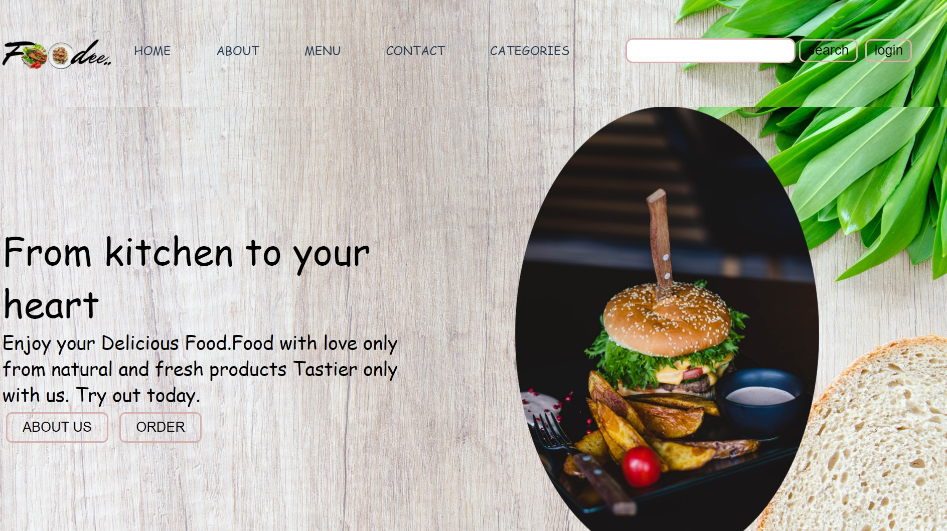

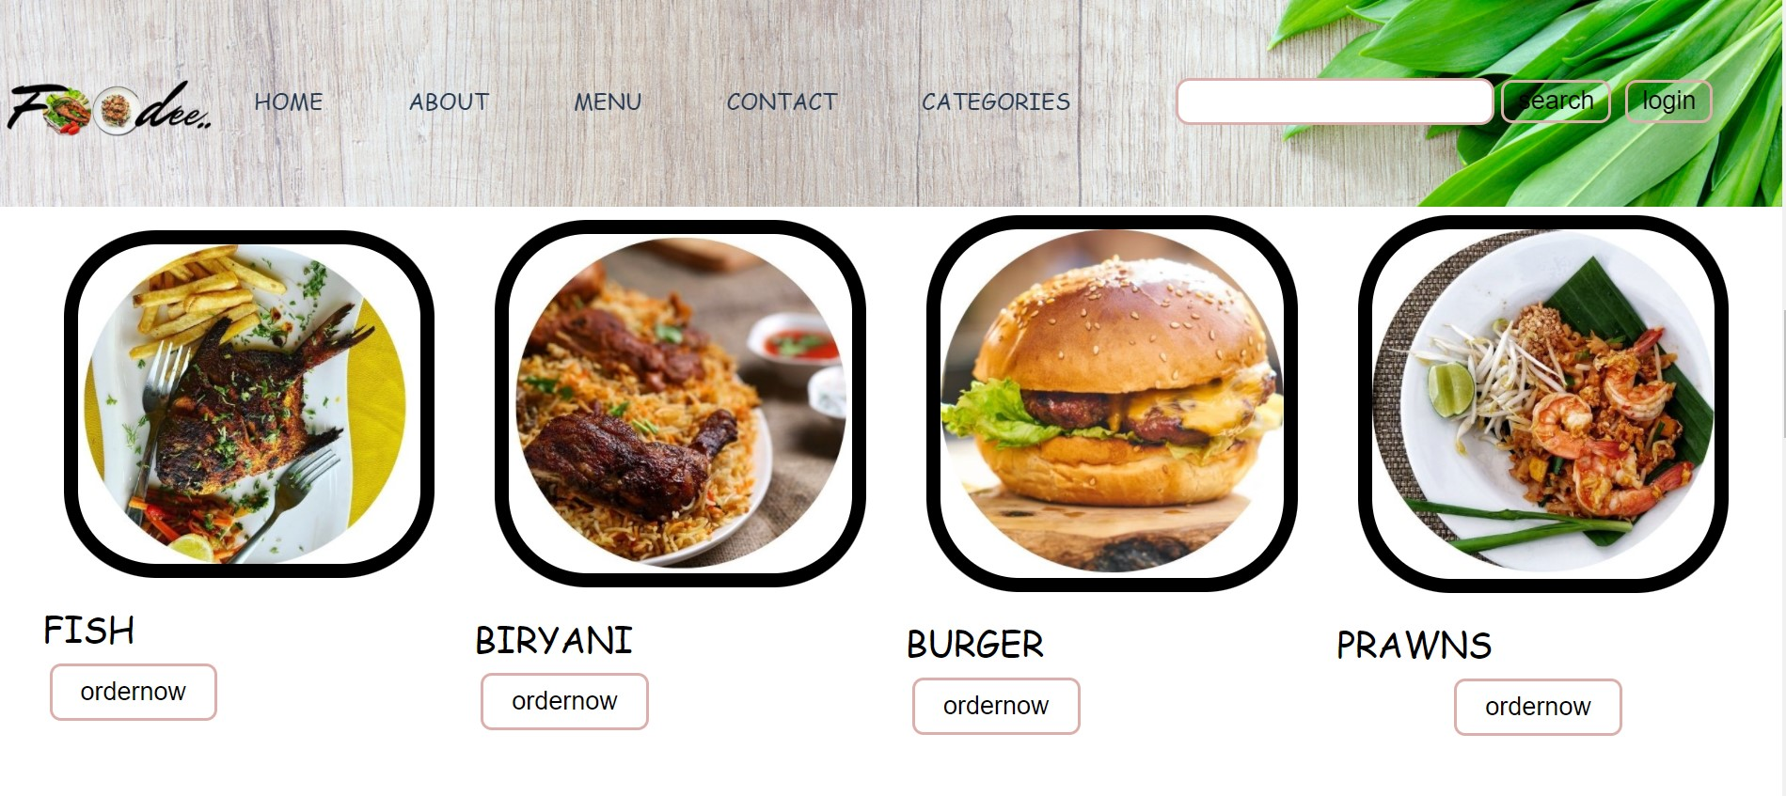

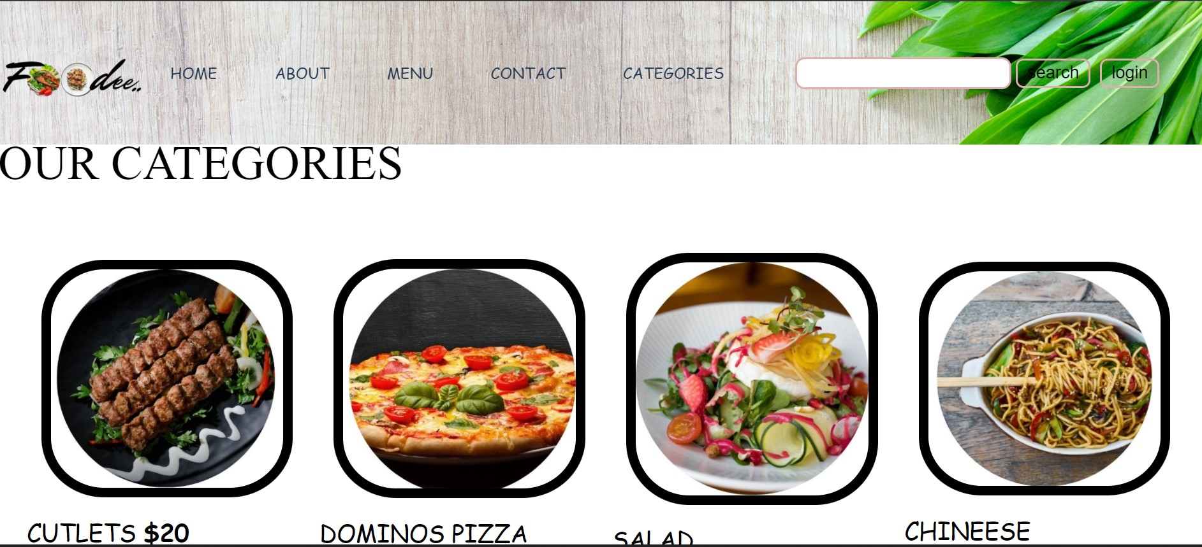

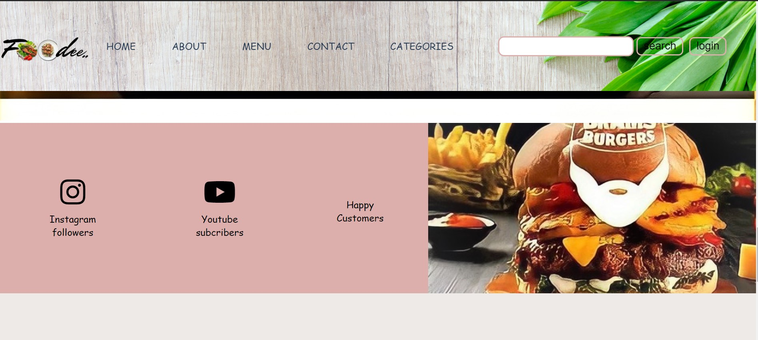

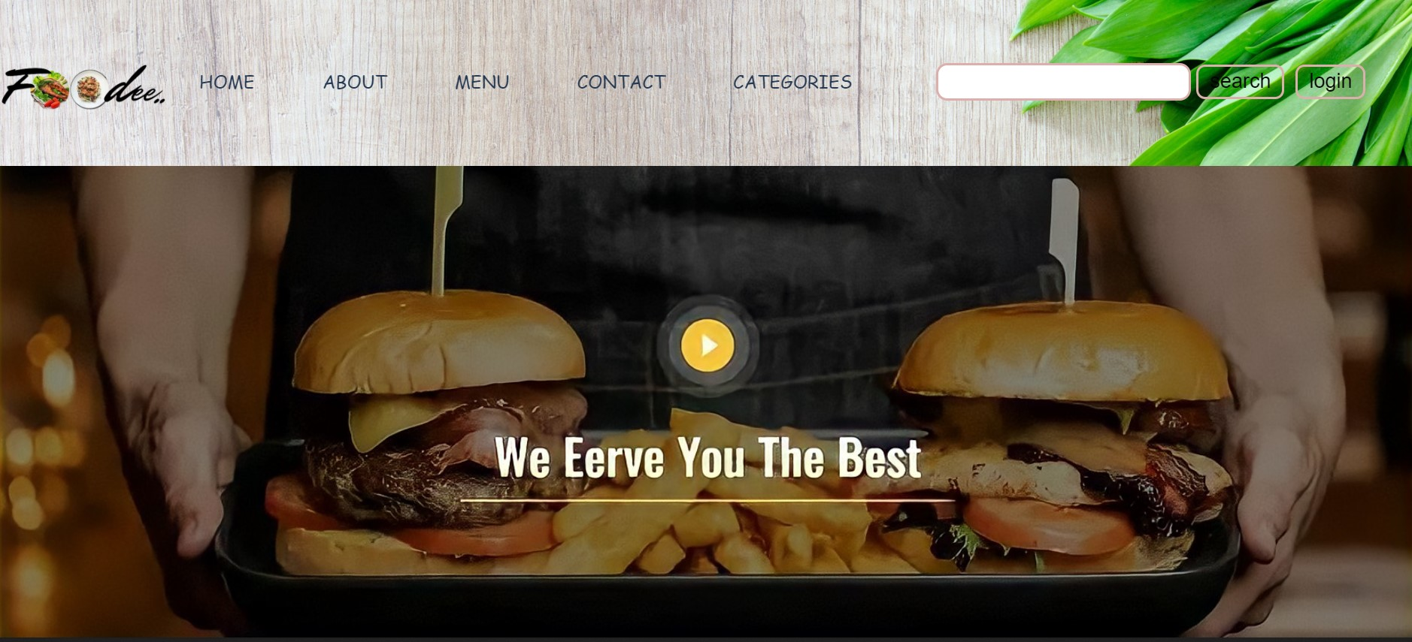

FOOTER PAGE

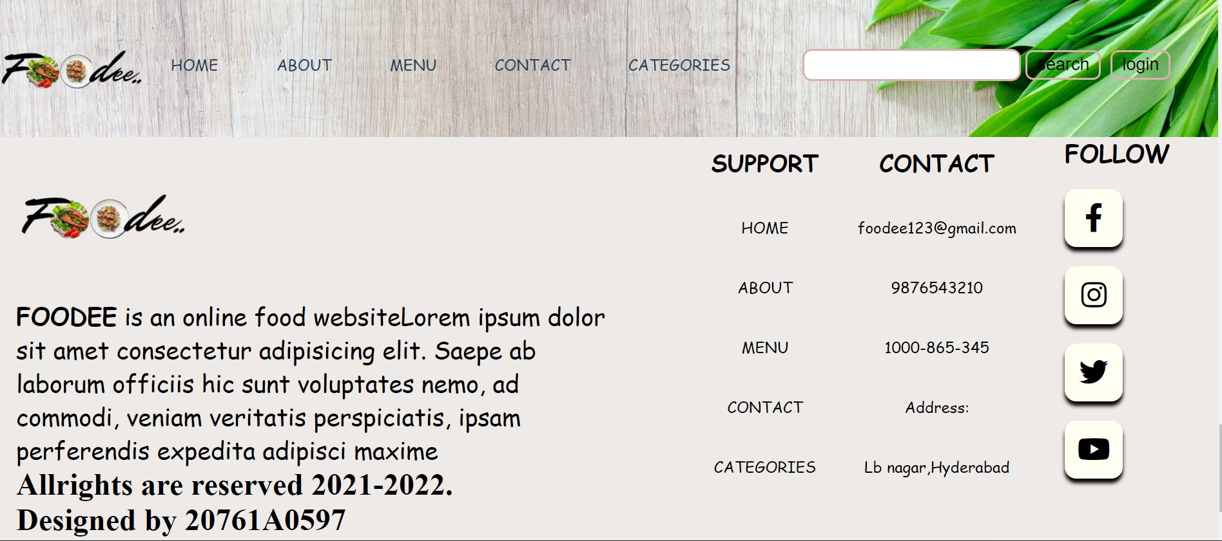

Conclusion:

At the end of this project I learnt basic webdevelopment techniques i.e,Html,Css,Javascript..
I was able to create my own website.
By seeing any website I was able to understand the source code of other websites.

References:

HTML Tutorial (w3schools.com)
CSS Tutorial (w3schools.com)
JavaScript Tutorial (w3schools.com)

