گزارش جلسه دو

سید عباس میرقاسمی

۹۷۲۴۳۰۶۸

بخش وارد کردن مقادیر جدول: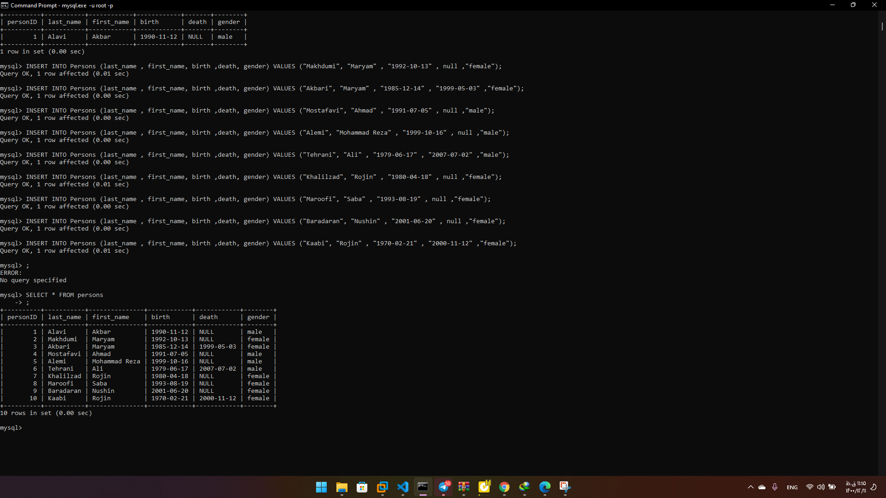

بخش آپدیت کردن مقادیر جدول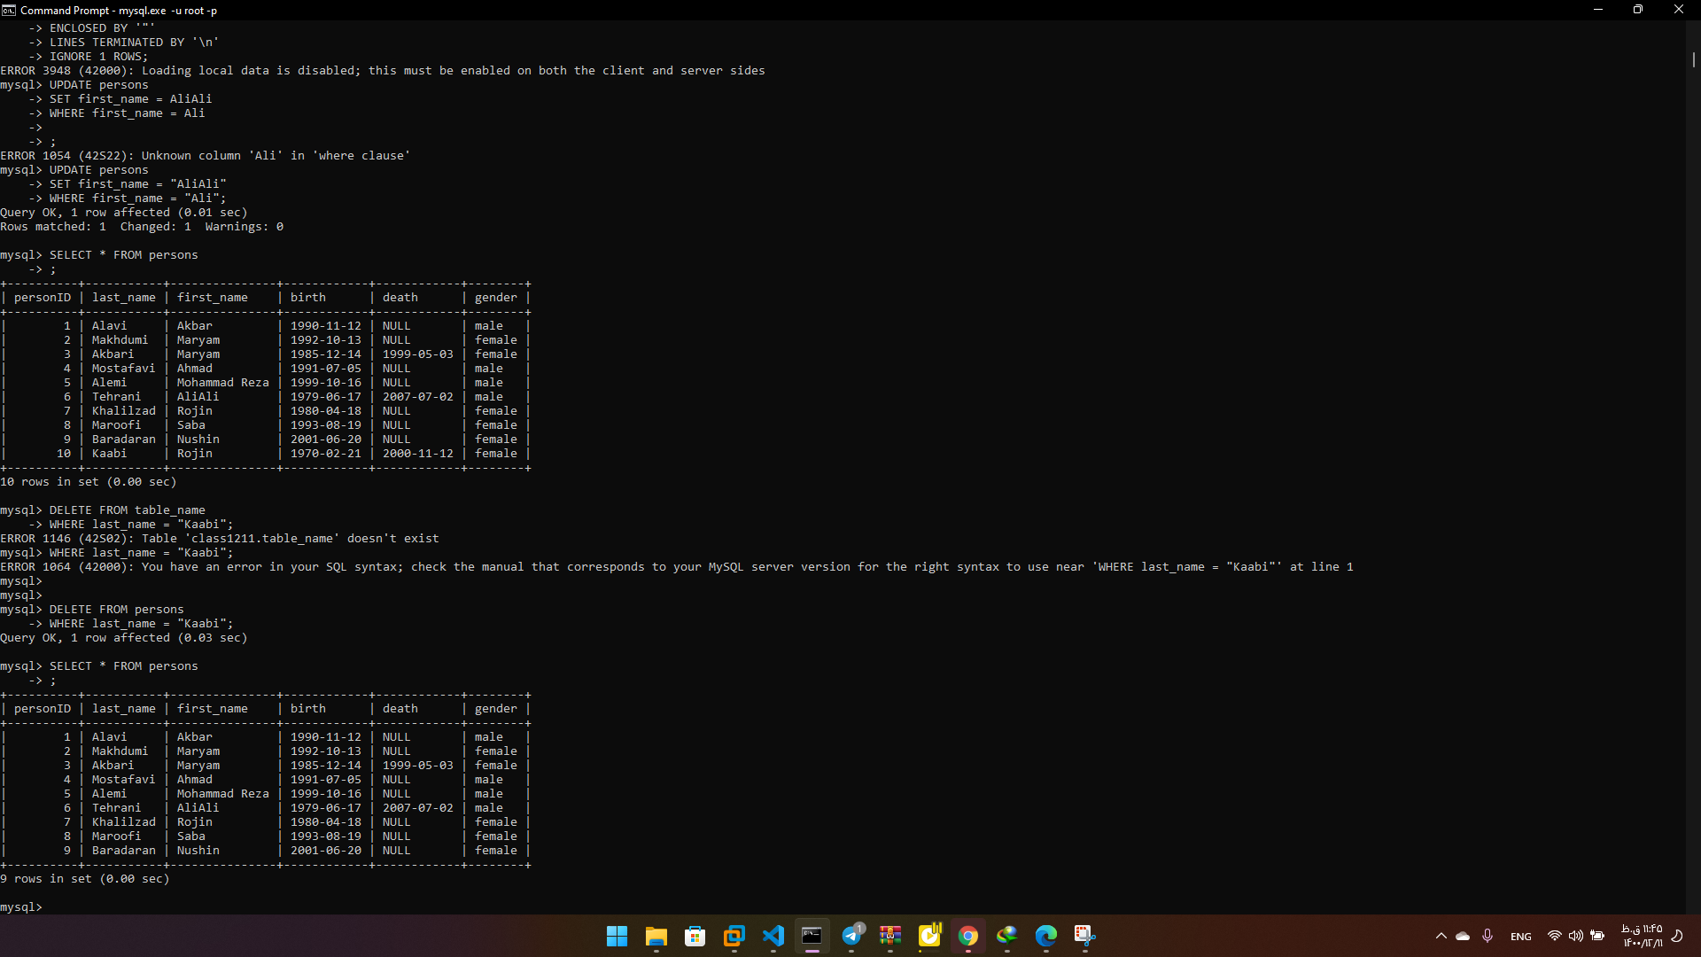بخش پاک کردن مقادیر جدول

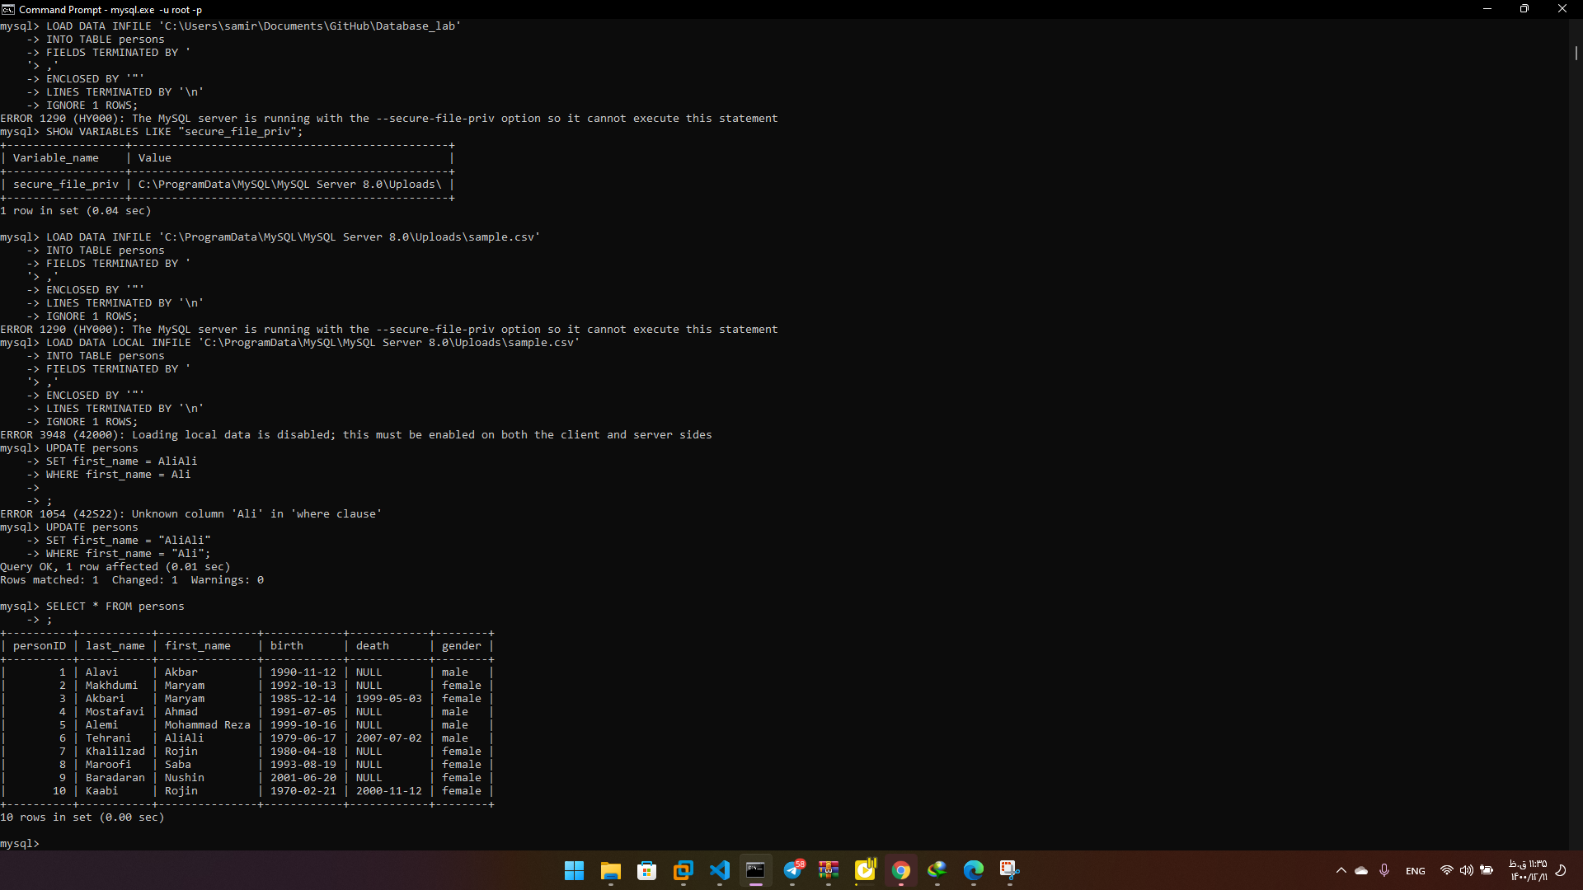دستورات مربوط به این جلسه:

CREATE DATABASE class1211;

USE class1211;

CREATE TABLE Persons (

    personID INT UNSIGNED NOT NULL AUTO_INCREMENT,

    last_name VARCHAR(255) NOT NULL,

    first_name VARCHAR(255) NOT NULL,

    birth DATE NOT NULL,

    death DATE,

    gender ENUM('female', 'male') NOT NULL,

    PRIMARY KEY (personID)

);

SELECT * FROM persons;

INSERT INTO Persons (last_name , first_name, birth ,death, gender) VALUES ("Alavi", "Akbar" , "1990-11-12" , null ,"male");

INSERT INTO Persons (last_name , first_name, birth ,death, gender) VALUES ("Makhdumi", "Maryam" , "1992-10-13" , null ,"female");

INSERT INTO Persons (last_name , first_name, birth ,death, gender) VALUES ("Akbari", "Maryam" , "1985-12-14" , "1999-05-03" ,"female");

INSERT INTO Persons (last_name , first_name, birth ,death, gender) VALUES ("Mostafavi", "Ahmad" , "1991-07-05" , null ,"male");

INSERT INTO Persons (last_name , first_name, birth ,death, gender) VALUES ("Alemi", "Mohammad Reza" , "1999-10-16" , null ,"male");

INSERT INTO Persons (last_name , first_name, birth ,death, gender) VALUES ("Tehrani", "Ali" , "1979-06-17" , "2007-07-02" ,"male");

INSERT INTO Persons (last_name , first_name, birth ,death, gender) VALUES ("Khalilzad", "Rojin" , "1980-04-18" , null ,"female");

INSERT INTO Persons (last_name , first_name, birth ,death, gender) VALUES ("Maroofi", "Saba" , "1993-08-19" , null ,"female");

INSERT INTO Persons (last_name , first_name, birth ,death, gender) VALUES ("Baradaran", "Nushin" , "2001-06-20" , null ,"female");

INSERT INTO Persons (last_name , first_name, birth ,death, gender) VALUES ("Kaabi", "Ali" , "1970-02-21" , "2000-11-12" ,"female");

LOAD DATA LOCAL INFILE 'C:\ProgramData\MySQL\MySQL Server 8.0\Uploads\sample.csv'

INTO TABLE persons

FIELDS TERMINATED BY '

,'

ENCLOSED BY '"'

LINES TERMINATED BY '\n'

IGNORE 1 ROWS;

UPDATE persons

SET first_name = "AliAli"

WHERE first_name = "Ali";

DELETE FROM persons

WHERE last_name = "Kaabi";

فایل csv:

last_name , first_name, birth ,death, gender

"Alavi", "Akbar" , "1990-11-12" , null ,"male"

"Makhdumi", "Maryam" , "1992-10-13" , null ,"female"

"Akbari", "Maryam" , "1985-12-14" , "1999-05-03" ,"female"

"Mostafavi", "Ahmad" , "1991-07-05" , null ,"male"

"Alemi", "Mohammad Reza" , "1999-10-16" , null ,"male"

"Tehrani", "Ali" , "1979-06-17" , "2007-07-02" ,"male"

"Khalilzad", "Rojin" , "1980-04-18" , null ,"female"

"Maroofi", "Saba" , "1993-08-19" , null ,"female"

"Baradaran", "Nushin" , "2001-06-20" , null ,"female"

"Kaabi", "Rojin" , "1970-02-21" , "2000-11-12" ,"female"