سید عباس میرقاسمی

97243068

SELECT first_name FROM persons;

SELECT DISTINCT first_name FROM persons;

SELECT first_name, last_name FROM persons;

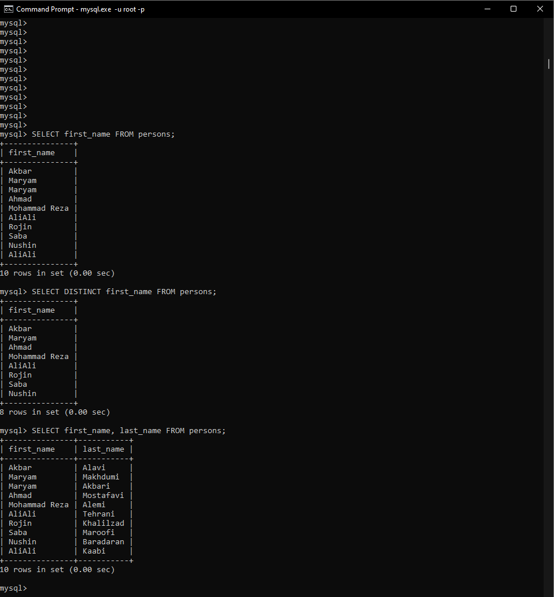

SELECT first_name, last_name, birth

FROM persons

WHERE death IS NULL;

SELECT *

FROM persons

WHERE birth >= '2000-1-1';

SELECT *

FROM persons

ORDER BY birth;

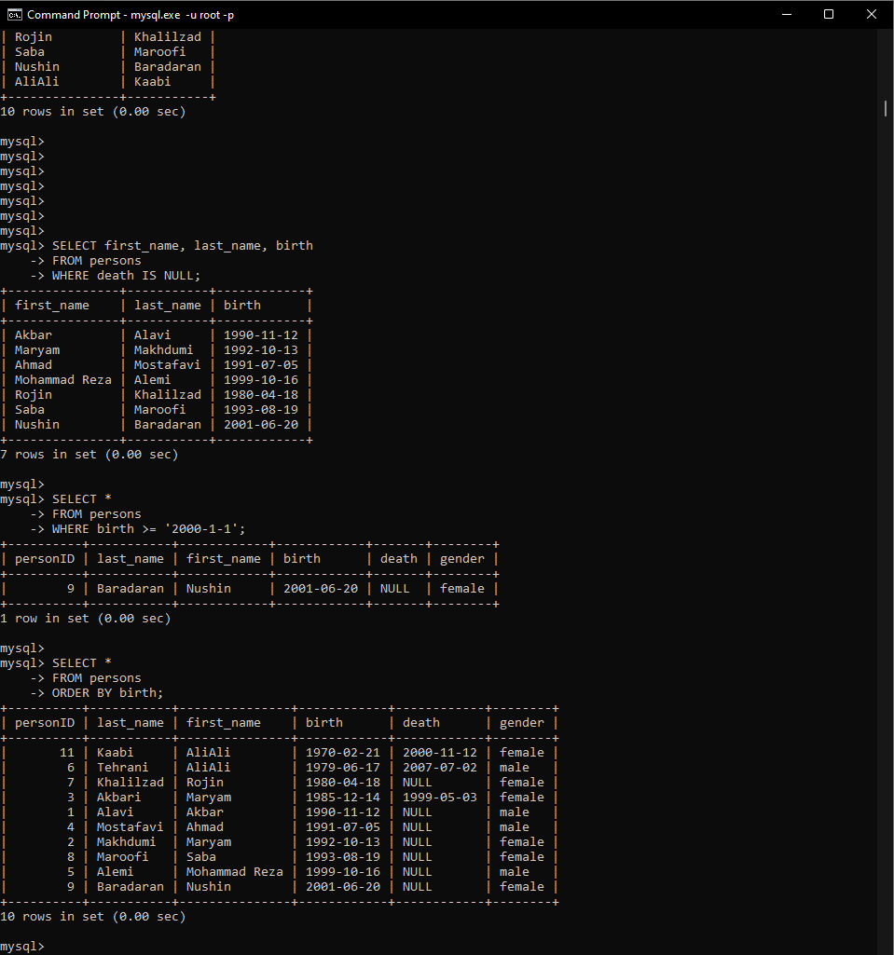

SELECT *

FROM persons

ORDER BY birth DESC;

SELECT *

FROM persons

ORDER BY birth , last_name DESC;

SELECT first_name, last_name, birth

FROM persons

WHERE MONTH(birth) = 10;

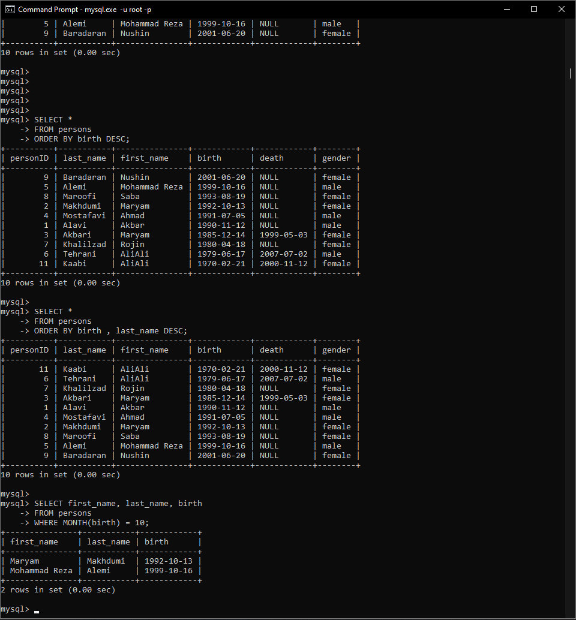

SELECT first_name, last_name, CURDATE(), TIMESTAMPDIFF(YEAR , birth , CURDATE()) AS age

FROM persons;

SELECT personID, first_name, last_name, birth

FROM persons

WHERE MONTH(birth) = MONTH(DATE_ADD(CURDATE() , INTERVAL 1 MONTH));

SELECT

    COUNT(personID) AS alive_count,

    MIN(TIMESTAMPDIFF(YEAR , birth, CURDATE())) AS min_age,

    MAX(TIMESTAMPDIFF(YEAR , birth, CURDATE())) AS max_age,

    AVG(TIMESTAMPDIFF(YEAR , birth, CURDATE())) AS average_age

FROM persons

WHERE death IS NULL;

