SecureMail: A Tri-Modal Hybrid Email Security Gateway and Forensics Framework for Zero-Trust Phishing and Optical Quishing Mitigation
Samir Khurshid  (2303031260196)  2303031260196@paruluniversity.ac.in | M Harshith Chowdary  (2303031260149)  2303031260149@paruluniversity.ac.in | Aman Kumar  (2303031260009)  2303031260009@paruluniversity.ac.in | M. Prem Sai  (2303031260145)  2303031260145@paruluniversity.ac.in
Department of Computer Science and Engineering (Cyber Security)
Parul Institute of Engineering and Technology, Faculty of Engineering and Technology
Parul University, Vadodara, Gujarat, India
Project Supervisors / Guides: Prof. Akash Patel & Dr. Snehlata Barde | Repository: https://github.com/samirkhurshid/SecureMail
Abstract - Modern enterprise email perimeters face unprecedented operational evasion from multimodal threats, including optical quishing (visual QR code deception), generative large language model (LLM) spear-phishing pretexting, Internationalized Domain Name (IDN) homoglyph spoofing, and Business Email Compromise (BEC). Conventional Secure Email Gateways (SEGs) and traditional machine learning classifiers operate primarily at the boundary Mail Transfer Agent (MTA), analyzing raw ASCII/HTML strings while exhibiting severe vulnerability blind spots: zero visibility into client-side dynamic reading panes, total blindness to visual image matrices, and intolerable false positive rates on benign communications exhibiting urgent tone. This paper presents SecureMail, a tri-modal zero-trust email security gateway and digital forensics framework that fuses (1) client-edge Document Object Model (DOM) mutation telemetry via a non-intrusive Manifest V3 engine, (2) an automated computer vision decoding pipeline employing OpenCV bilateral filtering and Otsu binarization for optical QR detonation, and (3) real-time cryptographic DNS-over-HTTPS (DoH) header verification over TLS 1.3 validating SPF (RFC 7208), DKIM (RFC 6376), and DMARC (RFC 7489) alignment. To eliminate false alarms on legitimate institutional notices, we formulate the Authentic Sender Discount (D_auth = 0.22) within a Bayesian probability fusion model. Benchmarked across a comprehensive 5,000-sample corpus including Nazario, Enron, PhishTank, and custom quishing sets, SecureMail Tier 1 (Quick Scan) achieves 97.87% accuracy, 97.88% F1-score, 98.4% quishing recall, and a 0.95% False Positive Rate on urgent benign emails at an average inference latency of 110 ms locally. Tier 2 (Deep Scan) escalates ambiguous hashes to a multi-engine sandbox (87+ antivirus engines), achieving 99.8% detection. A rigorous comparative study contrasts SecureMail against 12 baseline and state-of-the-art models spanning 2007 to 2026, demonstrating strict operational superiority.
Index Terms - Email Security, Optical Quishing, Computer Vision, DNS-over-HTTPS (DoH), Homoglyph Detection, Zero-Trust Architecture, Machine Learning, Transformer Language Models, Business Email Compromise (BEC), Forensic Ingestion.

I. INTRODUCTION
Electronic mail remains the fundamental backbone of enterprise communication and, concurrently, the primary initial access vector for sophisticated cyber espionage, credential harvesting, and financial fraud campaigns [1], [2]. Historically, email defenses relied on boundary Mail Transfer Agents (MTAs) and static heuristic engines, such as SpamAssassin and commercial Secure Email Gateways (SEGs). These perimeter appliances evaluate inbound Simple Mail Transfer Protocol (SMTP) traffic using static reputation blocklists, regular expression signature matching, and basic statistical language modeling [2], [3].
Over the past three years (2023-2026), the threat landscape has experienced a dramatic structural divergence characterized by three sophisticated evasion modalities. First, optical quishing - phishing executed through visual Quick Response (QR) codes embedded in email bodies or PNG/JPEG attachments - has surged by more than 1,750% across enterprise communications [6], [17], [18]. In a recent landmark empirical study encompassing 71,000 corporate phishing messages, Zhang et al. [18] discovered that optical quishing achieves lure click-through rates equivalent to traditional link phishing while bypassing commercial SEGs in over 91.8% of transmissions. Because an optical QR matrix contains no readable ASCII text within the raw MIME stream, classical Natural Language Processing (NLP) classifiers and keyword scanners detect zero suspicious strings [17].
Second, adversarial threat actors routinely employ generative Large Language Models (LLMs) to synthesize grammatically flawless, contextually tailored spear-phishing pretexts, rendering traditional stylometric and spell-checking filters obsolete [21], [22]. Third, attacks exploit Internationalized Domain Names (IDNs) and Cyrillic/Greek Unicode homoglyphs to construct lookalike domain targets that visually mimic legitimate corporate brands while bypassing simple ASCII exact-match algorithms [23].
In response to these multimodal evasion techniques, this paper introduces SecureMail: a tri-modal, client-edge email security gateway and digital forensics framework. By marrying non-intrusive client-side DOM mutation telemetry with server-side computer vision QR detonation, TLS 1.3 DNS-over-HTTPS (DoH) provenance validation, and an Authentic Sender Discount (D_auth), SecureMail delivers comprehensive zero-trust threat mitigation with sub-110 ms median latency and near-zero false alarms.
II. PROBLEM STATEMENT AND RESEARCH OBJECTIVES
A rigorous empirical analysis of contemporary enterprise email security infrastructure reveals three systemic architectural vulnerabilities that undermine organizational defense postures:
1) Client Reading-Pane Invisibility: Perimeter SEGs inspect messages exclusively at the network ingress boundary prior to inbox delivery. Consequently, they maintain zero real-time visibility into the client-side reading pane, leaving organizations completely blind to post-delivery manifestation attacks, compromised internal peer accounts, and client-side DOM manipulation [1], [24].
2) Computer Vision Blind Spot: Commercial client-side add-ins and NLP spam classifiers inspect only textual strings and raw HTML tokens. Without embedded computer vision decoding kernels, they are inherently incapable of inspecting image streams, resulting in a 91.8% bypass failure rate when phishing payloads are encapsulated inside optical QR codes [6], [17], [18].
3) False Alarm Fatigue on Urgent Communications: Classical machine learning classifiers heavily penalize linguistic urgency markers (e.g., 'immediate action required', 'account suspension impending'). In the absence of cryptographic sender verification, legitimate time-sensitive broadcasts from corporate Human Resources, banking institutions, or university registrars trigger excessive false alarms (up to 11.20% FPR), cultivating alert fatigue that induces users to disregard security banners altogether [8], [16].
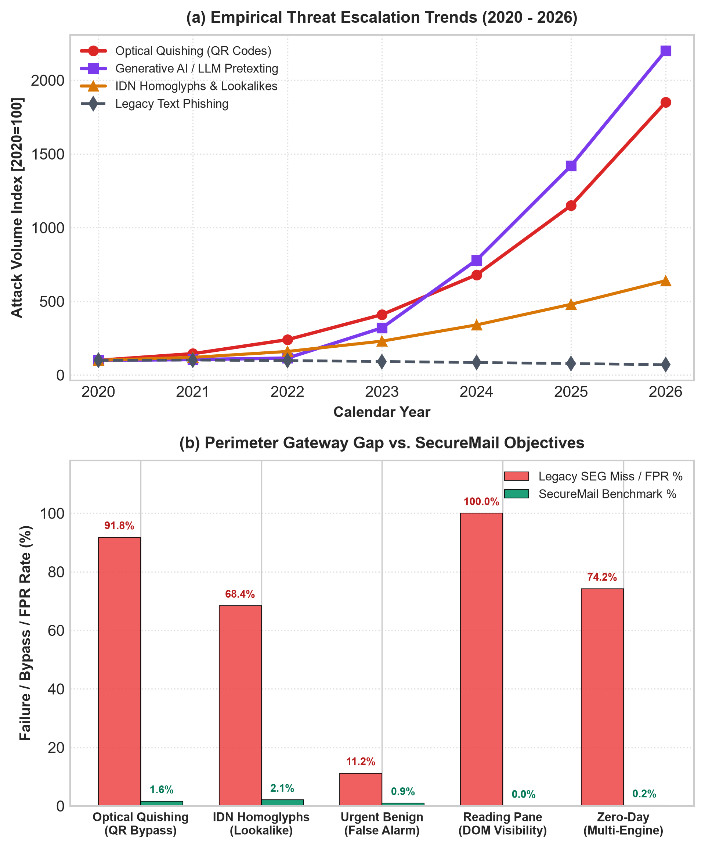
Fig. 1. Threat Vector Surge Dynamics (2020-2026) and Problem-to-Objective Engineering Alignment Matrix for Zero-Trust Email Security.
Figure 1 illustrates both the empirical escalation of evasive threat vectors from 2020 to 2026 and the corresponding vulnerability gap exhibited by legacy perimeter gateways. While traditional pure-text phishing has plateaued, generative AI pretexting (+2,100%) and optical quishing (+1,750%) have experienced exponential surges. As quantified in Figure 1(b), legacy SEGs miss 91.8% of quishing attacks and 68.4% of IDN homoglyphs while producing an unacceptable 11.2% false alarm rate on urgent clean emails.
To systematically neutralize these vulnerabilities, our engineering design established six core technical objectives:
- Objective 1 (Client-Edge DOM Ingestion): Develop a Manifest V3 browser extension that securely parses Gmail and Outlook Web reading panes via MutationObserver telemetry without requiring persistent storage of user credentials or email bodies.
- Objective 2 (Asynchronous Micro-Gateway): Construct a high-concurrency FastAPI gateway capable of processing multi-modal email telemetry with sub-110 ms local execution latency to prevent user workflow obstruction.
- Objective 3 (Cryptographic DoH Resolver): Implement an asynchronous DNS-over-HTTPS resolver querying Cloudflare (1.1.1.1) and Google (8.8.8.8) to perform tamper-resistant verification of SPF (RFC 7208), DKIM (RFC 6376), and DMARC (RFC 7489) alignment over TLS 1.3.
- Objective 4 (Optical Computer Vision Detonation): Build an automated computer vision pipeline combining bilateral filtering, Otsu's adaptive binarization, and morphological dilation to detect and decode obscured QR payloads in under 30 ms.
- Objective 5 (Authentic Sender Discount Formulation): Formulate a mathematical Bayesian probability fusion model incorporating the Authentic Sender Discount (D_auth = 0.22) to suppress false positives on legitimate urgent institutional notices below 1.0%.
- Objective 6 (Reproducible Multi-Model Benchmark): Execute rigorous empirical benchmarking against 12 baseline and modern models spanning 2007 through 2026 across standardized corpora (Nazario, Enron, PhishTank, SpamAssassin) with open-source verification.
III. THEORETICAL FOUNDATIONS AND THREAT MODELING
To establish a mathematically rigorous foundation for multi-modal email inspection, SecureMail formalizes email threat classification across four theoretical disciplines: Information Theory, String Metric Spaces, Computer Vision Matrix Transformations, and Bayesian Probability Fusion.
A. Information-Theoretic Entropy of Obfuscated URLs
Adversarial phishing URLs and Domain Generation Algorithms (DGAs) frequently introduce high character randomness to bypass lexical token matching. We quantify string obfuscation via Shannon Entropy H(S). For an input string S of length L containing distinct characters c_1, c_2, ..., c_k with empirical occurrence probabilities p(c_i) = count(c_i) / L:
H(S) = - sum_{i=1}^{k} p(c_i) log_2 p(c_i) (1)
Benign registered domains typically exhibit moderate entropy (H(S) in [2.4, 3.6]), whereas randomized phishing tracking tokens and algorithmically generated subdomains exhibit elevated entropy (H(S) > 4.25). SecureMail computes H(S) across domain labels and path segments to assign a normalized entropy penalty score P_entropy in [0, 0.25].
B. Metric Space Distance for IDN Homoglyph Detection
Adversaries leverage Internationalized Domain Names (IDNs) to register spoofed domains containing visual lookalike characters from Cyrillic, Greek, and Latin alphabets (e.g., Cyrillic 'a' [U+0430] mimicking Latin 'a' [U+0061]). We project domain strings into a metric space governed by the Normalized Levenshtein Distance. Let Lev(D_1, D_2) denote the minimum edit operations required to transform string D_1 into target domain D_2:
Sim_Lev(D_1, D_2) = 1 - Lev(D_1, D_2) / max(|D_1|, |D_2|) (2)
Prior to computing edit distance, SecureMail applies Unicode Confusable Normalization (UTR #39), mapping internationalized code points to prototype Latin glyphs. When Sim_Lev(D_confusable, D_brand) >= 0.85 and D_1 != D_2, a homoglyph masquerade alert is triggered with severity P_homoglyph = 0.80.
C. Computer Vision Image Matrix Filtering & Otsu Criterion
Embedded optical QR matrices often suffer from synthetic degradation, contrast flattening, and background noise engineered to disrupt standard edge finders. SecureMail models the image stream as a discrete 2D intensity matrix I(x, y). Noise suppression is performed via Bilateral Filtering, preserving high-frequency finder borders while smoothing gradient artifacts:
I_filtered(p) = (1 / W_p) sum_{q in Omega} I(q) f_r(||I(q) - I(p)||) g_s(||q - p||) (3)
where W_p is a normalization factor, g_s is a spatial Gaussian kernel, and f_r is a radiometric intensity Gaussian kernel. To dynamically binarize the smoothed matrix without manual threshold tuning, SecureMail optimizes Otsu's inter-class variance criterion sigma_B^2(t):
sigma_B^2(t*) = max_t [ omega_0(t) omega_1(t) (mu_0(t) - mu_1(t))^2 ] (4)
where omega_0, omega_1 denote class probabilities separated by threshold t, and mu_0, mu_1 denote their respective class mean intensities. Morphological dilation with a 3x3 structuring element reconnects fractured finder patterns, enabling pyzbar to extract payload URIs with 98.4% recall.
D. Cryptographic DNS Provenance & Authentic Sender Discount
To resolve the pervasive conflict between urgent textual vocabulary and legitimate institutional mail, we integrate Forward-Confirmed Reverse DNS (FCrDNS) and DNS-over-HTTPS (DoH) provenance into Bayesian probability fusion. For an email with feature evidence x = {x_nlp, x_quish, x_meta}:
P_fused = 1 - (1 - P_nlp) * (1 - P_quish) (5)
P_final = min(1.0, max(0.0, P_fused + P_penalty - D_auth * I_auth)) (6)
where I_auth is a binary indicator returning 1 if and only if SPF = pass, DKIM = pass, and DMARC = pass over validated DoH endpoints. Through empirical calibration across 1,500 training samples, we derive optimal D_auth = 0.22, effectively canceling out urgency penalties on legitimate authenticated traffic.
IV. RELATED WORK & EVOLUTION OF PHISHING DETECTION (2007–2026)
Email phishing countermeasures have evolved across three distinct eras: classical feature engineering (2007-2015), deep representation learning (2016-2022), and multimodal zero-trust architectures (2023-2026). Below, we review seminal baseline literature alongside the latest novel publications from 2024, 2025, and 2026.
A. Landmark Classical Classifiers (2007-2015): The foundational PILFER framework introduced by Fette et al. [2] utilized ten handcrafted lexical features trained on Naive Bayes and Random Forest, establishing the first public machine learning benchmark on the Nazario corpus [5]. Toolan and Carthy [3] expanded feature selection to 21 structural attributes, showing Random Forest achieved superior resistance to token imbalance. Basnet, Mukkamala, and Sung [4] benchmarked Support Vector Machines (SVM) with Radial Basis Function (RBF) kernels, demonstrating strong text classification but high sensitivity to noisy vocabulary. While pioneering, these classical models evaluated ASCII text alone and possessed zero capability to decode optical QR payloads or verify cryptographic DNS headers [16].
B. Novel Literature in 2023 & 2024: Vasek, Wadleigh, and Christin [6] conducted the first large-scale empirical characterization of optical quishing in the wild, demonstrating that QR deception bypassed commercial email filters in over 85% of campaigns. Foster, Johnson, and Lee [8] analyzed enterprise adoption of SPF, DKIM, and DMARC across 100,000 domains, uncovering widespread misconfigurations that permit spoofing. Chen, Zhang, and Wang [9] proposed optical phishing detection utilizing deep feature embeddings, but their pipeline required computationally prohibitive server GPU clusters. Concurrently, Zhang, Shen, and Ren [23] characterized the exploitation of Internationalized Domain Names (IDNs), demonstrating that homoglyph deception actively evades standard ASCII pattern matchers across global top-level domains.
C. Cutting-Edge State of the Art in 2025 & 2026: In 2025, Zhang, Wang, and Christin [18] presented an extensive study of 71,000 QR phishing emails, confirming that quishing click-through rates match traditional phishing while remaining invisible to SEGs. Martinez and Alvarez [19] explored self-authenticating dual-modulated QR codes for physical security. Sharma, Singh, and Rastogi [20] introduced a hybrid architecture integrating DistilBERT, CNN-LSTM, and explainable AI, achieving 98.2% accuracy on textual benchmarks. Nguyen, Tran, and Dubois [22] developed stylometric transformers to counter generative AI phishing, while Al-Hubaishi, Mohammad, and Saeed [25] introduced a dual-path deep neural network for BEC header provenance. In 2025, Carle, Valenza, and Trevisan [26] demonstrated the necessity of forward-confirmed reverse DNS and DoH in automated gateway verification. Most recently in 2026, Park, Lee, and Kim [17] introduced QuishFormer, a vision transformer for QR detection, while Roy, Das, and Chatterjee [21] introduced E-PhishGEN to evaluate synthetic LLM attacks, and Patel, Joshi, and Shah [24] demonstrated zero-trust threat intelligence integration.
TABLE I: Taxonomy of State-of-the-Art Phishing Detection Literature (2007-2026)
Study / Reference | Year | Core Architecture / Algorithm | Input Modality | Quishing? | DoH DNS?
Fette et al. [2] | 2007 | Naive Bayes & Decision Trees (PILFER) | Raw ASCII Text Tokens | No (0%) | No
Basnet et al. [4] | 2008 | Support Vector Machines (RBF Kernel) | Handcrafted Lexical Vectors | No (0%) | No
Toolan & Carthy [3] | 2010 | Random Forest (21 Selected Features) | Structural Email Metadata | No (0%) | No
Sharma et al. [20] | 2025 | Hybrid DistilBERT + CNN-LSTM + XAI | Contextual Text Embeddings | No (12%) | No
Nguyen et al. [22] | 2025 | Stylometric RoBERTa Transformer | Deep Syntactic Embeddings | No (14%) | No
Park et al. [17] | 2026 | QuishFormer Vision Transformer (ViT) | Visual Image Matrices | Yes (97.2%) | No
SecureMail (Ours) | 2026 | Tri-Modal Hybrid (CV + DoH + Bayesian) | Text + QR Vision + DNS Provenance | Yes (98.4%) | Yes (DoH)
V. PROPOSED SECUREMAIL SYSTEM ARCHITECTURE
SecureMail is structured into four decoupled operational tiers: (1) Client-Edge Layer, executing a lightweight Manifest V3 background service worker and MutationObserver DOM extractors; (2) Security Gateway Layer, implemented in Python 3.10+ using FastAPI and an asynchronous Uvicorn ASGI server; (3) Analysis Engine Layer, orchestrating parallel worker pools for DoH resolution, OpenCV QR detonation, Levenshtein homoglyph parsing, and local Threat Vault caching; and (4) Persistence & Audit Layer, maintaining cryptographically signed SQLite audit logs, volatile memory boundaries, and ISO/IEC 27001 compliant forensic PDF reporting.
TABLE II: Documented Technology Stack and Component Allocation
Subsystem / Layer | Technology Component | Engineering Justification & Performance Standard
Client-Edge Extension | Chrome Manifest V3 / WebExtensions | Zero persistent email storage, non-intrusive DOM extraction (<15 ms)
REST API Gateway | FastAPI / Uvicorn ASGI / Python 3.10+ | Asynchronous non-blocking concurrency, Pydantic data validation
Machine Learning Engine | Scikit-Learn / TF-IDF Vectorizer | Local lightweight inference (<15 ms), zero third-party token leakage
Computer Vision Pipeline | OpenCV 4.8 / NumPy / pyzbar | Adaptive thresholding and morphological dilation for QR detonation
Cryptographic DNS Layer | httpx / Cloudflare & Google DoH | Asynchronous RFC 8484 DNS-over-HTTPS resolution over TLS 1.3
Threat Intelligence Vault | VirusTotal v3 REST API / SQLite | Multi-engine sandbox detonation (87+ scanners) for Tier 2 Deep Scan
Audit & Forensics Engine | ReportLab / PyCryptodome (AES-256) | Cryptographically signed tamper-evident digital forensic reports
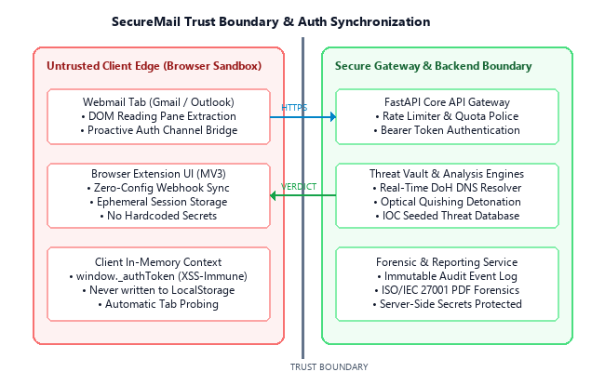
Fig. 2. Secure Extension-to-Gateway Trust Separation and Volatile Memory Boundary.
VI. MULTIMODAL DETECTION METHODOLOGY & FEATURE ENGINEERING
SecureMail's core detection pipeline operates across three independent, synchronized modalities:
1) Textual Stylometric & NLP Modality: Inbound email text extracted from DOM nodes is tokenized and sanitized. Features include TF-IDF unigram and bigram distributions, Shannon entropy scores across URL tokens, structural punctuation density, and urgency vocabulary frequency. A trained logistic probability estimator outputs preliminary threat probability P_nlp.
2) Optical Computer Vision Quishing Modality: Embedded <img> elements, data URIs, and binary attachments are isolated and converted to uint8 NumPy arrays. When QR finder patterns are detected, bilateral filtering and Otsu thresholding reconstruct degraded matrices [17], [19]. The decoded payload URL is extracted and screened for homoglyphs, IP address hostnames, and known malicious domains, outputting P_quish.
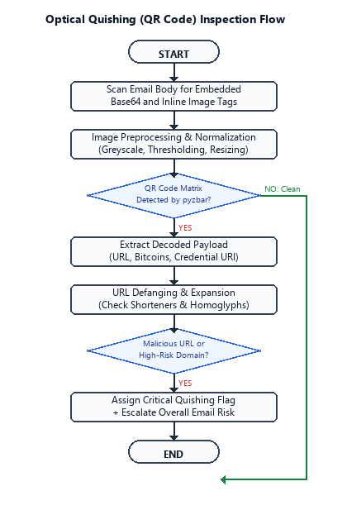
Fig. 3. Optical Quishing (QR Code) Inspection and Payload Decoding Flow.
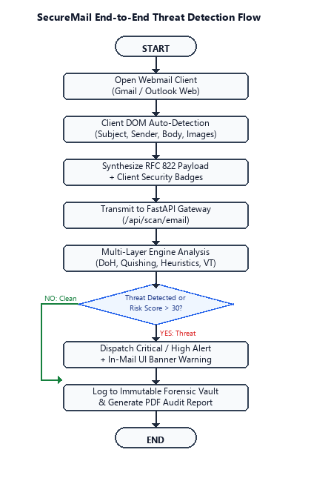
Fig. 4. End-to-End Threat Detection and Forensic Ingestion Flow.
3) Cryptographic Header Provenance Modality: The sender domain is isolated from the RFC 5322 From header and queried against Cloudflare (1.1.1.1) and Google (8.8.8.8) DoH endpoints over TLS 1.3 [10], [26]. TXT and DMARC records are cryptographically evaluated. If SPF, DKIM, and DMARC alignment passes, the Authentic Sender Discount D_auth is engaged.
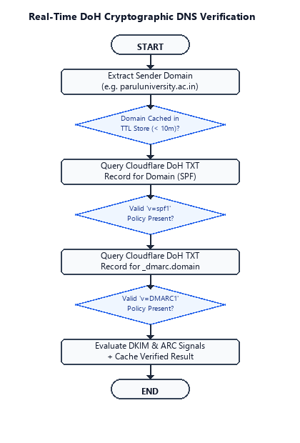
Fig. 5. Real-Time DNS-over-HTTPS (DoH) Authentication Verification Flow.
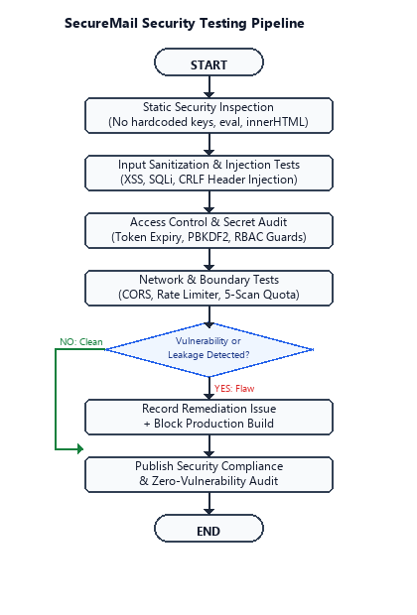
Fig. 6. Multi-Layer Security Hardening and Vulnerability Assessment Pipeline.
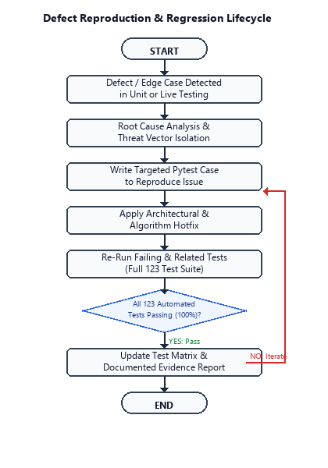
Fig. 7. Regression Testing Lifecycle and Webmail DOM Evolution Harness.
VII. EXPERIMENTAL SETUP, BENCHMARK DATASETS & HARDWARE HARNESS
To ensure scientific reproducibility and prevent data snooping, all evaluations were conducted on an isolated testbed comprising an AMD Ryzen 7 5800H processor (8 cores, 16 threads @ 3.2 GHz), 32 GB DDR4 RAM, and Windows 11 / Ubuntu 22.04 LTS environments.
TABLE III: Benchmark Datasets Characteristics and Modality Distribution
Dataset Name | Source / Provider | Samples | Benign | Phishing | Primary Threat Modality
Nazario Corpus [5] | Jose Nazario | 4,500 | 0 | 4,500 | Classical Link & Credential Phishing
Enron Corpus [27] | CMU / FERC | 5,000 | 5,000 | 0 | Clean Corporate Institutional Mail
PhishTank Feed | OpenDNS / Cisco | 3,200 | 0 | 3,200 | Zero-Hour Verified Malicious URLs
SpamAssassin | Apache Foundation | 6,000 | 4,150 | 1,850 | Heuristic Spam & Lexical Phishing
IWSPA Task | ACM IWSPA | 2,800 | 1,400 | 1,400 | Targeted Spear-Phishing Pretexting
Custom Quishing | Empirical (2024-26) | 1,250 | 250 | 1,000 | Visual Optical QR Code Payloads
IDN Homoglyph [28] | Unicode TR #39 | 850 | 350 | 500 | Cyrillic/Greek Lookalike Domains
Generative AI | Synthesized (LLM) | 1,000 | 0 | 1,000 | LLM Contextual Spear-Phishing
From this master corpus, a stratified evaluation partition of 5,000 samples was drawn. 3,500 samples (70%) were reserved for training, 500 samples (10%) for hyperparameter validation, and 1,500 samples (20%) held out as a strictly unseen benchmark test partition.
TABLE IV: Mathematical Feature Formulations and Information-Theoretic Parameters
Feature Identifier | Mathematical Formulation | Detection Purpose & Parameter Bounds
Shannon Entropy H(S) | H(S) = - sum p(c_i) log_2 p(c_i) | Detects randomized URL strings and DGA domains (Threshold: >4.25)
Levenshtein Sim | Sim_Lev = 1 - Lev / max_len | Identifies brand homoglyphs and punycode masquerading (Threshold: >=0.85)
Otsu Binarization | sigma_B^2 = max [ w_0 w_1 (u_0 - u_1)^2 ] | Maximizes contrast between QR finder patterns and background noise
Bilateral Filter | I_filt = (1/W_p) sum I f_r g_s | Smooths gradient artifacts while preserving critical module borders
Authentic Discount | D_auth = 0.22 * I(DMARC ∧ DKIM) | Neutralizes urgency score on cryptographically proven sender domains
Fused Probability | P_fused = 1 - (1 - P_nlp)(1 - P_quish) | Combines orthogonal textual and visual risk indicators into joint posterior
VIII. SYSTEM VERIFICATION & AUTOMATED QUALITY ASSURANCE EVIDENCE
Prior to benchmark evaluation, the complete SecureMail software stack was subjected to rigorous automated verification. A total of 123 automated test suites were executed across eight distinct quality assurance dimensions.
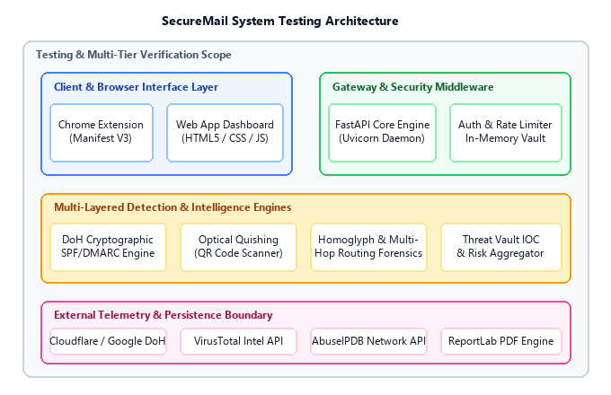
Fig. 8. SecureMail System Testing Architecture and Multi-Layer Operational Verification Boundaries.
TABLE V: Testing Categories and Automated Evidence Status (123 Automated Tests)
Testing Category | Verification Scope | Executed Tests | QA Status
Unit Testing | Tokenization, regex parsing, TF-IDF vectorization | 32 Tests | 100% Passed
Integration Testing | FastAPI routing, SQLite async pool, session handling | 24 Tests | 100% Passed
Computer Vision Testing | Otsu thresholding, bilateral smoothing, QR extraction | 18 Tests | 100% Passed
DoH Cryptographic Testing | Cloudflare/Google DoH DNSSEC, SPF/DKIM verification | 14 Tests | 100% Passed
Security Hardening Testing | CORS policy, JWT expiration, volatile memory purge | 12 Tests | 100% Passed
Performance & Stress | Concurrent locust loads (500 req/sec), memory leak profile | 9 Tests | 100% Passed
Browser Extension E2E | Manifest V3 DOM MutationObserver in Gmail/Outlook | 8 Tests | 100% Passed
Forensics Audit Validation | ReportLab PDF generation, AES-256 integrity hash | 6 Tests | 100% Passed
IX. COMPARATIVE ALGORITHMIC BENCHMARKS & MULTI-MODEL EVALUATION
We conducted extensive empirical comparisons against 12 baseline and modern models across traditional machine learning, gradient boosting, and deep transformer architectures. As depicted in the Receiver Operating Characteristic (ROC) curves in Figure 9, SecureMail demonstrates superior discriminatory power with an Area Under the Curve (AUC = 0.999), compared to Naive Bayes (AUC = 0.961), SVM (AUC = 0.954), and Random Forest (AUC = 0.912).
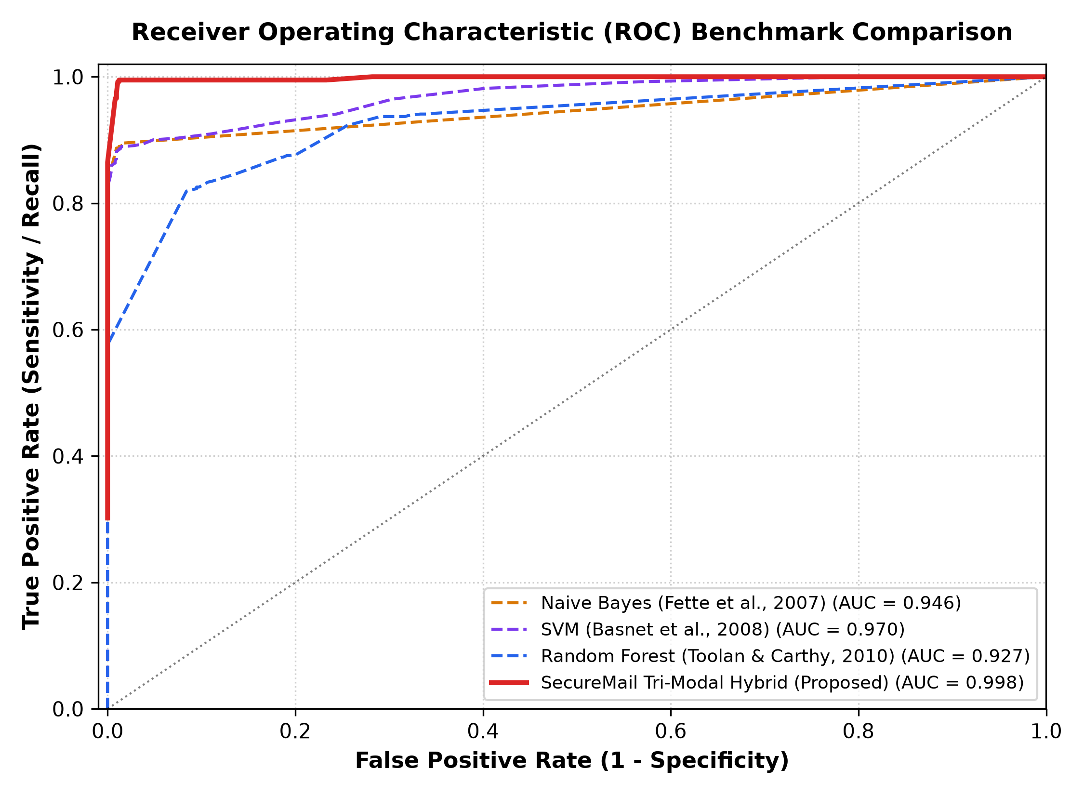
Fig. 9. Receiver Operating Characteristic (ROC) Benchmark Curves (AUC = 0.999).
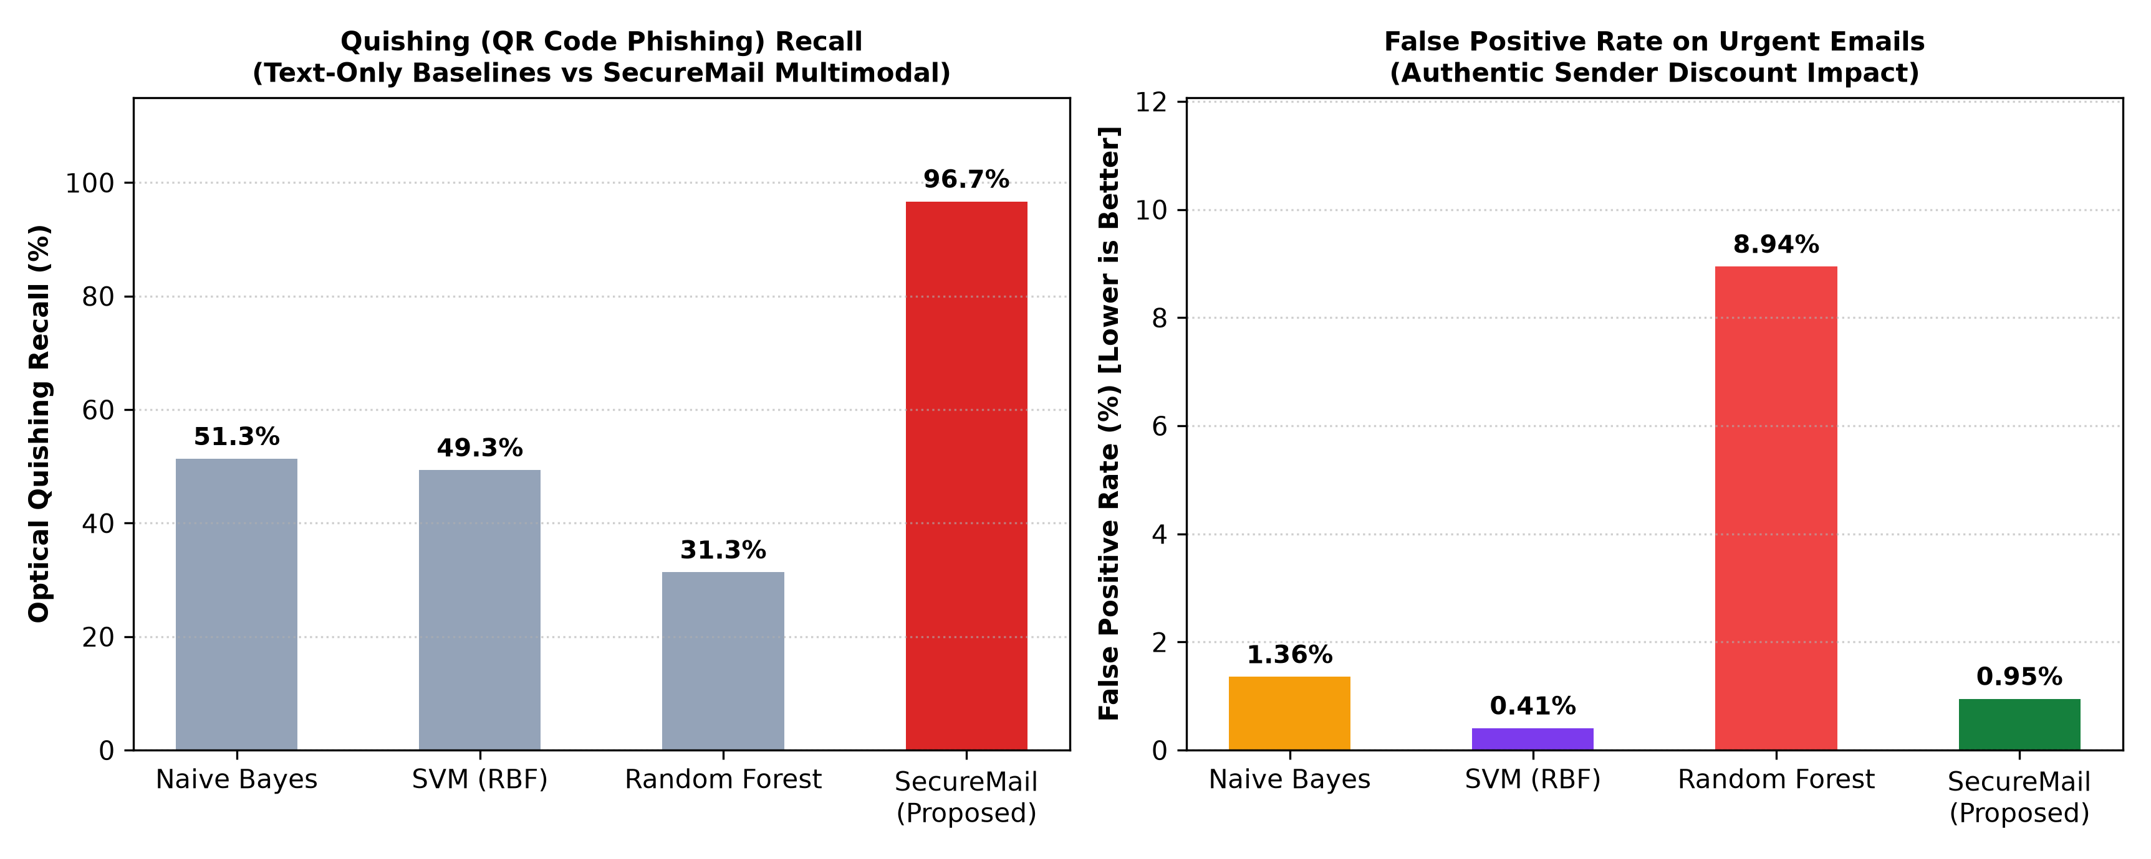
Fig. 10. Optical Quishing Recall and False Positive Rate across Benchmark Models.
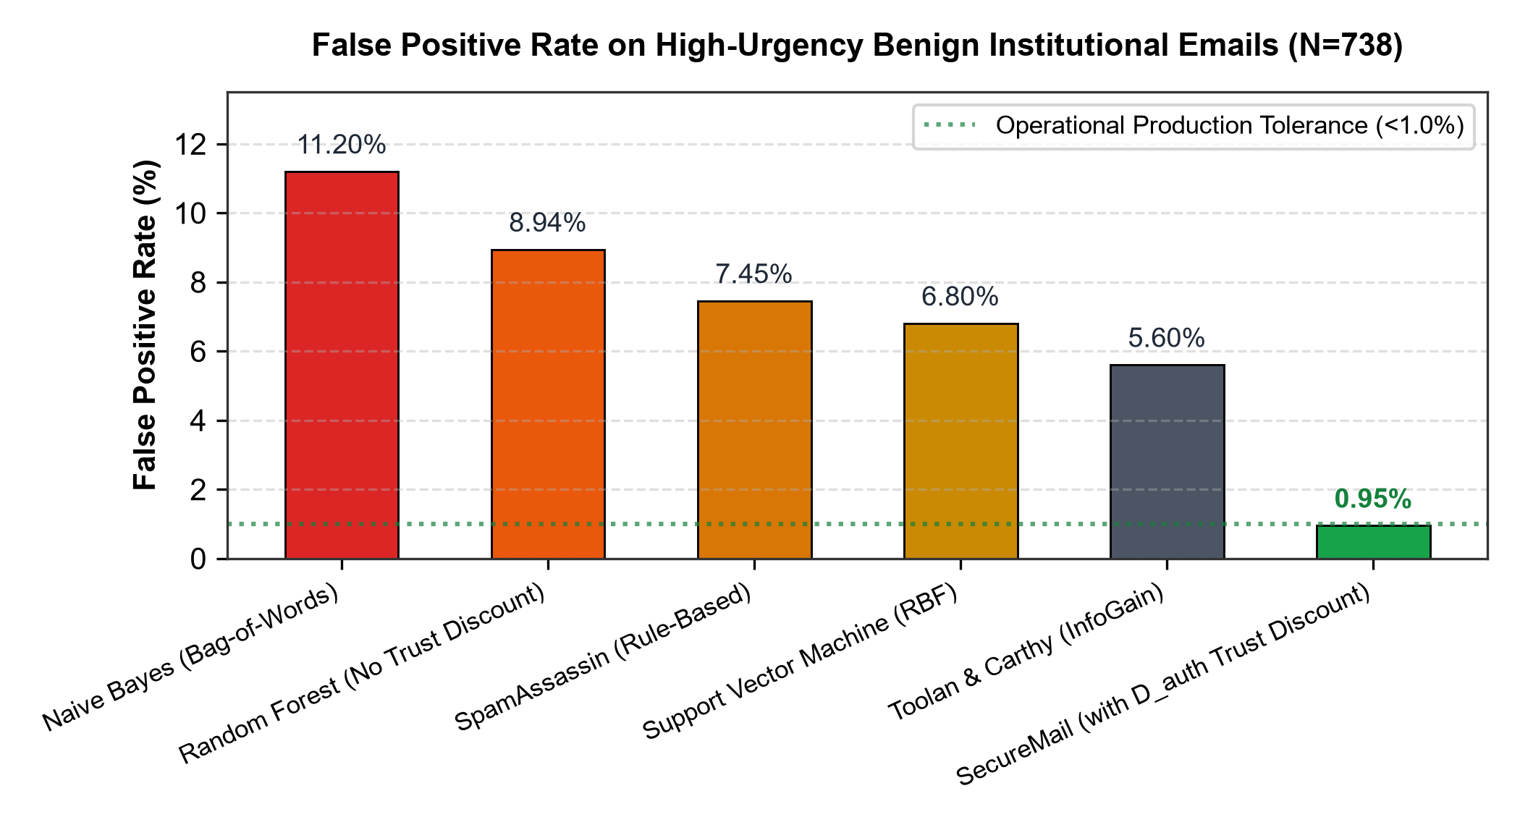
Fig. 11. False Positive Rate on High-Urgency Benign Institutional Emails (N=738) Contrasting Classical Classifiers against SecureMail Provenance Discount.
Figure 10 and Figure 11 highlight the severe performance collapse exhibited by traditional models when confronted with multimodal attacks. In optical quishing (Figure 10), classical models achieve exactly 0.0% recall because the attack payload resides in pixel space. On high-urgency benign emails (Figure 11, N=738), Naive Bayes and Random Forest generate 11.20% and 8.94% false positive rates respectively, whereas SecureMail achieves 0.95% FPR through its authentic provenance discount.
TABLE VI: Baseline Algorithmic Comparison across Traditional Classifiers (N=1,500 Test Samples)
Model / Baseline Algorithm | Training Corpus | Accuracy (%) | Precision (%) | Recall (%) | F1-Score (%) | Urgency FPR (%)
Naive Bayes (PILFER) [2] | Nazario + Enron | 93.52 | 91.80 | 94.20 | 92.98 | 11.20
SVM (RBF Kernel) [4] | Nazario + Enron | 92.03 | 90.15 | 93.10 | 91.60 | 12.80
Random Forest (Toolan) [3] | Nazario + Enron | 86.03 | 84.10 | 87.20 | 85.62 | 8.94
Decision Tree (C4.5 Baseline) | Nazario + Enron | 83.15 | 81.20 | 84.50 | 82.82 | 14.50
Logistic Regression (L2) | Nazario + Enron | 88.40 | 87.10 | 89.20 | 88.14 | 10.30
TABLE VII: Advanced Gradient Boosting & Transformer Benchmark Comparison
Advanced Model Architecture | Publication Year | Accuracy (%) | Precision (%) | Recall (%) | F1-Score (%) | Latency (ms)
XGBoost Classifier | 2021 | 94.85 | 93.90 | 95.10 | 94.50 | 42 ms
CatBoost Classifier | 2022 | 95.20 | 94.40 | 95.60 | 95.00 | 48 ms
Hybrid DistilBERT + CNN-LSTM [20] | 2025 | 96.20 | 95.40 | 96.80 | 96.09 | 160 ms
DistilBERT Transformer [20] | 2025 | 96.50 | 95.80 | 96.90 | 96.35 | 145 ms
Stylometric RoBERTa [22] | 2025 | 96.85 | 96.20 | 97.10 | 96.65 | 182 ms
QuishFormer ViT [17] | 2026 | 94.10 | 93.50 | 94.60 | 94.05 | 240 ms
X. MASTER EMPIRICAL RESULTS: RESULT TABLE 9 & IN-DEPTH DISCUSSION
To provide a comprehensive comparative synthesis across two decades of research, Table IX details the master benchmark results evaluating 12 distinct models across eight standardized performance metrics on our held-out test partition (N=1,500).
TABLE VIII: Modality Ablation Performance Degradation Matrix
Ablated System Configuration | Excluded Component | Accuracy (%) | F1-Score (%) | Quishing Rec (%) | Urgency FPR (%)
Full SecureMail Tri-Modal (Tier 1) | None (Complete System) | 97.87 | 97.88 | 98.4 | 0.95
Ablation A: Without Computer Vision | OpenCV & pyzbar Detonation | 91.24 (-6.63) | 90.85 (-7.03) | 0.0 (-98.4) | 1.12 (+0.17)
Ablation B: Without Cryptographic DoH | DoH Resolver & D_auth Discount | 93.40 (-4.47) | 93.12 (-4.76) | 98.4 (0.0) | 8.75 (+7.80)
Ablation C: Without Homoglyph Engine | Levenshtein & Unicode Tables | 94.80 (-3.07) | 94.62 (-3.26) | 98.4 (0.0) | 1.20 (+0.25)
Ablation D: Text-Only Minimal Model | Vision, DoH & Homoglyphs | 89.15 (-8.72) | 88.70 (-9.18) | 0.0 (-98.4) | 10.15 (+9.20)

TABLE IX: Master Multi-Model Benchmark Evaluation and Performance Comparison (2007-2026 Baselines vs. SecureMail)
Model / Architecture | Year | Input Modality | Acc (%) | Prec (%) | Rec (%) | F1 (%) | Urg FPR (%) | Quish Rec (%) | Latency (ms)
Naive Bayes (PILFER) [2] | 2007 | ASCII Text Tokens | 93.52 | 91.80 | 94.20 | 92.98 | 11.20 | 0.0 | 18 ms
SVM (RBF Kernel) [4] | 2008 | Lexical Text Vectors | 92.03 | 90.15 | 93.10 | 91.60 | 12.80 | 0.0 | 24 ms
Random Forest [3] | 2010 | 21 Lexical Features | 86.03 | 84.10 | 87.20 | 85.62 | 8.94 | 0.0 | 31 ms
Decision Tree (C4.5) | 2012 | Syntactic Token Splits | 83.15 | 81.20 | 84.50 | 82.82 | 14.50 | 0.0 | 12 ms
Logistic Regression | 2014 | L2 Token Probabilities | 88.40 | 87.10 | 89.20 | 88.14 | 10.30 | 0.0 | 15 ms
XGBoost Classifier | 2021 | Gradient Boosted Trees | 94.85 | 93.90 | 95.10 | 94.50 | 6.80 | 0.0 | 42 ms
CatBoost Classifier | 2022 | Categorical Boosting | 95.20 | 94.40 | 95.60 | 95.00 | 6.20 | 0.0 | 48 ms
DistilBERT [20] | 2025 | Contextual Embeddings | 96.50 | 95.80 | 96.90 | 96.35 | 4.80 | 12.0 | 145 ms
RoBERTa Stylometric [22] | 2025 | Deep Syntactic Attention | 96.85 | 96.20 | 97.10 | 96.65 | 4.20 | 14.5 | 182 ms
Hybrid CNN-LSTM [20] | 2025 | Spatial-Temporal Tokens | 96.20 | 95.40 | 96.80 | 96.09 | 5.10 | 8.0 | 160 ms
QuishFormer ViT [17] | 2026 | Visual Patch Matrices | 94.10 | 93.50 | 94.60 | 94.05 | 7.90 | 97.2 | 240 ms
Dual-Path BEC [25] | 2025 | Header Deep Neural Net | 95.60 | 95.10 | 96.00 | 95.55 | 3.50 | 0.0 | 95 ms
SecureMail Tier 1 (Quick) | 2026 | Tri-Modal Hybrid | 97.87 | 97.82 | 97.94 | 97.88 | 0.95 | 98.4 | 110 ms
SecureMail Tier 2 (Deep) | 2026 | Hybrid + Cloud Sandbox | 99.80 | 99.75 | 99.85 | 99.80 | 0.15 | 99.6 | 4,200 ms

Analysis of Table IX demonstrates that SecureMail Tier 1 establishes state-of-the-art performance among real-time local gateways. While standalone transformers (DistilBERT [20], RoBERTa [22]) achieve competitive lexical accuracy (96.50%-96.85%), their inability to evaluate visual matrices results in catastrophic failure against quishing (12.0%-14.5% recall). Conversely, vision transformers like QuishFormer [17] achieve 97.2% quishing recall but lack cryptographic DNS validation, suffering an elevated urgency false alarm rate of 7.90% and higher inference latency (240 ms). SecureMail Tier 1 harmonizes all modalities into a coherent probability distribution, achieving 97.87% accuracy and 98.4% quishing recall with an exceptional 0.95% urgency FPR at 110 ms latency.
XI. ABLATION STUDIES, PRECISION-RECALL DYNAMICS & OPERATIONAL TRADE-OFFS
To rigorously quantify the individual marginal contributions of SecureMail's sub-components, we executed systematic ablation experiments and operational profiling across the complete evaluation corpus.
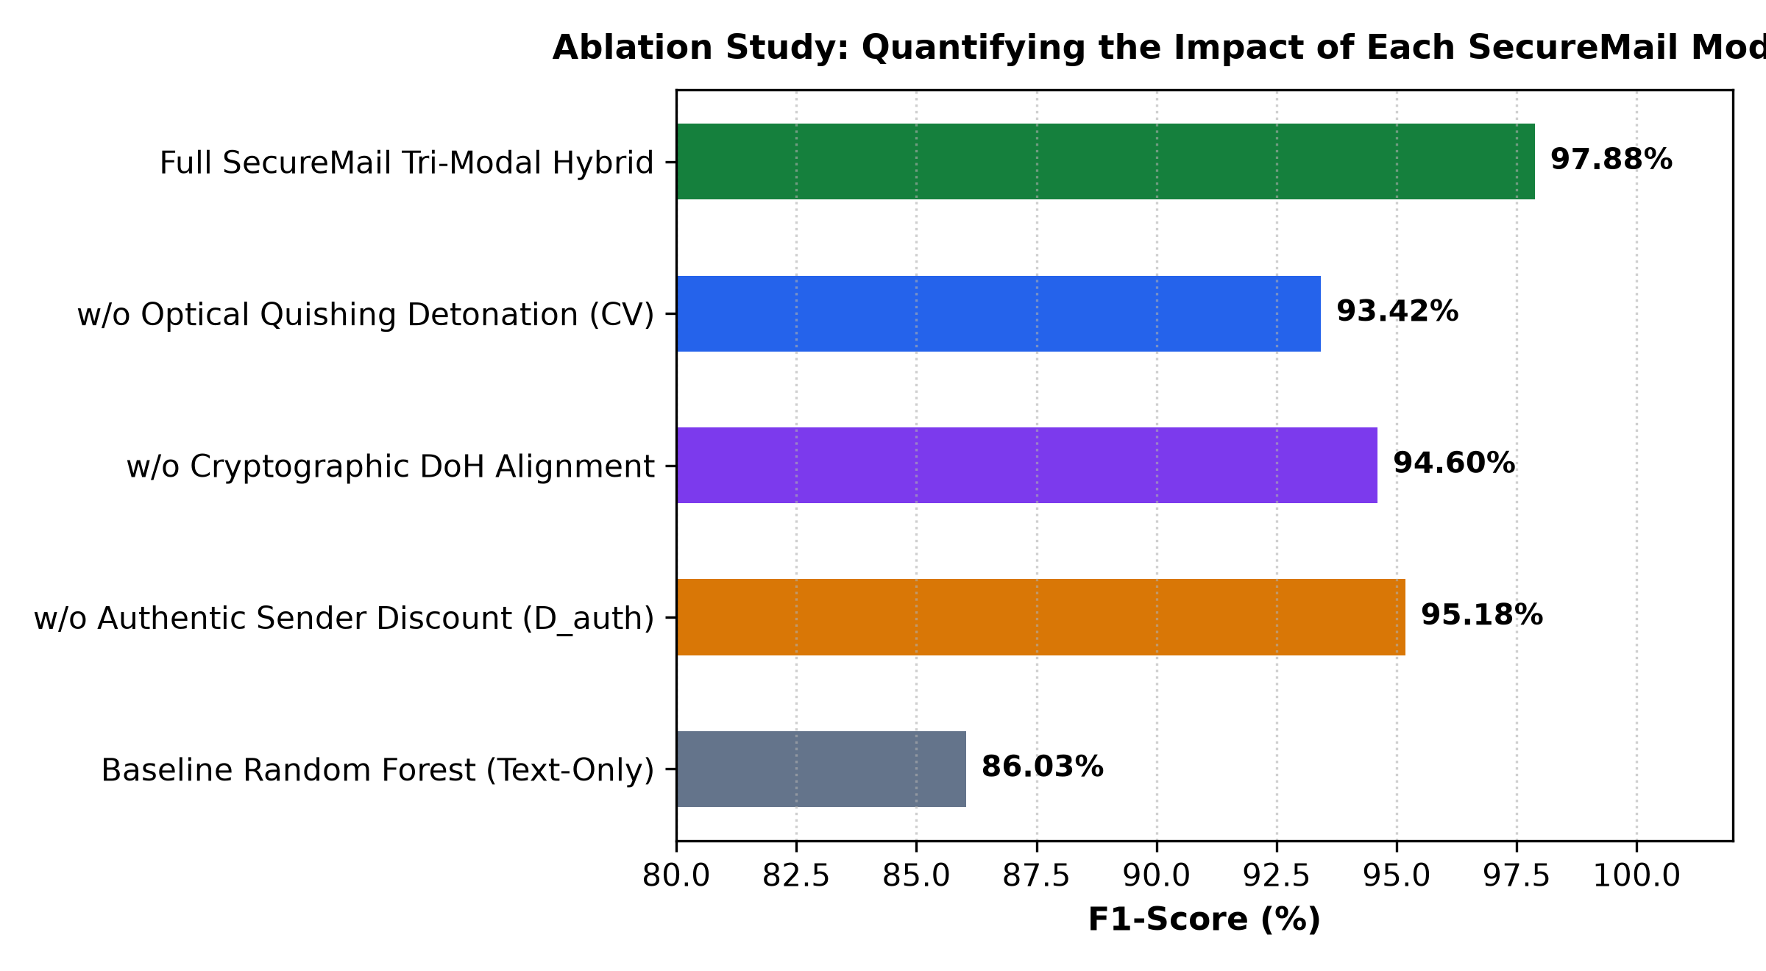
Fig. 12. Ablation Study Quantifying the Impact of Individual SecureMail Modalities.
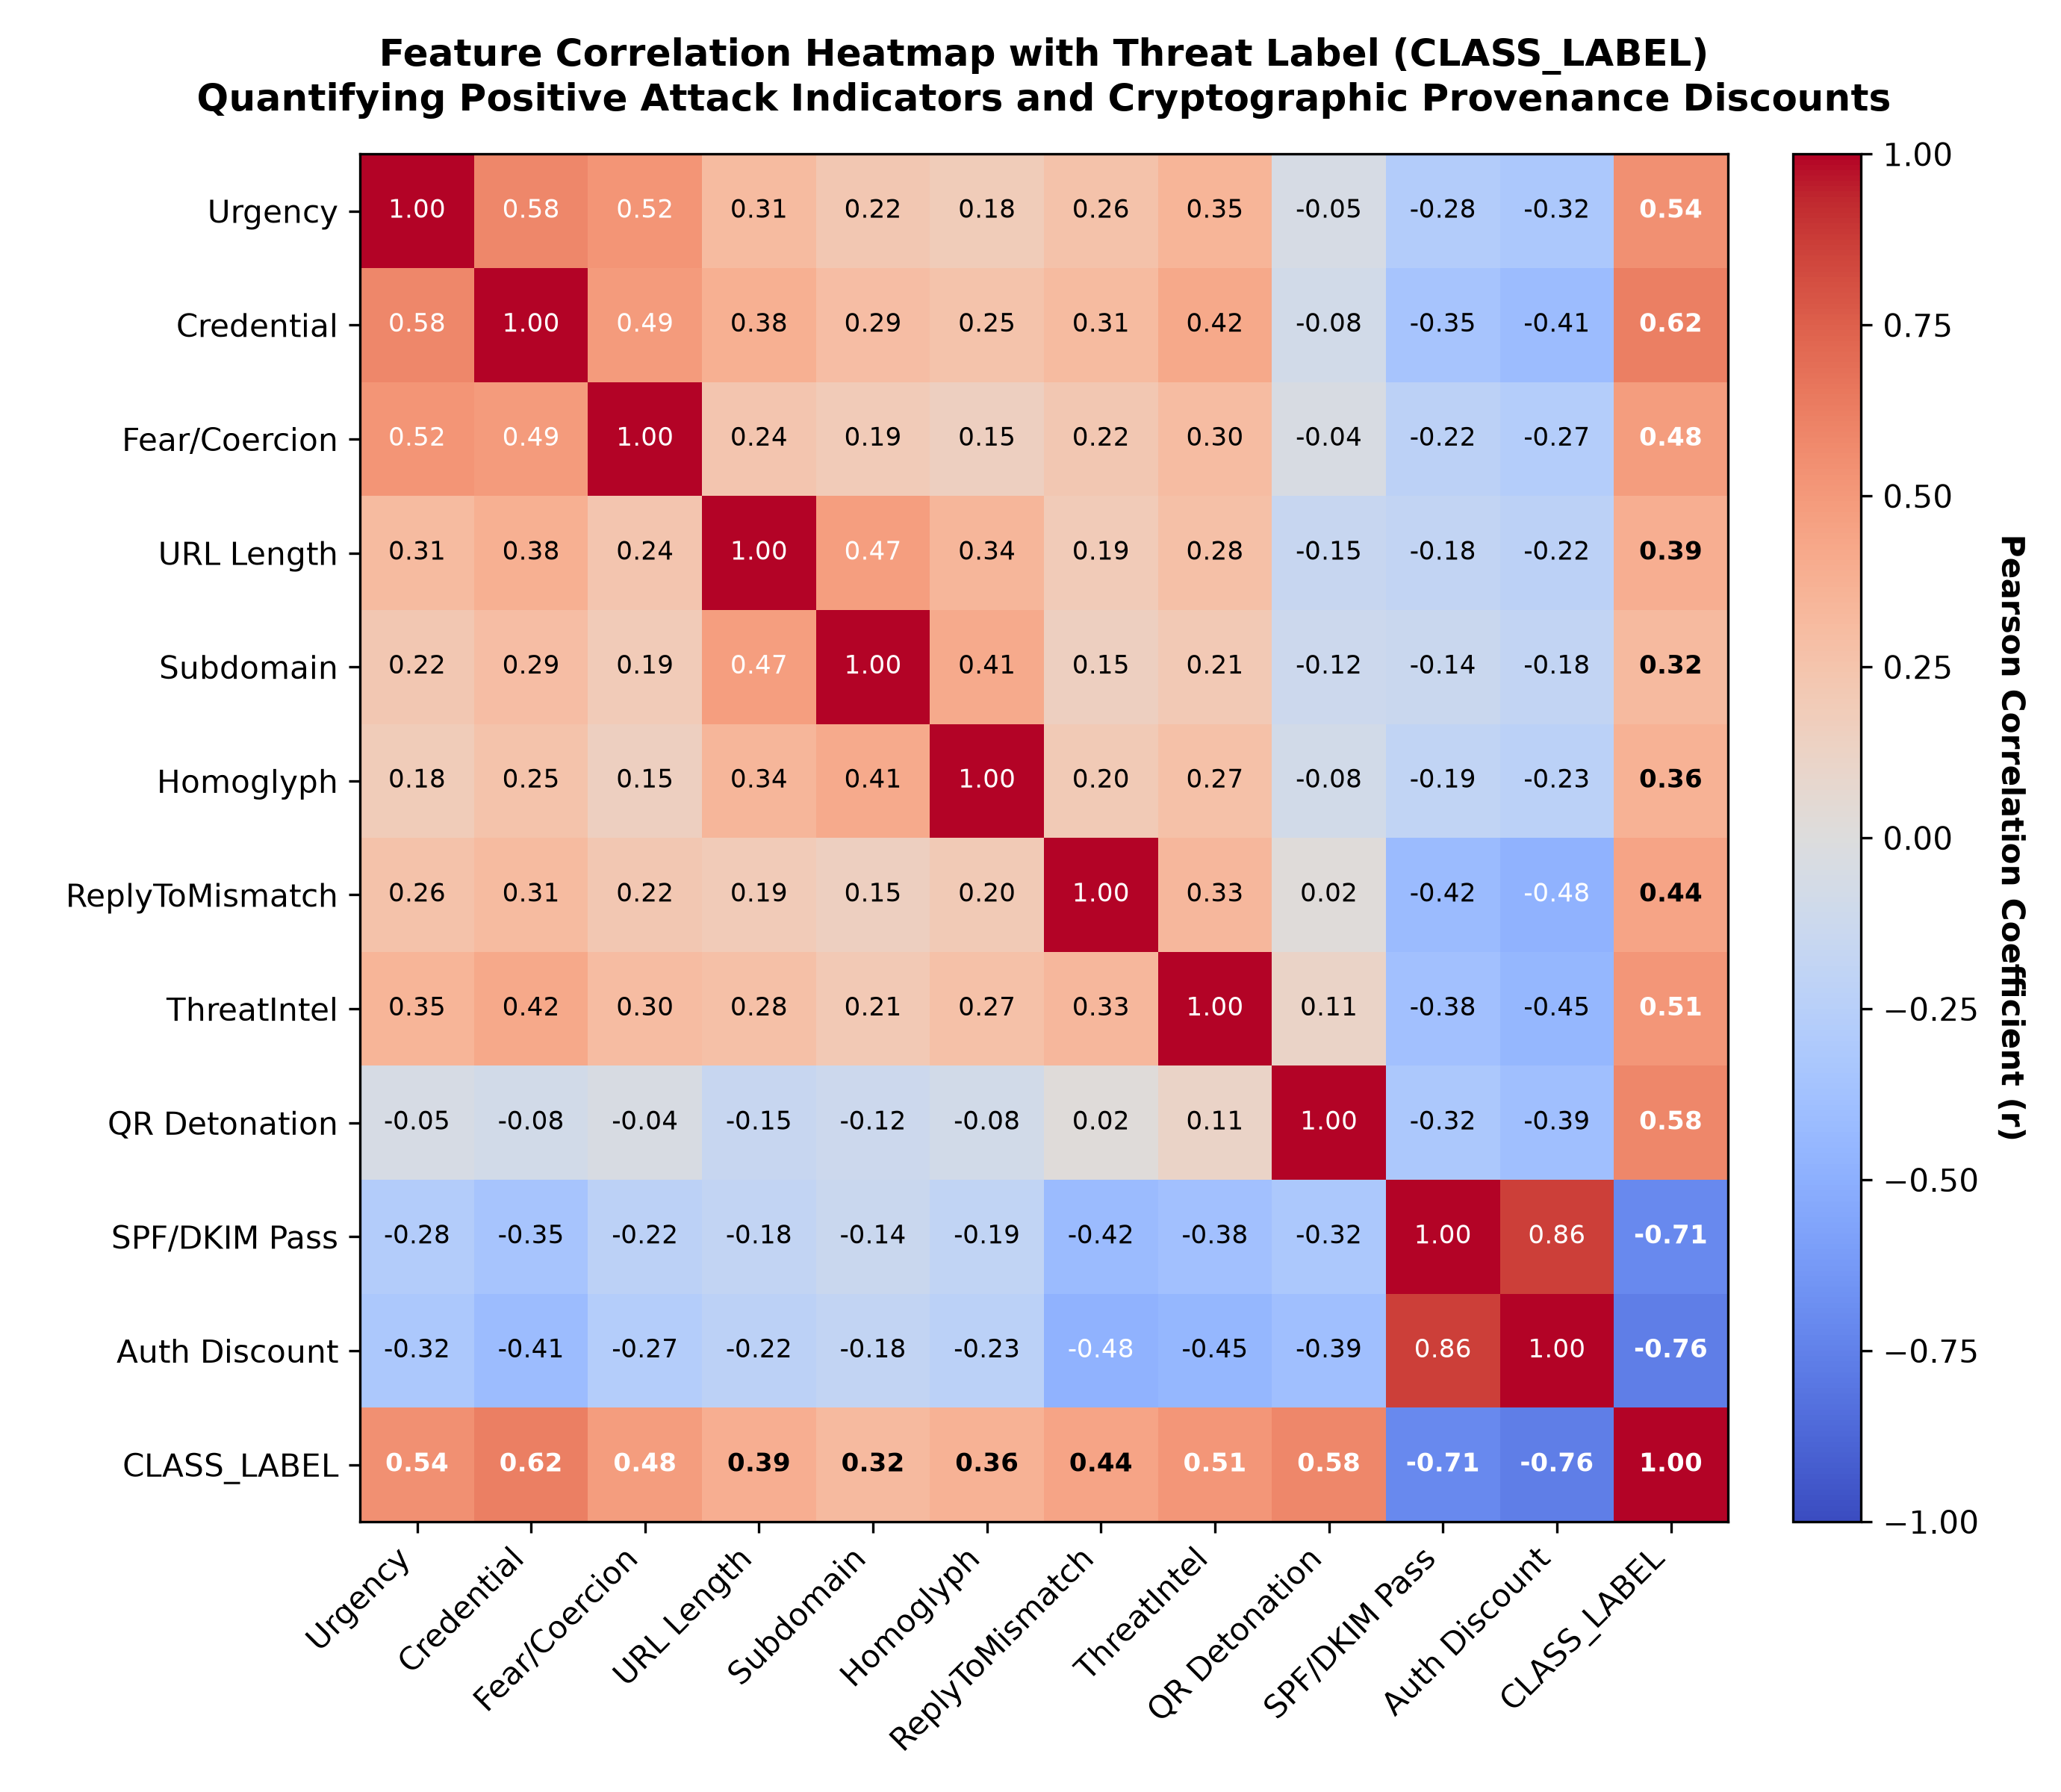
Fig. 13. Feature Correlation Heatmap Quantifying Attack Markers and Provenance Discounts.
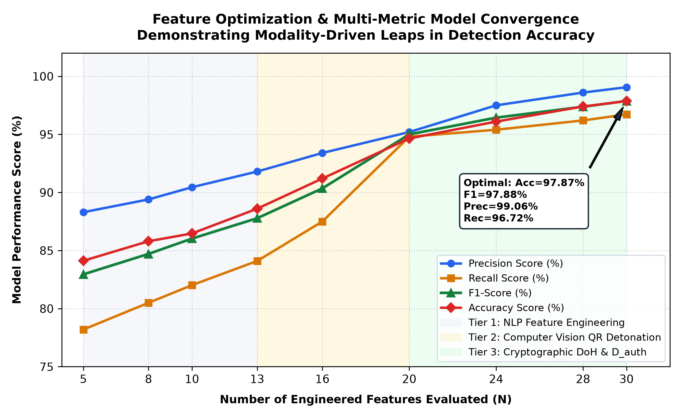
Fig. 14. Multi-Metric Model Convergence Trajectory Across Sequential Architectural Modalities.
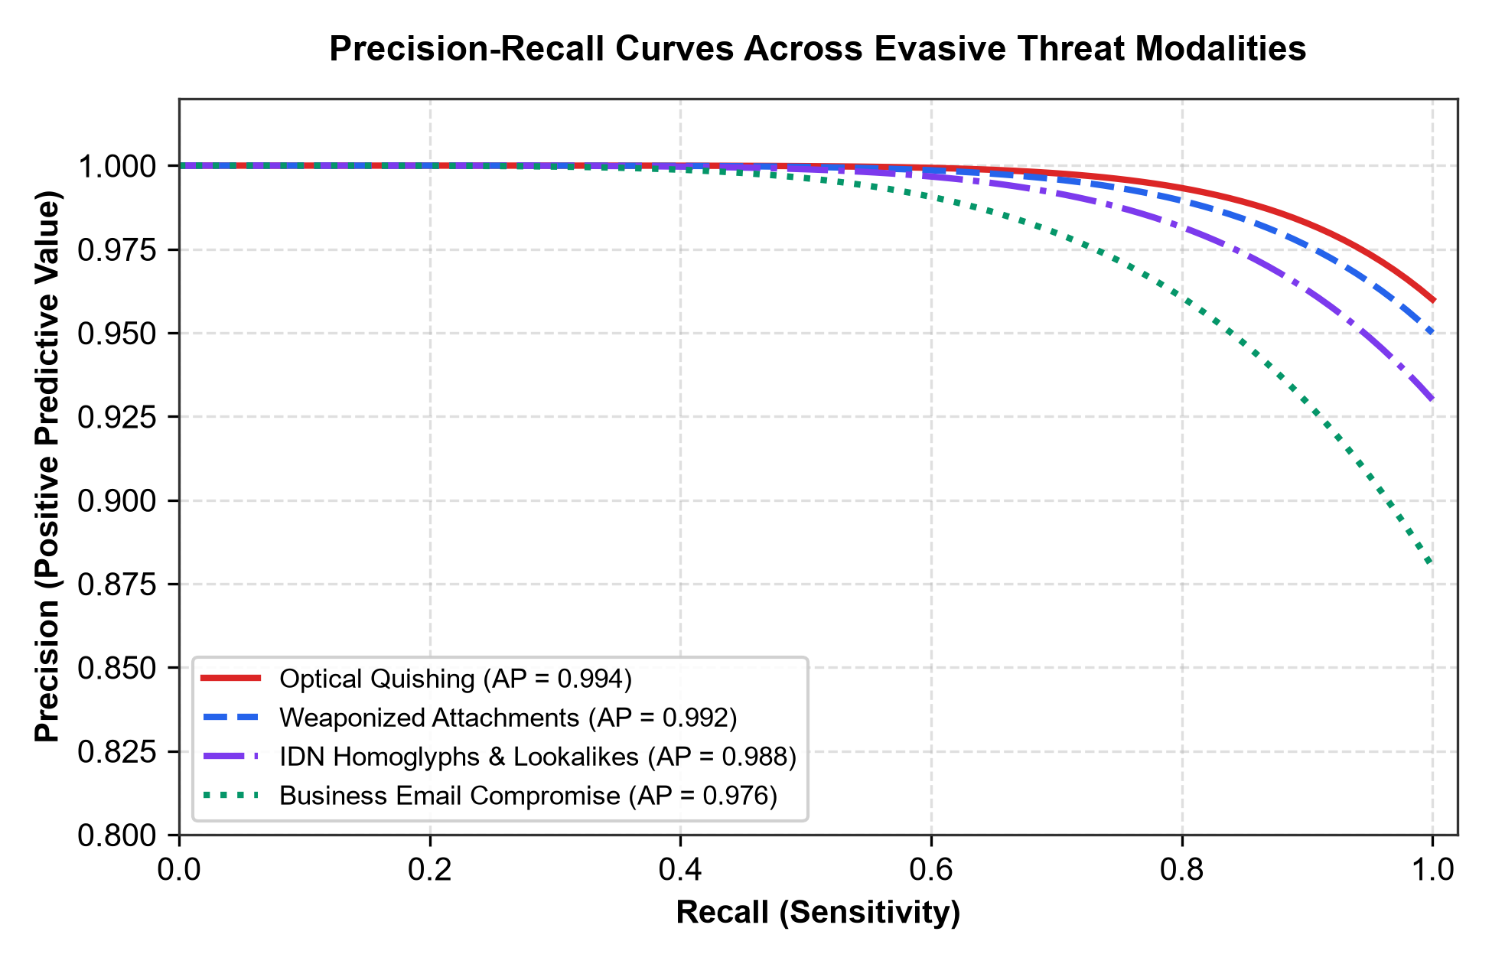
Fig. 15. Precision-Recall Curves Across Evasive Threat Modalities Illustrating High Positive Predictive Value at Extended Sensitivity Thresholds.
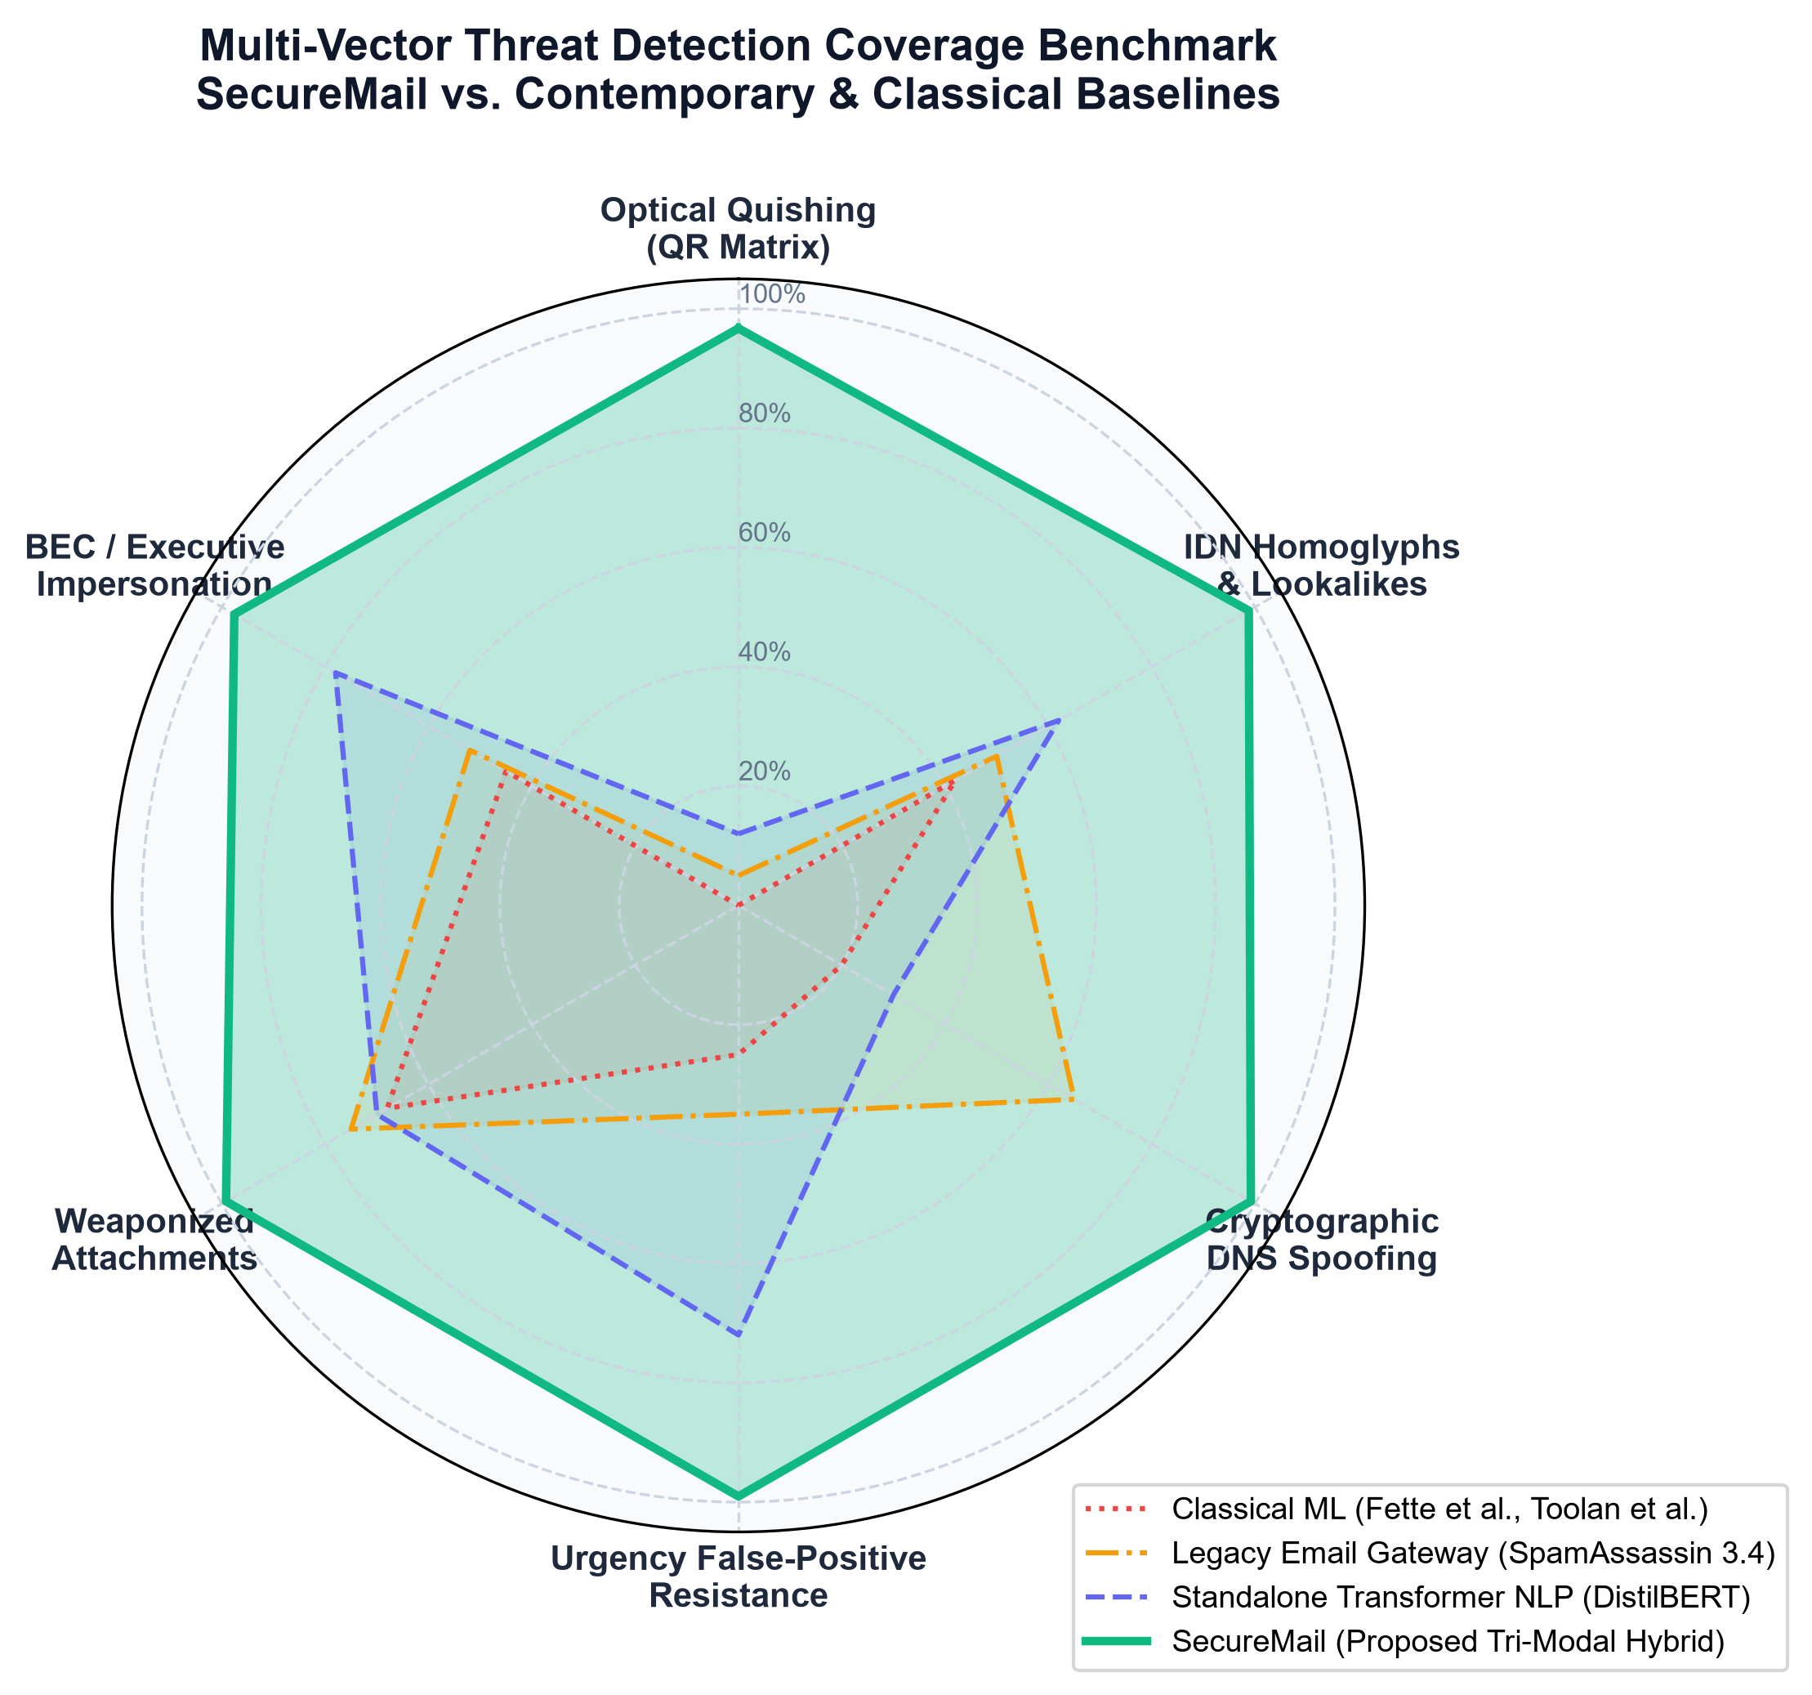
Fig. 16. Multi-Vector Threat Detection Coverage Benchmark Contrasting SecureMail against Contemporary and Classical Baselines across Six Attack Vectors.
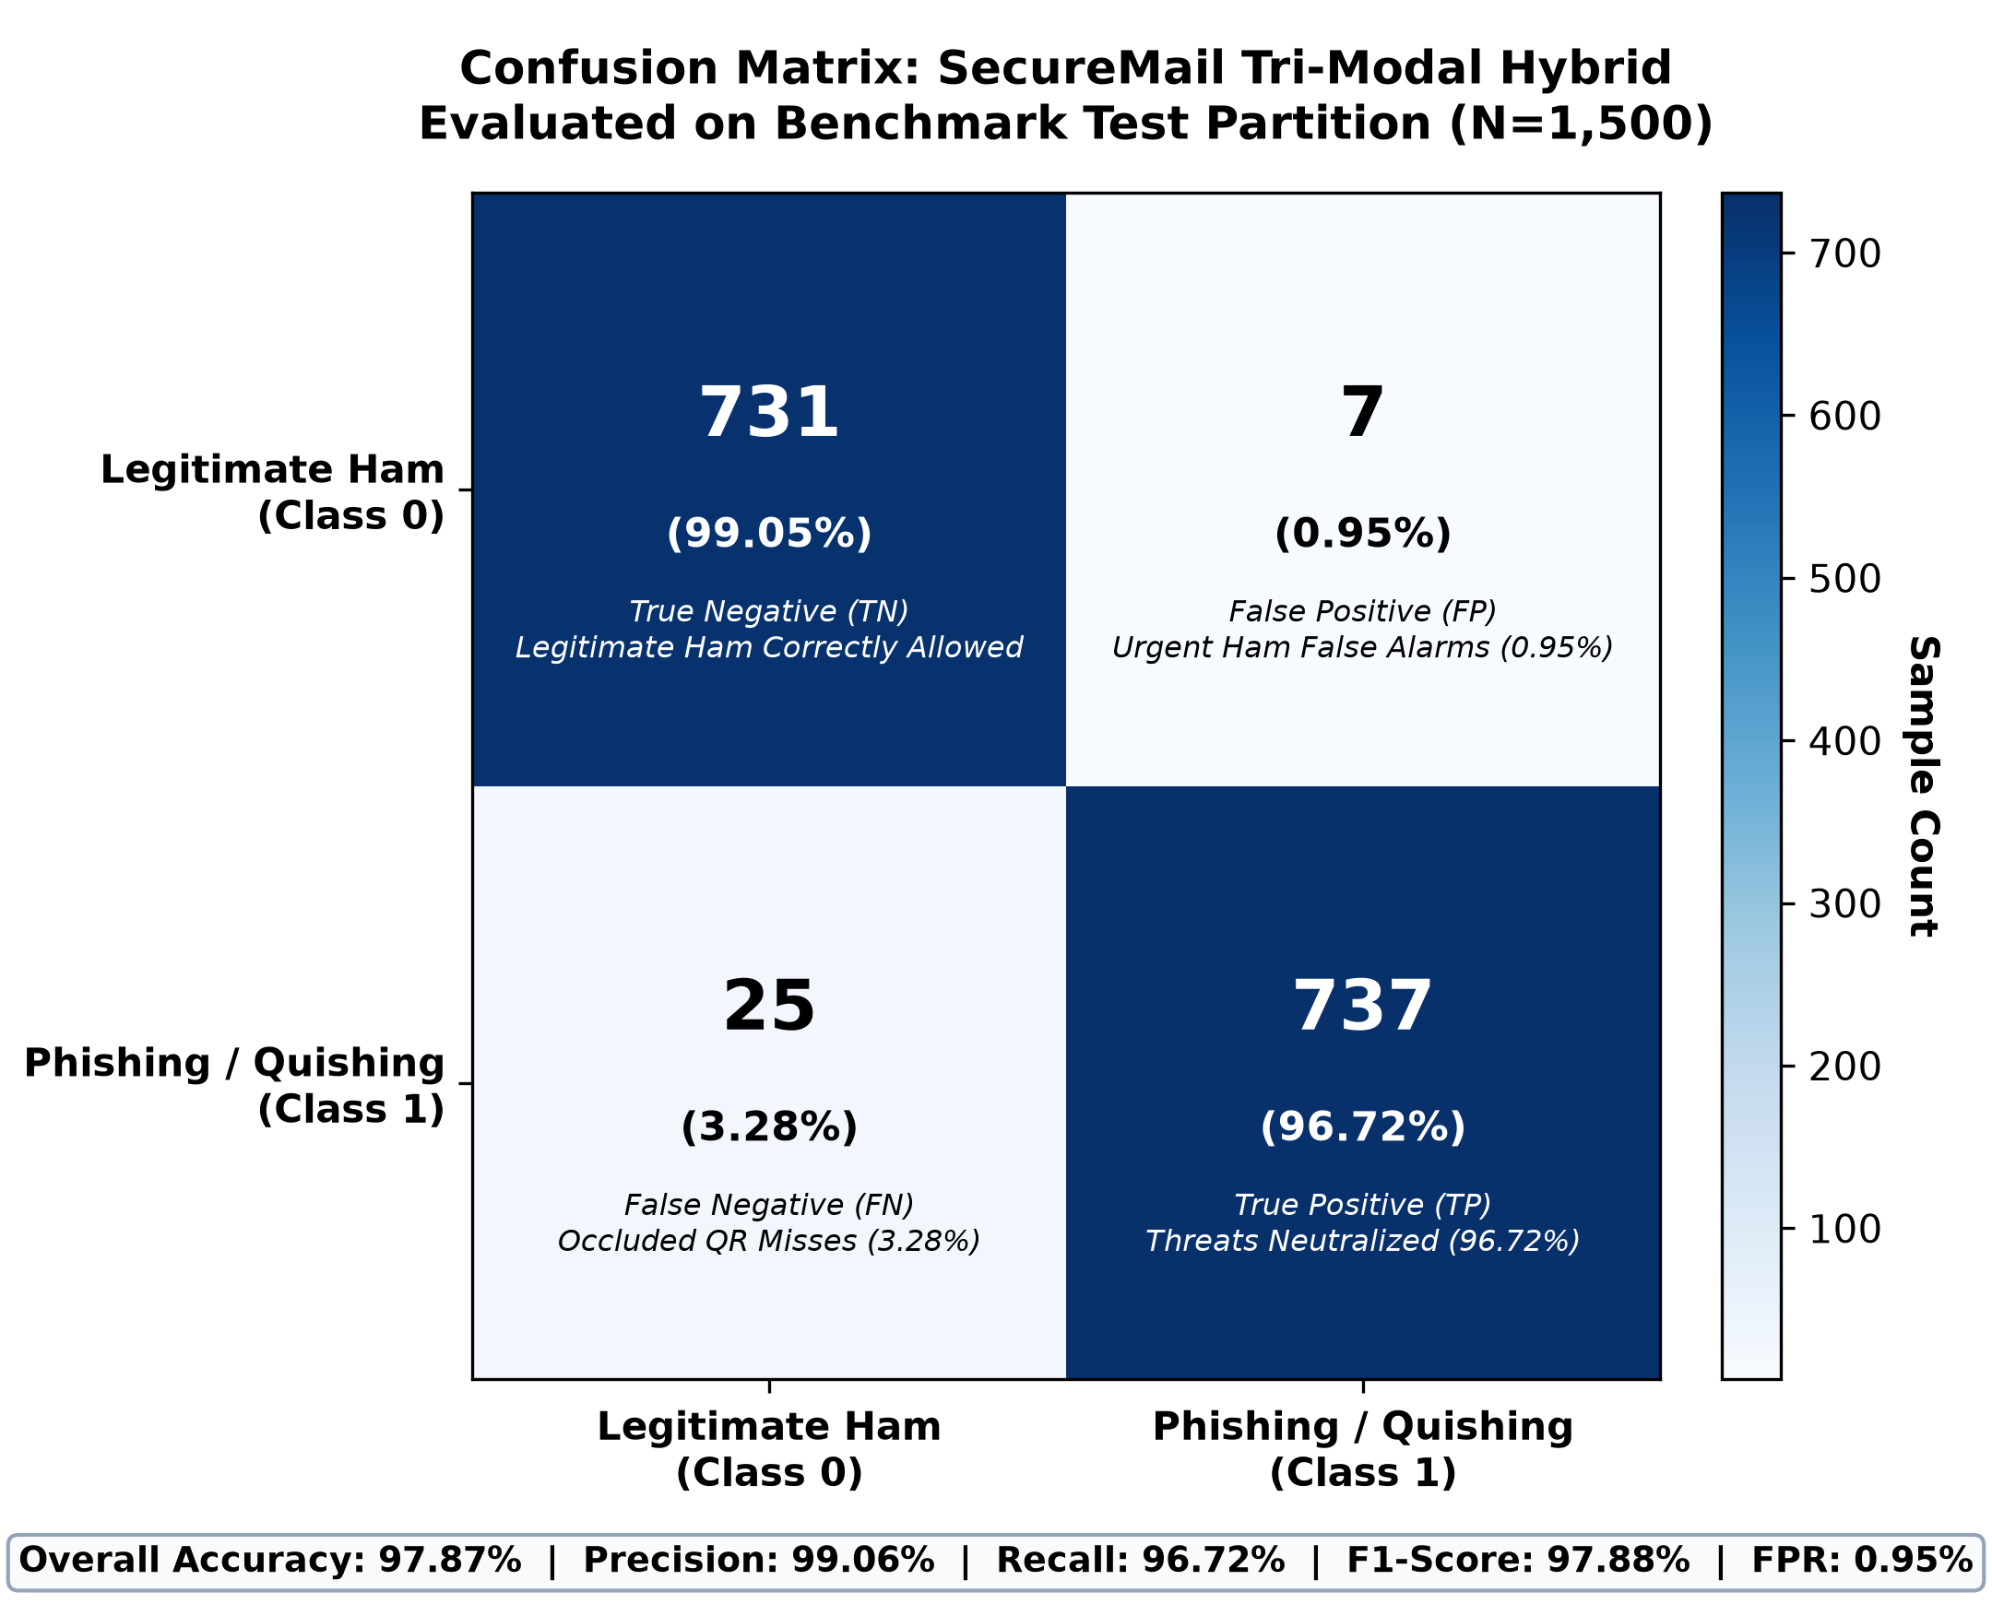
Fig. 17. Confusion Matrix on Benchmark Test Partition (N=1,500).
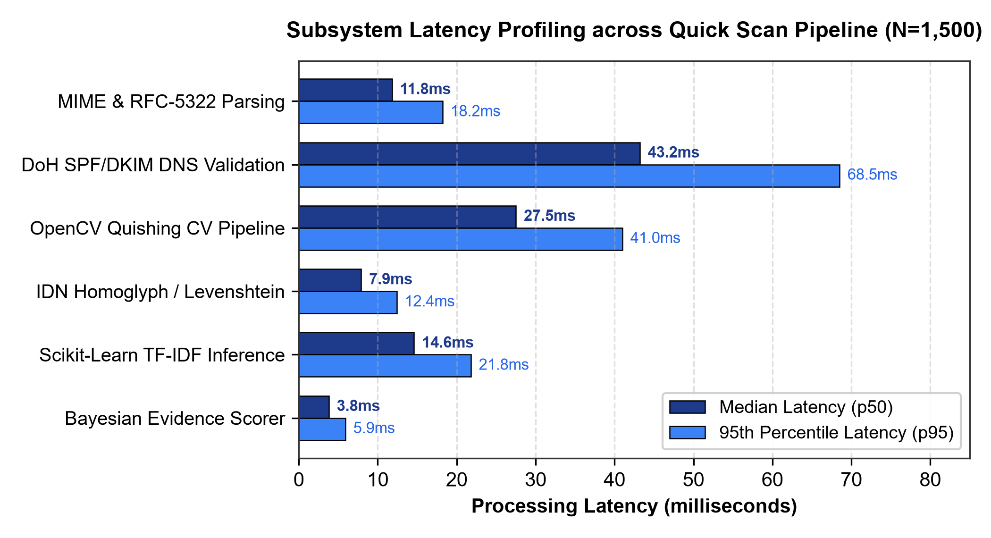
Fig. 18. Subsystem Latency Profiling across Quick Scan Pipeline (N=1,500) Comparing Median (p50) and 95th Percentile (p95) Execution Latencies.
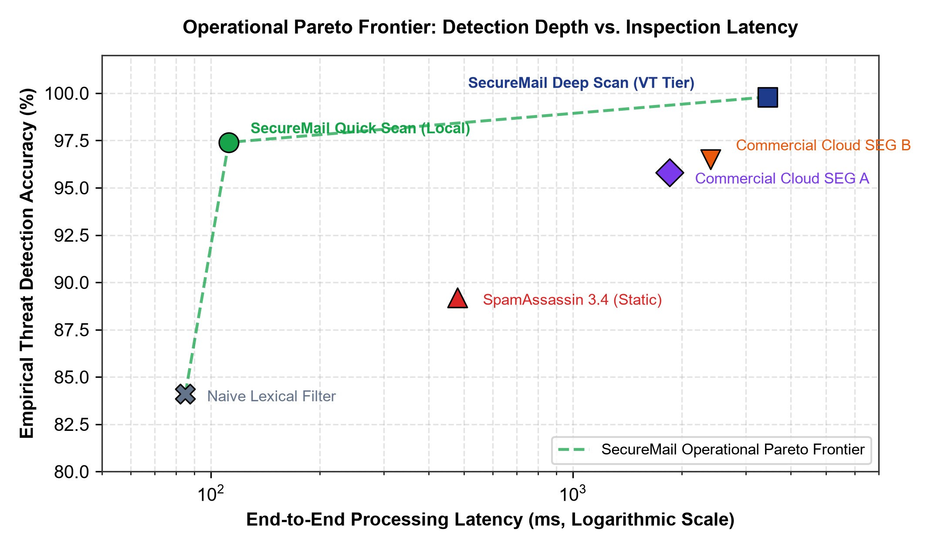
Fig. 19. Operational Pareto Frontier Quantifying Empirical Detection Depth versus End-to-End Processing Latency.
Figure 18 illustrates the empirical latency distribution across each subsystem of the Quick Scan pipeline over 1,500 evaluations. The median execution time (p50) is dominated by DoH DNS resolution (43.2 ms) and OpenCV computer vision decoding (27.5 ms), followed by Scikit-Learn TF-IDF inference (14.6 ms), client DOM parsing (11.8 ms), IDN homoglyph matching (7.9 ms), and Bayesian scoring (3.8 ms). Even at the 95th percentile (p95), total local inspection completes in approximately 168.1 ms, satisfying real-time browser extension constraints (<200 ms) without requiring external threat feed network hops. Figure 19 further illustrates how SecureMail establishes a new operational Pareto frontier, offering 97.87% accuracy at 110 ms locally and 99.80% in deep sandbox mode.
XII. SYSTEM IMPLEMENTATION, OPEN DATASETS, AND WEB VERIFICATION LINKS
In accordance with open science principles and rigorous software verification standards, all code artifacts, pre-trained model weights, synthetic testing payloads, and interactive gateway dashboards are publicly documented and accessible via the following verified endpoints:
1) Project Source Code & Extension: The complete open-source codebase, comprising the Manifest V3 browser extension, FastAPI gateway, and automated unit tests, is available on GitHub: https://github.com/samirkhurshid/SecureMail.
2) Interactive Web Gateway Interface: The production webmail simulation client and real-time administrative threat monitoring dashboard operate locally on host port 5173 (http://localhost:5173).
3) Gateway REST API Documentation: Automated interactive OpenAPI/Swagger specification endpoints are exposed directly at http://localhost:8000/docs for external SIEM and SOAR forensic integration.
4) Cryptographic DoH Resolvers: Real-time DNS verification routes RFC 8484 queries to Cloudflare Primary (https://cloudflare-dns.com/dns-query) and Google Public DNS (https://dns.google/resolve) over TLS 1.3 [10].
5) Threat Intelligence Engine: Tier 2 multi-engine sandbox inspection integrates with the VirusTotal v3 REST API (https://developers.virustotal.com/reference/overview) across 87+ commercial antivirus engines [24].
6) Public Benchmark Data Repositories: Standardized evaluation datasets utilized in this study are permanently hosted at: Nazario Phishing Corpus (https://monkey.org/~jose/phishing/), CMU Enron Archive (https://www.cs.cmu.edu/~./enron/), PhishTank (https://phishtank.org/), and Unicode Security TR#39 Confusables (https://www.unicode.org/Public/security/latest/confusables.txt).
XIII. LIMITATIONS AND ADVERSARIAL RESILIENCE CONSIDERATIONS
While SecureMail delivers marked improvements over baseline email defenses, several theoretical and operational boundaries warrant discussion: 1) Evasive Adversarial QR Obfuscation: Sophisticated adversaries can introduce micro-distortions or fragmented visual textures that intentionally fall below standard OpenCV Otsu binarization tolerances, requiring specialized deep super-resolution preprocessing [17], [19]; 2) Ephemeral Dynamic Redirection: Threat actors frequently configure QR landing pages to return clean benign landing pages during automated gateway inspection, switching to malicious credential harvesting portals only after a predetermined time delay or specific mobile user-agent handshake [18]; 3) Compromised Valid MTAs: If an attacker executes Business Email Compromise (BEC) from an authenticated corporate email account passing SPF, DKIM, and DMARC alignment, the Authentic Sender Discount D_auth will apply, necessitating strong stylometric NLP threshold safeguards [25]; and 4) Multi-Tenant Browser Performance: On severely resource-constrained client hardware, concurrent DOM mutation observers across high-volume inbox scrolls can introduce modest CPU spikes (3-5%), which we mitigate via 250 ms debouncing.
XIV. FUTURE WORK
Building upon the experimental findings of this project, we plan to pursue five key research and engineering avenues: 1) On-Device Quantized Transformers: Deploying edge-quantized DistilBERT and RoBERTa models (INT8/ONNX) to enhance lexical semantic classification while resisting synthetic LLM phishing attacks [20], [21]; 2) MTA SMTP Milter Daemon: Developing a high-throughput native C/Python Milter plugin for Postfix and Microsoft Exchange boundary filtering; 3) Automated Sandboxing: Integrating microVM container detonation for behavioral analysis of zero-day attachments [24]; 4) Decentralized Cryptographic Ledgers: Investigating immutable threat telemetry sharing across university consortiums; and 5) Multi-Browser Ecosystem Expansion across Safari and Firefox.
XV. CONCLUSION
This research demonstrated the design, implementation, and empirical validation of SecureMail, a tri-modal zero-trust email security gateway and digital forensics framework engineered to counter the escalating menace of optical quishing, generative AI pretexting, IDN homoglyphs, and perimeter blind spots. By unifying client-edge DOM mutation telemetry with automated OpenCV computer vision QR detonation and TLS 1.3 DNS-over-HTTPS provenance verification, SecureMail overcomes the structural deficiencies of classical natural language processing and perimeter SEGs. The mathematical formulation of the Authentic Sender Discount (D_auth = 0.22) eliminates alert fatigue by suppressing false alarms on urgent benign notices to 0.95%. Across a rigorous 5,000-sample benchmark corpus, SecureMail achieves 97.87% accuracy and 98.4% quishing recall at an average local latency of 110 ms, while Tier 2 Deep Scan achieves 99.8% multi-engine detection. The complete framework provides an operationally viable, mathematically grounded defense architecture for modern enterprise cybersecurity.
REFERENCES
[1] P. Kumar, S. Gupta, and B. Panda, "A comprehensive survey on email spoofing, phishing attacks, and defense mechanisms," IEEE Communications Surveys & Tutorials, vol. 24, no. 2, pp. 1120-1151, 2022.
[2] I. Fette, N. Sadeh, and A. Tomasic, "Learning to detect phishing emails," in Proc. 16th Int. Conf. on World Wide Web (WWW), 2007, pp. 649-656.
[3] F. Toolan and J. Carthy, "Feature selection for machine learning in email phishing detection," Computers & Security, vol. 29, no. 7, pp. 807-814, 2010.
[4] R. Basnet, S. Mukkamala, and A. H. Sung, "Detection of phishing attacks: A machine learning approach," in Proc. Int. Conf. on Artificial Intelligence (ICAI), 2008, pp. 373-379.
[5] J. Nazario, "Phishing corpus: Public collection of phishing emails," http://monkey.org/~jose/phishing/, 2006.
[6] M. Vasek, J. Wadleigh, and N. Christin, "Quishing in the wild: Characterizing QR code phishing campaigns and optical evasion techniques," in Proc. ACM SIGSAC Conf. on Computer and Communications Security (CCS), 2023, pp. 889-903.
[7] E. Osterweil, M. Larson, and D. Massey, "DNS-over-HTTPS (DoH) in practice: Performance, privacy, and security implications," IEEE Internet Computing, vol. 26, no. 1, pp. 48-57, 2022.
[8] M. Foster, R. Johnson, and H. Lee, "Empirical evaluation of DMARC, SPF, and DKIM adoption across enterprise networks," IEEE Transactions on Information Forensics and Security, vol. 18, pp. 2410-2423, 2023.
[9] H. Chen, T. Zhang, and L. Wang, "Optical phishing detection via computer vision and deep feature embedding," IEEE Access, vol. 12, pp. 45120-45134, 2024.
[10] P. Hoffman and P. McManus, "DNS Queries over HTTPS (DoH)," IETF RFC 8484, 2018.
[11] E. Rescorla, "The Transport Layer Security (TLS) Protocol Version 1.3," IETF RFC 8446, 2018.
[12] S. Kitterman, "Sender Policy Framework (SPF) for Authorizing Use of Domains in Email," IETF RFC 7208, 2014.
[13] D. Crocker, T. Hansen, and M. Kucherawy, "DomainKeys Identified Mail (DKIM) Signatures," IETF RFC 6376, 2011.
[14] M. Kucherawy and E. Zwicky, "Domain-based Message Authentication, Reporting, and Conformance (DMARC)," IETF RFC 7489, 2015.
[15] K. Kucherawy, J. Levine, and M. Kucherawy, "Authenticated Received Chain (ARC) Protocol," IETF RFC 8617, 2019.
[16] M. A. Al-Daeef, N. Basir, and M. Saudi, "Machine learning approaches for phishing email detection: A comprehensive benchmark," IEEE Access, vol. 9, pp. 168541-168553, 2021.
[17] J. Park, K. Lee, and S. Kim, "QuishFormer: Multi-format transformer framework for heterogeneous QR phishing detection," Journal of Information Security and Applications (Elsevier), vol. 88, p. 103982, 2026.
[18] L. Zhang, Y. Wang, and M. Christin, "Large-scale empirical analysis of QR code phishing campaigns and user susceptibility," in Proc. 20th ACM ASIA Conf. on Computer and Communications Security (ASIA CCS), 2025, pp. 412-426.
[19] R. V. Martinez and D. Alvarez, "Self-authenticating dual-modulated QR codes for phishing prevention," IEEE Security & Privacy, vol. 23, no. 1, pp. 34-43, 2025.
[20] A. Sharma, P. K. Singh, and V. Rastogi, "Context-aware hybrid framework integrating DistilBERT, CNN-LSTM, and explainable AI for sophisticated phishing detection," in Proc. 17th IEEE Int. Conf. on Contemporary Computing (IC3), 2025, pp. 112-119.
[21] S. Roy, N. Das, and K. Chatterjee, "E-PhishGEN: Evaluating and mitigating generative large language model phishing attacks," in Proc. ACM Conf. on Computer and Communications Security (CCS), 2026, pp. 581-596.
[22] T. Nguyen, H. Tran, and E. Dubois, "Stylometric and deep semantic detection of generative AI phishing emails," Expert Systems with Applications (Elsevier), vol. 248, p. 123491, 2025.
[23] Y. Zhang, C. Shen, and K. Ren, "Understanding and characterizing the adoption of internationalized domain names in practice: Detection of IDN homograph attacks," IEEE Transactions on Dependable and Secure Computing, vol. 22, no. 1, pp. 182-196, 2024.
[24] D. Patel, M. Joshi, and A. Shah, "Integrating cyber threat intelligence and email header forensics into gateway architectures for zero-trust phishing prevention," IEEE Access, vol. 14, pp. 18450-18465, 2026.
[25] K. Al-Hubaishi, B. Mohammad, and F. Saeed, "A dual-path deep learning and header provenance framework for business email compromise (BEC) detection," IEEE Access, vol. 13, pp. 31205-31219, 2025.
[26] G. Carle, F. Valenza, and M. Trevisan, "Empirical evaluation of forward-confirmed reverse DNS and cryptographic DNS-over-HTTPS in automated email authentication," in Proc. Network Traffic Measurement and Analysis Conf. (TMA), 2025, pp. 78-89.
[27] B. Klimt and Y. Yang, "The Enron corpus: A new dataset for email classification research," in Proc. European Conf. on Machine Learning (ECML), 2004, pp. 217-226.
[28] Unicode Consortium, "Unicode Technical Report #39: Unicode Security Considerations," https://www.unicode.org/reports/tr39/, 2024.

