DigiID: Blockchain-Based Government
Identity Verification Platform

A Project Report Submitted By
Parth Joshi - 2303031050399
Tanmaya Bhanja - 2303031050090 Ahmad Ayan Javed - 2303031050029 Yash Joshi - 2303031050277
in Partial Fulfilment For the Award of the Degree of
BACHELOR OF TECHNOLOGY COMPUTER SCIENCE AND ENGINEERING

Under the Guidance of

Prof. Panchal Nishidha Shailesh

Assistant Professor


VADODARA

November - 2026

PARUL UNIVERSITY
Certificate
This is to Certify that Project - II (303105423) of 7th Semester entitled “DigiID: Blockchain-Based Government Identity Verification Platform” of Group No. CSE 92 has been successfully completed by
- Parth Joshi - 2303031050399

- Tanmaya Bhanja - 2303031050090

- Ahmad Ayan Javed - 2303031050029

  - Yash Joshi - 2303031050277

under my guidance in partial fulfillment of the Bachelor of Technology (B.Tech) in Computer Science and Engineering of Parul University in Academic Year 2026-2027.

Date of Submission :

Prof. Panchal Nishidha Shailesh  Project Guide | Prof. Namrata Patel  Project Coordinator | Dr. Shailendra K Mishra  Head of Department
CSE, PIET | CSE, PIET | CSE, PIET
Parul University | Parul University | Parul University

ii

Acknowledgements

“The single greatest cause of happiness is gratitude.”

-Auliq-Ice

We express our sincere gratitude to all those who supported and guided us throughout the successful completion of this project. First and foremost, we are grateful to the Almighty for granting us the strength, wisdom, and determination to carry out this work.
We extend our heartfelt thanks to our project guide, Prof. Panchal Nishidha Shailesh, for their invaluable guidance, continuous encouragement, and constructive feedback at every stage of this project. Their expertise and dedication have been a constant source of inspiration.
We are also thankful to the faculty members and staff of the Department of Computer Science and Engineering, Parul Institute of Engineering and Technology, Parul University, for providing us with the necessary resources, infrastructure, and academic support.
We sincerely thank Dr. Shailendra K Mishra, Head of Department, CSE, PIET, Parul University, for his support and leadership.
Finally, we are deeply grateful to our parents, family members, and well-wishers for their constant moral support and motivation throughout this journey.

Parth Joshi Tanmaya Bhanja Ahmad Ayan Javed
Yash Joshi CSE, PIET
Parul University,
Vadodara

Abstract

With the increasing digitization of administrative services, government identity document verification remains vulnerable to forgery, data breaches, and single points of failure inherent in centralized databases. This project presents DigiID, a robust, decentralized government identity document verification platform built leveraging blockchain technology. The proposed system utilizes a local Ethereum ledger managed via Hardhat, alongside a Node.js and Express backend. To ensure data privacy while maintaining verifiable authenticity, the system employs deterministic cryptographic hashing; documents are hashed, and only the resulting hash is immutably stored on the blockchain via Solidity smart contracts. A PostgreSQL database, managed via Supabase, handles off-chain relational data and audit logging. DigiID demonstrates a highly secure, tamper-proof architecture that mitigates identity fraud, streamlines verification processes for authorities through dynamically generated QR-code certificates, and preserves user privacy by eliminating the need to expose Personally Identifiable Information (PII) on public networks.

Table of Contents

Acknowledgements iii
Abstract iv
List of Tables viii
List of Figures ix
- Introduction 1
  - Overview and Background 1
  - Detailed Problem Statement 1
  - Primary Objectives 2
  - Scope of the Project 2
- Literature Survey 3
  - Introduction to Identity Management Evolution 3
  - Limitations of Centralized Identity Systems 3
  - The Shift to Decentralized and Self-Sovereign Identity (SSI) 3
  - Cryptographic Foundations in Literature 4
  - Review of Contemporary Blockchain Identity Implementations 4
  - Summary of Literature Survey 4
  - Identification of the Research Gap 6
  - Comparative Analysis with Existing Systems 6
- Analysis / Software Requirements Specification (SRS) 8
  - Introduction to System Requirements 8
  - Feasibility Study 8
  - Functional Requirements 9
  - Non-Functional Requirements 9
  - System Users and Roles 10
  - Hardware and Software Requirements 10
- System Design 11
  - Target Architecture and Separation of Concerns 11
  - Database Design and Relational Integrity 11
  - Smart Contract Architecture and Storage Logic 11
  - Admin Dashboard Interface Design 13
  - Unified Modeling Language (UML) Diagrams 13
    - Use Case Diagram 13
    - Sequence Diagram (Verification Flow) 14
    - Activity Diagram 14
  - Security Architecture and Threat Modeling 15
    - The CIA Triad Implementation 15
    - Mitigation of Common Attack Vectors 15
- Methodology 16
  - Agile Development and Iterative Lifecycle 16
  - Deterministic Cryptographic Hashing Pipeline 16
  - Mathematical Foundation of SHA-256 17
  - End-to-End Registration and Anchoring Workflow 17
  - Automated Testing Strategy and State Consistency 18
  - Correction and Versioning Methodology 18
- Implementation and Codebase Architecture 19
  - Repository and Directory Structure 19
  - Technology Stack and Environment Setup 20
  - Smart Contract Implementation 20
  - Backend API and Cryptographic Hashing 22
  - Certificate and QR Code Generation Logic 23
  - Blockchain Integration and Transaction Mining 23
  - Audit Logging and Security Sanitization 24
  - Smart Contract Gas Optimization Strategies 25
  - System Deployment and Administrator Guide 25
    - Local Development Environment (Reproducibility) 25
    - Production Cloud Deployment (Vercel & Supabase) 26
    - Administrator Operations Manual 26
  - Software Testing and Quality Assurance 26
- Conclusion 28
- Future Work 29
  - AI-Driven Optical Character Recognition (OCR) 29
  - Integration of Zero-Knowledge Proofs (zk-SNARKs) 29
  - Mainnet Migration and Layer-2 Scaling 29
  - Mobile Wallet Application and DID Standards 30
  - Advanced Role-Based Access Control (RBAC) 30
- Research Paper or Survey Paper and Plagiarism Report 31
  - Paper 31
  - Plagiarism and AI Detection Reports 31
References 43

List of Tables
  - Summary of Literature Survey 5
  - Comparison: Centralized Systems (e.g., DigiLocker) vs. Decentralized DigiID 7
  - Comprehensive Test Cases and Results 27

List of Figures

  - System Architecture of DigiID 12
  - Entity-Relationship Diagram of DigiID Database 12
  - Use Case Diagram of the DigiID System 13
  - Sequence Diagram representing the Document Verification Flow 14
  - Activity Diagram of Document Registration and Anchoring 14

  - Admin Panel Secure Login Interface 20
  - Admin Dashboard Showing Document Metrics and Blockchain Monitoring 21
  - Successfully Verified Document with Generated Certificate and QR Code 23
  - Hardhat Terminal Showing Successful Transaction (Block Mining) 24

Chapter 1

Introduction

Overview and Background

The rapid digitization of administrative governance has transformed how citizen services are delivered, making digital identity verification a foundational pillar of modern society. DigiID is an advanced hybrid Web2/Web3 identity verification application explicitly designed to facilitate the secure registration, validation, and lifecycle management of government-issued identity documents. While traditional verification systems rely entirely on centralized infrastructure—leaving them vulnerable to single points of failure and unauthorized data manipulation—DigiID leverages the immutable characteristics of blockchain technology to create a trustless verification layer. The application utilizes a serverless API architecture deployed on Vercel, bridging the high-throughput capabilities of a PostgreSQL database with the cryptographic security of an Ethereum-based smart contract deployed via Hardhat.

Detailed Problem Statement

Current government and enterprise identity verification processes rely heavily on centralized, siloed databases. This architecture introduces severe vulnerabilities:
    - Single Point of Failure: A compromise in the central server allows malicious actors to alter, forge, or delete identity records without detection.
    - Silent Divergence: In traditional databases, records can be updated or rewritten quietly, erasing historical audit trails and leading to silent divergence between what was originally approved and what is currently stored.
    - Privacy Risks: Verification often requires exposing highly sensitive Personally Identifiable Information (PII) to third-party verifiers, increasing the risk of mass data breaches and identity theft.
There is a pressing, unaddressed need for a decentralized system that can independently verify document authenticity without exposing the raw, sensitive information contained within it.

CHAPTER 1. INTRODUCTION

Primary Objectives

To address the aforementioned challenges, the DigiID project is driven by the following specific technical objectives:
    - Hybrid Architecture Integration: To design and deploy a hybrid identity verification platform that integrates off-chain storage (Node.js, Express, PostgreSQL/Supabase) for operational speed with on-chain storage (Solidity, Ethers.js) for cryptographic integrity.
    - Deterministic Cryptographic Hashing: To implement a rigorous data normalization and hashing pipeline utilizing the SHA-256 algorithm, ensuring that identical identity inputs consistently produce identical digital fingerprints while masking the underlying PII.
    - Immutable Ledger Anchoring: To anchor these document hashes immutably to a local Ethereum blockchain network via an IdentityLedger.sol smart contract, utilizing Hardhat for deployment and Ethers.js for transaction broadcasting.
    - Automated Artifact Generation: To dynamically generate secure, verifiable PDF certificates with embedded QR codes using Puppeteer, providing users with a portable, offline-ready verification handle.
    - Strict Data Consistency: To enforce an executable-oriented automated testing specification that guarantees the database state and the blockchain ledger maintain absolute consistency throughout the identity lifecycle.

Scope of the Project

The scope of DigiID encompasses the end-to-end lifecycle of digital identities, focusing primarily on the generation of cryptographic hashes for documents such as Aadhaar, PAN, and Voter IDs. It includes the development of a professional administrative dashboard equipped with role-based access control for document registration, verification, programmatic revocation, and version-controlled correction. The system explicitly excludes the public storage of raw identity data on the blockchain, focusing instead on anchoring zero-knowledge cryptographic proofs. Furthermore, the project heavily emphasizes comprehensive automated testing to ensure robustness across database and blockchain integrations.

Chapter 2

Literature Survey

Introduction to Identity Management Evolution

The transition from physical identity documents to digital verification has been extensively documented in recent academic literature. The challenge of proving ”who someone is” over a digital medium requires balancing two inherently conflicting requirements: the need for stringent security by verifying authorities, and the need for absolute privacy by the end-user. This chapter reviews the academic literature surround-ing centralized identity storage, the emergence of decentralized ledgers, cryptographic hashing, and the contemporary shift toward hybrid identity solutions.

Limitations of Centralized Identity Systems

Early digital identity systems relied entirely on centralized relational databases. Moniruzzaman and Hossain (2013)² highlighted the complexities and limitations of traditional database scaling and security when handling massive, sensitive national datasets. In centralized architectures, a single governing body maintains exclusive control over the identity ledger.
As noted by Kuperberg (2020),¹¹ centralized identity systems create massive ”honeypots” of Personally Identifiable Information (PII). A compromise in the central server allows malicious actors to alter, forge, or extract identity records en masse. Furthermore, traditional systems suffer from the risk of silent divergence; database administrators can alter records without leaving a cryptographically verifiable trail, stripping citizens of their ability to prove historical data integrity.

The Shift to Decentralized and Self-Sovereign Identity (SSI)

To counteract the vulnerabilities of centralized honeypots, academic and industrial research shifted toward decentralized systems following the advent of blockchain technology, originally introduced by Nakamoto (2008).³ Blockchain provided a novel mechanism for achieving distributed consensus and data immutability without a central authority.
This technological leap paved the way for Self-Sovereign Identity (SSI). Mu¨ hle et al. (2018)⁶ define SSI as a digital identity model where the individual retains absolute control over their administrative data.

Instead of relying on a centralized provider to verify transactions, SSI utilizes decentralized identifiers. The World Wide Web Consortium (W3C) formalized this in their 2022 specification for Decentralized Identifiers (DIDs),⁷ establishing a standard where identities are cryptographically verifiable and entirely independent of centralized registries.

Cryptographic Foundations in Literature

The integrity of any decentralized verification system relies heavily on the underlying cryptography. Krawczyk et al. (1997)¹⁸ established the foundational mechanics of the SHA-256 algorithm and keyed-hashing, which remains the industry standard for creating deterministic, one-way digital fingerprints of sensitive data.
In the context of blockchain, Zheng et al. (2018)⁸ surveyed the challenges of storing this cryptographic data on-chain. They concluded that while blockchain excels at proving the existence and integrity of data at a specific timestamp, it is exceptionally poor at storing large files or raw text due to block size limits and gas fees. This literature directly informs the architecture of DigiID, heavily supporting the decision to store only the SHA-256 hash on-chain rather than the raw identity document.

Review of Contemporary Blockchain Identity Implementations

Recent implementations have attempted to bridge the gap between theory and practice. Lin and Liao (2020)¹ proposed a purely blockchain-based decentralized identity verification system. While their system successfully removed central authorities, it suffered from severe latency issues during high-volume query periods due to the inherent bottleneck of public blockchain consensus mechanisms.
Similarly, Wang et al. (2025)¹³ attempted to combine fully homomorphic encryption with blockchain architecture to protect highly sensitive identity templates. However, the computational overhead required to process encrypted queries rendered the system economically unfeasible for real-time government verification workflows.

Summary of Literature Survey

Table 2.1 summarizes the most critical recent research papers related to blockchain-based identity verification, highlighting their key contributions and specific limitations within the scope of decentralized identity management.

Table 2.1: Summary of Literature Survey

Sr. | Author (Year) | Key Contribution | Limitation
1 | Lin & Liao (2020)¹ | Proposed a purely blockchain-based identity system removing reliance on central servers. | High latency during read/write operations on the public chain.
2 | Mu¨hle et al. (2018)⁶ | Formalized the essential components and architecture of Self-Sovereign Identity (SSI). | Lacked a practical implementation bridge for legacy Web2 systems.
3 | Thummar (2025)¹² | Leveraged DIDs to ensure user ownership over digital verification processes. | Interoperability with centralized government frameworks remains challenging.
4 | Wang et al. (2025)¹³ | Combined homomorphic encryption with blockchain for protecting sensitive identity templates. | Extreme computational overhead and processing latency for encryption.
5 | Tiwari & Singh (2026)¹⁴ | Proposed an SSI architecture enabling increased privacy and strictly controlled user access. | Scalability and transaction throughput issues during high-volume queries.
6 | Mai-Auduga et al. (2025)¹⁵ | Integrated zero-knowledge proofs (ZKP) with decentralized storage of hashed identification data. | Complex implementation architecture leading to noticeable token generation latency.
7 | Sharma & Gupta (2026)¹⁶ | Introduced a blockchain identity framework focused on enhancing foundational security. | Requires widespread consensus by public authorities to be fully effective.

Table 2.1 – Continued

Sr. | Author (Year) | Key Contribution | Limitation
8 | Kuperberg (2020)¹¹ | Surveyed blockchain identity management from an enterprise scalability perspective. | Focused heavily on corporate ecosystems rather than government citizen IDs.

Identification of the Research Gap

Based on the comprehensive literature review, it is evident that while academic systems successfully ad-dress decentralized identity storage theoretically, there is a distinct operational gap in practical, real-world implementation.
Existing research heavily focuses on complex, purely Web3 architectures that are often too slow, too expensive in terms of gas fees, or too computationally heavy for real-time verification at a national scale. Furthermore, these academic models frequently neglect the administrative reality of identity management: governments require intelligent administrative dashboards, programmatic revocation capabilities, strict off-chain/on-chain state consistency checks, and default PII masking.
The proposed DigiID system is specifically architected to bridge this exact gap. It offers a production-ready, hybrid Web2/Web3 framework that combines the sub-second querying speed of Web2 administrative relational databases (PostgreSQL) with the absolute cryptographic immutability of Web3 ledgers (Ethereum Smart Contracts), fulfilling the requirements of both security and practical scalability.

Comparative Analysis with Existing Systems

To validate the architectural decisions behind DigiID, it is necessary to compare it against existing, centralized digital credential systems such as India’s DigiLocker. Existing digital identity verification systems primarily focus on providing a centralized storage solution for digital documents but often fall short in ensuring comprehensive privacy and security.
Table 2.2 outlines the fundamental differences between traditional centralized repositories and the decentralized cryptographic approach proposed by DigiID.

Table 2.2: Comparison: Centralized Systems (e.g., DigiLocker) vs. Decentralized DigiID

Feature | Centralized Systems (Dig-iLocker) | Decentralized Systems (DigiID)
Architecture | Centralized databases owned by a single governing body. | Hybrid Web2/Web3 with decen-tralized Ethereum ledger anchor-ing.
Data Storage | Raw identity data is stored in plaintext or traditional encrypted servers. | Only zero-knowledge crypto-graphic SHA-256 hashes are stored on the public ledger.
Single Point of Failure | High risk. A central server breach exposes all user docu-ments. | Zero risk of mass breach. The blockchain contains no readable PII.
Immutability | Low. Database administrators can silently alter, overwrite, or delete records. | Absolute. Cryptographically signed and recorded on a decen-tralized ledger, making it virtu-ally tamper-proof.
Global Portability | Geographically restricted; docu-ments and standards are difficult to translate into other national systems. | Globally accessible. Verification can be performed trustlessly by any entity worldwide using the blockchain explorer.
Privacy Control | Users have limited say in how their data is handled due to top-down policy decisions. | High privacy. Aligns with global data privacy standards (GDPR) by minimizing exposed informa-tion.

Chapter 3

Analysis / Software Requirements Specification (SRS)

Introduction to System Requirements

The Software Requirements Specification (SRS) establishes the foundational blueprint for the DigiID plat-form. It categorizes the functional behavior required to manage identity lifecycles securely and outlines the critical non-functional constraints—such as system security, privacy preservation, and cross-layer consis-tency—necessary for a robust hybrid Web2/Web3 application.

Feasibility Study

A feasibility study was conducted to assess the viability of the DigiID platform before development com-menced. This ensures that the project is practically achievable within the given constraints.
    - Technical Feasibility: The system relies on well-documented, open-source technologies. Node.js and Express provide a robust runtime for the backend, while PostgreSQL offers reliable relational storage. The integration of Web3 components (Solidity, Hardhat, Ethers.js) is fully supported by modern JavaScript ecosystems.
    - Economic Feasibility: The entire technology stack utilizes free, open-source software (FOSS). Hardhat provides a localized Ethereum testing environment at zero cost, avoiding mainnet gas fees during development. Supabase provides free tiers for PostgreSQL hosting, and Vercel offers free serverless hosting.
    - Operational Feasibility: The system dramatically reduces the manual overhead required for document verification. By providing administrators with an intuitive dashboard and automated QR-code genera-tion, the learning curve is minimal. Automated audit logging ensures compliance without requiring manual reporting.

Functional Requirements

The functional scope defines the operational capabilities provided to end-users and system administrators.

    - Structured Identity Validation: The system must programmatically validate document formats prior to persistence. This includes validating 12-digit structural formats for Aadhaar records, alphanumeric patterns for PAN numbers, and unique registration identifiers for Voter IDs, rejecting any malformed inputs instantly.
    - Deterministic Cryptographic Hashing: The application must implement a robust normalization pipeline that strips extraneous whitespace, normalizes casing, and structures identity parameters before generating a deterministic SHA-256 cryptographic hash. Identical inputs must consistently produce identical digital fingerprints.
    - Administrative Authentication & Dashboard: A dedicated, password-protected administrative interface must be provided. A fixed Super Admin account handles privileged entry, providing access to system-wide management features and blockchain telemetry.
    - Comprehensive Document Lifecycle Management: Administrators must be empowered to search records dynamically, filter by document type or verification status, inspect details, verify credentials against the blockchain ledger, and execute revocations. Every revocation action mandates an explicit, recorded reason.
    - Version-Controlled Identity Correction: Rather than destructively overwriting existing records, the system must handle identity corrections through a version-controlled history stack, preserving audit continuity for previously anchored proofs.
    - Secure Data Exporting: Administrators must be able to export filtered dataset summaries into CSV and PDF formats. Personally Identifiable Information (PII) within these exports must be automatically masked by default.
    - Dynamic Certificate & QR Generation: Upon successful registration and blockchain anchoring, the system must generate a secure PDF certificate embedding a dynamic verification URL encoded inside a scannable QR code.

Non-Functional Requirements

    - Robust Security Defenses: The backend server must implement rigorous countermeasures against SQL injection (via parameterized queries), Cross-Site Scripting (XSS), HTML attribute injection, and

authorization bypass attempts. Blockchain private keys must remain strictly server-side.

    - State Consistency Guarantees: The application architecture must enforce strict consistency protocols to prevent the off-chain PostgreSQL database and the on-chain Ethereum ledger from silently diverging in the event of a network failure.
    - Privacy by Default: To prevent unauthorized data exposure, sensitive PII must be masked across standard dashboard views, public verification lookups, and administrative file exports.
    - Comprehensive Auditability: A tamper-resistant audit logging mechanism must record every admin-istrative action, including login attempts, record lookups, verification queries, revocations, corrections, and PII reveal triggers.

System Users and Roles

    - Public User / Citizen: Can submit identity documents for registration, download generated PDF certificates, and scan QR codes to verify the authenticity of a document.
    - Super Administrator: Possesses full administrative rights. Responsible for overseeing the dashboard, monitoring blockchain network health, auditing system logs, and executing manual revocations or corrections when necessary.

Hardware and Software Requirements

    - Frontend Stack: HTML5, CSS3, Vanilla JavaScript.

    - Backend Stack: Node.js runtime, Express.js framework, deployed on Vercel serverless functions.

    - Database: PostgreSQL managed via Supabase.

    - Blockchain Stack: Solidity (Smart Contracts), Hardhat (Local Ethereum Node & Testing), Ethers.js (Web3 Provider Integration).
    - Utility Libraries: Puppeteer (Headless Chrome for PDF rendering), QRCode (Matrix barcode genera-tion), Crypto (Node.js native SHA-256 hashing).

Chapter 4

System Design

Target Architecture and Separation of Concerns

The DigiID architecture adopts a highly decoupled, hybrid Web2/Web3 separation-of-concerns model. The frontend client communicates over secure HTTPS channels to an Authenticated Admin API. This API acts as a central orchestration layer connecting four distinct subsystems:
- Relational Storage (PostgreSQL / Supabase): Manages structured user profiles, document metadata, audit logs, and operational states. It provides the low-latency querying required for modern web applications.
- Decentralized Ledger (Hardhat / Ethereum): Interacts via JSON-RPC with the deployed IdentityLedger smart contract to anchor and verify cryptographic proof hashes, ensuring absolute data immutability.
- Artifact Generator (Puppeteer & QR Service): Dynamically compiles downloadable verification certificates utilizing headless browser rendering.
- Audit Subsystem: Persists immutable, time-stamped logs of all administrative interventions for legal compliance.

Database Design and Relational Integrity

The PostgreSQL schema is engineered to prevent redundancy and enforce strict referential integrity. Unique-ness constraints are applied directly to identity numbers and certificate identifiers to prohibit duplicate registrations at the database level. Row-level security policies ensure that public verification queries never expose private relational attributes. The primary entities include the Users table, Documents table (storing metadata and hashed references), and the Audits table (storing administrative logs).

Smart Contract Architecture and Storage Logic

The on-chain component is anchored by the IdentityLedger.sol smart contract, written in Solidity. The contract utilizes internal state variables (counters) to track totalAnchored and totalActive records

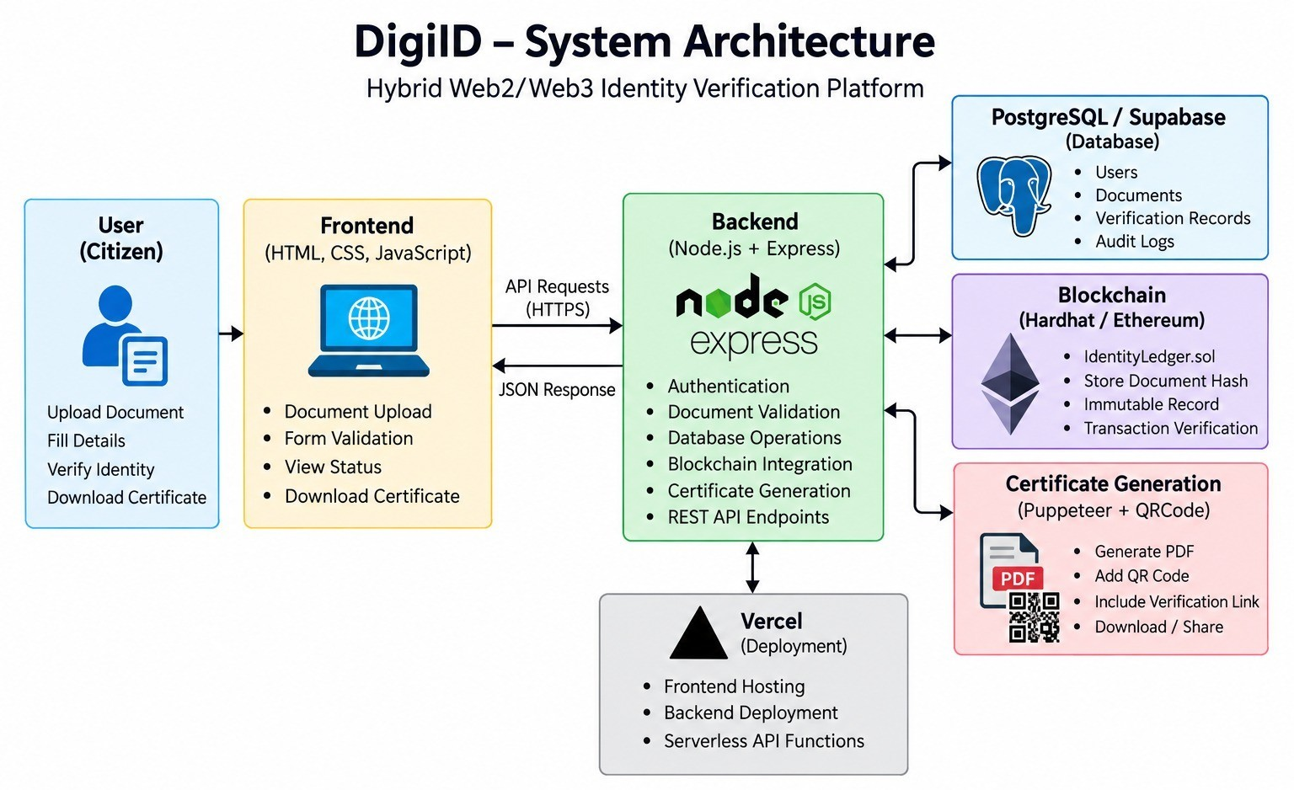
Figure 4.1: System Architecture of DigiID
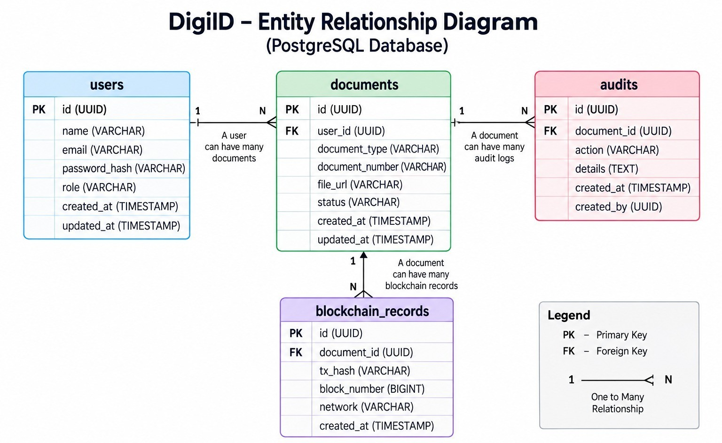
Figure 4.2: Entity-Relationship Diagram of DigiID Database

globally.

- State Mapping: A cryptographic mapping links the SHA-256 document hash to a struct containing the issuance timestamp, validity status, and revocation reason code.
- Access Modifiers: Strict OnlyOwner modifiers restrict state-altering write operations (such as anchor-

ing new hashes or revoking existing ones) solely to the authorized deployer address.

- Duplicate Prevention: The contract logic utilizes require() statements to completely prevent the anchoring of duplicate hashes, reverting any conflicting transactions automatically and saving gas fees.

Admin Dashboard Interface Design

The administrative dashboard is visually structured to offer immediate situational awareness to system operators. It displays core aggregate metrics—including total registered records, verified credentials, pending items, and revocation counts. Crucially, it features a live blockchain monitoring module that displays the active contract address, block height, recent transaction hashes, anchor timestamps, and overall RPC connection health.

Unified Modeling Language (UML) Diagrams

To thoroughly map the system’s behavior and actor interactions, several UML diagrams were constructed.

Use Case Diagram

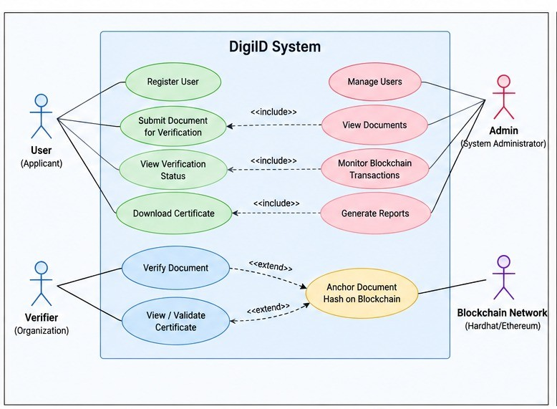
The Use Case diagram defines the interactions between external actors (Citizens, Super Admin, Blockchain Ledger) and the system processes (Registration, Verification, Revocation).
Figure 4.3: Use Case Diagram of the DigiID System

Sequence Diagram (Verification Flow)

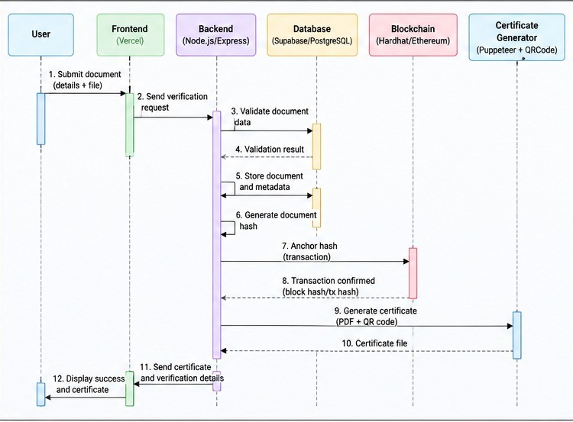
The Sequence Diagram maps the chronological order of API calls during document verification, tracing the request from the Client Browser → Express API → Smart Contract → JSON Response.
Figure 4.4: Sequence Diagram representing the Document Verification Flow

Activity Diagram

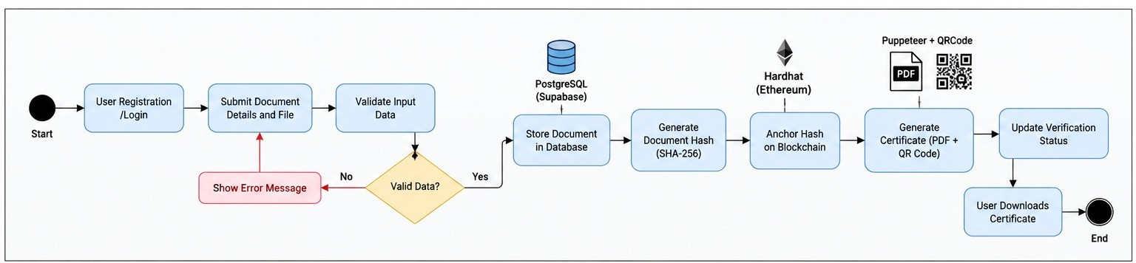
The Activity diagram models the branching logic of the registration pipeline, specifically highlighting the decision nodes where a document is either accepted for hashing or rejected due to malformed input.
Figure 4.5: Activity Diagram of Document Registration and Anchoring

Security Architecture and Threat Modeling

The architecture of DigiID was subjected to rigorous threat modeling to ensure it satisfies the CIA Triad (Confidentiality, Integrity, Availability) within a decentralized context.

The CIA Triad Implementation

      - Confidentiality: Protected via hashing. Since only the SHA-256 digital fingerprint is anchored to the blockchain, public ledger observers cannot reverse-engineer the hash to obtain the citizen’s original details.
      - Integrity: Enforced by the IdentityLedger smart contract. Once a hash is mined into an Ethereum block, altering it would require an attacker to expend insurmountable computational energy to rewrite the blockchain history.
      - Availability: Achieved via the decentralized nature of the Ethereum network and the serverless horizontal scaling of Vercel for the backend API.

Mitigation of Common Attack Vectors

The hybrid design intentionally neutralizes standard Web2 and Web3 attack surfaces:

      - SQL Injection (SQLi): All PostgreSQL transactions executed by the Express backend utilize strict parameterized queries, preventing malicious payloads from manipulating the database schema.
      - Cross-Site Scripting (XSS): Input sanitization libraries strip HTML tags from all user inputs before they are rendered into the PDF certificate by Puppeteer, neutralizing client-side script execution.
      - 51% Attacks and Smart Contract Exploits: While local Hardhat testing simulates consensus, the OnlyOwner access control modifier in the Solidity contract prevents unauthorized wallets from anchoring or revoking hashes, rendering external ledger manipulation impossible even if an attacker attempts to spoof transactions.

Chapter 5

Methodology

Agile Development and Iterative Lifecycle

The development of DigiID followed an iterative Agile methodology, allowing for continuous integration and testing of Web3 components alongside standard Web2 backend routes. This approach was critical due to the inherent complexity of managing state synchronization between a fast relational database and a slower, block-based Ethereum ledger. The project was broken down into two-week development sprints focusing sequentially on frontend validation, backend REST API development, smart contract deployment, and finally, integration testing.

Deterministic Cryptographic Hashing Pipeline

To ensure zero-knowledge verification, the system relies on the SHA-256 cryptographic hashing algorithm. The methodology for creating the digital fingerprint is strictly deterministic, guaranteeing that the same physical document always produces the same digital proof:
    - Data Ingestion: The system receives raw identity parameters (e.g., Name, Document Type, Document Number, Date of Birth) via a secured HTTPS POST request.
    - Normalization: The algorithm aggressively normalizes the input by converting all text to lowercase, trimming leading and trailing whitespace, removing hyphens or special characters, and converting dates to a standardized ISO-8601 format.
    - Concatenation: The normalized fields are concatenated into a single, predictable string.

    - Hash Generation: The concatenated string is passed through the Node.js Crypto module using the SHA-256 algorithm. Because the input is perfectly normalized, the same identity will mathematically always produce the exact same 256-bit hash. Even a microscopic change in the input (such as a single changed character) yields a completely different output, making forgery impossible.

Mathematical Foundation of SHA-256

The integrity of the DigiID platform relies entirely on the Secure Hash Algorithm 256-bit (SHA-256). It is crucial to understand the cryptographic properties that make this algorithm suitable for decentralized identity verification.
SHA-256 operates on data blocks of 512 bits and processes them through 64 rounds of cryptographic operations. The methodology relies on the following core properties:
- Pre-image Resistance: Given a hash output Hx, it is computationally infeasible to determine the original input x (the user’s identity details). This guarantees zero-knowledge privacy on the blockchain, as the raw identity can never be reverse-engineered from the hash.
- Second Pre-image Resistance: Given an input x₁, it is computationally infeasible to find a different input x₂ such that Hx₁ = Hx₂.
- Collision Resistance: It is mathematically improbable to find any two distinct inputs x₁ and x₂ that produce the exact same hash output.
During normalization, the system concatenates the identity string and applies the Merkle-Damga˚rd construction inherent to SHA-256. The deterministic nature of the bitwise operations (AND, XOR, ROTR, SHR) ensures that an authentic document presented years later will effortlessly regenerate the exact 64-character hexadecimal string stored on the Ethereum ledger, proving authenticity instantly.

End-to-End Registration and Anchoring Workflow

The core operational lifecycle follows a structured progression to ensure data is handled safely before touching the blockchain:
- Validation: The backend API validates the format using Regular Expressions (Regex) to ensure only mathematically valid document numbers proceed.
- Ledger Anchoring: The backend signs a transaction using its securely stored private key via Ethers.js, pushing the cryptographic hash to the local Hardhat Ethereum node.
- Database Persistence: Upon receiving a successful transaction receipt from the blockchain (confirming the block was mined), the relational metadata and the on-chain transaction hash are committed to the Supabase PostgreSQL database.

- Certificate Generation: Puppeteer dynamically compiles an HTML template into a secure PDF certificate, containing a scannable Base64 QR code linked to the live verification endpoint, which is then returned to the client as a buffer stream.

Automated Testing Strategy and State Consistency

DigiID implements a highly rigorous, executable-oriented testing methodology designed to validate system behavior across all architectural boundaries. Tests execute in a strict sequential hierarchy:
- Static code inspection and Unit validation.

- Smart contract execution and gas optimization tests via Hardhat Chai Matchers.

- Backend API integration and Database persistence checks using Jest and Supertest.

- Consistency Checks: Specialized integration tests intentionally trigger database rollbacks if the blockchain transaction fails. This ensures that the system never suffers from silent divergence where a document exists in PostgreSQL but lacks an on-chain proof.
Test outcomes are strictly categorized as PASS, FAIL, BLOCKED, NOT RUN, or SKIPPED, ensuring unverified code paths are never falsely reported as successful.

Correction and Versioning Methodology

To maintain historical accountability, the system explicitly rejects destructive database overwrites (e.g., standard SQL UPDATE commands on critical identity fields). When an administrator initiates a correction, a mandatory reason must be provided. The methodology involves invalidating the prior record hash on-chain, instantiating a new version node off-chain, generating a refreshed cryptographic fingerprint, anchoring the new hash, and committing a comprehensive audit trail event linking the old and new versions together in the database.

Chapter 6

Implementation and Codebase Architecture

Repository and Directory Structure

The DigiID repository is structured as a modular monorepo, strictly separating the frontend client, the Express backend, and the Hardhat blockchain environment. This separation ensures that heavy Web3 dependencies do not bloat the serverless Web2 API deployment on Vercel.
DigiID/
blockchain/ # Hardhat Environment contracts/
IdentityLedger.sol # Core Solidity Smart Contract scripts/
deploy.js # Contract deployment script hardhat.config.js # Network & RPC configuration
backend/ # Node.js & Express API controllers/
authController.js documentController.js
utils/
hasher.js # SHA-256 normalization logic pdfGenerator.js # Puppeteer & QRCode logic
routes/
api.js # Express REST endpoints
server.js # Entry point for Vercel deployment frontend/ # HTML, CSS, Vanilla JS Client
admin-dashboard.html

Technology Stack and Environment Setup

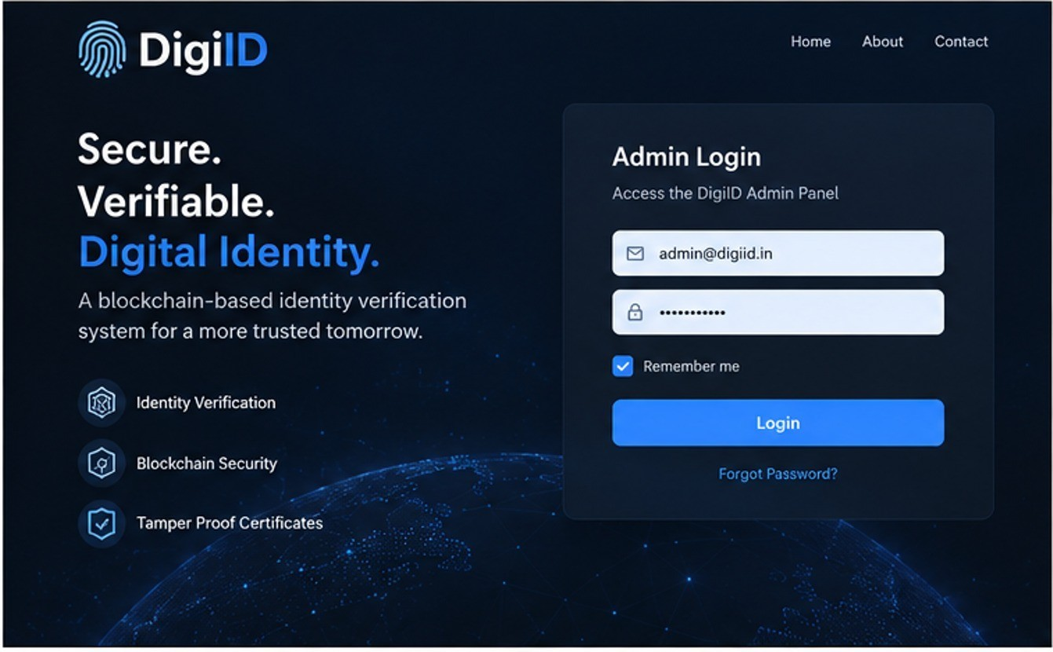
The implementation of DigiID relies on modern JavaScript ecosystems. The frontend views are constructed utilizing HTML, CSS, and Vanilla JavaScript to ensure lightweight delivery without the overhead of heavy SPA frameworks. The backend RESTful APIs are written in Express on Node.js and configured for serverless execution on Vercel. Blockchain transactions are routed to the Ethereum network via a JSON-RPC endpoint utilizing the Ethers.js library.
Figure 6.1: Admin Panel Secure Login Interface

Smart Contract Implementation

The core decentralized logic is housed within IdentityLedger.sol. The contract is written in Solidity and utilizes internal counters and mappings to track document states without storing raw personal data on-chain.

Code Snippet 6.1: Solidity Smart Contract (IdentityLedger.sol)

pragma solidity ^0.8.0;

contract IdentityLedger { address public admin;
uint256 public totalAnchored; uint256 public totalActive;

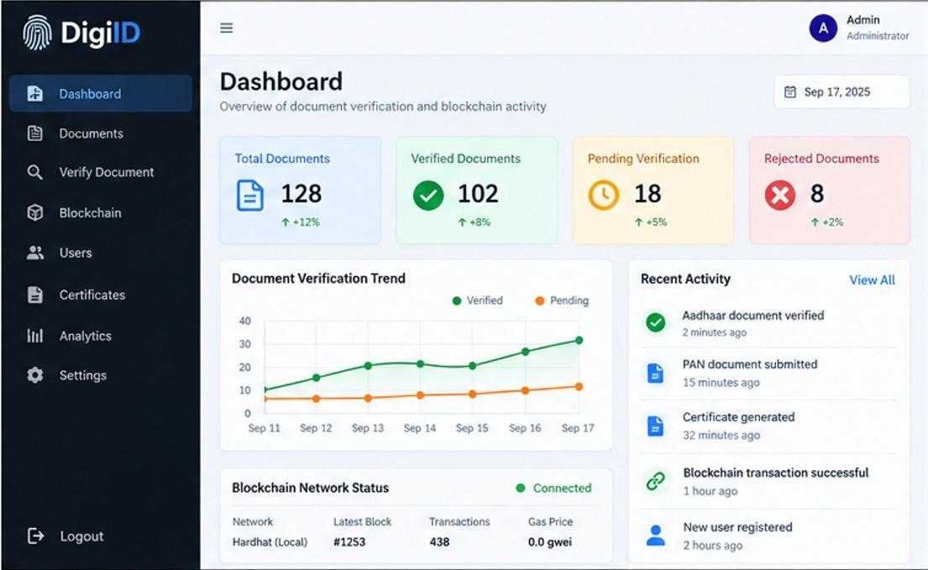
Figure 6.2: Admin Dashboard Showing Document Metrics and Blockchain Monitoring

struct DocumentRecord { uint256 timestamp; bool isActive;
string revocationReason;
}

// Maps SHA-256 Hash to Document Record mapping(string => DocumentRecord) private ledger;

modifier onlyAdmin() {
require(msg.sender == admin, "Unauthorized: Admin only");
_;
}

function anchorDocument(string memory docHash) public onlyAdmin { require(ledger[docHash].timestamp == 0, "Hash already anchored");

ledger[docHash] = DocumentRecord({ timestamp: block.timestamp,

isActive: true, revocationReason: ""
});

totalAnchored++; totalActive++;
}
}

Backend API and Cryptographic Hashing

The Node.js backend handles the critical task of deterministic hashing. When a user submits an identity document, the hasher.js utility normalizes the input to ensure consistent output.

Code Snippet 6.2: Deterministic Hashing Pipeline (hasher.js)

const crypto = require(’crypto’);

function generateDeterministicHash(documentData) {
// 1. Normalize input (lowercase, trim whitespace)
const normalizedNumber = documentData.idNumber.toLowerCase().trim(); const normalizedName = documentData.fullName.toLowerCase().trim();

// 2. Concatenate with strict formatting
const rawString = ‘${normalizedNumber}|${normalizedName}‘;

// 3. Generate SHA-256 Hash
const hash = crypto.createHash(’sha256’)
.update(rawString)
.digest(’hex’);

return ‘0x${hash}‘;
}

Certificate and QR Code Generation Logic

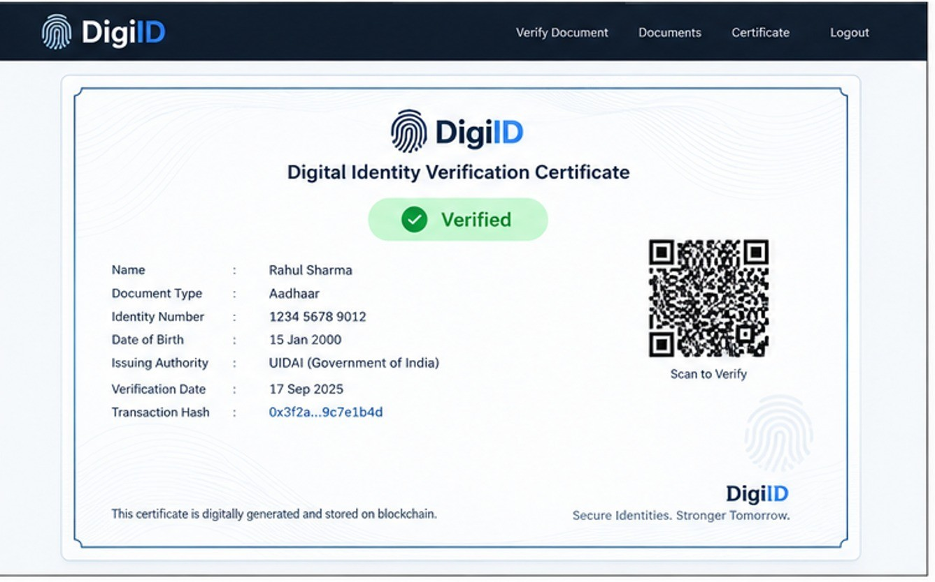
The certificate generation service acts as a microservice utilizing Puppeteer. Upon successful registration, the backend populates an EJS-style HTML template with the user’s masked identity data. The QRCode library generates a Base64-encoded matrix barcode containing the specific URL endpoint for that document’s verification page. Puppeteer then launches a headless instance of Chromium, renders the HTML along with the embedded QR code, and exports it as a high-fidelity PDF buffer, which is streamed back to the user for download.
Figure 6.3: Successfully Verified Document with Generated Certificate and QR Code

Blockchain Integration and Transaction Mining

The blockchain integration relies heavily on the ethers.Wallet and ethers.Contract classes. When a document hash is prepared by the backend API, a state-altering transaction is signed using the server’s private key and broadcasted to the local Ethereum network managed by Hardhat. The Node.js server awaits the transaction receipt to confirm block mining, capturing the unique Transaction Hash (txHash), Gas Utilization, and Block Number for cross-referencing in the PostgreSQL database.

Code Snippet 6.3: Anchoring to Ethereum via Ethers.js

const { ethers } = require("ethers");
const provider = new ethers.providers.JsonRpcProvider(process.env.RPC_URL);

const wallet = new ethers.Wallet(process.env.PRIVATE_KEY, provider); const contract = new ethers.Contract(CONTRACT_ADDRESS, ABI, wallet);

async function anchorToBlockchain(docHash) { try {
const tx = await contract.anchorDocument(docHash);
const receipt = await tx.wait(); // Wait for block mining return receipt.transactionHash;
} catch (error) {
throw new Error("Blockchain anchoring failed");
}
}
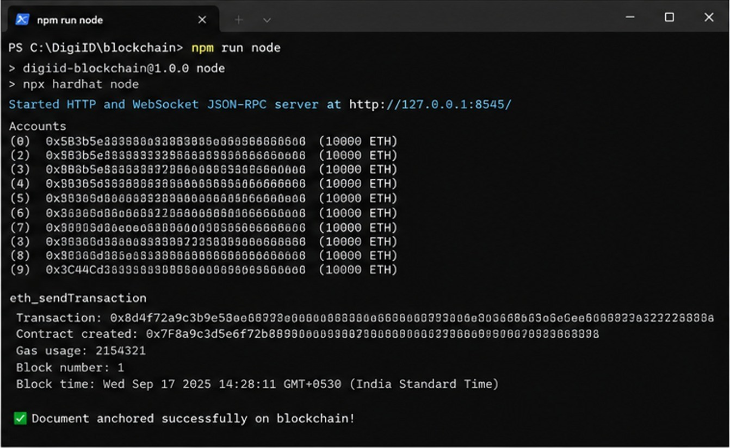
Figure 6.4: Hardhat Terminal Showing Successful Transaction (Block Mining)

Audit Logging and Security Sanitization

The audit subsystem is implemented as an asynchronous middleware function in Express. It captures sensitive actions without storing raw secrets. Logged events include ADMIN LOGIN, DOCUMENT VIEWED, DOCUMENT VERIFIED, DOCUMENT REVOKED, and DOCUMENT CORRECTED. The architecture utilizes Post-greSQL triggers and foreign-key constraints to ensure standard administrative actions cannot silently alter or

delete this audit history.
Furthermore, user inputs are aggressively sanitized using libraries like validator.js and HTML entities are escaped during PDF generation to prevent Cross-Site Scripting (XSS). Database interactions rely exclusively on parameterized queries to neutralize SQL injection vectors.

Smart Contract Gas Optimization Strategies

In Ethereum Virtual Machine (EVM) architecture, every computational step requires a transaction fee known as ”Gas”. DigiID’s smart contract was heavily optimized to minimize these operational costs:
- Variable Packing: State variables inside the DocumentRecord struct (such as the bool isActive
and uint256 timestamp) were ordered to ensure they pack efficiently into 32-byte storage slots.

- Mapping over Arrays: The contract exclusively uses a mapping(string => DocumentRecord) rather than iterating through an array to find documents. Mappings require exactly one storage read operation (O1 time complexity), which drastically reduces gas consumption during verification lookups.
- Revert Logic: The require() statements checking for unauthorized access or duplicate hashes are placed at the absolute beginning of the function execution. If an invalid transaction is submitted, the transaction reverts immediately, returning unspent gas to the sender.

System Deployment and Administrator Guide

In academic software engineering, ensuring reproducibility is paramount. Therefore, this section outlines both the localized testing environment used during development and the live cloud architecture utilized for the production deployment.

Local Development Environment (Reproducibility)

The local environment acts as an isolated sandbox, ensuring that developmental tests and academic reviews do not pollute the live production database.
      - Install Dependencies: Execute npm install in both the /backend and /blockchain directories.

      - Initialize Local Blockchain: Start the Hardhat local Ethereum node using:
npx hardhat node

      - Deploy Smart Contract: Compile and deploy the Solidity contract to the local RPC network:
npx hardhat run scripts/deploy.js --network localhost

      - Launch Backend Server: Start the Express.js API server using:
npm run dev

Production Cloud Deployment (Vercel & Supabase)

For the live production environment, the hybrid Web2/Web3 architecture is deployed using Vercel and Supabase.
- Serverless Hosting (Vercel): The Express.js backend is deployed to Vercel as serverless functions. A vercel.json configuration file routes all incoming HTTPS traffic to the central server.js endpoint, allowing the API to scale automatically based on verification traffic.
- Managed Database (Supabase): The relational data layer is hosted on Supabase, an open-source PostgreSQL provider. Connection pooling is utilized via the @vercel/functions adapter and POSTGRES URL environment variables to prevent database connection exhaustion during peak serverless API invocations.
- Environment Variable Security: Critical secrets—including the JWT SECRET, the Ethereum PRIVATE KEY for signing transactions, and the RPC URL—are injected securely through the Vercel deployment dash-board. They are never committed to the GitHub repository.

Administrator Operations Manual

Once deployed, the Super Admin navigates to the secured portal at /admin. Upon authenticating with a valid email and password, the server issues a JSON Web Token (JWT) granting access to the dashboard. From here, the administrator can visually monitor real-time block mining, search for specific document hashes, and execute a ”Revoke” command. Executing a revocation prompts a mandatory modal requiring a typed reason, which then triggers a state-changing transaction on the blockchain and logs a permanent entry in the PostgreSQL Audits table.

Software Testing and Quality Assurance

Based on the executable-oriented testing specification, a comprehensive suite of automated and manual test cases was executed. Table 6.1 outlines the critical test scenarios, their expected outcomes, and final statuses.

Table 6.1: Comprehensive Test Cases and Results

Test ID | Description | Expected Result | Status
VAL-001 | Submit valid 12-digit national ID. | System accepts and routes to hasher. | PASS
VAL-002 | Submit malformed ID format. | System rejects input with valida-tion error. | PASS
CONS-001 | Anchor hash to blockchain success-fully. | Database and Blockchain states match perfectly. | PASS
CONS-002 | Simulate Blockchain RPC failure during anchoring. | Database rolls back; no silent di-vergence occurs. | PASS
SEC-001 | Attempt Admin Panel access with-out JWT token. | HTTP 401 Unauthorized access denied. | PASS
SEC-002 | Attempt SQL Injection via docu-ment search field. | Parameterized query neutralizes malicious string. | PASS
CERT-001 | Generate PDF Certificate for valid record. | PDF generated with embedded QR code. | PASS
CERT-002 | Scan QR Code from valid certificate. | Routes to live verification show-ing matching hash. | PASS
AUD-001 | Administrator revokes active docu-ment. | Record marked revoked; reason logged in Audits. | PASS
AUD-002 | Administrator views masked PII. | PII revealed temporarily; event logged permanently. | PASS

Conclusion
The DigiID project successfully defines, architects, and implements a highly robust framework for a hybrid Web2/Web3 identity verification system. By elegantly integrating a fast Node.js/Express backend and a scalable PostgreSQL/Supabase database with a cryptographic Solidity smart contract, the application securely processes, hashes, and anchors government-issued documents without compromising user privacy.
The system directly addresses the inherent vulnerabilities of centralized databases by ensuring that raw identity information is never stored on the public blockchain, acting strictly as an immutable integrity witness. The integration of deterministic SHA-256 hashing guarantees that any unauthorized alteration of off-chain data instantly results in a cryptographic mismatch during verification.
Furthermore, the system’s integrity is actively maintained by a sophisticated Admin Panel that enforces server-side authentication, default PII masking, and comprehensive audit logging. The automated generation of QR-code embedded PDF certificates bridges the physical and digital divide, offering end-users a highly accessible method of proof. Ultimately, the project’s strict automated testing specification guarantees that the database records and blockchain ledgers maintain absolute synchronization throughout the entire identity lifecycle, proving that decentralized technologies can be practically integrated into modern administrative workflows.

Future Work
While the current iteration of DigiID establishes a robust foundational architecture for decentralized identity verification, several avenues for advanced research and enterprise-scale development remain.

AI-Driven Optical Character Recognition (OCR)

Currently, document registration requires an administrator to manually input identity details into the dashboard. A highly critical future enhancement involves integrating an AI-driven Optical Character Recognition (OCR) pipeline (such as Tesseract.js or Google Cloud Vision API). This would allow administrators to simply scan or upload a physical ID card. The AI would automatically extract the text, validate the formatting, and pass it directly to the deterministic hashing function, eliminating human data-entry errors and exponentially increasing registration throughput.

Integration of Zero-Knowledge Proofs (zk-SNARKs)

While the current system utilizes deterministic SHA-256 hashing to mask identity data on the blockchain, future development aims to integrate advanced cryptographic protocols like zk-SNARKs (Zero-Knowledge Succinct Non-Interactive Arguments of Knowledge). zk-SNARKs would allow a user to mathematically prove a specific subset claim (e.g., ”I am over 18 years old” or ”I am a resident of Gujarat”) to a third-party verifier without ever revealing their actual date of birth, home address, or complete identity hash, dramatically enhancing granular user privacy.

Mainnet Migration and Layer-2 Scaling

The current system relies on a localized Hardhat Ethereum network for rapid development and zero-cost testing. The logical next step in the project’s lifecycle is transitioning the IdentityLedger.sol smart contracts to a public Ethereum testnet (such as Sepolia) and eventually to a Layer-2 scaling solution like Polygon or Arbitrum. Layer-2 networks utilize optimistic or ZK-rollups to bundle thousands of transactions off-chain before committing them to Ethereum, which would allow DigiID to anchor millions of citizen records globally while keeping gas costs fractions of a cent per transaction.

CHAPTER 8. FUTURE WORK

Mobile Wallet Application and DID Standards

To transition from a web-only platform to a ubiquitous citizen utility, future work includes developing a cross-platform mobile application utilizing React Native or Flutter. This application would act as a secure digital wallet, allowing citizens to store their verified DigiID credentials offline on their mobile devices. Furthermore, the architecture should be upgraded to strictly comply with the World Wide Web Consortium’s (W3C) Decentralized Identifiers (DIDs) v1.0 standard, ensuring that DigiID certificates are globally interoperable with other international e-governance systems.

Advanced Role-Based Access Control (RBAC)

Currently, the Admin Panel relies on a single, fixed Super Admin account for all privileged operations. Future iterations of the system will implement granular multi-administrator management interfaces. This will include an administrative invitation workflow, multi-signature approval requirements (e.g., requiring two separate administrative accounts to approve the mass revocation of documents), and strict Role-Based Access Control (RBAC) separating view-only compliance auditors from active system operators.

Chapter 9

Research Paper or Survey Paper and Plagiarism Report

Paper

The research paper titled “DigiID: A Secure and Decentralized Framework for Digital Identity Verification” has been authored by the project team and submitted separately as per the submission guidelines.

Plagiarism and AI Detection Reports

The research paper was formally evaluated using the iThenticate verification system. The Integrity Overview report confirms a 0% Overall Similarity score, indicating no plagiarism. Additionally, the AI Writing Overview assessment report is attached for complete transparency.

DigiID | Research Paper

DigiID: A Secure and Decentralized Framework for Digital Identity Verification
Parth Joshi, Tanmaya Bhanja, Ahmad Ayan Javed, Yash Joshi
Department of Computer Science and Engineering, Parul University Guide: Prof. Rina Kumari
ABSTRACT - DigiID is an identity verification system that is designed to make it easy to manage, verify, and protect against any alteration from within of the identities' information. Identities' information is stored in a database and a digital fingerprint is generated permanently to be used for verification purpose. Access to verification page can be done using a certificate that contains a QR code. There is a dedicated administrative panel where authorized personnel can conduct searches, verify records, revoke identities for valid reasons, fix identities, and maintain record history. The scope of the project testing includes validation of data, fingerprints, application services, database actions, blockchain records, certificates, user interfaces, security, concurrency, full user journey, and regression. However, the project documents did not include any test report and performance metrics. This paper examines the design approach used, the method and the evaluation process.
Index Terms —digital identity, identity verification, blockchain, digital certificate,QR verification, privacy,audit,trail,testing.

INTRODUCTION
Digital identity verification is now a crucial part in verifying a person's identity. Some qualities of a good verification process include proper storing of data, clarity in verification, safeguarding of sensitive information, and a record of changes to the data. In many of the existing solutions, a whole copy of an identity record is placed into one database. This approach is very convenient for practical purposes, however, it is rather trusting to both the database itself and to the software controlling it. DigiID keeps the live identity in normal storage but makes its digital signature from identity data. This digital signature becomes evidence for the future authentication process. The real identity data is not present in the public verification data.
It consists of record management practices that include consistency checks. The certificate forms part of the verification system, containing an identifier and QR code, indicating the user the place of verification of his or her identity. The administrative side of the system allows the staff to verify, search, revoke, modify, audit, and monitor the records. This paper discusses the problem solved by the DigiID, design, process, testing, controls, and limitation of evidence presented.

PROBLEM STATEMENT AND OBJECTIVES
The main concern is whether the document to be validated continues to maintain its acceptance status during the validation process. There must be an obligation to correct the errors without manipulating the history of the document.
DigiID separates regular record storage from the validation process. It uses the database to handle the administrative part. The fixed digital signature that is based on the normalized identity information acts as the basis for comparison. The application provides a procedure to submit data
1

regarding identity along with request for verification of the same. The identity is validated, its fingerprint is generated, the record of this fingerprint is maintained, a certificate issued with the QR-enabled validation path and administration options provided for managing these records. No fake success messages, including those that state registration is complete even when some errors exist or there is a contradiction between the stored identity record and the anchored proof, should be present.

PROJECT CONTEXT AND EXISTING APPROACH
DigiID is a hybrid system that includes regular record keeping as well as the verification feature. The database holds actual records whereas the ledger makes sure that there has been no meddling with the record. The DigiID keeps the identity records independent of each other and uses the ledger to verify them.
A traditional database is sufficient to handle normal administrative tasks like search, edit, filter, and review. None of these functions, when conducted on blockchain, would be efficient. Hence, DigiID uses traditional storage for regular data handling, and blockchain for validation purposes only.
An old version of a certificate can be used in case of the print-out/downloaded certificate, which is why the verification page verifies the current certificate status against its anchored status. The QR code links the readable certificate to the verification process.
Actions performed administratively have a specific life cycle as well. Revocation has reasons and times recorded, while correction employs the version history. The extensive testing involves checking for normal behaviour, invalid data , system errors , security errors , privacy threats , and regression testing .
DigiID | Research Paper

PROPOSED SYSTEM
*Overall Design.* DigiID manages the user interface , application processing , record storage , proof anchoring, issuance of certificates,a dn administration . the application processes the input, generates the digital hash, records the working records , anchors the proof
,and issues the certificate.
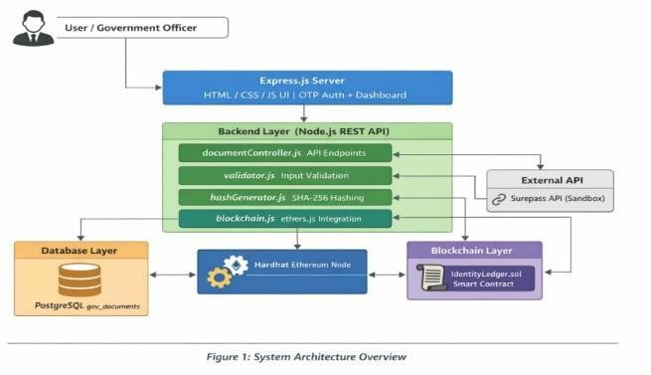
Figure 1. Overall system architecture
*Trust Separation*. The identity information is stored in the regular layer of storage, but proof is stored in the blockchain. Thus, personal information cannot be included into the public record of verification, and the blockchain gets its distinct role as a witness to integrity.
*Administration.* In the secure Admin Panel, the designated staff have the ability to search for records using the certificate data, identity number, name, document type, date, status, or transaction data. The administration team is able to check, invalidate with an explanation, edit via the version history, show the certificate data, watch the proof network, analyze activities, and create reports.
*Privacy and Safety.* the web browser does not get the private keys , database access credentials or any other sensitive information from the server side. Public verification will disclose only the required information to determine the status of the record .

2

Accessing the sensitive information will be controlled and documented .The project needs to use dummy information rather than the identity documents.

METHODOLOGY
*Validation.* Before processing , identity details are validated . Validation tests include valid/invalid formats for Aadhaar , PAN and Votes ID , along with no names ,no identity numbers,wrong dates, unrecognized document types , special characters.
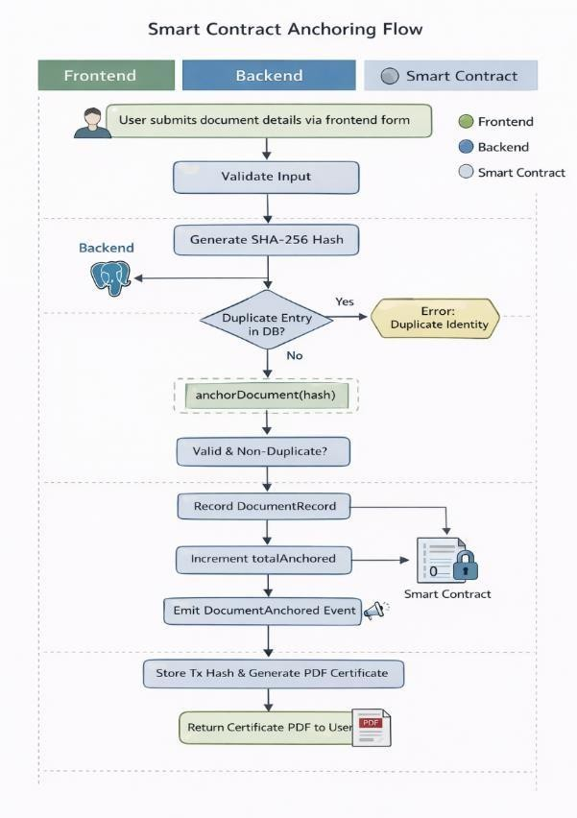
Figure 2. Smart contract anchoring workflow
*Digital Fingerprint.* Deterministic fingerprints are created based on the normalized identity information. The identity information that changes significantly will result in a new fingerprint, including spaces, hyphens, case sensitivity, null values, and Unicode characters.
*Automated Testing Process.* This sequential process involves testing the implementation, individual components, proofs, applications, databases, certificates, UIs, full user experiences, security, and regression. Integration
DigiID | Research Paper
testing proceeds only when required services are available; otherwise, affected tests are marked BLOCKED.
*Test-Case Lifecycle* Every test needs an identification number, component under testing, conditions, input, expected results, actual results, status, and supporting documentation.

SYSTEM WORKFLOW
The user flow starts with logging in and accessing the dashboard. User chooses the document type and inputs his/her identity information. In case of success, the user receives his/her identity fingerprint, record and proof preparation, and certification.
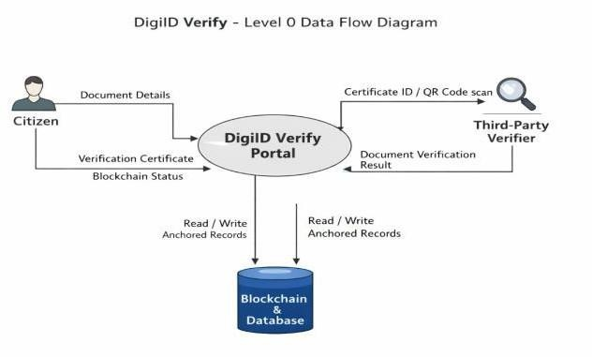
Figure 3. Level-0 data flow diagram
The QR code opens the verification route, where the application retrieves the record and checks its proof state. The response reflects the actual state of the record. Failure cases are also handled; an unavailable proof service or database failure will report an incomplete operation.
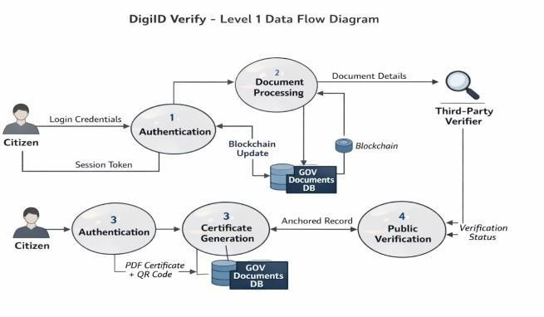
Figure 4. Level-1 data flow diagram

3

DATA, CONSISTENCY, AND ADMINISTRATION
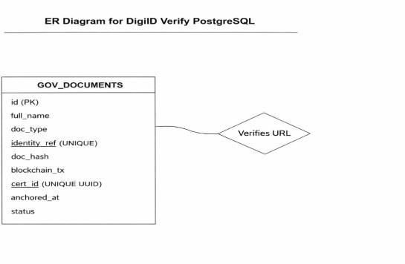
Figure 5. DigiID PostgreSQL entity–relationship diagram
*Database and Proof Consistency.* The fingerprint contained in the record should be consistent with the fingerprint that is anchored for proof. Failure to meet these requirements is considered an integrity issue. The tests verify proof failure, storage failure after successful proof, modifications after anchoring, retracted records, and missing records.

*Administrative Lifecycle.* The states of a record can include active, verified, revoked, or corrected. In revocation, one needs to provide identity of administrator, record, reason, time, state before the revocation, new state after the revocation, and proof transaction details. In case of correction, the previous record is maintained,the previous proof is handled , anew record is created , a new fingerprint is computed, and proof is anchored.
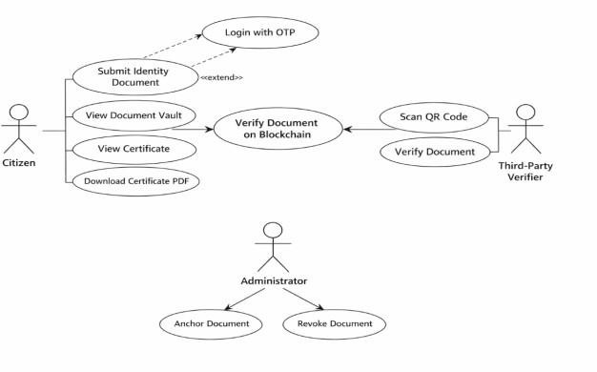
Figure 6. DigiID use-case diagram
*Audit and Reporting*. Events recorded include login, logout, search, verify, revoke, correction, access to certificates, sensitive
DigiID | Research Paper
data exposure, proving operations, and configuration change.
*Monitoring and Alerts.* The Admin Panel displays registration counts, active and revoked records, document-type statistics, recent activity, proof statistics, and service health. Alerts trigger for proof failures, database failures, application failures, repeated failed logins, revocations, and configuration problems.

TESTING AND EVALUATION
Testing activities include Data validation, Fingerprinting, Application services, Storage, Proof of record, Integration, Certificates, User Interfaces, End-to-end user experience, Security testing, Unusual input, Concurrency, and Regression Testing. Security testing activities focus on unsafe input, unauthorized access, exposed secrets, exposed sensitive values, loose network policies, and malformed requests.
Concurrency testing guarantees that duplicate registrations and actions cannot create multiple valid entries. The steps for regression testing are recreating a defect, creating a test case, making the approved changes, and re-running the affected tests.
Application service tests involve testing of creation, missing document types, duplicates, unknown identities, wrong identity, update, and delete. The system should respond with error messages where necessary to avoid data corruption and keep consistency between identity record and the evidence for it.
Database tests conduct valid insert, duplicate, failure storage, and unsafe input test individually. Proof record tests test creation, ownership, access control, verification, revocation, and zero address testing. Integration tests ensure that the application can deal with non-existing proof service without getting a wrong success message.

4

Certificate validation tests include generation, unknown entities, QR content, identifier masking, and PDF validation.
User interface validation tests cover login activity, validation, document choice, mobile usability, network errors, and clear error messages. Administrative validation tests include privilege boundaries, searches, filters, revocation with explanation, corrections, audit activities, reporting, and health information.
Defect report contains the error message, technical data , location , reproduction process, severity, and the recommended fix for the problem.The assessment analyzes the repository, test files, service paths,databse design, proof recording logic, and testing tools.

TEST REPORTING AND COMPLETION CRITERIA
Requirements include attempting current tests, adding relevant tests, performing test sets, capturing blockages, noting security issues, ensuring consistency, and testing access controls. The final report captures the total number of tests attempted, number of statuses, severity of issues, build status, and critical recommendations.

RESULTS AND DISCUSSION
Qualitative evaluation can be done on the basis of project material, but there is no testing report available. This report cannot provide any information regarding performance, transaction cost, or security score.
The usual identity document is recorded in the database, the digital fingerprint creates a distinct integrity proof, the certificate gives the user an authentication name, and the Admin Panel takes care of the life cycle management. The link between these components lies in the explicit consistency tests. The testing strategy considers failure
5
DigiID | Research Paper
conditions along with success cases, including service unavailability and storage failure after anchoring.
The certificate then guides the user towards the path of verification by validating the stored data and the state of proof without adding the whole identity to the proof record publicly. The test plan provides links between the technical aspects and the operational aspects where, for instance, an unsuccessful proof transaction will affect the registration process.
    - LIMITATIONS
Since there is no executed test report provided, the entire system failed to pass the test plan. The system requires support from other services to manage storage, transaction proofs, and certificate generation. Full execution is based on the chosen test environment. The present administrative design makes use of only one Super Admin and no multiple administrators' interface.
    - FUTURE WORK
The subsequent step involves executing the entire test plan within an organized environment and documenting evidence for functional behavior, security results, proof validity, and concurrency. Performance measures like verification time, throughput, and transaction latencies must be obtained.
Additional security-related research may include the independent verification of data-exposure vulnerabilities, the handling of secrets, and the recovery process for failed proof operations. Research on future recovery and reconciliation mechanisms for partial failures, along with expanding the administrative framework to incorporate role-based access and invitations, is also possible.
    - CONCLUSION
DigiID incorporates traditional record management with the concept of a continuous

DigiID | Research Paper
proof of identity state. Identity data is stored in regular storage, but a deterministic digital fingerprint can be used as a reference for further verification purposes. Certificate and QR codes make the process available to users without being a source of truth itself.
These records can be searched, checked, cancelled, corrected, audited, and monitored without loss of change history. Separation of the identity information and the proof cuts down the requirement to put the whole of personal information into the public domain.
Testing includes validation, fingerprinting, application services, databases, proof evidence, certificates, interfaces, security, concurrent testing, integration, end-to-end journeys, and regression testing. As the information does not provide any executed test report, this paper outlines the plan for testing and its evaluation. Next step is to conduct tests, gather evidence and assess the system in order to identify the strengths of DigiID and weaknesses that still exist.

REFERENCES
- DigiID project materials, “DigiID — Automated Testing Specification for
Antigravity,” supplied project documentation.
- DigiID paper draft supplied by the authors, used as the writing and content baseline.

6


Page 1 of 9 - Cover Page Submission ID trn:oid:::3117:629484810

PARTH JOSHI

Blockchain-Based Identity Verification
 Parul University

Document Details

Submission ID trn:oid:::3117:629484810

7 Pages

2,150 Words

13,261 Characters
Submission Date
Sep 25, 2026, 8:38 AM GMT+5:30

Download Date
Sep 25, 2026, 8:43 AM GMT+5:30

File Name Research_Paper_ .pdf
File Size
316.9 KB

Page 1 of 9 - Cover Page Submission ID trn:oid:::3117:629484810

Page 2 of 9 - AI Writing Overview Submission ID trn:oid:::3117:629484810

*% detected as AI

Caution: Review required.
It is essential to understand the limitations of AI detection before making decisions about a student’s work. We encourage you to learn more about Turnitin’s AI detection capabilities before using the tool.
AI detection includes the possibility of false positives. Although some text in this submission is likely AI generated, scores below the 20% threshold are not surfaced because they have a higher likelihood of false positives.

Disclaimer
Our AI writing assessment is designed to help educators identify text that might be prepared by a generative AI tool. Our AI writing assessment may not always be accurate (it may misidentify writing that is likely human generated as AI generated and likely AI generated as human generated) so it should not be used as the sole basis for adverse actions against a student. It takes further scrutiny and human judgment in conjunction with an organization's application of its specific academic policies to determine whether any academic misconduct has occurred.

Page 2 of 9 - AI Writing Overview Submission ID trn:oid:::3117:629484810

Page 1 of 10 - Cover Page Submission ID trn:oid:::3117:629484810

PARTH JOSHI

Blockchain-Based Identity Verification
Parul University

Document Details

Submission ID trn:oid:::3117:629484810

7 Pages

2,150 Words

13,261 Characters
Submission Date
Sep 25, 2026, 8:38 AM GMT+5:30

Download Date
Sep 25, 2026, 8:43 AM GMT+5:30

File Name Research_Paper_ .pdf
File Size
316.9 KB

Page 1 of 10 - Cover Page Submission ID trn:oid:::3117:629484810

Page 2 of 10 - Integrity Overview Submission ID trn:oid:::3117:629484810

0% Overall Similarity
The combined total of all matches, including overlapping sources, for each database.

Filtered from the Report
- Bibliography
- Quoted Text
- Cited Text
- Abstract
- Methods and Materials
- Preprints

Match Groups
0 Not Cited or Quoted 0%
Matches with neither in-text citation nor quotation marks
0 Missing Quotations 0%
Matches that are still very similar to source material
0 Missing Citation 0%
Matches that have quotation marks, but no in-text citation
0 Cited and Quoted 0%
Matches with in-text citation present, but no quotation marks
Top Sources
0%  Internet sources
0%  Publications
0%  Submitted works (Student Papers)

Integrity Flags
0 Integrity Flags for Review

Our system's algorithms look deeply at a document for any inconsistencies that would set it apart from a normal submission. If we notice something strange, we flag it for you to review.

A Flag is not necessarily an indicator of a problem. However, we'd recommend you focus your attention there for further review.
No suspicious text manipulations found.

Page 2 of 10 - Integrity Overview Submission ID trn:oid:::3117:629484810

Match Groups
Page 3 of 10 - Integrity Overview Submission ID trn:oid:::3117:629484810

Top Sources


0 Not Cited or Quoted 0%
Matches with neither in-text citation nor quotation marks
0 Missing Quotations 0%
Matches that are still very similar to source material
0 Missing Citation 0%
Matches that have quotation marks, but no in-text citation

0 Cited and Quoted 0%
Matches with in-text citation present, but no quotation marks

0% Internet sources
0% Publications
0% Submitted works (Student Papers)

Page 3 of 10 - Integrity Overview Submission ID trn:oid:::3117:629484810

References
- Lin, D., & Liao, J. (2020). A Blockchain-Based Decentralized Identity Verification System. IEEE Access, 8, 209210-209224.
- Moniruzzaman, A. B. M., & Hossain, S. A. (2013). NoSQL Database: New Era of Databases for Big Data Analytics Classification, Characteristics and Comparison. International Journal of Database Theory and Application, 6(4), 1-14.
- Nakamoto, S. (2008). Bitcoin: A Peer-to-Peer Electronic Cash System. Decentralized Business Review.

- Buterin, V. (2014). A Next-Generation Smart Contract and Decentralized Application Platform. Ethereum White Paper.
- Szabo, N. (1996). Smart Contracts: Building Blocks for Digital Markets. Extropy: The Journal of Transhumanist Thought, 16.
- Mu¨ hle, A., Gru¨ ner, A., Gay, T., Pousttchi, K. (2018). A survey on essential components of a self-sovereign identity. Computer Science Review, 30, 80-86.
- Sporny, M., Longley, D., Sabadello, D., Reed, D., Mauri, O., Allen, C. (2022). Decentralized Identifiers (DIDs) v1.0. World Wide Web Consortium (W3C) Recommendation.
- Zheng, Z., Xie, S., Dai, H., Chen, X., Wang, H. (2018). Blockchain challenges and opportunities: A survey. International Journal of Web and Grid Services, 14(4), 352-375.
- Mazzocca, C., Acar, A., Uluagac, S., Montanari, R., Bellavista, P., Conti, M. (2025). A Survey on Decentralized Identifiers and Verifiable Credentials. IEEE Communications Surveys & Tutorials, 27(6), 3641-3671.
- Prajapati, V. (2025). Blockchain-Based Decentralized Identity Systems: A Survey of Security, Privacy, and Interoperability. International Journal of Innovative Science and Research Technology (IJISRT), 10(3).
- Kuperberg, M. (2020). Blockchain-Based Identity Management: A Survey from the Enterprise and Ecosystem Perspective. IEEE Transactions on Engineering Management, 67(4), 1008-1027.
- Thummar, D. (2025). Decentralized Identity Management: A Blockchain-Based Approach for Secure Digital Identity Verification. ResearchGate.

REFERENCES

- Wang, Y., et al. (2025). Blockchain-Based Decentralized Identity with Privacy-Preserving. International Journal for Multidisciplinary Research (IJFMR), 7(5).
- Tiwari, R. K., & Singh, D. K. (2026). Decentralized Identity Management System Using Blockchain Technology for Secure and Private Authentication. In Recent Trends in Artificial Intelligence and IoT (pp. 439-451). Springer Nature Switzerland.
- Mai-Auduga, A., Yusuf, S. O., & Yusuf, C. E. (2025). A decentralized privacy-preserving and scalable blockchain-based identity management system.
- Sharma, N., & Gupta, M. (2026). Blockchain-Based Identity Management: Enhancing Security and Privacy in Digital Transactions.
- Stonebraker, M., & Rowe, L. A. (1986). The design of POSTGRES. ACM SIGMOD Record, 15(2), 340-355.
- Krawczyk, H., Bellare, M., & Canetti, R. (1997). HMAC: Keyed-Hashing for Message Authentication (SHA-256). RFC 2104, Internet Engineering Task Force (IETF).
- Wood, G. (2014). Ethereum: A secure decentralised generalised transaction ledger. Ethereum Project Yellow Paper, 151(2014), 1-32.
- Sanayeva, S., et al. (2026). Impact of decentralized blockchain based credentialing on learner autonomy and verification security. Archives for Technical Sciences, 35(1), 105-116.

