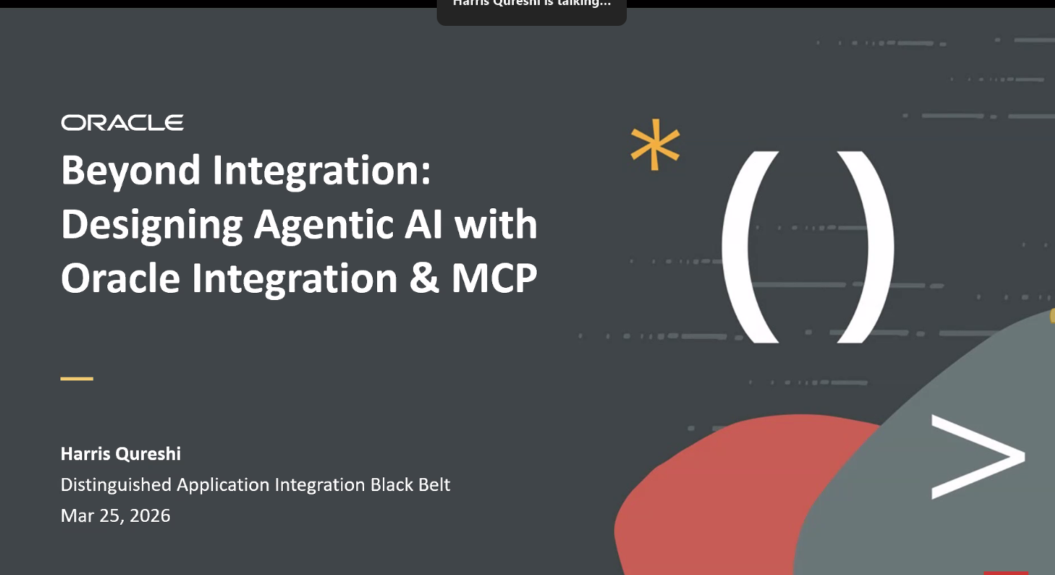
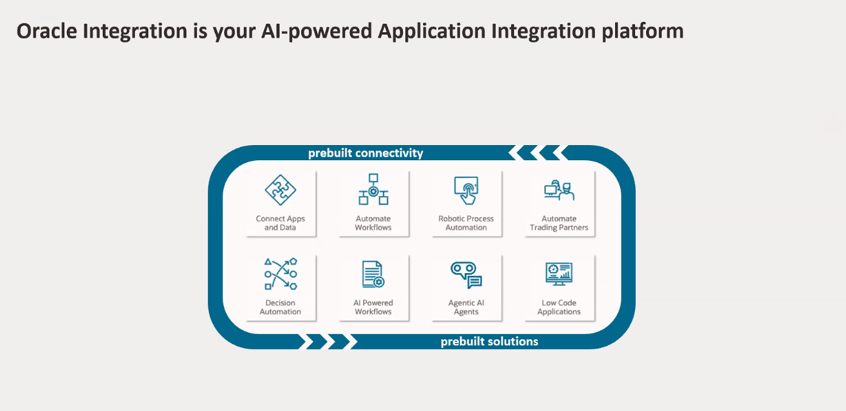
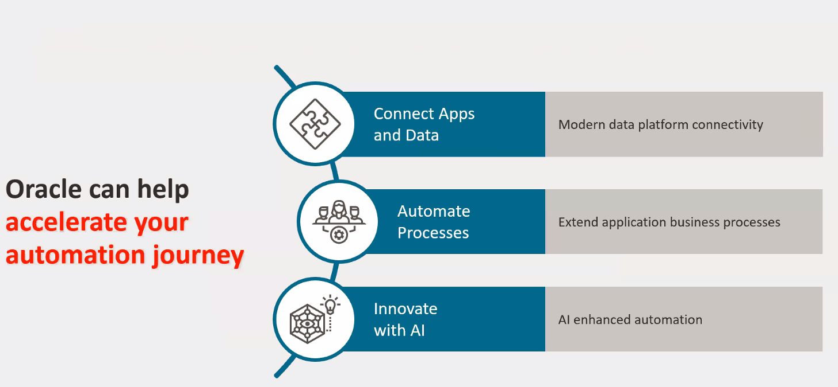
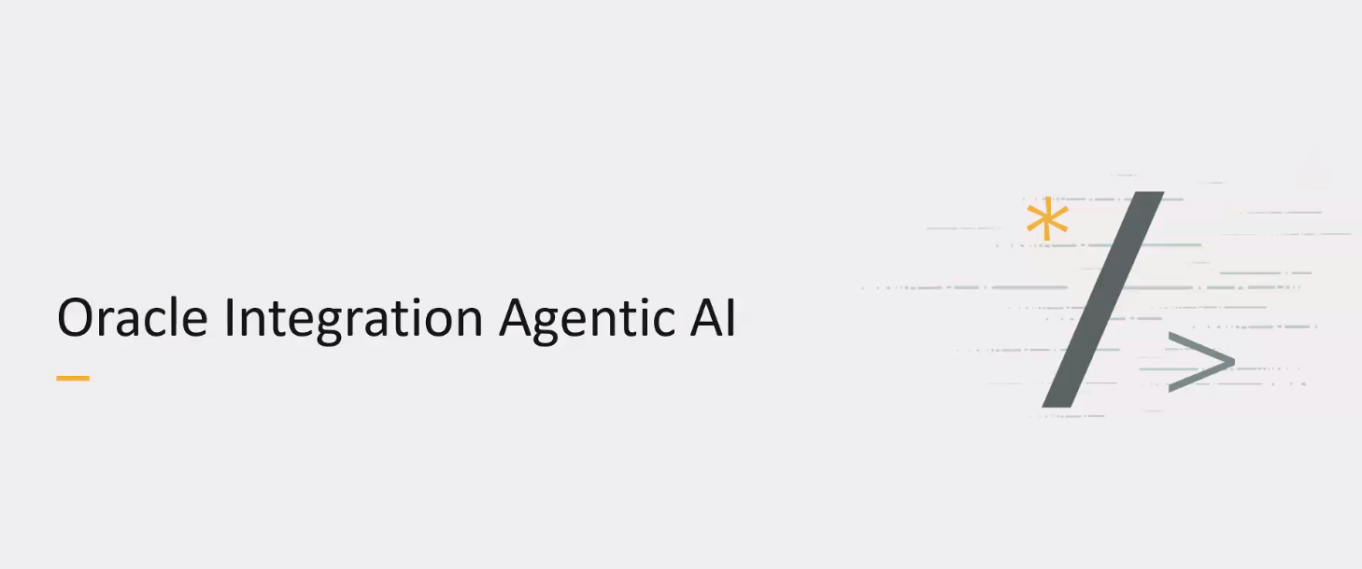
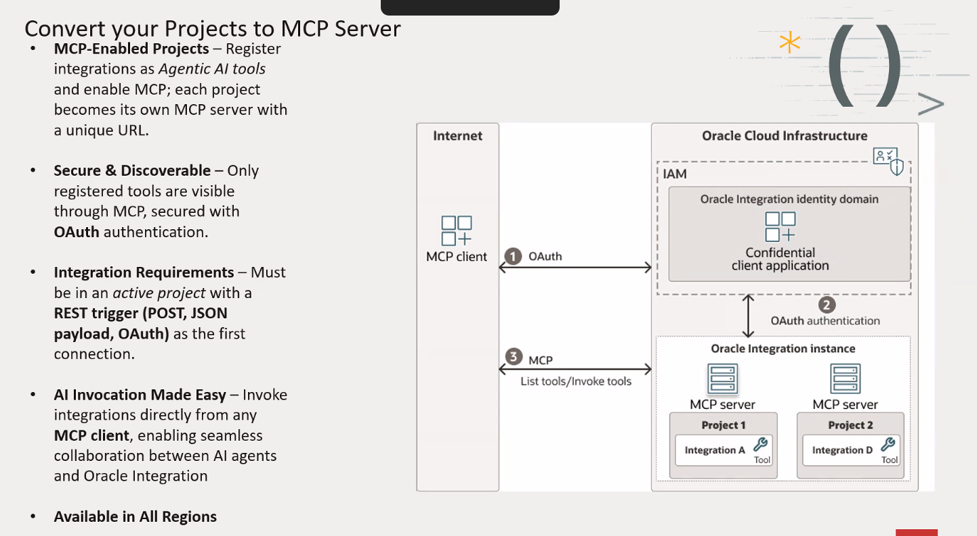
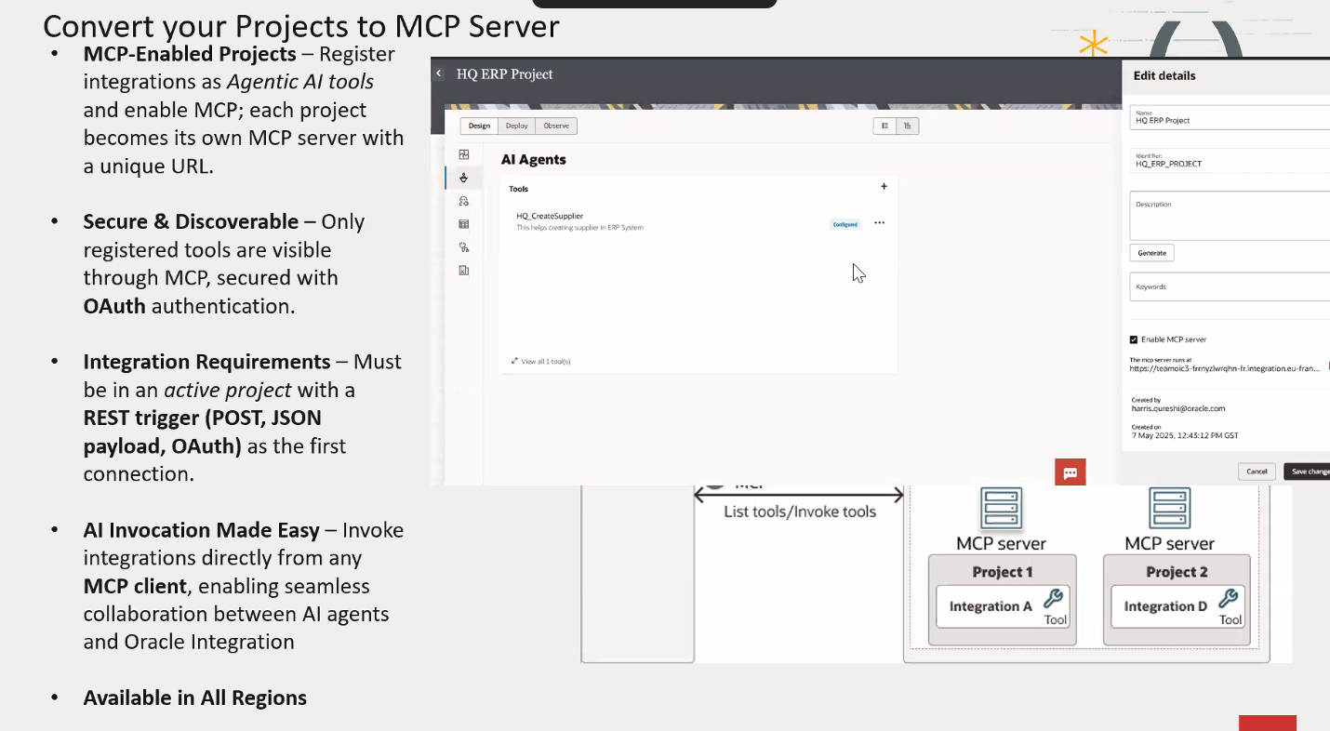
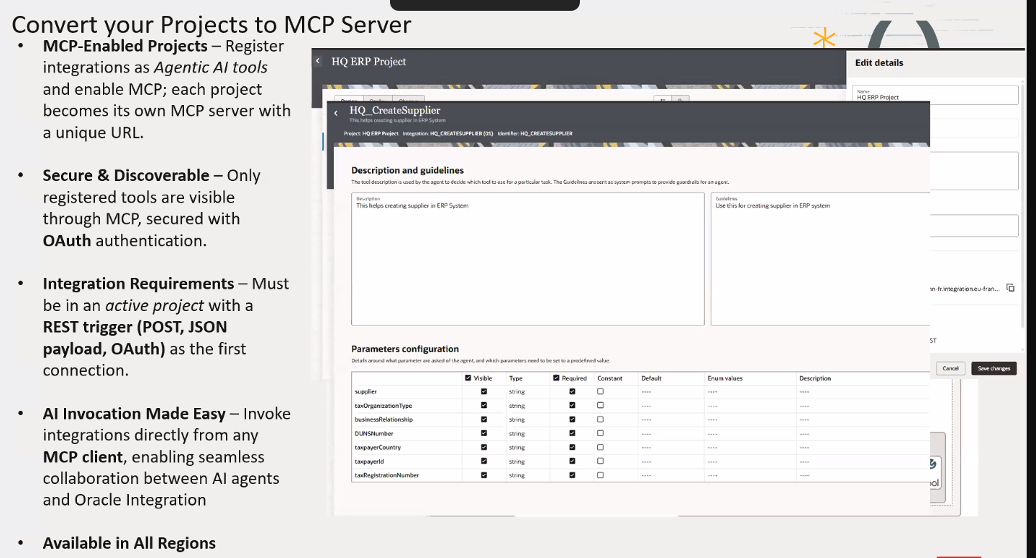
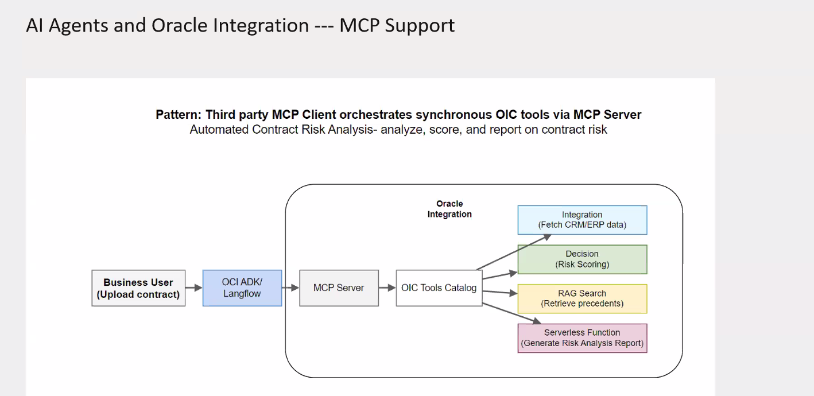
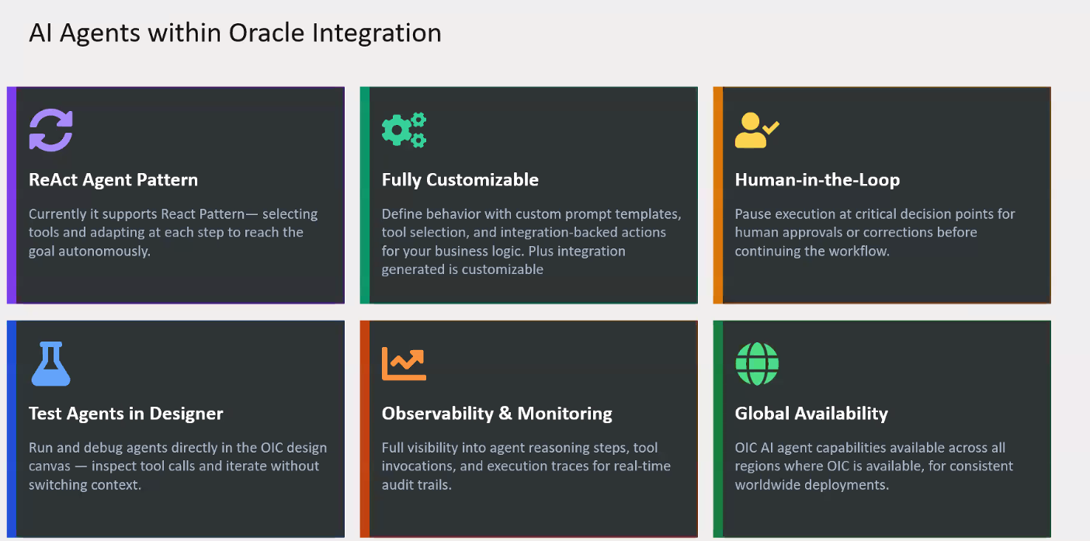
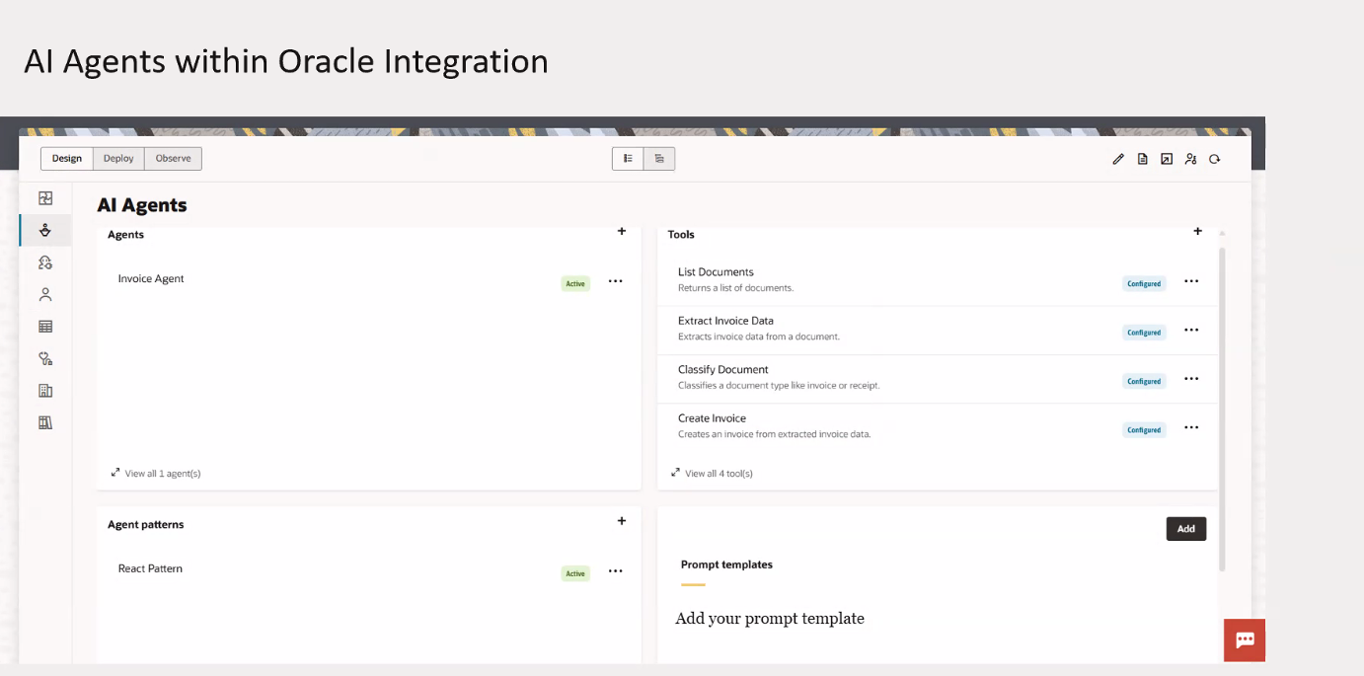
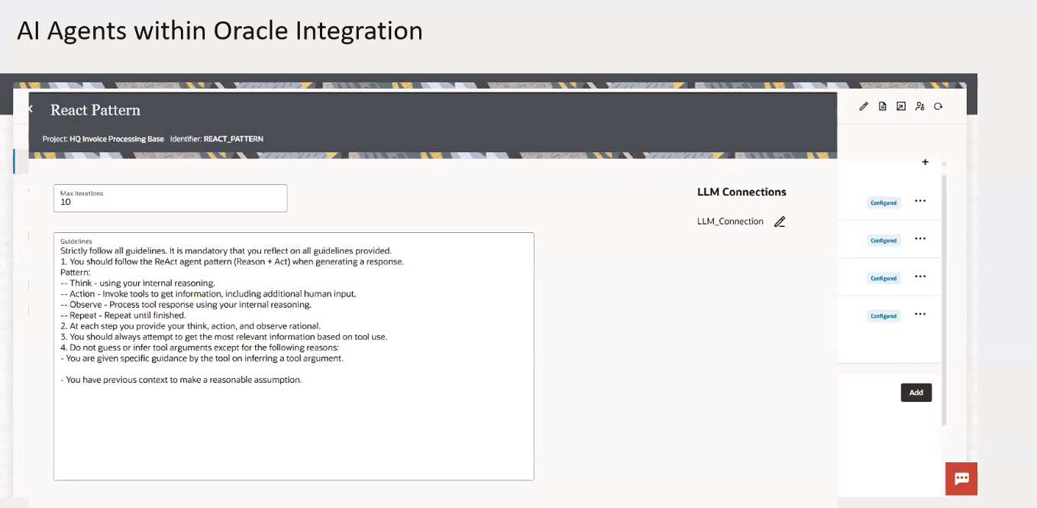
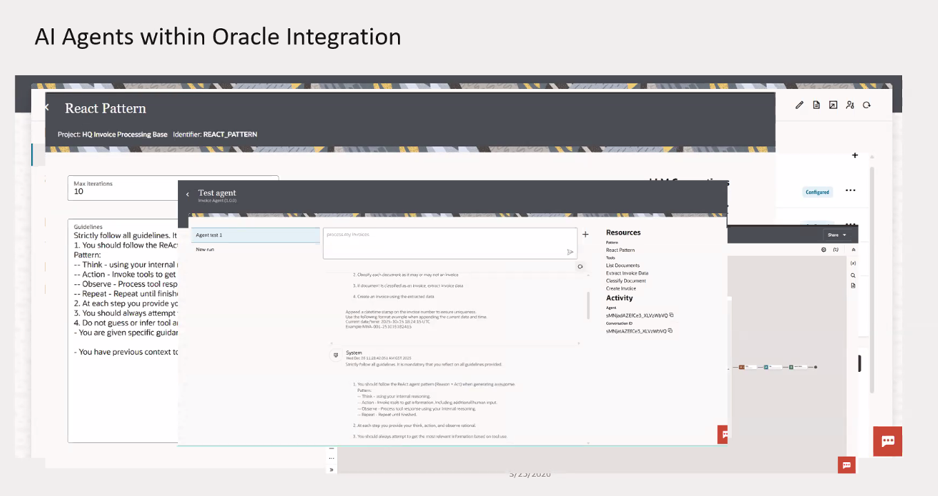
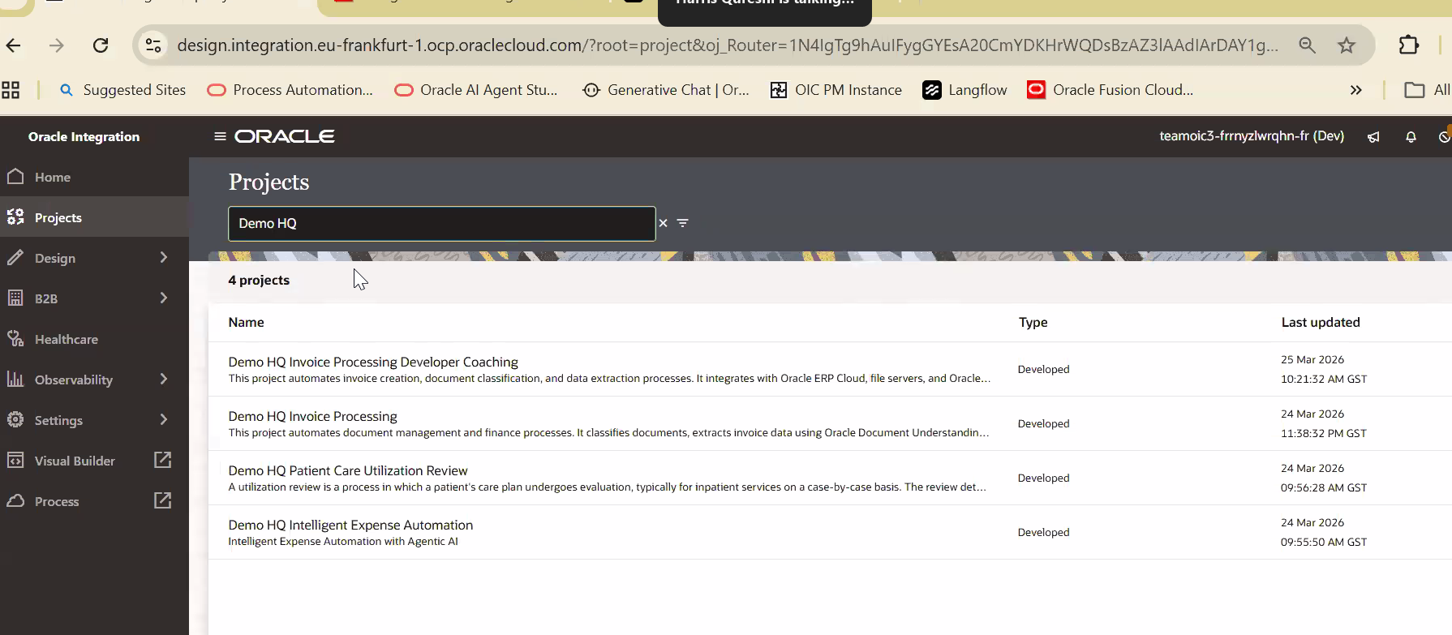
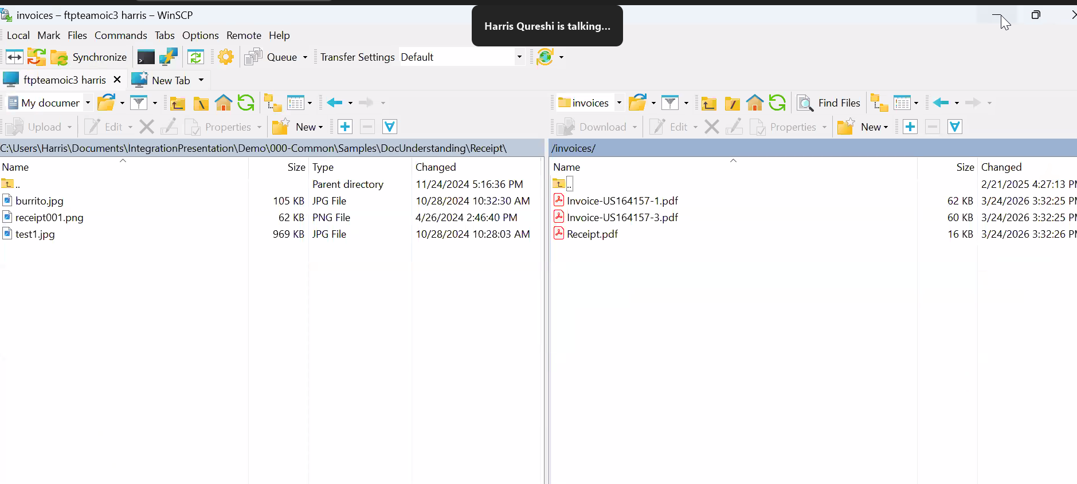
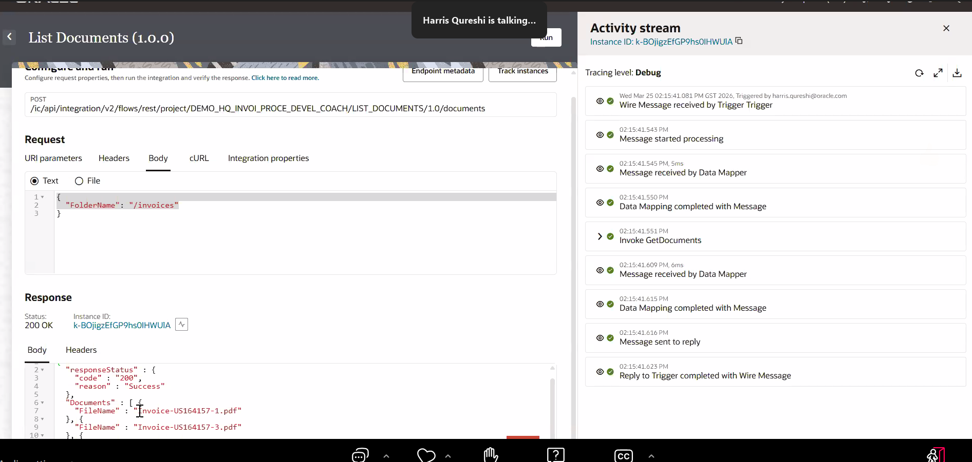
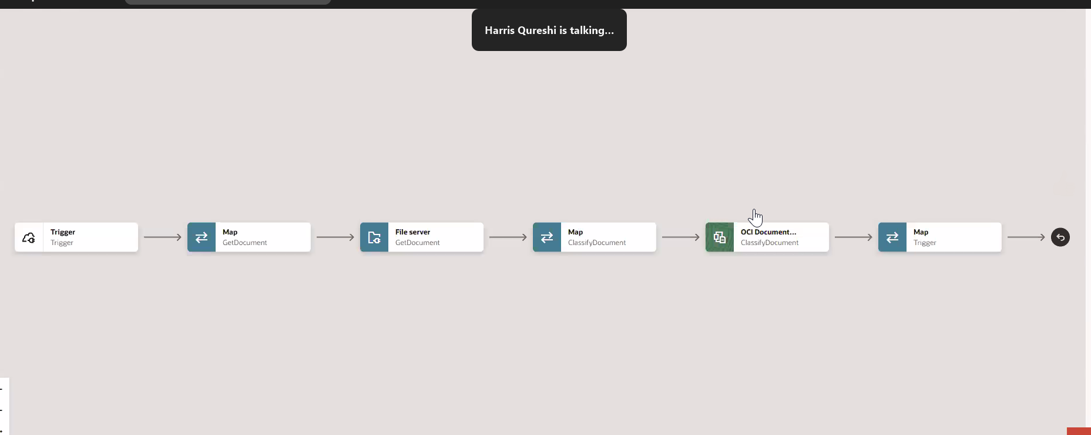
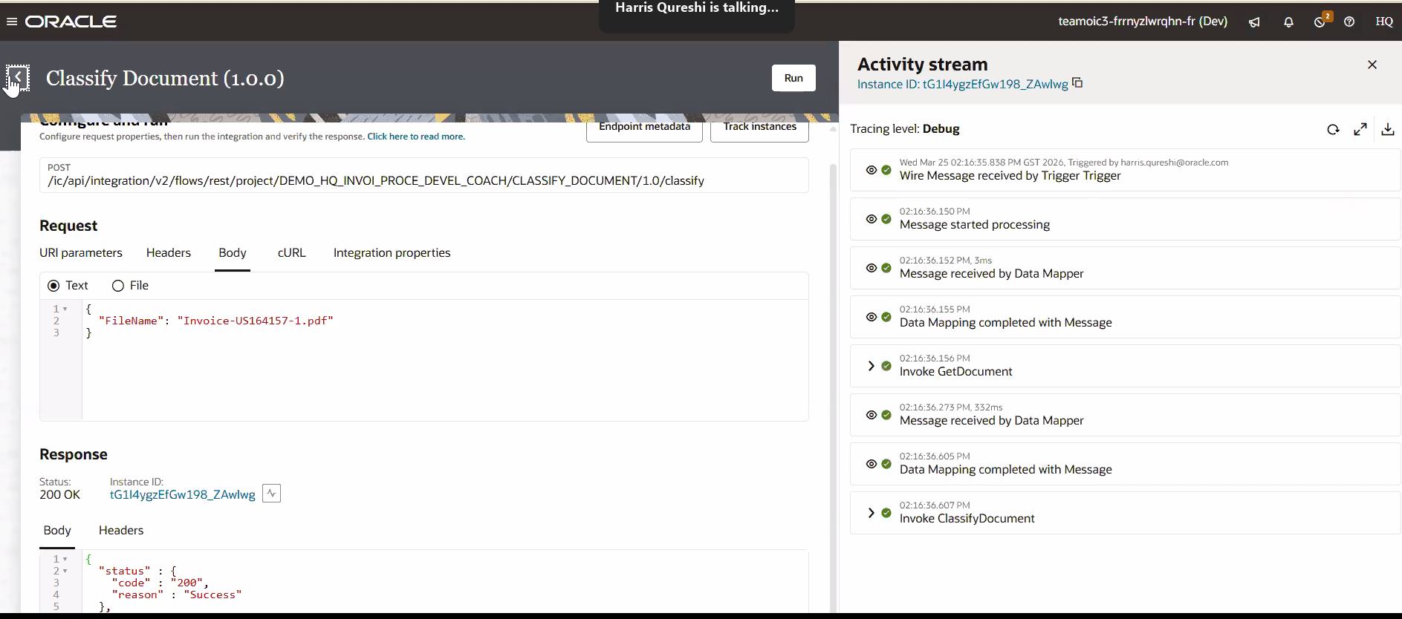
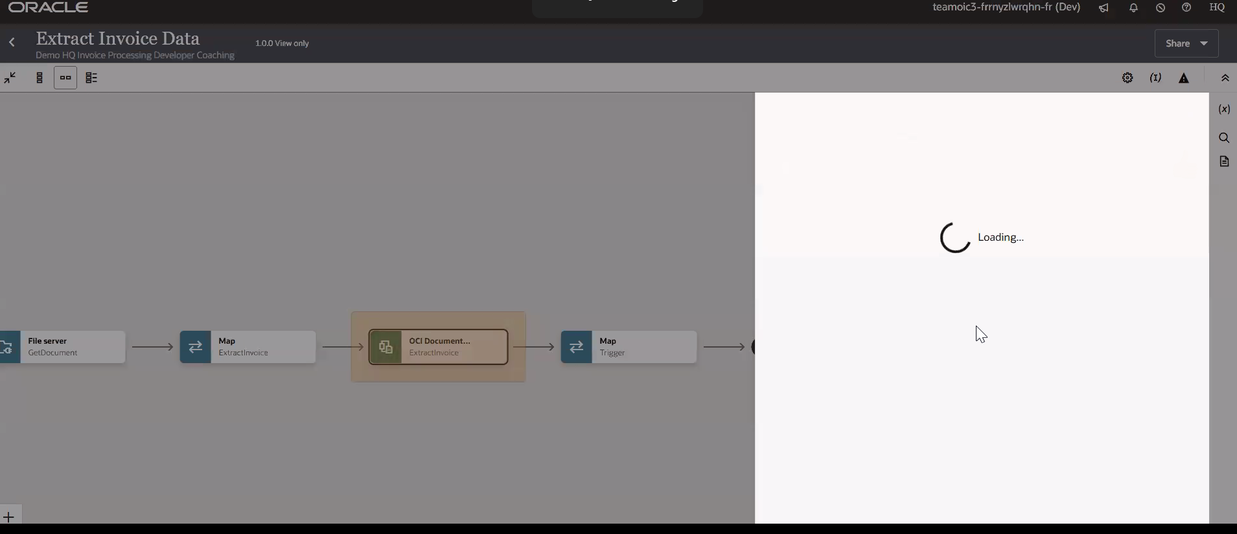
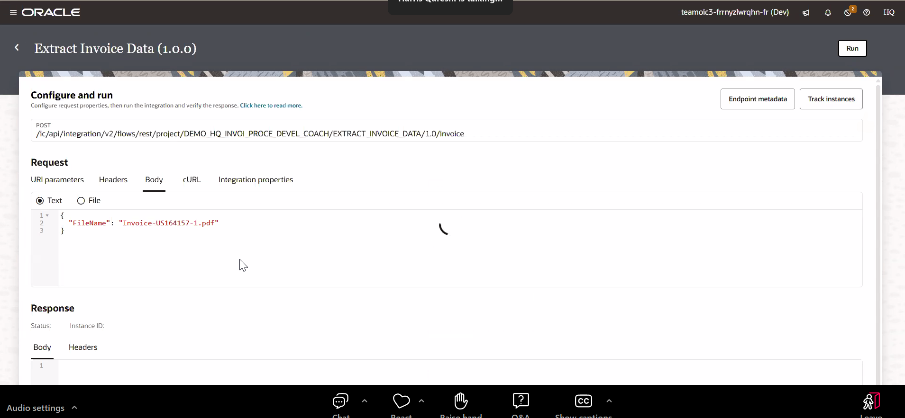
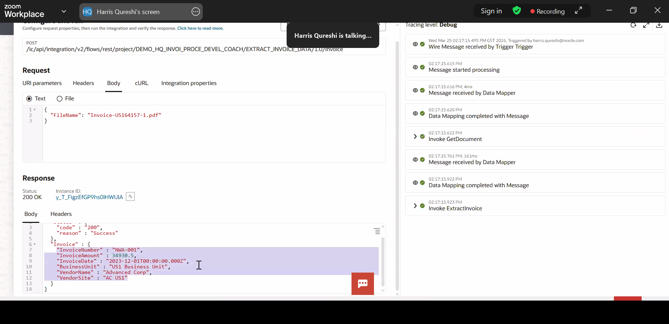
7. OCI In 5 page (guided learning path which helps you consolidate your OCI knowledge in one single place): https://www.oracle.com/emea/cloud/architecture-center/oci-in-5/
8. Get More Out of Your Oracle Investment with Oracle Support: https://youtu.be/5JGaqnqBft8?si=TnXZicji1cVq9HO6
9. Oracle Cloud Infrastructure Blog: https://blogs.oracle.com/cloud-infrastructure/post/what-is-new-in-oci
10. Cloud Coaching - Security-First approach for your OCI Tenancy: https://youtu.be/ZB87VUcK6Tg
11.Enable Multi-Factor Authentication (MFA) on Oracle Cloud / 2026: https://youtu.be/sjeSKzR4l0E
12. Free Oracle Technologies for Developers: https://oracle.github.io/free/#/
13. Visit the AI Solutions Hub: https://www.oracle.com/aisolutions
14. Visit OCI DigiHUB: https://mylearn.oracle.com/api/activation/subscription/b8101b96-22d5-4f05-ae8c-19f92295266f?destination=https://mylearn.oracle.com/ou/story/144011

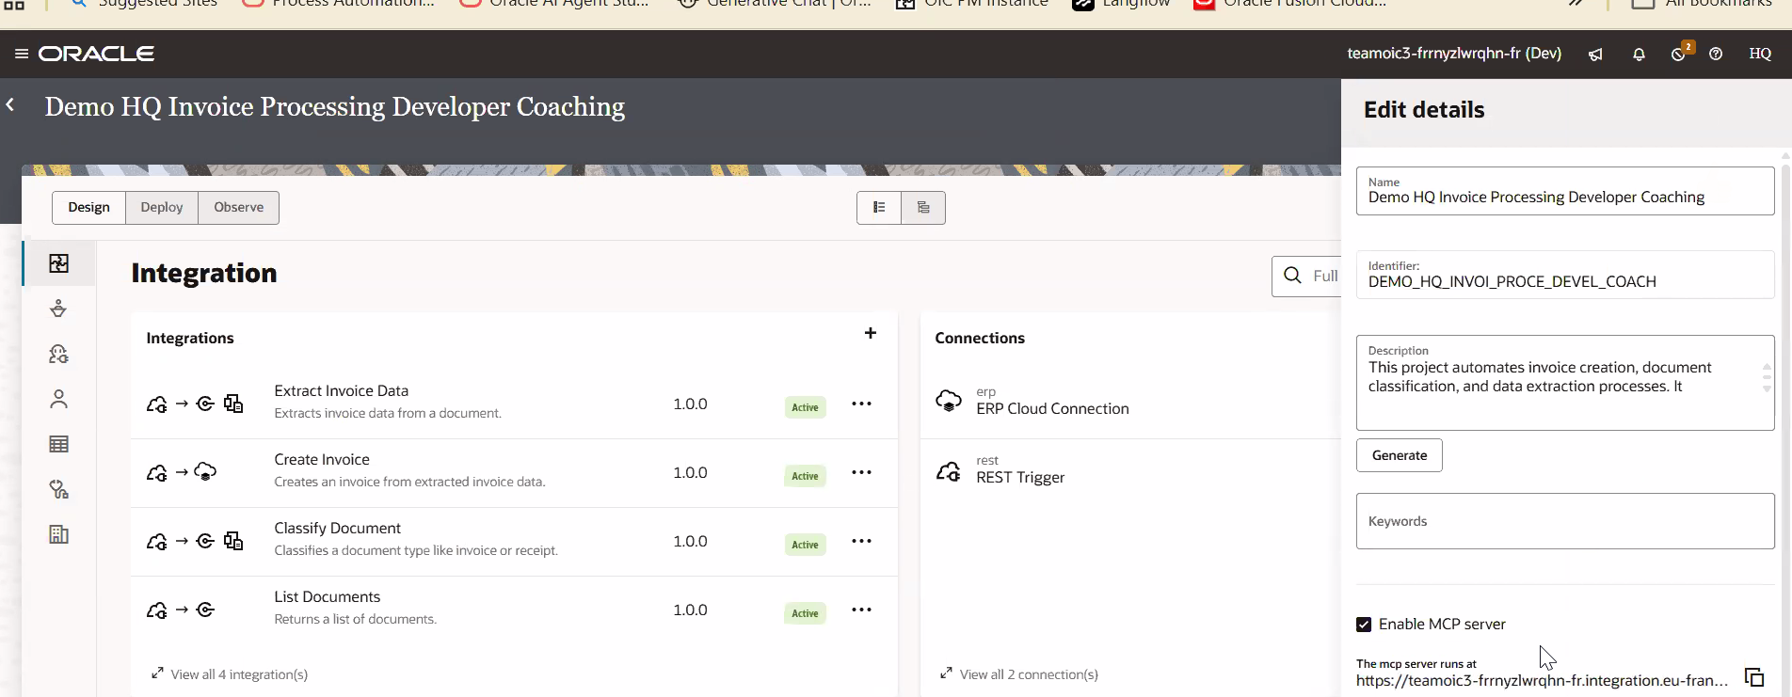
7. OCI In 5 page (guided learning path which helps you consolidate your OCI knowledge in one single place): https://www.oracle.com/emea/cloud/architecture-center/oci-in-5/
8. Get More Out of Your Oracle Investment with Oracle Support: https://youtu.be/5JGaqnqBft8?si=TnXZicji1cVq9HO6
9. Oracle Cloud Infrastructure Blog: https://blogs.oracle.com/cloud-infrastructure/post/what-is-new-in-oci
10. Cloud Coaching - Security-First approach for your OCI Tenancy: https://youtu.be/ZB87VUcK6Tg
11.Enable Multi-Factor Authentication (MFA) on Oracle Cloud / 2026: https://youtu.be/sjeSKzR4l0E
12. Free Oracle Technologies for Developers: https://oracle.github.io/free/#/
13. Visit the AI Solutions Hub: https://www.oracle.com/aisolutions
14. Visit OCI DigiHUB: https://mylearn.oracle.com/api/activation/subscription/b8101b96-22d5-4f05-ae8c-19f92295266f?destination=https://mylearn.oracle.com/ou/story/144011

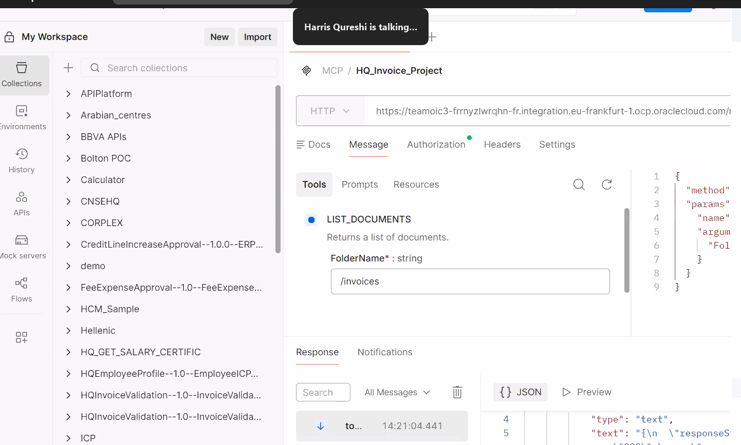

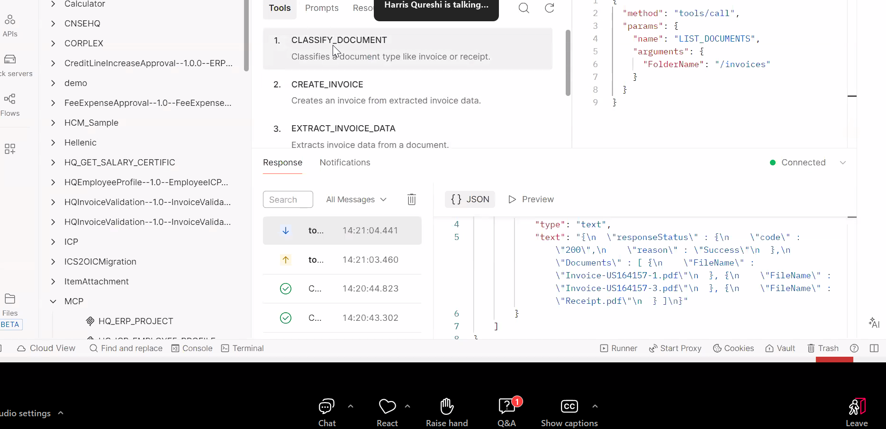
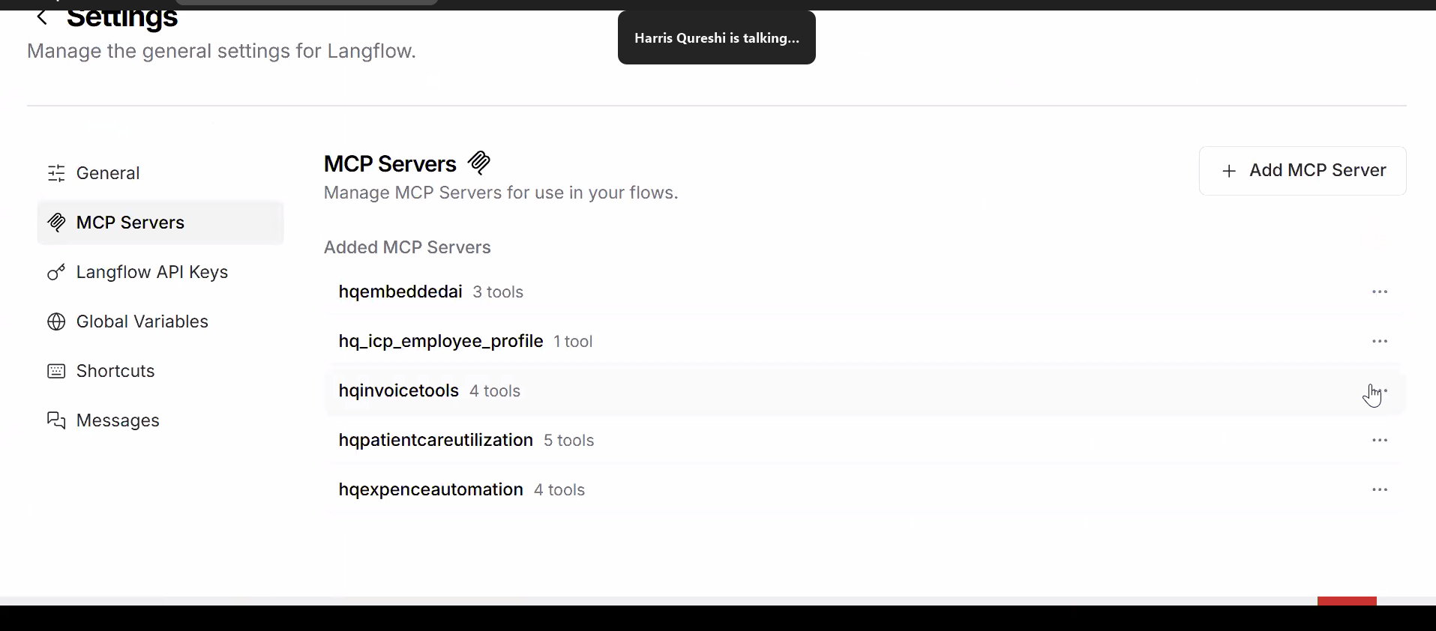
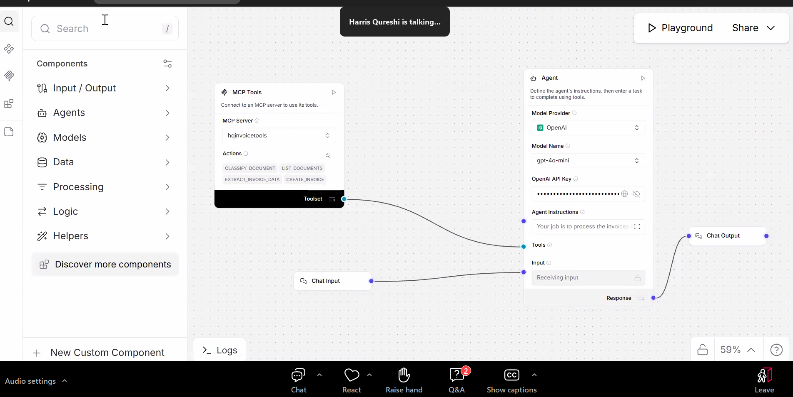

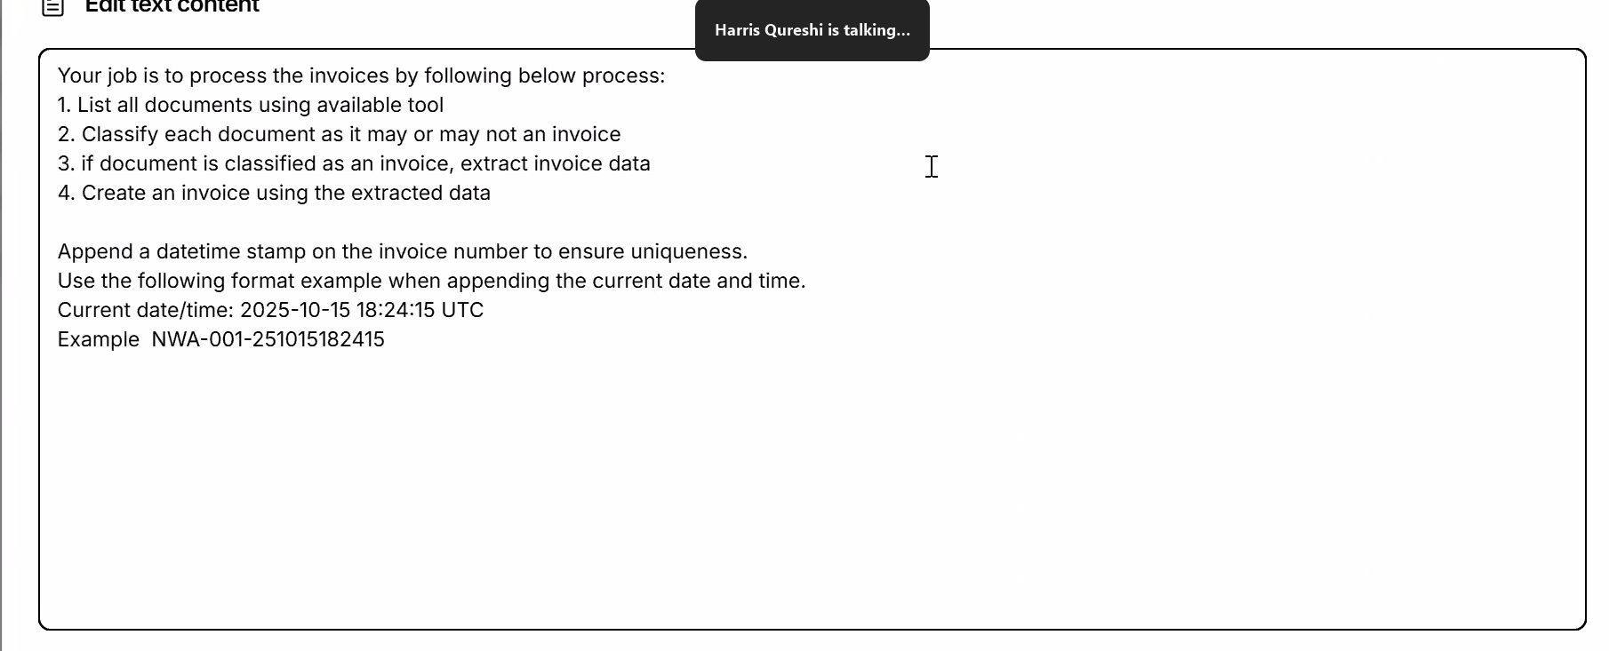
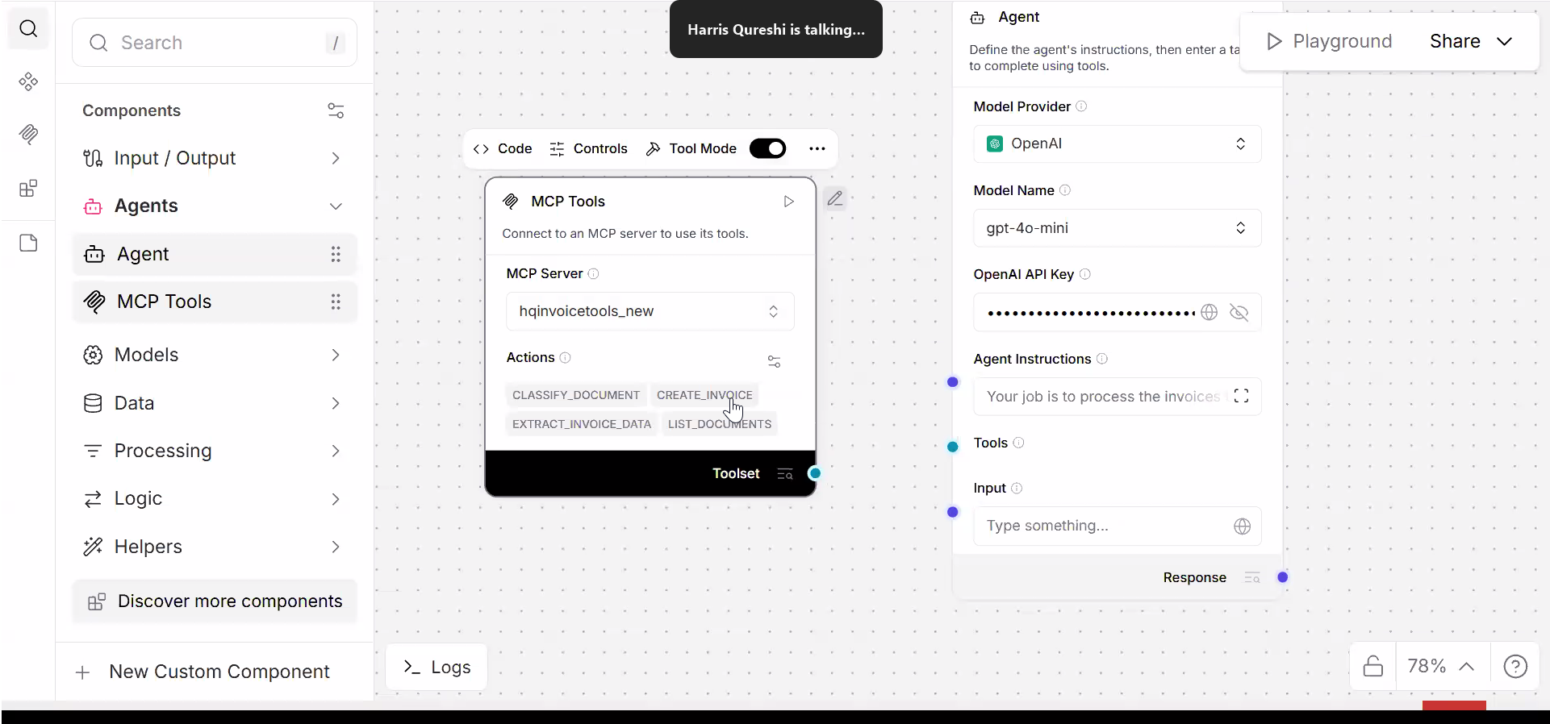
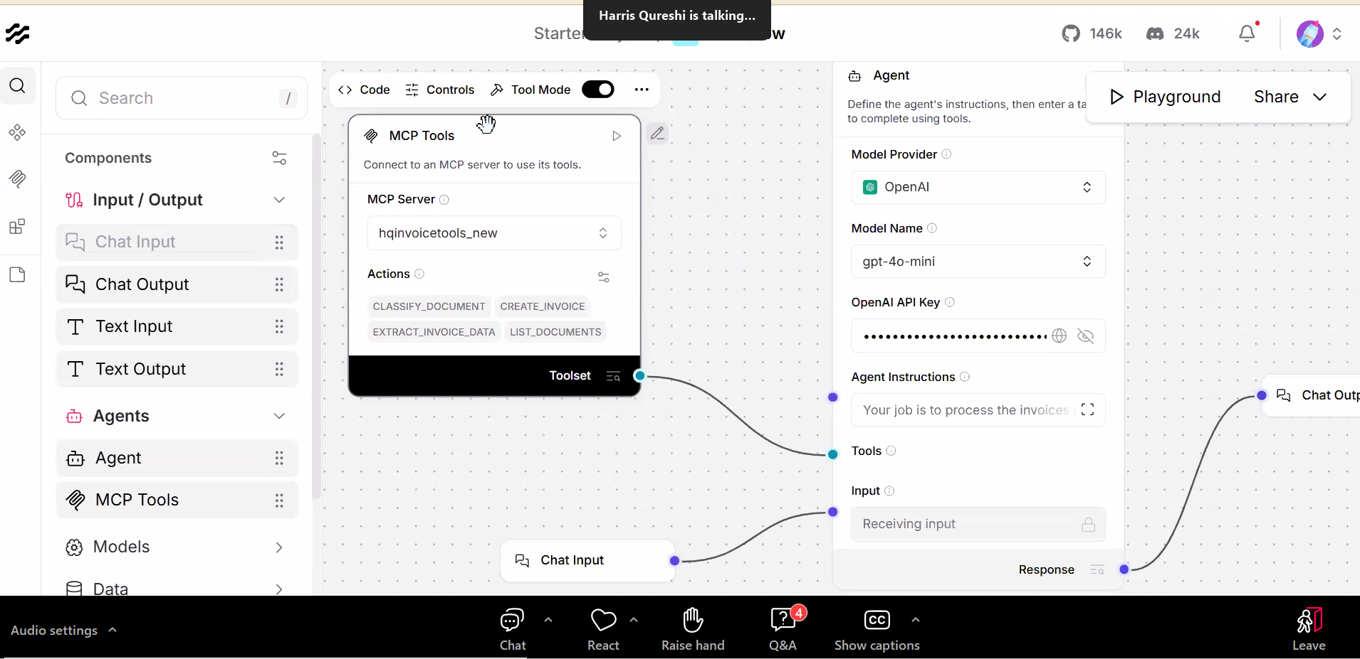
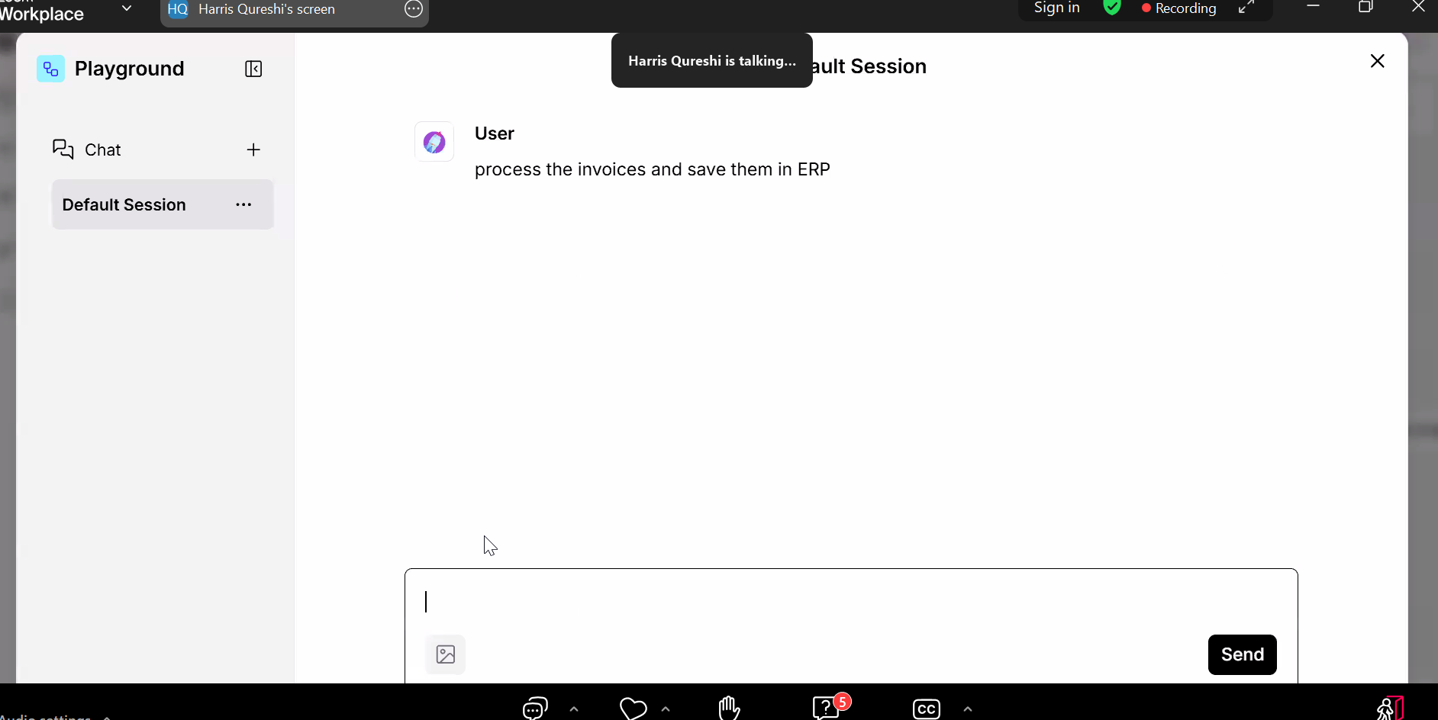
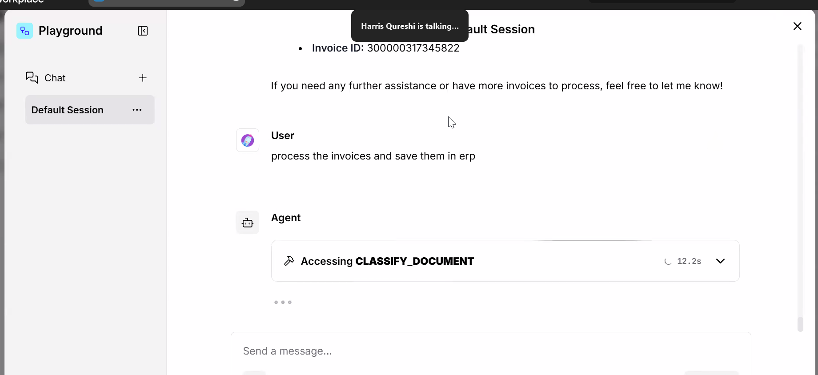
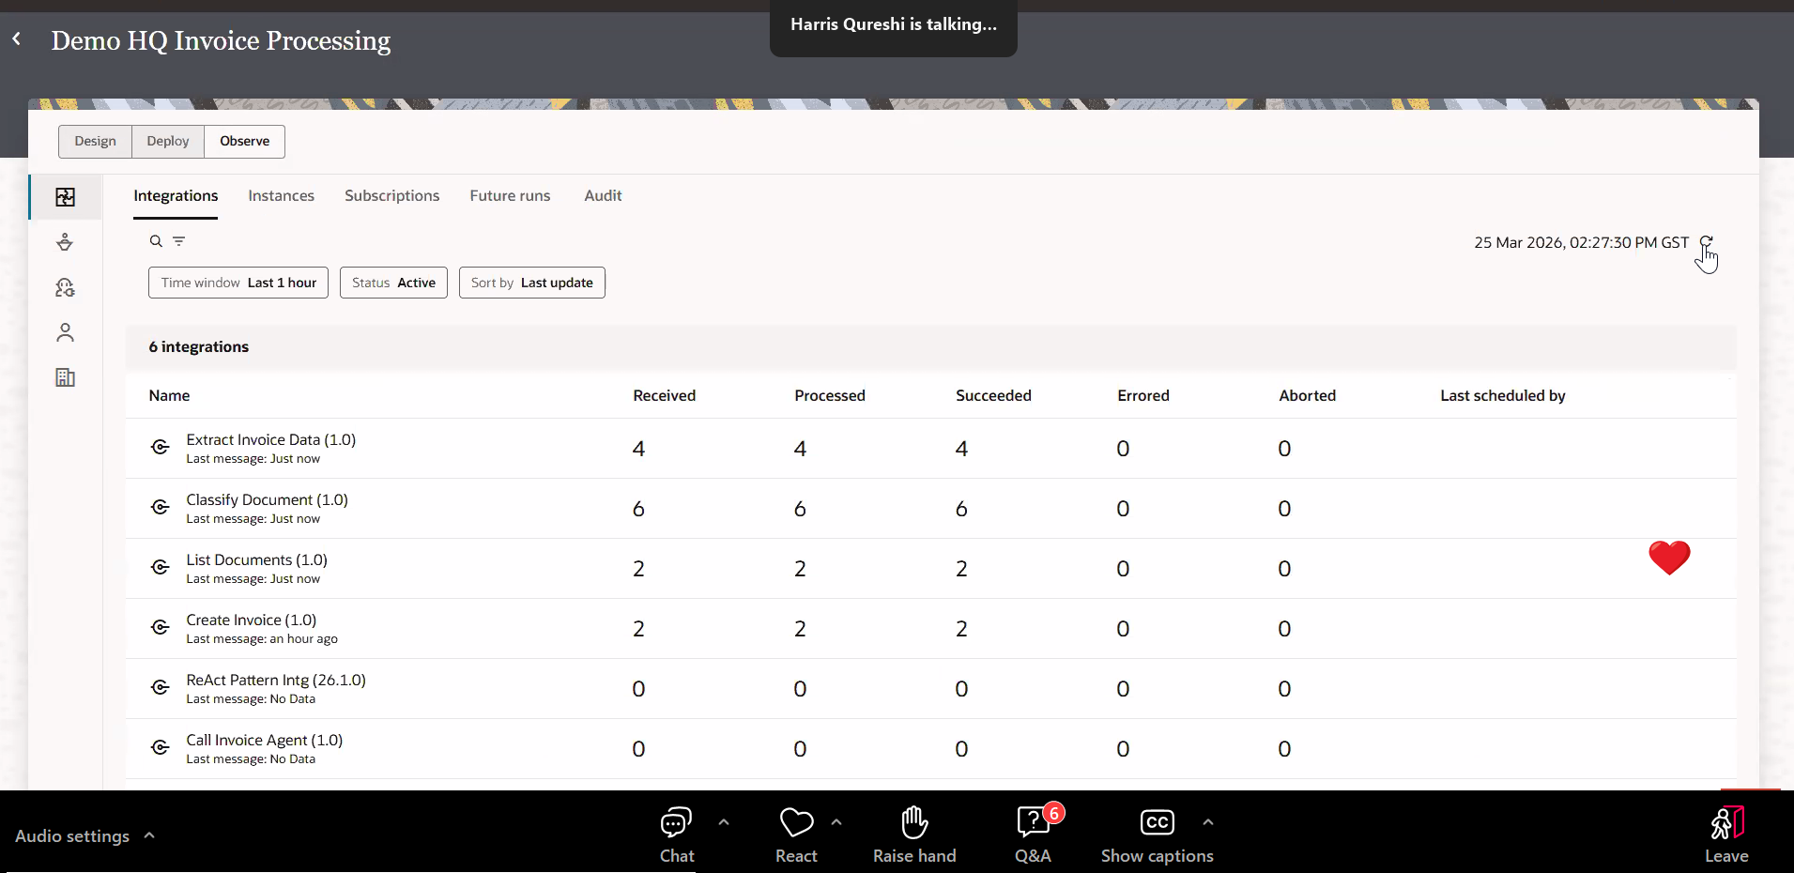

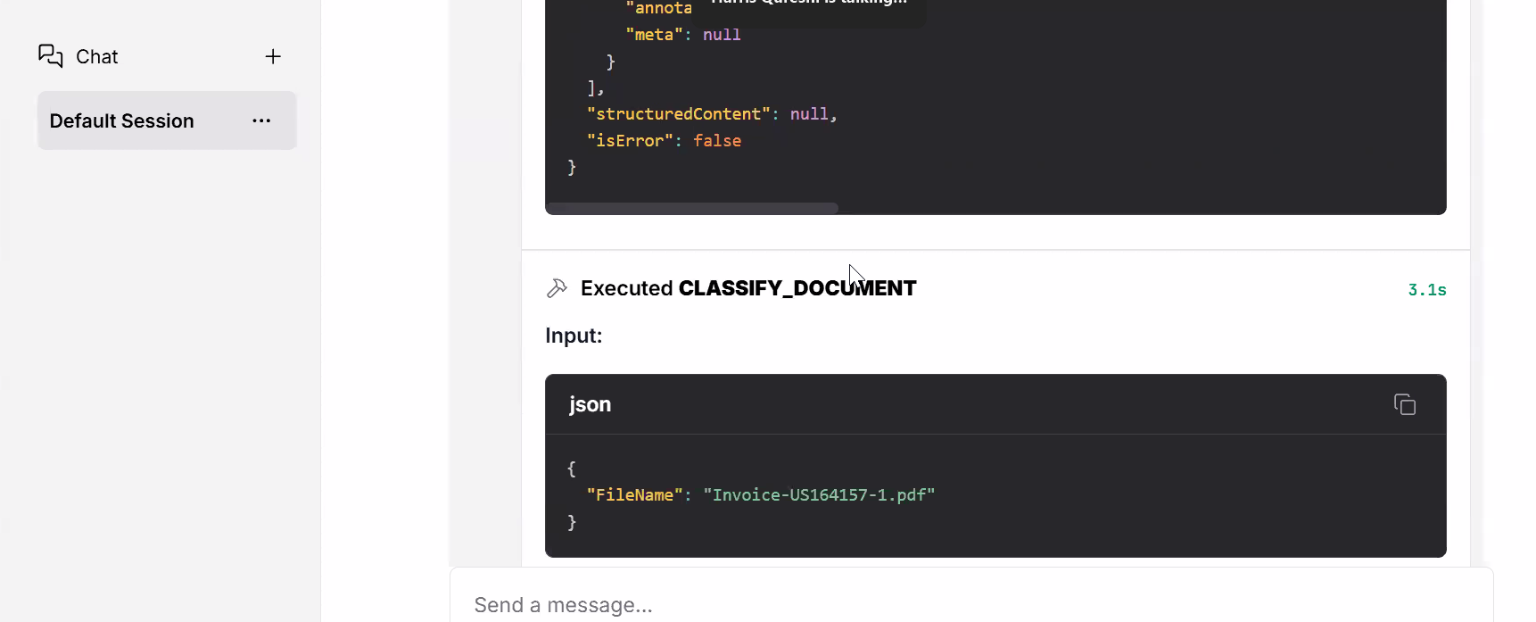
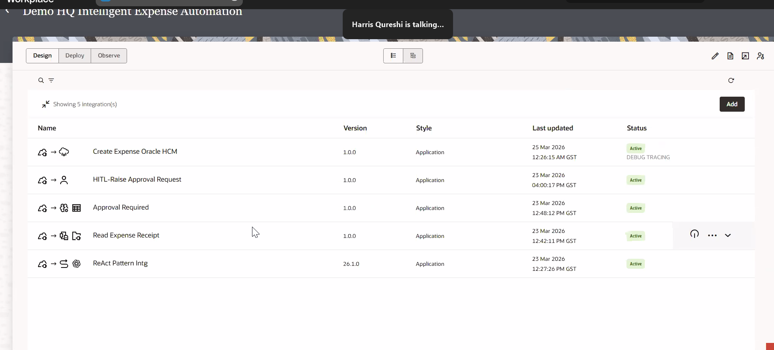
Decision work flow:
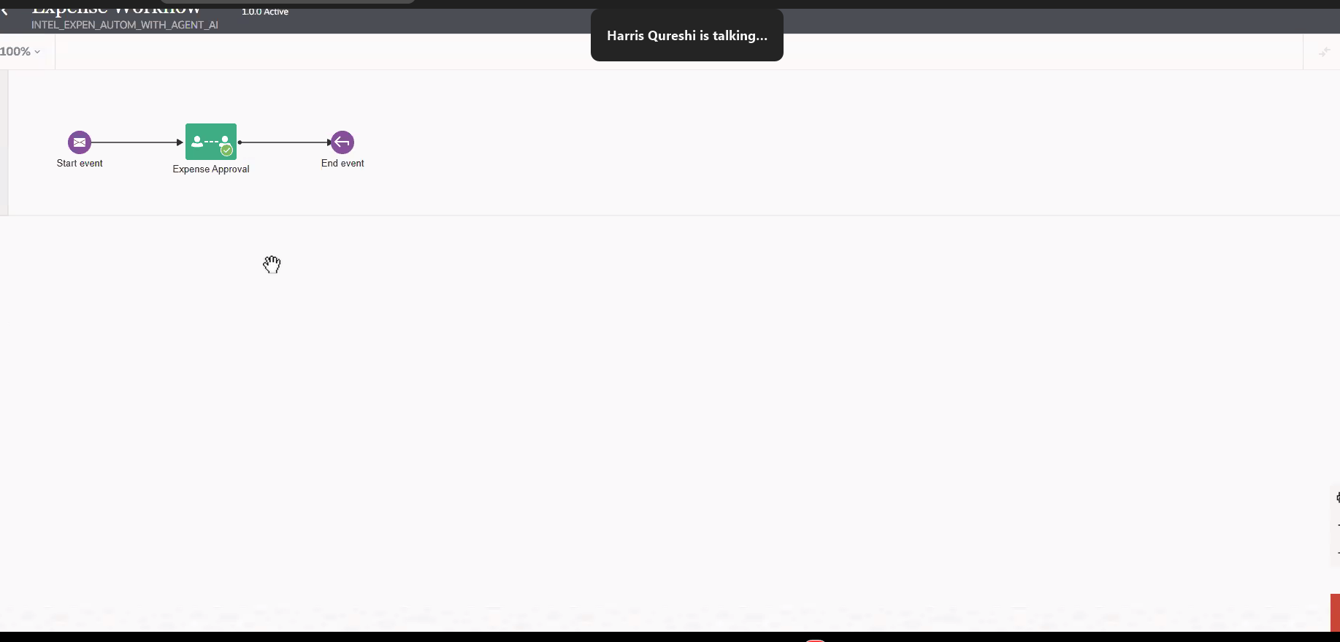
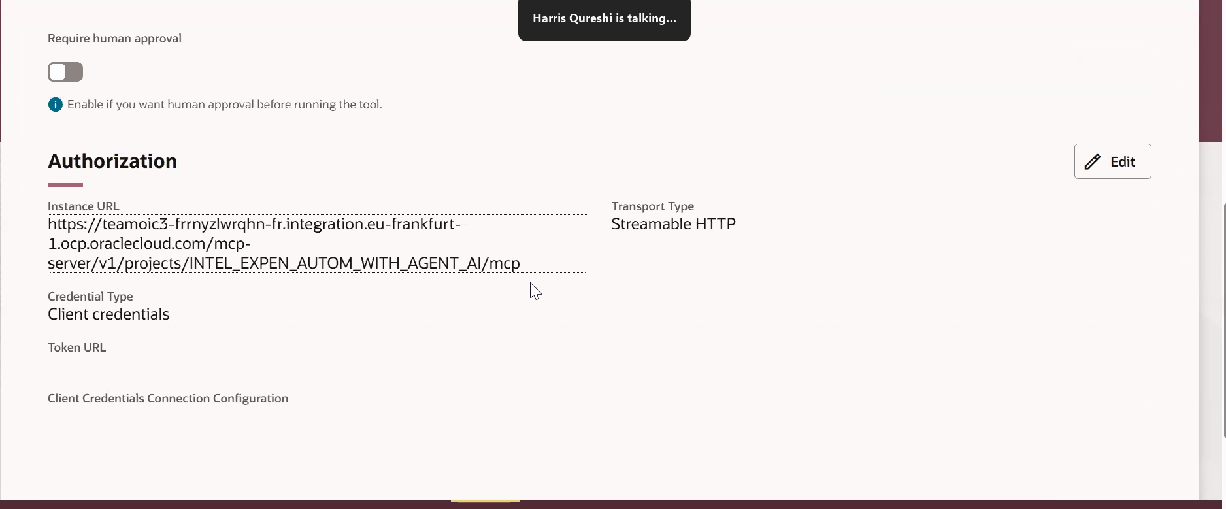
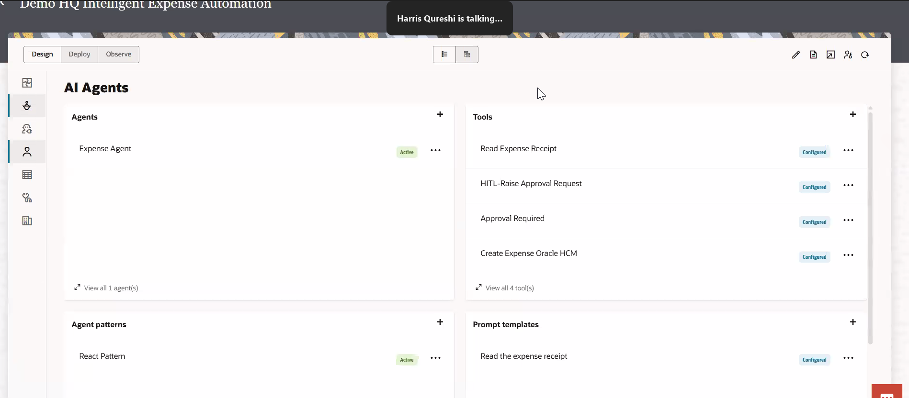

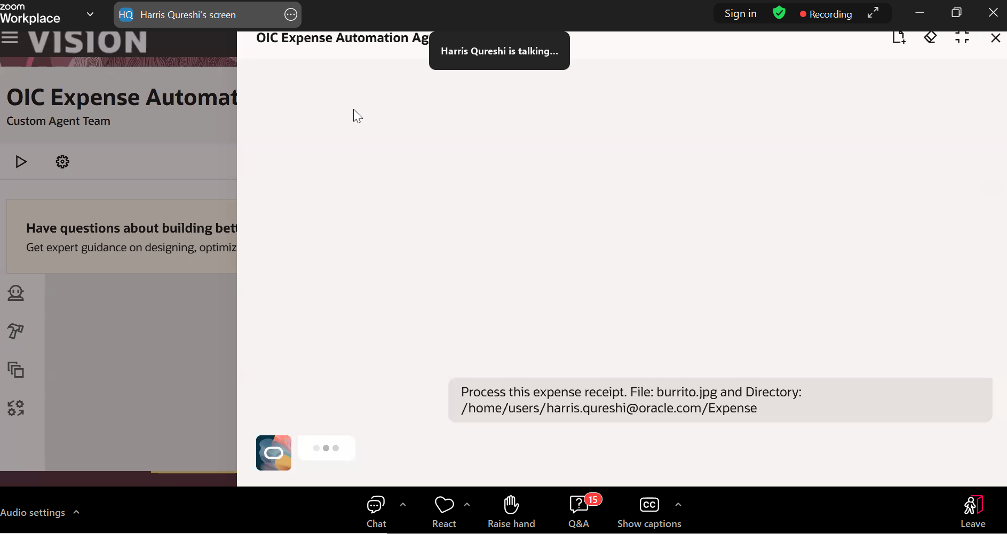
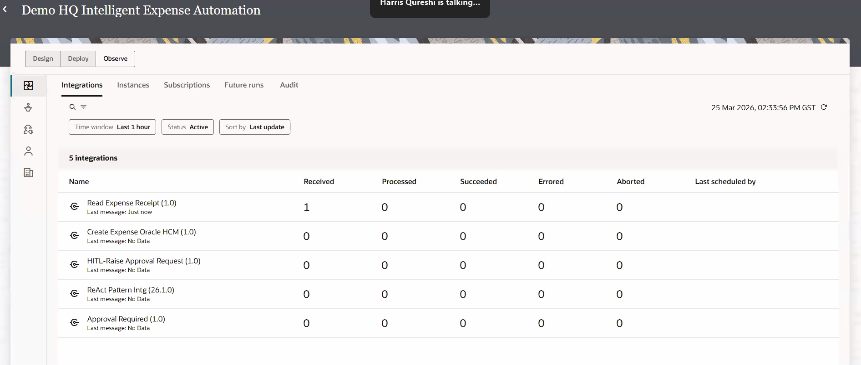
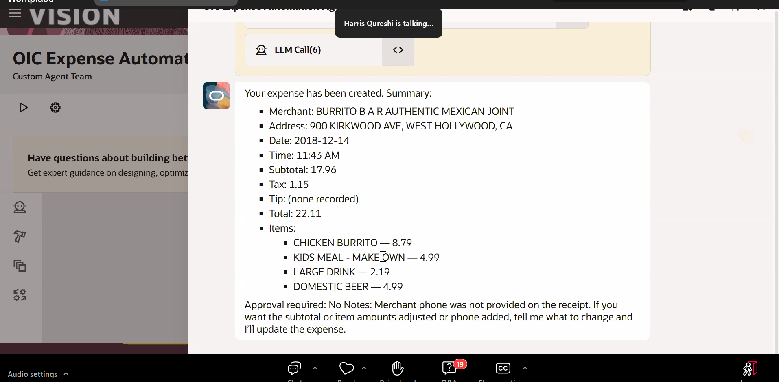
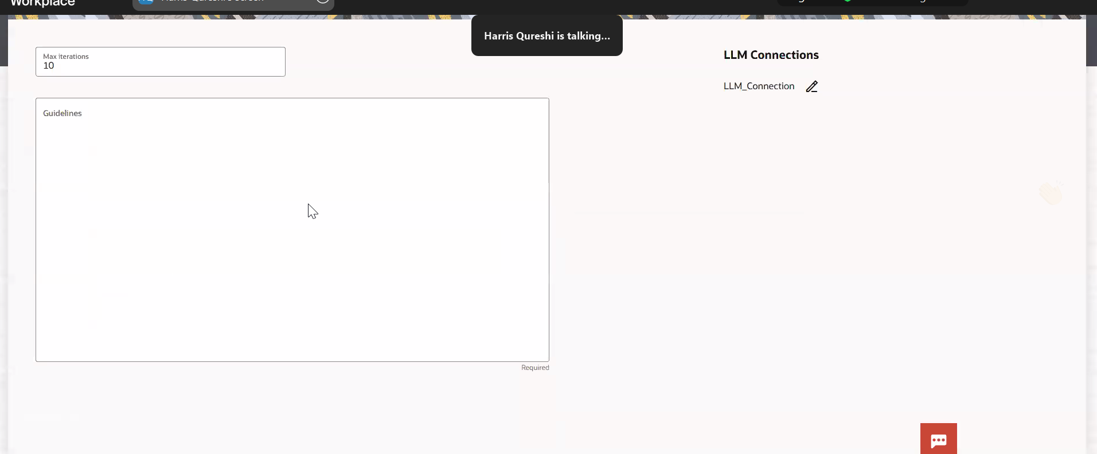
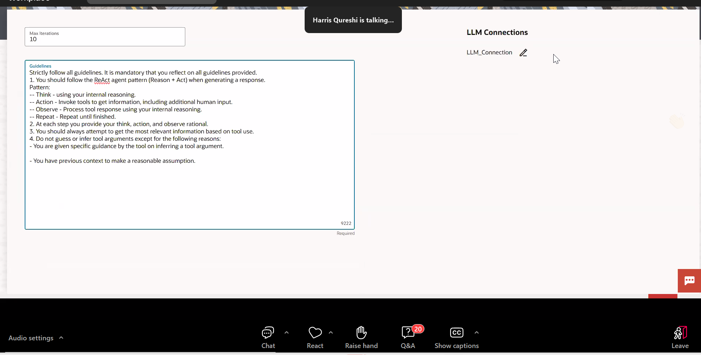
https://youtu.be/UrptzZbycm4?si=opv0_wc5F7SV86nx
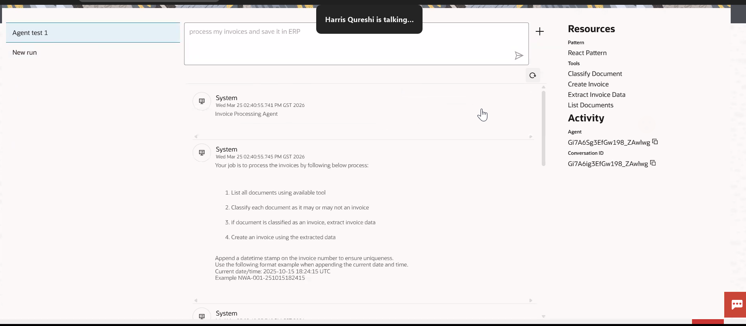
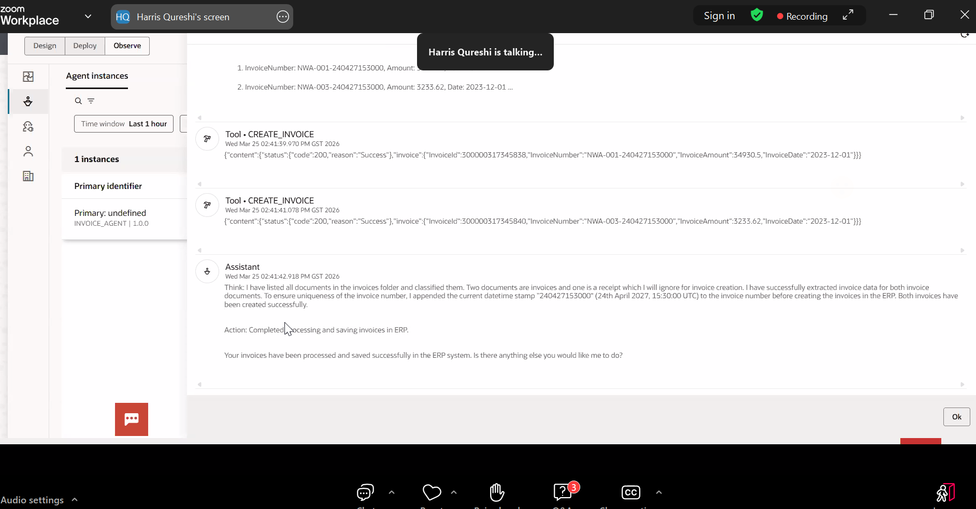
what is the usecase of creating Agent in OIC .When we can create it Fusion AI studio
Kishore 04:12 PM
Absolutely, you can create agents where the centre of gravity for your agent exists. Evaluate what tools the agent might need. Few examples: lets say you you are doing some kind of heavy lifting in one of tools , you may have to connect with a different external systems to take action or fetch data. OIC as mcp tools provider may be required to augment your agent built in fusion.
