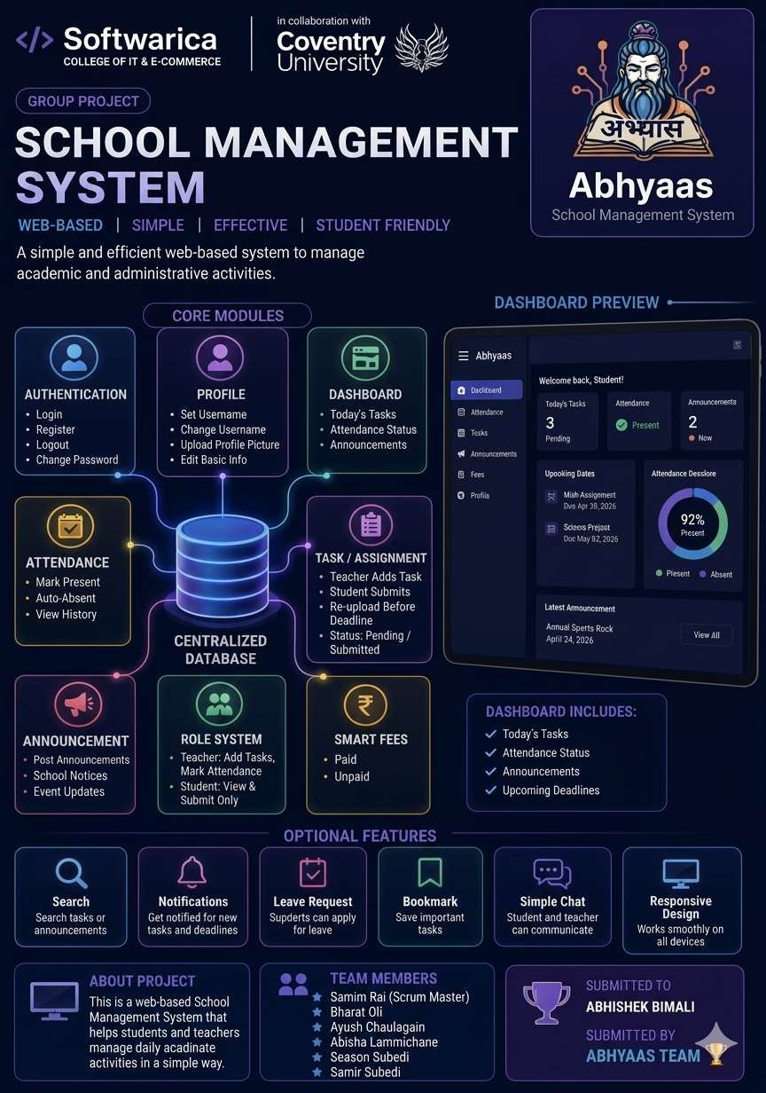

Contents
Keywords 4
Introduction 5
Aims 6
Objectives 6
Problem Statement 7
Literature Review 8
Features 9
Functionalities 10
Functional Requirements 10
Non Functional Requirements 11
Development Methodology 12
Framework 12
Tools and Technologies ................................................................................................................ 18
Conceptual Diagram 20
Scope 20
SWOT Analysis 21
Conclusion 21
References 22

Figure 1- Keywords ........................................................................................................................ 4
Figure 2- Abhyas Logo ................................................................................................................... 5
Figure 3-Problem Statement ........................................................................................................... 7
Figure 4- Features of Abhyas .......................................................................................................... 9
Figure 5- Agile Scrum Framework ............................................................................................... 12
Figure 6- Scrum Master ................................................................................................................ 13
Figure 7- Developers..................................................................................................................... 14
Figure 8- Sprint Plaining ............................................................................................................... 15
Figure 9- Sprint Backlog ............................................................................................................... 15
Figure 10- Scrum Meeting ............................................................................................................ 16
Figure 11- Scrum Retrospective ................................................................................................... 17
Figure 12-Sample Theme .............................................................................................................. 18
Figure 13- Tool and Technique..................................................................................................... 19
Figure 14- Conceptual Diagram of Abhyas .................................................................................. 20
Figure 15-: SWOT Analysis of Abhyas.......................................................................................... 21

Table 1- Functional Requirement of Abhyas ............................................................................ 10
Table 2- Non Functional Requirements of Abhyas .................................................................... 11

Keywords
- Login
- Register
- Logout
- Change Password
- Set Username / Change Username
- Upload Profile Picture
- Edit Basic Info
- Dashboard
- Attendance
- Task / Assignment
- Announcements
- Role System
- Smart Fees
- Search
- Notifications
- Leave Request
- Bookmark
- Dark Mode
- Simple Chat
- AI Features
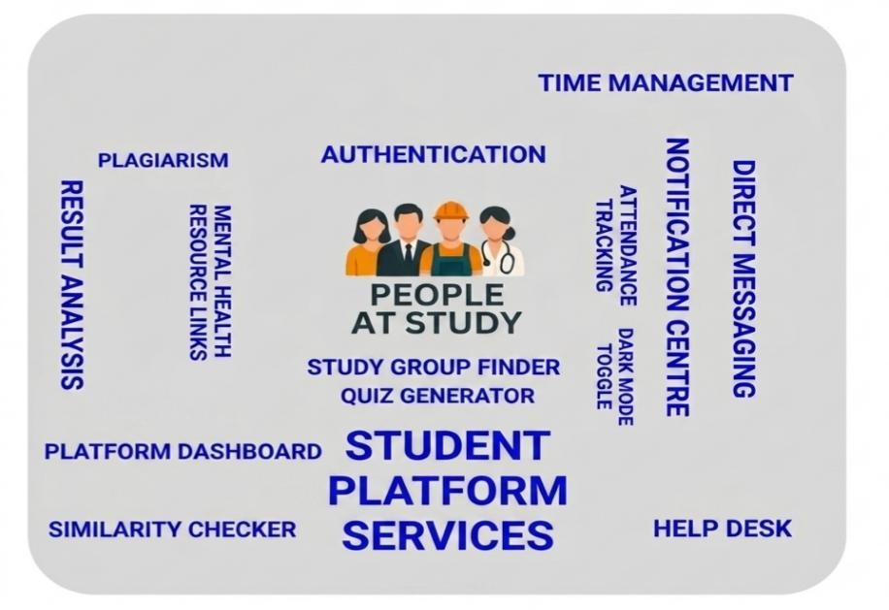
Figure 1- Keywords

Introduction
Students and teachers in schools and colleges in Nepal face a lot of problems when it comes to managing day-to-day activities. Things like tracking attendance, submitting assignments, checking fee status, and getting announcements are all done manually or on different platforms which makes it confusing and slow. There is no single place where a student can log in and see everything they need.
To solve this problem, we came up with Abhyas, which means "practice" or "study" in Nepali. Abhyas is a web-based education management system that is made for students and teachers. It brings together all the important features of a school or college management system into one easyto-use platform. From marking attendance to submitting assignments to checking if fees are paid, everything can be done from one place.
Abhyas is designed to be simple and straightforward. We did not want to make something overly complicated. We wanted to build something that a regular student or teacher can open and understand without needing any training. The system also has a role-based structure, meaning teachers and students see different things based on who they are.



Figure 2- Abhyas Logo

Aims
The main aim of Abhyas is to give students and teachers one platform where they can manage all education-related activities easily and without confusion. We want to remove the need for manual processes like paper attendance, physical notice boards, and separate fee tracking systems by putting everything in one digital system that is accessible from anywhere.

Objectives
- Build a working authentication system where users can register, log in, log out, and change their password.
- Allow students and teachers to set up and manage their profiles including username and profile picture.
- Create a dashboard that shows tasks, attendance status, and announcements in one place.
- Build a simple attendance system where users can mark themselves present and view their history.
- Let teachers post tasks and students submit and re-upload their work before the deadline.
- Allow teachers and admins to post announcements that all students can view.
- Set up a role system so teachers and students have the right level of access.
- Add a fee tracking system where admin can mark fees as paid or unpaid and students can check their status.
- Add search, notifications, leave requests, and bookmarks to improve the user experience.
- Include optional features like dark mode, a simple chat system, and basic AI tools if time allows.

Problem Statement
In most schools and colleges in Nepal, managing student and teacher activities is still done the old way. Attendance is taken on paper. Assignments are handed over physically or through random messaging apps like WhatsApp. Announcements are put on a notice board that not everyone sees. Fee records are kept in registers that can get lost or damaged. There is no single system that connects all of these together in one place.
This causes a lot of problems for both students and teachers. Students sometimes miss assignments because they did not see them in time. Teachers have to manually track who is present and who is not. Admins have to check paper records to know who has paid fees and who has not. Everything takes more time and effort than it needs to.
Abhyas is built to fix these problems. Instead of having everything scattered across different places, Abhyas puts everything together in one web-based system that is easy to use and accessible from any device. Students can log in, check their tasks, mark attendance, see announcements, and check their fee status all in one place. Teachers can manage tasks, post announcements, and approve leave requests. Admins can manage fees and users. This makes the whole process faster, cleaner, and easier to manage.
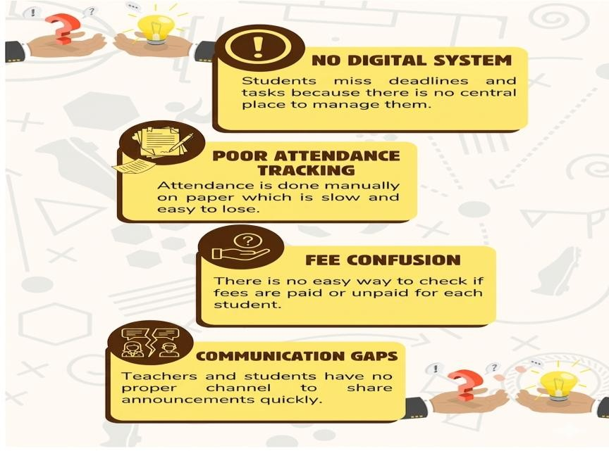
Figure 3-Problem Statement

Literature Review
The need for digital education management tools has been growing, especially after the COVID19 period when many schools and colleges had to go online for a short time. This showed that most institutions in Nepal were not ready for digital management. While some global platforms like Google Classroom and Microsoft Teams exist, they are not fully suited to the specific needs of Nepali schools and colleges. They are either too complex or lack features that are needed locally, like fee tracking or Nepali-context attendance systems.
Research has shown that simple and well-designed platforms are more likely to be used regularly by students and teachers compared to complicated systems with too many options. A system that is focused on what users actually need every day is more effective than one that tries to do everything at once (AltexSoft Editorial Team, 2023).
Mobile-friendly and web-based systems are also becoming more important as more students use phones and laptops to access the internet. A system that works on any browser without needing to install anything is more practical for most students in Nepal (Joshi, 2024).
Abhyas is built keeping all of this in mind. It focuses on the daily needs of students and teachers, keeps the interface simple, and works on any browser. It is not trying to compete with global giants like Google Classroom but instead targets the very specific and practical problems that students and teachers in Nepal face every day.

Features
- Authentication — Register, Login, Logout, Change Password
- Profile — Set Username, Change Username, Upload Profile Picture, Edit Basic Info
- Dashboard — View Today's Tasks, Attendance Status, Announcements
- Attendance — Mark Present, Auto Absent, View History
- Task / Assignment — Add Task, Submit, Re-upload, View Status
- Announcements — Post and View Announcements
- Role System — Teacher Role, Student Role
- Smart Fees — Mark Paid, Mark Unpaid, View Fee Status
- Search — Search Tasks, Search Announcements
- Notifications — New Task Alert, Deadline Reminder
- Leave Request — Student Applies, Teacher Approves or Rejects
- Bookmark — Save Task as Bookmark
- Dark Mode — Toggle Light and Dark Theme
- Simple Chat — Student Messages Teacher, Teacher Replies
- Basic AI — Generate Quiz from Text, Explain a Topic
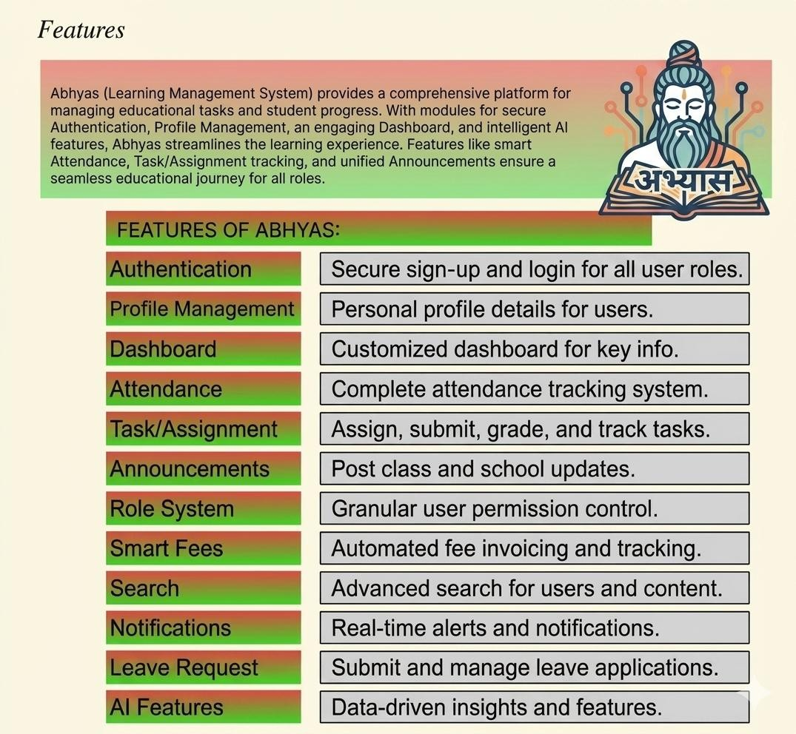
Figure 4- Features of Abhyas

Functionalities

Functional Requirements
Functional requirements describe what the system must do. These are the actual actions and features that the system needs to carry out so that users can do their work properly (AltexSoft Editorial Team, 2023).

Table 1- Functional Requirement of Abhyas
Requirement ID | Functional Requirement | Description
FR-001 | User Authentication | Lets users register an account, log in securely, log out, and change their password.
FR-002 | Profile Management | Allows users to set or change username, upload a profile picture, and edit basic info.
FR-003 | Dashboard | Shows today's tasks, attendance status, and latest announcements in one place.
FR-004 | Attendance System | Users can mark present once per day. Auto absent runs at end of day. History is viewable.
FR-005 | Task / Assignment System | Teachers post tasks, students submit and reupload before deadline. Status is tracked.
FR-006 | Announcements | Teachers and admins post announcements. All students can view them.
FR-007 | Role System | Teachers can manage tasks and attendance. Students can only view and submit.
FR-008 | Smart Fees | Admin marks fees as paid or unpaid. Students can see their fee status.
FR-009 | Search | Users can search tasks or announcements by title or keyword.
FR-010 | Notifications | Students get alerts for new tasks and deadline reminders.
FR-011 | Leave Request | Students apply for leave. Teachers approve or reject the request.
FR-012 | Bookmark | Students can save important tasks to their bookmarks list.

Non Functional Requirements
Non-functional requirements describe how the system should behave. They are about performance, security, and reliability rather than specific features.

Table 2- Non Functional Requirements of Abhyas

Requirement ID | Non Functional  Requirement | Description
NFR-001 | Performance | Pages should load within 2 to 3 seconds even with multiple users active at the same time.
NFR-002 | Usability | The interface should be simple enough for any student or teacher to use without training.
NFR-003 | Security | All user data is protected. Passwords are stored in encrypted form. Sessions are secure.
NFR-004 | Scalability | The system should handle more users and data as the number of students grows over time.
NFR-005 | Availability | The system should be available at all times and work on any browser or device.

Development Methodology
We have chosen the Agile model for developing Abhyas. Agile is a way of building software step by step instead of trying to build everything at once. It lets us get feedback early, fix problems quickly, and adjust the plan if something changes. This is a good fit for our project because we are building it as part of a semester, which means we need to manage our time carefully and keep making progress in small stages (Gurnov, 2025).

Framework
We will use the Scrum framework as our specific approach within Agile. Scrum works by dividing the work into short periods called Sprints, usually one to two weeks long. At the start of each sprint, we plan what we are going to build. Then we work on it and check the results at the end. This helps us stay on track and know exactly where we are at all times (Malsam, 2024).
We will hold short daily check-ins to talk about what we did, what we plan to do next, and if anything is blocking us. At the end of each sprint, we review the work and discuss what went well and what can be improved. This cycle keeps the development process moving forward in a healthy way.
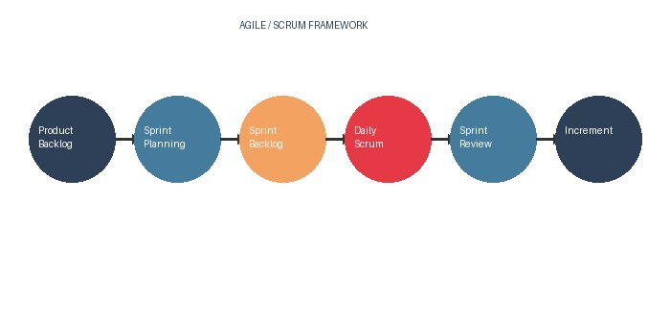

Figure 5- Agile Scrum Framework

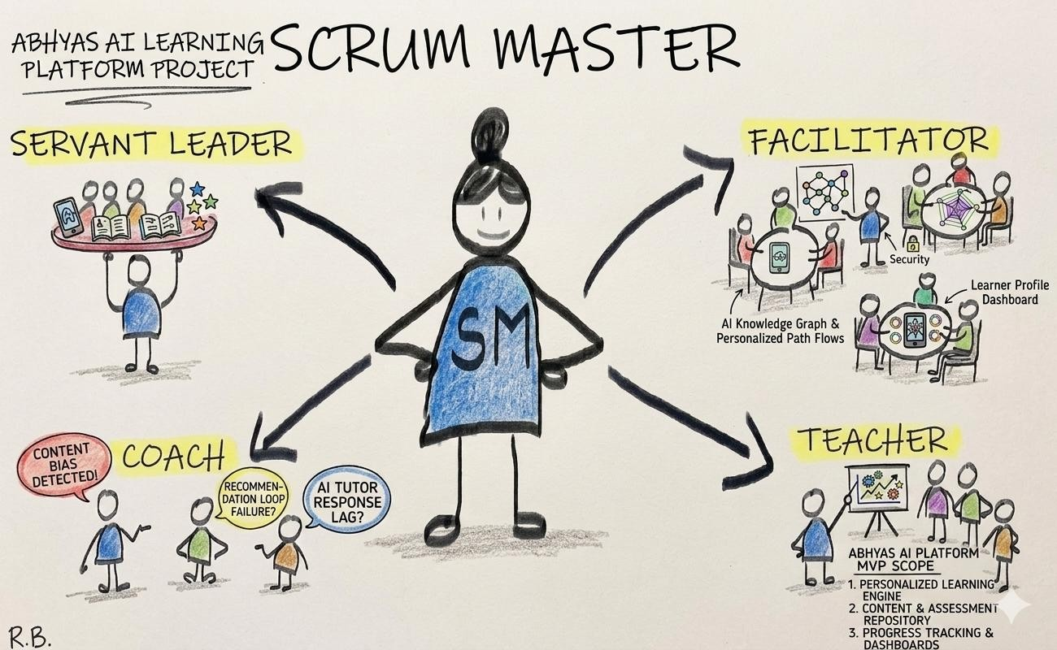

Figure 6- Scrum Master

The Scrum Master in our team is responsible for making sure the team follows the Scrum process. They help remove any blockers that slow the team down and make sure everyone is communicating well.

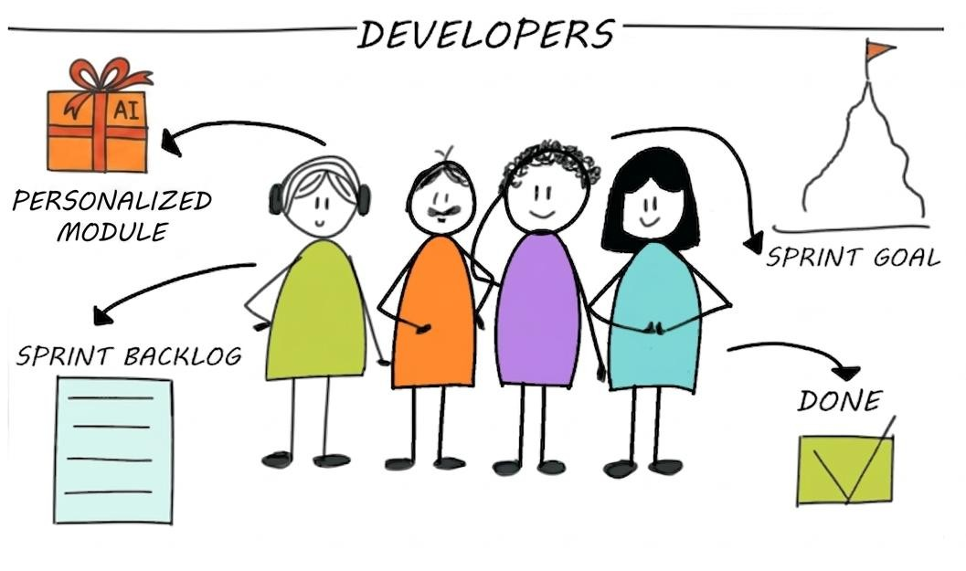

Figure 7- Developers
The developers in our team are responsible for actually building the features. Each sprint, developers pick tasks from the sprint backlog and work on completing them. They collaborate and help each other when something is difficult.

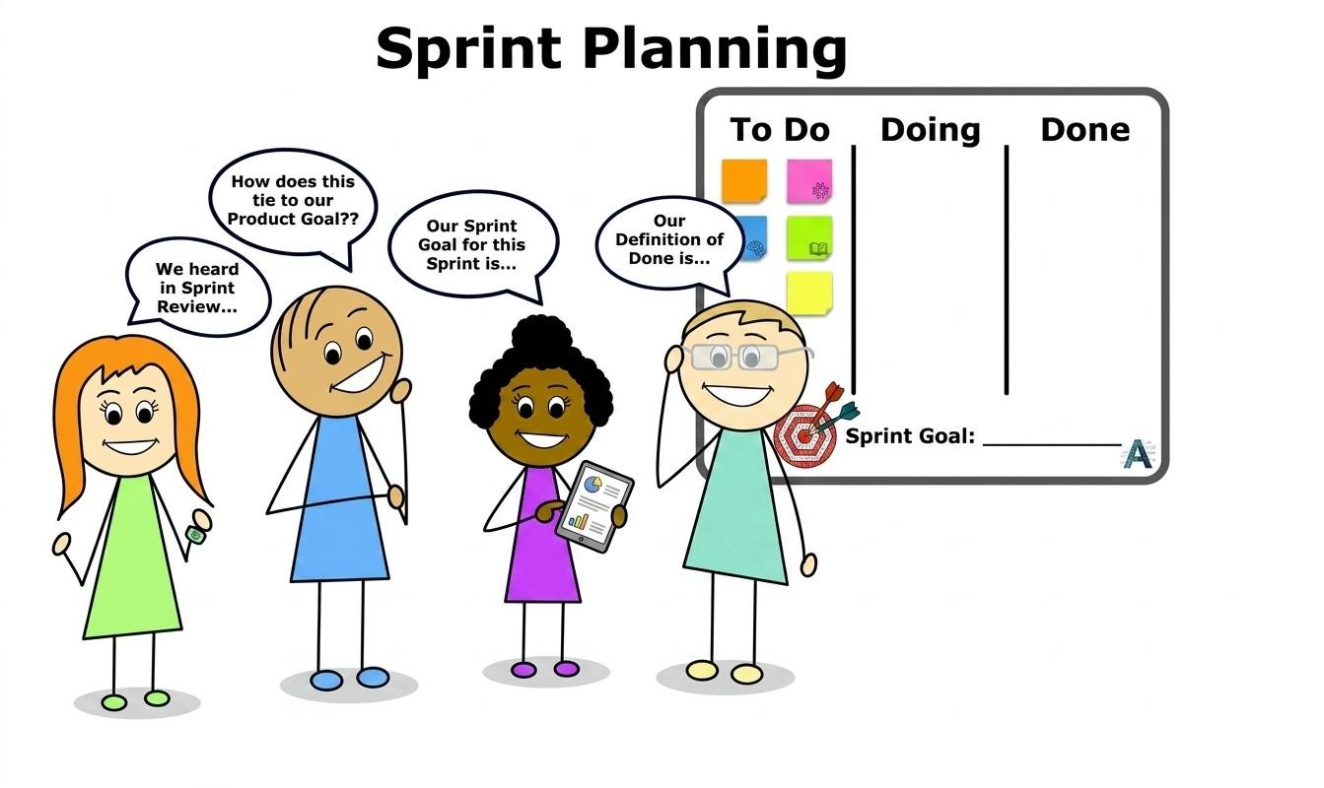

Figure 8- Sprint Plaining
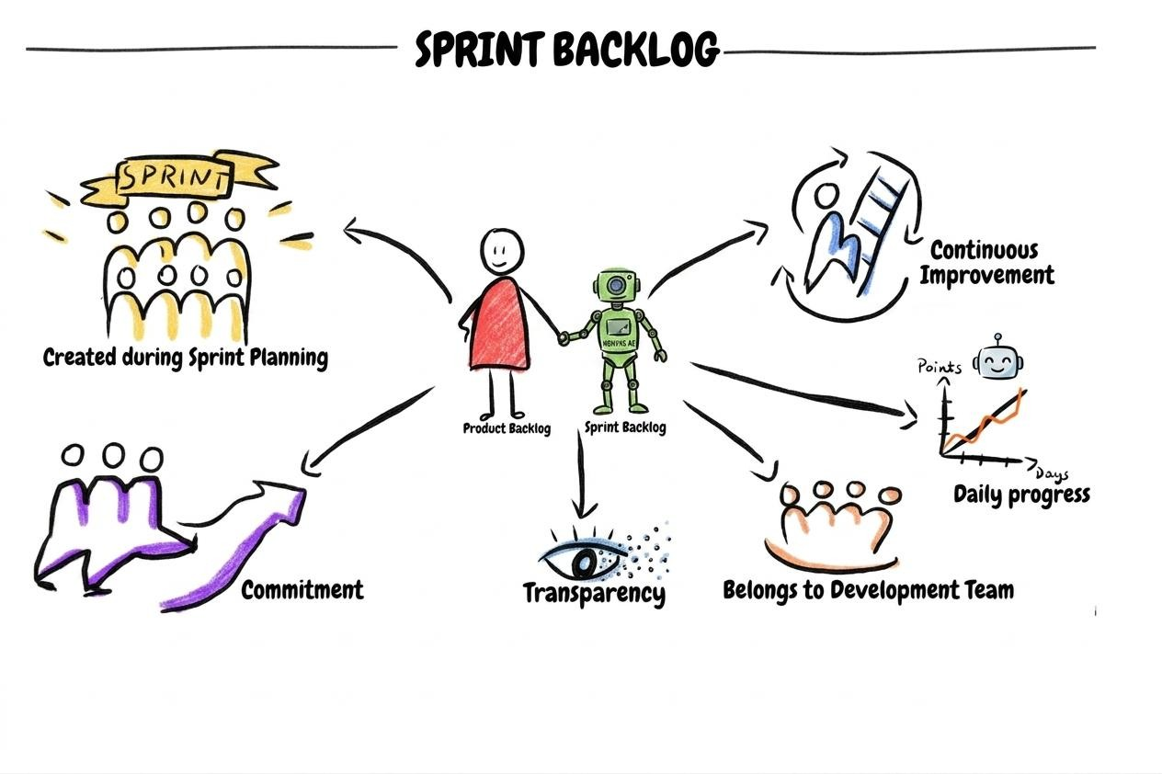
Figure 9- Sprint Backlog
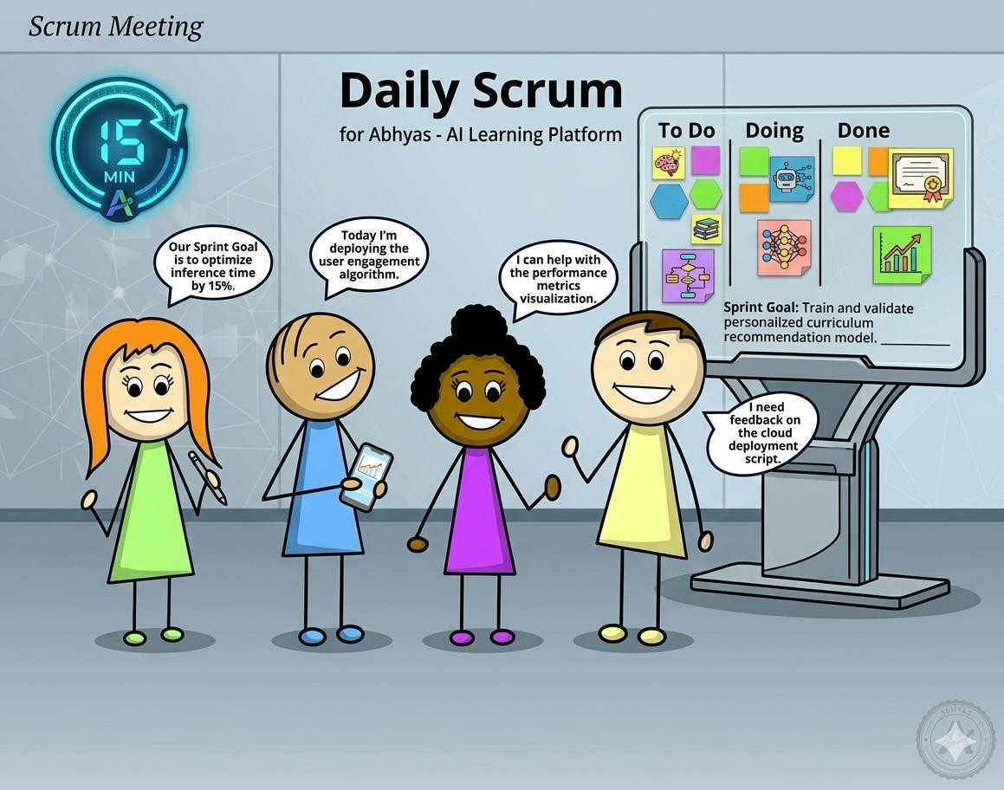

Figure 10- Scrum Meeting

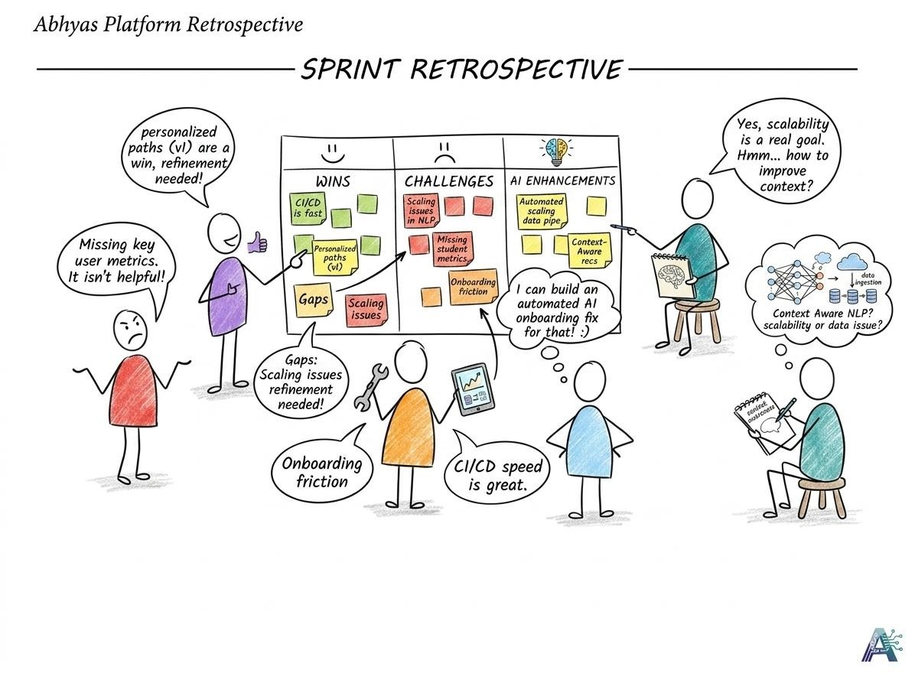

Figure 11- Scrum Retrospective

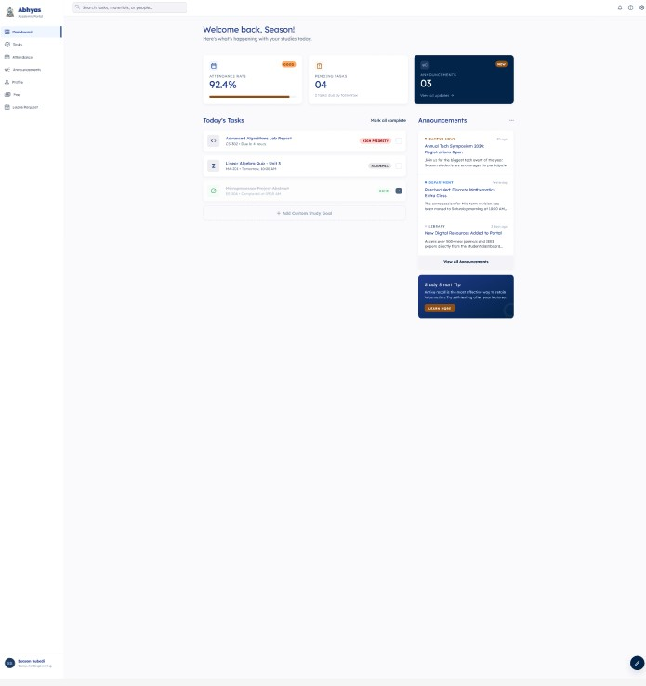
Figure 12-Sample Theme

Tools and Technologies
Here is a list of tools and technologies we will be using to build and manage the Abhyas project:
- Visual Studio Code as our main code editor
- Trello for managing tasks and keeping track of sprint progress
- Google Meet and WhatsApp for team communication and meetings
- Figma for designing the UI prototype before building it
- Plain HTML/CSS/JS for the front end
- Flask for the back end
- MySQL for the database
- Git and GitHub for version control and collaboration
- Draw.io for drawing system diagrams
- MS Word, MS Excel, and Google Docs for writing documentation and sprint records

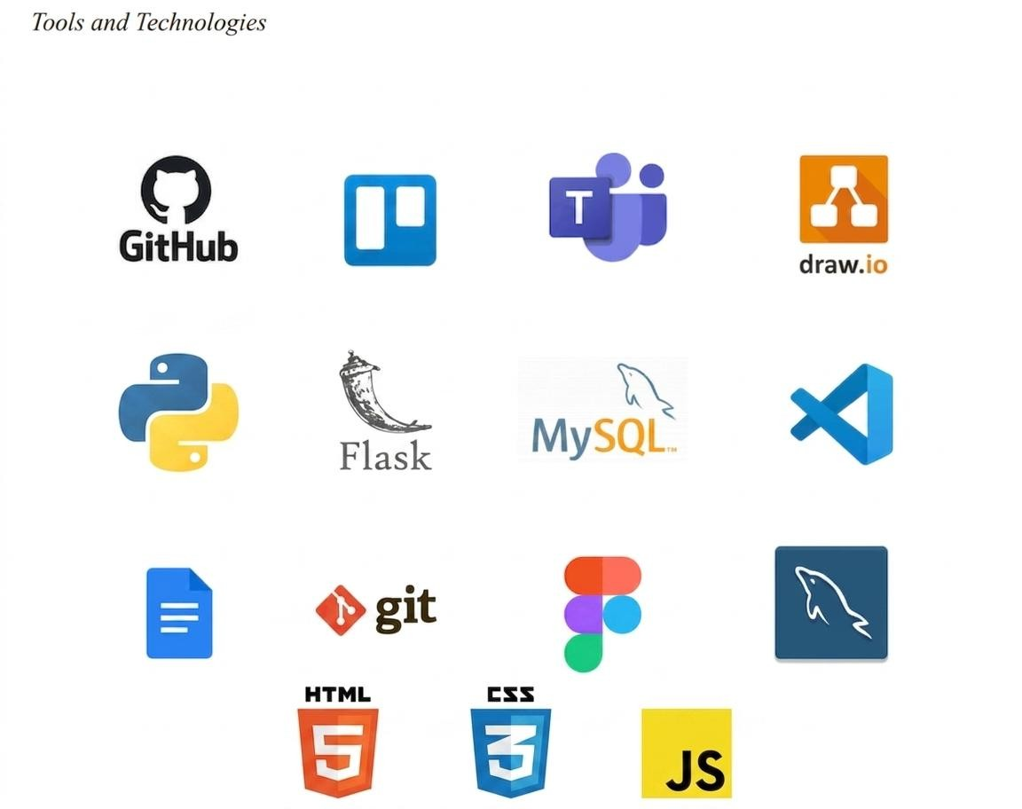
Figure 13- Tool and Technique

Conceptual Diagram
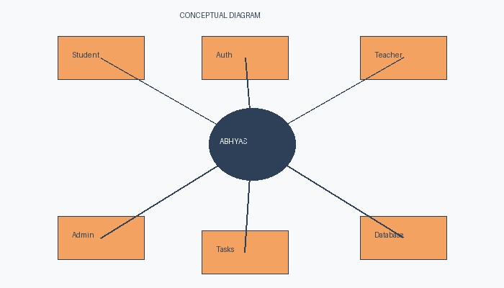
Figure 14- Conceptual Diagram of Abhyas

Scope
- Student and teacher account management
- Daily attendance tracking and history
- Assignment posting, submission, and deadline tracking
- Announcement board for teachers and admins
- Fee payment status tracking for students
- Role-based access for students, teachers, and admins
- Leave request management
- Search, notifications, and bookmark features
- Optional features: dark mode, simple chat, basic AI tools

SWOT Analysis
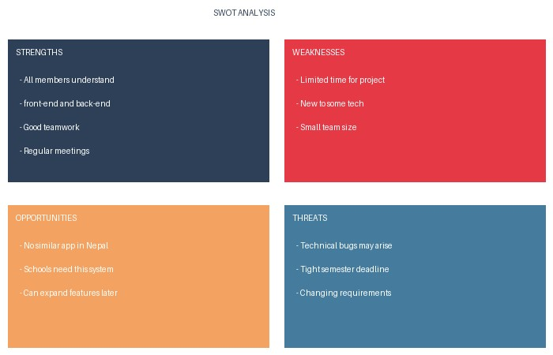
Figure 15-: SWOT Analysis of Abhyas

Conclusion
Abhyas is a practical and straightforward education management system that is built to solve real problems faced by students and teachers in Nepal. By putting attendance, assignments, announcements, fees, and other tools into one web-based platform, Abhyas removes the confusion and inefficiency that comes from managing all of these things separately.
This proposal has described the goals, features, methodology, and scope of the project. The system is designed to be simple to use so that any student or teacher can get started without needing technical knowledge. The Agile and Scrum approach will help us build the system step by step while making sure we stay on track and deliver something that actually works.
Overall, Abhyas has the potential to genuinely improve the daily experience of students and teachers by giving them one reliable platform they can depend on. We are confident that with good teamwork and proper planning, we will be able to deliver a working system that meets the needs of our users.

References
AltexSoft Editorial Team. (2023, November 30). Functional and nonfunctional requirements.
https://www.altexsoft.com/blog/functional-and-non-functional-requirements-specification-and-types
Gurnov, A. (2025, April 4). What is Agile methodology in Project Management? Wrike.
https://www.wrike.com/project-management-guide/faq/what-is-agile-methodology-in-project-management/
Joshi, A. (2024, September 10). Nepal's persistent digital divide.
https://thehimalayantimes.com/opinion/nepals-persistent-digital-divide-from-high-penetration-to-inclusion
Malsam, W. (2024, August 16). Scrum methodology: An introduction to the scrum process. ProjectManager.
https://www.projectmanager.com/blog/scrum-methodology
What is Scrum? - Scrum Methodology Explained - AWS. (n.d.). Amazon Web Services, Inc.
https://aws.amazon.com/what-is/scrum/
MySQL Documentation. (n.d.).
https://dev.mysql.com/doc/
Flask Documentation. (n.d.).
https://flask.palletsprojects.com/
Google Classroom Help Center. (n.d.).
https://support.google.com/edu/classroom
Microsoft Teams for Education. (n.d.).
https://www.microsoft.com/education/products/teams
IEEE. (1998). IEEE Recommended Practice for Software Requirements Specifications.
https://ieeexplore.ieee.org/

