Learners have to develop a Report to support the answers to the following questions and suggestions.

Objective Questions:
- In analyzing the hospital dataset with Power BI, ensure data cleaning to address inconsistencies and missing values before further analysis.

- Assess the Average Waiting Time: Analyse the patient wait times to identify the average duration a patient spends before receiving care.
ANSWER:- Average_waittime = AVERAGE('Hospital ER (1)'[patient_waittime])
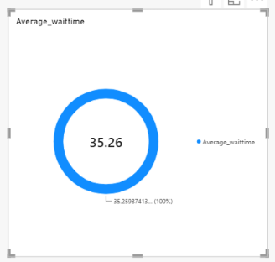

- Visits by Department Referral: Calculate the total number of visits to each department based on referrals to understand which departments are most frequently visited.
ANSWER:- Department Visits = COUNTROWS('Hospital ER (1)')
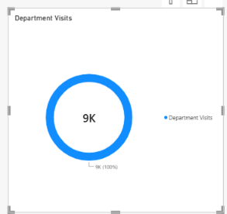

- Patient Visits by Age Group: Segregate patient visits according to different age groups to see which demographics utilize healthcare services the most.
ANSWER:- Age Group = SWITCH( TRUE(), 'Hospital ER (1)'[patient_age] <= 5, "0-5",
'Hospital ER (1)'[patient_age] <= 17, "6-17",
'Hospital ER (1)'[patient_age] <= 34, "18-34",
'Hospital ER (1)'[patient_age] <= 49, "35-49",
'Hospital ER (1)'[patient_age] <= 64, "50-64",
"65+")
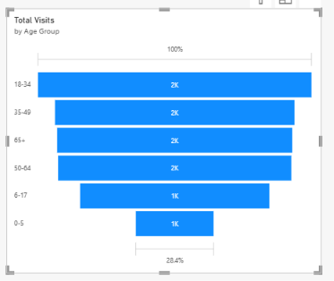

- Were there any Null values in the data? What would be the best way to handle these Null values and which approach have you opted for?
      - ANSWER:- (A) Numerical columns: For missing values in columns such as Patient Waittime or Billing Amount, I considered replacing them with the median or average, depending on the data distribution and business requirements.
- Categorical columns: For missing values in Department Referral or Gender, I used an appropriate category such as "Unknown" when necessary.
- Date columns: I checked missing dates and excluded records from date based analysis when the date could not be reliably recovered.
- Critical missing values: I removed records only when the missing information made them unsuitable for the analysis and could not be recovered reliably.
APPROACH:- I used Power Query to identify and handle NULL values based on the column type and business requirements. I avoided replacing every missing value with an average because it could distort the analysis.

6.Is there any relation between the number of visits and the Gender of the patients?
ANSWER:- Gender Visits = CALCULATE(COUNTROWS('Hospital ER (1)'),
'Hospital ER (1)'[patient_gender] IN {"Male", "Female"}
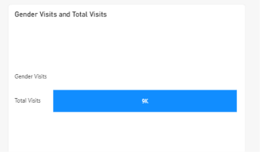

- Average Satisfaction by Demographics: Determine the relationship between patient satisfaction scores, their age groups, and racial backgrounds to pinpoint areas for improvement in patient experience.
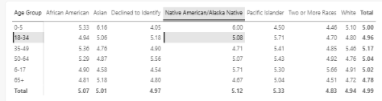
ANSWER:-
        - Average_patient_satisfaction = AVERAGE('Hospital ER (1)'[patient_sat_score])
        - Age Group = SWITCH( TRUE(), 'Hospital ER (1)'[patient_age] <= 5, "0-5",'Hospital ER (1)'[patient_age] <= 17, "6-17", 'Hospital ER (1)'[patient_age] <= 34, "18-34", 'Hospital ER (1)'[patient_age] <= 49, "35-49", 'Hospital ER (1)'[patient_age] <= 64, "50-64", "65+")

- The hospital's managing director seeks to evaluate the revenue of each department to understand how much revenue is generated by each.
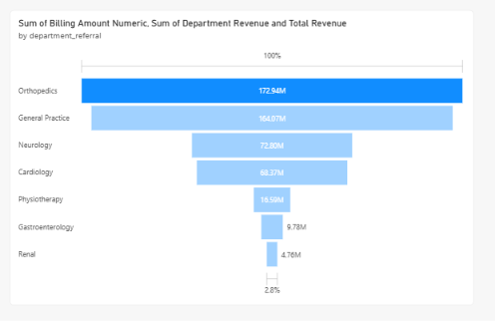
ANSWER:-

- Which department is charging the highest appointment fees in general? Use an aggregation DAX function to solve this question.
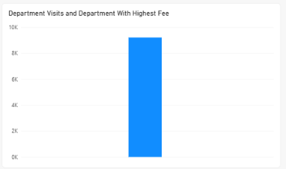
ANSWER:- Department With Highest Fee = VAR MaxFees=MAXX( ALL('Sheet1'),'Sheet1'[Appointment Fees])RETURN , CALCULATE (SELECTEDVALUE('Sheet1'[department_referral]),'Sheet1'[Appointment Fees]=MaxFees )

- Create a tabular visualization in the Report view which consists of Month-wise total visits in the hospital. Add a third column in the table that consists of the previous month’s total visits for each month’s row. Also, include a column that states whether the visits in a month are greater than that of the previous month's visits.
ANSWER:- 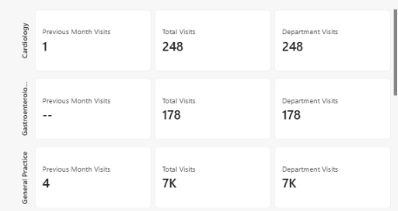

- Using ‘Calculate’ and a row iteration DAX function calculate the total number of patients who have visited Dr. Smith.
ANSWER:- 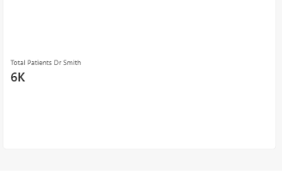
Total Patients Dr Smith = CALCULATE(SUMX('Sheet1',1),
'Sheet1'[Doctor Name]= "Dr. Smith")

- Calculate the average age of the patients who visit the Orthopedics department. Will the approach used to calculate this metric be different if the requirement had been all departments’ average age?
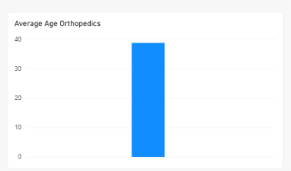
ANSWER:- Average Age Orthopedics = CALCULATE( AVERAGE('Hospita lER (1)'[patient_age]),'Hospital ER (1)'[department_referral] = "Orthopedics")

- Were there any data format issues in the data, and if there were/are how you handle them?
ANSWER:- "Yes, I checked the hospital dataset for data format issues in Power Query Editor. I corrected incorrect data types, converted text based numerical values into numeric formats, standardized inconsistent text values, and handled extra spaces. This improved data consistency and helped ensure accurate analysis in Power BI."
- Date → Date
- Age → Whole Number
- Patient Waittime → Whole Number or Decimal Number
- Billing Amount → Decimal Number
- Gender → Text

- When we add a column in Power Query what’s the code that comes in M language in the formula bar? What do you know about M-query?
ANSWER:-
- Identify the top 5 doctors who generated the most revenue but had the fewest patients. (SQL)
ANSWER:- USE hospital_analytics;
SELECT
doctor_id,
doctor_name,
SUM(total_bill) AS total_revenue,
COUNT(DISTINCT patient_id) AS patient_count
FROM doctor_patients
GROUP BY
doctor_id,
doctor_name
ORDER BY
total_revenue DESC,
patient_count ASC
LIMIT 5;

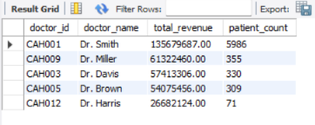
OUTPUT:-

- Find the department where the average waiting time has decreased over three consecutive months. (SQL)
ANSWER:- USE hospital_analytics;
WITH Monthly_Wait AS (
SELECT
Department_Referral AS Department,
YEAR(`Date`) AS Visit_Year,
MONTH(`Date`) AS Visit_Month,
ROUND(AVG(Patient_Waittime), 2) AS Avg_Waiting_Time
FROM hospital_er
WHERE `Date` IS NOT NULL
AND Department_Referral IS NOT NULL
AND Patient_Waittime IS NOT NULL
GROUP BY
Department_Referral,
YEAR(`Date`),
MONTH(`Date`)
),

Compare_Wait AS (
SELECT
Department,
Visit_Year,
Visit_Month,
Avg_Waiting_Time,

LAG(Avg_Waiting_Time, 1) OVER (
PARTITION BY Department
ORDER BY Visit_Year, Visit_Month
) AS Previous_Month_Wait,

LAG(Avg_Waiting_Time, 2) OVER (
PARTITION BY Department
ORDER BY Visit_Year, Visit_Month
) AS Two_Months_Ago_Wait

FROM Monthly_Wait
)

SELECT
Department,
Visit_Year,
Visit_Month,
Two_Months_Ago_Wait,
Previous_Month_Wait,
Avg_Waiting_Time
FROM Compare_Wait
WHERE Avg_Waiting_Time < Previous_Month_Wait
AND Previous_Month_Wait < Two_Months_Ago_Wait
ORDER BY
Department,
Visit_Year,
Visit_Month;
OUTPUT:- 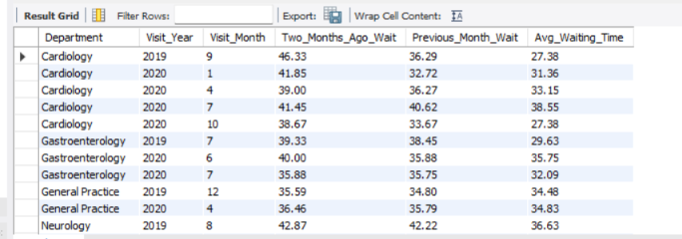

- Determine the ratio of male to female patients for each doctor and rank the doctors based on this ratio. (SQL)
ANSWER:- USE hospital_analytics;
WITH Doctor_Gender_Count AS (
SELECT
doctor_id,
doctor_name,
SUM(CASE
WHEN patient_gender = 'Male' THEN 1
ELSE 0
END) AS Male_Patients,
SUM(CASE
WHEN patient_gender = 'Female' THEN 1
ELSE 0
END) AS female_patients
FROM patient_complete_data
GROUP BY doctor_id, doctor_name
)

SELECT
doctor_id,
doctor_name,
male_patients,
female_patients,
ROUND(
male_patients / NULLIF(female_patients, 0),
2
) AS male_female_ratio,
RANK() OVER (
ORDER BY male_patients / NULLIF(female_patients, 0) DESC
) AS doctor_rank
FROM doctor_gender_count
ORDER BY doctor_rank;
OUTPUT:- 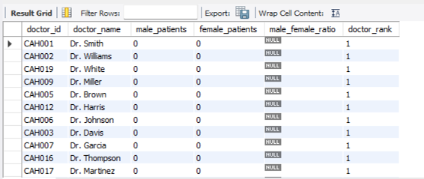

- Calculate the average satisfaction score of patients for each doctor based on their visits. (SQL)
ANSWER:- USE hospital_analytics;
SELECT
doctor_id,
doctor_name,
ROUND(AVG(`patient_sat_score`), 2) AS Average_Satisfaction_Score
FROM patient_complete_data
WHERE `patient_sat_score` IS NOT NULL
GROUP BY doctor_id, doctor_name
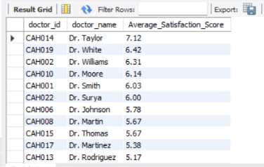
ORDER BY Average_Satisfaction_Score DESC;
OUTPUT:-

- Find doctors who have treated patients from different races and calculate the diversity of their patient base. (SQL)
ANSWER:- USE hospital_analytics;

SELECT
doctor_name,
COUNT(DISTINCT patient_race) AS Total_Races,
COUNT(DISTINCT patient_id) AS Total_Patients,
GROUP_CONCAT(
DISTINCT patient_race
ORDER BY patient_race
SEPARATOR ', '
) AS Patient_Races
FROM patient_complete_data
WHERE doctor_name IS NOT NULL
AND patient_race IS NOT NULL
GROUP BY doctor_id, doctor_name
HAVING COUNT(DISTINCT patient_race) > 1
ORDER BY Total_Races DESC, Total_Patients DESC;
OUTPUT:- 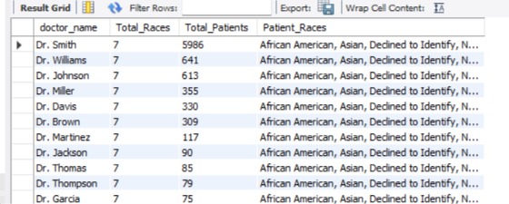

- Calculate the ratio of total bills generated by male patients to female patients for each department. (SQL)
ANSWER:- USE hospital_analytics;

SELECT
er_department_referral AS Department,

SUM(CASE
WHEN patient_gender = 'Male' THEN total_bill
ELSE 0
END) AS Male_Total_Bill,

SUM(CASE
WHEN patient_gender = 'Female' THEN total_bill
ELSE 0
END) AS Female_Total_Bill,

ROUND(
SUM(CASE
WHEN patient_gender = 'Male' THEN total_bill
ELSE 0
END)
/
NULLIF(
SUM(CASE
WHEN patient_gender = 'Female' THEN total_bill
ELSE 0
END),
0
),
2
) AS Male_Female_Bill_Ratio

FROM patient_complete_data
GROUP BY er_department_referral
ORDER BY er_department_referral;
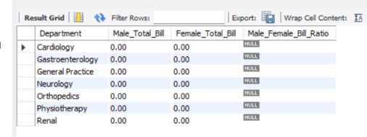
OUTPUT:-

- Update the patient satisfaction score for all patients who visited the "General Practice" department and had a waiting time of more than 30 minutes. Increase their satisfaction score by 2 points, but ensure that the satisfaction score does not exceed 10. (SQL)
ANSWER:- USE hospital_analytics;

UPDATE patient_complete_data
SET patient_sat_score = LEAST(patient_sat_score + 2, 10)
WHERE er_department_referral = 'General Practice'
AND patient_waittime > 30;

Subjective Questions

- What is the relation between patient wait time and satisfaction scores?
ANSWER:-
Approach:-
Average Satisfaction = AVERAGE('Hospital ER (1)'[Patient_ Satisfaction])
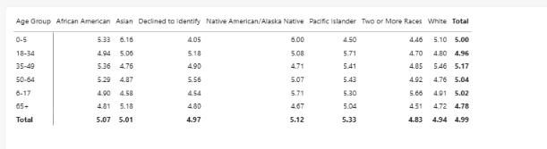

- Insights:- Overall Satisfaction: The hospital's overall average patient satisfaction score is 4.99.
- Highest Satisfaction Age Group: Patients aged 35–49 years have the highest average satisfaction score of 5.17.
- Lowest Satisfaction Age Group: Patients aged 65 and above have the lowest average score of 4.78, indicating an opportunity to improve their experience.
- Highest Satisfaction by Race: Pacific Islander patients report the highest overall average satisfaction score of 5.33.
- Lowest Satisfaction by Race: Patients who declined to identify their racial background have the lowest overall average score of 4.97.
- Age Group Comparison: Satisfaction varies across age groups, with the 35–49 group scoring highest and the 65+ group scoring lowest.
- Potential Improvement Area: The hospital should investigate the experiences of elderly patients and review whether waiting times, accessibility, or communication affect their satisfaction.

- How do patient demographics affect the frequency of visits to different departments?
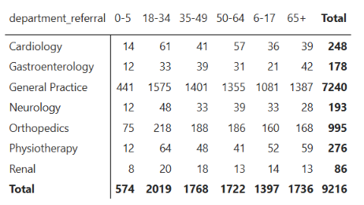
ANSWER:-
Approach:- Data cleaning , Create age group, Create A Matrix Visual, Analyz Reports

- INSIGHTS:- General Practice: It has the highest number of visits, with 7,240 visits. Patients aged 18–34 contribute the most visits (1,575), followed by those aged 35–49 (1,401) and 65+ (1,387).
- Age Group 18–34: This group records the highest total visits, with 2,019 visits, indicating that younger adults contribute significantly to hospital visits.
- Age Group 65+: Older patients account for 1,736 visits, showing considerable demand for healthcare services, particularly in General Practice and Gastroenterology.
- Cardiology: Records 248 visits, with the highest number among patients aged 18–34 (61), followed by those aged 50–64 (57).
- Orthopedics: Records 995 visits, with patients aged 18–34 contributing the most (218), followed by those aged 35–49 (188).
- Department Preference: General Practice receives substantially more visits than any other department, suggesting that it serves as the primary point of care for many patients.

- Recommendation:- Improve General Practice Services: Since General Practice has the highest number of visits (7,240), increase staff availability and optimize appointment scheduling to reduce patient waiting times.
- Focus on Young Adults: The 18–34 age group has the highest number of visits (2,019). Ensure adequate healthcare services and resources are available to meet their needs.
- Support Senior Patients: Patients aged 65+ account for 1,736 visits. Provide accessible healthcare services, regular health checkups, and appropriate support for older patients.
- Optimize Department Resources: Allocate doctors, staff, and medical equipment according to department wise patient demand.
- Monitor Patient Trends: Regularly analyze age group and department wise visits to identify changing healthcare needs and plan resources effectively.
- Improve Patient Experience: Monitor waiting times and patient satisfaction across all departments to identify areas for improvement and deliver better healthcare services.

- Is there a noticeable trend in the volume of patient visits throughout the year?
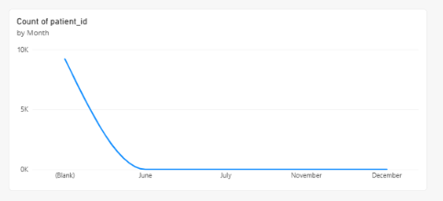
ANSWER:-
Approach:- Data Cleaning, Create Month Column, Create Visualization Line Chart
- Insights:- Monthly Fluctuations: Patient visits may increase or decrease across different months, indicating changes in hospital demand.
- Peak Periods: Months with the highest visits represent periods when additional doctors, staff, and medical resources may be required.
- Low Visit Periods: Months with fewer visits provide opportunities to schedule staff training, equipment maintenance, and other hospital activities.
- Demand Planning: Analyzing monthly visit patterns helps the hospital prepare for changes in patient volume and manage resources efficiently.
- Trend Monitoring: Comparing monthly visits helps identify sudden increases or decreases that may require further investigation.

- Recommendations:- Ensure sufficient doctors and staff are available during months with higher patient visits.
- Plan medical supplies and resources according to monthly demand.
- Investigate reasons for sudden increases or decreases in patient visits.
- Monitor monthly trends regularly to improve hospital planning and patient care.
- Which age groups report the highest and lowest satisfaction scores?
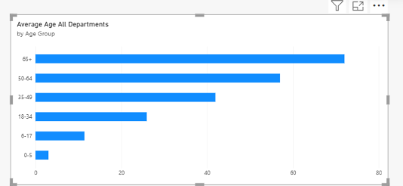
ANSWER:-
Approach:- Average Satisfaction =AVERAGE('Hospital ER (1)'[Patient Satisfaction Score])

- Insights:- Highest Satisfaction: Identify the age group with the highest average satisfaction score from the chart.
- Lowest Satisfaction: Identify the age group with the lowest average satisfaction score.
- Patient Experience: Differences in scores may indicate that some age groups have a better hospital experience than others.
- Improvement Areas: Investigate waiting times, department services, and patient feedback for age groups with lower satisfaction.
- Recommendations:- Focus on improving services for age groups reporting lower satisfaction.
- Monitor waiting times and service quality across all age groups.
- Collect patient feedback to understand the reasons behind lower satisfaction scores.
- Review satisfaction trends regularly to evaluate improvements.

- Say someone outside of the hospital claims that there is racial or gender-based discrimination in the hospital, how will you identify whether the claim was right or not?
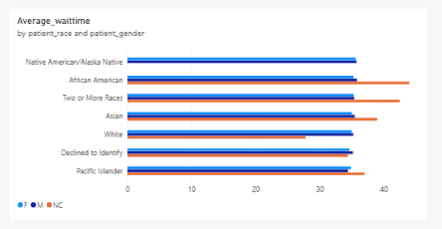
ANSWER:-
Approach:-

- 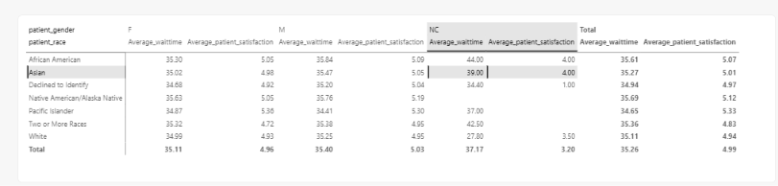
Insighs:- Differences in waiting times between racial or gender groups may indicate areas that need further investigation.
- Lower satisfaction scores for a particular group may suggest differences in patient experience.
- Differences in billing amounts should be examined in the context of treatment received and services provided.
- Consistent differences across several measures may warrant a more detailed investigation.
- Recommendations:- • Differences in waiting times between racial or gender groups may indicate areas that need further investigation.
- Lower satisfaction scores for a particular group may suggest differences in patient experience.
- Differences in billing amounts should be examined in the context of treatment received and services provided.
- Consistent differences across several measures may warrant a more detailed investigation.

- The hospital management intends to offer discounts to patients. How should these offers/discounts be assigned to patients, on what basis, and why?
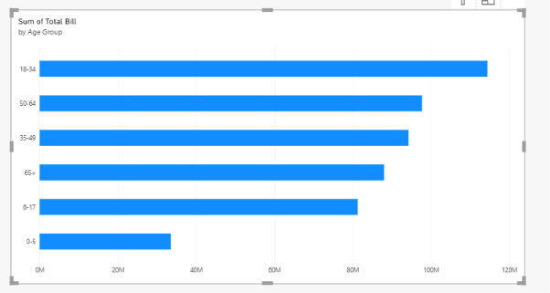
ANSWER:-
Approach:-
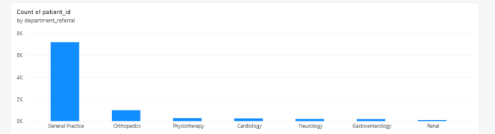
Insights:- The analysis can help the hospital identify patients with high medical expenses, frequent visits, or other indicators that warrant further eligibility assessment. The hospital can then design targeted discount programs without giving unnecessary discounts to every patient.
Recommendation:- The hospital should introduce a transparent, need based discount policy that prioritizes financially disadvantaged patients, provides assistance for high eligible medical bills, and encourages preventive healthcare. Regularly reviewing discount usage and its impact on patient access and hospital revenue will help management maintain both affordability and financial sustainability.

- The hospital has a budget to hire 2-3 new doctors. They have asked for your suggestions on which departments they should hire.
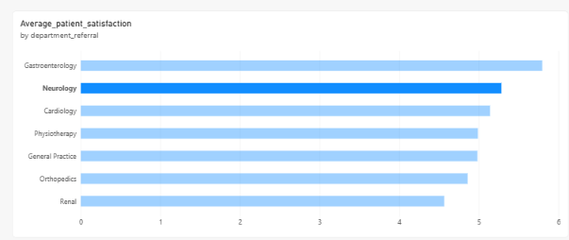
ANSWER:-
Approach:-
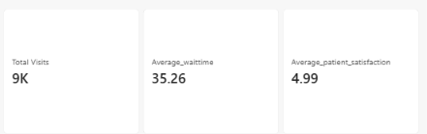

- Is the hospital profitable? How will you determine the profitability?
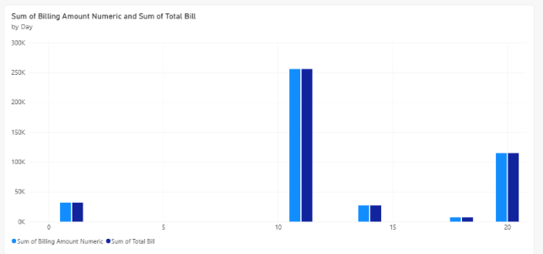
ANSWER:-
Approach:-

Insights:-
Positive profit: Revenue exceeds expenses.
Negative profit: Expenses exceed revenue.
Low profit margin: The hospital may need to review operating costs.
High revenue but low profit: Expenses may be consuming a large share of revenue.
Recommendation:-
- Control Operating Costs: Review expenses such as staff salaries, medical supplies, equipment maintenance, and utility bills to identify opportunities for cost reduction.
- Improve Revenue Generation: Identify departments generating higher revenue and evaluate opportunities to improve services in departments with lower revenue.
- Optimize Resource Utilization: Ensure doctors, hospital beds, and medical equipment are used efficiently to reduce unnecessary expenses.
- Monitor Monthly Performance: Use Power BI dashboards to compare monthly revenue, expenses, and profit to identify financial trends.
- Analyze Department Performance: Compare revenue and expenses across departments to identify areas that need financial improvement.
- Track Profit Margins: Calculate net profit and profit margin regularly to evaluate the hospital's financial performance.

- Any Department for which the waiting time is oddly large?
ANSWER:--
Approach:-
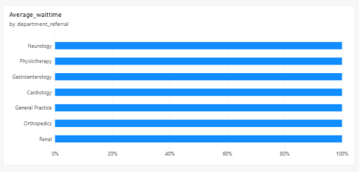
Insights:-
- Departments with higher average waiting times may have insufficient staff or high patient demand.
- Departments with lower average waiting times may be managing patient flow more efficiently.
- Management should investigate departments with unusually long waits and review staffing, appointment scheduling, and patient volumes.
Recommendation:-
- Increase staffing in departments with consistently long waiting times.
- Improve appointment scheduling and patient flow management.
- Monitor waiting times monthly using a Power BI dashboard.
- Investigate unusually long individual waits to identify operational bottlenecks.
- Come up with strategies to provide discounts to the patients.
ANSWER:-
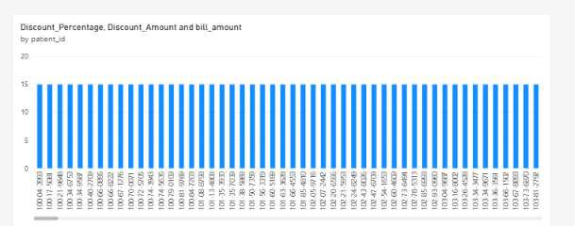
Approach:-

Insigts:-
- Income based discounts can improve access to healthcare for financially disadvantaged patients.
- Frequent visit discounts may encourage patient retention.
- Monitoring discounts against revenue helps management control costs.
- Comparing patient satisfaction before and after discounts can help evaluate their effectiveness.
Recommendation:-
- Prioritize financially disadvantaged patients.
- Establish transparent discount eligibility criteria.
- Set a discount budget to protect hospital profitability.
- Review discount effectiveness monthly using Power BI.
- Ensure discounts are assigned fairly, without discrimination based on race or gender.
- Say you need to align the doctors of the “General Practice” department to work in one of the two shifts, how will you identify what will these two shifts' timings be, and how will you divide the doctors in these two shifts? And also will this 2 shift policy be helpful for the hospital?

ANSWER:-
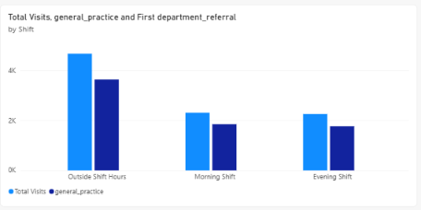
Approach:-
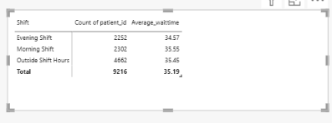

Insights:-
- Patient Visit Distribution: Compare the number of patient visits during the morning and evening shifts to identify peak hours.
- Waiting Time: The shift with a higher average waiting time may require additional doctors to manage patient demand.
- Doctor Allocation: Assign more doctors to the shift with higher patient volume and longer waiting times.
- Resource Utilization: If patient visits are low during a particular shift, management can review doctor allocation and scheduling.
- Patient Satisfaction: Compare satisfaction scores across both shifts to determine whether waiting times affect the patient experience.
- Two Shift Policy: Implementing two shifts based on patient demand can improve doctor utilization, reduce waiting times, and improve patient satisfaction.
Recommendation:-
- Identify Peak Hours: Analyze patient visits by hour to identify the busiest periods in the General Practice department.
- Allocate Doctors Properly: Assign more doctors to the shift with higher patient demand and longer waiting times.
- Reduce Waiting Time: Monitor average patient waiting time in both shifts and adjust staffing when delays increase.
- Improve Patient Satisfaction: Compare satisfaction scores across shifts and identify areas that need improvement.
- Monitor Shift Performance: Use a Power BI Matrix to compare total patient visits and average waiting time for morning and evening shifts.
- Evaluate the Two Shift Policy: Compare waiting times and patient satisfaction before and after introducing the policy to determine whether it is effective.

- What do you understand by PowerBI gateway? What are its use cases?
ANSWER:-
Meaning Of PowerBI Gateway:-
A Power BI Gateway is a software that securely connects data sources, such as MySQL databases, SQL Server, or Excel files stored on a local computer or server, to the Power BI Service (online).
It allows Power BI to access updated data without manually uploading the data every time.
For Example:
If your hospital analytics project uses a MySQL database, a Power BI Gateway can connect that database to Power BI Service and refresh your hospital dashboard automatically.
Types of Power BI Gateway:-
Standard Gateway:- Suitable for organizations that need to share gateway connections across multiple users and reports.
Personal Gateway:- Designed for an individual user to refresh imported data; it does not support shared gateway connections or Direct Query.

- How would you approach this problem, if the objective and subjective questions weren't given?
ANSWER:-
If the objective and subjective questions were not given, I would first try to understand the dataset and the main goal of the project. Then, I would identify the important business problems and decide what insights could help the hospital improve its performance.
Approach:-
First, I would understand the hospital data and its main purpose. Then, I would clean the data and check for missing values or errors. After that, I would use SQL and Power BI to analyze patient visits, waiting times, satisfaction scores, and billing. Based on the results, I would identify problems and suggest improvements to help the hospital make better decisions.
Insights:-
The analysis can help identify which departments receive the most patients, when waiting times are high, and how satisfied patients are with the hospital's services. It can also show patterns in patient visits, doctor performance, and billing. These insights can help the hospital improve patient care, manage staff effectively, reduce waiting times, and make better decisions.
Recommendation:-
- Reduce Waiting Time: Assign more doctors to departments where patients wait longer.
- Improve Patient Satisfaction: Identify the reasons for low satisfaction scores and improve the quality of care.
- Manage Staff Properly: Allocate doctors and nurses according to patient demand.
- Improve Hospital Services: Focus on departments that receive more patients and need additional support.
- Monitor Performance: Use Power BI dashboards to track patient visits, waiting times, and satisfaction regularly.
- Make Data Based Decisions: Use the analysis to plan budgets, manage resources, and improve patient care.
- Can you analyze and write the type of relationship between the doctor id and department, is it one-to-one?
ANSWER:-
To identify the relationship between Doctor ID and Department, I would check how many different departments each doctor works in.
Identify The Relationship:-
- One to One: Each doctor is linked to only one department, and each department has only one doctor.
- Many to One: Many doctors work in one department, but each doctor belongs to only one department.
- Many to Many: A doctor can work in multiple departments, and each department can have multiple doctors.
Insights:-
- Multiple doctors can work in the same department, such as General Practice or Orthopedics.
- If each doctor works in only one department, the relationship is Many to One from Doctor to Department.
- If a doctor works in multiple departments, the relationship may be Many to Many.
- This analysis helps the hospital understand doctor allocation and plan staffing according to patient demand.
FINAL RECOMMENDATION:-
The hospital should maintain accurate doctor and department records and assign doctors according to their specialties and patient demand. Since multiple doctors can work in the same department, management should ensure that each department has enough doctors to provide timely treatment. Regularly reviewing doctor allocation and patient waiting times will help improve staff management and patient care.

Report
The hospital has asked for a report with three tabs:
- Main Tab
- Doctors’ Tab
- Patients’ Tab

- Using the Main tab in the report, the hospital should be able to look at the overall metrics like the number of daily visits, revenue produced on that day, customer satisfaction, how busy are different departments on that day, and general waiting time on that day. This tab should have a slicer of date.

- Using the Doctors’ Tab, the Chief Of Staff at the hospital should be able to look at the individual doctor’s performance metrics like customer satisfaction, the number of patients he was visited by, the revenue he has generated, and his appointment fees. This tab should have a slicer of the Doctor's Name or ID.

- Using the Patients’ Tab, the Patient’s Care Chief at the hospital wants to look at a customer’s profile which would involve metrics like the most frequently visited department, their age, their race, their waiting time, number of visits, the total amount that they have paid to the hospital, etc. All the metrics using which they can address the patient very carefully in their visits. This tab should have a slicer of the Patient's Name or ID.

Make sure that all the visualizations look decent and are placed in a proper order. Each tab has different POCs (Point Of Contact), so make sure you involve all the metrics that POC may look at in that tab along with those mentioned in the tab description.
After making the report on the Desktop ensure that it is hosted on PowerBI service and use the hosted link for submission of the dashboard and mentioning on the resume.

