Sensitivity of AI-Generated Credit Ratings to Elicitation Choices
Samir Chincholikar, Robin Chawla. Independent researcher, New York, USA.

Abstract
LLMs are increasingly used to support credit assessments, but it is unclear whether elicitation choices merely reveal a stable credit view or shape the rating. We examine this with a pre-registered specification-curve design that holds fundamentals fixed while varying how the assessment is elicited. A fixed 90-item battery spans a balanced grid of provider, model version, temperature, prompt paraphrase, output format, few-shot exemplars, and presentation, with three seeds (12,960 elicitations, three model families); credit-health profiles use a pre-specified Altman Z$″$ benchmark. Our estimand is stability, not accuracy. No controllable axis accounts for more than about 5% of rating variance, while run-to-run variation accounts for about a quarter. Instability persists even under deterministic execution (permutation $p=0.001$). Cross-specification agreement stays limited at every resolution: Fleiss’ $κ$ reaches at most 0.46 even for the investment-grade/high-yield split, for which 26.8% of matched pairs disagree; switching or pooling providers does not remove it. Modal calls imply 56.8% portfolio turnover, and a post-hoc recast swings the same $45 billion book between $2.0 and $4.2 billion of Pillar-1 capital. A complementary arm of 31 anonymized, perturbed real issuers under a decontamination gate shows the same instability. Elicitation specification is a material source of model risk.
Keywords: large language models, credit ratings, specification-curve analysis, model risk, reproducibility, investment grade

Introduction
Large language models (LLMs) are increasingly used as an analytic tool in finance, including for financial-statement interpretation, risk assessment, investment recommendations, and credit analysis [1]. In such applications a user usually provides financial information and asks the model to make a judgment such as a credit rating, risk category, or trading recommendation. Implicit in such use is the presumption that the model has a sufficiently stable underlying assessment, and that reasonable changes to the phrasing of the question simply reveal that assessment. If this assumption is correct, then choices such as prompt wording, output format, sampling temperature, or model provider are mostly procedural. If it does not hold, then these choices are embedded in the measurement process itself.
This distinction is of particular importance for credit evaluation. Credit ratings are categorical decisions with economically important cut points. The investment-grade/high-yield split influences index eligibility, ratings-based investment mandates, treatment of collateral, covenant provisions, cost of financing, and regulatory capital. A model that reaches different assessments because the same financial information is presented under a different but defensible elicitation specification can lead to materially different downstream decisions even when the underlying firm fundamentals are unchanged. In our experiments, around 27% of matched elicitation pairs place the same credit profile on opposite sides of the investment-grade/high-yield boundary. The key question we ask is therefore not whether an LLM can produce a plausible credit rating, but whether the rating is sufficiently stable when reasonable elicitation choices change.
Prompt sensitivity and run-to-run variability in LLMs have been well documented in computer science [2, 3], and recent work has shown related variability in LLM-generated financial recommendations [4]. But three questions remain unresolved for high-stakes credit applications. First, it is unclear how large this instability is in the units used by credit practitioners, rather than generic measures of textual variation. Second, the variation observed may be due to a small number of controllable design choices, in which case the instability could be mitigated through an appropriate choice of prompt or model configuration, or it may signal a broader noise floor that persists across the elicitation process. Third, evaluation using real firms poses a further challenge: general-purpose LLMs may recognize issuers from publicly available financial information, making it hard to distinguish independent credit assessment from memorized issuer knowledge.
We address these questions using a pre-registered specification-curve design based on the multiverse-analysis literature [5, 6]. Specification-curve analysis considers a single defensible analytical pipeline as a member of a larger family of reasonable specifications and tests whether the substantive result depends on the particular choice. Related approaches have been used to study researcher degrees of freedom and annotation variability [7]. We extend this logic to machine elicitation, where the elicitation specification is varied systematically while the financial information and the underlying task are held fixed. The distribution of ratings obtained is a direct measure of the dependence of the machine-generated credit opinion on the way it is asked.
In the main experiment, we fix the number of items to 90 and pre-register a grid of elicitation choices over model provider, model version, temperature, prompt paraphrase, output format, few-shot exemplars, and answer presentation. The design comprises 12,960 planned elicitations across three model families over three repeated seeds. The financial profiles of the credit-health items are built on a pre-specified Altman Z$″$ accounting-based benchmark [8]. The benchmark provides a fixed, independently computable reference for credit health, whereas the elicitation specification varies. Our principal estimand is therefore not rating accuracy but stability across specifications.
The paper makes four contributions. First, we measure the sensitivity of machine-generated credit ratings to the specification and decompose the rating variation into variation across firm characteristics, variation due to the elicitation process, variation across providers, and residual run-to-run variation. This allows us to distinguish instability that could reasonably be addressed by improved specification choices from variation that remains as a more general noise floor. Second, we study the persistence of the instability under two natural remedies, deterministic execution and provider selection, and we measure agreement at different rating resolutions, from the full letter scale to the investment-grade/high-yield split, to determine whether a stable credit opinion emerges after coarsening the rating scale. Third, we convert the observed instability into economically interpretable quantities: rating-boundary migration, portfolio turnover, implied credit-spread variation, and an illustrative regulatory-capital recast. These analyses relate specification sensitivity to the kinds of decisions that credit ratings are generally used for. Fourth, we test the persistence of the results outside the constructed battery while explicitly addressing contamination from model memorization. We compile a set of 31 U.S. business-to-business issuers with disclosed agency ratings, anonymize the profiles, perturb all dollar values by an issuer-specific multiplicative factor that preserves financial ratios, and employ a pre-registered fingerprinting gate to test whether the issuer remains identifiable from the financial information; identification drops from 22% with unperturbed profiles to 2.9% after decontamination.

Related work

Prompt sensitivity and non-determinism in large language models
Large language models are built on transformer-based foundation models, and their output depends not only on the information provided to them but also on how that information is elicited [9, 10, 11]. Prior work has demonstrated that semantically irrelevant or substantively minor changes to prompt construction—such as paraphrasing, answer format, ordering of options, and sampling configuration—can produce materially different outputs even when the underlying task is unchanged [2, 12]. Non-determinism can also be observed in settings intended to produce deterministic responses [2].
These results pose a significant measurement challenge for empirical applications of LLMs. If conclusions are sensitive to a single wording of a prompt, then an observed model response could be an artifact of the elicitation specification rather than a stable underlying assessment. Mizrahi et al. [13] demonstrate how single-prompt evaluation can produce fragile conclusions and argue for evaluation across multiple prompt formulations. In finance, Chon et al. [4] likewise find large variation in stock recommendations produced by LLMs depending on the prompting and model choice.

Multiverse analysis and specification curves
Empirical results often depend on a set of reasonable analytical choices rather than a single, uniquely correct specification. The problem has been described as the “garden of forking paths,” in which several defensible decisions can lead to different reported results even in the absence of intentional specification search [14, 15]. Multiverse analysis and specification-curve analysis tackle this problem by assessing the effect across a specified set of reasonable analytical specifications rather than a single chosen pipeline [6, 5].
Specification-curve analysis is particularly useful when the emphasis is on how sensitive a result is to the choices made by the researcher. The approach examines the distribution of outcomes over the entire set of defensible specifications, rather than asking whether a given specification leads to a desired outcome. Similarly, Camuffo et al. [7] introduce a variance-aware approach for LLM-assisted management annotation, underlining the importance of accounting for the variability introduced by machine-generated annotations.
We extend this framework to LLM elicitation. We treat each combination of the model and the prompting choices as one specification, while holding the financial information provided to the model fixed. We treat the LLM as the estimator under study, and the specification curve that arises measures the degree to which the inferred credit assessment varies solely due to reasonable choices in how that assessment is solicited.

Large language models for finance, credit, and supervision
LLMs are increasingly employed for financial tasks that were previously the preserve of specialist judgment, traditional statistical models, or structured quantitative systems. General-purpose [16, 17, 18] and finance-specific [19, 20] language models have been evaluated for financial-statement analysis [21], return prediction [22], analysis of central-bank communication [23], risk profiling [1], banking supervision [24], and credit-rating prediction [25].
Much of this literature evaluates capability: whether an LLM can extract useful financial information, produce accurate forecasts, classify firms, or approximate expert judgments. For instance, recent work on credit-rating forecasting compares generative LLMs with established predictive approaches and finds that conventional methods can retain an accuracy advantage [25]. These studies concern whether the model performs the task well.
Our question comes before that comparison. An LLM-generated credit assessment should be sufficiently reproducible under reasonable elicitation choices to be interpretable as a meaningful measurement. A model can appear accurate under one prompt and output a materially different rating under another equally defensible prompt. We therefore emphasize stability versus capability: whether the credit opinion itself is unchanged when the information being evaluated is unchanged but the elicitation specification differs.

Credit ratings, economic consequences, and model risk
Quantitative credit-risk assessment has a long history. Altman’s bankruptcy-prediction framework [8] and later probabilistic approaches such as Ohlson’s model [26] showed that accounting information contains systematic signal about corporate financial distress. Credit ratings encode economically relevant differences across firms, and disagreement among human rating agencies has been studied as a meaningful feature of the credit-rating process itself [27, 28, 29].
Rating stability matters because shifts in rating categories can influence financing terms and institutional choices. Rating differences are associated with borrowing costs and market pricing [28, 29, 30], and migration across the investment-grade/high-yield boundary can have particularly important implications for investment mandates, portfolio composition, and capital treatment. On the regulatory side, the Basel standardized approach maps external credit assessments into risk weights for capital calculations [31], and supervisory exercises have documented considerable dispersion in risk-weighted assets even for common portfolios [32].
These concerns connect LLM elicitation to the broader literature on model risk. Under supervisory guidance, models must be validated, their limitations understood, and the uncertainty in their outputs appropriately characterized [33]. If the elicitation specification for an LLM-generated credit rating changes the rating materially, then the specification itself becomes part of the model-risk environment. Our work ties these literatures together by directly measuring that instability and quantifying it not only through statistical disagreement but also through rating migration, portfolio turnover, spread implications, and regulatory-capital translations.

Results
The pre-registered design assesses the stability of ratings across three model providers, using current and prior model snapshots where available. One prior-version xAI snapshot returned empty responses for all assigned cells and is retained as a documented dead cell rather than imputed. Comparisons that require full snapshot coverage therefore use the OpenAI and Google model families, while analyses that do not require balanced historical coverage retain the available xAI observations.

Sources of rating variation
We first consider the source of variation in the machine-generated credit rating. A mixed-effects decomposition of the full letter-rating rank attributes variance to the firm profile, individual elicitation-design axes, the provider-by-item interaction, and residual run-to-run variation.
As expected, the firm profile explains most of the observed variance, about 63%, indicating that the models respond strongly to differences in the underlying financial information. But the remaining variation is important because the financial information is constant within each item. The largest non-item component of variance ($∼$25% of the total) is residual seed-level variation. In contrast, no individual controllable elicitation choice explains more than about 5% of rating variance. The largest measured design-axis contribution is answer presentation ($∼$5.0%), with the model-provider main effect contributing $∼$1.3%. The provider-by-item interaction accounts for about 2.2% (Table 1).
These results indicate that specification sensitivity is not concentrated in a single elicitation choice that could be avoided by simply selecting a preferred prompt, format, or provider. Instead, the observed instability is spread across the elicitation process, with variation across repeated calls much larger than that attributable to any single controllable axis.
The same pattern appears in the specification curve (Fig. 1). The three seeds are pooled, and each point is a pre-registered specification, ordered by benchmark-consistent credit-band accuracy against the frozen Altman Z$″$ reference. Even when the underlying firm profiles are identical, performance varies substantially across defensible specifications, with roughly half of the specifications falling on opposite sides of the pre-registered majority-accuracy threshold. The specification curve therefore demonstrates that conclusions drawn from a single elicitation configuration do not necessarily generalize to other plausible configurations.
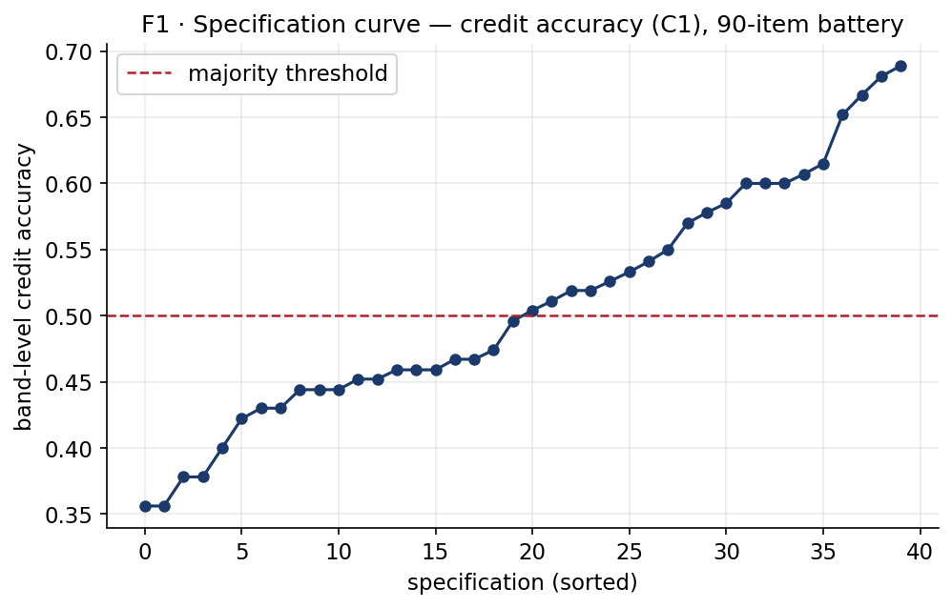
Specification curve of the machine credit rating. Each point is one of the pre-registered specifications (three seeds pooled), ordered by majority-correct credit-band accuracy against the Altman Z$″$ benchmark. Accuracy ranges widely across specifications despite identical firm fundamentals, and roughly half reverse the pre-registered accuracy verdict (specification-curve flip share $≈0.50$)—the multiverse the method is named for.
Variance shares of the machine credit letter-rank (mixed-effects). Every controllable design choice is small relative to run-to-run noise.
Component | Variance share
Item (firm profile) | $∼$63%
Residual seed (run-to-run variation) | $∼$25%
Answer presentation ($A_{7}$, largest design axis) | $∼$5.0%
Provider $×$ item interaction | $∼$2.2%
Model provider ($A_{1}$, main effect) | $∼$1.3%

Specification fragility under deterministic execution
One explanation of this residual variation is that some model providers do not fully honor a requested temperature of zero. If so, the observed instability might largely reflect stochastic sampling rather than sensitivity to the elicitation specification per se.
We therefore perform the pre-registered determinism test and restrict the analysis to the provider-setting combination for which the returned metadata confirm deterministic execution: Google at temperature 0. This subgrid removes repeated-call sampling variation but retains substantial specification dependence. In it, 62.5% of specifications fall on opposite sides of the majority-accuracy threshold, and benchmark-consistent credit-band accuracy ranges from 0.36 to 0.69 across deterministic prompt configurations.
A one-sided label-permutation test rejects the null of specification invariance. Across 999 permutations, no permuted labeling produced a between-specification spread as large as the observed statistic, giving $p=(k+1)/(n+1)=0.001$. Deterministic execution thus removes run-to-run jitter but does not eliminate sensitivity to prompt and presentation choices; indeed, the specification-curve flip share within the deterministic subgrid is higher than the pooled estimate. The instability therefore cannot be ascribed solely to stochastic sampling.

Agreement within and between providers
The small provider main effect might suggest that provider choice does not matter much. Direct agreement comparisons reveal a more complex pattern.
Within-provider agreement is consistently higher than cross-provider agreement in the two model families with full current-and-prior snapshot coverage. Within a single provider, 73.7% of identical firm profiles agree at the three-way credit-band level, but only 50.4% agree across providers. At the full letter-rating level, agreement across providers falls to 5.2% from 22.5% within providers.
These findings are consistent with the variance decomposition. Providers respond differently to specific firm profiles, creating a provider-by-item interaction. The interaction does not appear to reflect a constant directional shift in ratings; a simple global adjustment does not allow one provider to be characterized as systematically more conservative or more generous than another. The disagreement is issuer-specific.
This distinction is important operationally. Changing vendors does not provide a predictable correction to the rating of a specific firm, and aggregating outputs across vendors does not remove the underlying specification dependence. Vendor diversification therefore does not resolve the conceptual measurement problem or the need to characterize uncertainty across elicitation specifications.

Stability across rating resolutions
Credit ratings are inherently hierarchical. A model may not reproduce an exact letter grade yet still express a stable broader assessment. We therefore assess cross-specification agreement as we move from the full 21-grade letter-rating scale to notch categories, three broad credit bands, and the binary investment-grade/high-yield distinction.
Agreement improves as the scale is coarsened but does not become fully stable. Raw cross-specification agreement is approximately 16% at the letter level, 34% at the notch level, 65% for the three-way credit band, and 73% for the investment-grade/high-yield split. Equivalently, matched elicitation pairs disagree in about 84%, 66%, 35%, and 27% of comparisons, respectively (Fig. 2).
The same conclusion follows from chance-corrected agreement. Fleiss’ $κ$ is 0.08 at the full letter scale, 0.18 at the notch level, 0.39 for the three-way band, and reaches a maximum of only 0.46 for the investment-grade/high-yield split (Fig. 3). No evaluated rating resolution meets the conventional threshold for substantial agreement ($κ=0.60$).
The instability is not caused by the models collapsing to a narrow set of central ratings. All 21 letter grades are used across the experiment, and scale-usage entropy is 4.03 of a maximum 4.39 bits. The models therefore use the available rating scale extensively but do not reproduce the same assessment consistently across specifications.
The most economically consequential result appears at the coarsest resolution. Even when all finer distinctions are dropped and only the investment-grade/high-yield classification is retained, 26.8% of matched elicitation pairs place the same firm profile on opposite sides of the boundary. Coarsening reduces specification sensitivity but does not eliminate it.
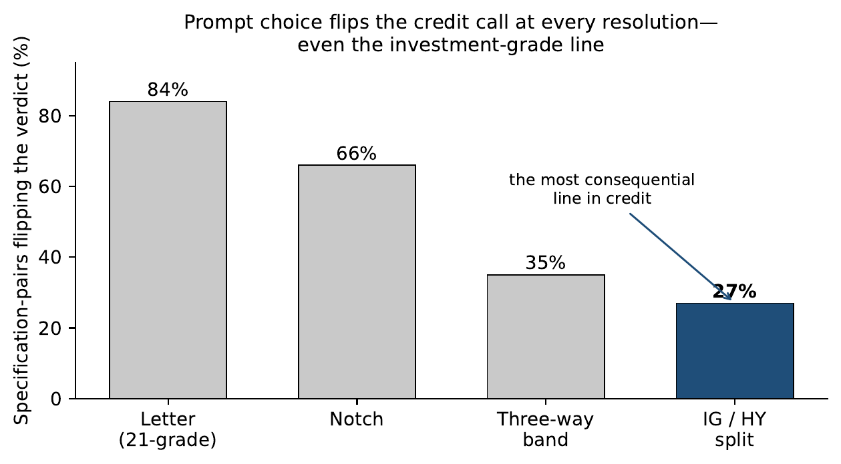
Share of matched elicitation pairs whose credit verdicts differ, by rating granularity, where the two elicitations of a firm may differ on any grid axis (provider, model version, temperature, paraphrase, format, few-shot, presentation) and seed. Even at the coarse investment-grade/high-yield split—the most consequential line in credit—27% of matched pairs disagree.
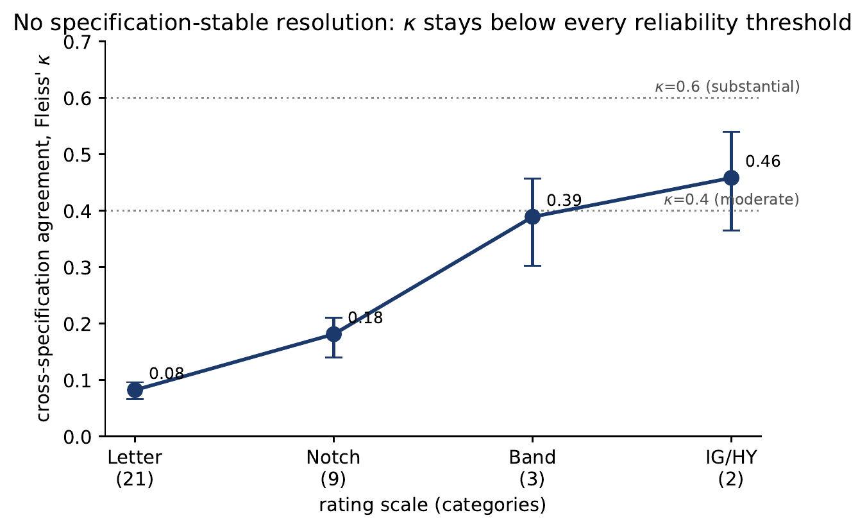
Chance-corrected cross-specification agreement (Fleiss $κ$) by granularity; agreement never reaches the $κ=0.6$ substantial-agreement threshold, peaking at 0.46 on the IG/HY split.

Economic implications of elicitation instability
Statistical disagreement is economically important when alternative specifications produce decisions on opposite sides of consequential credit boundaries. We translate the observed rating instability into three decision-relevant quantities: investment-grade/high-yield migration, portfolio turnover, and illustrative spread and capital implications.
For each credit-health profile we draw two elicitations from its observed specification distribution, allowing the pair to differ on any elicitation axis and on seed. We then compute, for each firm, the probability that the two resulting ratings fall on opposite sides of the investment-grade/high-yield boundary, and average across profiles. This per-comparison flip probability is one minus the Gini–Simpson concentration of the firm’s binary IG/HY outcomes.
This yields an investment-grade/high-yield flip rate of 26.8% (95% CI 20.9–32.5%): more than a quarter of matched ratings for the same underlying credit profile disagree on which side of the investment-grade boundary the profile falls.
The implication for the directional task is similar. A strategy that mechanically follows the modal buy/hold/sell call across specifications would incur 56.8% implied turnover (95% CI 50.9–62.7%) due solely to elicitation choices. With the financial inputs unchanged, this turnover reflects specification instability rather than new economic information.
We also offer two post-hoc economic calibrations. Across all profiles, the median implied within-name spread range is about 860 basis points under the rating-spread schedule of Cornaggia et al. [30], inflated by names saturating in the CCC region; for non-saturating profiles the median range is about 261 basis points, and no profile falls below about 106 basis points. Mapping each specification’s rating through the Basel standardized external-ratings risk-weight framework [31] for a single hypothetical $45 billion equal-weight corporate portfolio, the resulting Pillar-1 minimum-capital requirement—driven only by the elicitation specification—ranges from approximately $2.0 billion to $4.2 billion. Two randomly drawn specifications differ by about $0.65 billion on average, or 20.5% of the median computed capital requirement—comparable to the $∼$20% relative dispersion the Basel RCAP exercise found across internal-model banks holding identical portfolios [32]. Although these spread and capital calculations are explicitly post-hoc calibrations rather than confirmatory tests, they indicate that the magnitude of specification-induced rating dispersion is economically non-trivial (Table 2).
Fragility in decision and economic units.
Quantity | Result
Specifications flipping majority credit band verdict (pooled / determ.) | $∼$50% / 62.5%
Credit-band accuracy range, honored-determinism subgrid | 0.36–0.69
Permutation test, determinism subgrid | $p=0.001$
Within- vs cross-vendor agreement (band / letter) | 73.7/50.4 $⋅$ 22.5/5.2
Max chance-corrected agreement (Fleiss $κ$, IG/HY) | 0.46 (no scale $≥0.6$)
Per-comparison IG/HY boundary flip | 26.8% (95% CI 20.9–32.5%)
Implied turnover (modal-call instability) | 56.8% (95% CI 50.9–62.7%)
Implied spread range per name (non-saturating / median) | $∼$261 / $∼$860 bps
Pillar-1 capital range, same $45bn book (post-hoc cut) | $2.0bn – $4.2bn

Robustness on decontaminated real issuers
The constructed battery provides the controlled context in which to identify elicitation instability, but a key external-validity concern is whether similar behavior appears for real firms. Direct evaluation on real issuers raises a further methodological problem: an LLM may recognize a company from publicly available financial figures even when the company name is removed.
We test this possibility first, before using real issuers as a robustness sample. When presented with anonymized but otherwise unchanged financial profiles, Gemini-Flash correctly identifies about 22% of the selected mid-cap issuers from their financial numbers alone. This shows that anonymizing the issuer name does not guarantee that an LLM makes an independent credit assessment rather than relying on memorized issuer information.
The pre-registered fingerprinting gate lowered the issuer-identification rate from 22% to 2.9%, below the pre-specified 5% threshold. The decontaminated firms are then rated on a frozen 12-specification grid at three seeds, and the constructed battery is re-rated under exactly the same specification grid to provide a matched comparison.
The real-firm WATCH-stratum flip share is 0.226 (95% CI 0.147–0.308), relative to 0.318 (95% CI 0.223–0.406) for the matched constructed battery. The estimated difference is $−0.091$ (95% CI $−0.213$ to $0.032$; Table 3). The difference is not statistically distinguishable from zero; however, the pre-registered two-one-sided-tests (TOST) equivalence test at the $±0.15$ margin does not establish quantitative equivalence ($p=0.179$), consistent with limited power at 16 real and 15 battery WATCH observations.
The appropriate conclusion is therefore narrower than numerical equivalence: substantial specification instability remains observable in decontaminated real issuers under the same elicitation conditions. The real-firm point estimate is somewhat lower than the matched battery’s, but the available sample is too small to determine whether that difference is a stable population difference. As a separate descriptive reference, machine-generated credit bands match the disclosed agency ratings about 54% of the time.
Real-firm arm: 31 decontaminated business-to-business issuers, agency-rating benchmark.
Quantity | Result
Fingerprint identification, naive (exact figures) | 22%
Fingerprint identification, decontaminated (gate) | 2.9%
WATCH-stratum flip-share, real arm | 0.226 (0.147–0.308)
WATCH-stratum flip-share, battery (same 12 specs) | 0.318 (0.223–0.406)
Difference (real $−$ battery), 95% CI | $−0.091$ ($−0.213$, $0.032$)
Equivalence test (TOST, $±0.15$ margin) | $p=0.179$ (not established; underpowered)
Interpretation | substantial instability persists; equivalence not established
Machine band vs. disclosed agency rating (descriptive) | 54%

Discussion
We examine whether an LLM-generated credit rating can be treated as a stable assessment of a firm’s financial health or whether it depends heavily on how that measure is elicited. The main finding of the pre-registered specification curve is that substantial instability remains even after controlling for the underlying financial information. As expected, firm characteristics explain most of the total variation in ratings, but the residual variation due to elicitation and repeated calls is large enough to change economically meaningful decisions.
The variance decomposition clarifies the origin of this instability. No single controllable design choice explains more than $∼$5% of rating variance, whereas residual run-to-run variation accounts for about a quarter of the total. This distinction matters because it implies that the instability cannot be resolved by selecting a preferred prompt formulation, output format, temperature, or provider. No single elicitation parameter dominates the observed instability; instead, the same financial information can produce meaningfully different credit assessments under multiple reasonable specifications.
The real-issuer experiment complements, rather than substitutes for, this identification strategy. Crucially, it first demonstrates that direct evaluation on anonymized real firms is not automatically clean: a model identifies around 22% of the unperturbed issuers from financial information alone. After issuer-specific scaling and screening, the fingerprint rate falls to 2.9%, and substantial specification instability is still observed in the real-firm arm under this decontamination gate. The real and constructed WATCH estimates are not shown to be quantitatively equivalent, and the sample is too small to support such a claim; nevertheless, the qualitative pattern persists and suggests that the main finding is not confined to the controlled battery.
The fingerprinting result also has implications beyond the credit-rating experiment at hand. Public companies’ financial information is widely disseminated and may have been included in the training data of general-purpose LLMs. Removing company names does not necessarily remove issuer identity from an evaluation: if a model can infer the issuer from the precise financial numbers, then a judgment that appears to be based on the inputs may also draw on memorized information about that company. Perturbation combined with explicit identification testing is a practical way to mitigate this risk when evaluating LLMs on public financial entities.
Taken together, the results suggest that a credit rating produced by an LLM should not be interpreted as a specification-invariant point estimate. Each response is one realization from a broader distribution induced by the elicitation procedure. This does not imply that LLMs cannot contribute to credit analysis, and the present study does not assess whether their ratings are more or less accurate than established credit-assessment methods. Rather, a prerequisite for reliable use is to characterize the uncertainty associated with reasonable elicitation choices before treating a point rating as a stable model output.
This interpretation ties directly to model-risk management. Model outputs used in consequential financial decisions are generally expected to be validated and their uncertainty and limitations understood [33]. Our results suggest that, for LLM-based credit assessment, the elicitation specification itself should be part of that uncertainty assessment. Reporting a single rating without evaluating its sensitivity to plausible specifications can convey a false sense of precision. Repeated elicitation, related stability diagnostics, or specification curves therefore provide a more informative representation of machine-generated credit opinions than a single prompted response.

Limitations
These findings have several limitations that bound their scope. First, the study considers three model families and the specific model snapshots and configurations included in the pre-registered design; the results should therefore be viewed as evidence of how the evaluated systems behave, not as a universal numerical estimate for all current or future LLMs. One earlier-version xAI snapshot returned no usable content and is retained as a documented dead cell rather than imputed.
Second, the main identification sample is a fixed 90-item constructed battery, with 45 profiles in the credit-health task and 45 in the directional task. Repeated specifications increase coverage of the elicitation space but not the number of independent underlying firm profiles, so the flip rates and variance estimates remain sample statistics for the battery considered.
Third, the real-firm arm comprises 31 U.S. mid-cap business-to-business issuers selected under the decontamination design. This sample checks external validity but is much smaller than the controlled battery at the relevant strata; in particular, the WATCH-stratum comparison lacks the power to detect the pre-specified equivalence margin, and quantitative equivalence between the constructed and real-firm estimates is not established.
Fourth, the study measures stability, not absolute credit-rating capability. The Altman Z$″$ mapping provides a pre-specified accounting-based benchmark for constructing and evaluating the controlled credit-health battery, while disclosed agency ratings provide an alternative descriptive reference; neither is treated as a unique ground-truth credit opinion. Whether generative models can produce more accurate credit assessments than established statistical, market-based, or agency methods is a separate research question.
Finally, the spread and regulatory-capital translations are post-hoc calibrations that express observed rating dispersion in economically interpretable units. They are not pre-registered tests and are not intended as simulations of a real regulatory or institutional implementation. Within these bounds, the main stability finding is robust across the specification curve, the deterministic subgrid, the provider comparison, the rating-resolution analysis, and the decontaminated real-firm arm.

Future work
The present design suggests several extensions. Larger and sector-stratified real-issuer samples would yield more precise estimates of how specification instability varies with firm characteristics and distance from rating boundaries. Similar designs could test retrieval-augmented or tool-using credit agents, where access to external information may reduce some forms of uncertainty while adding further specification choices. Human-in-the-loop workflows could also be explored to determine whether providing analysts with distributions of machine ratings or specification curves leads to more reliable decisions than a single model-generated assessment. More broadly, the decontamination procedure could be applied to other evaluations of financial LLMs involving publicly documented entities: explicitly testing whether an ostensibly anonymized case remains identifiable, in tasks such as risk assessment, valuation, investment recommendation, and supervisory analysis, may help separate independent reasoning from memorized entity knowledge.

Conclusion
This study shows that reproducibility in AI-assisted credit assessment cannot be taken for granted from a single elicitation. Across a pre-registered specification curve, firm fundamentals explain most of the total variation in machine-generated ratings, but substantial specification- and run-level instability remains after controlling for the underlying financial information. No single controllable elicitation choice explains much of this variation, and the instability persists even when the analysis is limited to verified deterministic execution.
These results are not evidence that LLMs are accurate credit raters, and they do not imply that all current or future models will exhibit the same level of instability. For the systems studied here they make a more basic point: the elicitation procedure is part of the measurement. Unless stability with respect to reasonable elicitation choices has been demonstrated, a machine-generated credit rating should not be treated as a specification-independent point estimate. In AI-assisted credit analysis, the outcome includes the specification.

Methods

Design, battery, and benchmark
The study is designed to measure elicitation stability: whether an LLM produces a credit assessment that is consistent when the underlying financial information is held constant but reasonable choices in how the assessment is elicited vary. The aim is therefore not to estimate rating accuracy on a naturally occurring population of firms, but to isolate variation attributable to the elicitation process.
We use a constructed battery as the main identification environment because it allows firm fundamentals to be held fixed while the elicitation specification varies, permits balanced representation across credit-health conditions, and provides a benchmark that can be computed before any model is queried. Restricting the analysis to public companies would introduce a further source of uncertainty, because an LLM might identify an issuer from financial information it was exposed to during training. We therefore use the controlled battery for the main analysis and a separately decontaminated real-firm sample for a complementary external-validity test.
The battery consists of 90 fixed firm-quarter profiles. Each profile is summarized in a compact financial statement, including revenue, EBIT, total assets and liabilities, equity, working-capital figures, and retained earnings. The profiles comprise two equally sized task families: 45 credit-health items, for which the model produces a credit rating, and 45 directional items, for which the model produces a buy/hold/sell call. All credit-rating agreement and investment-grade/high-yield analyses use the 45 credit-health profiles; the directional profiles are used only for the portfolio-turnover translation.
For the credit-health task, each profile is associated with a pre-specified Altman Z$″$ accounting-based reference [8], computed with coefficients 6.56, 3.26, 6.72, and 1.05 and cutoffs 2.60 and 1.10. The resulting safe, watch, and distress strata each contain 15 observations, evenly distributed across the 45 credit-health profiles. The Altman mapping provides a deterministic accounting reference for constructing and stratifying the controlled battery and is not treated as a unique ground-truth agency rating, because our interest is stability across elicitation specifications rather than absolute rating accuracy. The benchmark and battery were frozen under a pre-registration hash before any model query, and an independent post-hoc re-execution from the frozen financial facts reproduces all 45 benchmark classifications.

Specification grid and data collection
We manipulate seven researcher-controlled elicitation dimensions: model provider (OpenAI, Google, xAI), model version (a current and a prior snapshot per provider), temperature (0 or 1.0), prompt paraphrase (three semantically equivalent formulations), output format (JSON or free-text), few-shot exemplars (zero or two), and answer presentation (original prose versus a table with reversed option ordering). A balance-constrained D-optimal fractional design of 48 specifications was generated from an effect-coded main-effects model with the design seed frozen in advance. Each specification was evaluated over three seeds. Provider metadata were preserved as returned, including effective generation settings where available; the requested temperature of 0 was not uniformly honored by providers.
The complete planned experiment therefore comprises $90×48×3=12,960$ elicitation cells, of which 10,793 returned substantive content. One earlier-version xAI snapshot returned blank answers for all 2,160 cells assigned to it; this block is retained as a documented dead cell and is not imputed. Comparisons requiring full current-and-prior snapshot coverage therefore use the two providers with full coverage. Each call is stored as an immutable JSON record containing the experimental specification, the returned content, and the available provider metadata. Data collection and analysis are separated: all confirmatory analyses run only on the frozen response corpus and do not re-query any model.

Outcome construction and statistical analysis
Stored model responses are parsed under three rules—strict, lenient, and tolerant—applied after collection. Credit ratings are first expressed on the full 21-grade letter scale and then deterministically aggregated into notch categories, three broad credit bands, and the binary investment-grade/high-yield classification. This permits examination of stability at increasingly coarse rating resolutions without additional model calls.
Agreement across specifications is measured with Fleiss’ $κ$. Within- and cross-provider agreement is computed on matched firm profiles and seeds, and the contrast between homogeneous and heterogeneous ensembles is summarized by $Δκ$ with profile-clustered bootstrap confidence intervals. Variation in the full letter-rating rank is decomposed with a mixed-effects model with effects for the underlying item, the elicitation-design dimensions, the provider-by-item interaction, and residual run-level variation.
All analyses are pre-registered unless labelled post-hoc, and inference uses distribution-free resampling throughout, so no normality assumption is made. Uncertainty for the main quantities is estimated by percentile bootstrap resampling over the underlying firm profiles rather than over individual model calls, thereby preserving dependence among repeated elicitations of the same profile. The investment-grade/high-yield flip rate and the portfolio-turnover estimate use 2,000 bootstrap replicates, and specification-curve quantities use 1,000 replicates where applicable; point estimates are reported with two-sided 95% confidence intervals. Specification invariance under deterministic execution is tested on the provider-setting combination whose metadata confirm that temperature was honored (Google at temperature 0): the observed between-specification spread in credit-band accuracy is compared with the distribution generated by 999 permutations in a one-sided label-permutation test, $p=(k+1)/(n+1)$, where $k$ is the number of permuted statistics at least as extreme as the observed statistic and $n=999$. The test is one-sided because only an observed spread larger than the permutation distribution constitutes evidence against specification invariance. For the real-firm robustness analysis, quantitative equivalence of the real-firm and constructed-battery WATCH-stratum flip shares is assessed with two one-sided tests (TOST) against a pre-registered margin of $±0.15$, based on 16 real-firm and 15 constructed WATCH observations. The significance threshold is $α=0.05$ for all formal tests. To mitigate the risk of selective reporting within the specification multiverse, we pre-registered the estimands and specification grid and report the entire specification curve rather than a selected subset. We reserve “significant” for results accompanied by a $p$-value and otherwise use “substantial” or “considerable.”
For the binary IG/HY outcome, the per-comparison flip probability is computed separately for each credit-health profile from its observed distribution of ratings across the entire elicitation grid, so that two elicitations may differ on any specification dimension or seed. The resulting pair falls on opposite sides of the IG/HY boundary with probability equal to one minus the Gini–Simpson concentration of the profile’s binary labels, and the reported flip rate is the average of this quantity over the 45 credit-health profiles.

Economic translation
The economic translations are post-hoc calibrations that express the magnitude of rating instability in decision-relevant units; they are not confirmatory tests. Portfolio turnover is computed from the 45 directional profiles as the share of positions whose modal buy/hold/sell decision changes across elicitation specifications. Rating dispersion is transformed into indicative credit-spread variation using the rating-spread schedule of Cornaggia et al. [30] and a cached daily option-adjusted-spread series. For the regulatory-capital illustration, each specification’s rating is mapped through the Basel CRE20 standardized external-ratings risk-weight schedule [31] and applied to the same hypothetical $45 billion equal-weight corporate portfolio, so that the capital range reflects only differences in the elicited rating. The comparison with the Basel Regulatory Consistency Assessment Programme [32] is used only as a magnitude calibration, not as an identity between the two settings.

Real-firm arm
To test the persistence of specification instability outside the constructed battery, we assemble a complementary sample of 31 U.S. business-to-business issuers with market capitalizations between $2 billion and $15 billion whose most recent Form 10-K discloses a current long-term agency credit rating. S&P is the primary rating source; where S&P ratings are unavailable, Moody’s or Fitch ratings are mapped to a common scale. Each rating is preserved with a verbatim filing quotation, a permanent SEC document URL, and a document hash.
Because these figures are publicly reported by real issuers, there is a risk of contamination if a model can identify a company. We therefore first perform a pre-registered fingerprinting test in which the models are asked to identify issuers from anonymized financial profiles; Gemini-Flash identifies about 22% of the selected issuers from the original figures, confirming that removing the company name does not guarantee independence from memorized issuer information. To reduce this risk, every dollar-denominated quantity for an issuer is multiplied by a single issuer-specific factor sampled from a log-uniform distribution over $[0.6,1.7]$. The same factor applies to all monetary amounts, so the credit-health analysis retains the financial-ratio structure while disrupting exact-figure lookup. We also exclude consumer-facing companies to reduce recognition from highly distinctive public profiles. The fingerprint-identification rate falls to 2.9% after perturbation, below the pre-registered 5% decontamination threshold.
Each decontaminated issuer is then scored on a fixed 12-specification grid spanning presentation, provider, prompt paraphrase, and output format, at three seeds, and the constructed battery is re-scored under the same grid for a matched comparison on the WATCH stratum. This arm uses disclosed agency ratings as a descriptive real-world reference; the primary comparison is stability across specifications.

Reproducibility
The entire experimental pipeline is archived so that the reported results can be reproduced without further model calls. The frozen materials comprise the 90-item battery, the specification grid, the prompt templates, the rating scale, the full 12,960-record response corpus, the analysis panel, the real-firm arm, the analysis code, the generated outputs, and SHA-256 integrity manifests. The complete set of confirmatory tables, figures, and reported statistics regenerates from a single offline entry point. Provider API credentials are required only to collect new model responses and are not needed to reproduce any result reported in this study.
Use of generative AI. Generative AI was used to assist with grammar correction and minor language edits of the authors’ own text, and with software scaffolding, development, and coding of the analysis and reproducibility pipeline (Anthropic Claude), in all cases under the authors’ direction. Separately, large language models are the object of study in this work—the credit-rating elicitations under analysis—as described above; every such elicitation is recorded in the specification grid and frozen corpus. The authors reviewed and verified all such output and take full responsibility for the content.

Data availability
All data and code required to reproduce the study are openly available in a deterministic, offline reproducibility capsule (CodeOcean DOI assigned at deposit; MIT license), mirrored in the source repository at https://github.com/samirrc2/prompt-choice-credit-ratings. Within the capsule, the data/frozen/main/ directory contains the pre-registered 90-item firm battery (battery_90.json; 45 credit-health $+$ 45 directional items), the specification grid (grid_definition.json), the prompt paraphrases (paraphrase_templates.json), the rating scale (rating_scale.json), and the Basel capital map (capital_map.json); data/raw/main/ holds the complete frozen corpus of 12,960 model responses; data/panel/panel.parquet is the analysis panel built once from that corpus; and data/frozen/realarm/ with data/raw/realarm/ contain the decontaminated real-firm arm (the anonymized perturbed battery battery_real45.json, the sealed issuer crosswalk, the rating provenance ratings_provenance.csv with a verbatim 10-K quotation, permanent SEC URL, and document hash per issuer, and the arm/comparator/fingerprint model-output panels). The analysis code is in analysis/, pre-computed outputs and figures in results/, and SHA-256 integrity manifests in manifest/. A single offline entry point, reproduce.sh, regenerates every reported number, table, and figure byte-for-byte, with no model calls and no API keys. Issuer identities in the real-firm arm are anonymized and the sealed crosswalk is withheld; the underlying SEC filings (Form 10-K and company-facts XBRL) are publicly available through the SEC EDGAR system, with permanent document URLs listed in data/frozen/realarm/ratings_provenance.csv.

Code availability
All collection, panel-construction, and analysis code is released under the MIT license in the same repository; a single reproduce.sh regenerates every reported number, table, and figure from the frozen data offline. Provider API keys are required only to re-collect the corpus (not to reproduce any result) and are not distributed.

References
- Hens, T. & Nordlie, T. How good are LLMs in risk profiling? Finance Research Letters 85, 108102 (2025).
- Atil, B. et al. Non-determinism of “deterministic” LLM settings. Tech. Rep., arXiv:2408.04667 (2024).
- Kaplan, J. et al. Scaling laws for neural language models. arXiv preprint arXiv:2001.08361 (2020).
- Chon, S., Kim, J. & Kim, J. Multifaceted variability in LLM-driven stock recommendations. Finance Research Letters (2025). Forthcoming.
- Simonsohn, U., Simmons, J. P. & Nelson, L. D. Specification curve analysis. Nature Human Behaviour 4, 1208–1214 (2020).
- Steegen, S., Tuerlinckx, F., Gelman, A. & Vanpaemel, W. Increasing transparency through a multiverse analysis. Perspectives on Psychological Science 11, 702–712 (2016).
- Camuffo, A., Gambardella, A., Kazemi, S., Malachowski, J. & Pandey, A. Variance-aware LLM annotation for strategy research: Sources, diagnostics, and a protocol for reliable measurement. Tech. Rep., arXiv:2601.02370 (2026).
- Altman, E. I. Financial ratios, discriminant analysis and the prediction of corporate bankruptcy. The Journal of Finance 23, 589–609 (1968).
- Vaswani, A. et al. Attention is all you need, Vol. 30 (2017).
- Devlin, J., Chang, M.-W., Lee, K. & Toutanova, K. BERT: Pre-training of deep bidirectional transformers for language understanding (2019).
- Bommasani, R. et al. On the opportunities and risks of foundation models. arXiv preprint arXiv:2108.07258 (2021).
- Sclar, M., Choi, Y., Tsvetkov, Y. & Suhr, A. Quantifying language models’ sensitivity to spurious features in prompt design (2024).
- Mizrahi, M. et al. State of what art? a call for multi-prompt LLM evaluation. Transactions of the Association for Computational Linguistics 12 (2024).
- Gelman, A. & Loken, E. The garden of forking paths: Why multiple comparisons can be a problem, even when there is no “fishing expedition”. Department of Statistics, Columbia University (working paper) (2013).
- Simmons, J. P., Nelson, L. D. & Simonsohn, U. False-positive psychology: Undisclosed flexibility in data collection and analysis allows presenting anything as significant. Psychological Science 22, 1359–1366 (2011).
- Brown, T. B. et al. Language models are few-shot learners, Vol. 33 (2020).
- Ouyang, L. et al. Training language models to follow instructions with human feedback, Vol. 35 (2022).
- OpenAI. GPT-4 technical report. arXiv preprint arXiv:2303.08774 (2023).
- Wu, S. et al. BloombergGPT: A large language model for finance. arXiv preprint arXiv:2303.17564 (2023).
- Xie, Q. et al. PIXIU: A large language model, instruction data and evaluation benchmark for finance, Vol. 36 (2023).
- Kim, A., Muhn, M. & Nikolaev, V. Financial statement analysis with large language models. arXiv preprint arXiv:2407.17866 (2024).
- Lopez-Lira, A. & Tang, Y. Can ChatGPT forecast stock price movements? return predictability and large language models. arXiv preprint arXiv:2304.07619 (2023).
- Hansen, A. L. & Kazinnik, S. Can ChatGPT decipher Fedspeak? SSRN Electronic Journal (2024).
- García-Llorente, C. & Olmeda, I. Large language models for banking supervision: Reliability evidence from European systemic banks. Finance Research Letters (2026).
- Drinkall, F., Pierrehumbert, J. B. & Zohren, S. Forecasting credit ratings: A case study where traditional methods outperform generative LLMs, 118–133 (2025).
- Ohlson, J. A. Financial ratios and the probabilistic prediction of bankruptcy. Journal of Accounting Research 18, 109–131 (1980).
- Cantor, R. & Packer, F. Differences of opinion and selection bias in the credit rating industry. Journal of Banking & Finance 21, 1395–1417 (1997).
- Kliger, D. & Sarig, O. The information value of bond ratings. Journal of Finance 55, 2879–2902 (2000).
- Tang, T. T. Information asymmetry and firms’ credit market access: Evidence from Moody’s credit rating format refinement. Journal of Financial Economics 93, 325–351 (2009).
- Cornaggia, J., Cornaggia, K. J. & Israelsen, R. D. Credit ratings and the cost of municipal financing. Review of Financial Studies 31, 2038–2079 (2018).
- Basel Committee on Banking Supervision. CRE20: Standardised approach: individual exposures. Tech. Rep., Basel Framework, Bank for International Settlements (2019). In force 1 January 2023.
- Basel Committee on Banking Supervision. Regulatory Consistency Assessment Programme (RCAP): Analysis of risk-weighted assets for credit risk in the banking book. Tech. Rep. BCBS 256, Bank for International Settlements (2013).
- Board of Governors of the Federal Reserve System and Office of the Comptroller of the Currency. Supervisory guidance on model risk management. Tech. Rep., SR Letter 11-7 / OCC Bulletin 2011-12 (2011).

Author contributions
S.C.: Conceptualization, Methodology, Software, Formal analysis, Data curation, Writing – original draft, Writing – review & editing. R.C.: Conceptualization, Validation, Writing – review & editing. All authors reviewed and approved the manuscript.

Ethics declarations
This study did not involve human participants, human tissue, or animal subjects, and used no personally identifiable or sensitive personal data; ethical approval was therefore not required. The analysis uses only synthetic firm profiles, publicly available corporate financial disclosures (SEC filings), and the authors’ own model elicitations.

Additional Information
Competing interests: The authors declare no competing interests.
Funding: This research received no external funding.

