Investment concentration and financing in the AI boom
Samir Chincholikar Robin Chawla
Independent researcher, New York, USA

Abstract
Among the 500 largest U.S. public companies, incremental operating cash flow covers 117% of the 2022–2025 investment increase at the five largest investors and 102% at the top ten, accounting for 52.8% of it, but −61% across the remaining 213 firms. Concentrated investment booms need not be characterised by project-level financing conditions. Concentration alone does not produce this: the more concentrated 2018–2021 window has the tail as its best-covered group. Because firms accounting for more than half the increase generated enough incremental internal cash to cover it, the boom's headline size overstates the investment not covered by internal cash generation.
Keywords: investment concentration internal finance capital expenditure artificial intelligence granularity
JEL: G31 G32 E22 O33 E44

1. Introduction
The 500 largest U.S. public companies' incremental operating cash flow over 2022–2025 covers 117% of the incremental capital expenditure of the five largest investors and 102% of the top ten, accounting for 52.8% of the positive increment, but −61% across the other 213 firms with rising investment (Table~1). The five—Alphabet, Amazon, Oracle, Meta and Microsoft—chosen mechanically as those with the largest absolute increase in real capital expenditure, account for 38.9% of that increment themselves.
Such a gradient is important because financing evidence collected at the project margin need not describe the investment-weighted aggregate. Recent work documents the artificial-intelligence buildout being financed through private credit, infrastructure funds, off-balance-sheet vehicles and hardware-collateralised lending and asks what the exposures imply for financial stability (Van Nieuwerburgh, 2026). That evidence is reported for particular projects and particular firms. An aggregate is a capital-expenditure-weighted sum, so it is dominated by wherever the incremental spending occurred, and here the incremental spending is extraordinarily concentrated: the Herfindahl index of capital expenditure among the 500 moves from 173 in 2021 to 309 in 2025, while excluding the five largest spenders it moves only from 95 to 104. The granular mechanism of Gabaix (2011), Carvalho and Gabaix (2013) and di Giovanni et al. (2014) is that a few firms can dominate an aggregate. We apply it to financing rather than to fluctuations.
Both the concentration of investment and firm-level covariation between internal funds and investment are documented (Grullon et al., 2018; Gutiérrez and Philippon, 2017; Fazzari et al., 1988; Kaplan and Zingales, 1997; Myers and Majluf, 1984). We document the alignment between them during this boom and show that it is historically unusual, as an accounting decomposition of realised flows rather than a causal test.

2. Data and methodology
Firm-level data are built from the SEC's XBRL frames interface for 2013–2025 and reconciled to the underlying filings. The construction unions alternative tags: filers do not use a single tag for a given concept, and a single-tag series would leave out Amazon, the largest U.S. capital spender, as well as 454 other firms accounting for $404 billion of 2025 capital expenditure (Appendix A, Table~A2). We measure the buildout using total capital expenditure, as in Soto et al. (2026) and Van Nieuwerburgh (2026).
The universe is the 500 largest U.S. registrants by fiscal-2024 revenue, excluding non-filers. Private firms are excluded by construction. Figures are deflated to 2025 dollars using the BLS producer price index for private capital equipment (WPUFD41312).
The exercise cumulates incremental flows rather than comparing two annual observations. For each series X and firm i,
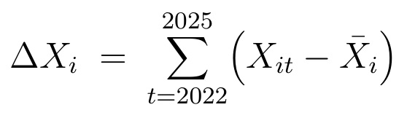 (1)
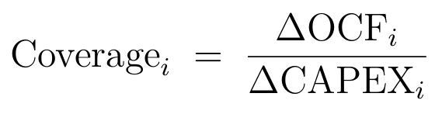 (2)
where X_i is either the 2021 value (baseline A) or the 2017–2021 average (baseline B).
Let
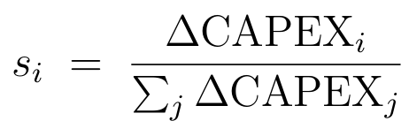
be firm i's share of the aggregate increment. Then
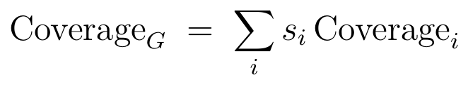 (3)
so the aggregate coverage ratio is the increment-weighted mean of firm-level coverage. Thus, a group aggregate places greatest weight on its largest incremental investors, irrespective of the coverage of the remaining firms in the group.
The ratio requires an observed baseline and a positive denominator; otherwise a firm not present in 2021 would have a baseline of zero and all of its subsequent spending would appear incremental. Of the 500 firms, 404 report capital expenditure at both endpoints. Of these, 263 show a positive cumulative increment and 141 do not. The other 96 lack an observation at one or both endpoints, 17 of which report 2025 spending with no 2021 baseline, which would otherwise enter as $28 billion of spurious increment. Rather than assigning a signed ratio, we exclude firms whose investment fell.
The five focal firms are selected mechanically from financial statements, not from AI disclosures. Appendix A, Table~A1 reports what each firm's own filings say, including cases where the capex–AI attribution is only partial. Coverage above 100% means internally generated cash grew by more than investment did, not that specific dollars paid for specific assets. All reported numbers are produced from frozen, hashed source files by a single script, and the manuscript is gated against the resulting claims file.

3. Results

3.1. A historically unusual rank–coverage gradient
The main result is shown in Table~1. Ranking the 263 firms by cumulative incremental capital expenditure shows a rank–coverage gradient: internal cash coverage peaks at the five largest investors and then declines at every subsequent cut, from 117% for the top five to −61% for the remaining 213. The top ten firms account for 52.8% of positive incremental capital expenditure at 102% coverage. The top-five figure is not driven by one firm: coverage remains at least 79% excluding any one of them.
The positive-increment restriction affects only the tail. Coverage at every cut through the top fifty is invariant to it because those cuts contain the same firms either way. When we admit the 141 firms whose investment fell, with signed increments, the top-five share of the increment rises from 38.9% to 46.0% and the gradient becomes steeper, not weaker.
Concentration and internal finance are not the same phenomenon. The 2018–2021 window was more top-heavy than 2022–2025, with a top-five share of 41.9% versus 38.9%, yet its rank pattern runs the other way: the tail is its best-covered group, as in 2014–2017 (Table~2). Concentration alone therefore does not imply high internal cash coverage. What is unusual about the present episode is the coincidence of the two.
Three checks bound the top-five aggregate. First, the baseline: on the 2017–2021 average baseline, the corresponding figures are 757 billion, 587 billion and coverage of 129%, so both baselines give the same answer. Second, dependence on one firm: coverage ranges from 79% without Amazon to 135% without Alphabet and exceeds 100% in four of the five cases. Third, dispersion within the group: firm-level coverage ranges from 63% at Alphabet and 64% at Oracle to 118% at Microsoft and 361% at Amazon. This is why the cumulative ratio is not monotone across the first three cuts—63%, then 68%, then 117%—and why sufficiency is a property of the group aggregate rather than of every constituent (Appendix A, Table~A3). Coverage is also an end-of-period property: for the fixed group of five largest 2022–2025 incremental investors, coverage is −65% through 2022 and reaches 117% in 2025 (Figure~1c).

3.2. The gradient survives sector exclusions
One concern is that the tail contains regulated, extractive and financial firms whose cash-flow economics differ from the rest of the sample. Excluding these groups does not attenuate the gradient. The 25 regulated and extractive firms in the tail are its best-covered group, with 122% coverage on 19.9% of tail investment. The 25 financial firms cover 298%. The tail's −61% coverage is driven by the remaining 163 firms, which account for 73.0% of tail investment at −146% coverage.
Removing regulated, extractive and financial firms from the sample entirely leaves the gradient intact and makes it steeper: 117% for the top five, 97% for the top ten, 80% for the top fifty and −324% for the remainder (Appendix A, Table~A3). Using 10-K text to construct an AI-intensity cut without reference to any financing outcome gives the same answer (Appendix A, Table~A1).

3.3. Limitations
Three limitations bound the interpretation. First, the sample selects on an observed 2021 baseline and on a positive increment; Section~3.1 reports what relaxing the second condition does. Second, coverage is an accounting relationship between realised flows, not a financing statement: it does not trace particular dollars to particular assets and identifies no counterfactual of firm behaviour. Third, the universe consists of large public filers, so private firms and special-purpose vehicles lie outside it by construction.
Table 1. Internal cash coverage of incremental investment, cumulative flows
 | Firms | Share of increase (%) | Coverage (%)
Top 1 | 1 | 10.2 | 63
Top 3 | 3 | 26.5 | 68
Top 5 | 5 | 38.9 | 117
Top 10 | 10 | 52.8 | 102
Top 20 | 20 | 64.3 | 82
Top 50 | 50 | 81.7 | 53
Remaining firms | 213 | 18.3 | −61
the 263 firms among the 500 largest U.S. registrants by fiscal-2024 revenue that report capital expenditure in both 2021 and 2025 and whose cumulative incremental capital expenditure over 2022–2025 is positive; their aggregate incremental capital expenditure is 941 billion. Increments follow equation~(1) and coverage equation~(2). Shares are of that 941 billion. Amounts in billions of 2025 dollars, deflated by BLS series WPUFD41312. On the 2017–2021 average baseline the top five show coverage of 129%.
Table 2. Internal cash coverage by investment rank, earlier four-year windows
 | 2022–25 | 2018–21 | 2014–17
Top 5 | 117 | 176 | 186
Top 10 | 102 | 159 | 181
Top 20 | 82 | 127 | 158
Top 50 | 53 | 136 | 152
Remaining firms | −61 | 548 | 193
Top-5 share of increase | 38.9 | 41.9 | 21.0
, computed as in Table~1, on the same construction and baseline convention. Each window uses its own baseline year (2021, 2017 and 2013) and its own sample of firms with positive cumulative incremental capital expenditure over the four years following.

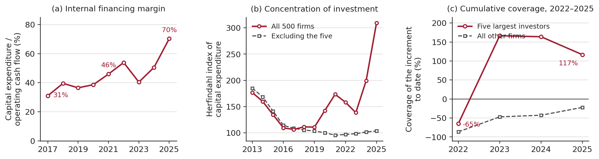
Figure 1. Internal cash coverage of incremental investment, cumulative flows 2022–2025 tab:ladder tabularl S[table-format=3.0] S[table-format=2.1] S[table-format=-3.0] & Firms & Share of & Coverage & & increase (%) & (%) Top 1 & 1 & 10.2 & 63 Top 3 & 3 & 26.5 & 68 Top 5 & 5 & 38.9 & 117 Top 10 & 10 & 52.8 & 102 Top 20 & 20 & 64.3 & 82 Top 50 & 50 & 81.7 & 53 Remaining firms & 213 & 18.3 & -61 tabular 5pt minipage0.96 Notes. Sample: the 263 firms among the 500 largest U.S. registrants by fiscal-2024 revenue that report capital expenditure in both 2021 and 2025 and whose cumulative incremental capital expenditure over 2022–2025 is positive; their aggregate incremental capital expenditure is 941 billion. Increments follow equation~(1) and coverage equation~(2). Shares are of that 941 billion. Amounts in billions of 2025 dollars, deflated by BLS series WPUFD41312. On the 2017–2021 average baseline the top five show coverage of 129%. minipage table table[htbp] Internal cash coverage by investment rank, earlier four-year windows tab:placebo tabularl S[table-format=-3.0] S[table-format=-3.0] S[table-format=-3.0] & 2022–25 & 2018–21 & 2014–17 Top 5 & 117 & 176 & 186 Top 10 & 102 & 159 & 181 Top 20 & 82 & 127 & 158 Top 50 & 53 & 136 & 152 Remaining firms & -61 & 548 & 193 [3pt] Top-5 share of increase & 38.9 & 41.9 & 21.0 tabular 5pt minipage0.86 Notes. Coverage in percent, computed as in Table~1, on the same construction and baseline convention. Each window uses its own baseline year (2021, 2017 and 2013) and its own sample of firms with positive cumulative incremental capital expenditure over the four years following. minipage table figure[htbp] [width=]figures/Figure_1.pdf (a) Capital expenditure as a share of operating cash flow, the five largest incremental investors, 2017–2025. (b) Herfindahl index of capital expenditure among the 500 largest U.S. public companies by revenue, with and without those five firms. (c) Coverage of the increment cumulated from the 2021 baseline through each year, on fixed membership: the five against the other 258 analysis firms.

4. Conclusion
The financing of marginal projects need not define an investment boom in the aggregate. During the AI buildout, internal cash coverage falls from 117% at the five largest incremental investors to −61% across the remaining 213 firms. The gradient is specific to the current episode in our comparison and is absent in the preceding two four-year windows, including the more concentrated 2018–2021 period.
This reconciles, rather than contradicts, the evidence on external finance, with project-finance structures largely outside our sample. For the firms accounting for more than half of the increment, incremental internal cash was in aggregate sufficient to cover their share of the boom, so the headline size of the investment boom overstates the amount of incremental investment for which incremental internal cash was insufficient. The result is time-specific: in 2025, capital expenditure absorbed 70% of the five firms' operating cash flow, versus 31% in 2017, so internal financing slack narrowed sharply over the sample.

CRediT authorship contribution statement
Samir Chincholikar: Conceptualization, Methodology, Software, Formal analysis, Writing – original draft. Robin Chawla: Conceptualization, Validation, Writing – review & editing, Supervision.

Declaration of competing interest
The authors declare that they have no known competing financial interests or personal relationships that could have appeared to influence the work reported in this paper.

Funding
This research did not receive any specific grant from funding agencies in the public, commercial, or not-for-profit sectors.

Data availability
The replication archive is deposited on Zenodo (https://doi.org/10.5281/zenodo.22392416) and contains the frozen source files, the collection and analysis code, the machine-generated claims file against which every reported number is checked, a SHA-256 manifest of every archived file, a one-command verification script, and a companion document describing the archive in full. Firm-level data were retrieved from the SEC's XBRL frames interface, one call per tag and year, at https://data.sec.gov/api/xbrl/frames/us-gaap/<tag>/USD/CY<year>.json; 10-K text and registrant classifications come from EDGAR and the submissions API (https://www.sec.gov/edgar/sec-api-documentation). The tags unioned for each series, including capital expenditure and operating cash flow, are listed in code/engine.py. The deflator is Bureau of Labor Statistics series WPUFD41312, final demand–private capital equipment, annual averages, retrieved with code/collect_deflator.py from the BLS public timeseries API. The frames interface returns the most recently filed value for each fact, so a later retrieval may differ where a filing or its presentation has since changed; the frozen copies in the archive are the basis for every figure reported here.

Declaration of generative AI and AI-assisted technologies in the manuscript preparation process
During the preparation of this work the authors used Claude (Anthropic) for code scaffolding, code review, minor grammatical edits and readability improvements. The tool was not used to generate, analyse or alter any datum, estimate, table or figure: all results are produced by the deposited scripts from the frozen source files. After using this tool the authors reviewed and edited the content as needed and take full responsibility for the content of the publication.

References
[1] Ante, L., Saggu, A., 2025. Quantifying a firm's AI engagement: constructing objective, data-driven, AI stock indices using 10-K filings. Technological Forecasting and Social Change 212, 123965.
[2] Carvalho, V. M., Gabaix, X., 2013. The great diversification and its undoing. American Economic Review 103 (5), 1697–1727.
[3] di Giovanni, J., Levchenko, A. A., Mejean, I., 2014. Firms, destinations, and aggregate fluctuations. Econometrica 82 (4), 1303–1340.
[4] Fazzari, S. M., Hubbard, R. G., Petersen, B. C., 1988. Financing constraints and corporate investment. Brookings Papers on Economic Activity 1988 (1), 141–206.
[5] Gabaix, X., 2011. The granular origins of aggregate fluctuations. Econometrica 79 (3), 733–772.
[6] Grullon, G., Hund, J., Weston, J. P., 2018. Concentrating on q and cash flow. Journal of Financial Intermediation 33, 1–15.
[7] Gutiérrez, G., Philippon, T., 2017. Investmentless growth: an empirical investigation. Brookings Papers on Economic Activity 2017 (2), 89–190.
[8] Hoberg, G., Phillips, G., 2016. Text-based network industries and endogenous product differentiation. Journal of Political Economy 124 (5), 1423–1465.
[9] Kaplan, S. N., Zingales, L., 1997. Do investment-cash flow sensitivities provide useful measures of financing constraints? Quarterly Journal of Economics 112 (1), 169–215.
[10] Loughran, T., McDonald, B., 2011. When is a liability not a liability? Textual analysis, dictionaries, and 10-Ks. Journal of Finance 66 (1), 35–65.
[11] Myers, S. C., Majluf, N. S., 1984. Corporate financing and investment decisions when firms have information that investors do not have. Journal of Financial Economics 13 (2), 187–221.
[12] Soto, P. E., Thieu, M., Allen, J. S., 2026. The AI buildout and the economy: publicly available data to assess AI's impact. FEDS Notes, 17 July.
[13] Van Nieuwerburgh, S., 2026. Financing the AI buildout. Working paper. https://doi.org/10.2139/ssrn.6444363.

Appendix A. Supplementary evidence
The appendix tables (A1 attribution and AI-exposure robustness, A2 data construction and validation, A3 firm-level and sectoral robustness) are set in the typeset PDF; see manuscript.pdf.

