Evaluating LLM-Based Credit Rating Systems: A Pre-Registered Specification-Curve Analysis
Anonymous
Large language models (LLMs) are increasingly used to support credit assessments, but it is unclear whether elicitation choices merely reveal a stable credit view or shape the rating. Using a pre-registered specification-curve design that holds fundamentals fixed while varying how the assessment is elicited, we evaluate a fixed 90-item battery across a balanced grid of model version, temperature, prompt paraphrase, output format, few-shot exemplars, and presentation over two providers (four snapshots; 8,640 elicitations, 4,320 on credit-health profiles benchmarked to Altman Z$″$). Our estimand is stability, not accuracy. No controllable axis explains more than about 5% of rating variance, and pure run-to-run variation contributes about 8%; instability persists under deterministic execution (one provider, temperature 0; permutation $p=0.001$). Cross-specification agreement stays limited at every resolution: unweighted Fleiss’ $κ$ reaches at most 0.49 at the investment-grade/high-yield split, where 25.2% of matched pairs disagree, and switching or pooling providers does not remove it. Modal calls imply 53.5% portfolio turnover, and a post-hoc recast swings a $45 billion book between $2.0 and $4.1 billion of Pillar-1 capital. Substantial instability persists on 31 decontaminated real issuers, and a post-hoc check finds no evidence that it attenuates on flagship models. We frame the elicitation specification as a model-risk parameter and develop a specification-instability score that predicts held-out instability (ROC-AUC 0.94; 0.70 on real issuers), a lightweight, ground-truth-free control.
Prompt and model choices move $∼$25% of AI credit ratings across the IG/HY line.
No single elicitation axis explains $>$5% of variance; pure seed noise is $∼$8%.
Instability persists even under deterministic execution (one provider, temp 0).
Unweighted cross-specification agreement stays modest (Fleiss $κ≤0.49$).
Score validated on held-out specs (ROC-AUC 0.94) gives a deployable model-risk control.
large language models ,credit ratings ,specification-curve analysis ,model risk ,reproducibility ,investment grade

Introduction
Large language models (LLMs) are increasingly used as an analytic tool in finance, including for financial-statement interpretation, risk assessment, investment recommendations, and credit analysis (Hens and Nordlie, 2025). In such applications a user usually provides financial information and asks the model to make a judgment such as a credit rating, risk category, or trading recommendation. Implicit in such use is the presumption that the model has a sufficiently stable underlying assessment, and that reasonable changes to the phrasing of the question simply reveal that assessment. If this assumption is correct, then choices such as prompt wording, output format, sampling temperature, or model provider are mostly procedural. If it does not hold, then these choices are embedded in the measurement process itself.
This distinction is of particular importance for credit evaluation. Credit ratings are categorical decisions with economically important cut points. The investment-grade/high-yield split influences index eligibility, ratings-based investment mandates, treatment of collateral, covenant provisions, cost of financing, and regulatory capital. A model that reaches different assessments because the same financial information is presented under a different but defensible elicitation specification can lead to materially different downstream decisions even when the underlying firm fundamentals are unchanged. In our experiments, around 25% of matched elicitation pairs place the same credit profile on opposite sides of the investment-grade/high-yield boundary. The key question we ask is therefore not whether an LLM can produce a plausible credit rating, but whether the rating is sufficiently stable when reasonable elicitation choices change.
Prompt sensitivity and run-to-run variability in LLMs have been well documented in computer science (Atil et al., 2024; Kaplan et al., 2020), and recent work has shown related variability in LLM-generated financial recommendations (Chon et al., 2025). But three questions remain unresolved for high-stakes credit applications. First, it is unclear how large this instability is in the units used by credit practitioners, rather than generic measures of textual variation. Second, the variation observed may be due to a small number of controllable design choices, in which case the instability could be mitigated through an appropriate choice of prompt or model configuration, or it may signal a broader noise floor that persists across the elicitation process. Third, evaluation using real firms poses a further challenge: general-purpose LLMs may recognize issuers from publicly available financial information, making it hard to distinguish independent credit assessment from memorized issuer knowledge.
We address these questions using a pre-registered specification-curve design based on the multiverse-analysis literature (Simonsohn et al., 2020; Steegen et al., 2016). Specification-curve analysis considers a single defensible analytical pipeline as a member of a larger family of reasonable specifications and tests whether the substantive result depends on the particular choice. Related approaches have been used to study researcher degrees of freedom and annotation variability (Camuffo et al., 2026). We extend this logic to machine elicitation, where the elicitation specification is varied systematically while the financial information and the underlying task are held fixed. The distribution of ratings obtained is a direct measure of the dependence of the machine-generated credit opinion on the way it is asked.
This paper makes two co-equal contributions: an intelligent-systems reliability framework that quantifies how LLM-based credit ratings depend on elicitation, and a deployable model-risk control derived from it. Concretely, we (i) quantify the sensitivity of machine-generated credit ratings to the elicitation specification and decompose the rating variation into firm, elicitation-axis, provider-by-item, pure seed, and other unexplained components; (ii) test the persistence of the instability under two natural remedies, deterministic execution and provider selection, and across rating resolutions from the full letter scale to the investment-grade/high-yield split; (iii) translate the instability into decision-relevant quantities (boundary migration, portfolio turnover, implied spread, and an illustrative regulatory-capital recast); (iv) test external validity on a decontaminated real-issuer arm that first demonstrates, and then controls for, contamination by model memorization; and (v) develop a deployable model-risk control, a specification-instability score with pseudocode, a governance workflow, and a per-issuer cost model, and validate that it predicts held-out instability (ROC-AUC 0.94). The diagnosis and the control are co-equal contributions: the first quantifies the problem, the second gives practitioners a ground-truth-free instrument to manage it. The main experiment fixes 90 items and pre-registers a grid of elicitation choices, model version, temperature, prompt paraphrase, output format, few-shot exemplars, and answer presentation, evaluated across two providers over three repeated seeds (8,640 elicitations). The credit-health profiles rest on a pre-specified Altman Z$″$ accounting-based benchmark (Altman, 1968), which provides a fixed, independently computable reference while the elicitation specification varies; our estimand is therefore not rating accuracy but stability across specifications.

Related work

Prompt sensitivity and non-determinism in large language models
Large language models are built on transformer-based foundation models, and their output depends not only on the information provided to them but also on how that information is elicited (Vaswani et al., 2017; Devlin et al., 2019; Bommasani and others, 2021). Prior work has demonstrated that semantically irrelevant or substantively minor changes to prompt construction, such as paraphrasing, answer format, ordering of options, and sampling configuration, can produce materially different outputs even when the underlying task is unchanged (Atil et al., 2024; Sclar et al., 2024). Non-determinism can also be observed in settings intended to produce deterministic responses (Atil et al., 2024).
These results pose a significant measurement challenge for empirical applications of LLMs. If conclusions are sensitive to a single wording of a prompt, then an observed model response could be an artifact of the elicitation specification rather than a stable underlying assessment. Mizrahi et al. (2024) demonstrate how single-prompt evaluation can produce fragile conclusions and argue for evaluation across multiple prompt formulations. In finance, Chon et al. (2025) likewise find large variation in stock recommendations produced by LLMs depending on the prompting and model choice.

Uncertainty quantification for LLM outputs
A parallel literature seeks to quantify how confident a model’s output is. Self-consistency samples a model repeatedly and aggregates by majority vote, improving reasoning accuracy and exposing answer dispersion (Wang et al., 2023). Semantic-entropy methods cluster semantically equivalent generations and measure entropy over meanings to detect unreliable answers (Kuhn et al., 2023). Others elicit confidence directly, teaching models to verbalize calibrated uncertainty (Lin et al., 2022) or probing whether models “know what they know” (Kadavath et al., 2022). These methods largely target open-ended generation and token-level or free-text confidence. Our specification-instability score is a complementary uncertainty measure aimed at a categorical decision: rather than sampling one prompt many times or reading token probabilities, it measures dispersion of the decision class across a fixed set of defensible elicitation specifications, requires no ground truth or model internals, and reports directly in the units of the downstream decision (for example, the IG/HY boundary).

Multiverse analysis and specification curves
Empirical results often depend on a set of reasonable analytical choices rather than a single, uniquely correct specification. The problem has been described as the “garden of forking paths,” in which several defensible decisions can lead to different reported results even in the absence of intentional specification search (Gelman and Loken, 2014; Simmons et al., 2011). Multiverse analysis and specification-curve analysis tackle this problem by assessing the effect across a specified set of reasonable analytical specifications rather than a single chosen pipeline (Steegen et al., 2016; Simonsohn et al., 2020).
Specification-curve analysis is particularly useful when the emphasis is on how sensitive a result is to the choices made by the researcher. The approach examines the distribution of outcomes over the entire set of defensible specifications, rather than asking whether a given specification leads to a desired outcome. Similarly, Camuffo et al. (2026) introduce a variance-aware approach for LLM-assisted management annotation, underlining the importance of accounting for the variability introduced by machine-generated annotations.
We extend this framework to LLM elicitation. We treat each combination of the model and the prompting choices as one specification, while holding the financial information provided to the model fixed. We treat the LLM as the estimator under study, and the specification curve that arises measures the degree to which the inferred credit assessment varies solely due to reasonable choices in how that assessment is solicited.

Large language models for finance, credit, and supervision
LLMs are increasingly employed for financial tasks that were previously the preserve of specialist judgment, traditional statistical models, or structured quantitative systems. General-purpose (Brown and others, 2020; Ouyang and others, 2022; OpenAI, 2023) and finance-specific (Wu et al., 2023; Xie et al., 2023) language models have been evaluated for return prediction (Lopez-Lira and Tang, 2023), analysis of central-bank communication (Hansen and Kazinnik, 2024), risk profiling (Hens and Nordlie, 2025), banking supervision (García-Llorente and Olmeda, 2026), and credit-rating prediction (Drinkall et al., 2025).
Much of this literature evaluates capability: whether an LLM can extract useful financial information, produce accurate forecasts, classify firms, or approximate expert judgments. For instance, recent work on credit-rating forecasting compares generative LLMs with established predictive approaches and finds that conventional methods can retain an accuracy advantage (Drinkall et al., 2025). These studies concern whether the model performs the task well.
Our question comes before that comparison. An LLM-generated credit assessment should be sufficiently reproducible under reasonable elicitation choices to be interpretable as a meaningful measurement. A model can appear accurate under one prompt and output a materially different rating under another equally defensible prompt. We therefore emphasize stability versus capability: whether the credit opinion itself is unchanged when the information being evaluated is unchanged but the elicitation specification differs.

Credit ratings, economic consequences, and model risk
Quantitative credit-risk assessment has a long history. Altman’s bankruptcy-prediction framework (Altman, 1968) and later probabilistic approaches such as Ohlson’s model (Ohlson, 1980) showed that accounting information contains systematic signal about corporate financial distress. Credit ratings encode economically relevant differences across firms, and disagreement among human rating agencies has been studied as a meaningful feature of the credit-rating process itself (Cantor and Packer, 1997; Kliger and Sarig, 2000; Tang, 2009).
Rating stability matters because shifts in rating categories can influence financing terms and institutional choices. Rating differences are associated with borrowing costs and market pricing (Kliger and Sarig, 2000; Tang, 2009; Cornaggia et al., 2018), and migration across the investment-grade/high-yield boundary can have particularly important implications for investment mandates, portfolio composition, and capital treatment. On the regulatory side, the Basel standardized approach maps external credit assessments into risk weights for capital calculations (Basel Committee on Banking Supervision, 2019), and supervisory exercises have documented considerable dispersion in risk-weighted assets even for common portfolios (Basel Committee on Banking Supervision, 2013).
These concerns connect LLM elicitation to the broader literature on model risk. Under supervisory guidance, models must be validated, their limitations understood, and the uncertainty in their outputs appropriately characterized (Board of Governors of the Federal Reserve System and Currency, 2011). If the elicitation specification for an LLM-generated credit rating changes the rating materially, then the specification itself becomes part of the model-risk environment. Our work ties these literatures together by directly measuring that instability and quantifying it not only through statistical disagreement but also through rating migration, portfolio turnover, spread implications, and regulatory-capital translations.

Results
The pre-registered design assesses the stability of ratings across two providers (OpenAI and Google), each evaluated at a current and a prior model snapshot (four snapshots in total), giving balanced coverage across providers, versions, and the elicitation axes. Exact snapshot identifiers are listed in the Methods (Table 7).

Sources of rating variation
We first consider the source of variation in the machine-generated credit rating. An analysis-of-variance decomposition of the full letter-rating rank (ordinary least squares with Type-II sums of squares) attributes variance to the firm profile, individual elicitation-design axes, the provider-by-item interaction, and a residual term (Table 1).
As expected, the firm profile explains most of the observed variance, about 65% (95% CI 54–72%), indicating that the models respond strongly to differences in the underlying financial information. But the remaining variation is important because the financial information is constant within each item. No individual controllable elicitation choice explains more than about 5% of rating variance; the largest measured design-axis contribution is answer presentation ($∼$4.6%), and the model-provider main effect contributes only $∼$0.3%, with a provider-by-item interaction of $∼$1.4%. The OLS residual is $∼$25%. Because a raw residual can conflate genuine run-to-run randomness with structure the model omits, we separate the two: pure within-cell seed variation, the variance across the three seeds of each identical item$×$specification cell, accounts for only 8.1% of total variance (95% CI 6.4–10.8%), while the remaining $∼$17% reflects unmodeled interactions (for example item$×$prompt or presentation$×$item) not captured by the main-effects model. Run-to-run sampling noise is therefore a real but minority component; most residual variation is structured sensitivity to how the rating is elicited.
These results indicate that specification sensitivity is not concentrated in a single elicitation choice that could be avoided by simply selecting a preferred prompt, format, or provider. Instead, the observed instability is spread across the elicitation process.
The same pattern appears in the specification curve (Fig. 1). The three seeds are pooled, and each point is a pre-registered specification, ordered by benchmark-consistent credit-band accuracy against the frozen Altman Z$″$ reference. Even when the underlying firm profiles are identical, performance varies substantially across defensible specifications: the specifications split roughly 56/44 around the pre-registered majority-accuracy threshold, with about 56% yielding a majority-incorrect credit-band verdict and 44% a majority-correct one. The specification curve therefore demonstrates that conclusions drawn from a single elicitation configuration do not necessarily generalize to other plausible configurations.
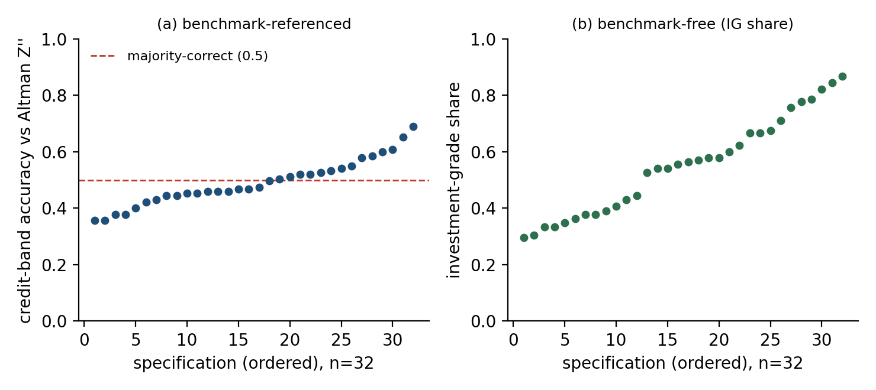
Specification curves of the machine credit rating; each point is one pre-registered specification (three seeds pooled), specifications sorted independently in each panel. (a) Benchmark-referenced: majority-correct credit-band accuracy against the Altman Z$″$ reference; the specifications split about 56/44 around the majority-accuracy threshold. (b) Benchmark-free: the share of a specification’s credit elicitations rated investment grade, which needs no ground truth and ranges widely across specifications, direct evidence that the verdict, not merely its accuracy, moves with the elicitation. This is the multiverse the method is named for.
Variance shares of the machine credit letter-rank (OLS decomposition with Type-II ANOVA; $n=45$ items). The residual is split into pure within-cell seed variance and other unexplained variance. Parenthetical values are issuer-clustered bootstrap 95% confidence intervals.
Component | Variance share
Item (firm profile) | 64.9% (53.9–72.3%)
Residual (total) | 25.2%
— pure within-cell seed variation | 8.1% (6.4–10.8%)
— other unexplained (unmodeled interactions) | $∼$17%
Answer presentation ($A_{7}$, largest design axis) | 4.6%
Provider $×$ item interaction | 1.4%
Prompt paraphrase / few-shot / format / version | $≤$1.0% each
Model provider (main effect) | 0.3%
The item, design-axis, provider$×$item interaction, and residual shares partition the total variance and sum to 100% up to rounding; the two indented rows are a decomposition of the residual, not additional components.

Specification fragility under deterministic execution
One explanation of this residual variation is that a provider may not fully honor a requested temperature of zero. If so, the observed instability might largely reflect stochastic sampling rather than sensitivity to the elicitation specification per se.
We therefore perform the pre-registered determinism test and restrict the analysis to the provider-setting combination for which the returned metadata confirm deterministic execution: Google at temperature 0. This subgrid removes repeated-call sampling variation but retains substantial specification dependence. In it, 62.5% of specifications fall on opposite sides of the majority-accuracy threshold, and benchmark-consistent credit-band accuracy ranges from 0.36 to 0.69 across deterministic prompt configurations.
A one-sided permutation test rejects the null of specification invariance: specification labels are shuffled across the deterministic subgrid, breaking the specification–outcome association. Across 999 permutations, no permuted labeling produced a between-specification spread as large as the observed statistic, giving $p=(k+1)/(n+1)=0.001$, the minimum attainable with 999 permutations. Deterministic execution thus removes run-to-run jitter but does not eliminate sensitivity to prompt and presentation choices; indeed, the specification-curve flip share within the deterministic subgrid is higher than the pooled estimate. The instability therefore cannot be ascribed solely to stochastic sampling, consistent with the variance decomposition, in which pure seed variation is a minority of the residual.

Agreement within and between providers
The small provider main effect might suggest that provider choice does not matter much. Direct agreement comparisons reveal a more complex pattern.
Within-provider agreement is consistently higher than cross-provider agreement. Within a single provider, 82.5% of identical firm profiles agree at the three-way credit-band level, but only 64.4% agree across the two providers. At the full letter-rating level, agreement across providers falls to 11.1% from 30.4% within providers.
These findings are consistent with the variance decomposition. The two providers respond differently to specific firm profiles, creating a provider-by-item interaction. The interaction does not appear to reflect a constant directional shift in ratings; a simple global adjustment does not allow one provider to be characterized as systematically more conservative or more generous than the other. The disagreement is issuer-specific.
This distinction is important operationally. Changing vendors does not provide a predictable correction to the rating of a specific firm, and aggregating outputs across vendors does not remove the underlying specification dependence. Vendor diversification therefore does not resolve the conceptual measurement problem or the need to characterize uncertainty across elicitation specifications.

Stability across rating resolutions
Credit ratings are inherently hierarchical. A model may not reproduce an exact letter grade yet still express a stable broader assessment. We therefore assess cross-specification agreement as we move from the full 21-grade letter-rating scale to notch categories, three broad credit bands, and the binary investment-grade/high-yield distinction (the deterministic mappings are given in Table 6).
Agreement improves as the scale is coarsened but does not become fully stable. Raw cross-specification agreement is approximately 17% at the letter level, 36% at the notch level, 68% for the three-way credit band, and 75% for the investment-grade/high-yield split. Equivalently, matched elicitation pairs disagree in about 83%, 64%, 32%, and 25% of comparisons, respectively (Fig. 2).
The same conclusion follows from chance-corrected agreement. Fleiss’ $κ$ is 0.10 at the full letter scale, 0.21 at the notch level, 0.43 for the three-way band, and reaches a maximum of only 0.49 for the investment-grade/high-yield split (Fig. 3). No evaluated rating resolution meets the conventional threshold for substantial agreement ($κ=0.60$) under unweighted scoring.
Because unweighted $κ$ on 21 ordinal grades penalizes an AAA-versus-AA$+$ disagreement as heavily as AAA-versus-C, we also report ordinal-weighted agreement on the letter-rank scale: Krippendorff’s $α$ is 0.44 under linear weighting and 0.65 under quadratic weighting. Fine-grained disagreement is therefore concentrated among adjacent grades. This weighting, however, cannot apply to the binary investment-grade/high-yield decision, where the only two categories are maximally distant and 25.2% of matched pairs still cross the boundary; the decision-relevant instability is unaffected by how ordinal proximity is credited.
The instability is not caused by the models collapsing to a narrow set of central ratings. All 21 letter grades are used across the experiment (pooled scale-usage entropy 3.89 of a maximum 4.39 bits). This spread is not merely across firms: the mean per-firm rating entropy is 2.85 bits, so a single firm’s rating is itself distributed over roughly seven effective grades as the specification varies. The models therefore use the available rating scale extensively but do not reproduce the same assessment consistently across specifications.
The most economically consequential result appears at the coarsest resolution. Even when all finer distinctions are dropped and only the investment-grade/high-yield classification is retained, 25.2% of matched elicitation pairs place the same firm profile on opposite sides of the boundary. Coarsening reduces specification sensitivity but does not eliminate it.
This boundary instability is not uniform across the credit spectrum; it concentrates near the investment-grade cut. The per-comparison IG/HY flip is 13.0% among benchmark-SAFE profiles, rises to 35.5% among benchmark-WATCH profiles adjacent to the boundary, and is 27.1% among benchmark-DISTRESS profiles. Because the battery is balanced across the three strata by construction (15 profiles each), the pooled 25.2% is the average over strata rather than an artifact of oversampling near-boundary firms.
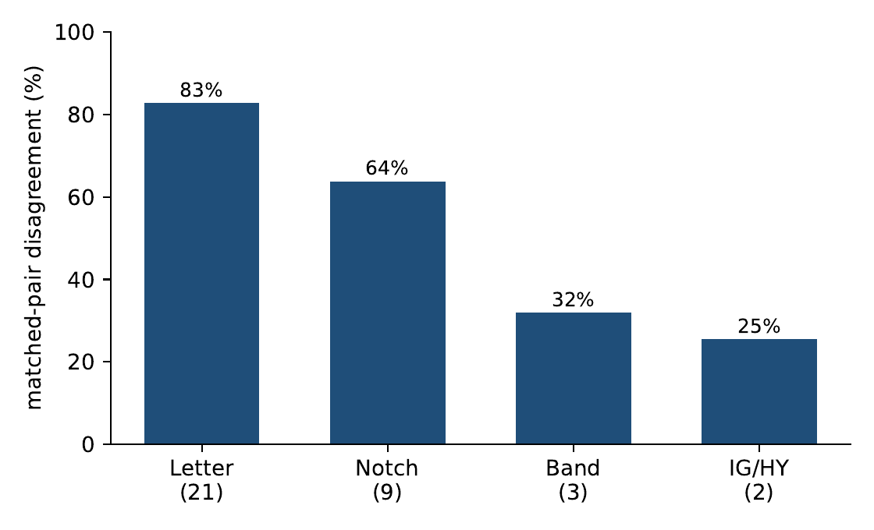
Share of matched elicitation pairs whose credit verdicts differ, by rating granularity, where the two elicitations of a firm may differ on any grid axis (provider, model version, temperature, paraphrase, format, few-shot, presentation) and seed. Even at the coarse investment-grade/high-yield split, the most consequential line in credit, about 25% of matched pairs disagree.
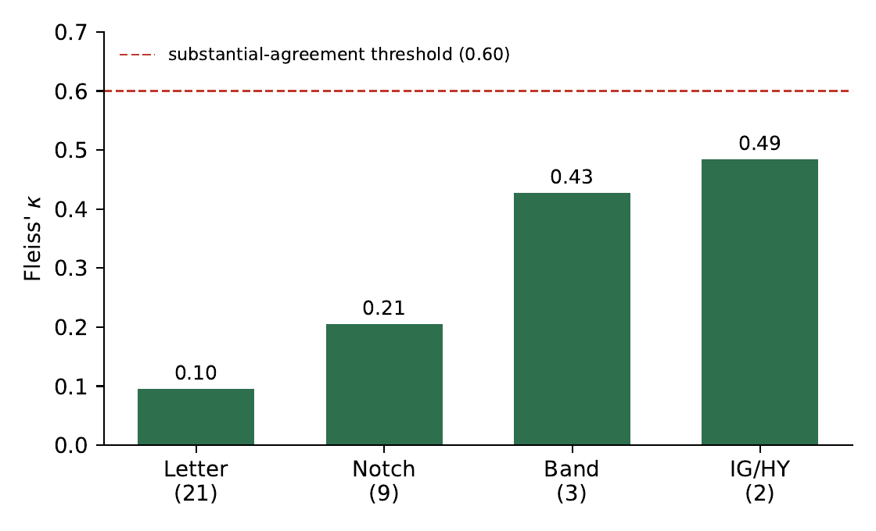
Chance-corrected cross-specification agreement (unweighted Fleiss $κ$) by granularity; agreement peaks at 0.49 on the IG/HY split and no resolution reaches the $κ=0.6$ substantial threshold under unweighted scoring. Ordinal weighting raises letter-scale agreement (Krippendorff’s $α=0.65$ quadratic), but the binary IG/HY flip is unaffected by weighting.

Economic implications of elicitation instability
Statistical disagreement is economically important when alternative specifications produce decisions on opposite sides of consequential credit boundaries. We translate the observed rating instability into three decision-relevant quantities: investment-grade/high-yield migration, portfolio turnover, and illustrative spread and capital implications.
For each credit-health profile we draw two elicitations from its observed specification distribution, allowing the pair to differ on any elicitation axis and on seed. We then compute, for each firm, the probability that the two resulting ratings fall on opposite sides of the investment-grade/high-yield boundary, and average across profiles. This per-comparison flip probability is one minus the Gini–Simpson concentration of the firm’s binary IG/HY outcomes.
This yields an investment-grade/high-yield flip rate of 25.2% (95% CI 19.7–31.2%): about a quarter of matched ratings for the same underlying credit profile disagree on which side of the investment-grade boundary the profile falls.
The implication for the directional task is similar. A strategy that mechanically follows the modal buy/hold/sell call across specifications would incur 53.5% implied turnover (95% CI 47.4–58.9%) due solely to elicitation choices. With the financial inputs unchanged, this turnover reflects specification instability rather than new economic information.
We also offer two post-hoc economic calibrations. Across all profiles, the median within-name spread range is about 275 basis points under the rating-spread schedule of Cornaggia et al. (2018), rising to about 860 basis points for names saturating in the CCC region; for non-saturating profiles the median range is about 261 basis points, with a floor near 42 basis points. Mapping each specification’s rating through the Basel standardized external-ratings risk-weight framework (Basel Committee on Banking Supervision, 2019) for a single hypothetical $45 billion equal-weight corporate portfolio, the resulting Pillar-1 minimum-capital requirement, driven only by the elicitation specification, ranges from approximately $2.0 billion to $4.1 billion (median $3.1 billion; interquartile range $2.9–3.6 billion), so the dispersion is not driven only by extreme specifications. Two randomly drawn specifications differ by about $0.57 billion on average, or 18.3% of the median computed capital requirement; under value-weighting this pairwise dispersion is 20.5%, comparable to the $∼$20% relative dispersion the Basel RCAP exercise found across internal-model banks holding identical portfolios (Basel Committee on Banking Supervision, 2013). Although these spread and capital calculations are explicitly post-hoc calibrations rather than confirmatory tests, they indicate that the magnitude of specification-induced rating dispersion is economically non-trivial (Table 2).
Fragility in decision and economic units. Parenthetical values are 95% confidence intervals (issuer-clustered percentile bootstrap).
Quantity | Result
Specifications flipping majority credit band verdict (pooled / determ.) | $∼$56% / 62.5%
Credit-band accuracy range, honored-determinism subgrid | 0.36–0.69
Permutation test, determinism subgrid | $p=0.001$ (999 perms)
Within- vs cross-provider agreement (band / letter) | 82.5/64.4 $⋅$ 30.4/11.1
Max chance-corrected agreement (Fleiss $κ$, IG/HY) | 0.49 (no scale $≥0.6$)
Per-comparison IG/HY boundary flip | 25.2% (95% CI 19.7–31.2%)
Implied turnover (modal-call instability) | 53.5% (95% CI 47.4–58.9%)
Implied spread range per name (non-saturating / median) | $∼$261 / $∼$275 bps
Pillar-1 capital range, same $45bn book (post-hoc cut) | $2.0–4.1bn (IQR 2.9–3.6)

Robustness on decontaminated real issuers
The constructed battery provides the controlled context in which to identify elicitation instability, but a key external-validity concern is whether similar behavior appears for real firms. Direct evaluation on real issuers raises a further methodological problem: an LLM may recognize a company from publicly available financial figures even when the company name is removed.
We test this possibility first, before using real issuers as a robustness sample. When presented with anonymized but otherwise unchanged financial profiles, Gemini-Flash correctly identifies about 22% of the selected mid-cap issuers from their financial numbers alone. This shows that anonymizing the issuer name does not guarantee that an LLM makes an independent credit assessment rather than relying on memorized issuer information.
The pre-registered fingerprinting gate lowered the issuer-identification rate from 22% to 2.9%, below the pre-specified 5% threshold. The decontaminated firms are then rated on a frozen 12-specification grid at three seeds, and the constructed battery is re-rated under exactly the same specification grid to provide a matched comparison.
The real-firm WATCH-stratum flip share is 0.226 (95% CI 0.147–0.308), relative to 0.318 (95% CI 0.223–0.406) for the matched constructed battery. The estimated difference is $−0.091$ (95% CI $−0.213$ to $0.032$; Table 3). The difference is not statistically distinguishable from zero, and the pre-registered two-one-sided-tests (TOST) equivalence test at the $±0.15$ margin does not establish quantitative equivalence ($p=0.179$), consistent with limited power at 16 real and 15 battery WATCH observations. We therefore treat this arm as an illustrative external-validity check rather than a formal equivalence claim: substantial specification instability remains observable in decontaminated real issuers under the same elicitation conditions, but the small sample cannot certify that its magnitude equals the constructed battery’s. As a separate descriptive reference, machine-generated credit bands match the disclosed agency ratings about 54% of the time, above the $∼$33% expected by chance on three bands, but far from reliable agreement.
Real-firm arm: 31 decontaminated business-to-business issuers, agency-rating benchmark. Parenthetical values are 95% confidence intervals (issuer-clustered percentile bootstrap).
Quantity | Result
Fingerprint identification, naive (exact figures) | 22%
Fingerprint identification, decontaminated (gate) | 2.9%
WATCH-stratum flip-share, real arm | 0.226 (0.147–0.308)
WATCH-stratum flip-share, battery (same 12 specs) | 0.318 (0.223–0.406)
Difference (real $−$ battery), 95% CI | $−0.091$ ($−0.213$, $0.032$)
Equivalence test (TOST, $±0.15$ margin) | $p=0.179$ (not established; underpowered)
Interpretation | illustrative external check; equivalence not established
Machine band vs. disclosed agency rating (descriptive) | 54% ($∼$33% chance)

Robustness across model tiers (post-hoc)
This analysis is post-hoc: it was not part of the pre-registered design and was carried out in a separate run on 30 August 2026, after the confirmatory corpus was frozen (7 July 2026), to address the concern that the instability might be an artifact of the low-cost model tier. We re-ran the frozen 12-specification grid over the 45 credit-health profiles at three seeds using each provider’s flagship model (gpt-5.4 and gemini-3.1-pro-preview), and compared it to the nano/flash tier evaluated on the identical grid. The per-comparison IG/HY flip is 23.6% (95% CI 19.4–27.8%) on the flagship tier versus 24.7% (95% CI 19.1–30.6%) on nano/flash; the paired difference is $−1.1$ percentage points (95% CI $−7.6$ to $+6.0$), not distinguishable from zero (Table 4). The three-way band flip is likewise statistically indistinguishable ($−5.3$ points; 95% CI $−11.9$ to $+1.3$). Flagship models are notably more lenient, they assign investment grade to 79.9% of elicitations versus 58.6% at the nano/flash tier, yet are no more stable across elicitation choices. We find no evidence that specification sensitivity attenuates at the flagship tier: the paired difference is small and statistically indistinguishable from zero, consistent with the instability being a property of how the categorical judgment is elicited rather than of model scale.
Two caveats attach to this comparison. First, the pooled figure masks provider heterogeneity: the flagship IG/HY flip is 26.7% for OpenAI (versus 17.3% at the nano tier) but 16.7% for Google (versus 20.5%), so the pooled near-equality reflects partial cancellation across providers rather than uniform stability. Second, the tiers are not perfectly generation-matched on the Google side, no Gemini-3.5 Pro model exists, so the flagship gemini-3.1-pro-preview is one minor generation behind its gemini-3.5-flash nano counterpart, whereas the OpenAI pair (gpt-5.4 versus gpt-5.4-nano) is generation-matched. Finally, the flagship models are not more accurate against the Altman benchmark despite their leniency: flagship credit-band accuracy is 36.7% versus 44.3% for nano/flash, so the 21-point investment-grade leniency shift reflects a more permissive rating posture, not better benchmark agreement.
Model-tier robustness (post-hoc; not pre-registered): per-comparison flip share on the same frozen 12-specification grid ($45$ credit-health items, three seeds). Parenthetical values are 95% issuer-clustered bootstrap confidence intervals; the difference is paired by item.
Flip share | Nano/flash | Flagship | Difference (95% CI)
IG/HY (pooled) | 24.7% (19.1–30.6) | 23.6% (19.4–27.8) | $−1.1$ ($−7.6$, $+6.0$)
IG/HY, OpenAI | 17.3% | 26.7%
IG/HY, Google | 20.5% | 16.7%
Three-way band | 30.5% | 25.2% | $−5.3$ ($−11.9$, $+1.3$)
Band accuracy vs. Altman | 44.3% | 36.7%
IG rate (leniency) | 58.6% | 79.9%

Self-consistency: does aggregation remove the instability? (post-hoc)
This analysis is post-hoc and was not part of the pre-registration. A natural remedy is self-consistency: instead of acting on a single elicitation, query the model under $k$ defensible specifications and act on the majority vote. We quantify how much this helps by computing, for each issuer, the residual probability that two independent $k$-of-$n$ majority votes land on opposite sides of the IG/HY boundary, averaged over issuers, for $k=1,3,5,9,15$ (Fig. 4). Aggregation reduces but does not remove the instability: the residual flip falls from 25.2% at $k=1$ to 19.4% ($k=3$), 16.6% ($k=5$), 13.6% ($k=9$), and 11.1% at $k=15$. Even fifteen aggregated elicitations therefore leave roughly one in nine matched issuer assessments crossing the investment-grade boundary. Self-consistency is a partial control whose cost grows linearly in $k$; it motivates reporting the residual dispersion explicitly rather than assuming a single call is representative, which is the role of the specification-instability score developed next.
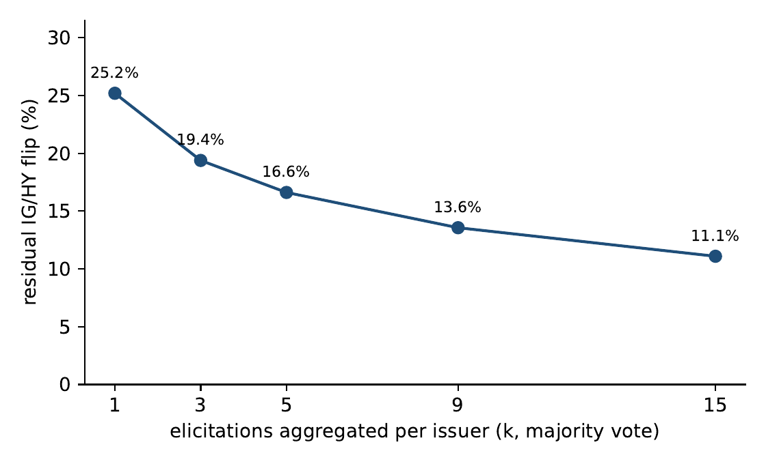
Self-consistency curve: residual per-comparison IG/HY flip after aggregating $k$ elicitations per issuer by majority vote. Aggregation lowers instability with diminishing returns and does not eliminate it, about 11% of matched assessments still cross the boundary at $k=15$.

A specification-instability score for model-risk control
The diagnosis above is actionable. Because the instability is a property of the elicitation process, it can be measured at inference time from the model’s own outputs and reported alongside every rating, turning the specification curve from a research diagnostic into an operational model-risk control. This section defines the control, validates that it predicts held-out instability, and specifies its deployment cost and governance use.

Definition
For an issuer $x$, fix a small set $S$ of $k$ defensible elicitation specifications and a decision resolution $g$ (for example, the map from letter grade to the IG/HY class). Query the model once per specification, map each rating to its decision class, and let $p_{x,c}$ be the fraction of the $k$ elicitations that fall in class $c$. The specification-instability score is the Gini–Simpson dispersion of that distribution,
SIS(x) = 1−c​px,c2,
reported alongside the modal rating $\hat{r}(x)=\text{arg}{\text{max}}_{c}p_{x,c}$. A score of zero denotes a perfectly stable, specification-invariant rating; higher values flag issuers whose rating is substantially an artifact of how the question was asked (the theoretical maximum for a binary decision is $0.5$). The score requires no ground truth and no access to model internals, so it applies to any API-served model (Algorithm 1, Fig. [alg:sis]). The Gini–Simpson form itself is a standard dispersion index; the contribution here is not a new mathematical index but its use as a deployable credit-model-risk control, its validation on held-out specifications, its governance trigger, and its cost model.

Post-hoc validation on held-out specifications
This validation is post-hoc (it was not part of the pre-registration) and tests generalization across specifications, not across an external issuer sample. A control is only useful if it predicts instability it has not seen, so we split the 32 specifications into a 16-specification calibration set and a disjoint 16-specification validation set, compute $SIS$ for each issuer on the calibration set only, and ask whether it predicts that issuer’s behaviour on the held-out validation specifications. The calibration score is strongly rank-correlated with the held-out flip rate (Spearman $ρ=0.89$). Treating “the issuer’s modal IG/HY call flips on at least one held-out specification” as the event to be flagged (base rate $0.76$), the calibration score achieves an ROC-AUC of $0.94$ (issuer-clustered bootstrap 95% CI $0.86$–$0.99$) and average precision of $0.98$. To rule out sensitivity to a single partition, we repeat the analysis over 300 balanced random calibration/validation splits: the median AUC is $0.88$ (interquartile range $0.86$–$0.91$; full range $0.73$–$0.98$). The score therefore identifies, from a handful of elicitations, the issuers whose ratings will prove unstable under specifications not yet tried, the screening function required of a deployable model-risk control.
We also check whether this generalizes beyond the synthetic battery by repeating the validation on the 31 decontaminated real issuers (Section 3.6), for which the same 12-specification grid was collected. Splitting those specifications 6/6, the calibration-set score remains predictive of held-out-specification instability on real firms (ROC-AUC 0.70, issuer-clustered bootstrap 95% CI 0.51–0.87; Spearman $ρ=0.41$; base rate 0.61). Discrimination is weaker than on the synthetic battery and the interval is wide, expected given only 31 issuers and a coarser six-specification calibration, but the score carries a genuine, same-direction signal on real issuers, not only on the constructed profiles. We nonetheless emphasize that the validation is across held-out specifications; a fully out-of-sample external issuer population remains future work.

Deployment: aggregation level and cost
The number of elicitations $k$ trades stability against cost. The self-consistency curve (Section 3.8) shows steeply diminishing returns: the modal call’s residual IG/HY flip falls from 25.2% at $k=1$ to 13.6% at $k=9$ and 11.1% at $k=15$, so a moderate $k​≈​9$ captures most of the achievable stabilization while still exposing residual dispersion through the score. The cost is modest and linear in $k$: at $k=9$, scoring one thousand issuers requires about $3.7$ million tokens and costs roughly $7 on a nano/flash tier or $118 on a flagship tier (Table 5). Because the score is computed from calls the workflow already makes, its marginal cost over simply issuing a rating is the $k−1$ additional elicitations.
Deployment cost of the specification-instability score by aggregation level $k$: cost to score 1,000 issuers, from the observed per-call token counts and provider pricing.
$k$ | Tokens/issuer | $/1,000 (nano/flash) | $/1,000 (flagship)
1 | 416 | 0.83 | 13.12
3 | 1,248 | 2.48 | 39.37
5 | 2,080 | 4.13 | 65.61
9 | 3,745 | 7.43 | 118.10
15 | 6,242 | 12.38 | 196.84
Token counts are the observed per-call means; dollar figures use provider list pricing accessed 30 August 2026 from the OpenAI and Google API pricing pages and will change as pricing changes.

Governance workflow
In a model-risk workflow the score sits between the model and the decision (Fig. 5). Each issuer is elicited $k$ times; the modal rating and its score are recorded; issuers whose modal rating sits near a consequential boundary (such as IG/HY) and whose score exceeds a pre-set tolerance are routed to human review, while stable issuers pass through. This yields an auditable, ground-truth-free control that scales with the rating pipeline and directly answers a supervisory model-risk question: how much of this rating is a property of the firm, and how much of how we asked?
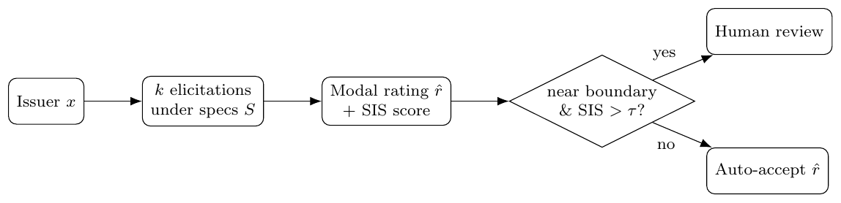
Governance workflow. Each issuer is elicited $k$ times; the modal rating and specification-instability score are recorded; issuers that are both near a consequential boundary and unstable are routed to review.

Discussion
We evaluate whether an LLM-generated credit rating can be treated as a stable assessment of a firm’s financial health or whether it depends heavily on how that measure is elicited. The main finding of the pre-registered specification curve is that substantial instability remains even after controlling for the underlying financial information. As expected, firm characteristics explain most of the total variation in ratings, but the residual variation due to elicitation is large enough to change economically meaningful decisions.
The variance decomposition clarifies the origin of this instability, and its interpretation is important. No single controllable design choice explains more than $∼$5% of rating variance. Of the $∼$25% OLS residual, only about 8% is pure run-to-run seed variation; the remainder is structured but unmodeled sensitivity to the elicitation specification. This distinction matters because it implies that the instability is neither reducible to a single tunable knob nor dismissible as mere sampling noise: the same financial information produces meaningfully different credit assessments under multiple reasonable specifications.
It is useful to separate two kinds of risk this induces, because they call for different controls. Build-time risk is the one-time consequence of fixing a particular provider, model snapshot, and prompt template when a system is designed: each design choice carries up to about 5% of variance and the provider$×$item interaction is non-negligible, so the chosen configuration selects a point on the specification curve that need not generalize to other defensible configurations. Run-time risk is the ongoing 8.1% pure seed variation that recurs on every call even with the configuration held fixed. The two map to different mitigations, build-time risk is managed by evaluating across specifications before deployment (the specification-instability score of Section 4), run-time risk by aggregating repeated calls (self-consistency, Section 3.8), and to different lines of a supervisory model-risk framework such as SR 11-7, one concerning model selection and validation, the other ongoing monitoring.
The real-issuer experiment complements, rather than substitutes for, this identification strategy. Crucially, it first demonstrates that direct evaluation on anonymized real firms is not automatically clean: a model identifies around 22% of the unperturbed issuers from financial information alone. After issuer-specific scaling and screening, the fingerprint rate falls to 2.9%, and substantial specification instability is still observed. The real and constructed estimates are not shown to be quantitatively equivalent, and the sample is too small to support such a claim; nevertheless, the qualitative pattern persists and suggests that the main finding is not confined to the controlled battery.

A reusable decontamination protocol
The fingerprinting result also has implications beyond the credit-rating experiment at hand. Public companies’ financial information is widely disseminated and may have been included in the training data of general-purpose LLMs. Removing company names does not necessarily remove issuer identity from an evaluation: if a model can infer the issuer from the precise financial numbers, then a judgment that appears to be based on the inputs may also draw on memorized information about that company. Perturbation combined with explicit identification testing is a practical way to mitigate this risk when evaluating LLMs on public financial entities.
Taken together, the results suggest that a credit rating produced by an LLM should not be interpreted as a specification-invariant point estimate. Each response is one realization from a broader distribution induced by the elicitation procedure. This does not imply that LLMs cannot contribute to credit analysis, and the present study does not assess whether their ratings are more or less accurate than established credit-assessment methods. Rather, a prerequisite for reliable use is to characterize the uncertainty associated with reasonable elicitation choices before treating a point rating as a stable model output.

Limitations
These findings have several limitations that bound their scope. First, the study considers two model providers and the specific model snapshots and configurations included in the pre-registered design (Table 7); the results should therefore be viewed as evidence of how the evaluated systems behave, not as a universal numerical estimate for all current or future LLMs. Relatedly, the evaluated snapshots are each provider’s low-cost (nano/flash) tier rather than a frontier model. We study this tier deliberately, because cost pressure makes it the realistic choice for high-volume, per-issuer credit screening. The concern that specification sensitivity might attenuate at the frontier is directly tested in Section 3.7 above: on the same grid, flagship models (gpt-5.4, gemini-3.1-pro-preview) show an IG/HY flip statistically indistinguishable from the nano/flash tier, so the instability is not an artifact of model scale. The flagship comparison nonetheless covers one model per provider on a reduced grid, and a fuller frontier sweep remains a useful extension.
Second, the main identification sample is a fixed 90-item constructed battery, with 45 profiles in the credit-health task and 45 in the directional task. Repeated specifications increase coverage of the elicitation space but not the number of independent underlying firm profiles, so the flip rates and variance estimates remain sample statistics for the 45 credit-health items considered; we report issuer-clustered confidence intervals throughout to make this uncertainty explicit.
Third, the real-firm arm comprises 31 U.S. mid-cap business-to-business issuers selected under the decontamination design. This sample checks external validity but is much smaller than the controlled battery at the relevant strata; in particular, the WATCH-stratum comparison lacks the power to detect the pre-specified equivalence margin, and quantitative equivalence between the constructed and real-firm estimates is not established.
Fourth, the study measures stability, not absolute credit-rating capability. The Altman Z$″$ mapping provides a pre-specified accounting-based benchmark for constructing and evaluating the controlled credit-health battery, while disclosed agency ratings provide an alternative descriptive reference; neither is treated as a unique ground-truth credit opinion. Whether generative models can produce more accurate credit assessments than established statistical, market-based, or agency methods is a separate research question.
A further methodological caveat concerns the variance decomposition. The 32-specification grid is a balance-constrained D-optimal fraction chosen to make the main effects mutually near-orthogonal, but with $N$ not divisible by the strength-2 requirement the design is resolution-limited: main effects can be partially aliased with two-factor interactions. We therefore read the decomposition main-effects-first and report the structured portion of the residual as “unmodeled interactions” rather than attributing it to specific axes; the headline stability results (flip shares, agreement) are model-free and do not depend on the ANOVA partition.
Finally, the spread and regulatory-capital translations are post-hoc calibrations that express observed rating dispersion in economically interpretable units. They are not pre-registered tests and are not intended as simulations of a real regulatory or institutional implementation. Within these bounds, the main stability finding is robust across the specification curve, the deterministic subgrid, the provider comparison, the rating-resolution analysis, and the decontaminated real-firm arm.

Future directions
The present design suggests several extensions. Larger and sector-stratified real-issuer samples would yield more precise estimates of how specification instability varies with firm characteristics and distance from rating boundaries. Similar designs could test retrieval-augmented or tool-using credit agents, where access to external information may reduce some forms of uncertainty while adding further specification choices. The proposed specification-instability score could be calibrated against downstream decision quality and integrated into human-in-the-loop workflows. More broadly, the decontamination procedure could be applied to other evaluations of financial LLMs involving publicly documented entities: explicitly testing whether an ostensibly anonymized case remains identifiable, in tasks such as risk assessment, valuation, investment recommendation, and supervisory analysis, may help separate independent reasoning from memorized entity knowledge.
Overall, reproducibility in AI-assisted credit assessment cannot be taken for granted from a single elicitation. Across a pre-registered specification curve, firm fundamentals explain most of the total variation in machine-generated ratings, but substantial specification-level instability remains after controlling for the underlying financial information, only a minority of which is pure run-to-run noise. For the systems studied here, the elicitation procedure is part of the measurement: unless stability with respect to reasonable elicitation choices has been demonstrated, a machine-generated credit rating should not be treated as a specification-independent point estimate, and the specification-instability score offers a concrete way to report that uncertainty.

Methods

Design, battery, and benchmark
The study is designed to measure elicitation stability: whether an LLM produces a credit assessment that is consistent when the underlying financial information is held constant but reasonable choices in how the assessment is elicited vary. The aim is therefore not to estimate rating accuracy on a naturally occurring population of firms, but to isolate variation attributable to the elicitation process.
We use a constructed battery as the main identification environment because it allows firm fundamentals to be held fixed while the elicitation specification varies, permits balanced representation across credit-health conditions, and provides a benchmark that can be computed before any model is queried. Restricting the analysis to public companies would introduce a further source of uncertainty, because an LLM might identify an issuer from financial information it was exposed to during training. We therefore use the controlled battery for the main analysis and a separately decontaminated real-firm sample for a complementary external-validity test.
The battery consists of 90 fixed firm-quarter profiles. Each profile is summarized in a compact financial statement, including revenue, EBIT, total assets and liabilities, equity, working-capital figures, and retained earnings. The profiles comprise two equally sized task families: 45 credit-health items, for which the model produces a credit rating, and 45 directional items, for which the model produces a buy/hold/sell call. All credit-rating agreement and investment-grade/high-yield analyses use the 45 credit-health profiles; the directional profiles are used only for the portfolio-turnover translation.
For the credit-health task, each profile is associated with a pre-specified Altman Z$″$ accounting-based reference (Altman, 1968), computed with coefficients 6.56, 3.26, 6.72, and 1.05 and cutoffs 2.60 and 1.10 (Z$″≥2.60$ = safe, $1.10<​$Z$″<2.60$ = watch, Z$″≤1.10$ = distress). The resulting safe, watch, and distress strata each contain 15 observations, evenly distributed across the 45 credit-health profiles. The machine’s letter rating is mapped deterministically to notch, three-band, and IG/HY outcomes as in Table 6; the Altman mapping provides a deterministic accounting reference for constructing and stratifying the controlled battery and is not treated as a unique ground-truth agency rating, because our interest is stability across elicitation specifications rather than absolute rating accuracy. The benchmark and battery were frozen under a pre-registration hash before any model query, and an independent post-hoc re-execution from the frozen financial facts reproduces all 45 benchmark classifications.
Deterministic mapping from the machine letter rating to coarser resolutions, and the Altman Z$″$ benchmark strata. The three-way band and the IG/HY split share the same investment-grade cut.
Letter grade | Notch | Three-way band | IG/HY
AAA | AAA | SAFE | Investment grade
AA$+$ | AA | SAFE | Investment grade
AA | AA | SAFE | Investment grade
AA$−$ | AA | SAFE | Investment grade
A$+$ | A | SAFE | Investment grade
A | A | SAFE | Investment grade
A$−$ | A | SAFE | Investment grade
BBB$+$ | BBB | SAFE | Investment grade
BBB | BBB | SAFE | Investment grade
BBB$−$ | BBB | SAFE | Investment grade
BB$+$ | BB | WATCH | High yield
BB | BB | WATCH | High yield
BB$−$ | BB | WATCH | High yield
B$+$ | B | WATCH | High yield
B | B | WATCH | High yield
B$−$ | B | WATCH | High yield
CCC$+$ | CCC | DISTRESS | High yield
CCC | CCC | DISTRESS | High yield
CCC$−$ | CCC | DISTRESS | High yield
CC | CC | DISTRESS | High yield
C | C | DISTRESS | High yield
The notch resolution drops the $+$/$−$ modifiers, collapsing the 21 letter grades to 9 notches. Altman Z$″$ strata: SAFE $≥2.60$; WATCH $1.10$–$2.60$; DISTRESS $≤1.10$.

Specification grid and data collection
We manipulate seven researcher-controlled elicitation dimensions: model provider (OpenAI, Google), model version (a current and a prior snapshot per provider), temperature (0 or 1.0), prompt paraphrase (three semantically equivalent formulations), output format (JSON or free-text), few-shot exemplars (zero or two), and answer presentation (original prose versus a table with reversed option ordering). The exact model snapshots and the collection window are listed in Table 7. A balance-constrained D-optimal fractional grid was generated from an effect-coded main-effects model with the design seed frozen in advance; the two-provider portion used here comprises 32 specifications, each evaluated over three seeds. Provider metadata were preserved as returned, including effective generation settings where available; the requested temperature of 0 was not uniformly honored by providers.
The confirmatory experiment therefore comprises $90×32×3=8,640$ elicitation cells ($4,320$ on the 45 credit-health profiles), of which 8,633 returned substantive content. The seven non-substantive cells (empty or unparseable responses, $0.08\%$) are dropped listwise: they enter no agreement, flip, or variance computation, and because every statistic is an average over the cells that did parse, their omission cannot manufacture instability. Each call is stored as an immutable JSON record containing the experimental specification, the returned content, and the available provider metadata. Data collection and analysis are separated: all confirmatory analyses run only on the frozen response corpus and do not re-query any model.
Model snapshots evaluated. The four confirmatory snapshots (two providers, current and prior each) constitute the main $8,640$-cell experiment; the two flagship snapshots are the separate model-tier robustness arm (Section 3.7). Responses were collected once and frozen; all reported results reproduce offline from the frozen corpus.
Provider | Model snapshot | Role
OpenAI | gpt-5.4-nano | current (confirmatory)
OpenAI | gpt-5-nano-2025-08-07 | prior (confirmatory)
Google | gemini-3.5-flash | current (confirmatory)
Google | gemini-2.5-flash | prior (confirmatory)
OpenAI | gpt-5.4 | flagship (robustness)
Google | gemini-3.1-pro-preview | flagship (robustness)
The four confirmatory snapshots were queried once in the frozen run of 7 July 2026; the two flagship snapshots in the robustness run of 30 August 2026. All were used offline thereafter; aliases without an embedded date stamp are pinned by these query dates.

Outcome construction and statistical analysis
Stored model responses are parsed under three rules, strict, lenient, and tolerant, applied after collection. Credit ratings are first expressed on the full 21-grade letter scale and then deterministically aggregated into notch categories, three broad credit bands, and the binary investment-grade/high-yield classification (Table 6). This permits examination of stability at increasingly coarse rating resolutions without additional model calls.
Agreement across specifications is measured with Fleiss’ $κ$. Within- and cross-provider agreement is computed on matched firm profiles and seeds. Variation in the full letter-rating rank is decomposed by ordinary least squares with Type-II analysis of variance, with terms for the underlying item, the elicitation-design dimensions, the provider-by-item interaction, and a residual. To interpret the residual, we additionally estimate the pure within-cell seed variance as the sum of squares across the three seeds within each identical item$×$specification cell, divided by the total sum of squares; the difference between the OLS residual and this pure-seed component is reported as “other unexplained” (unmodeled interactions).
All analyses are pre-registered unless labelled post-hoc, and inference uses distribution-free resampling throughout, so no normality assumption is made. Uncertainty for the main quantities is estimated by issuer-clustered percentile bootstrap resampling over the underlying firm profiles rather than over individual model calls, thereby preserving dependence among repeated elicitations of the same profile; we report the variance shares (item and pure-seed), the IG/HY flip rate, and the turnover estimate with two-sided 95% confidence intervals (2,000 replicates for the economic quantities, 1,000 for the variance-share and specification-curve quantities). Specification invariance under deterministic execution is tested on the provider-setting combination whose metadata confirm that temperature was honored (Google at temperature 0): the observed between-specification spread in credit-band accuracy is compared with the distribution generated by 999 permutations in a one-sided label-permutation test, $p=(k+1)/(n+1)$, where $k$ is the number of permuted statistics at least as extreme as the observed statistic and $n=999$. The test is one-sided because only an observed spread larger than the permutation distribution constitutes evidence against specification invariance. For the real-firm robustness analysis, quantitative equivalence of the real-firm and constructed-battery WATCH-stratum flip shares is assessed with two one-sided tests (TOST) against a pre-registered margin of $±0.15$, based on 16 real-firm and 15 constructed WATCH observations. The significance threshold is $α=0.05$ for all formal tests. To mitigate the risk of selective reporting within the specification multiverse, we pre-registered the estimands and specification grid and report the entire specification curve rather than a selected subset. We reserve “significant” for results accompanied by a $p$-value and otherwise use “substantial” or “considerable.”
For the binary IG/HY outcome, the per-comparison flip probability is computed separately for each credit-health profile from its observed distribution of ratings across the entire elicitation grid, so that two elicitations may differ on any specification dimension or seed. The resulting pair falls on opposite sides of the IG/HY boundary with probability equal to one minus the Gini–Simpson concentration of the profile’s binary labels, and the reported flip rate is the average of this quantity over the 45 credit-health profiles. The same per-issuer quantity, reported at the decision resolution of interest, is the specification-instability score proposed in the Discussion.

Economic translation
The economic translations are post-hoc calibrations that express the magnitude of rating instability in decision-relevant units; they are not confirmatory tests. Portfolio turnover is computed from the 45 directional profiles as the share of positions whose modal buy/hold/sell decision changes across elicitation specifications. Rating dispersion is transformed into indicative credit-spread variation using the rating-spread schedule of Cornaggia et al. (2018) and a cached daily option-adjusted-spread series. For the regulatory-capital illustration, each specification’s rating is mapped through the Basel CRE20 standardized external-ratings risk-weight schedule (Basel Committee on Banking Supervision, 2019) and applied to the same hypothetical $45 billion equal-weight corporate portfolio, so that the capital range reflects only differences in the elicited rating. The comparison with the Basel Regulatory Consistency Assessment Programme (Basel Committee on Banking Supervision, 2013) is used only as a magnitude calibration, not as an identity between the two settings.

Real-firm arm
To test the persistence of specification instability outside the constructed battery, we assemble a complementary sample of 31 U.S. business-to-business issuers with market capitalizations between $2 billion and $15 billion whose most recent Form 10-K discloses a current long-term agency credit rating. S&P is the primary rating source; where S&P ratings are unavailable, Moody’s or Fitch ratings are mapped to a common scale. Each rating is preserved with a verbatim filing quotation, a permanent SEC document URL, and a document hash.
Because these figures are publicly reported by real issuers, there is a risk of contamination if a model can identify a company. We therefore first perform a pre-registered fingerprinting test in which the models are asked to identify issuers from anonymized financial profiles; Gemini-Flash identifies about 22% of the selected issuers from the original figures, confirming that removing the company name does not guarantee independence from memorized issuer information. To reduce this risk, every dollar-denominated quantity for an issuer is multiplied by a single issuer-specific factor sampled from a log-uniform distribution over $[0.6,1.7]$. The same factor applies to all monetary amounts, so the credit-health analysis retains the financial-ratio structure while disrupting exact-figure lookup. We also exclude consumer-facing companies to reduce recognition from highly distinctive public profiles. The fingerprint-identification rate falls to 2.9% after perturbation, below the pre-registered 5% decontamination threshold.
Each decontaminated issuer is then scored on a fixed 12-specification grid spanning presentation, provider, prompt paraphrase, and output format, at three seeds, and the constructed battery is re-scored under the same grid for a matched comparison on the WATCH stratum. This arm uses disclosed agency ratings as a descriptive real-world reference; the primary comparison is stability across specifications.

Reproducibility
The entire experimental pipeline is archived so that the reported results can be reproduced without further model calls. The frozen materials comprise the 90-item battery, the specification grid, the prompt templates, the rating scale, the frozen response corpus, the analysis panel, the real-firm arm, the analysis code, the generated outputs, and SHA-256 integrity manifests. The complete set of confirmatory tables, figures, and reported statistics regenerates from a single offline entry point. Provider API credentials are required only to collect new model responses and are not needed to reproduce any result reported in this study.

Declaration of generative AI and AI-assisted technologies in the manuscript preparation process
Generative AI was used to assist with grammar correction and minor language edits of the authors’ own text, and with software scaffolding, development, and coding of the analysis and reproducibility pipeline (Anthropic Claude), in all cases under the authors’ direction. Separately, large language models are the object of study in this work, the credit-rating elicitations under analysis, as described above; every such elicitation is recorded in the specification grid and frozen corpus. The authors reviewed and verified all such output and take full responsibility for the content.

Declaration of competing interest
The authors declare no competing interests.

Funding
This research received no external funding.

Ethics
This study did not involve human participants, human tissue, or animal subjects, and used no personally identifiable or sensitive personal data; ethical approval was therefore not required. The analysis uses only synthetic firm profiles, publicly available corporate financial disclosures (SEC filings), and the authors’ own model elicitations.

Data availability
All data and code required to reproduce the study are openly available in a deterministic, offline reproducibility capsule (MIT license) that accompanies this submission; the public repository and its citable DOI are withheld here for double-blind review and will be provided on acceptance. Within the capsule, data/frozen/main/ contains the pre-registered 90-item firm battery (battery_90.json; 45 credit-health $+$ 45 directional items), the specification grid, the prompt paraphrases, the rating scale, and the Basel capital map; data/raw/main/ holds the frozen response corpus; data/panel/panel.parquet is the analysis panel; and data/frozen/realarm/ with data/raw/realarm/ contain the decontaminated real-firm arm (anonymized perturbed battery, sealed issuer crosswalk, rating provenance with verbatim 10-K quotation, permanent SEC URL, and document hash per issuer, and the arm/comparator/fingerprint model-output panels). The flagship model-tier arm (gpt-5.4 $+$ gemini-3.1-pro-preview on the frozen 12-specification grid) is in capture/flagship_runs/, fixed by MANIFEST_FLAGSHIP.sha256. Analysis code is in analysis/, outputs and figures in results/, and SHA-256 manifests in manifest/. A single offline entry point, reproduce.sh, regenerates every reported number, table, and figure, with no model calls and no API keys. A self-contained companion document (REPRODUCIBILITY_DOCUMENTATION.pdf, provided with this submission) describes the complete archive—data inputs and provenance, every analysis script and its outputs, the one-command reproduction, the verification and determinism procedure, and the pinned environment—so that the study can be understood and re-run from that single file. The underlying SEC filings (Form 10-K and company-facts XBRL) are publicly available through the SEC EDGAR system.

References
Altman (1968). Financial ratios, discriminant analysis and the prediction of corporate bankruptcy. The Journal of Finance.
Atil, Aykent, Chittams, Fu, Passonneau, Radcliffe, Rajagopal, Sloan, Tudrej, Ture, Wu, Xu, Baldwin (2024). Non-determinism of “deterministic” LLM settings. arXiv:2408.04667.
Basel Committee on Banking Supervision (2013). Regulatory Consistency Assessment Programme (RCAP): Analysis of risk-weighted assets for credit risk in the banking book. Bank for International Settlements.
Basel Committee on Banking Supervision (2019). CRE20: Standardised approach: individual exposures. Basel Framework, Bank for International Settlements.
Board of Governors of the Federal Reserve System, Currency (2011). Supervisory guidance on model risk management. SR Letter 11-7 / OCC Bulletin 2011-12.
Bommasani, others (2021). On the opportunities and risks of foundation models. arXiv preprint arXiv:2108.07258.
Brown, others (2020). Language models are few-shot learners. Advances in Neural Information Processing Systems (NeurIPS).
Camuffo, Gambardella, Kazemi, Malachowski, Pandey (2026). Variance-aware LLM annotation for strategy research: Sources, diagnostics, and a protocol for reliable measurement. arXiv:2601.02370.
Cantor, Packer (1997). Differences of opinion and selection bias in the credit rating industry. Journal of Banking
& Finance.
Chon, Kim, Kim (2025). Multifaceted variability in LLM-driven stock recommendations. Finance Research Letters.
Cornaggia, Cornaggia, Israelsen (2018). Credit ratings and the cost of municipal financing. Review of Financial Studies.
Devlin, Chang, Lee, Toutanova (2019). BERT: Pre-training of deep bidirectional transformers for language understanding. Proceedings of NAACL-HLT.
Drinkall, Pierrehumbert, Zohren (2025). Forecasting credit ratings: A case study where traditional methods outperform generative LLMs. Proceedings of the Joint Workshop of FinNLP, FNP, and LLMFinLegal (COLING 2025).
García-Llorente, Olmeda (2026). Large language models for banking supervision: Reliability evidence from European systemic banks. Finance Research Letters.
Gelman, Loken (2014). The statistical crisis in science. American Scientist.
Hansen, Kazinnik (2024). Can ChatGPT decipher Fedspeak?. SSRN Electronic Journal.
Hens, Nordlie (2025). How good are LLMs in risk profiling?. Finance Research Letters.
Kadavath, Conerly, Askell, Henighan, others (2022). Language Models (Mostly) Know What They Know. arXiv preprint arXiv:2207.05221.
Kaplan, McCandlish, Henighan, Brown, Chess, Child, Gray, Radford, Wu, Amodei (2020). Scaling laws for neural language models. arXiv preprint arXiv:2001.08361.
Kliger, Sarig (2000). The information value of bond ratings. Journal of Finance.
Kuhn, Gal, Farquhar (2023). Semantic Uncertainty: Linguistic Invariances for Uncertainty Estimation in Natural Language Generation. International Conference on Learning Representations (ICLR).
Lin, Hilton, Evans (2022). Teaching Models to Express Their Uncertainty in Words. Transactions on Machine Learning Research (TMLR).
Lopez-Lira, Tang (2023). Can ChatGPT forecast stock price movements? Return predictability and large language models. arXiv preprint arXiv:2304.07619.
Mizrahi, Kaplan, Malkin, Dror, Shahaf, Stanovsky (2024). State of what art? A call for multi-prompt LLM evaluation. Transactions of the Association for Computational Linguistics.
Ohlson (1980). Financial ratios and the probabilistic prediction of bankruptcy. Journal of Accounting Research.
OpenAI (2023). GPT-4 technical report. arXiv preprint arXiv:2303.08774.
Ouyang, others (2022). Training language models to follow instructions with human feedback. Advances in Neural Information Processing Systems (NeurIPS).
Sclar, Choi, Tsvetkov, Suhr (2024). Quantifying language models’ sensitivity to spurious features in prompt design. International Conference on Learning Representations (ICLR).
Simmons, Nelson, Simonsohn (2011). False-positive psychology: Undisclosed flexibility in data collection and analysis allows presenting anything as significant. Psychological Science.
Simonsohn, Simmons, Nelson (2020). Specification curve analysis. Nature Human Behaviour.
Steegen, Tuerlinckx, Gelman, Vanpaemel (2016). Increasing transparency through a multiverse analysis. Perspectives on Psychological Science.
Tang (2009). Information asymmetry and firms’ credit market access: Evidence from Moody’s credit rating format refinement. Journal of Financial Economics.
Vaswani, Shazeer, Parmar, Uszkoreit, Jones, Gomez, Kaiser, Polosukhin (2017). Attention is all you need. Advances in Neural Information Processing Systems (NeurIPS).
Wang, Wei, Schuurmans, Le, Chi, Narang, Chowdhery, Zhou (2023). Self-Consistency Improves Chain of Thought Reasoning in Language Models. International Conference on Learning Representations (ICLR).
Wu, Irsoy, Lu, Dabravolski, Dredze, Gehrmann, Kambadur, Rosenberg, Mann (2023). BloombergGPT: A large language model for finance. arXiv preprint arXiv:2303.17564.
Xie, Han, Zhang, Lai, Peng, Lopez-Lira, Huang (2023). PIXIU: A large language model, instruction data and evaluation benchmark for finance. Advances in Neural Information Processing Systems (NeurIPS).

