The Price of De-correlation: Quantifying the Agreement–Cost Trade-off in Heterogeneous Large Language Model Ensembles
Samir Chincholikar¹, Robin Chawla¹
¹Independent researchers. Corresponding author: Samir Chincholikar (samir.chincholikar@gmail.com, ORCID 0009-0007-2779-3492). Manuscript submitted August 3, 2026.
Large language model (LLM) ensembles are increasingly used as decision-making committees under the assumption that aggregating multiple agents improves reliability. However, ensembles composed of repeated instances of the same model may produce correlated judgments and create an appearance of consensus without genuine independence. This study quantifies the relationship between cross-provider model heterogeneity, ensemble agreement, and inference cost. In a 54,000-call primary experiment, we evaluate three five-agent ensemble configurations with increasing provider diversity on a directional financial-analysis task covering 100 equities across 12 dates. Cross-provider heterogeneity significantly reduces within-ensemble agreement, with a primary reduction of $Δκ=0.336$ (95% CI: $0.304$–$0.369$), but increases inference cost by approximately $4.4×$. A capability-matched control indicates that the effect is driven primarily by provider diversity rather than model capability differences. We also introduce an independent-draw measurement protocol that prevents shared sampling conditions from inflating estimated agreement. Although heterogeneity does not produce a reliable improvement in average directional accuracy, exploratory results indicate that homogeneous ensembles generate unanimous incorrect decisions at $1.84$ times the rate of heterogeneous ensembles. These findings show that model diversity provides less-correlated judgments rather than guaranteed correctness, and offer a practical agreement–cost framework for designing LLM ensemble systems.
Index Terms— Large language models, multi-agent systems, ensemble learning, model heterogeneity, inter-rater agreement, algorithmic monoculture, inference cost, reliable artificial intelligence.

Introduction
Multi-agent large language model systems increasingly aggregate multiple agents through voting, debate, or other consensus mechanisms[1, 2]. These approaches are commonly motivated by the wisdom-of-crowds principle, under which combining multiple judgments can reduce individual errors. Their effectiveness, however, depends on the extent to which the participating agents produce independent errors. An ensemble comprising repeated instances of the same model may exhibit substantial output correlation, thereby providing less effective diversity than its number of agents suggests. Cross-provider model heterogeneity offers a potential remedy, but it also introduces additional inference cost, and its ability to reduce correlated behavior has not been established quantitatively. Recent evidence that LLMs may exhibit correlated errors even across providers and architectures further raises concerns about algorithmic monoculture[3].
Existing research supports two competing expectations regarding cross-provider heterogeneity. Under the diversity hypothesis, models developed by different providers, using distinct training procedures, datasets, and architectures, should generate less-correlated outputs and therefore contribute more diverse judgments. In contrast, the algorithmic-monoculture hypothesis[3] suggests that common training data, objectives, and evaluation practices may cause substantial behavioral similarity even across model families. These perspectives imply materially different agreement–cost relationships. If provider identity contributes little additional diversity, increasing heterogeneity will raise inference cost without meaningfully reducing agreement. Conversely, a substantial reduction in agreement would indicate that cross-provider diversity is measurable and can be evaluated against its associated cost. This study tests these alternatives empirically.
Despite the growing use of heterogeneous LLM ensembles, three related issues remain insufficiently examined. First, few studies directly quantify the extent to which cross-provider heterogeneity reduces within-ensemble agreement. Second, the corresponding inference-cost premium is rarely incorporated into evaluations of ensemble design. Third, agreement estimates may be distorted when supposedly independent agents share random seeds, sampling trajectories, cached outputs, or other elements of the generation context. Consequently, existing evaluations may conflate genuine model similarity with artifacts of the measurement procedure. We address these limitations by jointly estimating the magnitude of ensemble de-correlation, the associated inference cost, and the effect of independent-draw measurement controls.
This distinction is practically important because LLM ensembles are increasingly considered for financial analysis and other consequential decision-support applications in which multiple agents are expected to provide independent second opinions. When agents exhibit highly correlated behavior, repeated calls may increase computational expenditure while producing an overstated impression of evidential consensus. Practitioners therefore require evidence on both the degree of independence obtained through model heterogeneity and the cost required to obtain it. By estimating these quantities jointly, this study provides an empirical basis for selecting ensemble configurations according to the reliability and cost requirements of a given application.

Contributions
This paper makes the following contributions.
- Pre-registered empirical measurement. We conduct a pre-registered empirical study comprising 54,000 model calls to quantify the effect of cross-provider heterogeneity on within-ensemble agreement. Agreement decreases substantially and monotonically as provider diversity increases, with a primary contrast of $Δκ=0.336$ and a 95% confidence interval of $[0.304,0.369]$.
- An empirical agreement–cost frontier. We quantify the inference-cost premium associated with cross-provider diversity. Moving from the homogeneous to the fully heterogeneous configuration reduces agreement at an approximately $4.4×$ increase in inference cost.
- A reproducible independent-draw measurement protocol. We separate genuine model agreement from agreement induced by shared sampling conditions. In a controlled pilot, shared per-run seeding inflated the estimated de-correlation effect by approximately fourfold, whereas unique per-agent seeds removed the artifact. To support replication, we provide a frozen, hash-verified dataset, fixed experimental configurations, and a deterministic seeded analysis pipeline that regenerates the reported figures and tables.
- An exploratory analysis of consensus structure. Although heterogeneity does not produce a statistically reliable improvement in average directional accuracy, homogeneous ensembles generate unanimous incorrect directional decisions at $1.84×$ the rate of fully heterogeneous ensembles, motivating confirmatory evaluation of collective-error risk.
We distinguish reduction in ensemble agreement from improvement in predictive accuracy. Cross-provider heterogeneity substantially increases observed behavioral diversity, but it does not reliably improve average correctness in the evaluated directional-finance task. Thus, model diversity should be evaluated according to whether the additional diversity improves the downstream objective rather than being treated as beneficial by default.

Related Work

LLM ensembles and mixture-of-agents
Aggregating multiple LLM outputs through voting, debate, or layered mixture-of-agents architectures has been investigated as a means of improving response quality and reliability[1, 2, 4]. However, prior studies indicate that naive aggregation may provide only limited gains over the strongest individual model and may amplify systematic errors when correlated weaker models outvote a stronger model[3]. Related scaling studies also report diminishing or negative returns from repeatedly adding homogeneous agents, whereas more diverse ensembles can provide more sustained improvements[5].
These findings have motivated diversity-aware methods such as the focal-diversity pruning strategy used in LLM-TOPLA[6], the fingerprint-based ensemble selection of DFPE[7], and heterogeneous consensus frameworks such as Council Mode[8]. Such approaches generally evaluate diversity through downstream performance. In contrast, the present study treats within-ensemble agreement as the primary quantity of interest and directly measures how cross-provider heterogeneity affects agreement, statistical uncertainty, and inference cost.

Correlated errors and algorithmic monoculture
Kim et al.[3] document substantial error correlation across a large set of LLMs, including models developed by different providers, and relate this dependence to the systemic risk of algorithmic monoculture. Their analysis concerns error correlation—that is, the tendency of models to fail on the same instances—whereas the present study examines output agreement across all decisions, regardless of whether those decisions are correct.
These quantities are related but not equivalent. Lower output agreement may indicate greater behavioral diversity, but it does not necessarily imply less-correlated errors or improved predictive performance. In the vision-language setting, Bugaud[9] similarly reports that models from the same architectural family exhibit correlated errors that reduce the effective number of independent voters and shows that family-aware aggregation can improve ensemble performance.
The present work extends this line of inquiry to text-based LLM committees by measuring provider-level agreement, comparing same-provider and cross-provider agent pairs, and incorporating the inference-cost trade-off associated with model heterogeneity.

Inter-rater agreement and diversity metrics
Fleiss’ $κ$[10] is a chance-corrected agreement statistic designed for categorical ratings produced by multiple raters. We apply it by treating the five LLM agents as interchangeable raters, each $(ticker,date)$ pair as a rated subject, and BUY, HOLD, and SELL as nominal categories.
Unlike diversity measures used primarily to select, weight, or prune ensemble members[6], our objective is to estimate agreement itself and determine how it varies with provider heterogeneity and inference cost. Because Fleiss’ $κ$ can be sensitive to category prevalence, we additionally assess the robustness of the observed configuration ordering using Krippendorff’s $α$[11] and Gwet’s AC1[12]. Statistical uncertainty is estimated through cluster-bootstrap resampling at the equity level[13].

Reproducibility and pre-registration
Pre-registration and frozen, hash-verified datasets remain uncommon in empirical LLM research. We adopt a confirmatory design—specifying the analysis plan in advance, collecting data once, and re-analyzing deterministically—to limit researcher degrees of freedom, and we release the resulting artifacts. The freezing, seeding, and reproducibility procedures are described in detail in Section IV-D.

Problem Formulation and Metrics

Ensemble configurations
Each ensemble contains five agents that independently respond to the same prompt through separate application programming interface (API) calls. We designate OpenAI as the primary provider and define the heterogeneity level of configuration $c$ as the number of agents drawn from a non-primary provider:
$$h_{c}=\sum_{i=1}^{5}{I}\left(p_{i}≠p_{primary}\right),$$
where $p_{i}$ denotes the provider of agent $i$. We evaluate three configurations:
- HOM ($h=0$): five agents using the primary-provider model;
- HET-LITE ($h=1$): four primary-provider agents and one Google agent;
- HET ($h=3$): two primary-provider agents, two Google agents, and one xAI agent.
The exact model identifiers, provider roles, and token prices used during data collection are reported in Table 1.
TABLE 1. Model registry (verified via a live probe). Prices are USD per ${10}^{6}$ tokens at time of experiment.
Provider (role) | Model string | In | Out
OpenAI (primary) | gpt-5.4-nano | 0.20 | 1.25
Google (het.) | gemini-3.5-flash | 1.50 | 9.00
xAI (het.) | grok-4.3 | 1.25 | 2.50

Agreement statistic
For each configuration $c$, experimental run $r$, and evaluation cell $s=(ticker,date)$, the five agents return one categorical direction from $Y=\{BUY,HOLD,SELL\}$. We treat agents as raters and evaluation cells as rated subjects. Fleiss’ $κ$ is computed separately within each run, producing the run-level agreement statistic $κ_{c,r}$. Configuration-level agreement is then defined as the mean across the $R=3$ runs:
$$κ_{c}=\frac{1}{R}\sum_{r=1}^{R}{κ_{c,r}}.$$
The pre-registered primary endpoint is the reduction in agreement between the homogeneous and fully heterogeneous configurations:
$$Δκ_{HOM−HET}=κ_{HOM}−κ_{HET}.$$
The pre-registered secondary contrasts are $Δκ_{HOM−HET\text{-}LITE}=κ_{HOM}−κ_{HET\text{-}LITE}$ and $Δκ_{HET\text{-}LITE−HET}=κ_{HET\text{-}LITE}−κ_{HET}$. Positive values indicate that increasing cross-provider heterogeneity reduces within-ensemble agreement.

Independent-draw estimand
The estimand of interest is agreement among independently sampled agent responses. Accordingly, every agent response is generated through a separate, stateless API request, without shared conversation state, response caching, or multi-sample batching, so that no two agents share a sampling trajectory through the request structure itself. Each request is additionally assigned a unique, reproducible seed:
$${seed}_{r,c,s,i}=SHA\text{-}256(master,r,c,ticker,date,i)mod2^{31},$$
where $i$ identifies the agent position within the ensemble. Including the agent identifier gives repeated instances of the same model distinct seeds—and therefore distinct sampling trajectories on endpoints that honor the seed parameter—while keeping those calls reproducible. All three provider endpoints used in this study accept a seed parameter, and the unique per-agent seed is transmitted on every call, masked to a positive 32-bit integer as some endpoints require; the model registry and supplementary manifest record the seed sent with each call. Because provider seed support is best-effort rather than a determinism guarantee, reproducibility ultimately rests on the archived raw responses (Section IV-D) in addition to re-executable seeding.
As a diagnostic for residual within-run dependence, we compare agreement among the five draws generated within a run with agreement estimated from independently generated draws across runs. For the homogeneous configuration, these quantities should be approximately equal when all five agents are sampled independently. A materially positive within-run minus cross-run gap would indicate that shared seeds or another common sampling condition is artificially increasing measured agreement. For heterogeneous configurations, the cross-run calculation also introduces additional same-model replicate pairs and is therefore interpreted as a secondary consistency check rather than a direct independence test.

Uncertainty quantification
Uncertainty in the agreement contrasts is estimated using a cluster bootstrap with equities as the resampling unit[13]. Clustering at the equity level preserves the dependence among repeated analysis dates for the same security while allowing variation across securities to determine the confidence interval. For each of 2,000 bootstrap replications, equities are sampled with replacement, all associated dates and agent responses are retained, and the configuration-level agreement statistics and contrasts are recomputed. We use the percentile method with a fixed random-number-generator seed of 42 to construct 95% confidence intervals (CIs). Under the pre-registered decision rule, the primary hypothesis is considered supported when $Δκ_{HOM−HET}>0$ and its 95% confidence interval excludes zero.

Experimental Design

Task and grid
For each evaluation cell $s=(j,t)$, where $j$ denotes an equity and $t$ denotes an analysis date, every agent receives the same dated information set and independently returns a response conforming to the following JavaScript Object Notation (JSON) schema:
{
"direction": "BUY | HOLD | SELL",
"conviction": <integer 1-5>,
"rationale": "<free-text explanation>"
}
The direction field constitutes the categorical output used in the primary agreement analysis. The conviction field is an integer from 1 to 5, and the conviction and rationale fields are retained for secondary and exploratory analyses. The complete prompt template and response schema are frozen and included in the reproducibility package.
Each response is parsed as strict JSON against this schema. A response that fails to parse, omits a required field, or returns a direction outside $\{BUY,HOLD,SELL\}$ is treated as invalid and reissued with the same per-agent seed, up to a pre-registered maximum of five retries, with every attempt logged. Calls interrupted by provider daily-quota limits were deferred and re-issued after the quota reset under the same seeds. A cell that remained invalid after the retry budget would have been handled under the pre-registered exclusion rule; in the confirmatory dataset, all 54,000 grid cells ultimately returned schema-valid responses, so no cells were excluded. The complete attempt history, including failed and deferred calls, is preserved in the released log.
The experiment covers 100 large-cap equities distributed across all 11 Global Industry Classification Standard sectors and 12 analysis dates in 2026. For each equity-date pair, responses are generated under three ensemble configurations, three independent runs, and five agents per ensemble. The complete design therefore contains $100×12×3×3×5=54,000$ individual model calls.
The dates are selected to reduce the possibility that model responses rely on memorized post-event information and to ensure that the 20-trading-day forward-return window used in the secondary accuracy analysis has fully elapsed. They are also chosen to span distinct 2026 market conditions. The equity universe, sector allocation, inclusion criteria, and complete ticker list are reported in the supplementary materials.

No-lookahead context
Each agent receives a price-derived information set constructed solely from observations available through the trading day immediately preceding the corresponding analysis date. For every equity-date cell, the context contains the trailing one-week return, the trailing one-month return, the trailing three-month return, the 21-trading-day realized volatility, and the security’s position within its trailing 63-trading-day price range. No observations from the analysis date or any subsequent date are included in the agent prompt. The same information set is supplied to all agents evaluating a given cell, ensuring that differences in responses arise from model behavior rather than differences in the available inputs.
For exact replication, the return horizons are defined in trading days. For example, the range-position feature is computed as
$${RangePos}_{j,t}=\frac{P_{j,t−1}−\underset{τ∈W_{63}}{\text{min}}P_{j,τ}}{\underset{τ∈W_{63}}{\text{max}}P_{j,τ}−\underset{τ∈W_{63}}{\text{min}}P_{j,τ}},$$
where $W_{63}$ denotes the preceding 63-trading-day window. End-of-day prices are obtained from a single market-data vendor (Financial Modeling Prep), fetched once, and frozen in the released cache; realized volatility is computed over the trailing 21-trading-day window, and the treatment of missing observations is specified in the supplementary materials. Data provenance and the exact information supplied to each model call are recorded in the experimental logs.

Models
All model calls are executed using a sampling temperature of 0.7. Exact provider and model identifiers are fixed for the duration of data collection and reported in Table 1, together with their roles in each ensemble configuration and the input- and output-token prices applicable during the experiment. Each agent response is generated through a separate API request under the independent-sampling protocol described in Section III-C. Apart from the model and provider assignments defined by the ensemble configuration, agents evaluating the same cell receive identical prompts and inference settings.
Because proprietary model endpoints may be modified or replaced by their providers, the archived call-level dataset constitutes the empirical record of the experiment. The conclusions therefore apply to the responses generated by the specified endpoints during the reported collection period rather than to future versions carrying similar product names. To support replication and auditability, the experimental log records the model identifier, provider, timestamp, seed, prompt hash, token usage, cost, and raw response for every call.
TABLE 2. Primary and secondary $Δκ$ (cluster bootstrap over equities, 2,000 draws, seed 42).
Contrast | $Δκ$ | 95% CI
HOM $−$ HET (primary) | 0.336 | $[0.304, 0.369]$
HOM $−$ HET-LITE | 0.249 | $[0.218, 0.280]$
HET-LITE $−$ HET | 0.087 | $[0.067, 0.105]$

Pre-registration, freezing, and reproducibility
Empirical evaluations of LLM systems involve several design choices, including model selection, prompt construction, sampling parameters, evaluation endpoints, exclusion rules, and statistical procedures. Revising these choices after observing the results can increase researcher degrees of freedom and make replication more difficult. We therefore adopt a confirmatory workflow that separates pre-specified analyses from subsequent exploratory investigations.
Before confirmatory data collection, we froze the hypotheses, ensemble configurations, prompt template, experimental grid, random-seed construction, primary and secondary endpoints, uncertainty-estimation procedure, and decision rule. The resulting pre-registration was assigned a SHA-256 hash to establish that the design preceded the collection of the confirmatory dataset. Raw outputs were collected once and stored in an immutable, read-only, hash-verified dataset. The analysis pipeline reads only the frozen dataset and experimental configuration, and all stochastic procedures, including bootstrap resampling, use fixed seeds. The pipeline regenerates the reported tables and figures deterministically.
Analyses not included in the original pre-registration are identified explicitly as exploratory or as documented amendments. This separation prevents post hoc results from being presented as confirmatory evidence and allows the primary findings to be evaluated against the design specified before data collection. The frozen dataset, pre-registration materials, orchestration configuration, and analysis code are included in the accompanying reproducibility package.

Results
The analysis includes the complete planned set of 54,000 model calls across 100 equities, 12 analysis dates, three ensemble configurations, three independent runs, and five agents per ensemble. Unless otherwise stated, agreement statistics are computed separately within each run and then averaged across runs.

Heterogeneity de-correlates ensembles (primary)
Within-ensemble agreement decreases monotonically as cross-provider heterogeneity increases. Fleiss’ $κ$ is 0.552 for HOM, 0.302 for HET-LITE, and 0.215 for HET, as reported in Table 4 and illustrated in Fig. 1. Using the unrounded configuration-level estimates, the pre-registered primary contrast is
$$Δκ_{HOM−HET}=κ_{HOM}−κ_{HET}=0.336,$$
with a 95% cluster-bootstrap confidence interval of $[0.304,0.369]$. Because the confidence interval excludes zero, the pre-registered primary hypothesis that cross-provider heterogeneity reduces within-ensemble agreement is supported. In Landis–Koch[14] terms, homogeneous ensembles reach “moderate–substantial” internal agreement while fully heterogeneous ones fall to “fair.” Both pre-registered secondary contrasts are also positive, with confidence intervals excluding zero (Table 2). Agreement therefore decreases at each observed increase in heterogeneity, from HOM to HET-LITE and from HET-LITE to HET. These results establish a monotonic relationship between provider heterogeneity and within-ensemble de-correlation in the evaluated task.
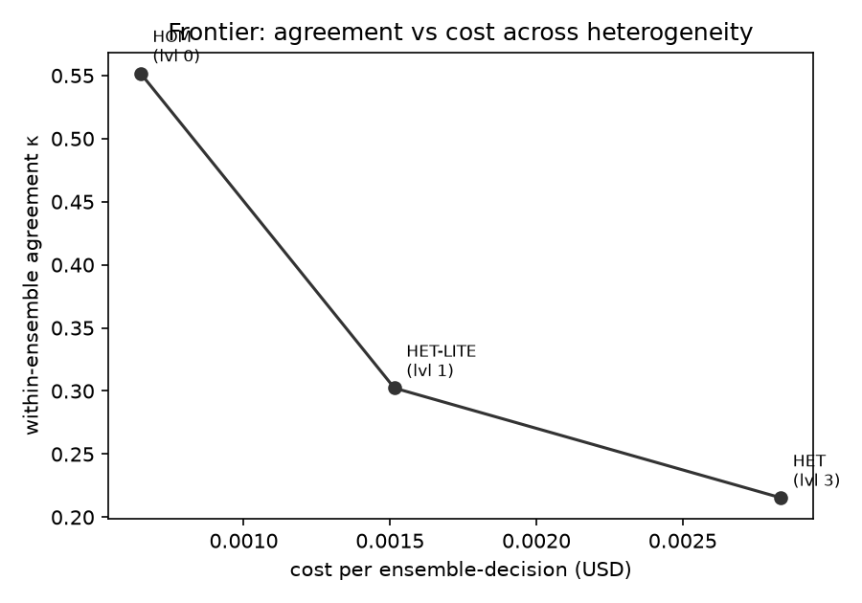
FIGURE 1. Agreement–cost frontier. Within-ensemble Fleiss’ $κ$ ($y$) versus cost per ensemble decision ($x$) at heterogeneity levels $\{0,1,3\}$. Lower $κ$ indicates lower observed within-ensemble agreement; the horizontal spread is the cost premium.

Robustness of the agreement statistic
The marginal distribution of BUY, HOLD, and SELL responses changes across ensemble configurations. In particular, the proportion of HOLD responses decreases from 0.71 in HOM to 0.56 in HET. Because Fleiss’ $κ$ can be sensitive to category prevalence (the “$κ$ paradox”), this shift could affect its absolute value independently of changes in the underlying level of agreement. We therefore recompute agreement using Krippendorff’s $α$[11] for nominal outcomes and Gwet’s AC1[12]. All three statistics produce the same monotonic configuration ordering: HOM $>$ HET-LITE $>$ HET (Table 3). Krippendorff’s $α$ closely tracks Fleiss’ $κ$, while Gwet’s AC1 produces higher absolute values but preserves both the ordering and the substantial HOM-to-HET reduction. The primary conclusion is therefore robust to alternative treatments of chance agreement and is not attributable solely to changes in the category marginals.
TABLE 3. Agreement under three statistics (per-run averaged), with the per-config directional marginals. All three statistics agree on the ordering despite the prevalence shift in HOLD.
(lr)2-4(lr)5-7 Config | $κ$ | $α$ | AC1 | BUY | HOLD | SELL
HOM | 0.552 | 0.552 | 0.743 | 0.212 | 0.709 | 0.079
HET-LITE | 0.302 | 0.303 | 0.548 | 0.282 | 0.653 | 0.064
HET | 0.215 | 0.216 | 0.398 | 0.358 | 0.556 | 0.085
TABLE 4. Frontier: within-ensemble agreement and cost by heterogeneity level.
Config | $h$ | $κ$ | $ / ensemble-decision
HOM | 0 | 0.552 | $6.48×{10}^{−4}$
HET-LITE | 1 | 0.302 | $1.52×{10}^{−3}$
HET | 3 | 0.215 | $2.84×{10}^{−3}$

The agreement–cost frontier
The reduction in agreement is accompanied by higher inference cost. The observed cost per five-agent ensemble decision increases from approximately $\$6.5×{10}^{−4}$ for HOM to $\$1.5×{10}^{−3}$ for HET-LITE and $\$2.8×{10}^{−3}$ for HET. Moving from the homogeneous to the fully heterogeneous configuration therefore increases inference cost by approximately $4.4×$ (Table 4). Fig. 1 presents within-ensemble agreement against inference cost for the three configurations. The resulting frontier quantifies the additional expenditure associated with lower agreement and allows ensemble configurations to be compared jointly on behavioral diversity and cost. The frontier does not, by itself, establish that the additional disagreement improves downstream predictive performance.

Shared-seed dependence and measurement validation

Exactly what was shared
In the initial pilot implementation, the random seed was derived at the ensemble-run level rather than at the individual-agent level. Consequently, all five same-model agents evaluating a given cell received the same prompt and seed. Under this configuration, the calls produced near-verbatim responses, indicating that they did not function as independent draws for the purpose of measuring homogeneous-model agreement. The confirmatory implementation instead assigns every agent a unique, reproducible seed determined by its run, configuration, equity, date, and agent position (Fig. 2). The prompt, model, temperature, and experimental grid remain unchanged. This modification preserves reproducibility while allowing repeated instances of the same model to follow distinct sampling trajectories.
# Before (artifact): one seed shared by
# all agents in a run
seed = f(master, run)
for agent in 1..5:
call(model, prompt, seed) # identical draw
# After (fix): unique per-agent seed,
# independent draws
seed = SHA256(master, run, config,
ticker, date, agent) & 0x7FFFFFFF
call(model, prompt, seed) # independent draw
FIGURE 2. The one-line fix. The pilot derived the seed per run, so all five same-model agents shared a sampling path; the study derives a distinct integer-safe seed per agent, restoring independent draws from the same model.

Ruling out adjacent explanations
The pilot duplication was not attributable to request batching, because every agent response was generated through a separate API request. Prompt caching was also disabled during collection. Within the controlled pilot setup, the disappearance of near-duplicate behavior after introducing per-agent seeds is therefore consistent with shared-seed dependence as the source of the inflated agreement.

Diagnostic verification
We evaluate residual within-run dependence by comparing within-run and cross-run agreement (Table 5). After adopting unique per-agent seeds, the HOM within-minus-cross difference is approximately 0.001, indicating that agreement among the five agents within a run is nearly identical to agreement obtained from separately generated draws across runs. In the controlled pilot, the estimated primary contrast was 0.485 under shared per-run seeding and 0.113 under independent per-agent seeding; shared seeding therefore overstated the estimated de-correlation effect by approximately fourfold (Fig. 3). The pilot grid comprised 8 equities $×$ 2 analysis dates $×$ 2 configurations (HOM and HET) $×$ 3 runs $×$ 5 agents, i.e. 480 calls per seeding arm—far smaller than the confirmatory grid—so the pilot contrasts are point estimates whose role is diagnostic, demonstrating the artifact and its removal, rather than confirmatory. This factor is specific to the pilot configuration and should not be interpreted as a universal inflation constant for all LLM ensemble studies. The heterogeneous configurations produce within-minus-cross differences of $−0.048$ and $−0.074$. These differences arise because cross-run pooling introduces additional repeated draws from the same underlying models, increasing pooled agreement relative to the single-draw within-run calculation. The primary endpoint uses the within-run estimate and is therefore not increased by this pooling effect.
TABLE 5. Non-determinism check: within-run vs. cross-run $κ$ (must be $≈0$ for the primary/homogeneous configuration).
Config | within | cross | within$−$cross
HOM | 0.552 | 0.551 | $+0.001$
HET-LITE | 0.302 | 0.350 | $−0.048$
HET | 0.215 | 0.289 | $−0.074$
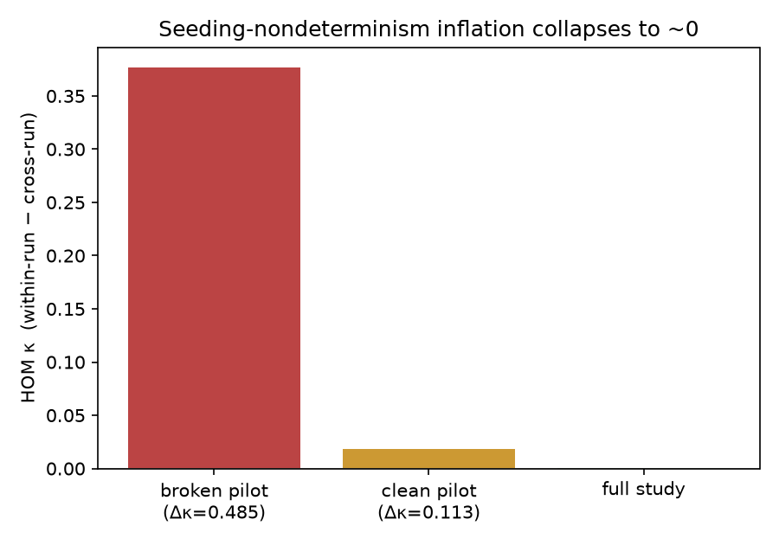
FIGURE 3. Shared-seed dependence inflates measured agreement. The homogeneous within$−$cross $κ$ gap collapses from a seed-shared pilot ($Δκ=0.485$) to the independent-draw pilot ($Δκ=0.113$) to $≈0$ in the full study, showing that shared-seed dependence in the pilot, not model similarity, produced the inflation.

Provider-pair agreement
The pairwise directional-agreement matrix in Fig. 4 provides additional evidence regarding the source of ensemble de-correlation. Same-provider agreement is 0.92 for Google agent pairs and 0.80 for OpenAI agent pairs, whereas cross-provider agreement ranges from 0.43 to 0.63. Agents supplied by the same provider therefore agree more frequently than agents supplied by different providers under identical prompt and information conditions. This pattern is consistent with provider identity being an important source of behavioral similarity and helps explain the lower overall agreement observed in the heterogeneous ensembles.
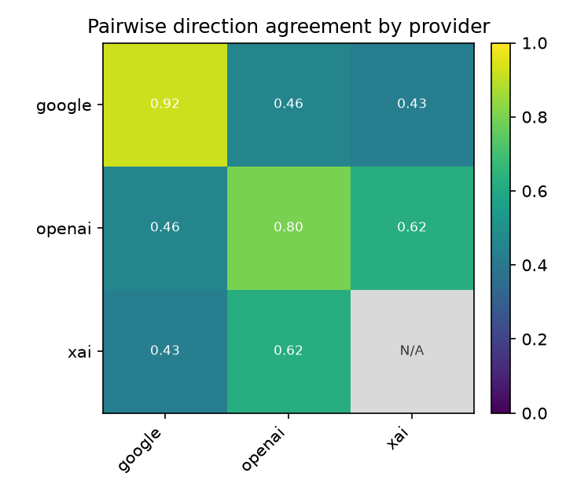
FIGURE 4. Pairwise directional-agreement matrix by provider. Diagonal (within-provider) agreement greatly exceeds off-diagonal (cross-provider), the source of ensemble de-correlation. The xAI–xAI diagonal is undefined (marked N/A, not 0): each HET cell contains a single xAI agent, so no within-xAI agent pair exists.

Secondary directional-accuracy analysis
As a pre-declared secondary analysis, we compare each ensemble’s majority-vote direction with the sign of the realized 20-trading-day forward return. HOLD decisions are treated as abstentions and excluded from the corresponding hit-rate calculation. The estimated directional hit rates are 0.438 for HOM, 0.463 for HET-LITE, and 0.488 for HET (Table 6). The associated Wilson confidence intervals[15] are wide and overlapping. Moreover, the experiment was powered for the agreement endpoint rather than for differences in directional accuracy. The estimates therefore do not provide sufficient evidence that cross-provider heterogeneity improves average directional accuracy. The numerical upward trend is reported descriptively and should not be interpreted as a demonstrated performance improvement.
Hit rates at or modestly below 0.5 are the expected baseline for this task rather than a defect of the design: 20-trading-day directional forecasting from public price history alone is approximately unpredictable under near-efficient prices, and the abstention rule further shifts the effective base rate by scoring only the subset of cells on which an ensemble commits to a direction. Crucially, the agreement estimand is well-defined independent of task difficulty: Fleiss’ $κ$ and the $Δκ$ contrasts are functionals of the joint distribution of agent outputs, computed without reference to outcome labels, so the de-correlation results measure how similarly the agents behave regardless of whether the task admits exploitable predictive signal. A low-signal task is, if anything, a conservative setting for the primary question, because agents cannot inflate measured agreement merely by all being correct.
TABLE 6. Accuracy proxy (SECONDARY; underpowered by design). Hit-rate of majority-vote direction vs. 20-day forward-return sign; HOLD abstains.
Config | hit-rate | $n$ | 95% CI (Wilson)
HOM | 0.438 | 315 | $[0.384, 0.493]$
HET-LITE | 0.463 | 339 | $[0.411, 0.516]$
HET | 0.488 | 525 | $[0.445, 0.530]$

Exploratory analysis of consensus errors
Average directional accuracy may conceal differences in how errors are distributed across committee members. We therefore conduct a post hoc exploratory analysis of consensus structure using the same frozen dataset. This analysis was not included in the pre-registered hypotheses, and its results are treated as hypothesis-generating rather than confirmatory. We examine three quantities: the proportion of decisions for which all five agents select the same label; the proportion that are unanimous, directional, and incorrect—the “manufactured-consensus” failure that monoculture warnings describe[3]; and, conditional on an incorrect majority decision, the proportion of agents endorsing that incorrect majority (Table 7).
The unanimity rate decreases from 0.591 for HOM to 0.315 for HET-LITE and 0.267 for HET. Homogeneous ensembles therefore produce identical five-agent decisions more than twice as frequently as fully heterogeneous ensembles. The proportion of decisions that are unanimous, directional, and incorrect is 0.058 for HOM, 0.030 for HET-LITE, and 0.032 for HET. The homogeneous ensemble therefore produces this form of collective error at approximately $1.84×$ the rate of the fully heterogeneous ensemble. HET-LITE achieves a reduction comparable to HET at an approximately $2.3×$, rather than $4.4×$, cost premium. Within this exploratory analysis, HET-LITE therefore appears to be a candidate cost-efficient configuration for reducing unanimous directional errors. This conclusion requires confirmatory evaluation before being treated as a general design recommendation.
Conditional on an incorrect majority vote, the proportion of agents endorsing the incorrect majority decreases from 0.824 for HOM to 0.761 for HET-LITE and 0.636 for HET. Errors in the heterogeneous ensembles therefore contain more within-committee dissent, which may provide an observable signal for escalation, abstention, or further review. These findings suggest that heterogeneity may affect the concentration of collective errors even when it does not produce a detectable improvement in mean directional accuracy. However, they do not establish a reduction in financial tail risk, because the analysis measures decision-error structure rather than the distribution of realized monetary losses.
Self-reported conviction does not exhibit a reliable positive relationship with per-agent directional accuracy in any configuration (Fig. 5). Higher-conviction responses do not consistently achieve higher hit rates, and no conviction category produces a reliably above-chance result. Consequently, the exploratory benefit of heterogeneity appears in the structure of collective agreement and dissent rather than in the calibration of individual agents’ reported conviction. These findings motivate a separate, appropriately powered evaluation of calibration and collective-error risk.
TABLE 7. Consensus structure by heterogeneity (exploratory; 3,600 scoreable five-agent decisions per config). “Unan. wrong” $=$ all five agents agree on one directional call that is wrong; “pile-on” $=$ $P(agent endorses majority∣majority wrong)$.
Config | unanimity | unan. wrong | pile-on
HOM | 0.591 | 0.058 | 0.824
HET-LITE | 0.315 | 0.030 | 0.761
HET | 0.267 | 0.032 | 0.636
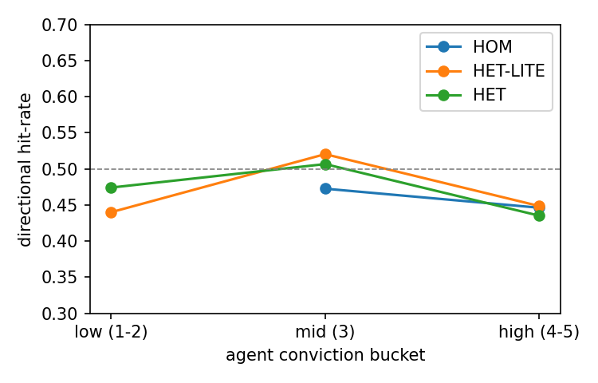
FIGURE 5. Self-reported conviction does not predict directional accuracy. Per-agent directional hit-rate by self-reported conviction bucket; no configuration rises reliably above chance ($0.5$, dashed), consistent with the secondary directional-accuracy analysis.

Robustness: capability-matched control
The primary ensemble configurations vary both provider identity and model capability tier. To reduce this confounding, we conduct a pre-registered capability-matched control using three OpenAI efficient-tier agents and two Google efficient-tier agents (Het-SameTier). An equivalent efficient-tier xAI model was not available, so this control varies provider across two rather than three model families. Across the same 100-equity and 12-date grid, the homogeneous baseline produces $κ_{HOM}=0.552$, whereas the capability-matched heterogeneous configuration produces $κ_{HET\text{-}SameTier}=0.236$. The resulting contrast is
$$Δκ_{HOM−SameTier}=0.315, 95\% CI [0.288, 0.341],$$
which excludes zero. This capability-matched estimate is approximately 94% of the primary HOM-to-HET contrast. The result indicates that the observed de-correlation is largely preserved when model tier is held approximately constant, supporting provider identity as a major contributor to the primary effect. The control substantially reduces the capability-tier concern but does not eliminate it completely, because matching is approximate and covers only two providers. (The reproduction of $κ_{HOM}=0.552$ to four decimals across two independently collected datasets also re-confirms determinism of the homogeneous baseline.)

Robustness: temperature sensitivity
Agreement can vary with sampling temperature, raising the possibility that the primary result is specific to the main operating point of $T=0.7$. We therefore evaluated a separate stratified subgrid comprising eight equities, two analysis dates, three ensemble configurations, and three independent runs at $T∈\{0.0,0.7,1.0\}$. These observations were stored separately from the frozen confirmatory dataset and analyzed using the same seeded estimator. The ordering $κ_{HOM}>κ_{HET\text{-}LITE}>κ_{HET}$ is preserved at every tested temperature. The corresponding HOM-to-HET contrasts are 0.299, 0.509, and 0.385 at $T=0.0$, $0.7$, and $1.0$, respectively, with 95% confidence intervals excluding zero in each case (Table 8). Absolute agreement levels, however, vary non-monotonically with temperature; for example, $κ_{HOM}$ ranges from approximately 0.33 to 0.67. This variation reflects changes in both within-cell concordance and the marginal distribution of BUY, HOLD, and SELL responses. At $T=0$, the homogeneous configuration produces a more nearly uniform label distribution, whereas at $T=0.7$ and $T=1.0$, responses are more concentrated in HOLD. The results therefore indicate that the relative reduction in agreement associated with provider heterogeneity is robust within the tested subgrid, while absolute agreement remains temperature-dependent. We note that the subgrid’s contrast at the main operating point ($0.509$ at $T=0.7$) differs from the full-grid estimate ($0.336$) at the same temperature; this discrepancy is attributable to the sampling variance of the small $8×2$ subgrid, whose wide confidence interval ($[0.21, 0.78]$) comfortably contains the full-grid estimate. The subgrid is accordingly informative about the sign and ordering of the effect, not its magnitude. Because this analysis uses a substantially smaller grid than the primary experiment, it is interpreted as supporting evidence rather than an independent replication. The temperature analysis was conducted under a documented protocol amendment and does not alter the frozen confirmatory dataset.
TABLE 8. Temperature-sensitivity robustness ($8×2$ subgrid, 3 runs per cell). The ordering ($κ_{HOM}>κ_{HET\text{-}LITE}>κ_{HET}$) and the primary contrast $Δκ_{HOM−HET}$ (positive, CI excludes 0) hold at every temperature; absolute $κ$ levels vary non-monotonically, so it is the contrast, not the absolute agreement, that is temperature-stable.
$T$ | $κ_{HOM}$ | $κ_{HET\text{-}LITE}$ | $κ_{HET}$ | $Δκ$ [95% CI]
0.0 | 0.33 | 0.17 | 0.03 | 0.30 $[0.16, 0.44]$
0.7 | 0.67 | 0.38 | 0.16 | 0.51 $[0.21, 0.78]$
1.0 | 0.53 | 0.27 | 0.15 | 0.38 $[0.19, 0.54]$

Discussion
The results provide a quantitative characterization of the relationship between provider heterogeneity, ensemble agreement, and inference cost. Within-ensemble agreement decreases from $κ=0.552$ for the homogeneous configuration to $κ=0.215$ for the fully heterogeneous configuration, while inference cost increases by approximately $4.4×$. The provider-pair analysis further shows that agents from the same provider agree more frequently than agents from different providers under identical prompt and information conditions. Together with the capability-matched control, these findings support provider identity as an important source of behavioral similarity within LLM ensembles.
Reduced agreement is a necessary but not sufficient condition for improved ensemble performance. Greater behavioral diversity is useful only when the additional judgments provide relevant information or enable more reliable downstream decisions. In the present study, cross-provider heterogeneity substantially reduces within-ensemble agreement but does not produce a statistically reliable improvement in average directional accuracy. This result is consistent with the algorithmic-monoculture literature[3] in showing that greater behavioral diversity does not automatically translate into greater correctness. The exploratory consensus analysis nevertheless indicates that heterogeneity changes the structure of collective errors. Homogeneous ensembles produce unanimous incorrect directional decisions at approximately $1.84×$ the rate of fully heterogeneous ensembles and exhibit greater concentration of agents around an incorrect majority decision. These findings suggest that disagreement may provide value through reduced error concentration and increased visibility of dissent, even when mean accuracy does not improve. However, this interpretation remains exploratory and requires confirmatory evaluation using an appropriately powered downstream endpoint.
The agreement–cost frontier provides a practical framework for ensemble selection. Practitioners should not assume that the additional cost of provider heterogeneity is justified solely because it reduces agreement. Instead, they should evaluate whether the resulting diversity improves a task-relevant objective, such as calibration, robustness, abstention quality, or the frequency of concentrated collective errors. In the exploratory analysis, HET-LITE achieves a reduction in unanimous directional errors comparable to HET at an approximately $2.3×$, rather than $4.4×$, cost premium. A single second-provider agent may therefore represent a candidate cost-efficient operating point for this task, although this conclusion should be validated prospectively before being generalized to other applications.
The shared-seed pilot also has a methodological implication for empirical studies of LLM ensembles. When repeated model instances receive the same seed or otherwise share elements of the sampling trajectory, their outputs may not represent independent draws, causing within-ensemble agreement and configuration contrasts to be materially distorted. Agreement studies should therefore document the sampling context, assign separate reproducible seeds to individual agents when supported, and include a diagnostic for residual within-run dependence.

Threats to Validity
Heterogeneity vs. capability confound. The primary ensemble configurations differ in both provider composition and model capability tier. HOM contains five instances of an efficient-tier OpenAI model, whereas the heterogeneous configurations introduce models from other providers, including higher-tier models. Consequently, part of the observed reduction in agreement could reflect capability differences rather than provider identity alone. Two analyses reduce, but do not eliminate, this concern. First, the provider-pair matrix (Fig. 4) compares agents evaluating the same equity-date cell under identical prompt and information conditions and shows substantially higher agreement for same-provider pairs ($0.80$–$0.92$) than for cross-provider pairs ($0.43$–$0.63$). Second, the capability-matched control (Section V-H) holds model tier approximately constant across OpenAI and Google and produces a contrast of $Δκ=0.315$, approximately 94% of the primary HOM-to-HET effect. The de-correlation therefore remains substantial after approximate tier matching. However, the control covers only two providers because an equivalent efficient-tier xAI model was unavailable, and differences in training data, architecture, alignment procedures, and effective capability cannot be completely separated from provider identity.
Single task domain. The experiment evaluates one directional financial-analysis task using a single prompt template and a three-class BUY/HOLD/SELL output space. The magnitude of agreement reduction may differ for other tasks, prompts, domains, label structures, or reasoning requirements. In particular, tasks involving factual retrieval, open-ended generation, numerical reasoning, or multi-turn interaction may exhibit different within-provider and cross-provider dependence. The present results should therefore be interpreted as evidence for the evaluated task rather than as a universal estimate of LLM ensemble de-correlation. An out-of-domain replication using the same ensemble configurations, independent-sampling protocol, and agreement estimator is required to determine whether the observed ordering generalizes beyond the financial setting.
Model-version pinning. Proprietary model endpoints may be updated by their providers without preserving identical behavior under the same product name. We mitigate this limitation by recording the exact model identifiers, timestamps, seeds, prompt hashes, and raw responses associated with every call and by treating the frozen, hash-verified dataset as the empirical object of record. The findings therefore apply to the archived outputs generated during the reported collection period and may not reproduce exactly with later endpoint versions.
Single-run collection. Although the design contains three independent runs per configuration, the confirmatory responses were collected within a single experimental period. Provider-side updates, transient service conditions, or undocumented inference changes occurring outside that period are therefore not averaged across multiple collection windows. Repeating the experiment at later dates would be necessary to evaluate temporal stability.
Accuracy underpowered. The experiment was designed and powered for the agreement endpoint rather than for differences in directional accuracy. The accuracy analysis uses a descriptive proxy based on the sign of the 20-trading-day forward return, treats HOLD as an abstention, and produces relatively wide confidence intervals. It therefore cannot establish that heterogeneity improves or fails to improve predictive performance. The reported hit rates should not be interpreted as evidence of investment alpha, trading profitability, or economically significant forecasting ability.
Generalization. The findings are specific to five-agent ensembles, three provider mixtures, the selected models, and the tested heterogeneity levels. Different ensemble sizes, provider allocations, aggregation rules, model tiers, prompts, or cost structures may produce different agreement–cost frontiers. In addition, lower agreement is not inherently beneficial; its value depends on whether disagreement improves a relevant downstream outcome. Generalization therefore requires replication across alternative ensemble compositions and decision tasks.

Conclusion
This study presents a pre-registered empirical evaluation of how cross-provider heterogeneity affects agreement and inference cost in LLM ensembles. Across a 54,000-call primary experiment, within-ensemble agreement decreases monotonically as provider diversity increases, with a primary HOM-to-HET contrast of $Δκ=0.336$ (95% CI: $[0.304,0.369]$). This reduction is accompanied by an approximately $4.4×$ increase in inference cost, producing an explicit agreement–cost frontier for the evaluated configurations. A capability-matched control preserves approximately 94% of the primary effect, supporting provider identity as a major contributor to ensemble de-correlation while not fully eliminating capability-related confounding. We also introduce an independent-draw measurement protocol that controls dependence caused by shared sampling seeds. In a controlled pilot, shared per-run seeding inflated the estimated de-correlation effect by approximately fourfold, demonstrating the importance of verifying sampling independence in ensemble-agreement studies.
Cross-provider heterogeneity does not produce a statistically reliable improvement in average directional accuracy at the scale of this experiment. However, exploratory results indicate that homogeneous ensembles generate unanimous incorrect directional decisions at approximately $1.84×$ the rate of fully heterogeneous ensembles and concentrate more agents around incorrect majority decisions. These findings suggest that heterogeneity may provide value by reducing concentrated collective errors and preserving disagreement signals, although this interpretation requires confirmatory evaluation. Overall, the results show that model diversity can reduce output agreement and yield less-correlated judgments, but the practical value of that reduced agreement must be established against a downstream objective such as calibration, robustness, abstention quality, or collective-error reduction. Future work should evaluate the observed agreement ordering across additional tasks, ensemble compositions, and fully tier-matched provider configurations.

Data and Code Availability
To support reproduction, we release: (i) the immutable, read-only, SHA-256-stamped raw dataset (runs.csv), containing 54,000 logged calls with the per-call model, seed, prompt hash, timestamp, token usage, cost, and raw response; (ii) the pre-registration materials and the cryptographic freeze receipt; (iii) the deterministic, seeded analysis pipeline that regenerates every table and figure in this paper, together with a replication check; and (iv) the orchestration harness, including the Het-SameTier control configuration. Code and data are available at https://github.com/samirrc2/price-of-decorrelation. A Code Ocean compute capsule enabling keys-free reproduction has been prepared and submitted for review; the public capsule link and DOI will be inserted here when issued. The dataset SHA-256 hash and analysis commit hash are recorded in the supplementary manifest.

Acknowledgment
The authors thank colleagues and reviewers for feedback.

Use of Generative AI
The authors acknowledge the use of artificial intelligence (AI) tools for the preparation of this manuscript. Specifically, OpenAI’s ChatGPT (GPT-5, 2025) and Anthropic’s Claude were employed to support tasks such as text drafting, language polishing, formatting guidance, and code review. All outputs from these tools were critically examined, verified, and edited by the authors to ensure accuracy and originality.

References
[1] Y. Du, S. Li, A. Torralba, J. B. Tenenbaum, and I. Mordatch, “Improving factuality and reasoning in language models through multiagent debate,” arXiv preprint arXiv:2305.14325, 2023.
[2] J. Wang, J. Wang, B. Athiwaratkun, C. Zhang, and J. Zou, “Mixture-of-agents enhances large language model capabilities,” arXiv preprint arXiv:2406.04692, 2024.
[3] E. Kim, A. Garg, K. Peng, and N. Garg, “Correlated errors in large language models,” in Proc. 42nd Int. Conf. Mach. Learn. (ICML), ser. Proc. Mach. Learn. Res., vol. 267, 2025, [Online]. Available: https://arxiv.org/abs/2506.07962.
[4] Z. Chen, J. Li, P. Chen, Z. Li, K. Sun, Y. Luo, Q. Mao, D. Yang, H. Sun, and P. S. Yu, “Harnessing multiple large language models: A survey on LLM ensemble,” arXiv preprint arXiv:2502.18036, 2025.
[5] J. Li, Q. Zhang, Y. Yu, Q. Fu, and D. Ye, “More agents is all you need,” Trans. Mach. Learn. Res., 2024, [Online]. Available: https://arxiv.org/abs/2402.05120.
[6] S. F. Tekin, F. Ilhan, T. Huang, S. Hu, and L. Liu, “LLM-TOPLA: Efficient LLM ensemble by maximising diversity,” in Findings Assoc. Comput. Linguistics: EMNLP, 2024, [Online]. Available: https://arxiv.org/abs/2410.03953.
[7] S. Cohen, N. Goldshlager, N. Cohen-Inger, B. Shapira, and L. Rokach, “DFPE: A diverse fingerprint ensemble for enhancing LLM performance,” arXiv preprint arXiv:2501.17479, 2025.
[8] S. Wu, X. Li, Y. Feng, Y. Li, Z. Wang, and R. Wang, “Council mode: A heterogeneous multi-agent consensus framework for reducing LLM hallucination and bias,” arXiv preprint arXiv:2604.02923, 2026.
[9] Z. Bugaud, “Hidden clones: Exposing and fixing family bias in vision-language model ensembles,” arXiv preprint arXiv:2603.17111, 2026.
[10] J. L. Fleiss, “Measuring nominal scale agreement among many raters,” Psychol. Bull., vol. 76, no. 5, pp. 378–382, 1971.
[11] K. Krippendorff, Content Analysis: An Introduction to Its Methodology, 4th ed.1em plus 0.5em minus 0.4emThousand Oaks, CA, USA: Sage, 2019.
[12] K. L. Gwet, “Computing inter-rater reliability and its variance in the presence of high agreement,” Brit. J. Math. Statist. Psychol., vol. 61, no. 1, pp. 29–48, 2008.
[13] B. Efron and R. J. Tibshirani, An Introduction to the Bootstrap.1em plus 0.5em minus 0.4emNew York, NY, USA: Chapman & Hall, 1993.
[14] J. R. Landis and G. G. Koch, “The measurement of observer agreement for categorical data,” Biometrics, vol. 33, no. 1, pp. 159–174, 1977.
[15] E. B. Wilson, “Probable inference, the law of succession, and statistical inference,” J. Amer. Statist. Assoc., vol. 22, no. 158, pp. 209–212, 1927.
Samir Chincholikar received the B.E. degree from the University of Mumbai, India, in 2013, the M.B.A. degree in finance from the Jamnalal Bajaj Institute of Management Studies, University of Mumbai, in 2016, and the M.S. degree in financial engineering from the University of Illinois Urbana-Champaign, Urbana, IL, USA, in 2019. He has over a decade of professional experience in quantitative risk analytics and machine learning in the financial services industry. His research interests include large language models, multi-agent systems, the use of AI to automate engineering workflows, machine learning evaluation, and reproducible empirical methods in computational finance.
Robin Chawla received the B.Tech. degree in computer science and engineering from the Indian Institute of Technology (BHU), Varanasi, India. He has about eight years of professional experience as a software engineer at a proprietary trading firm, focused on low-latency systems, performance-oriented software, and the use of AI to automate engineering workflows. His research interests include large language models, multi-agent systems, machine learning for engineering workflows and automation, and reproducible evaluation of generative AI for decision-making.

