Ref: https://dzone.com/articles/creating-rest-services-with-flask
*** Note: Make sure apache2 and mod_wsgi setup is done as in setup.txt

$ mkdir -p ~/Desktop/flask/restinflask
$ cd ~/Desktop/flask/restinflask

Now it is time to create our entry application file app.py:

from flask import Flask, request
from flask_restful import Api, Resource
app = Flask(__name__)
api = Api(app)
items = []

class ItemList(Resource):
def get(self):
return {'items':items}, 200

class Item(Resource):
def _find_item(self, name):
return next(filter(lambda i: i["name"] == name, items), None)

def get(self, name):
item = self._find_item(name)
return {"item": item}, 200 if item is not None else 404

def post(self, name):
existing_item = self._find_item(name)
if existing_item is not None:
return {"message": "Item already created"}, 409
data = request.get_json()
new_item = {"name": name, "price":data["price"]}
items.append(new_item)
return {"item": new_item}, 201

def put(self, name):
data = request.get_json()
existing_item = self._find_item(name)
if existing_item is not None:
existing_item["price"]=data["price"]
return {"item": existing_item}, 201
else:
new_item = {"name": name, "price": data["price"]}
items.append(new_item)
return {"item": new_item}, 201

api.add_resource(Item, '/item/<string:name>')
api.add_resource(ItemList, '/items')
app.run(port=5000)

The lines 4, 5, 33, and 35 are the boilerplate codes, which bootstraps the application.
Lines from 9 through 31 implements the API. Our Item class implements the Resource class which maps HTTP verbs to methods. The get , post , and put methods are to handle corresponding Http methods.

Now let's run the application and test it:

(restinflask) D:\dev\workspaces\python\restinflask>pyhton app.py
$ sudo python app.py

* Serving Flask app "api" (lazy loading)
* Environment: production
WARNING: Do not use the development server in a production environment.
Use a production WSGI server instead.
* Debug mode: off
* Running on http://127.0.0.1:5000/ (Press CTRL+C to quit)

Add postman to browser as plugin.
First, create a table item with price 13.57.
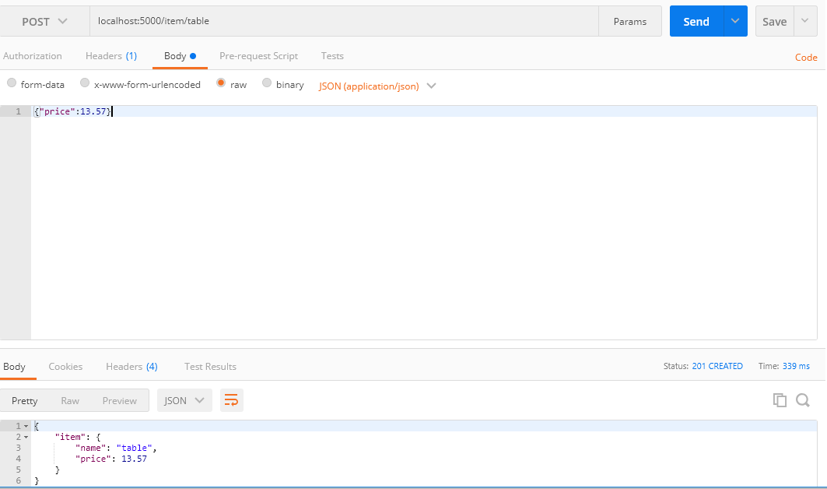
Now query it with an http-get;
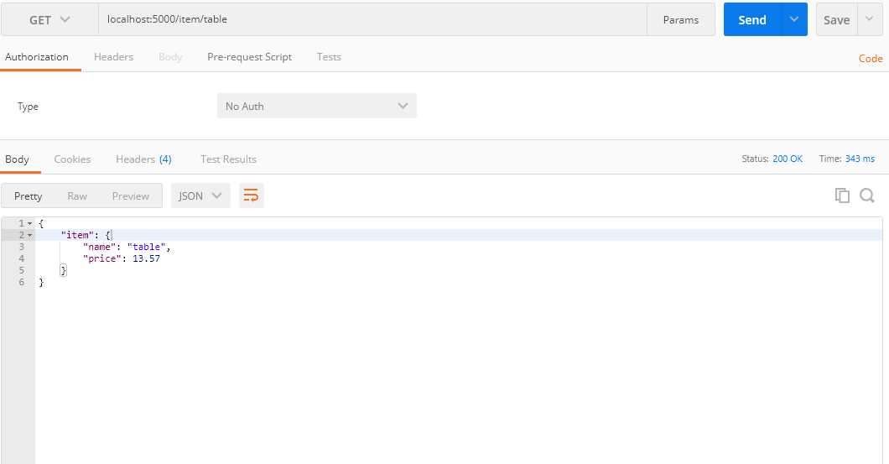
Update the existing item with an http-put;
