Ref: https://medium.com/aws-activate-startup-blog/using-containers-to-build-a-microservices-architecture-6e1b8bacb7d1

Using Containers to Build a Microservices Architecture
In a previous post, I talked about how Linux container technology, such as Docker, can be used to streamline the development and testing experience. Because containers are portable across different types of infrastructure — they can run in AWS just as easily as they can on bare-metal servers — containers make deployment of code extremely convenient. For development and test workloads this eliminates a lot of the guesswork and finger pointing that tend to occur when slight difference between the development and test environments causes a deployment to fail.
In this post, we’ll explore how many of the characteristics that make containers a great choice for dev/test workloads also make them an excellent choice for building a microservices-based architecture in AWS. A microservices architecture is an approach that makes web based development more agile and code bases easier to maintain. We’ll discuss how this architecture enables developers to be highly productive, and to quickly iterate and evolve a code base. For fast moving start-up companies, the microservices architecture can really help dev teams be nimble and agile in their development efforts.

A Brief History of Web Development
But first, let’s take a quick walk through the history of web-based development over the last 20 years or so, as this will provide some important context to explain why microservices architectures have become so popular, and the problems such an architecture solves.
In the earliest days of web application development, applications were built using the Common Gateway Interface (CGI). This interface provided a way for a web server to execute a script — usually written in Perl — when handling an HTTP request from a browser. The CGI architecture didn’t scale well, because a Perl process would be launched for each incoming request for a script resource. To solve this, the popular web servers at the time added support for modules. Apache, one of the most popular web servers to this day, added something called “mod_perl”, which was a way of running Perl code inside the server itself. This allowed CGI scripts to execute much faster.
Although technologies like mod_perl were a big improvement over traditional CGI, there were still problems. Namely, the code responsible for building the views (i.e. emitting the dynamic portions of HTML on the page) was intermingled with the business logic of the application. This meant that completing a simple task, like adding a column to an HTML table or a new element to a form, often required changing low-level application code. So the next round of evolution in web programming technology resulted in “server pages,” which were templating frameworks that allowed executable code to be embedded alongside HTML. This allowed for much cleaner separation of application logic from view logic. In the Java programming world, a design pattern called “Model 2” rapidly emerged, which involved putting application code into Java servlets, data into classes called Java Beans, and view logic into Java server pages, as shown in Figure 1:
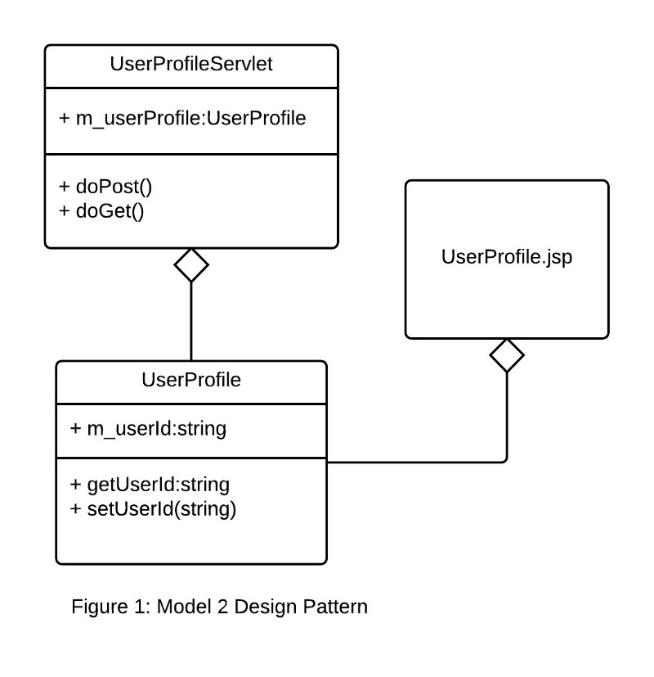
The “Model 2” design evolved quickly into the Model-View-Controller (MVC) design that is widely used today. Many of the early MVC frameworks were Java-based (like Apache Struts), but others, like Ruby on Rails grew rapidly in popularity. With the MVC design pattern, “controller” classes define methods that are mapped to URL patterns using a class called a “route.” The controller methods utilize “model” classes that encapsulate the business logic and the data of the core application entities. Finally, each controller method renders a “view” used to display and edit the data in the corresponding model class. This pattern imposes a clean separation of concerns between business, application, and view logic, as shown in Figure 2:
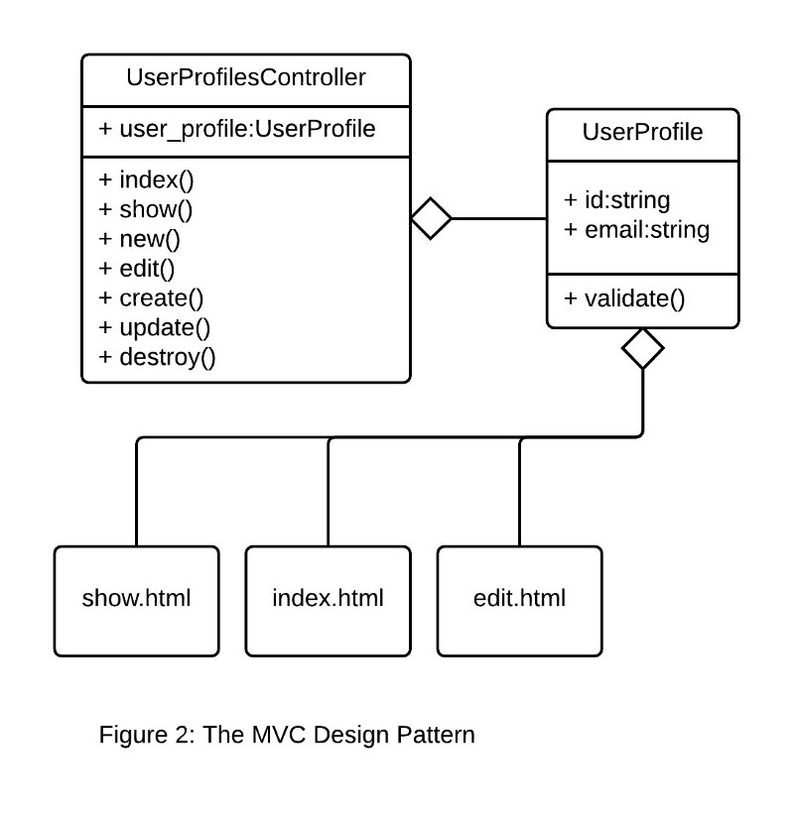

The Rise of the REST Protocol
Coinciding with the rapid adoption of MVC as the defacto choice for web development was the evolution of interprocess communication (IPC) to make use of text-based serialization formats, like XML and JSON. Protocols such as SOAP allowed IPC across HTTP, and soon web developers were not just building web applications that served content to browsers, but web services that performed actions and delivered data to other programs. This services-based architecture proved to be very powerful, as it eliminated dependencies on shared code libraries, and allowed application developers to further decouple their application components. The SOAP protocol and the related WS-* standards soon became increasingly complex and heavily dependent on specific implementations in application servers, so developers migrated to the much lighter-weight REST protocol. As the use of mobile devices exploded, and as web UX development switched to AJAX and JavaScript frameworks, application developers started to make extensive use of REST for transmitting data between the client devices and the web servers.
As it turns out, MVC frameworks are also well suited for developing REST endpoints. The resource-oriented nature of REST maps nicely to the concept of controllers and models, as shown in Figure 3.
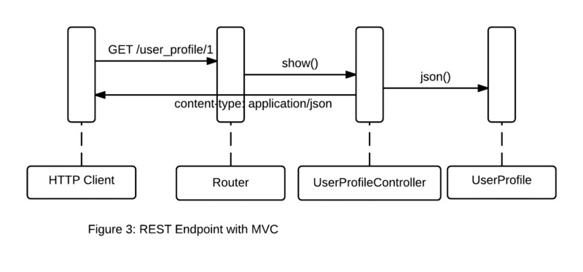

The Monolithic Architecture
So the MVC applications that had once consisted of models, views, and controllers to serve up primarily HTML content morphed into applications that served up not only traditional HTML, but also JSON via REST endpoints. Many of these applications used a monolithic architecture. The application is deployed as a single file (i.e. Java) or a collection of files rooted at the same directory (i.e. Rails). All the application code runs in the same process. Scaling requires deploying multiple copies of the exact same application code to multiple servers. A monolithic architecture is depicted in Figure 4:
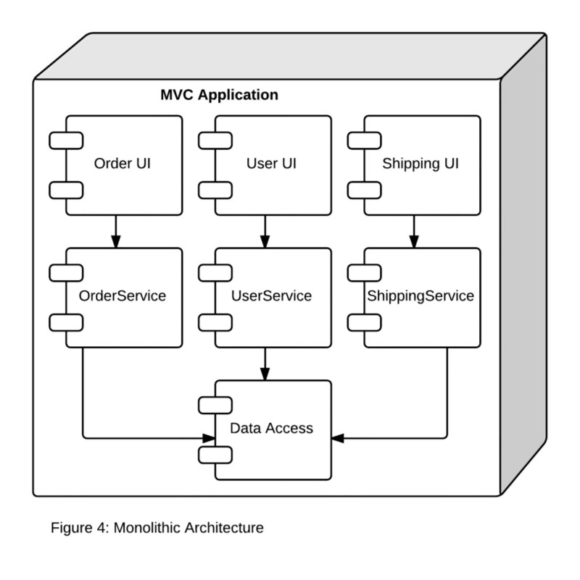
There are a number of problems with the monolithic architecture. First, as features and services are added to the application, the code base will grow substantially more complex. This can be daunting and intimidating to new developers. Modern IDEs may even have problems loading the entire application code, and compile and build times are long. Because all the application code runs in the same process on the server, it is difficult (if not impossible) to scale individual portions of the application. If one service is memory intensive and another CPU intensive, the server must be provisioned with enough memory and CPU to handle the baseline load for each service. This can get expensive if each server needs high amount of CPU and RAM, and is exacerbated if load balancing is used to scale the application horizontally. Finally, and more subtlety, the engineering team structure will often start to mirror the application architecture over time. UX engineers will be tasked with building the UI components, middle-tier developers will build the service endpoints, and database engineers and DBAs will handle the data access components and database. If a UX engineer wants to add some data to a screen, this will involve coordination with the middle-tier and database engineers. Like water, humans tend to take the path of least resistance, and this means that each engineering group will try to embed as much logic into the portion of the application they control. This is a formula that guarantees unmaintainable code over time.

The Microservices Architecture
The microservices architecture is designed to address these issues. The services defined in the monolithic application architecture are decomposed into individual services, and deployed separately from one another on separate hosts.
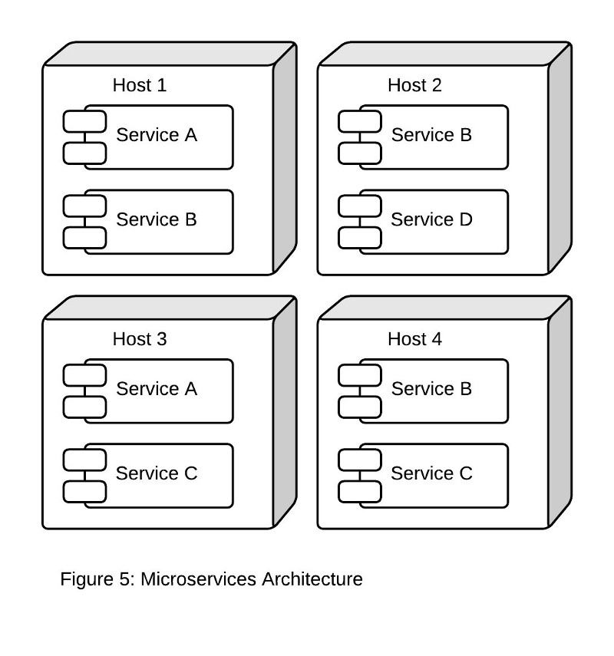
Each microservice is aligned with a specific business function, and only defines the operations necessary to that business function. This may sound exactly like service-oriented architecture (SOA), and indeed, microservices architecture and SOA share some common characteristics. Both architectures organize code into services, and both define clear boundaries representing the points at which a service should be decoupled from another. However, SOA arose from the need to integrate monolithic applications that exposed an API (usually SOAP-based) with one another. In SOA, integration relies heavily on middleware, in particular enterprise service bus (ESB). Microservices architecture may often make use of a message bus, but there is no logic in the messaging layer whatsoever—it is purely used as a transport for messages from one service to another. This differs dramatically from ESB, which contains substantial logic for message routing, schema validation, message translation, and business rules. As a result, microservices architectures are substantially less cumbersome than traditional SOA, and don’t require the same level of governance and canonical data modeling to define the interface between services. With microservices, development is rapid and services evolve alongside the needs of the business.
Another key advantage of the microservices architecture is that a service can be individually scaled based on its resource requirements. Rather than having to run large servers with lots of CPU and RAM, microservices can be deployed on smaller hosts containing only those resources required by that service. In addition, each service can be implemented in the language most suitable for the operations that service performs. An image processing service can be implemented using a high-performance language like C++. A service performing math or statistical operations may be implemented in Python. Services performing basic CRUD operations for resources might be best implemented in Ruby. The microservices architecture doesn’t require the “one size fits all” model of the monolithic architecture, which will generally use a single MVC framework and a single programming language.
But there are some disadvantages to microservices as well. Because services will be spread across multiple hosts, it can be difficult to keep track of which hosts are running certain services. Also, even though each host may not be as powerful as the host running the monolithic application, as the microservices architecture scales out, the number of hosts will grow faster than it will with a monolithic architecture. In the AWS environment, there may even be microservices that don’t require all the resources of even the smallest EC2 instance type. This results in over-provisioning and increased costs. If services are implemented in different programming languages, this means the deployment of each service will require a completely different set of libraries and frameworks, making deployment to a server complex.

Containers to the Rescue
Linux containers can help mitigate many of these challenges with the microservices architecture. Linux containers make use of kernel interfaces such as cnames and namespaces, which allow multiple containers to share the same kernel while running in complete isolation from one another. The Docker execution environment uses a module called libcontainer, which standardizes these interfaces. Docker also provided a GitHub-like repository for container images called DockerHub, making it easy to share and distribute containers.
It is this isolation between containers running on the same host that makes deploying microservice code developed using different languages and frameworks very easy. Using Docker, we could create a DockerFile describing all the language, framework, and library dependencies for that service. For example, the following DockerFile could be used to define a Docker image for a microservice that uses Ruby and the Sinatra framework:
FROM ubuntu:14.04
MAINTAINER John Doe <jdoe@example.com>
RUN apt-get update && apt-get install -y curl wget default-jre git
RUN adduser --home /home/sinatra --disabled-password --gecos '' sinatra
RUN adduser sinatra sudo
RUN echo '%sudo ALL=(ALL) NOPASSWD:ALL' >> /etc/sudoers
USER sinatra
RUN curl -sSL https://get.rvm.io | bash -s stable
RUN /bin/bash -l -c "source /home/sinatra/.rvm/scripts/rvm"
RUN /bin/bash -l -c "rvm install 2.1.2"
RUN /bin/bash -l -c "gem install sinatra"
RUN /bin/bash -l -c "gem install thin"
A container created from this image could easily be placed on a host running another container created from a Docker image using Java and the DropWizard framework. The container execution environment isolates each container running on the host from one another, so there is no risk that the language, library, or framework dependencies used by one container will collide with that of another.
The portability of containers also makes deployment of microservices a breeze. To push out a new version of a service running on a given host, the running container can simply be stopped and a new container started that is based on a Docker image using the latest version of the service code. All the other containers running on the host will be unaffected by this change.
Containers also help with the efficient utilization of resources on a host. If a given service isn’t using all the resources on an Amazon EC2 instance, additional services can be launched in containers on that instance that make use of the idle resources. Of course, deploying services in containers, managing which services are running on which hosts, and tracking the capacity utilization of all hosts that are running containers will quickly become unmanageable if done manually.
The recently announced Amazon EC2 Container Service (Amazon ECS) takes care of all of this for you. With Amazon ECS, you define a pool of compute resources called a “cluster.” A cluster consists of one or more Amazon EC2 instances. Amazon ECS manages the state of all container-based applications running in your cluster, provides telemetry and logging, and manages capacity utilization of the cluster, allowing for efficient scheduling of work. Amazon ECS provides a construct called a “task definition”, which is used to define a grouping of containers that comprise an application. Each container in the task definition specifies the resources required by that container, and Amazon ECS will schedule that task for execution based on the available resources in the cluster.
A microservice is easily defined as a task and might consist of two containers — one running the service endpoint code, and another a database. Amazon ECS manages the dependencies between these containers, as well as all the balancing of resources across the cluster. Amazon ECS also provides seamless access to important AWS services like Elastic Load Balancing, Amazon EBS, Elastic Network Interface, and Auto Scaling. With Amazon ECS, all these essential features for deploying applications using Amazon EC2 become available to container-based applications.
Container management solutions like Amazon ECS also simplify the implementation of something called “service discovery.” Because microservices are often deployed across multiple hosts, and often scale up and down based on load, service discovery is needed in order for one service to know how to locate other services. In the simplest case, a load balancer can be used for this. But in many cases it’s necessary to use a true distributed configuration service, such as Apache Zookeeper. The Amazon ECS API makes it possible to integrate with 3rd party tools like Zookeeper. It is also possible to use Amazon ECS to manage a Zookeeper cluster. The containers comprising the Zookeeper cluster can be grouped together using a task definition, and scheduled for execution on the Amazon EC2 hosts in the cluster by the Amazon ECS service.
In many ways, the use of containers to implement a microservices architecture is an evolution not unlike those observed over the past 20 years in web development. Much of this evolution has been driven by the need to make better use of compute resources and the need to maintain increasingly complex web-based applications. As we’ve seen, the use of a microservices architecture with Linux containers addresses both these needs. We touched briefly on how a microservice can be defined as a task in Amazon ECS, but the use of containers in distributed systems goes far beyond microservices. Increasingly, containers are becoming “first class citizens” in all distributed systems, and in a future post we’ll discuss how tools like Amazon ECS are essential for managing container-based computing.
Ref: https://medium.com/aws-activate-startup-blog/cluster-based-architectures-using-docker-and-amazon-ec2-container-service-f74fa86254bf

Cluster-Based Architectures Using Docker and Amazon EC2 Container Service
In the first post of this series, we examined how Linux container technology, like Docker, can be used to streamline software development and testing. The lightweight portability of Docker containers makes it very easy to deploy code in a way that minimizes the issues that arise due to slight differences between development, test, stage, and production environments. In the second post, we illustrated how the characteristics of Docker-based application development and deployment mesh very nicely with the modern, distributed systems architecture known as “microservices.” We also briefly touched upon the need to deploy container-based architectures using some sort of container framework. As the number of containers grows, it becomes increasingly difficult to manage manually, and this is where services like the Amazon EC2 Container Service (ECS) can really help.
In this post, we’re going to take a deeper dive into the architectural concepts underlying cluster computing using container management frameworks such as ECS. We will show how these frameworks effectively abstract the low-level resources such as CPU, memory, and storage, allowing for highly efficient usage of the nodes in a compute cluster. Building on some of the concepts detailed in the earlier posts, we will discover why containers are such a good fit for this type of abstraction, and how the Amazon EC2 Container Service fits into the larger ecosystem of cluster management frameworks.

Sharing Resources in a Compute Cluster
Before we taker a deeper dive into ECS, it’s helpful to review a few key concepts of cluster-based computing. Simply put, a compute cluster is a multi-tenant computing environment consisting of servers (called “nodes”) whose resources have been pooled together and are used to execute processes. A collection of processes that are executed together is called a task, and a collection of tasks executed together is called a job. In most cases, the author of a job need not know (or care) about which node(s) in the cluster actually execute the underlying processes defined in the tasks that make up the job. To enable this behavior, the nodes in a cluster must be managed by some sort of cluster management framework. Figure 1 depicts the components that comprise the typical cluster management framework:
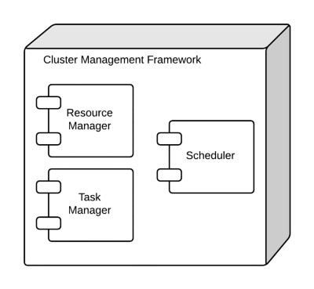
Let’s look at each of these components individually. The Resource Manager is responsible for keeping track of resources like memory, CPU, and storage that are available at any given time in the cluster. Each executing task consumes some of the available resources, and it’s up to the Resource Manger to keep track of this information. The Task Manager is responsible for the task execution lifecycle. This component is usually implemented as a state machine. Finally, the Scheduler is responsible for scheduling tasks for execution. It must contain algorithms for managing dependencies between the tasks that comprise a job, as well as algorithms for assigning tasks to nodes in the cluster based on the resources required to execute the task. In many ways, the scheduler is the most important component of the cluster management framework — and, as we’ll see later, this has important implications to the architecture of the EC2 Container Service.
A cluster management framework such as the one depicted above provides a very useful abstraction of the low-level details for executing tasks in a shared computing environment. To run a job, a programmer simply needs to express the job — often through a config file or shell script — as a collection of tasks and then submit the job to the scheduler for execution. The cluster management framework will take care of everything else, including check-pointing and re-queuing of failed tasks. Because different teams within an organization may share a cluster, prioritization can be used to tell the scheduler which jobs to execute before others. Cluster resources can be subdivided so that no one team can saturate the cluster with their jobs such that other teams are starved of resources.

Moving Beyond “One Size Fits All” Scheduling
This simple-but-effective cluster management has worked really well for decades. But there are some problems that have become exacerbated in recent years. A cluster management framework can efficiently allocate resources and schedule tasks, but only if all users of the cluster “play by the same rules.” This means that all jobs have to be submitted through the same scheduler. Jobs that are run using different schedulers in different cluster management frameworks won’t be subject to the same set of rules governing prioritization and resource utilization.
In recent years, in part due to the popularity of parallel computing frameworks like Hadoop and Spark, it has become much more common to run multiple frameworks on a single cluster. This means that the monolithic architecture used by traditional cluster management frameworks, in which resource management is coupled with scheduling, no longer works. If you want to run Spark jobs along side Hadoop YARN jobs on the same cluster, both Spark and YARN need to be aware of the resources available on the cluster. In addition, these jobs can’t conflict with one another if executed on the same node. They need to be run in isolation.
These requirements have led to the following architecture, in which scheduling and the execution environment has been decoupled from the resource and task management components of the cluster manager:
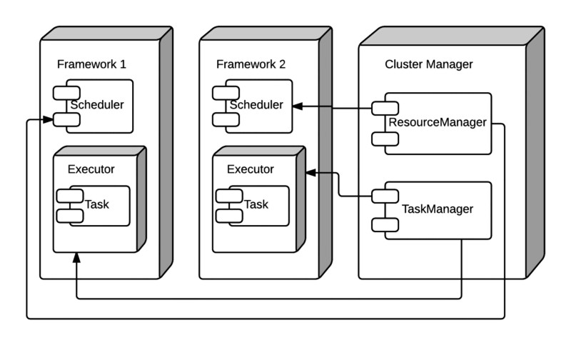
This architecture defines a “framework”, which includes a scheduler and an execution environment. The scheduler components from different frameworks interact with the same cluster manager, which is responsible for the task lifecycle as well as resource management. To ensure that tasks execute in isolation from one another on a node, tasks are launched into an execution environment, which is typically a type of container. With frameworks like YARN and Spark, the container is a JVM. But it can also be a Linux container execution environment, like Docker.
In order for this architecture to support concurrent scheduling, the schedulers in each framework must have some way of knowing the available resources in the cluster. There are several design patterns that can be employed for this. The first is called “two level pessimistic scheduling“ and it works as follows:
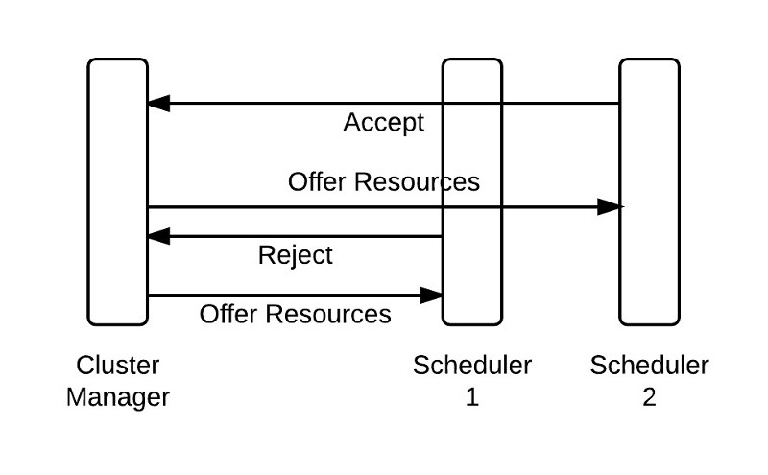
In this model, the cluster manager offers up resources like CPU and memory to a scheduler. The scheduler then makes a choice: it can decide whether it wants to execute task(s) using the offered resources, or reject the offer because the offered resources don’t meet the constraints of the tasks that the scheduler has in it’s queue. There are two important characteristics of this pattern:
- Each scheduler only sees a sub-portion of the state of the resources on the cluster in the form of an offer.
- The concurrency model is pessimistic — offers are not made to other schedulers until a pending offer is accepted or rejected.
The second pattern for sharing cluster resource availability to a scheduler is called “shared state optimistic scheduling” and it works as follows:
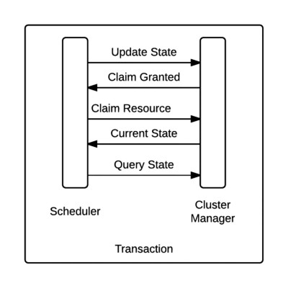
In this model, all schedulers can see the current state of the cluster at all times. Each scheduler periodically queries the current cluster state, and makes a claim for any available resources. The scheduler then updates the cluster state with the newly claimed resources in an atomic transaction. In the event of a conflict (i.e. two schedulers lay claim to the same resource) only one transaction will succeed. Because all schedulers see all available resources at all times, this model is optimistic, as resources are never locked while being offered to a scheduler.
In practice, the shared state optimistic scheduling model has proven to be far more versatile than two-level pessimistic scheduling. Research has show that the pessimistic method, which is used by the Apache Mesos cluster management framework, performs best when jobs execute quickly. But it is common to run both short and long running jobs (called “services”) on the same cluster. For this use-case, the shared state optimistic scheduling model works much better.

EC2 Container Service Architecture
Now that we’ve reviewed the key components of a modern, cluster management framework, we can clearly define what the EC2 Container Service is: A cluster management framework that uses optimistic, shared state scheduling to execute processes on EC2 instances using Docker containers. The architecture of ECS is as follows:
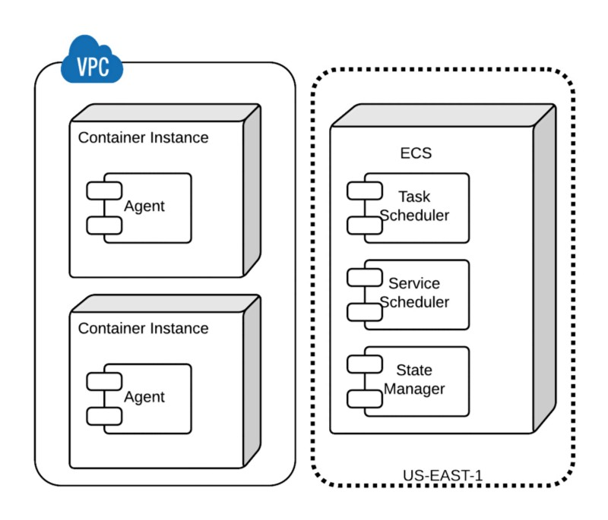
This architecture has some important characteristics:
- The container instances comprising the cluster live in the customer’s VPC and are controlled and secured entirely by the customer.
- Container instances communicate with the ECS service through an “agent,” which is a Docker container running on the instance. This is automatically included in the Amazon ECS-Optimized Amazon Linux AMI.
- ECS includes shared state, optimistic schedulers for short running tasks and long running services.
- Task and service state management is provided by a fully ACID compliant, distributed datastore.
Like other managed services in AWS, such as Amazon DynamoDB, the ECS takes care of many of the challenges in running a distributed system. Customers need not worry about monitoring the health and availability of “master” nodes that provide the scheduling and resource management capabilities. Instead, this is all handled transparently by ECS itself. In addition, ECS provides a robust solution to the very challenging problem of storing state information in an ACID compliant way in a distributed system. Finally, ECS is designed to scale horizontally and for high availability. The net effect of all this is that customers can focus on building their distributed applications using Docker containers without getting bogged down with operational complexity.
That being said, ECS is both extensible and interoperable. The service is designed to participate in the larger container-based cluster management ecosystem. One of the more powerful properties of a shared-state optimistic scheduler is that it is “backwards compatible” with other scheduling models, like two-level pessimistic scheduling. This means frameworks compatible with popular cluster management systems like Apache Mesos can work just as well with ECS. If you’re using a framework like Marathon to execute tasks on a Mesos-managed cluster, you can use that same framework to execute tasks on an ECS-managed cluster. Extensibility is achieved through the service API: a low-level API that can be used as a foundation for building higher-level services on top of it.

Conclusion
In this post, we took a detailed look at the architecture of ECS, and how this helps solve many of the more challenging problems when running container-based applications and services on a shared compute cluster. In the next post, we’ll show these concepts in action by walking through an example of how to actually run a Docker-based application in ECS.
Ref: https://medium.com/aws-activate-startup-blog/running-services-using-docker-and-amazon-ec2-container-service-bde16b099cb9

Running Services Using Docker and Amazon EC2 Container Service
In the previous post, we took a detailed look at the architecture underpinning the Amazon EC2 Container Service. Now that we understand important concepts like scheduling, state management, and resource allocations, let’s see these in action by actually running a service in ECS.
The first step in building an application designed to run on ECS is to package the application code into one or more Docker containers. As discussed in the first post, Docker containers are based on images, and images are defined in Dockerfiles. A Dockerfile is a text file that describes how to “build” the image. For example, if we want to run a Wordpress application in ECS, the Dockerfile might look like this:
FROM php:5.6-apache
RUN a2enmod rewrite
# install the PHP extensions we need
RUN apt-get update && apt-get install -y libpng12-dev libjpeg-dev && rm -rf /var/lib/apt/lists/* \
&& docker-php-ext-configure gd — with-png-dir=/usr — with-jpeg-dir=/usr \
&& docker-php-ext-install gd
RUN docker-php-ext-install mysqli
VOLUME /var/www/html
ENV WORDPRESS_VERSION 4.1.1
ENV WORDPRESS_UPSTREAM_VERSION 4.1.1
ENV WORDPRESS_SHA1 15d38fe6c73121a20e63ccd8070153b89b2de6a9
# upstream tarballs include ./wordpress/ so this gives us /usr/src/wordpress
RUN curl -o wordpress.tar.gz -SL https://wordpress.org/wordpress-${WORDPRESS_UPSTREAM_VERSION}.tar.gz \
&& echo “$WORDPRESS_SHA1 *wordpress.tar.gz” | sha1sum -c — \
&& tar -xzf wordpress.tar.gz -C /usr/src/ \
&& rm wordpress.tar.gz
COPY docker-entrypoint.sh /entrypoint.sh
# grr, ENTRYPOINT resets CMD now
ENTRYPOINT [“/entrypoint.sh”]
CMD [“apache2-foreground”]
The Dockerfile is used to build an image, which will be stored in a repository. Again, as discussed in the first post, this is accomplished by running the docker build command. In order for ECS to access the image, it must be put in a publicly accessible Docker image repository. All images in DockerHub are available to ECS by default. So, for the purposes of our example using the Dockerfile defined above, we’ll use the Wordpress image built from that Dockerfile that lives in the DockerHub repo.
And that’s basically about all there is to packaging up the application code. If it can run in a Docker container, then it can run in ECS. This portability of Docker containers is quite powerful. We can build, test, and debug our code on any machine capable of running Docker (which is any machine with a Linux kernel). When the code is ready, we can package it up into a Docker image by building the image from a Dockerfile and storing it in a repository.
Now that we’ve packaged up our code to run in a Docker container, we need to provide the compute resources required to run containers. In ECS, this is called a cluster, and it consists of EC2 instances called “container instances” that are running the ECS agent. To create an ECS cluster of container instances, we simply launch one or more EC2 instances using the Amazon ECS-Optimized Amazon Linux AMI. Any EC2 instance launched from this AMI will be automatically placed in the “default” ECS cluster — every AWS account will have a “default” ECS cluster for each region the service runs in. If you want to launch the instance into a different ECS cluster, simply create the cluster using the ECS console or the following AWS CLI command (Note: for this post, I’m using the CLI because the console didn’t exist until recently. But all the CLI commands listed here can easily be executed via the GUI in the console):
$ aws ecs create-cluster — cluster-name Wordpress
Launching EC2 container instances into the cluster is as simple as launching an instance through the EC2 console. The instance will need to be associated with an IAM role that allows the agent running on the instance to make the necessary API calls to ECS. Details are documented here.
When launching the EC2 container instances into this cluster, include the following user-data script in the “advanced” section of the “instance details” page when launching EC2 instances from the console:
#!/bin/bash echo ECS_CLUSTER=Wordpress >> /etc/ecs/ecs.config
When the EC2 instances launch, we should see that they are now associated with the “Wordpress” cluster:
$ aws ecs list-container-instances — cluster Wordpress
{
“containerInstanceArns”: [
“arn:aws:ecs:us-west-2:xxxxx:container-instance/1ef890e2-a42f-4ed5-bff5–7b39edd66c9d”,
“arn:aws:ecs:us-west-2:xxxxx:container-instance/315e5dbd-924b-4a86–9fa3–32ca3f7982b3”,
“arn:aws:ecs:us-west-2:xxxxx:container-instance/52b5ef99-add7–4dc4-a7e3–49019e1b7c9e”,
“arn:aws:ecs:us-west-2:xxxxx:container-instance/f00d41ad-043f-46c8–8437-cc4ea22aacf5”,
“arn:aws:ecs:us-west-2:xxxxx:container-instance/f7486c80–4b5f-4ba4–94db-2e238406bcc9”
]
}
We now have an ECS cluster capable of running Docker containers. The next step is to tell ECS how to run the containers that comprise our Wordpress application. To do this, we use an entity called a “task definition.” An ECS task definition can be thought of a prototype for running an actual task — for any given task definition, there can be zero or more task instances running in the cluster. The task definition allows for one or more containers to be specified. For tasks consisting of more than one container, the dependencies between containers are expressed in the task definition. For example, if we want to run Wordpress, we’d need both the Wordpress container (described above) as well as a MySQL container. The ECS task definition would look like this:
{
“containerDefinitions”: [
{
“name”: “wordpress”,
“links”: [
“mysql”
],
“image”: “wordpress”,
“essential”: true,
“portMappings”: [
{
“containerPort”: 80,
“hostPort”: 80
}
],
“memory”: 500,
“cpu”: 10
},
{
“environment”: [
{
“name”: “MYSQL_ROOT_PASSWORD”,
“value”: “password”
}
],
“name”: “mysql”,
“image”: “mysql”,
“cpu”: 10,
“memory”: 500,
“essential”: true
}
],
“family”: “wordpress”
}
The ECS documentation describes in detail all of the task definition parameters. However, the ones to note here are the image and links parameter. This task definition includes two containers, wordpress and mysql. The image parameter is used to specify the name of the image for each container in DockerHub. The links parameter is what tells ECS that the wordpress container has a network dependency on the mysql container. So instead of having to manage the two containers required to run our Wordpress application individually, we can instead treat the entire application as a single task definition.
Let’s go ahead and register this new task definition by saving the JSON to a file called ecs-wordpress-task-def.json and running this command:
$ aws ecs register-task-definition --family wordpress --cli-input-json file://./ecs-wordpress-task-def.json
The above task definition is actually all we need to execute our Wordpress application in ECS. However, ECS defines another entity called a “service,” which is useful for long-running tasks, like web applications. A service allows multiple instances of a task definition to be run simultaneously. It also provides integration with the Elastic Load Balancing service. For this example, we’re not using ELB because each Wordpress service instance contains both the web layer and the database. For a production deployment, the database would be stored on some sort of persistent storage, and shared with all the instances of the web layer behind the ELB. For the purposes of example, though, it still makes sense to schedule our Wordpress task definition as a service. But, if we were running a different type of application — perhaps a command-line app that does batch processing — all we would need is the task definition and we could schedule tasks in ECS directly from that.
To launch our Wordpress application as an ECS service, we need a service definition like the following:
{
"cluster": "Wordpress",
"serviceName": "wordpress",
"taskDefinition": "wordpress:1",
"loadBalancers":[],
"desiredCount": 1,
}
Let’s create the service using the following command:
$ aws ecs create-service --cluster Wordpress --service-name wordpress --task-definition wordpress:1 --desired-count 1
Again, the service definition parameters are defined in detail in the ECS documentation. But note that the service definition is where load balancers can be specified, which is one of the primary reasons why long-running tasks like web applications should be launched in ECS as a service. In microservices architecture, each endpoint (or collection of related endpoints) can be defined as an ECS service, each managed independently from one another using different Docker images. In this scenario, ECS provides an extremely convenient way to deploy service endpoints.
If all goes well, we should now have a running instance of our Wordpress application:
$ aws ecs list-tasks — cluster Wordpress{
“taskArns”: [
“arn:aws:ecs:us-west-2:xxxxx:task/7af1a8c0-d199–47af-b05c-9d0496a9d97d”
]
}
$ aws ecs describe-tasks — cluster Wordpress — tasks 7af1a8c0-d199–47af-b05c-9d0496a9d97d
{
“failures”: [],
“tasks”: [
{
“taskArn”: “arn:aws:ecs:us-west-2:xxxxx:task/7af1a8c0-d199–47af-b05c-9d0496a9d97d”,
“overrides”: {
“containerOverrides”: [
{
“name”: “mysql”
},
{
“name”: “wordpress”
}
]
},
“lastStatus”: “RUNNING”,
“containerInstanceArn”: “arn:aws:ecs:us-west-2:xxxxx:container-instance/1ef890e2-a42f-4ed5-bff5–7b39edd66c9d”,
“clusterArn”: “arn:aws:ecs:us-west-2:xxxxx:cluster/Wordpress”,
“desiredStatus”: “RUNNING”,
“taskDefinitionArn”: “arn:aws:ecs:us-west-2:xxxxxx:task-definition/wordpress:1”,
“startedBy”: “ecs-svc/9223370607723201507”,
“containers”: [
{
“containerArn”: “arn:aws:ecs:us-west-2:xxxxx:container/0d2073be-88be-4f54-a8e1-ed27f4daf90d”,
“taskArn”: “arn:aws:ecs:us-west-2:xxxxx:task/7af1a8c0-d199–47af-b05c-9d0496a9d97d”,
“lastStatus”: “RUNNING”,
“name”: “mysql”,
“networkBindings”: []
},
{
“containerArn”: “arn:aws:ecs:us-west-2:xxxxx:container/83a63f47-b1ab-488e-87b7–923463c9072d”,
“taskArn”: “arn:aws:ecs:us-west-2:xxxxx:task/7af1a8c0-d199–47af-b05c-9d0496a9d97d”,
“lastStatus”: “RUNNING”,
“name”: “wordpress”,
“networkBindings”: [
{
“bindIP”: “0.0.0.0”,
“containerPort”: 80,
“hostPort”: 80
}
]
}
]
}
]
}
From the above JSON, we can determine where the task is running by looking at the “containerInstanceArn” parameter. We can use this to determine the specific EC2 instance running our application’s containers:
$ aws ecs describe-container-instances — cluster Wordpress — container-instances 1ef890e2-a42f-4ed5-bff5–7b39edd66c9d
{
“failures”: [],
“containerInstances”: [
{
“status”: “ACTIVE”,
“registeredResources”: [
{
“integerValue”: 4096,
“longValue”: 0,
“type”: “INTEGER”,
“name”: “CPU”,
“doubleValue”: 0.0
},
{
“integerValue”: 7483,
“longValue”: 0,
“type”: “INTEGER”,
“name”: “MEMORY”,
“doubleValue”: 0.0
},
{
“name”: “PORTS”,
“longValue”: 0,
“doubleValue”: 0.0,
“stringSetValue”: [
“2376”,
“22”,
“51678”,
“2375”
],
“type”: “STRINGSET”,
“integerValue”: 0
}
],
“ec2InstanceId”: “i-8224cc75”,
“agentConnected”: true,
“containerInstanceArn”: “arn:aws:ecs:us-west-2:xxxxx:container-instance/1ef890e2-a42f-4ed5-bff5–7b39edd66c9d”,
“pendingTasksCount”: 0,
“remainingResources”: [
{
“integerValue”: 4076,
“longValue”: 0,
“type”: “INTEGER”,
“name”: “CPU”,
“doubleValue”: 0.0
},
{
“integerValue”: 6483,
“longValue”: 0,
“type”: “INTEGER”,
“name”: “MEMORY”,
“doubleValue”: 0.0
},
{
“name”: “PORTS”,
“longValue”: 0,
“doubleValue”: 0.0,
“stringSetValue”: [
“2376”,
“22”,
“80”,
“51678”,
“2375”
],
“type”: “STRINGSET”,
“integerValue”: 0
}
],
“runningTasksCount”: 1
}
]
}
$ aws ec2 describe-instances — filters Name=instance-id,Values=i-8224cc75 | jq ‘.Reservations[].Instances[] | {PublicDnsName}’
{
“PublicDnsName”: “ec2–54–149–174–11.us-west-2.compute.amazonaws.com”
}
If we log into the EC2 instance, we should see our running Docker containers:
$ ssh -i ~/.ssh/id_myKeyPair ec2-user@ec2–54–149–174–11.us-west-2.compute.amazonaws.com
[ec2-user@ip-10–0–0–115 ~]$ docker ps
CONTAINER ID IMAGE COMMAND CREATED STATUS PORTS NAMES
0f69a8ed2cf1 wordpress:4 “/entrypoint.sh apac 32 minutes ago Up 32 minutes 0.0.0.0:80->80/tcp ecs-wordpress-1-wordpress-94e3ffd5aafdb8df5300
edcd8fe51c21 mysql:5 “/entrypoint.sh mysq 32 minutes ago Up 32 minutes 3306/tcp ecs-wordpress-1-mysql-ccdff1db88a4bed44b00
278fd30d86e5 amazon/amazon-ecs-agent:latest “/agent” 2 hours ago Up 2 hours 127.0.0.1:51678->51678/tcp ecs-agent
Likewise, if the security group used to launch the EC2 cluster instances is set up to allow inbound access on port 80, we should be able to see our Wordpress application running in the browser:
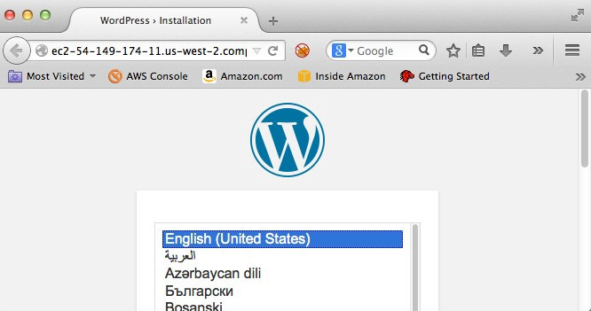

Conclusion
ECS is a sophisticated cluster management service that enables developers to harness the full power of Docker containers. Using ECS, engineers can take full advantage of the efficient development and test cycles made possible by the portability of Docker containers. Complex, distributed microservices architectures benefit from the isolation of the Docker execution environment. ECS allows distributed applications built using these architectures to be run in a clustered computing environment under full control of the customer, but with the full benefits of a managed service. In this post, we explored some of the architectural principals of container-based cluster computing. In later posts, we’ll further explore some of the other advantages of deploying applications in a clustered environment. Until then, we encourage you to explore ECS and Docker further. Have fun!

