**Faculty of Computing**

**SE-314: Software Construction**

**Class: BESE 13AB**

# Lab 09: Abstract Data Type - II

**CLO-03:** Design and develop solutions based on Software Construction principles.  
**CLO-04:** Use modern tools such as Eclipse, NetBeans etc. for software construction.

**Date: 18th Nov 2024**

**Time: 10:00 AM** **- 12:50 PM   
 02:00 PM – 04:50 PM**

**Instructor: Dr. Mehvish Rashid  
Lab Engineer: Mr. Aftab Farooq**

**Introduction:**

# Lab 09: ADT- II

Students will have hands-on experience on designing, testing, and implementing abstract data types. Given a set of specifications, you will write unit tests that check for compliance with the specifications, and then implement code that meets the specifications. Use GitHub to collaborate with your group members and mention the work distribution.

**Material:**

<https://ocw.mit.edu/ans7870/6/6.005/s16/psets/ps2/>

Lectures on LMS regarding designing Abstract Data Types   
**Lab Tasks**

Solve problem 4 of problem set 2 listed on the link. **Task1: Test Graph Poet**

## Devise, document, and implement tests for GraphPoet in

**GraphPoetTest.java** .

**Task2: Implement GraphPoet in GraphPoet.java .**

## You must use Graph in the rep of GraphPoet , but the implementation is otherwise entirely up to you.

**- Push Your Code on GitHub  
- Add Git Link in Document.**

**Source Code: Zip your source code and upload one file (Including Git link) on LMS as well.**

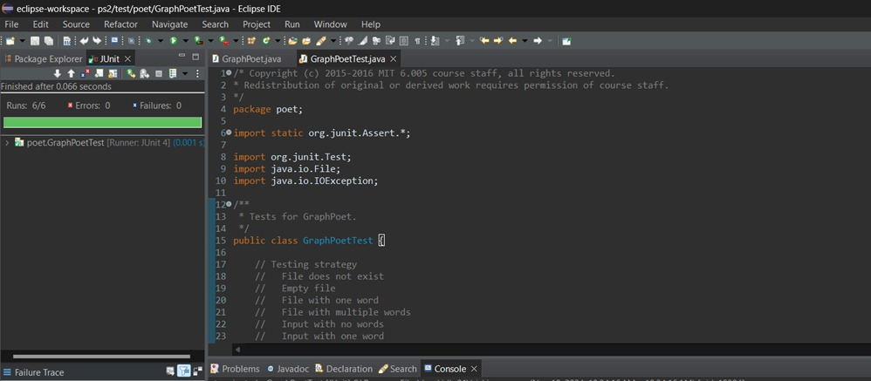

**Solution**

**Deliverables:**

Compile a single word document by filling in the solution part and submit this Word file on LMS. In case of any problems with submissions on LMS, submit your Lab assignments by emailing it to [aftab.farooq@seecs.edu.pk.](mailto:aftab.farooq@seecs.edu.pk.)