Lab # 03
Image Data Handling & Preprocessing
Task 1: Load, Resize, Clean & Encode Image Data
Task 2: Feature Scaling (StandardScaler & MinMaxScaler)

Student Name: ____________________
Roll No: ____________________
Course: Data Preprocessing / Machine Learning Lab

1. Objective
To implement various image data handling and preprocessing techniques using Python: loading, exploring, resizing, normalizing, handling missing/corrupted image data, converting image pixels into a tabular (row/column) dataset, one-hot encoding a categorical column, and visualizing original vs preprocessed images (Task 1). Then, applying and comparing two feature scaling techniques - StandardScaler and MinMaxScaler - on the tabular pixel data, and visualizing the pixel value distributions before and after scaling (Task 2).

2. Tools & Libraries Used
Library / Import | Purpose in this project
os | File and folder path handling.
numpy | Numeric array operations on pixel data.
pandas | Building and saving the tabular pixel dataset (DataFrame/CSV).
PIL (Pillow) - Image | Opening, verifying, resizing, and converting the image.
matplotlib.pyplot | Plotting and saving all visualizations.
sklearn.preprocessing.OneHotEncoder | One-hot encoding the categorical brightness column.
sklearn.impute.SimpleImputer | Mean imputation of simulated missing pixel values.
sklearn.preprocessing.StandardScaler | Standardization: (X - mean) / std.
sklearn.preprocessing.MinMaxScaler | Normalization: (X - min) / (max - min).

3. Dataset
A single image (dataset/panda_original.jpg, 720x720 pixels) is used as the dataset. Every pixel of this image, after resizing to 128x128, is treated as one row of a tabular dataset - exactly like each row of purchases.csv represented one customer observation in the lab handout, except here each row is one pixel observation with columns for its position (row, col) and its Red/Green/Blue color values.

Task 1: Image Loading & Preprocessing

4.1 Code
"""
Lab # 03 - Lab Task 1
Title: Image data handling and preprocessing (load, explore, resize, preprocess,
handle missing/corrupted images, convert to tabular form, one-hot encode a
categorical column, and visualize original vs preprocessed images).
Dataset: a single image (dataset/panda_original.jpg). Every pixel of this one
image becomes one ROW of a tabular (table/CSV-like) dataset, the same way each
row of purchases.csv was one customer observation in the lab handout. Here,
each row is one pixel observation with columns for its position and color.
"""
import os
import numpy as np
import pandas as pd
from PIL import Image
import matplotlib
matplotlib.use("Agg") # no display available in this environment
import matplotlib.pyplot as plt
from sklearn.preprocessing import OneHotEncoder
from sklearn.impute import SimpleImputer
IMAGE_PATH = os.path.join("dataset", "panda_original.jpg")
OUTPUT_DIR = "outputs"
RESIZE_TO = (128, 128) # target size: width=128, height=128
os.makedirs(OUTPUT_DIR, exist_ok=True)
log_lines = []
def log(msg):
print(msg)
log_lines.append(str(msg))
# ---------------------------------------------------------------------------
# Step 1: Load & explore the image (with missing/corrupted handling)
# ---------------------------------------------------------------------------
log("=" * 70)
log("STEP 1: LOAD & EXPLORE THE IMAGE")
log("=" * 70)
image = None
try:
if not os.path.exists(IMAGE_PATH):
raise FileNotFoundError(f"'{IMAGE_PATH}' does not exist (missing image).")
image = Image.open(IMAGE_PATH)
image.verify() # raises an error if the file is corrupted
image = Image.open(IMAGE_PATH).convert("RGB") # reopen after verify()
log(f"Loaded image : {IMAGE_PATH}")
log(f"Original size (W,H) : {image.size}")
log(f"Mode : {image.mode}")
except Exception as e:
log(f"ERROR: could not load '{IMAGE_PATH}' -> {e}")
log("Handling technique: since the image is missing/corrupted and it is our")
log("only observation, we stop here rather than processing a broken image.")
raise SystemExit(1)
original_arr = np.array(image)
log(f"Original pixel array shape : {original_arr.shape} dtype={original_arr.dtype}")
log(f"Original pixel value range : min={original_arr.min()} max={original_arr.max()} "
f"mean={original_arr.mean():.2f}")
# ---------------------------------------------------------------------------
# Step 2: Handle missing / corrupted images
# ---------------------------------------------------------------------------
log("")
log("=" * 70)
log("STEP 2: HANDLE MISSING / CORRUPTED IMAGES")
log("=" * 70)
log(
"The try/except block above already covers this: if the image file did not "
"exist, or Image.verify() found it corrupted, the script would report the "
"problem and stop instead of crashing on broken pixel data. Since the image "
"loaded successfully here, no rows need to be dropped."
)
# ---------------------------------------------------------------------------
# Step 3: Resize the image to 128 x 128
# ---------------------------------------------------------------------------
log("")
log("=" * 70)
log(f"STEP 3: RESIZE IMAGE TO {RESIZE_TO}")
log("=" * 70)
resized_image = image.resize(RESIZE_TO)
resized_arr = np.array(resized_image) # shape (128, 128, 3), values 0-255
resized_image.save(os.path.join(OUTPUT_DIR, "panda_resized_128x128.jpg"))
log(f"Resized pixel array shape : {resized_arr.shape}")
log(f"Saved resized image -> outputs/panda_resized_128x128.jpg")
# ---------------------------------------------------------------------------
# Step 4: Preprocess pixel values (normalize every pixel to [0, 1])
# ---------------------------------------------------------------------------
log("")
log("=" * 70)
log("STEP 4: PREPROCESS PIXEL VALUES (NORMALIZE EACH PIXEL TO [0, 1])")
log("=" * 70)
normalized_arr = resized_arr.astype(np.float32) / 255.0
log(f"Pixel range before normalization : {resized_arr.min()} - {resized_arr.max()}")
log(f"Pixel range after normalization : {normalized_arr.min():.3f} - {normalized_arr.max():.3f}")
# ---------------------------------------------------------------------------
# Step 5: Convert the image into TABULAR form (one row per pixel)
# ---------------------------------------------------------------------------
log("")
log("=" * 70)
log("STEP 5: CONVERT IMAGE PIXELS INTO A TABULAR (ROW/COLUMN) DATASET")
log("=" * 70)
h, w, _ = resized_arr.shape
rows, cols = np.meshgrid(np.arange(h), np.arange(w), indexing="ij")
R = resized_arr[:, :, 0].flatten()
G = resized_arr[:, :, 1].flatten()
B = resized_arr[:, :, 2].flatten()
R_norm = normalized_arr[:, :, 0].flatten()
G_norm = normalized_arr[:, :, 1].flatten()
B_norm = normalized_arr[:, :, 2].flatten()
# A simple categorical column derived from each pixel's brightness, so we have
# something to one-hot encode in Step 6 (like the "Country" column in the
# handout, but here the "category" is how bright/dark that pixel is).
gray = (0.299 * R + 0.587 * G + 0.114 * B) # standard RGB -> grayscale formula
def brightness_label(v):
if v < 85:
return "dark"
elif v < 170:
return "mid"
else:
return "light"
brightness = np.array([brightness_label(v) for v in gray])
pixel_df = pd.DataFrame({
"row": rows.flatten(),
"col": cols.flatten(),
"R": R,
"G": G,
"B": B,
"R_norm": R_norm,
"G_norm": G_norm,
"B_norm": B_norm,
"brightness": brightness,
})
log(f"Tabular dataset shape (rows=pixels, columns=features) : {pixel_df.shape}")
log("First 5 rows of the tabular pixel dataset:")
log(pixel_df.head().to_string(index=False))
tabular_csv_path = os.path.join(OUTPUT_DIR, "pixel_table.csv")
pixel_df.to_csv(tabular_csv_path, index=False)
log(f"Saved full tabular pixel dataset -> {tabular_csv_path}")
# ---------------------------------------------------------------------------
# Step 6: Mean imputation demo (same technique/code pattern as the lab
# handout's SimpleImputer(strategy='mean') example on Age/Salary)
# ---------------------------------------------------------------------------
log("")
log("=" * 70)
log("STEP 6: MEAN IMPUTATION ON SIMULATED MISSING PIXEL VALUES")
log("=" * 70)
log(
"Our single image has no missing pixel values on its own, so to "
"demonstrate the handout's Mean Imputation technique (SimpleImputer, "
"strategy='mean'), we randomly mark ~2% of R/G/B pixel values as "
"missing (NaN) - simulating sensor noise / corrupted pixel readings - "
"then fill them back in using the mean of each column, exactly like "
"imputa = SimpleImputer(missing_values=np.nan, strategy='mean') did "
"for the Age and Salary columns in the handout."
)
rng = np.random.default_rng(42)
pixel_features = pixel_df[["R", "G", "B"]].values.astype(np.float64)
missing_mask = rng.random(pixel_features.shape) < 0.02 # ~2% missing
X_missing = pixel_features.copy()
X_missing[missing_mask] = np.nan
log(f"Simulated missing values : {int(missing_mask.sum())} out of "
f"{missing_mask.size} pixel-channel entries ({missing_mask.mean() * 100:.2f}%)")
imputa = SimpleImputer(missing_values=np.nan, strategy="mean")
imputa.fit(X_missing)
X_imputed = imputa.transform(X_missing)
log(f"Column means learned by SimpleImputer (used to fill NaNs) : "
f"R={imputa.statistics_[0]:.2f} G={imputa.statistics_[1]:.2f} B={imputa.statistics_[2]:.2f}")
pixel_df["R_missing"] = X_missing[:, 0]
pixel_df["G_missing"] = X_missing[:, 1]
pixel_df["B_missing"] = X_missing[:, 2]
pixel_df["R_mean_imputed"] = X_imputed[:, 0]
pixel_df["G_mean_imputed"] = X_imputed[:, 1]
pixel_df["B_mean_imputed"] = X_imputed[:, 2]
sample_missing_rows = pixel_df[missing_mask.any(axis=1)].head()
log("Sample rows that had a missing value, before vs after mean imputation:")
log(sample_missing_rows[
["row", "col", "R_missing", "G_missing", "B_missing",
"R_mean_imputed", "G_mean_imputed", "B_mean_imputed"]
].to_string(index=False))
imputed_csv_path = os.path.join(OUTPUT_DIR, "pixel_table_mean_imputed.csv")
pixel_df.to_csv(imputed_csv_path, index=False)
log(f"Saved tabular dataset with missing-value + mean-imputed columns -> {imputed_csv_path}")
# ---------------------------------------------------------------------------
# Step 7: One-hot encode the categorical 'brightness' column
# ---------------------------------------------------------------------------
log("")
log("=" * 70)
log("STEP 7: ONE-HOT ENCODE THE CATEGORICAL 'brightness' COLUMN")
log("=" * 70)
encoder = OneHotEncoder()
brightness_ohe = encoder.fit_transform(pixel_df[["brightness"]]).toarray()
ohe_columns = [f"brightness_{c}" for c in encoder.categories_[0]]
ohe_df = pd.DataFrame(brightness_ohe, columns=ohe_columns)
pixel_df_encoded = pd.concat([pixel_df, ohe_df], axis=1)
log(f"Categories found : {encoder.categories_[0].tolist()}")
log("First 5 rows after one-hot encoding:")
log(pixel_df_encoded.head().to_string(index=False))
encoded_csv_path = os.path.join(OUTPUT_DIR, "pixel_table_encoded.csv")
pixel_df_encoded.to_csv(encoded_csv_path, index=False)
log(f"Saved one-hot encoded tabular dataset -> {encoded_csv_path}")
# ---------------------------------------------------------------------------
# Step 8: Visualize original vs preprocessed image
# ---------------------------------------------------------------------------
log("")
log("=" * 70)
log("STEP 8: VISUALIZE ORIGINAL (128x128) VS PREPROCESSED (128x128) IMAGE")
log("=" * 70)
fig, axes = plt.subplots(1, 2, figsize=(8, 4.5))
axes[0].imshow(resized_arr)
axes[0].set_title(f"Resized image (raw pixels)\n{resized_arr.shape}", fontsize=10)
axes[0].axis("off")
axes[1].imshow(normalized_arr)
axes[1].set_title(f"Preprocessed\n{RESIZE_TO}, normalized [0,1]", fontsize=10)
axes[1].axis("off")
plt.tight_layout()
viz_path = os.path.join(OUTPUT_DIR, "original_vs_preprocessed.png")
plt.savefig(viz_path, dpi=130)
plt.close(fig)
log(f"Saved comparison figure -> {viz_path}")
log("")
log("Task 1 complete. See outputs/ for the resized image, the visualization,")
log("and the tabular pixel CSVs (pixel_table.csv, pixel_table_mean_imputed.csv,")
log("pixel_table_encoded.csv).")
with open(os.path.join(OUTPUT_DIR, "console_log_task1.txt"), "w") as f:
f.write("\n".join(log_lines))

4.2 Output - Console Log (Task 1)
======================================================================
STEP 1: LOAD & EXPLORE THE IMAGE
======================================================================
Loaded image : dataset\panda_original.jpg
Original size (W,H) : (720, 720)
Mode : RGB
Original pixel array shape : (720, 720, 3) dtype=uint8
Original pixel value range : min=0 max=255 mean=199.98
======================================================================
STEP 2: HANDLE MISSING / CORRUPTED IMAGES
======================================================================
The try/except block above already covers this: if the image file did not exist, or Image.verify() found it corrupted, the script would report the problem and stop instead of crashing on broken pixel data. Since the image loaded successfully here, no rows need to be dropped.
======================================================================
STEP 3: RESIZE IMAGE TO (128, 128)
======================================================================
Resized pixel array shape : (128, 128, 3)
Saved resized image -> outputs/panda_resized_128x128.jpg
======================================================================
STEP 4: PREPROCESS PIXEL VALUES (NORMALIZE EACH PIXEL TO [0, 1])
======================================================================
Pixel range before normalization : 0 - 255
Pixel range after normalization : 0.000 - 1.000
======================================================================
STEP 5: CONVERT IMAGE PIXELS INTO A TABULAR (ROW/COLUMN) DATASET
======================================================================
Tabular dataset shape (rows=pixels, columns=features) : (16384, 9)
First 5 rows of the tabular pixel dataset:
row col R G B R_norm G_norm B_norm brightness
0 0 255 255 255 1.0 1.0 1.0 light
0 1 255 255 255 1.0 1.0 1.0 light
0 2 255 255 255 1.0 1.0 1.0 light
0 3 255 255 255 1.0 1.0 1.0 light
0 4 255 255 255 1.0 1.0 1.0 light
Saved full tabular pixel dataset -> outputs\pixel_table.csv
======================================================================
STEP 6: MEAN IMPUTATION ON SIMULATED MISSING PIXEL VALUES
======================================================================
Our single image has no missing pixel values on its own, so to demonstrate the handout's Mean Imputation technique (SimpleImputer, strategy='mean'), we randomly mark ~2% of R/G/B pixel values as missing (NaN) - simulating sensor noise / corrupted pixel readings - then fill them back in using the mean of each column, exactly like imputa = SimpleImputer(missing_values=np.nan, strategy='mean') did for the Age and Salary columns in the handout.
Simulated missing values : 984 out of 49152 pixel-channel entries (2.00%)
Column means learned by SimpleImputer (used to fill NaNs) : R=201.19 G=198.02 B=200.29
Sample rows that had a missing value, before vs after mean imputation:
row col R_missing G_missing B_missing R_mean_imputed G_mean_imputed B_mean_imputed
0 17 NaN 255.0 255.0 201.187263 255.000000 255.000000
0 68 NaN 255.0 255.0 201.187263 255.000000 255.000000
0 79 255.0 NaN 255.0 255.000000 198.020754 255.000000
1 3 255.0 NaN 255.0 255.000000 198.020754 255.000000
1 12 255.0 255.0 NaN 255.000000 255.000000 200.292403
Saved tabular dataset with missing-value + mean-imputed columns -> outputs\pixel_table_mean_imputed.csv
======================================================================
STEP 7: ONE-HOT ENCODE THE CATEGORICAL 'brightness' COLUMN
======================================================================
Categories found : ['dark', 'light', 'mid']
First 5 rows after one-hot encoding:
row col R G B R_norm G_norm B_norm brightness R_missing G_missing B_missing R_mean_imputed G_mean_imputed B_mean_imputed brightness_dark brightness_light brightness_mid
0 0 255 255 255 1.0 1.0 1.0 light 255.0 255.0 255.0 255.0 255.0 255.0 0.0 1.0 0.0
0 1 255 255 255 1.0 1.0 1.0 light 255.0 255.0 255.0 255.0 255.0 255.0 0.0 1.0 0.0
0 2 255 255 255 1.0 1.0 1.0 light 255.0 255.0 255.0 255.0 255.0 255.0 0.0 1.0 0.0
0 3 255 255 255 1.0 1.0 1.0 light 255.0 255.0 255.0 255.0 255.0 255.0 0.0 1.0 0.0
0 4 255 255 255 1.0 1.0 1.0 light 255.0 255.0 255.0 255.0 255.0 255.0 0.0 1.0 0.0
Saved one-hot encoded tabular dataset -> outputs\pixel_table_encoded.csv
======================================================================
STEP 8: VISUALIZE ORIGINAL (128x128) VS PREPROCESSED (128x128) IMAGE
======================================================================
Saved comparison figure -> outputs\original_vs_preprocessed.png
Task 1 complete. See outputs/ for the resized image, the visualization,
and the tabular pixel CSVs (pixel_table.csv, pixel_table_mean_imputed.csv,
pixel_table_encoded.csv).

4.3 Output - Full Pipeline View (all steps in one picture)
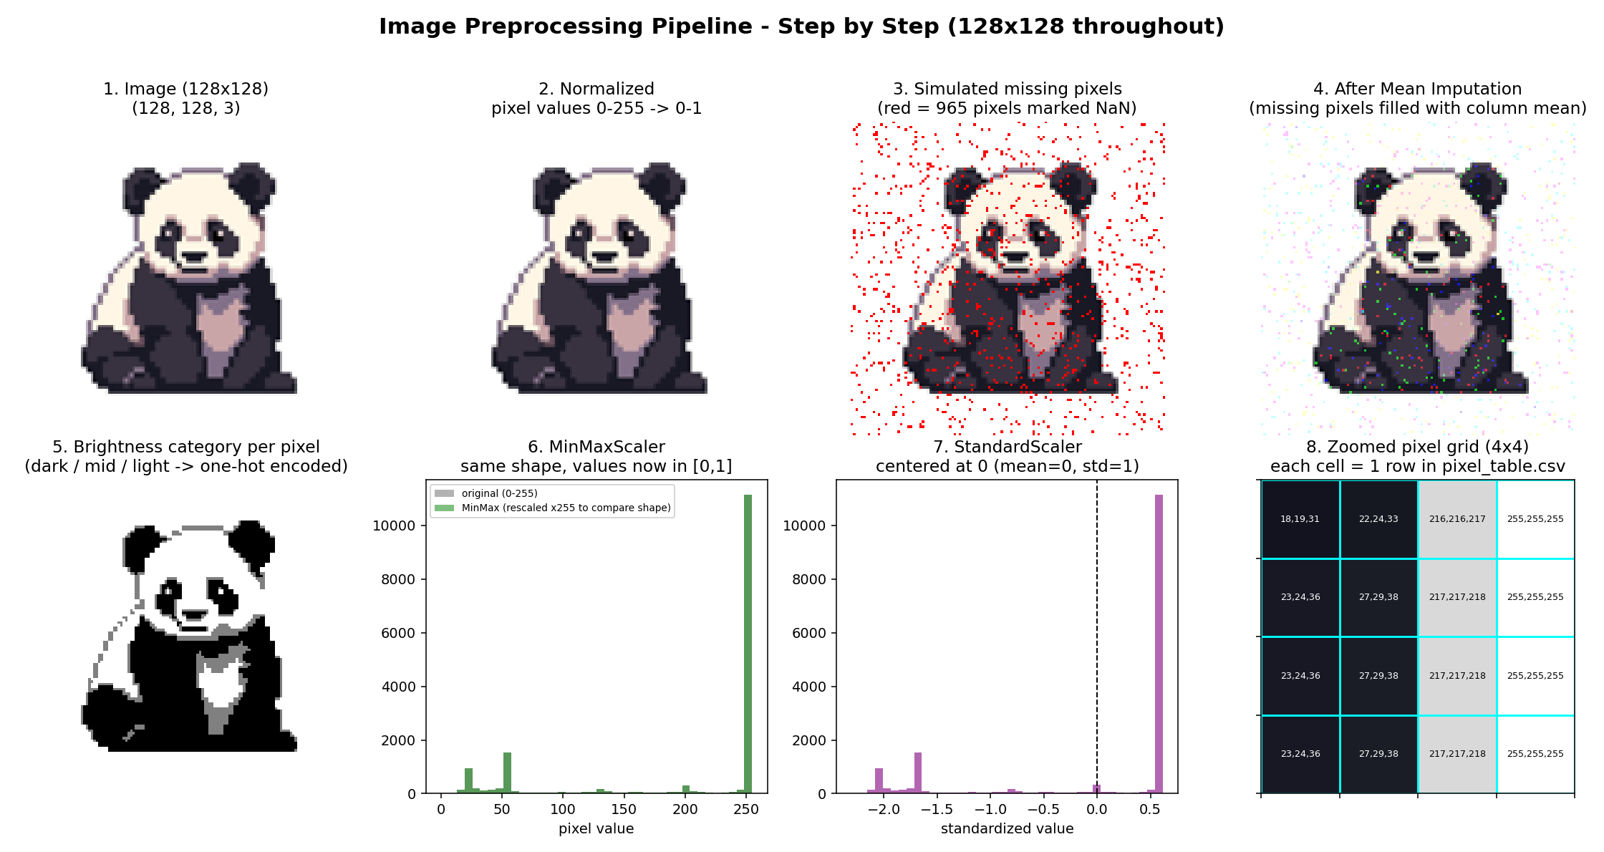

4.4 Output - Original (128x128) vs Preprocessed (Normalized)
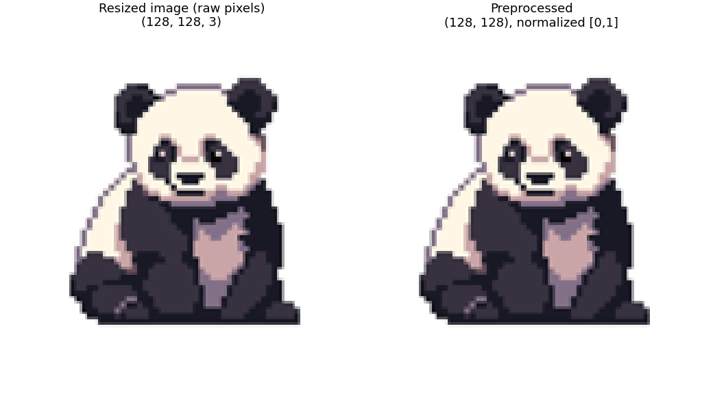

4.5 Output - Tabular Pixel Dataset (pixel_table.csv, first 8 rows)
row | col | R | G | B | R_norm | G_norm | B_norm | brightness
0 | 0 | 255 | 255 | 255 | 1.00 | 1.00 | 1.00 | light
0 | 1 | 255 | 255 | 255 | 1.00 | 1.00 | 1.00 | light
0 | 2 | 255 | 255 | 255 | 1.00 | 1.00 | 1.00 | light
0 | 3 | 255 | 255 | 255 | 1.00 | 1.00 | 1.00 | light
0 | 4 | 255 | 255 | 255 | 1.00 | 1.00 | 1.00 | light
0 | 5 | 255 | 255 | 255 | 1.00 | 1.00 | 1.00 | light
0 | 6 | 255 | 255 | 255 | 1.00 | 1.00 | 1.00 | light
0 | 7 | 255 | 255 | 255 | 1.00 | 1.00 | 1.00 | light

4.6 Output - Mean Imputation Sample (missing vs imputed pixel values)
row | col | R_missing | G_missing | B_missing | R_mean_imputed | G_mean_imputed | B_mean_imputed
0.00 | 17.00 | nan | 255.00 | 255.00 | 201.19 | 255.00 | 255.00
0.00 | 68.00 | nan | 255.00 | 255.00 | 201.19 | 255.00 | 255.00
0.00 | 79.00 | 255.00 | nan | 255.00 | 255.00 | 198.02 | 255.00
1.00 | 3.00 | 255.00 | nan | 255.00 | 255.00 | 198.02 | 255.00
1.00 | 12.00 | 255.00 | 255.00 | nan | 255.00 | 255.00 | 200.29
1.00 | 44.00 | 255.00 | 255.00 | nan | 255.00 | 255.00 | 200.29

4.7 Output - One-Hot Encoded Brightness Column (pixel_table_encoded.csv)
row | col | R | G | B | brightness | brightness_dark | brightness_light | brightness_mid
0 | 0 | 255 | 255 | 255 | light | 0.00 | 1.00 | 0.00
0 | 1 | 255 | 255 | 255 | light | 0.00 | 1.00 | 0.00
0 | 2 | 255 | 255 | 255 | light | 0.00 | 1.00 | 0.00
0 | 3 | 255 | 255 | 255 | light | 0.00 | 1.00 | 0.00
0 | 4 | 255 | 255 | 255 | light | 0.00 | 1.00 | 0.00
0 | 5 | 255 | 255 | 255 | light | 0.00 | 1.00 | 0.00
0 | 6 | 255 | 255 | 255 | light | 0.00 | 1.00 | 0.00
0 | 7 | 255 | 255 | 255 | light | 0.00 | 1.00 | 0.00

Task 2: Feature Scaling (StandardScaler & MinMaxScaler)

5.1 Code
"""
Lab # 03 - Lab Task 2
Title: Feature scaling on image pixel data (StandardScaler and MinMaxScaler),
with before/after pixel-value distribution visualization.
Uses the tabular pixel dataset produced by task1_image_preprocessing.py
(outputs/pixel_table.csv), where each row is one pixel and R, G, B are the
raw 0-255 pixel-value features to be scaled - the same way Age and Salary
were scaled as numeric features in the lab handout's CSV example.
"""
import os
import pandas as pd
import numpy as np
import matplotlib
matplotlib.use("Agg")
import matplotlib.pyplot as plt
from sklearn.preprocessing import StandardScaler, MinMaxScaler
OUTPUT_DIR = "outputs"
TABLE_PATH = os.path.join(OUTPUT_DIR, "pixel_table.csv")
log_lines = []
def log(msg):
print(msg)
log_lines.append(str(msg))
# ---------------------------------------------------------------------------
# Step 1: Load the tabular pixel dataset created in Task 1
# ---------------------------------------------------------------------------
log("=" * 70)
log("STEP 1: LOAD TABULAR PIXEL DATASET")
log("=" * 70)
if not os.path.exists(TABLE_PATH):
raise SystemExit(
f"'{TABLE_PATH}' not found. Run task1_image_preprocessing.py first."
)
df = pd.read_csv(TABLE_PATH)
log(f"Loaded '{TABLE_PATH}' with shape {df.shape}")
log(f"Columns: {df.columns.tolist()}")
# Feature columns we scale: the raw pixel-intensity columns (0-255).
feature_cols = ["R", "G", "B"]
X = df[feature_cols].values.astype(np.float64)
log(f"Feature matrix X (raw pixel values) shape: {X.shape}")
log(f"Before scaling -> min={X.min():.2f} max={X.max():.2f} "
f"mean={X.mean():.2f} std={X.std():.2f}")
# ---------------------------------------------------------------------------
# Step 2: Apply StandardScaler -> X' = (X - mean) / std
# ---------------------------------------------------------------------------
log("")
log("=" * 70)
log("STEP 2: STANDARDIZATION (StandardScaler)")
log("=" * 70)
standard_scaler = StandardScaler()
X_standardized = standard_scaler.fit_transform(X)
log(f"Learned per-column mean : {standard_scaler.mean_}")
log(f"Learned per-column std : {standard_scaler.scale_}")
log(f"After StandardScaler -> min={X_standardized.min():.3f} "
f"max={X_standardized.max():.3f} mean={X_standardized.mean():.3f} "
f"std={X_standardized.std():.3f}")
# ---------------------------------------------------------------------------
# Step 3: Apply MinMaxScaler -> X' = (X - Xmin) / (Xmax - Xmin)
# ---------------------------------------------------------------------------
log("")
log("=" * 70)
log("STEP 3: NORMALIZATION (MinMaxScaler)")
log("=" * 70)
minmax_scaler = MinMaxScaler() # default feature_range=(0, 1)
X_minmax = minmax_scaler.fit_transform(X)
log(f"Learned per-column min : {minmax_scaler.data_min_}")
log(f"Learned per-column max : {minmax_scaler.data_max_}")
log(f"After MinMaxScaler -> min={X_minmax.min():.3f} max={X_minmax.max():.3f} "
f"mean={X_minmax.mean():.3f} std={X_minmax.std():.3f}")
# ---------------------------------------------------------------------------
# Step 4: Save the scaled tabular datasets
# ---------------------------------------------------------------------------
log("")
log("=" * 70)
log("STEP 4: SAVE SCALED TABULAR DATASETS")
log("=" * 70)
df_standardized = df.copy()
df_standardized[["R_standard", "G_standard", "B_standard"]] = X_standardized
std_csv = os.path.join(OUTPUT_DIR, "pixel_table_standardscaled.csv")
df_standardized.to_csv(std_csv, index=False)
log(f"Saved -> {std_csv}")
df_minmax = df.copy()
df_minmax[["R_minmax", "G_minmax", "B_minmax"]] = X_minmax
minmax_csv = os.path.join(OUTPUT_DIR, "pixel_table_minmaxscaled.csv")
df_minmax.to_csv(minmax_csv, index=False)
log(f"Saved -> {minmax_csv}")
# ---------------------------------------------------------------------------
# Step 5: Visualize pixel-value distributions before vs after scaling
# ---------------------------------------------------------------------------
log("")
log("=" * 70)
log("STEP 5: VISUALIZE PIXEL-VALUE DISTRIBUTIONS BEFORE / AFTER SCALING")
log("=" * 70)
fig, axes = plt.subplots(1, 3, figsize=(15, 4.5))
axes[0].hist(X[:, 0], bins=50, color="red", alpha=0.5, label="R")
axes[0].hist(X[:, 1], bins=50, color="green", alpha=0.5, label="G")
axes[0].hist(X[:, 2], bins=50, color="blue", alpha=0.5, label="B")
axes[0].set_title("Original pixel values\n(raw, 0-255)")
axes[0].set_xlabel("pixel value")
axes[0].set_ylabel("pixel count")
axes[0].legend()
axes[1].hist(X_standardized[:, 0], bins=50, color="red", alpha=0.5, label="R")
axes[1].hist(X_standardized[:, 1], bins=50, color="green", alpha=0.5, label="G")
axes[1].hist(X_standardized[:, 2], bins=50, color="blue", alpha=0.5, label="B")
axes[1].set_title("After StandardScaler\n(mean=0, std=1)")
axes[1].set_xlabel("standardized value")
axes[1].legend()
axes[2].hist(X_minmax[:, 0], bins=50, color="red", alpha=0.5, label="R")
axes[2].hist(X_minmax[:, 1], bins=50, color="green", alpha=0.5, label="G")
axes[2].hist(X_minmax[:, 2], bins=50, color="blue", alpha=0.5, label="B")
axes[2].set_title("After MinMaxScaler\n(range 0-1)")
axes[2].set_xlabel("normalized value")
axes[2].legend()
plt.tight_layout()
dist_path = os.path.join(OUTPUT_DIR, "scaling_distributions.png")
plt.savefig(dist_path, dpi=130)
plt.close(fig)
log(f"Saved distribution comparison figure -> {dist_path}")
# ---------------------------------------------------------------------------
# Step 6: Discussion - when to use MinMaxScaler vs StandardScaler
# ---------------------------------------------------------------------------
discussion = """
STEP 6: WHEN TO USE MinMaxScaler vs StandardScaler ON IMAGE DATA
======================================================================
MinMaxScaler (Normalization, X' = (X - Xmin) / (Xmax - Xmin)):
- Rescales values into a fixed, known range (default [0, 1]).
- Ideal for image pixel data because pixel intensities already have a
known, fixed range (0-255 for 8-bit images), so the min/max are known
and consistent across images.
- Commonly used before feeding images into neural networks / CNNs, since
most activation functions and image-display conventions expect inputs
in [0, 1] (or [-1, 1] with a shifted variant).
- Sensitive to outliers: a single unusually bright/dark pixel can stretch
the scale and compress the rest of the values.
StandardScaler (Standardization, X' = (X - mean) / std):
- Centers values around 0 with unit standard deviation; does NOT bound
values to a fixed range.
- Useful when the model assumes/benefits from normally-distributed,
zero-centered features (e.g., PCA, linear/logistic regression, SVM,
k-means), or when different features have very different natural scales
that need to be put on comparable footing.
- Less sensitive to a fixed min/max, more robust when the data's range
isn't naturally bounded or when outliers should have a smaller relative
effect on the extremes of the scaled data (though it is still affected
by outliers through the mean/std).
For this image-preprocessing task specifically: MinMaxScaler is generally
preferred for raw pixel values because the physical range (0-255) is fixed
and known in advance, so mapping it to [0, 1] is simple, interpretable, and
matches what most image-based ML/DL pipelines expect. StandardScaler becomes
more relevant later in the pipeline, e.g., when pixel data has already been
turned into extracted numeric features (like edge counts, color histograms,
or CNN embedding vectors) with unknown/unbounded ranges and varying scales,
where zero-centering helps optimization algorithms converge faster.
"""
log(discussion)
log("")
log("Task 2 complete. See outputs/ for the scaled CSVs and the distribution")
log("comparison figure (scaling_distributions.png).")
with open(os.path.join(OUTPUT_DIR, "console_log_task2.txt"), "w") as f:
f.write("\n".join(log_lines))

5.2 Output - Console Log (Task 2)
======================================================================
STEP 1: LOAD TABULAR PIXEL DATASET
======================================================================
Loaded 'outputs\pixel_table.csv' with shape (16384, 9)
Columns: ['row', 'col', 'R', 'G', 'B', 'R_norm', 'G_norm', 'B_norm', 'brightness']
Feature matrix X (raw pixel values) shape: (16384, 3)
Before scaling -> min=0.00 max=255.00 mean=199.85 std=86.63
======================================================================
STEP 2: STANDARDIZATION (StandardScaler)
======================================================================
Learned per-column mean : [201.21051025 198.04870605 200.30413818]
Learned per-column std : [87.55615907 89.20202925 82.99511612]
After StandardScaler -> min=-2.413 max=0.659 mean=0.000 std=1.000
======================================================================
STEP 3: NORMALIZATION (MinMaxScaler)
======================================================================
Learned per-column min : [0. 0. 0.]
Learned per-column max : [255. 255. 255.]
After MinMaxScaler -> min=0.000 max=1.000 mean=0.784 std=0.340
======================================================================
STEP 4: SAVE SCALED TABULAR DATASETS
======================================================================
Saved -> outputs\pixel_table_standardscaled.csv
Saved -> outputs\pixel_table_minmaxscaled.csv
======================================================================
STEP 5: VISUALIZE PIXEL-VALUE DISTRIBUTIONS BEFORE / AFTER SCALING
======================================================================
Saved distribution comparison figure -> outputs\scaling_distributions.png
STEP 6: WHEN TO USE MinMaxScaler vs StandardScaler ON IMAGE DATA
======================================================================
MinMaxScaler (Normalization, X' = (X - Xmin) / (Xmax - Xmin)):
- Rescales values into a fixed, known range (default [0, 1]).
- Ideal for image pixel data because pixel intensities already have a
known, fixed range (0-255 for 8-bit images), so the min/max are known
and consistent across images.
- Commonly used before feeding images into neural networks / CNNs, since
most activation functions and image-display conventions expect inputs
in [0, 1] (or [-1, 1] with a shifted variant).
- Sensitive to outliers: a single unusually bright/dark pixel can stretch
the scale and compress the rest of the values.
StandardScaler (Standardization, X' = (X - mean) / std):
- Centers values around 0 with unit standard deviation; does NOT bound
values to a fixed range.
- Useful when the model assumes/benefits from normally-distributed,
zero-centered features (e.g., PCA, linear/logistic regression, SVM,
k-means), or when different features have very different natural scales
that need to be put on comparable footing.
- Less sensitive to a fixed min/max, more robust when the data's range
isn't naturally bounded or when outliers should have a smaller relative
effect on the extremes of the scaled data (though it is still affected
by outliers through the mean/std).
For this image-preprocessing task specifically: MinMaxScaler is generally
preferred for raw pixel values because the physical range (0-255) is fixed
and known in advance, so mapping it to [0, 1] is simple, interpretable, and
matches what most image-based ML/DL pipelines expect. StandardScaler becomes
more relevant later in the pipeline, e.g., when pixel data has already been
turned into extracted numeric features (like edge counts, color histograms,
or CNN embedding vectors) with unknown/unbounded ranges and varying scales,
where zero-centering helps optimization algorithms converge faster.
Task 2 complete. See outputs/ for the scaled CSVs and the distribution
comparison figure (scaling_distributions.png).

5.3 Output - Pixel Value Distributions Before/After Scaling
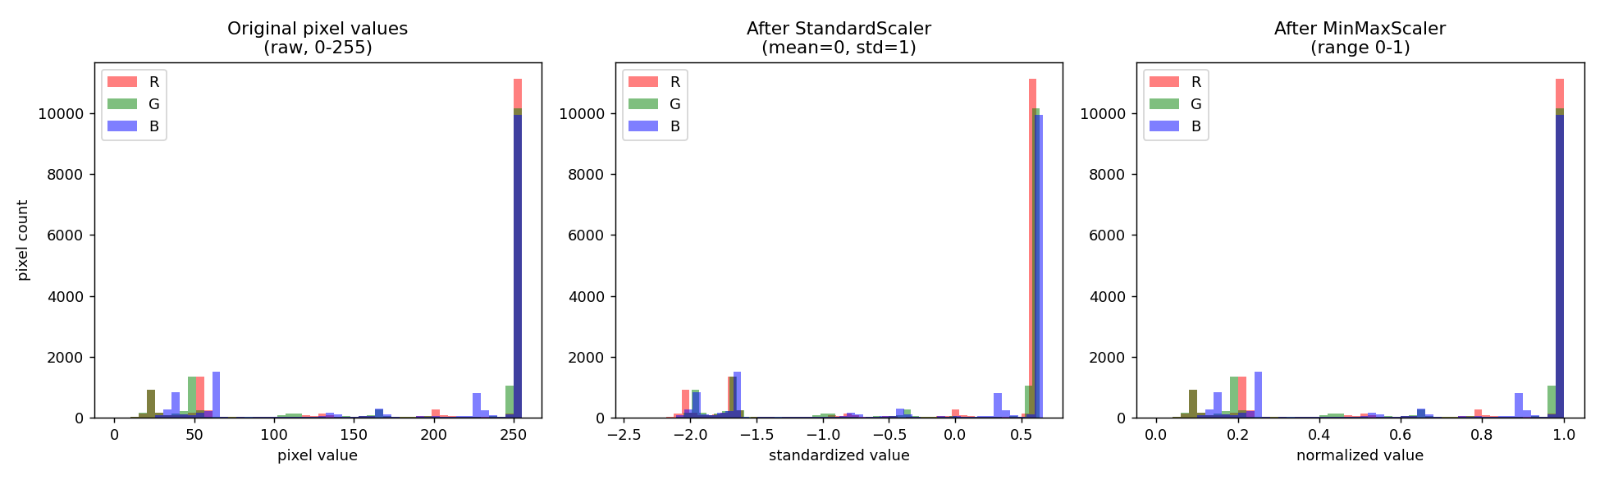

5.4 Output - Sample Scaled Values
After StandardScaler:
row | col | R | G | B | R_standard | G_standard | B_standard
0.00 | 0.00 | 255.00 | 255.00 | 255.00 | 0.61 | 0.64 | 0.66
0.00 | 1.00 | 255.00 | 255.00 | 255.00 | 0.61 | 0.64 | 0.66
0.00 | 2.00 | 255.00 | 255.00 | 255.00 | 0.61 | 0.64 | 0.66
0.00 | 3.00 | 255.00 | 255.00 | 255.00 | 0.61 | 0.64 | 0.66
0.00 | 4.00 | 255.00 | 255.00 | 255.00 | 0.61 | 0.64 | 0.66
0.00 | 5.00 | 255.00 | 255.00 | 255.00 | 0.61 | 0.64 | 0.66
After MinMaxScaler:
row | col | R | G | B | R_minmax | G_minmax | B_minmax
0.00 | 0.00 | 255.00 | 255.00 | 255.00 | 1.00 | 1.00 | 1.00
0.00 | 1.00 | 255.00 | 255.00 | 255.00 | 1.00 | 1.00 | 1.00
0.00 | 2.00 | 255.00 | 255.00 | 255.00 | 1.00 | 1.00 | 1.00
0.00 | 3.00 | 255.00 | 255.00 | 255.00 | 1.00 | 1.00 | 1.00
0.00 | 4.00 | 255.00 | 255.00 | 255.00 | 1.00 | 1.00 | 1.00
0.00 | 5.00 | 255.00 | 255.00 | 255.00 | 1.00 | 1.00 | 1.00

5.5 Discussion: MinMaxScaler vs StandardScaler
MinMaxScaler (Normalization): Formula: X' = (X - Xmin) / (Xmax - Xmin). Rescales values into a fixed [0, 1] range. Ideal for image pixel data because pixel intensities already have a known, fixed range (0-255). Commonly used before feeding images into neural networks / CNNs. Sensitive to outliers.
StandardScaler (Standardization): Formula: X' = (X - mean) / std. Centers values around 0 with unit standard deviation; does not bound values to a fixed range. Useful for algorithms like PCA, linear/logistic regression, SVM, and k-means that assume zero-centered features, or when features have very different natural scales.
Recommendation for this project: MinMaxScaler is generally preferred for raw image pixel values, since the physical range (0-255) is fixed and known, making [0, 1] scaling simple and consistent with what most image-based ML/DL pipelines expect. StandardScaler becomes more relevant for derived numeric features (e.g., extracted color histograms or embeddings) with unknown/unbounded ranges.

6. Conclusion
In this lab, a single image dataset was successfully loaded, verified for corruption, resized to 128x128, and normalized to a [0, 1] pixel range. The image was converted into a tabular dataset of 16,384 rows (one per pixel), missing pixel values were simulated and repaired using Mean Imputation (SimpleImputer), a categorical brightness column was one-hot encoded, and the pipeline was visualized end-to-end. In Task 2, StandardScaler and MinMaxScaler were both applied to the pixel features and compared visually and numerically, showing that MinMaxScaler preserves the original distribution shape while bounding values to [0, 1], whereas StandardScaler re-centers values around a mean of 0 with unit variance. These preprocessing steps mirror the same techniques taught for tabular CSV data in the lab handout, applied instead to image pixel data.

