NUMERICAL METHODS
Laboratory Manual
Lab 7
Numerical Interpolation
Reconstructing a Symmetric Face Outline
Field | Details
Name | ______________________________
Roll No. | ______________________________
Section / Class | ______________________________
Instructor | ______________________________
Date | 13 October 2026
Language / Tools | Python 3 (NumPy, SciPy, Matplotlib)

1. Objectives
- Understand how interpolation estimates values between known data points.
- Implement Lagrange, Newton divided-difference, and natural cubic spline interpolation from first principles.
- Model a face outline as a practical interpolation problem.
- Compare the methods and identify the best choice for a smooth shape.

2. Problem Statement
A graphics designer is reconstructing a symmetrical face outline for an animation. Only the left half of the outline is available. The coordinates are measured at equally spaced heights along the y-axis:
y (height; 0 = chin) | 0 | 2 | 4 | 6 | 8 | 10
x (distance from midline) | 0.0 | 1.1 | 1.8 | 2.4 | 2.0 | 1.3

Tasks:
- Use interpolation to estimate the left outline between the known points.
- Reflect the left outline across the vertical midline to create the right side.
- Plot the complete face outline.

3. Understanding the Half-Face Data

3.1 Coordinate system
The line x = 0 is the face midline. The height y runs from the chin (y = 0) to the top (y = 10). At each height, x is the horizontal distance from the midline to the left edge. Thus, x is the half-width of the face.
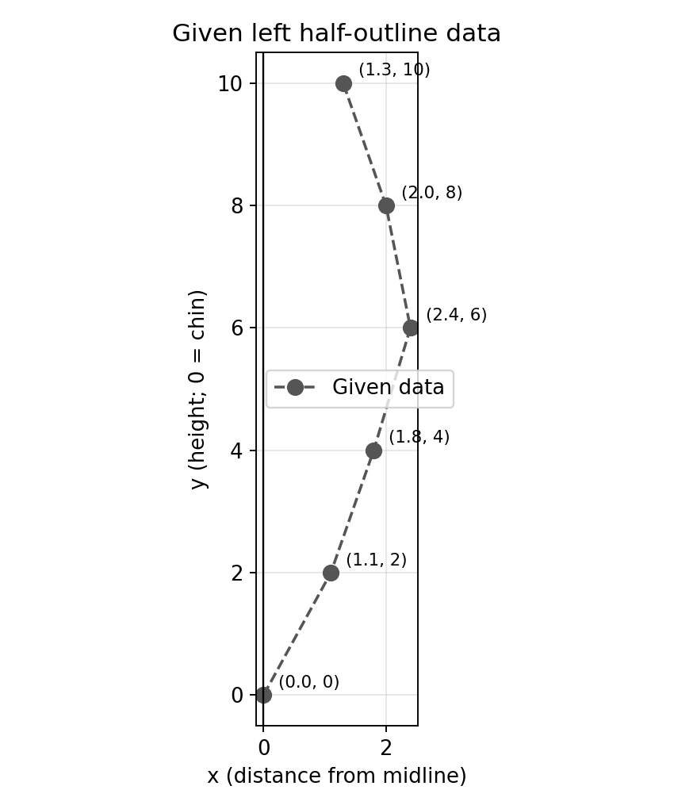
Figure 1. The six known points on the left half of the outline.

3.2 Interpreting the data
- y = 0, x = 0.0: the chin point lies exactly on the midline.
- y = 0 to 6: the half-width grows from 0 to 2.4. This is the jaw widening up to the cheekbones.
- y = 6, x = 2.4: the widest point of the data (cheekbone/temple level).
- y = 6 to 10: the half-width shrinks to 2.0 and then 1.3, which is the forehead narrowing toward the top of the head.
The outline is a function x = f(y), so y is the independent variable and x is the dependent variable. We interpolate x as a function of y because the same x value can occur at two different heights.

3.3 Why symmetry lets us use half the data
For a symmetric face, x_right(y) = -x_left(y). After finding the left outline (-f(y), y), reflect it to obtain the right outline (+f(y), y). This means we only need to interpolate once.

4. Theory

4.1 What is interpolation?
Given n + 1 distinct nodes (y_0, x_0), ..., (y_n, x_n), interpolation constructs a function P(y) that passes through every node. It then estimates x between the nodes. Unlike regression, interpolation matches every data point exactly. That is appropriate here because the outline data are treated as exact.

4.2 Lagrange interpolation
The unique polynomial of degree at most n through n + 1 points is:
P(y) = Σ x_i · L_i(y), L_i(y) = Π_{j≠i} (y − y_j) / (y_i − y_j)
Each basis polynomial L_i equals 1 at y_i and 0 at every other node, which guarantees P(y_i) = x_i. With our 6 points the result is a degree-5 polynomial.

4.3 Newton divided-difference interpolation
Newton's form represents the same polynomial using divided differences:
P(y) = f[y0] + f[y0,y1](y−y0) + f[y0,y1,y2](y−y0)(y−y1) + …
f[y_i,…,y_{i+k}] = ( f[y_{i+1},…,y_{i+k}] − f[y_i,…,y_{i+k−1}] ) / ( y_{i+k} − y_i )
The interpolating polynomial is unique, so Newton and Lagrange produce the same values apart from rounding error. Newton form is also easier to extend when a new point is added.

4.4 Natural cubic spline
A high-degree polynomial can oscillate between nodes. A cubic spline avoids this by using a separate cubic on each interval [y_i, y_{i+1}]:
S_i(y) = a_i + b_i (y − y_i) + c_i (y − y_i)² + d_i (y − y_i)³
The coefficients make S pass through every node while keeping S, S' and S'' continuous at interior nodes. The natural boundary condition sets S'' = 0 at both endpoints. With h_i = y_{i+1} - y_i, the c_i values satisfy the tridiagonal system:
h_{i−1} c_{i−1} + 2(h_{i−1}+h_i) c_i + h_i c_{i+1} = 3[(x_{i+1}−x_i)/h_i − (x_i−x_{i−1})/h_{i−1}]
The remaining coefficients are then computed from a_i, b_i, and d_i. Splines produce smooth curves, which makes them useful for computer graphics and animation.

5. Methodology / Algorithm
- Store the six (y, x) pairs of the left half-outline.
- Build the Newton divided-difference table and evaluate the Newton polynomial.
- Evaluate the Lagrange polynomial directly from the basis functions.
- Assemble and solve the tridiagonal system for the natural cubic spline, then evaluate it.
- Create 501 fine y values between 0 and 10 and evaluate all interpolants on them.
- Verify: Lagrange = Newton, our spline = SciPy's CubicSpline, and all methods pass through the data.
- Mirror the left outline: x_right = −x_left (sign flip), y unchanged.
- Plot the left half, right half, and complete face. Compare methods with leave-one-out cross-validation.

7. Output and Results

7.1 Console output
Screenshots of the program output (also saved as results.txt):
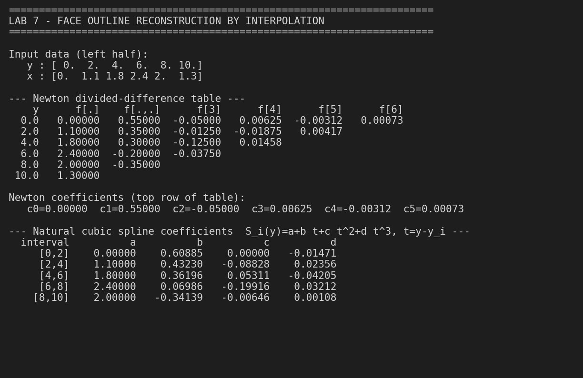
Figure 2: Console output, part 1 (data, divided-difference table, spline coefficients).
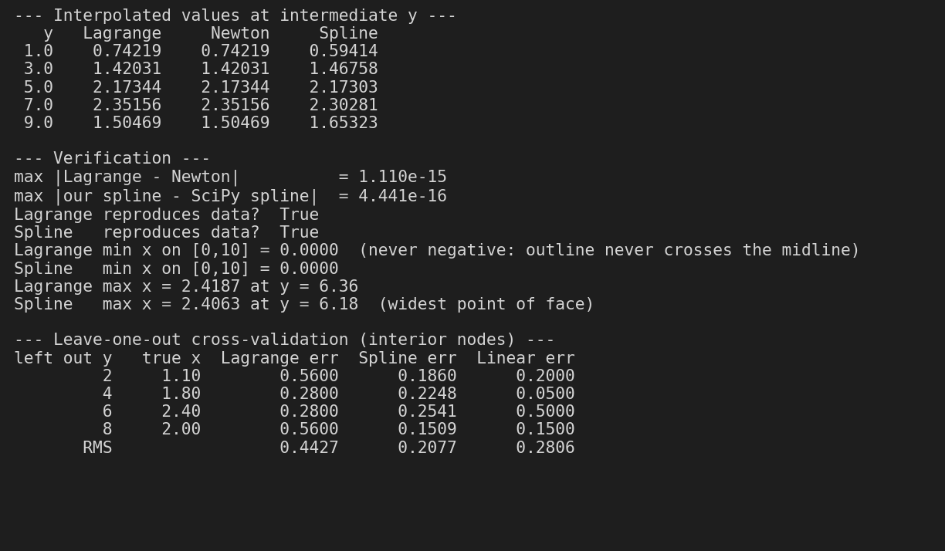
Figure 3: Console output, part 2 (interpolated values, verification, cross-validation).

7.2 Interpolated values at intermediate heights
y | Lagrange | Newton | Cubic spline
1 | 0.74219 | 0.74219 | 0.59414
3 | 1.42031 | 1.42031 | 1.46758
5 | 2.17344 | 2.17344 | 2.17303
7 | 2.35156 | 2.35156 | 2.30281
9 | 1.50469 | 1.50469 | 1.65323
Table 1: Estimated half-width x at the mid-points between nodes.
Lagrange and Newton agree to about 1e-15 (rounding error only), confirming that both construct the same unique degree-5 polynomial. Our hand-written spline agrees with SciPy's CubicSpline to about 4e-16, confirming the implementation is correct. All methods reproduce the six given data points exactly.

7.3 Reconstructed left half-outline
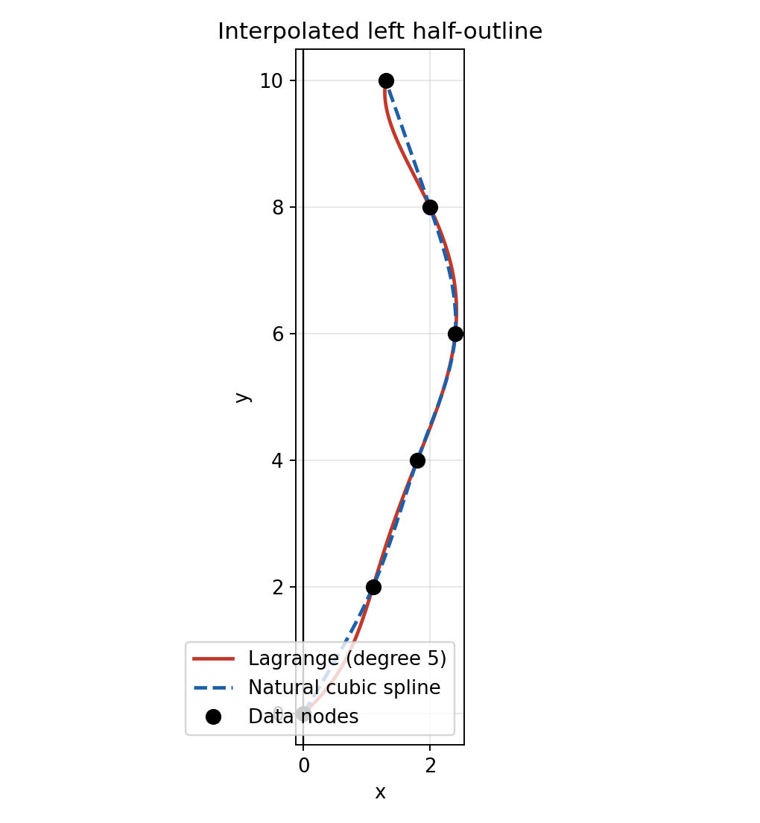
Figure 4: Left half-outline from Lagrange (solid red) and natural cubic spline (dashed blue).
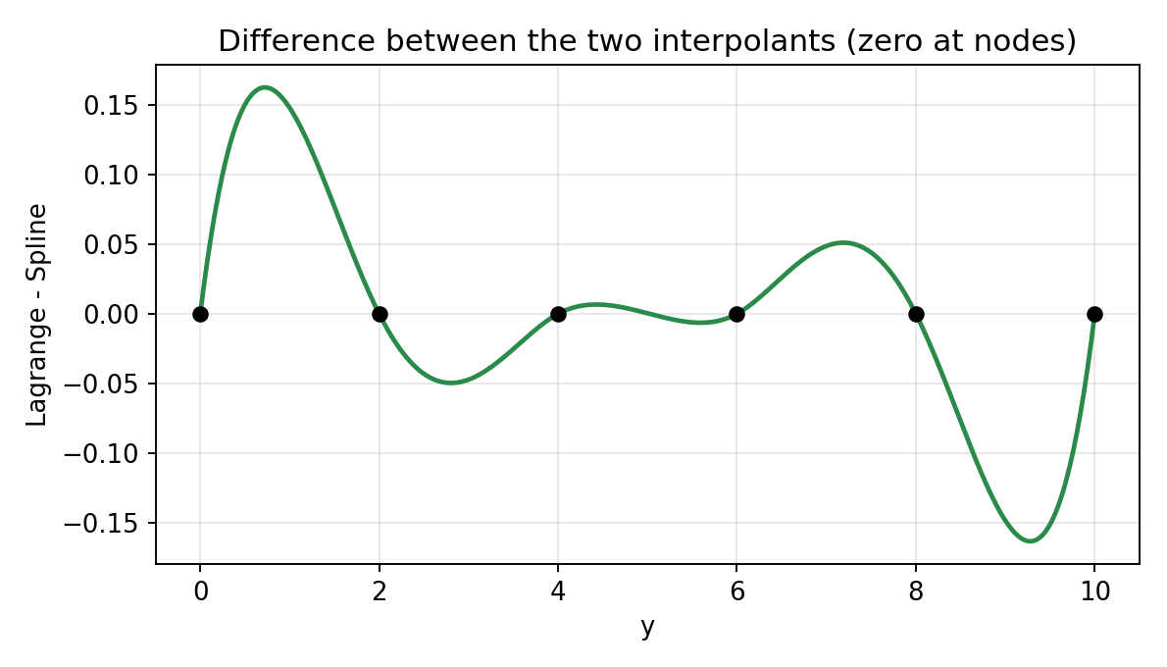
Figure 5: Lagrange minus spline. The two curves agree at the nodes and differ most near the chin (y between 0 and 2) and near the top (y between 8 and 10).

7.4 Mirror image and complete face
Because the face is symmetric about x = 0, the right half is obtained by negating the x values of the left half. The complete outline is the union of both halves.
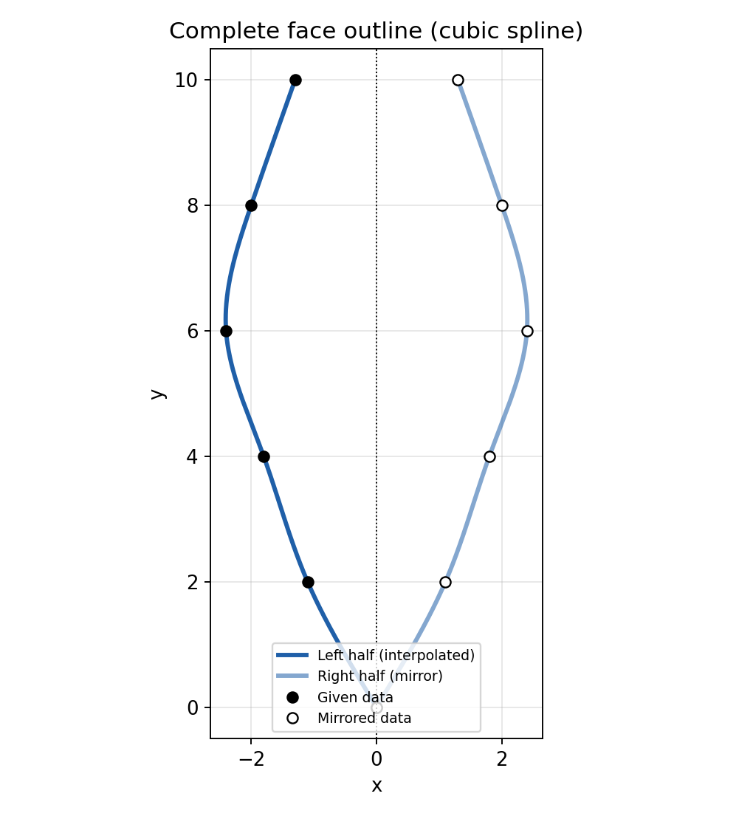
Figure 6: Complete face outline using the cubic spline (left = interpolated, right = mirror).
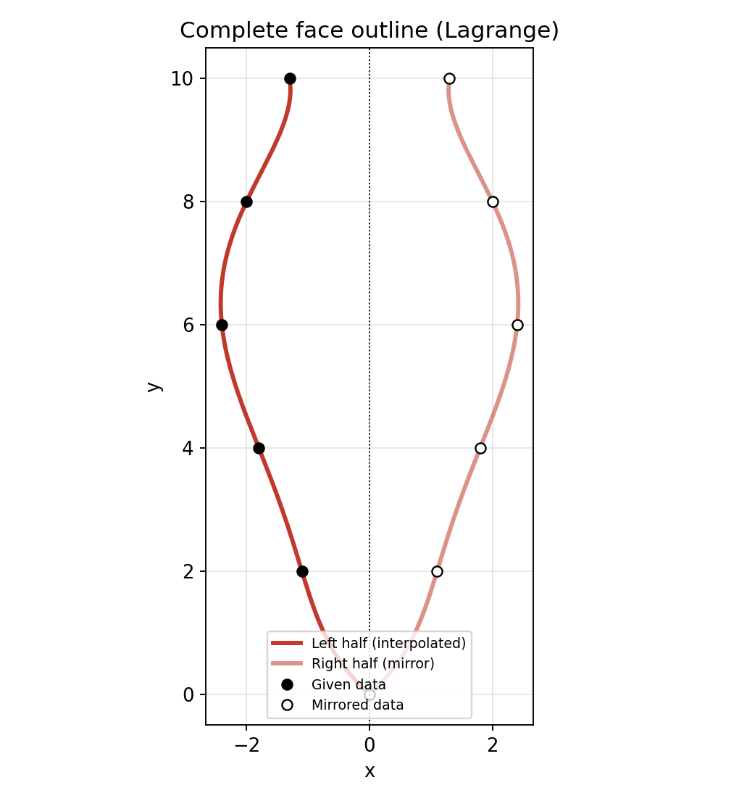
Figure 7: Complete face outline using Lagrange interpolation.
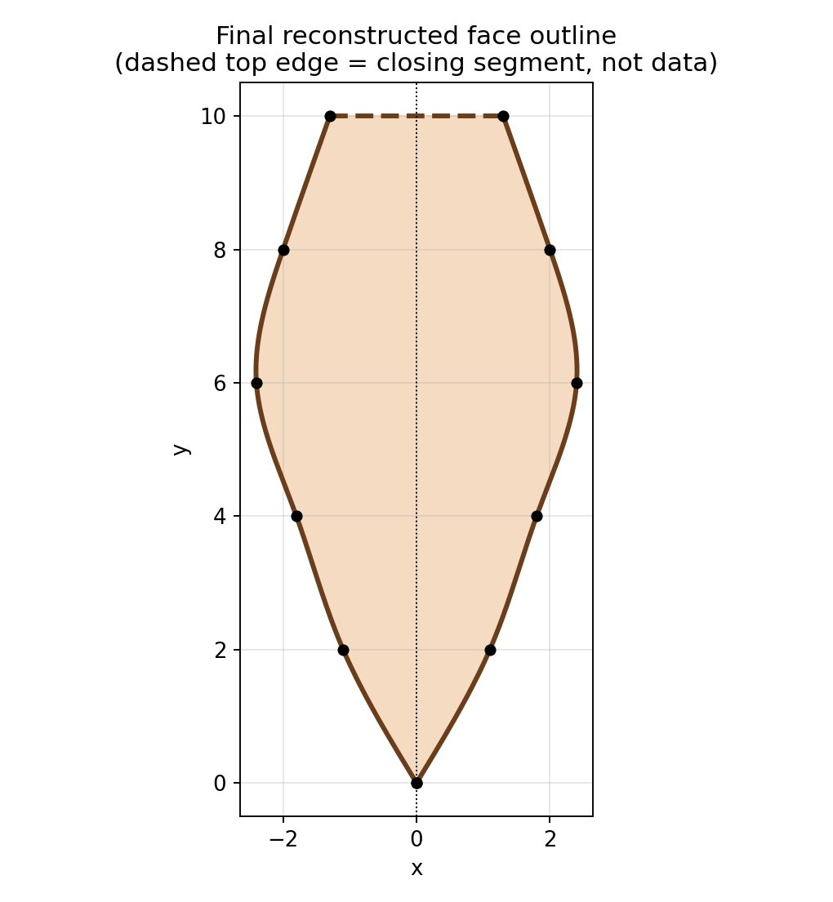
Figure 8: Final reconstructed face (spline). The dashed top edge is only a closing segment added for display; it is not part of the data.

7.5 Comparison of methods
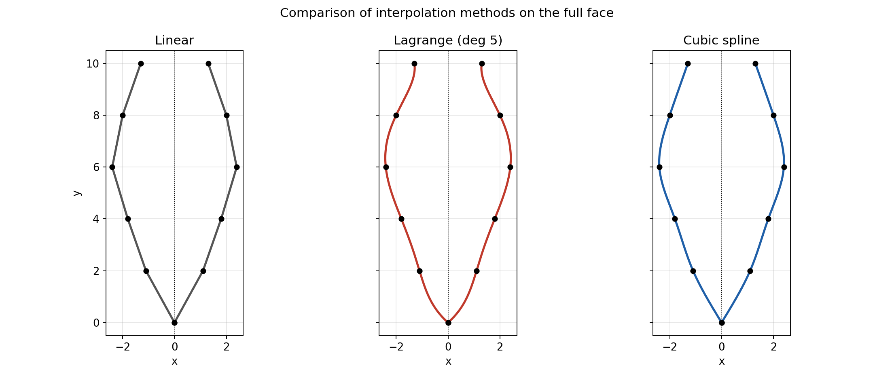
Figure 9: Linear, Lagrange (degree 5) and cubic spline reconstructions side by side.
Leave-one-out cross-validation: each interior data point was removed in turn, estimated from the remaining points by each method, and compared with its true value.
Point left out (y) | Lagrange error | Spline error | Linear error
2 | 0.5600 | 0.1860 | 0.2000
4 | 0.2800 | 0.2248 | 0.0500
6 | 0.2800 | 0.2541 | 0.5000
8 | 0.5600 | 0.1509 | 0.1500
RMS | 0.4427 | 0.2077 | 0.2806
Table 2: Leave-one-out errors (smaller is better).

8. Discussion
- Widest point of the face. The spline gives a maximum half-width of about 2.41 at y of about 6.18, so the full face is about 4.8 units wide at cheekbone level. Lagrange gives 2.42 at y of about 6.36.
- Lagrange vs Newton. They are the same polynomial written in two forms; the maximum difference is 1.1e-15.
- Behaviour of the degree-5 polynomial. Fitting a single polynomial through six points gives larger swings between nodes. In Figure 7 the polynomial bulges outward near y = 1 (0.74 versus 0.59 for the spline) and curls in sharply at the top, which is why its leave-one-out error (RMS 0.44) is the worst.
- Why the spline suits this problem. It is built from low-degree pieces with continuous first and second derivatives, so it follows the data locally and gives a smooth outline. It has the lowest leave-one-out RMS error (0.21).
- Linear interpolation. It is simple and never overshoots, but it gives visible corners at every node, which look unnatural for a face (Figure 9).
- Chin point. Natural boundary conditions make the spline have zero curvature at the chin and the top. Real chins are rounded, so a clamped spline (with a specified slope) or a symmetric extension could be used if the end shapes matter.
- Limitations. The data stop at y = 10, so the top of the head is not recovered; the dashed edge in Figure 8 is only a visual closing line. Six samples are also a coarse description of a real face; the reconstructed curve is an estimate, not the original outline.

9. Conclusion
The corrupted half-outline of the face was reconstructed using three interpolation methods implemented from scratch in Python. Lagrange and Newton interpolation gave identical degree-5 polynomials, while the natural cubic spline gave a smoother and more stable curve with the lowest cross-validation error. The right half was obtained by mirroring the left half across the midline (x → −x), and the complete symmetric face outline was plotted. The lab shows how a real-world graphics problem (repairing a corrupted shape) can be formulated as a numerical interpolation task, and why the choice of interpolation method matters for the quality of the result.

10. Review Questions
Q1. Why is x interpolated as a function of y rather than y as a function of x? Because the face outline is single-valued in y (one half-width per height) but not in x: the same x occurs on both the jaw and the forehead.
Q2. Why must Lagrange and Newton agree? The interpolating polynomial of degree at most n through n + 1 distinct points is unique; the two methods only write it in different bases.
Q3. What is Runge's phenomenon? Oscillation of a high-degree interpolating polynomial between nodes, especially near the ends of the interval; splines avoid it by using low-degree pieces.
Q4. What does the natural boundary condition mean? S″ = 0 at the first and last node, so the curve is straight-ending (no curvature) at the end points.
Q5. How is the right half generated? By symmetry: (x, y) → (−x, y), a reflection across the vertical midline x = 0.

