AI TRADE
Signal & Execution Design Document
Phase 2 - turning a macro shortlist into a controlled trade lifecycle | Version 0.3
Document status | Living design document. Strategy 01 is defined for implementation and backtest; it is not live-trading approval.
Relationship to Phase 1 | Phase 1 provides macro context and a shortlist; this document defines the technical signal, risk, execution, and learning layer.
Current scope | Strategy 01 on SPY through IBKR paper. Backtest and shadow mode precede all order submission.

Core design decision: Phase 2 is not separate from Phase 1; it is the next decision layer. Macro tells us which environments and candidates deserve attention. Phase 2 turns a candidate into a testable trade plan and only then, after risk checks, an executable order.

Contents
- 1. From macro shortlist to trade lifecycle
- 2. Decision layers and handoff rules
- 3. Signal contract: what a valid trade must contain
- 4. Operating modes and safety gates
- 5. Initial design decisions and next step
- 6. Strategy 01 - Bill Williams Alligator + Heikin Ashi + RRMS
- 7. Trading automation maturity model

1. From Macro Shortlist to Trade Lifecycle

Purpose of this chapter
This chapter establishes the first design boundary for the AI Trade project. It explains how the Phase 1 Macro Dashboard and Phase 2 trading system work together, what each layer is responsible for, and how a trade should travel from idea to measurement. It is intentionally a design document, not yet a product specification or live-trading authorization.

The handoff
Phase 1 has already narrowed the opportunity space: the macro regime, preferred sectors, risk appetite, and a shortlist of US stocks provide context. That work is necessary, but it does not yet answer the trading questions that determine whether capital should be put at risk today.
Phase 2 begins when a shortlisted asset is assessed by an explicit strategy. The strategy needs technical entry and exit rules, a defined invalidation point, position-sizing logic, and an objective way to evaluate the result after the trade closes.

What each phase owns
Layer | Primary question | Output
Phase 1: Macro | Where should attention go? | Regime, risk stance, preferred sectors/themes, and a candidate shortlist.
Phase 2A: Setup | Is there a tradable technical setup? | A rule-based setup with market, timeframe, conditions, and expiry.
Phase 2B: Signal | Should we enter now, and on what terms? | Entry, stop, target/exit logic, expected reward-to-risk, and confidence.
Phase 2C: Risk + execution | May this intent become an order? | Approved/rejected intent, permitted size, venue order, and verified fill.
Track + improve | Did reality match the thesis and simulation? | Trade record, post-trade review, strategy scorecard, and version decision.

Lifecycle visual
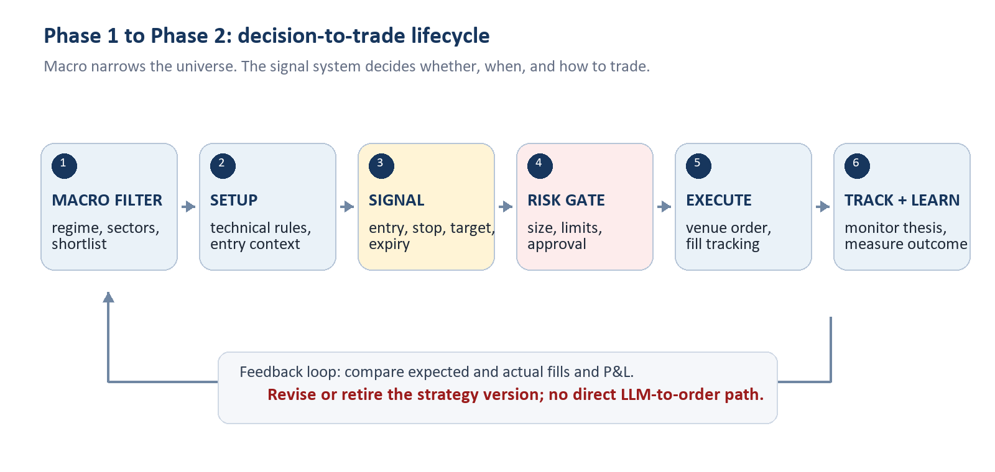
Figure 1. The strategy loop is closed only when real outcomes feed back into the next version of the strategy.

2. Decision Layers and Handoff Rules
The system should preserve a clear separation between deciding, approving, and doing. This prevents a promising chart or an AI-generated explanation from bypassing risk control.
1. Macro context. Optional filter: market regime, sector preference, and event risk determine whether a setup is allowed or should be treated cautiously.
2. Strategy setup. Deterministic technical criteria identify the market, timeframe, and conditions that qualify a candidate for a possible trade.
3. Signal. A qualifying setup becomes an intent only when the defined trigger occurs. The signal contains no discretionary gaps.
4. Risk gateway. Checks permitted market, capital allocation, maximum loss, leverage, existing exposure, trading hours, and daily stop rules.
5. Execution adapter. Maps an approved intent to venue-specific order instructions and records acknowledgements, partial fills, rejections, and cancellations.
6. Tracking and review. Reconciles broker truth with internal records and measures the result against the strategy's expected behavior.

3. Signal Contract: What a Valid Trade Must Contain
A signal is a structured trade proposal, not a vague direction such as 'buy Tesla.' Before it can reach the risk gateway, it must provide the following fields.
Field | Required meaning
Identity | Strategy version, venue, symbol, timeframe, and a unique signal ID.
Why now | Exact setup and trigger conditions that fired; macro context may be attached as a filter, not invented after entry.
Entry | Order side, allowed entry price/range, order type, and time-to-live.
Invalidation | Stop-loss or condition that proves the thesis wrong and ends the trade.
Exit plan | Profit target, trailing or time-based exit, and rules for partial exits if used.
Risk | Maximum loss, proposed position size, leverage if applicable, and expected fees/funding assumptions.
Audit | Data timestamp, model/configuration version, and every later state transition.

Non-negotiable rule: An LLM can help explain, test ideas, or summarize context. It does not submit an order. Only an explicit strategy intent that passes the risk gateway may reach an execution adapter.

4. Operating Modes and Safety Gates
The same strategy should advance through explicit modes. Promotion is deliberate; it never happens simply because a backtest looks attractive.
Mode | What runs | Gate to leave the mode
Backtest | Historical data and simulated orders. | Reproducible report with realistic costs and an untouched out-of-sample period.
Shadow | Live data; hypothetical trades only. | Signals, timing, and health checks behave as specified for a meaningful observation period.
Paper | Orders sent only to a paper environment. | Order states, restarts, fills, and balances reconcile with the venue.
Limited live | Small, constrained real orders. | Explicit user authorization, limits configured, alerts working, and manual kill switch tested.

5. Initial Design Decisions and Next Step

Decisions made in this chapter
- Phase 1 and Phase 2 overlap by design: the macro layer filters the universe; it does not replace a technical strategy.
- The current project owns signal generation, backtesting, risk controls, broker/exchange adapters, reconciliation, monitoring, and strategy improvement.
- The initial release focuses on a single small experiment rather than a multi-strategy dashboard or unrestricted live trading.
- Broker/exchange records are the source of truth for positions, balances, orders, and fills.
- Any strategy change creates a new version that must repeat backtest, shadow, and paper validation before live use.

Next design step
Define the first experiment in a one-page strategy brief. The brief must choose one venue, one market, one timeframe, one fully rule-based setup, and the costs/limits that a realistic backtest must include. That brief becomes the input to the data-collection and backtesting work.
First experiment selected: Strategy 01 will be developed on SPY with IBKR paper trading. MEXC spot and futures remain later extensions after the core cycle has been proven.

6. Strategy 01 - Bill Williams Alligator + Heikin Ashi + RRMS
Implementation status: This is the first strategy selected for implementation. Its first use is a historical backtest, then shadow mode, then IBKR paper trading. It is not approved for live trading.

6.1 Strategy objective and scope
Strategy 01 is an intraday trend-following system for the S&P 500 using the SPY ETF as the initial executable instrument. The Macro Dashboard is the context layer: it determines whether S&P 500 trades are allowed. The 1-hour chart confirms trend direction, and the 15-minute chart determines the setup and entry.
Design item | Decision
Strategy name | Strategy 01 - Bill Williams Alligator + Heikin Ashi + RRMS
Market | S&P 500, initially executed as SPY through IBKR paper trading. A continuous S&P chart may be used for research only; it is not an executable contract.
Macro filter | S&P 500 trading is allowed only when the Phase 1 macro stance permits it.
Trend confirmation | 1-hour chart
Entry timeframe | 15-minute chart
Direction | Long and short rules are defined symmetrically; the initial backtest will report their results separately.
Initial reward model | 1R target: target distance equals the actual entry-to-stop distance. This is provisional and must be tested.

6.2 Indicator definitions and no-lookahead rule
The Alligator uses three smoothed moving averages of median price, where median price is (high + low) / 2. The Jaw is a 13-period smoothed moving average displayed 8 bars forward; Teeth is an 8-period average displayed 5 bars forward; Lips is a 5-period average displayed 3 bars forward. Heikin Ashi candles are used to reduce visual noise in the entry signal.
Backtest integrity: Forward offsets are display offsets only. The implementation must never use candles that did not exist at the decision time. Every 1-hour and 15-minute rule is evaluated only from completed data available at that time.

6.3 Trade rules
Rule | Long | Short
Macro | Macro stance permits the trade. | Macro stance permits the trade.
1-hour confirmation | Lips above Teeth above Jaw; all three rise; mouth is open rather than compressed. | Lips below Teeth below Jaw; all three fall; mouth is open rather than compressed.
15-minute setup | Same bullish line order and open-mouth condition. | Same bearish line order and open-mouth condition.
Trigger | Completed Heikin Ashi candle body closes above Lips. | Completed Heikin Ashi candle body closes below Lips.
Entry | Next 15-minute candle open after the trigger. | Next 15-minute candle open after the trigger.
Stop | Below the 15-minute Jaw plus a small configured buffer. | Above the 15-minute Jaw plus a small configured buffer.
Target | Entry + 1R, where R is the actual entry-to-stop distance. | Entry - 1R, where R is the actual entry-to-stop distance.
Trend exit | A confirmed opposite setup or an Alligator mouth-closing rule, to be tested alongside the fixed target. | A confirmed opposite setup or an Alligator mouth-closing rule, to be tested alongside the fixed target.

Parameter still to formalize: 'Mouth open' and 'parallel' are visual concepts. Before coding, the strategy brief will set numerical thresholds for line separation, slope, and whether separation must be widening. No discretionary chart reading will be used in the backtest.

6.4 RRMS position-sizing overlay
RRMS is separate from the entry logic. The Alligator and Heikin Ashi rules determine whether a trade exists and the Jaw determines its stop. RRMS determines the maximum account loss and converts that loss budget into position size.
State | Risk of account equity | Purpose | If stop-loss hits
Normal | 0.15% | First trade / reset tier | Move to Recovery 1
Recovery 1 | 0.35% | After one stop-loss | Move to Recovery 2
Recovery 2 | 0.70% | After two consecutive stop-losses | Move to Recovery 3
Recovery 3 | 1.50% | After three consecutive stop-losses | Stop trading and require review

Sizing formula
Risk dollars = current account equity x RRMS tier percentage
Risk per unit = absolute value of (planned entry price - stop price)
Quantity = floor(risk dollars / risk per unit), limited by available buying power and venue minimum size.

- A profitable closed trade resets RRMS to the Normal 0.15% tier.
- RRMS advances only after a stop-loss event. A break-even or other discretionary exit does not advance the tier and is flagged for review.
- After four consecutive stop-losses, the system blocks new Strategy 01 entries until a manual review. It does not continue increasing position size.
- The backtest will report strategy results with fixed sizing and with RRMS separately. RRMS must not hide whether the entry strategy itself has an edge.

6.5 Implementation sequence
- Collect and validate SPY 1-hour and 15-minute historical bars.
- Implement Heikin Ashi and no-lookahead Alligator calculations.
- Define numerical open-mouth, parallel-slope, Jaw-buffer, and trading-hours parameters.
- Backtest the entry strategy with fixed sizing first, then apply the RRMS overlay as a separate result series.
- Run shadow mode on live data before IBKR paper orders are considered.

7. Trading Automation Maturity Model
Algo trading is the use of programmed rules to make trading decisions and/or execute them. Order types such as market, limit, stop-loss, and take-profit are broker instructions; the algorithm is the decision and risk logic that determines whether, when, and how those instructions are used.

7.1 Four levels of automation
Level | Decision owner | SPY Alligator example
1. Order automation | Trader | The trader identifies a setup. A position sizer calculates quantity from permitted account risk and the selected stop, then prepares or submits an entry with its protective stop and 1R target.
2. Signal automation | Strategy + trader approval | The system detects the 1h, 15m, and 5m alignment, applies time and risk gates, and records or alerts a complete proposed trade. The trader decides whether to approve it.
3. Rule-based execution | Strategy | After the same checks, the system independently sends and manages the bracket order, records fills and errors, and applies defined exit rules. Human intervention is still available through a kill switch.
4. Systematic portfolio system | Portfolio-level rules | Several validated strategies and instruments share capital. The system controls total risk and correlation, monitors real-versus-expected performance, pauses degradation, and promotes only validated strategy versions.

7.2 Position Sizer classification
The MetaTrader Position Sizer used in the course is Level 1 order automation when it takes the trader's chosen entry and stop, calculates position size from a risk amount or percentage, derives the take-profit from the chosen reward/risk ratio, and creates the ready-to-send order. The trader still chooses the trade. If a tool only displays the calculation and does not create an order ticket, it is a risk calculator rather than order automation.
For this project, the first safe execution milestone is a broker-neutral position-sizing and bracket-order preview. It must remain manual-confirmation only. This is distinct from and comes before any automated order submission.

7.3 Current project position and promotion path
The project currently has components of Level 2: read-only IBKR data, locally cached historical bars, deterministic Alligator strategies, backtests, saved reports/visuals, and a time-gated shadow-signal process. It intentionally has no broker-order permission.
- Next: add a manual position-sizing and bracket preview; no order is transmitted until the trader explicitly confirms it.
- Then: connect the preview to IBKR paper trading, with reconciliation, protective-order handling, daily loss limits, alerts, and a manual kill switch.
- Later: consider rule-based execution only after a strategy has passed long out-of-sample tests, realistic cost/slippage tests, Monte Carlo stress tests, and sustained shadow and paper evidence.
- A multi-strategy portfolio system is a future architecture stage, not a prerequisite for validating Strategy 01.

