AI TRADE
Signal & Execution Design Document
Phase 2 - turning a macro shortlist into a controlled trade lifecycle
Document status | Living design document. First chapter drafted before strategy implementation.
Relationship to Phase 1 | Phase 1 provides macro context and a shortlist; this document defines the technical signal, risk, execution, and learning layer.
Current scope | One strategy, one market, backtest first. No live trade permissions or order submission in this phase.

Core design decision: Phase 2 is not separate from Phase 1; it is the next decision layer. Macro tells us which environments and candidates deserve attention. Phase 2 turns a candidate into a testable trade plan and only then, after risk checks, an executable order.

Contents
- 1. From macro shortlist to trade lifecycle
- 2. Decision layers and handoff rules
- 3. Signal contract: what a valid trade must contain
- 4. Operating modes and safety gates
- 5. Initial design decisions and next step

1. From Macro Shortlist to Trade Lifecycle

Purpose of this chapter
This chapter establishes the first design boundary for the AI Trade project. It explains how the Phase 1 Macro Dashboard and Phase 2 trading system work together, what each layer is responsible for, and how a trade should travel from idea to measurement. It is intentionally a design document, not yet a product specification or live-trading authorization.

The handoff
Phase 1 has already narrowed the opportunity space: the macro regime, preferred sectors, risk appetite, and a shortlist of US stocks provide context. That work is necessary, but it does not yet answer the trading questions that determine whether capital should be put at risk today.
Phase 2 begins when a shortlisted asset is assessed by an explicit strategy. The strategy needs technical entry and exit rules, a defined invalidation point, position-sizing logic, and an objective way to evaluate the result after the trade closes.

What each phase owns
Layer | Primary question | Output
Phase 1: Macro | Where should attention go? | Regime, risk stance, preferred sectors/themes, and a candidate shortlist.
Phase 2A: Setup | Is there a tradable technical setup? | A rule-based setup with market, timeframe, conditions, and expiry.
Phase 2B: Signal | Should we enter now, and on what terms? | Entry, stop, target/exit logic, expected reward-to-risk, and confidence.
Phase 2C: Risk + execution | May this intent become an order? | Approved/rejected intent, permitted size, venue order, and verified fill.
Track + improve | Did reality match the thesis and simulation? | Trade record, post-trade review, strategy scorecard, and version decision.

Lifecycle visual
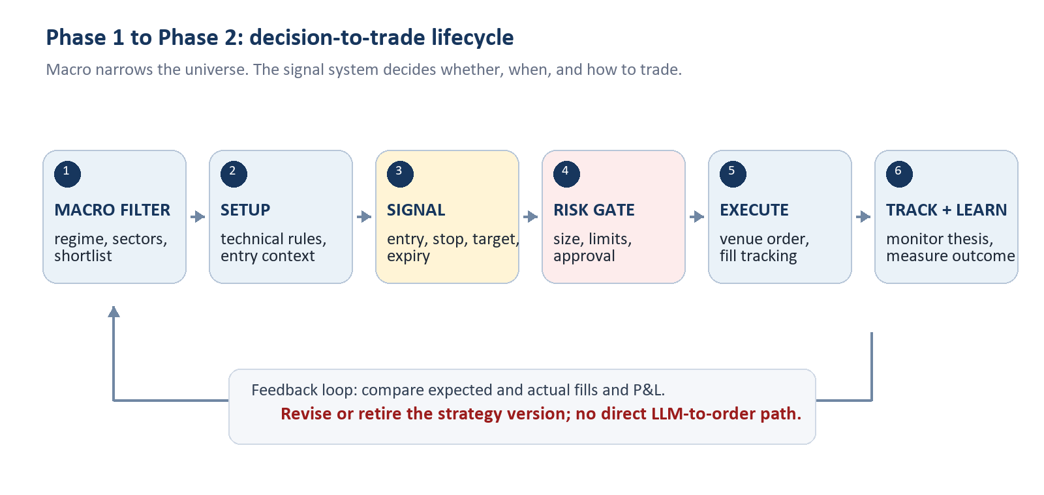
Figure 1. The strategy loop is closed only when real outcomes feed back into the next version of the strategy.

2. Decision Layers and Handoff Rules
The system should preserve a clear separation between deciding, approving, and doing. This prevents a promising chart or an AI-generated explanation from bypassing risk control.
1. Macro context. Optional filter: market regime, sector preference, and event risk determine whether a setup is allowed or should be treated cautiously.
2. Strategy setup. Deterministic technical criteria identify the market, timeframe, and conditions that qualify a candidate for a possible trade.
3. Signal. A qualifying setup becomes an intent only when the defined trigger occurs. The signal contains no discretionary gaps.
4. Risk gateway. Checks permitted market, capital allocation, maximum loss, leverage, existing exposure, trading hours, and daily stop rules.
5. Execution adapter. Maps an approved intent to venue-specific order instructions and records acknowledgements, partial fills, rejections, and cancellations.
6. Tracking and review. Reconciles broker truth with internal records and measures the result against the strategy's expected behavior.

3. Signal Contract: What a Valid Trade Must Contain
A signal is a structured trade proposal, not a vague direction such as 'buy Tesla.' Before it can reach the risk gateway, it must provide the following fields.
Field | Required meaning
Identity | Strategy version, venue, symbol, timeframe, and a unique signal ID.
Why now | Exact setup and trigger conditions that fired; macro context may be attached as a filter, not invented after entry.
Entry | Order side, allowed entry price/range, order type, and time-to-live.
Invalidation | Stop-loss or condition that proves the thesis wrong and ends the trade.
Exit plan | Profit target, trailing or time-based exit, and rules for partial exits if used.
Risk | Maximum loss, proposed position size, leverage if applicable, and expected fees/funding assumptions.
Audit | Data timestamp, model/configuration version, and every later state transition.

Non-negotiable rule: An LLM can help explain, test ideas, or summarize context. It does not submit an order. Only an explicit strategy intent that passes the risk gateway may reach an execution adapter.

4. Operating Modes and Safety Gates
The same strategy should advance through explicit modes. Promotion is deliberate; it never happens simply because a backtest looks attractive.
Mode | What runs | Gate to leave the mode
Backtest | Historical data and simulated orders. | Reproducible report with realistic costs and an untouched out-of-sample period.
Shadow | Live data; hypothetical trades only. | Signals, timing, and health checks behave as specified for a meaningful observation period.
Paper | Orders sent only to a paper environment. | Order states, restarts, fills, and balances reconcile with the venue.
Limited live | Small, constrained real orders. | Explicit user authorization, limits configured, alerts working, and manual kill switch tested.

5. Initial Design Decisions and Next Step

Decisions made in this chapter
- Phase 1 and Phase 2 overlap by design: the macro layer filters the universe; it does not replace a technical strategy.
- The current project owns signal generation, backtesting, risk controls, broker/exchange adapters, reconciliation, monitoring, and strategy improvement.
- The initial release focuses on a single small experiment rather than a multi-strategy dashboard or unrestricted live trading.
- Broker/exchange records are the source of truth for positions, balances, orders, and fills.
- Any strategy change creates a new version that must repeat backtest, shadow, and paper validation before live use.

Next design step
Define the first experiment in a one-page strategy brief. The brief must choose one venue, one market, one timeframe, one fully rule-based setup, and the costs/limits that a realistic backtest must include. That brief becomes the input to the data-collection and backtesting work.
Open design question: Should the first experiment be MEXC spot (simpler operational risk) or MEXC futures (closer to the user's current history but requiring funding, leverage, and liquidation assumptions)?

