# Chapter 2: Analysis

# 2.1 Introduction

Analysis emphasizes an investigation of the problem and requirements, rather than a solution. Analysis is a broad term, best qualifies, as in requirements analysis (an investigation of the requirements) or object-oriented analysis (an investigation of the domain object). It is an interpretive process that draws conclusions from a set of facts.

# 2.2 Analysis Methodology

Analysis Methodology gives you both in-depth knowledge and best practices. It is organized by analytical function. There are many methodology presented in today world. Here we going to use hard system methodology in restaurant management system.

Hard system methodology is an approach to real-world problems in which an objective or end-to-be-achieved can be taken as given. It assume that the problems associated with such systems are well-defined. It can be used to optimize aspects of the solutions that’s why I have choose to use this methodology.

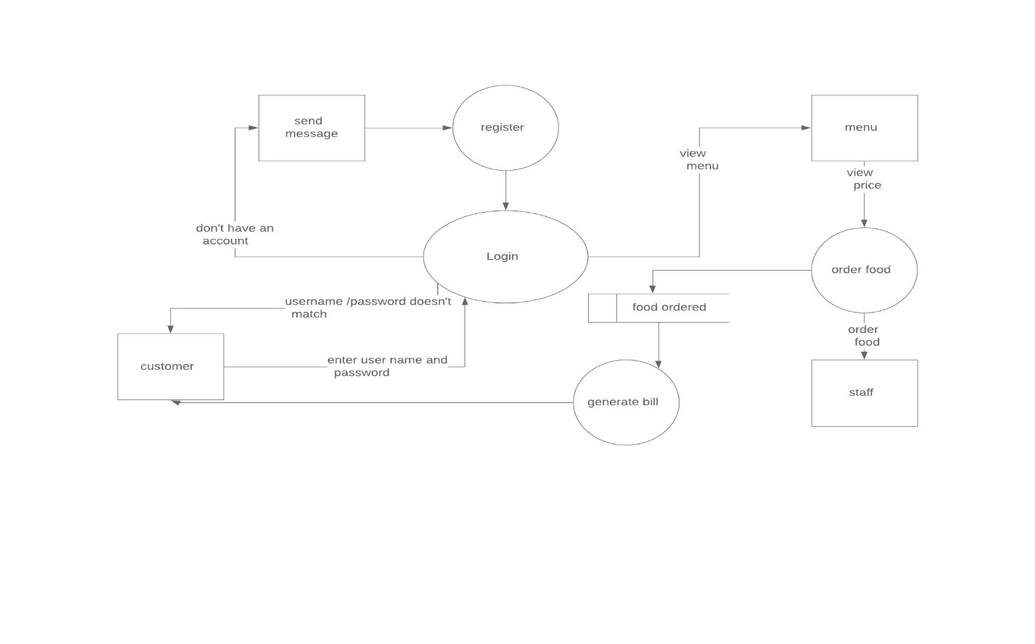

## 2.2.1 Information gathering technique:

* Interview

Interview of the users and stakeholders are important for creating a better software. Without having any information regarding the expectation and goal of the stakeholders and users, then there are chances of satiate them. While developing the software we have to understand the perspective of the people we have interview so that we can do it in proper address and weigh their inputs.

* Observation

The observation convers the study of users in it natural habitat. By watching users, a process flow, pain points, awkward steps and opportunities can be determined by an analyst for improvement. It can either be passive or active.

* Survey

Gathering information from different and many people and interview with time constraints and less budget: a questionnaire survey can be used. The survey tells users to choose between the given options like agree/disagree or sometimes rating is also available. Survey cannot we made by one person but one can add meaningful insight in it.

# 2.3 Feasibility Study

A feasibility study is an analysis that takes a project’s relevant factors into account including economic, technical, legal, and scheduling considerations to ascertain the likelihood of completing the project successfully. It is initial design stage of any project, which brings together the elements of knowledge that indicate if a project is possible or not. It is used to determine if it is practical or not. There are some sectors in the feasibility study which are mentioned below:

* Technical Feasibility

It is one of the most important criteria for selecting material for digitization. The physical characteristics of source material and the project goals for capturing, presenting and storing the digital surrogates dictate the technical requirements.

* Economic Feasibility

It is the most commonly used method for determining the efficiency of a new project. It is also known as cost analysis. Helps in identifying profit against investment expected from a project. The essential factors involved in this field of study are cost and time.

* Legal Feasibility

Legal feasibility is the study to know if the proposed project conform the legal and ethical requirements. There are things to consider in legal feasibility and they are privacy, nepotism and accountability. It is to ensure that the project is legally doable.

* Scheduling Feasibility

It is the process of assessing the degree to which the potential time frame and completion dates for all major activities within a project meet organizational deadlines and constraints for affecting change.

* Behavioral Feasibility

It includes how strong the reaction of staff will be towards the development of new system that involves computer’s use in their daily work. So resistant to change is identified.

# 2.4 Software Requirement specification:

Requirement Analysis is the process of defining the expectations of the user for an application that is to be built or modified. It is team effort that demands a combination of hardware, software and human factors engineering expertise as well as skills in dealing with people. It also involves all the tasks that are conducted to identify the needs of different stakeholders. The requirement analysis means to analyze, documents, validate and manage system requirements.

## 2.4.1Functional Requirements:

|  |  |  |  |  |
| --- | --- | --- | --- | --- |
| ID | Title | Description | Rational | Dependency |
| FR101 | Registration | Users can create a new account in the system with this function. | To create a new account. | N/A |
| FR102 | Login | Users can login to their account. | To login to their account. | FR101 |
| FR103 | Logout | After log in users can logout from their account. | To logout their account. | FR102 |
| FR104 | Add to stock | Admin can add the available dishes in the restaurant menu. | To let users know about the available dishes | N/A |
| FR105 | Update stock | Admin can update the available dishes in the menu. | To update the dishes on the menu. | FR104 |
| FR106 | Delete stock | Admin can delete a particular dish from the menu if it’s not available. | Delete a particular dish from the menu. | FR105 |
| FR107 | View Orders | Users can see what they have placed the orders of food items and admin can also know what orders have been made. | Makes easier to recheck the orders before confirming it. | N/A |
| FR108 | View Members | Admin can see how many people have made account. | To know about people log in and users information. | N/A |
| FR109 | Search Food items | Users can search food they want rather than going through all the menu. | To make user easier and letting them know about the food is available or not. | N/A |
| FR110 | View Food menu | Users can see the food menu of all the categories they have search of. | To see all the categories of food which available in the restaurant. | FR109 |
| FR111 | Price of the food | Users can also see how much the food is cost. | To make sure that the users knows the cost of food before they make the payment | FR110 |
| FR112 | View according to the categories of food | The menu should be according to the categories where the food is placed. | To make users clear about the food items categories. | N/A |
| FR113 | Edit profile | User sometimes makes mistake and want to change their profile so this helps them. | Being easier for the user to edit their profile anytime and anywhere. |  |
| FR114 | User review | After visiting the restaurant user makes review about the food. | Being a platform for making other users know how actually this place is. | N/A |
| FR115 | Generate Bill | When users place and pay the amount then it should be able to give a bill of their total price by sending it on mail or message | To make them know that the payment have been made. | N/A |
| FR116 | Forget Password | Users forget their password and can’t login into their account. | To recover the password they have forgotten. | N/A |

## 

## Non-functional requirements:

* Performance:

In the system, it should make a utilization of the time, deals with the strength, optimization etc. To make the software work properly performance of the system is very important.

* Security:

Arrangement of strong and high security should be provided which should be for the users. If there is not strong security they the date might be lost and problems will be arise.

* Availability:

The system should be made in such a way that it can be run in every possible platform not only a choice. The system should be available for the users when they want to use it.

* Usability

While making the software it should not only made from one perspective but make it by being a user friendly one so that the user won’t find it difficult to use it and enjoy to use.

* Recoverability

Sometime there might be some problem occurring which might be crush in the system as well as failures so they system should be able to recover it by not missing a single information. They should maintain a proper back up while the time of failures.

* Reliability:

Designing is certainly somehow important part of it but it should be made like it has been designed. If it works as it has been designed then users will be more reliable to the system.

* Supportability

While making a website it should be made as if it fits to every screen sizes of every pcs and mobile phone sizes.

## MoSCoW prioritization:

MoSCoW prioritization, also known as the MoSCoW method or MoSCoW analysis, is a popular prioritization technique for managing requirements. The method is commonly used to help key stakeholders understand the significance of initiatives in a specific release.

**MOSCOW** stands for:

**M: Must have**

**S: Should have**

**C: Could have**

**W: Won’t Have**

|  |  |  |  |
| --- | --- | --- | --- |
| Functional Requirements | Requirements | MoSCoW prioritization | Description to use |
| FR(101) | Registration for customer | M | To know customers info, store customer’s data for business purpose. |
| FR(102) | Login for admin | M | Admin’s login opens admin dashboard where only admin could access through it. |
| FR(103) | Login for customer | M | Customer’s login allow access to book food items, view description of foods. |
| FR(104) | Add to stock | M | Stocks are added by admins, admin should add the all the stock available. |
| FR(105) | Update stock | M | Details of food items might get changed in some aspect like price or other specification which should be changed. |
| FR(106) | Delete stock | C | Stocks which are not more available on the stocks should be deleted or sometimes wrong information might be added. |
| FR(107) | View order | C | User could view what they have place order (User), also for (admins) they should know what the orders are so far. |
| FR(108) | View members | C | Admins could view the joined members in the restaurant website to retrieve the user’s info. |
| FR(109) | Search for Food items | M | For the customer’s they must search the dish they want to have. |
| FR(110) | View Food Menu | C | Many list of food items are available in the website so that customer view through it. |
| FR(111) | Show price of Dish | M | Prices of dish should be viewing to know how much the food costs. |
| FR(112) | View according to Categories of Food | S | Customer may view food according to categories of it. |
| FR(113) | Edit Profile | S | If some changes might be done with profile. |
| FR(114) | User Review | C | Review of user help to improve the restaurant. |
| FR(115) | Generate Bill | M | After ordering food, bills should be given. |
| FR(116) | Forget Password | C | To recover the password. |
| FR(117) | Cancel Order | M | To Cancelling booking. |
| FR(118) | Confirm Order | M | To Confirm your booking. |
| NF(R19) | Logout | M | Logout after you use the site. |

# 2.4.4 Hardware Specification

Restaurant Management system should be able to work with the given below hardware specification:

OS: Windows XP/Vista/7/8 and Linux

CPU: Pentium IIII (700MHz) and above

Memory: 128 MB and above

Capacity: Network interface card, mouse, keyboard and monitor

# 2.4.5 Software Specification

As restaurant management system is an application based on website, internet connection should be connected. The restaurant management system software should be support of MySQL as DBMS.

# 2.5 Use Case Diagram

A use case diagram is a dynamic or behavior diagram in UML. Use case diagrams model the functionality of a system using actors and use cases. Use cases are a set of actions, services, and functions that the system needs to perform. In this context, a "system" is something being developed or operated, such as a web site. The "actors" are people or entities operating under defined roles within the system.

Use case diagrams are valuable for visualizing the functional requirements of a system that will translate into design choices and development priorities. They also help identify any internal or external factors that may influence the system and should be taken into consideration.

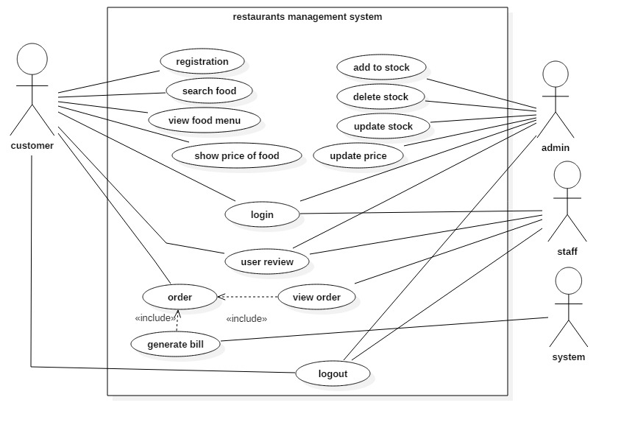

# 2.6 NLA (Natural Language Analysis)

Natural language processing (NLP) is the ability of a computer program to understand human language as it is spoken. NLP is a component of artificial intelligence. It is done for computers to process understand natural language in order to perform tasks like language translation and question answering.

A restaurant needs a system that can manage orders of customers. The system must allow customers, staff and administrator to have an account. Customer must be able to view menu, orders done by them, price of food and also give review. Whereas staff of the restaurant must be able to take orders and view reviews given by customers. And the administrator must be able to add, delete and update stock and it information. The admin should also be able to reviews, order, menus and price of foods. The bill must generate automatically once the order is done by customers.

Separating nouns (class):

Restaurant

Orders

Menu

Order

Price of food

Review

Customers

Staff

Admin

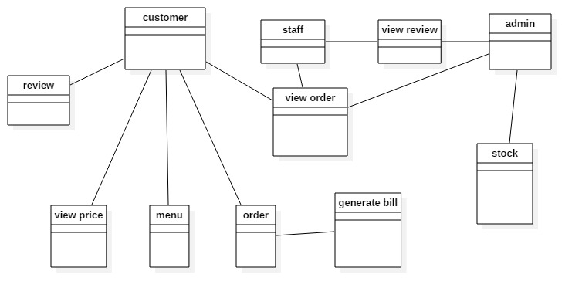

## 3.3 System architecture:

The system architecture is a generic discipline to handle objects called system, in a way that supports reasoning about the structural properties of these objects. The system architecture is a conceptual design that helps to explain a system view, behavior and its structure. I have used a three-tier architecture for this project. Below is the diagram of three tier architecture for better understanding:

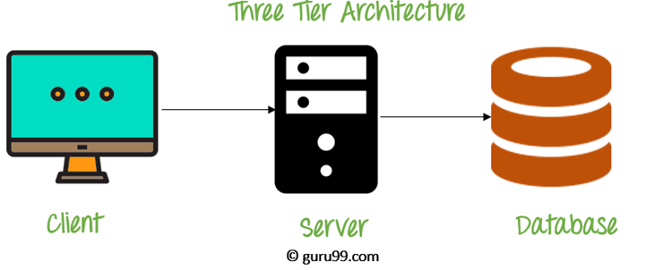

Figure 3 Three Tier Architecture

The three-tier architecture consists of three part:

* Client tier: It is the application clients that access a JAVA EE server and located on a different machine from server.
* Server tier: It is entire application which is distributed across different computing layer.
* Database tier: This is responsible for the database for functional storage, processing, and integrity of data.