# VISVESVARAYA TECHNOLOGICAL UNIVERSITY

### BELAGAVI – 590018, Karnataka INTERNSHIP REPORT

**ON**

“Chatbot for Healthcare System Using AI”

***Submitted in partial fulfilment for the award of degree(21INT68)***

### BACHELOR OF ENGINEERING IN

**Artificial Intelligence and Machine Learning**

***Submitted by: SAMITH CU***

**4AI21AI045**



Conducted at

**COMPSOFT TECHNOLOGIES**



# ADICHUNCHANAGIRI INSTITUTE OF TECHNOLOGY

**Department of AIML Accredited by NBA, New Delhi**

**Jyothi nagara,Chikkamagaluru -577102**

# 

Internship report 2023-24 1

### 

**CERTIFICATE**

This is to certify that the Internship titled **“**Chatbot for Healthcare System Using AI**”** carried out by **Mr.SAMITH CU** a bonafide student of Adichunchanagiri Institute of Technology, in partial fulfillment for the award of **Bachelor of Engineering**, in **AIML** under Visvesvaraya Technological

University, Belagavi, during the year 2022-2023. It is certified that all corrections/suggestions indicated have been incorporated in the report.

The project report has been approved as it satisfies the academic requirements in respect of Internship prescribed for the course Internship / Professional Practice (21INT68)

|  |  |  |
| --- | --- | --- |
| **Signature of Guide** | **Signature of HOD External Viva:** | **Signature of Principal** |
| Name of the Examiner |  | Signature with Date |

1)

2)

# D E C L A R A T I O N

I, **SAMITH CU** , third year student of AIML, ADICHUNCHANAGIRI INSTITUTE OF TECHNOLOGY - 577102, declare that the Internship has been successfully

Internship report 2023-24 2

completed, in **COMPSOFT TECHNOLOGIES**. This report is submitted in partial fulfillment of the requirements for award of Bachelor Degree in AIML, during the academic year 2022-2023.

Date : 04-12-2023 :

Place : Chikkmagaluru

USN : 4AI21AI045

NAME : SAMITH C U

Internship report 2023-24 3

### OFFER LETTER

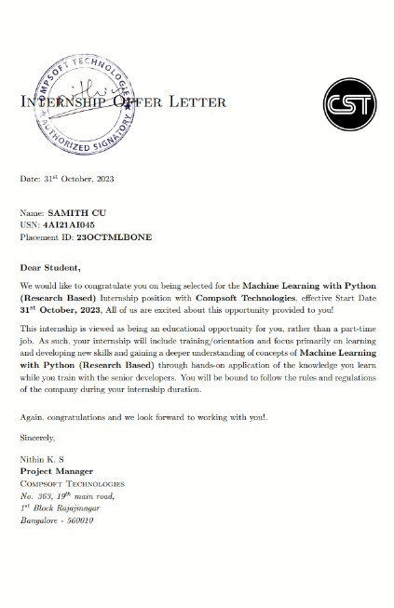

Internship report 2023-24 4

# A C K N O W L E D G E M E N T

This Internship is a result of accumulated guidance, direction and support of several important persons. We take this opportunity to express our gratitude to all who have helped us to complete the Internship.

We express our sincere thanks to our Dr. C T JAYDEV Principal, for providing us adequate facilities to undertake this Internship.

We would like to thank our Dr. SUNITHA M R ,Professor and Head of the Department of AIML, for providing us an opportunity to carry out Internship and for his valuable guidance and support.

We would like to thank our Lab assistant for Software Services for guiding us during the period of internship.

We express our deep and profound gratitude to our guide, Assistant/Associate Prof, for her keen interest and encouragement at every step in completing the Internship.

We would like to thank all the faculty members of our department for the support extended during the course of Internship.

We would like to thank the non-teaching members of our dept, for helping us during the Internship.

Last but not the least, we would like to thank our parents and friends without whose constant help, the completion of Internship would have not been possible.

**NAME:SAMITH CU USN: 4AI21AI045**

# ABSTRACT

This internship report investigates the planning, creation, and deployment of an artificial intelligence (AI) chatbot for healthcare systems. Using AI-driven chatbots offers a creative way to improve patient engagement, deliver timely medical information, and expedite communication between healthcare providers and users in response to the growing demand for effective and accessible healthcare services.

Internship report 2023-24 5

The report starts out by discussing the need for cutting-edge technologies in the healthcare industry and highlighting the advantages of incorporating AI-powered chatbots. The goal of the project is to create a user-friendly chatbot that can comprehend and reply to users' inquiries about their health, provide tailored support, and provide pertinent medical data.

The approach entails a thorough analysis of the body of research on artificial intelligence (AI), natural language processing (NLP), and chatbots used in healthcare. The report goes into the technical aspects of developing chatbots after providing a theoretical framework. It describes how to choose the right technologies, prepare data, and train models.

The chatbot's integration into the healthcare system is covered in implementation details, with a focus on privacy, data security, and regulatory compliance. The usefulness and efficacy of the chatbot are also assessed, and approaches for gathering feedback and conducting user testing are covered. The outcomes highlight the healthcare chatbot's effective implementation, showcasing its capacity to respond to a range of user inquiries, provide medical guidance, and function as a useful instrument for information sharing.

All things considered, this internship report adds to the expanding corpus of information regarding AI applications in healthcare and lays the groundwork for upcoming studies and advancements at the nexus of technology and healthcare services.

Internship report 2023-24 6

# Table of Contents

|  |  |  |
| --- | --- | --- |
| **Sl no** | **Description** | **Page no** |
| 1 | Company Profile | 9 |
| 2 | About the Company | 11 |
| [3](https://1.bp.blogspot.com/-dODuK8N5h1Q/Wlnyb3V9HFI/AAAAAAAACL4/WxQtCJ1pM5wccDABg4wIrTBUB0vlikXQQCLcBGAs/s1600/poly1.jpg) | Introduction | 15 |
| [4](https://1.bp.blogspot.com/-dODuK8N5h1Q/Wlnyb3V9HFI/AAAAAAAACL4/WxQtCJ1pM5wccDABg4wIrTBUB0vlikXQQCLcBGAs/s1600/poly1.jpg) | System Analysis | 17 |
| [5](https://1.bp.blogspot.com/-dODuK8N5h1Q/Wlnyb3V9HFI/AAAAAAAACL4/WxQtCJ1pM5wccDABg4wIrTBUB0vlikXQQCLcBGAs/s1600/poly1.jpg) | Requirement Analysis | 19 |
| 6 | Design [Analysis](https://4.bp.blogspot.com/-IOOxgPaXMVc/Wlj3LWvcnjI/AAAAAAAACKE/UeTFYvAxDmUDel5UBjdifeWaApB3-dXVgCLcBGAs/s1600/img1.jpg) | 20 |
| 7 | [Implementation](https://4.bp.blogspot.com/-IOOxgPaXMVc/Wlj3LWvcnjI/AAAAAAAACKE/UeTFYvAxDmUDel5UBjdifeWaApB3-dXVgCLcBGAs/s1600/img1.jpg) | 26 |
| 8 | Snapshots | 28 |
| 9 | Conclusion | 31 |
| 10 | References | 32 |

Internship report 2023-24 7

|  |  |  |
| --- | --- | --- |
| Internship report | 2023-24 | 8 |

1. **COMPANY PROFILE**

### A Brief History of Compsoft Technologies

Compsoft Technologies, was incorporated with a goal, “To provide high quality and optimal

Technological Solutions to business requirements of our clients”. Every business is a different and has a unique business model and so are the technological requirements. They understand this and hence the solutions provided to these requirements are different as well. They focus on clients requirements and provide them with tailor made technological solutions. They also understand that Reach of their Product to its targeted market or the automation of the existing process into e-client and simple process are the key features that our clients desire from Technological Solution they are looking for and these are the features that we focus on while designing the solutions for their clients.

Sarvamoola Software Services. is a Technology Organization providing solutions for all web design and development, MYSQL, PYTHON Programming, HTML, CSS, ASP.NET and LINQ. Meeting the ever increasing automation requirements, Sarvamoola Software Services. specialize in ERP, Connectivity, SEO Services, Conference Management, effective web promotion and tailor-made software products, designing solutions best suiting clients requirements.

Compsoft Technologies, strive to be the front runner in creativity and innovation in software development through their well-researched expertise and establish it as an out of the box software development company in Bangalore, India. As a software development company, they translate this software development expertise into value for their customers through their professional solutions.

They understand that the best desired output can be achieved only by understanding the clients demand better. Compsoft Technologies work with their clients and help them to defiine their exact solution requirement. Sometimes even they wonder that they have completely redefined

Internship report 2023-24 9

their solution or new application requirement during the brainstorming session, and here they position themselves as an IT solutions consulting group comprising of high caliber consultants.

They believe that Technology when used properly can help any business to scale and achieve new heights of success. It helps Improve its efficiency, profitability, reliability; to put it in one sentence ” Technology helps you to Delight your Customers” and that is what we want to achieve.

# [CHAPTER](https://1.bp.blogspot.com/-dODuK8N5h1Q/Wlnyb3V9HFI/AAAAAAAACL4/WxQtCJ1pM5wccDABg4wIrTBUB0vlikXQQCLcBGAs/s1600/poly1.jpg) [2](https://1.bp.blogspot.com/-dODuK8N5h1Q/Wlnyb3V9HFI/AAAAAAAACL4/WxQtCJ1pM5wccDABg4wIrTBUB0vlikXQQCLcBGAs/s1600/poly1.jpg) ABOUT THE COMPANY

Internship report 2023-24 11

|  |  |  |
| --- | --- | --- |
| Internship report | 2023-24 | 10 |

# ABOUT THE COMPANY

Compsoft Technologies is a Technology Organization providing solutions for all web design and development, MYSQL, PYTHON Programming, HTML, CSS, ASP.NET and LINQ. Meeting the ever increasing automation requirements, Compsoft Technologies specialize in ERP, Connectivity, SEO Services, Conference Management, effective web promotion and tailor-made software products, designing solutions best suiting clients requirements. The organization where they have a right mix of professionals as a stakeholders to help us serve our clients with best of our capability and with at par industry standards. They have young, enthusiastic, passionate and creative Professionals to develop technological innovations in the field of Mobile technologies, Web applications as well as Business and

Enterprise solution. Motto of our organization is to “Collaborate with our clients to provide them with best Technological solution hence creating Good Present and Better Future for our client which will bring a cascading a positive effect in their business shape as well”. Providing a Complete suite of technical solutions is not just our tag line, it is Our Vision for Our Clients and for Us, We strive hard to achieve it.

### Products of Compsoft Technologies.

#### Android Apps

It is the process by which new applications are created for devices running the Android operating system. Applications are usually developed in Java (and/or Kotlin; or other such option) programming language using the Android software development kit (SDK), but other development environments are also available, some such as Kotlin support the exact same Android APIs (and bytecode), while others such as Go have restricted API access.

The Android software development kit includes a comprehensive set of development tools. These include a debugger, libraries, a handset emulator based on QEMU, documentation, sample code, and tutorials. Currently supported development platforms include computers running Linux (any modern desktop Linux distribution), Mac OS X 10.5.8 or later, and Windows 7 or later. As of March 2015, the SDK is not available on Android itself, but software development is possible by using specialized Android applications.

#### Web Application

It is a client–server computer program in which the client (including the user interface and client- side logic) runs in a web browser. Common web applications include web mail, online

Internship report 2023-24 13

retail sales, online auctions, wikis, instant messaging services and many other functions. web applications use web documents written in a standard format such as HTML and JavaScript, which are supported by a variety of web browsers. Web applications can be considered as a specific variant of client–server software where the client software is downloaded to the client machine when visiting the relevant web page, using standard procedures such as HTTP. The Client web software updates may happen each time the web page is visited. During the session, the web browser interprets and displays the pages, and acts as the universal client for any web application. The use of web application frameworks can often reduce the number of errors in a program, both by making the code simpler, and by allowing one team to concentrate on the framework while another focuses on a specified use case. In applications which are exposed to constant hacking attempts on the Internet, security- related problems can be caused by errors in the program.

Frameworks can also promote the use of best practices such as GET after POST. There are some who view a web application as a two-tier architecture. This can be a “smart” client that performs all the work and queries a “dumb” server, or a “dumb” client that relies on a “smart” server. The client would handle the presentation tier, the server would have the database (storage tier), and the business logic (application tier) would be on one of them or on both. While this increases the scalability of the applications and separates the display and the database, it still doesn’t allow for true specialization of layers, so most applications will outgrow this model. An emerging strategy for application software companies is to provide web access to software previously distributed as local applications. Depending on the type of application, it may require the development of an entirely different browser-based interface, or merely adapting an existing application to use different presentation technology. These programs allow the user to pay a monthly or yearly fee for use of a software application without having to install it on a local hard drive. A company which follows this strategy is known as an application service provider (ASP), and ASPs are currently receiving much attention in the software industry.

Security breaches on these kinds of applications are a major concern because it can involve both enterprise information and private customer data. Protecting these assets is an important part of any web application and there are some key operational areas that must be included in the development process. This includes processes for authentication, authorization, asset handling, input, and logging and auditing. Building security into the applications from the beginning can be more effective and less disruptive in the long run.

#### Web design

It is encompassing many different skills and disciplines in the production and maintenance of websites. The different areas of web design include web graphic design; interface design; authoring, including standardized code and proprietary software; user experience design; and

Internship report 2023-24 12

Internship report 2023-24 15

search engine optimization. The term web design is normally used to describe the design process relating to the front-end (client side) design of a website including writing mark up. Web design partially overlaps web engineering in the broader scope of web development. Web designers are expected to have an awareness of usability and if their role involves creating mark up then they are also expected to be up to date with web accessibility guidelines. Web design partially overlaps web engineering in the broader scope of web development.

### Departments and services offered

Compsoft Technologies plays an essential role as an institute, the level of education, development of student’s skills are based on their trainers. If you do not have a good mentor then you may lag in many things from others and that is why we at Compsoft Technologies gives you the facility of skilled employees so that you do not feel unsecured about the academics. Personality development and academic status are some of those things which lie on mentor’s hands. If you are trained well then you can do well in your future and knowing its importance of Compsoft Technologies always tries to give you the best.

They have a great team of skilled mentors who are always ready to direct their trainees in the best possible way they can and to ensure the skills of mentors we held many skill development programs as well so that each and every mentor can develop their own skills with the demands of the companies so that they can prepare a complete packaged trainee.

### Services provided by Compsoft Technologies.

* Core Java and Advanced Java
* Web services and development
* Dot Net Framework
* Python
* Selenium Testing
* Conference / Event Management Service
* Academic Project Guidance
* On The Job Training
* Software Training

# [CHAPTER](https://1.bp.blogspot.com/-dODuK8N5h1Q/Wlnyb3V9HFI/AAAAAAAACL4/WxQtCJ1pM5wccDABg4wIrTBUB0vlikXQQCLcBGAs/s1600/poly1.jpg) [3](https://1.bp.blogspot.com/-dODuK8N5h1Q/Wlnyb3V9HFI/AAAAAAAACL4/WxQtCJ1pM5wccDABg4wIrTBUB0vlikXQQCLcBGAs/s1600/poly1.jpg) INTRODUCTION

Internship report 2023-24 17

|  |  |  |
| --- | --- | --- |
| Internship report | 2023-24 | 14 |

# 3. INTRODUCTION

### Introduction to ML:

A revolutionary area of artificial intelligence called machine learning (ML) enables systems to learn and adapt on their own from data without the need for explicit programming. Leveraging machine learning has become essential for improving decision-making processes, improving patient outcomes, and optimising overall healthcare delivery in the healthcare industry, where massive amounts of data are generated on a daily basis.

Healthcare uses machine learning in a variety of ways, from diagnostics and medical imaging to personalised medicine and predictive analytics. Medical images, including MRIs and X-rays, can be analysed by algorithms, which helps in the early diagnosis of illnesses. Proactive interventions are made possible by predictive models, which help identify people who are at risk of developing particular health conditions. Furthermore, drug discovery, treatment optimisation, and the simplification of administrative procedures in healthcare systems are all facilitated by machine learning algorithms.

Machine learning is important for the healthcare industry because it can identify complex patterns in a variety of datasets and extract insightful information that can guide medical decisions. Machine learning makes it easier to find patterns, correlations, and predictive models by allowing computers to learn from past patient data. This improves diagnosis accuracy and facilitates the creation of individualized treatment programs that are catered to the requirements of each patient.

Machine learning is essential to our project since it will help us create a chatbot for the healthcare system. The integration of machine learning algorithms can enable the chatbot to enhance its comprehension of user inquiries, furnish precise medical data, and proffer tailored health recommendations. The chatbot continuously learns and adjusts as users engage with it, making sure that the support and information it provides is up to date and pertinent

### Problem Statement:

The delivery of effective, individualised, and easily accessible healthcare to a patient population that is becoming more demanding and diverse presents a number of challenges for the healthcare industry. The inefficiency and delay in giving users timely and accurate medical information is one major problem. Patients frequently face obstacles when trying to get access to emergency care, which causes them to put off getting the right medical attention.

Conventional means of communication between users and healthcare providers, like websites and phone lines, can be time-consuming and may not offer instant answers to questions about health.

The creation of an artificial intelligence (AI) chatbot for the healthcare system appears to be a viable way to address these issues. The goal is to develop a conversational, intelligent agent that can comprehend user inquiries, deliver accurate medical information, and make tailored recommendations. By filling in the gaps in healthcare communication, this chatbot promises to provide users with timely and accurate answers to their queries about their health.

Internship report 2023-24 19

# [CHAPTER](https://1.bp.blogspot.com/-dODuK8N5h1Q/Wlnyb3V9HFI/AAAAAAAACL4/WxQtCJ1pM5wccDABg4wIrTBUB0vlikXQQCLcBGAs/s1600/poly1.jpg) [4](https://1.bp.blogspot.com/-dODuK8N5h1Q/Wlnyb3V9HFI/AAAAAAAACL4/WxQtCJ1pM5wccDABg4wIrTBUB0vlikXQQCLcBGAs/s1600/poly1.jpg) SYSTEM ANALYSIS

|  |  |  |
| --- | --- | --- |
| Internship report | 2023-24 | 16 |

**4. SYSTEM ANALYSIS**

### Existing System:

The current state of healthcare communication is based on conventional techniques such as web-based portals and phone consultations. These systems do, however, have certain drawbacks, including limited operating hours, delayed access, and static information delivery. Large datasets on web-based platforms can be overwhelming for users, making it difficult to navigate and find reliable advice. A deficiency of personalization and inconsistent information quality lead to less- than-ideal user experiences.

These constraints necessitate change, opening the door for an adaptable, flexible, and customized answer. These issues are addressed by introducing an artificial intelligence-powered chatbot that provides a personalised healthcare advisor, accurate information delivery, and instant assistance through an interactive interface. This change is in line with how healthcare technologies are developing, which should lead to better user experiences and more efficient provider-to-user communication.

### Proposed System:

The system under consideration aims to create a state-of-the-art healthcare chatbot that is enabled by artificial intelligence and machine learning. Through its ability to respond to user inquiries in real-time, interactively, and individually, this chatbot will completely transform healthcare communication. The chatbot uses machine learning algorithms to comprehend user intent, provide precise medical information, and provide tailored health advice based on each user's unique profile.

Important characteristics include dynamic engagement through interactive conversations, quick access to medical advice, and a dedication to providing accurate and current information. The suggested system promises a smooth and effective channel that promotes user empowerment, engagement, and accessibility to trustworthy healthcare information. It also addresses the

Internship report 2023-24 21

shortcomings of the current healthcare communication environment. The proposed system aims to redefine the user experience in the healthcare industry by integrating cutting-edge technologies.

### Objective of the System

The ultimate goal is to create a user-centric platform that fosters collaboration between users and healthcare providers, promoting an inclusive, adaptive, and accessible healthcare communication ecosystem.

It aims to provide real-time and interactive assistance, ensuring users have immediate access to accurate medical guidance. Privacy and security measures are integral, ensuring the confidentiality of user data and compliance with healthcare privacy regulations.

# [CHAPTER](https://1.bp.blogspot.com/-dODuK8N5h1Q/Wlnyb3V9HFI/AAAAAAAACL4/WxQtCJ1pM5wccDABg4wIrTBUB0vlikXQQCLcBGAs/s1600/poly1.jpg) [5](https://1.bp.blogspot.com/-dODuK8N5h1Q/Wlnyb3V9HFI/AAAAAAAACL4/WxQtCJ1pM5wccDABg4wIrTBUB0vlikXQQCLcBGAs/s1600/poly1.jpg) REQUIREMENT ANALYSIS

Internship report 2023-24 23

|  |  |  |
| --- | --- | --- |
| Internship report | 2023-24 | 18 |

# 5. REQUIREMENT ANALYSIS

### Software Requirement Specification:

* 1. **Programming Language**:

Python: Python is a popular programming language for creating AI and machine learning systems.

### Frameworks for Development:

Rasa: An open-source conversational artificial intelligence framework for creating chatbots that can comprehend natural language.

### Processing of Natural Language (NLP) Libraries:

For processing and comprehending natural language include spaCy and NLTK (Natural Language Toolkit). For this project we specifically use spaCy.

### Machine Learning Libraries:

PyTorch or TensorFlow are well-liked libraries for putting machine learning models into practice. Here we use TensorFlow.

### Version Control and Management:

Git: For version control and collaborative development. pip: For managing Python package dependencies.

### Collaboration Tools:

GitHub or GitLab: Platforms for collaborative development and version control.

* 1. Integration with APIs related to healthcare to obtain medical data or databases.

Internship report 2023-24 25

# [CHAPTER](https://1.bp.blogspot.com/-dODuK8N5h1Q/Wlnyb3V9HFI/AAAAAAAACL4/WxQtCJ1pM5wccDABg4wIrTBUB0vlikXQQCLcBGAs/s1600/poly1.jpg) [6](https://1.bp.blogspot.com/-dODuK8N5h1Q/Wlnyb3V9HFI/AAAAAAAACL4/WxQtCJ1pM5wccDABg4wIrTBUB0vlikXQQCLcBGAs/s1600/poly1.jpg) DESIGN & ANALYSIS

|  |  |  |
| --- | --- | --- |
| Internship report | 2023-24 | 20 |

**6. DESIGN & ANALYSIS**

## System Architecture:

The healthcare chatbot system is carefully designed to allow for the seamless integration of components necessary for an effective conversational interface. The architecture is based on the Rasa framework, TensorFlow, and Keras, which together provide a modular and scalable structure and enable the chatbot to process user queries, comprehend intents, and produce context-aware responses.

## Chatbot Flow:

Navigating around the system requires following a planned sequence of conversations. Initial processing of user queries is done by the open-source conversational AI framework Rasa. With the addition of natural language comprehension capabilities, the Rasa framework is able to extract entities and intent from user messages. Renowned machine learning libraries TensorFlow and Keras are essential for improving the chatbot's responsiveness. Graphs and flowcharts help explain how decisions are made and demonstrate how Rasa, TensorFlow, and Keras work together seamlessly.

## User Story Integration:

The design and functionality of the healthcare chatbot system are enriched through carefully crafted user stories, illustrating diverse user interactions and scenarios.

Internship report 2023-24 27

These stories provide a glimpse into the dynamic conversational flow facilitated by the Rasa framework and contribute to the overall analysis of the system's responsiveness. The integration of user stories ensures that the chatbot adapts to users' emotional states, responding appropriately to greetings, positive sentiments, and instances where users’ express distress.

1. Happy Paths:

The "happy path" stories depict seamless interactions, starting with a greeting, leading to positive sentiments, and concluding with a farewell. These scenarios showcase the chatbot's ability to maintain engaging conversations and appropriately respond to users' positive moods.

1. Sad Paths:

"Sad path" stories explore situations where users express unhappiness. The chatbot effectively employs strategies such as cheering up and seeking affirmation to address users' concerns. These paths highlight the chatbot's empathy and its capacity to guide users towards positive outcomes.

1. Farewell Interaction:

The "say goodbye" story reflects the chatbot's graceful handling of users bidding farewell. The system appropriately responds to users expressing the intent to leave, ensuring a positive and courteous conclusion to the interaction.

1. Bot Challenge:

The "bot challenge" story demonstrates the chatbot's ability to handle user inquiries about its identity. The chatbot responds confidently, asserting its role as a bot and contributing to a transparent and engaging user experience.

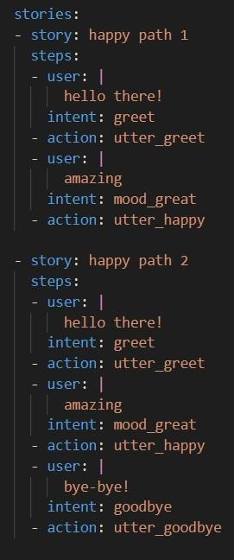 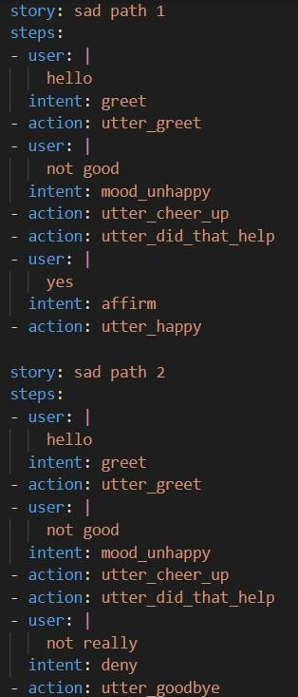 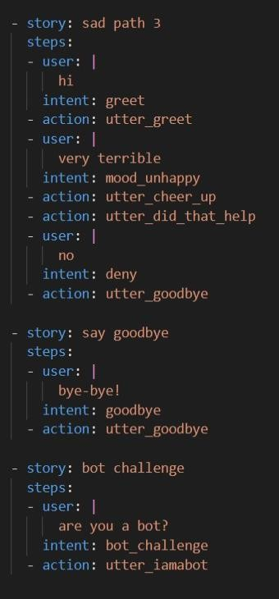

#### Fig.6.1 User Story Implementation

Internship report 2023-24 29

In the Natural Language Understanding (NLU) component, the system is

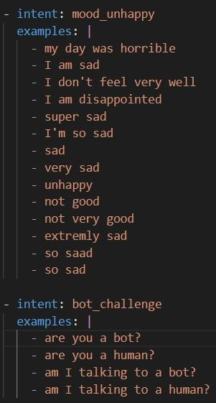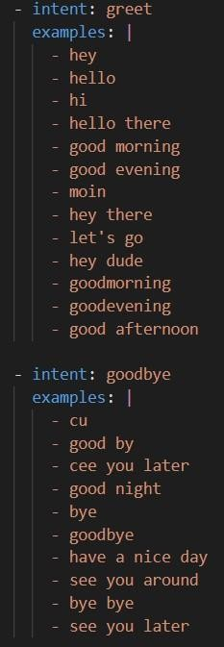

equipped to comprehend a variety of user intents, allowing the healthcare chatbot to engage in meaningful conversations. The intents captured include greetings,

farewells, affirmations, denials, expressions of mood (both positive and negative), and a specific inquiry challenging the bot's identity.

### Intent Summaries:

i) Greet:

Recognizes user greetings, fostering a warm and responsive interaction. Examples encompass casual greetings, time-specific salutations, and informal expressions. ii) Goodbye:

Captures user farewells in diverse forms, ensuring the chatbot concludes

interactions gracefully. Recognizes variations of goodbye expressions. iii) Affirm: Identifies affirmative responses, acknowledging user agreement or confirmation. Examples cover positive affirmations and agreement expressions. iv) Deny:

Recognizes user denials, indicating disagreement or negation. Examples include straightforward denials and expressions of disagreement.

1. Mood Great:

Captures positive emotional states and moods, allowing the chatbot to tailor responses based on users expressing happiness or satisfaction. vi) Mood Unhappy:

Identifies negative emotional states, enabling the chatbot to respond

empathetically to users expressing sadness or dissatisfaction. vii) Bot Challenge: Handles inquiries challenging the bot's identity,

providing transparent responses to users questioning whether they are interacting with a human or a bot.

Internship report 2023-24 31

A strong framework for understanding a broad range of user intents is revealed by the analysis of the Natural Language Understanding (NLU) component, which enables the healthcare chatbot to have complex and contextually relevant conversations. By including greetings and farewells, you can guarantee a courteous and approachable exchange that creates a positive atmosphere for participation. Because the system can reliably record affirmations and denials, it can adjust dynamically to users' responses and promote a conversational flow that suits their preferences. Furthermore, the chatbot's ability to distinguish between different emotional states— from joyful moods to moments of sadness—highlights its compassionate architecture and improves its capacity to offer tailored and encouraging responses.

The system's transparency and skill in responding to user inquiries regarding its identity are demonstrated by the addition of a specific intent for bot challenges. This thorough analysis demonstrates the NLU component's adaptability and establishes it as a vital component in developing a user-friendly and intuitive healthcare chatbot experience.

Internship report 2023-24 24

Internship report 2023-24 33

# [CHAPTER](https://1.bp.blogspot.com/-dODuK8N5h1Q/Wlnyb3V9HFI/AAAAAAAACL4/WxQtCJ1pM5wccDABg4wIrTBUB0vlikXQQCLcBGAs/s1600/poly1.jpg) 7 IMPLEMENTATION

|  |  |  |
| --- | --- | --- |
| Internship report | 2023-24 | 25 |

**7. IMPLEMENTATION**

Implementation is the stage where the theoretical design is turned into a working system. The most crucial stage in achieving a new successful system and in giving confidence on the new system for the users that it will work efficiently and effectively.

The system can be implemented only after thorough testing is done and if it is found to work according to the specification. It involves careful planning, investigation of the current system and it constraints on implementation, design of methods to achieve the change over and an evaluation of change over methods a part from planning.

Two major tasks of preparing the implementation are education and training of the users and testing of the system. The more complex the system being implemented, the more involved will be the system analysis and design effort required just for implementation.

The implementation phase comprises of several activities. The required hardware and software acquisition is carried out. The system may require some software to be developed. For this, programs are written and tested. The user then changes over to his new fully tested system and the old system is discontinued.

### TESTING

The testing phase is an important part of software development. It is the Information zed system will help in automate process of finding errors and missing operations and also a complete verification to determine whether the objectives are met and the user requirements are satisfied. Software testing is carried out in three steps:

1. The first includes unit testing, where in each module is tested to provide its correctness, validity and also determine any missing operations and to verify whether the objectives have been met. Errors are noted down and corrected immediately.
2. Unit testing is the important and major part of the project. So errors are rectified easily in particular module and program clarity is increased. In this project entire system is divided into several modules and is developed individually. So unit testing is conducted to individual modules.
3. The second step includes Integration testing. It need not be the case, the software whose modules when run individually and showing perfect results, will also show perfect results when run as a whole.

Internship report 2023-24 26

# [CHAPTER](https://1.bp.blogspot.com/-dODuK8N5h1Q/Wlnyb3V9HFI/AAAAAAAACL4/WxQtCJ1pM5wccDABg4wIrTBUB0vlikXQQCLcBGAs/s1600/poly1.jpg) 8 SNAPSHOTS

|  |  |  |
| --- | --- | --- |
| Internship report | 2023-24 | 27 |

#### Fig 8.5. Example for Migrane

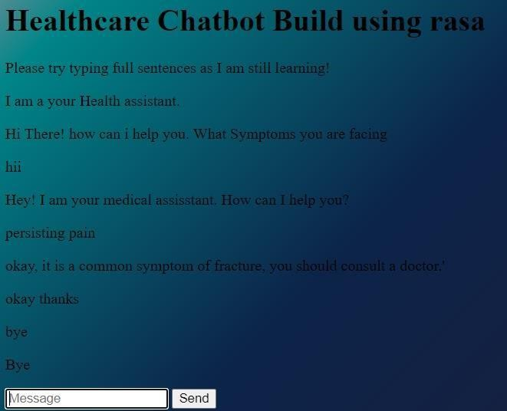

Internship report 2023-24 29

# [CHAPTER](https://1.bp.blogspot.com/-dODuK8N5h1Q/Wlnyb3V9HFI/AAAAAAAACL4/WxQtCJ1pM5wccDABg4wIrTBUB0vlikXQQCLcBGAs/s1600/poly1.jpg) 9 CONCLUTION

|  |  |  |
| --- | --- | --- |
| Internship report | 2023-24 | 30 |

**9. CONCLUTION**

The package was designed in such a way that future modifications can be done easily. The following conclusions can be deduced from the development of the project:

 Automation of the entire system improves the efficiency

 It provides a friendly graphical user interface which proves to be better when compared to the existing system.

 It gives appropriate access to the authorized users depending on their permissions.

 It effectively overcomes the delay in communications.

 Updating of information becomes so easier

 System security, data security and reliability are the striking features.

 The System has adequate scope for modification in future if it is necessary.

31

Internship report 2023-24

**10. REFERENCE**

|  |  |  |
| --- | --- | --- |
| Internship report | 2023-24 | 32 |