Optimization Methods Programming Assignment
Solving a Real-World Optimization Problem
Problem Title | Medical Delivery Route Optimization in the Galle Region
Exact Method | Held-Karp Dynamic Programming
Heuristic Method | Nearest Neighbor + 2-opt Local Search
Prepared For | Optimization Methods - Programming Assignment

1. Introduction
This report studies a realistic distribution problem where a central medical depot must visit multiple delivery locations and return to the depot while minimizing total travel distance. The setting represents medicine distribution to pharmacies and clinics around the Galle region. The problem is important because route efficiency directly affects fuel cost, delivery time, and service reliability.

2. Problem Selection and Context
The selected optimization problem is a Traveling Salesman Problem (TSP), a classic NP-hard routing problem. A delivery vehicle starts from the depot, visits every demand point exactly once, and returns to the depot. This is a suitable assignment topic because it is realistic, mathematically rich, and allows comparison between an exact method and a heuristic approach.

3. Data Description
A synthetic but realistic dataset was created using 12 health-service points and one depot. The coordinates represent relative map positions inspired by towns around southern Sri Lanka. Synthetic data is acceptable under the assignment brief as long as realism is explained. Distances were computed using Euclidean distance, which is reasonable for comparative optimization experiments.
Table 1. Delivery locations used in the experiment.
ID | Location | x | y
0 | Depot - Galle General Hospital | 0.0 | 0.0
1 | Hikkaduwa Pharmacy | 16 | 18
2 | Ambalangoda Medical Center | 28 | 30
3 | Elpitiya Clinic | 24 | 10
4 | Baddegama Pharmacy | 12 | 8
5 | Akuressa Rural Hospital | -8 | 18
6 | Imaduwa Medical Point | 4 | -10
7 | Koggala Pharmacy | 10 | -18
8 | Weligama Health Store | 22 | -24
9 | Deniyaya Clinic | -18 | 12
10 | Yakkalamulla Pharmacy | -6 | -6
11 | Udugama Rural Dispensary | -20 | 2
12 | Karapitiya Sub Depot | 2 | 4

4. Mathematical Formulation
Let N = {0,1,2,...,n} be the set of nodes, where node 0 is the depot. Let d_ij denote the travel distance from node i to node j. Define the binary decision variable x_ij as:
x_ij = 1 if the route travels directly from i to j, and 0 otherwise.
Objective function:
Minimize Z = Σ Σ d_ij x_ij
Subject to:
1. Each node is entered exactly once.
2. Each node is exited exactly once.
3. Subtours are eliminated so that the result is one complete tour.
4. x_ij ∈ {0,1}.
For the exact implementation, the problem is solved with the Held-Karp dynamic programming recurrence: C(S, j) = min_i∈S\{j} [C(S\{j}, i) + d_ij], where S is a subset of non-depot nodes and j is the last visited node in the subset.

5. Optimization Methods
Exact method - Held-Karp Dynamic Programming: This method evaluates subsets of visited nodes and guarantees the globally optimal route. Its main weakness is exponential growth in time and memory as the number of nodes increases.
Heuristic method - Nearest Neighbor + 2-opt: The route is first constructed greedily by repeatedly visiting the closest unvisited node. Then a 2-opt local search improves the solution by reversing route segments whenever doing so reduces the total distance. This approach is fast and often produces high-quality routes, but it does not guarantee optimality.

6. Implementation
The assignment was implemented in Python. The final package includes a Jupyter notebook, a standalone Python script, a plain-text code appendix, the dataset files, and this report. The implementation is reproducible and does not depend on proprietary tools.

7. Experimental Results
Method | Distance | Runtime (s) | Comment
Exact DP | 189.31 | 0.102423 | Guaranteed optimum
Nearest Neighbor | 200.40 | 0.000033 | Fast initial route
NN + 2-opt | 193.51 | 0.000215 | Improved heuristic solution
The exact method produced an optimal total distance of 189.31 units. The final heuristic solution produced 193.51 units, which is 2.22% above the optimum. This confirms that the heuristic is very competitive on this instance while taking negligible computation time.
Nodes | Exact Distance | Heuristic Distance | Gap % | Exact Runtime (s) | Heuristic Runtime (s)
8.0 | 140.09 | 140.09 | 0.0 | 0.000288 | 8e-05
10.0 | 172.04 | 174.55 | 1.46 | 0.002153 | 0.000111
13.0 | 189.31 | 193.51 | 2.22 | 0.030646 | 0.000224
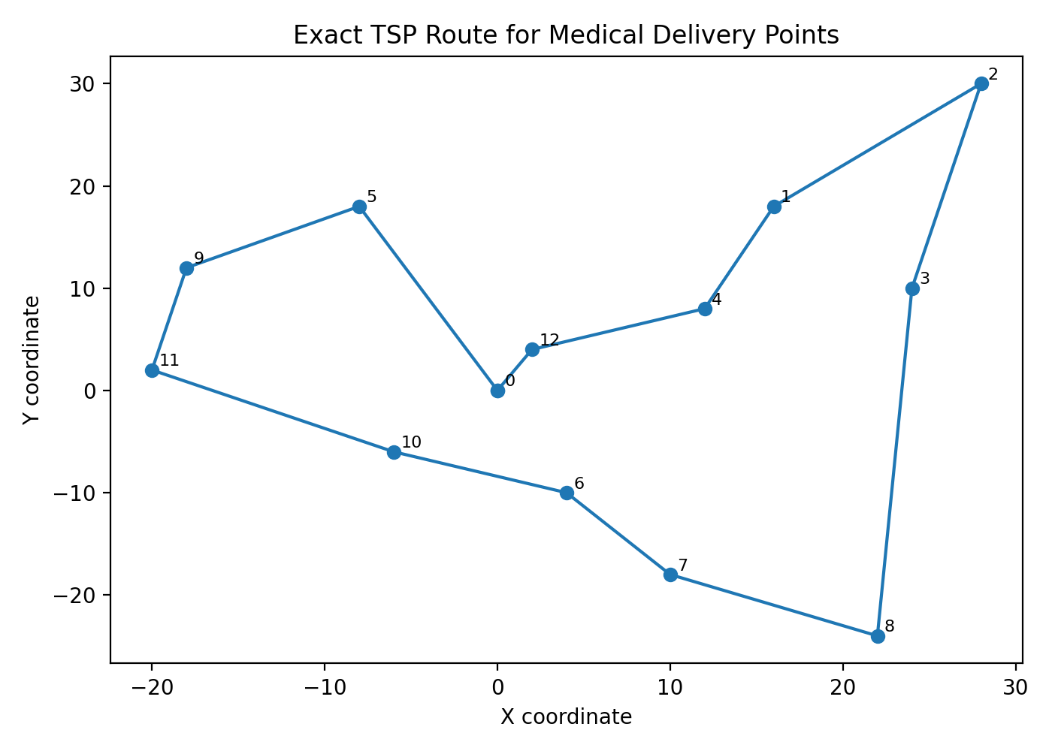
Figure 1. Optimal route found by the exact dynamic programming method.
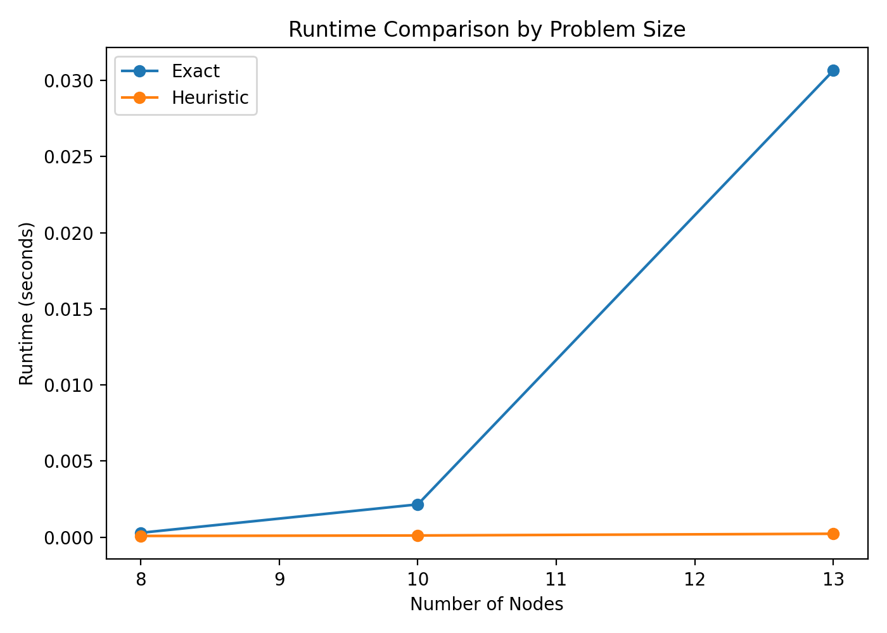
Figure 2. Runtime comparison between the exact and heuristic methods.

8. Discussion
The exact method is best when the instance size is small and the true optimum is required. However, scalability quickly becomes a limitation because the TSP is NP-hard. The heuristic method is much more practical for large-scale routing because it finds a near-optimal solution almost instantly. This trade-off between optimality and computational efficiency is the key lesson from the assignment.
The chosen heuristic performed well because the points have a strong geographic structure, allowing 2-opt to remove crossing edges and improve the greedy construction. In larger real-world settings with traffic, time windows, or multiple vehicles, more advanced metaheuristics such as simulated annealing, tabu search, or genetic algorithms could be used.

9. Individual Contribution
This section should be updated by the group before submission. Suggested format: Member 1 - data preparation, mathematical formulation, exact algorithm. Member 2 - heuristic implementation, experimentation, video preparation, and GitHub documentation.

10. Conclusion and Future Work
This assignment successfully modeled a real-world routing problem as an optimization problem and compared two fundamentally different solution strategies. Held-Karp dynamic programming gave the true optimal solution, while nearest neighbor with 2-opt produced a very close solution in a fraction of the time. Future work can extend the model to multiple vehicles, delivery capacities, road-network distances, and time-window constraints.

Appendix A. Best Routes
Exact route order: Depot - Galle General Hospital -> Karapitiya Sub Depot -> Baddegama Pharmacy -> Hikkaduwa Pharmacy -> Ambalangoda Medical Center -> Elpitiya Clinic -> Weligama Health Store -> Koggala Pharmacy -> Imaduwa Medical Point -> Yakkalamulla Pharmacy -> Udugama Rural Dispensary -> Deniyaya Clinic -> Akuressa Rural Hospital -> Depot - Galle General Hospital
Heuristic route order: Depot - Galle General Hospital -> Karapitiya Sub Depot -> Baddegama Pharmacy -> Elpitiya Clinic -> Ambalangoda Medical Center -> Hikkaduwa Pharmacy -> Akuressa Rural Hospital -> Deniyaya Clinic -> Udugama Rural Dispensary -> Yakkalamulla Pharmacy -> Imaduwa Medical Point -> Koggala Pharmacy -> Weligama Health Store -> Depot - Galle General Hospital

Appendix B. Submission Checklist
- members.txt included
- submission.txt included with dataset, GitHub, and YouTube links
- Jupyter notebook included
- Python script included
- Plain-text code appendix included
- PDF report generated
- GitHub repo should show meaningful commit history before final submission

